HealthApp Automation- Appointment Module

Pre-requisite:

As soon as you import project in eclipse, update the project using maven update option as below. This is to resolve issue if any maven dependency not downloaded properly:

1. Right click on project : Go to “Maven” : Select “Update Project”

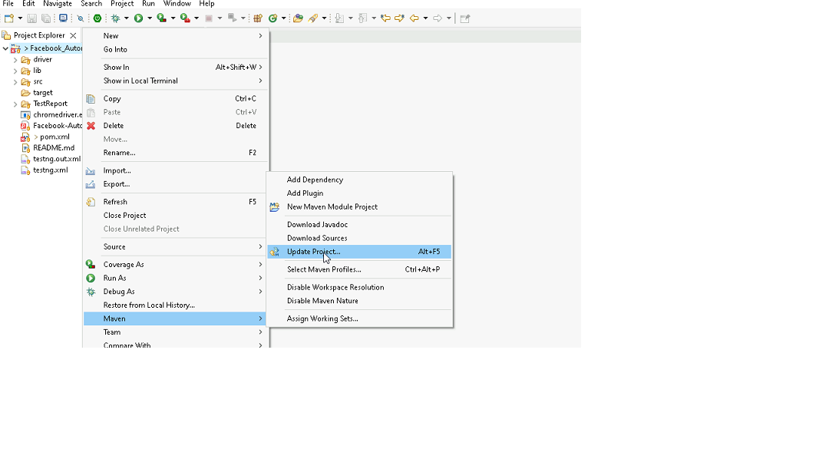

1. In Update Maven Project Box Select “Force Update of Snapshots/Releases” and click OK

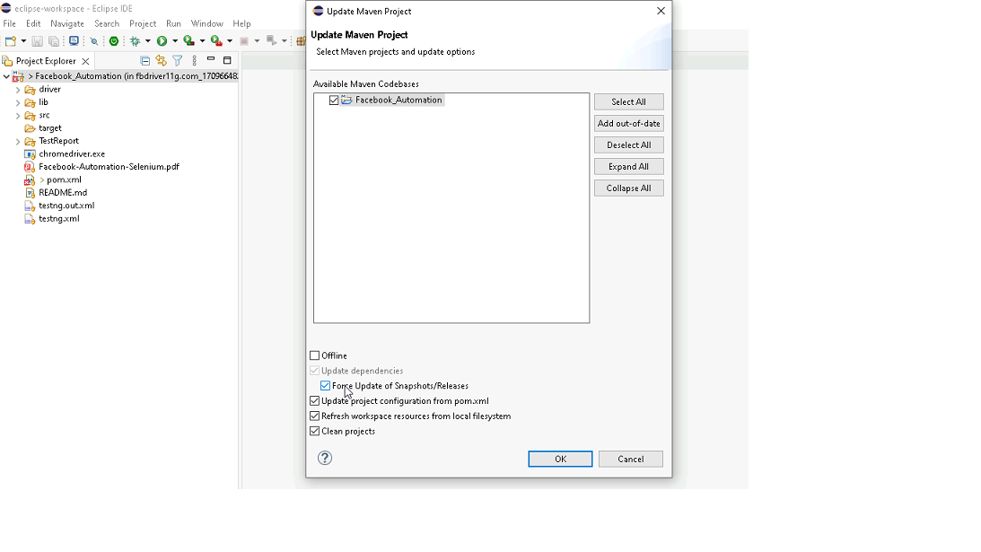

Template Code Structure:

1. Below are the packages and files you will be required to work upon.
2. Other Files and packages you can ignore.
3. In other Files and packages do not do any changes. It would affect your evaluation.
4. You are not required to work in “Test” Folder. Files there are non-editable. Editing those files and trying to save them will throw error and would affect your evaluation.

|  |  |  |
| --- | --- | --- |
| **Package** | **Class/File** | **Description** |
| src/main/java/coreUtilities/utils/ | FileOperations.java | 1. Contains methods to read from json file. 2. Method is in templated form. 3. **You will be required to implement these methods as very first activity, because even URL to navigate to, is read using these methods.** |
| /src/main/java/pages | appointment_Pages.java | 1. All core activities (mentioned in list above) to be performed here. 2. The comments associated with each templated method here describe the expectation. 3. You can define locators and xpath here. 4. Declare any variable/object you need to share data/status between different methods. 5. Do not modify the signature of methods declared here. 6. You can create additional supportive common methods in CommonEvents class. |
| /src/main/resources/ | Config.json | URL to navigate to. Already URL is defined here |
|  | expected_data.json | Contains data to fill in form |
| /src/main/java/coreUtilities/utils | CommonEvents.java | 1. Contains all common activities. 2. Certain templated common method declared here. 3. You implement them as per your need. 4. You can add any additional method for common activity here |
|  | Testng.xml | Execution needs to kick started from TestNG xml |

PROBLEM STATEMENT

Need to automate the following activities using Selenium + Java.

Key Activities to implement:

|  |  |  |  |  |
| --- | --- | --- | --- | --- |
| **Sl No.** | **Summary** | **Action** | **Expected Result** | **Validation Rules** |
| **1** | * Navigate to the URL. * Retrieve Title and URL of the current page. * Verify Title & URL: Check if the title & URL matches the expected title. | 1. Go to url : **https://healthapp.yaksha.com/**  2. login as valid credential (username : **admin** , password : **pass123**) and click on "SignIn" Button  3. get the title and url of the current page 4. validate the title and url of the current page | Title should be : DanpheHealth Url should be : https://healthapp.yaksha.com/ | Validate the title of the web page & Validate the URL of the web page |
| **2** | * Verify that Appointment module is present or not ? * While trying to navigate to the Appointment Module, it popups the "Select Counter" Page  * Verify the "Select Counter" Page Name | 1. user must be logged in 2. Check Appointment module is present in left navigation  3. Click on the Expand icon of Appointment Module  4. Check whether the "Select Counter" popups comes or not. 5. If "Select Counter" popups is present, then verify the "Select Counter" page name | Appointment module should be present While trying to navigate to the Appointment Module, Select Counter popup should comes and popup page name should be "Select Counter" | **Link** : Validate existency (Presence/Visibility) and operation (Click) **Text** : Validate existency (Presence/Visibility) and operation (Read Text) |
| **3** | On the Appointment module's "**New Visit"** Page, Verify the "New Patient" Button is present or not ? If "New Patient" button is present, then click on it. If it clicking on "New Patient" button, then verify the "Patient Information" text is present or not ? | 1. User must be present on "**Select Counter**" popups 2. Click on **"New 1**" link of the **Selecte Counter** popup, it will take to you **"New Visit"** Page. 3. Then validate the **"New Patient"** button is present or not ? 4. click on the "New Patient" button  5. verify the"Patient Information" text is present or not? | User should able to navigate to the "New Visit" page. "New Patient" button should be present "Patient Information" text should be present | Button : Validate existency (Presence/Visibility) and operation (Click) Text : Validate existency (Presence/Visibility) and operation (Read Text) |
| **4** | On the Appointment module's **New Visit** Page, scroll to the buttom of the page. Then highlight the **"Care of Person Contact**" textbox as Blue color | 1. User must be present on **New Visit** page. 2. Then scroll to the buttom of the **New Visit** page 3. Then click on "Care of Person Contact" textbox  4. Then highlight the **"Care of Person Contact"** textbox as Yellow color | User should able to scroll to the buttom of the "**New Visit**" page. "Care of Person Contact" textbox should be click and highlight | Scroll : Validate the scroll on a page Highlight : Validate existency (Presence/Visibility) and operation (element should be higlight) |
| **5** | On the Appointment module's New Visit Page, user must be on buttom of the page,  Then click on  **"Care of Person"** textbox and get the placeholder name of the **"Care of Person"** textbox. Then Verify the placeholder name is **"Care Taker Person"** | 1. On the Appointment module's New Visit Page, user must be on buttom of the page,  2. Then click on "**Care of Person"** textbox  3. Get the placeholder name of "**Care of Person**" textbox  4. Then verify the placeholder name is "**Care Taker Person"** | **"Care of Person"** textbox should be clickable and placeholder name should be **"Care Taker Person"** | Placeholder : Validate existency (Presence/Visibility) and validate the placeholder name |
| **6** | On the Appointment module's "New Visit" page, validate the error message in "Patient Information" form's lastname textfield after clicking on "Print Invoice" Button without filling any information in the form. | 1. User must be on **New Visit** Page of Appointment module's 2. click on "Print Invoice" button directly without fill any information in "Patient Information" form's  3. After clicking on "Print Invoice" button , it will popup **"Confirm ! Are you sure you want to Print Invoice ?"** Message. 4. click on "Confirm" button. 5. then an error message will display under the lastname textfield. 6. then validate error message ( Last Name is required. ) | Error message should be : Last Name is required. | Exception Handling and Error Logging : Verify handling and logging of unexpected behavior in applications |
| **7** | On the Appointment module's "New Visit" page, Fill all given textfields which are present inside the **Patient Information** form. Validate the entered values. | 1. User must be on New Visit Page of Appointment module's 2. then enter the values to the below fields of "patient Information" form  3. Enter data in the First Name textbox.  4. Enter data in the Middle Name textbox. 5.Enter data in the Last Name textbox. 6.Enter data in the Age textbox. 7.Enter data in the Phone No. textbox. | Given text fields value inside the "**Patient Information"** form are filled with appropriate information. The entered data should be correctly displayed in First Name, Middle Name, Last Name, Age and Contact Number Field on "Patient Information" form of New visit page | **Textbox** : Validate existency (Presence/Visibility) and operation (Click, Enter Text) **Attributes** : Validate existency (Presence/Visibility) and operation (get the text from the field) **Test Data Reading/Writing** : Validate the ability to read from and write to various data sources (Excel, DB, JSON). |
| **8** | On the New Visit" page's "Patient Information" form, click on "Have DOB ?" checkbox and verify that the "Have DOB ?" is selected or not.  After validation verify that the "Datepicker" field is coming after click on " "Have DOB ?" checkbox | 1. user must be on New Visit" page's "Patient Information" form 2. click on the  **"Have DOB ?"** checkbox 3. verify that the "Have DOB ?" is selected or not  4. After validation verify that the "Datepicker" field is coming after click on " "Have DOB ?" checkbox | "Have DOB ?" checkbox should be selected  "Datepicker" field should be come after click on "Have DOB ?" checkbox. | Checkbox : Validate existency (Presence/Visibility) and operation (Check, Uncheck) |
| **9** | On the New Visit" page's "Visit Information" form, An **External**? Checkbox must be selected. Click on **"+"** icon to popup the Add External Referral form then entered the data only "**Referrer Name*"** textbox (get the data from json) and then click on "**Add**" button then verify the success notifications message. ( **"Success update ")** | 1. User must be on "Visit Information" form of New Visit" page' and External? Checkbox must selected. 2. click on external **"+"** icon 3. then entered the data only "Referrer Name*" textbox (get data from json) 4. click on "Add" button , then a success notification popup will show on the buttom of the page. 5. then verify that "succes notification" message | message should be "**Success update** " | handle notification popups (Validate existency (Presence/Visibility) and operation (Read Data)) |
| **10** | On the New Visit" page's "Patient Information" form, scroll to the **"Relation With Patient"** dropdownand then select "**Son**" from the "Relation With Patient" dropdown. validate "**Son"** is properly selected or not. | 1. user must be on New Visit" page's "Patient Information" form 2. scroll to the "Relation With Patient" dropdown 3. select "Son" from the "Relation With Patient" dropdown. 4. validate "Son" is properly selected or not. | User should able to select Son from the "Relation With Patient" dropdown menu. | Dropdown : Validate existency (Presence/Visibility) and operation (Select Option) |
| **11** | On the "Appointment" module's, click on "Book Appointment" Sub module.  (Expand Appointment module, if not) On the "Book Appointment" page, select the "Month" radio button and verify that the "Month" radio button is selected or not. After the validation deselect the "Month" radio button. | **(Expand Appointment module, if not)** 1. scroll to the "Appointment" module  2. Click on "Book Appointment" sub modules of "Appointment" module  3. click on "New Patient" button 4. select the "Month" radiod button  5. verify that the "Month" radio button is selected 6. after validation "deselect" the "Month" radio button by click on "days" radio button and validate "Month" radio button is deselected | "Month" radio button should be selected and after validation should be deselect | **Radio Button** : ( Validate existency (Presence/Visibility) and operation (Select, Deselect) |
| **12** | On the "Appointment" module's "Book Appointment" page , send the value to the below textbox using javascript. Following Textbox are: 1. FirstName Text box 2. Middle Name Text Box 3. Last Name Text box and then click on "Male" radio button using java script | 1. user must be on "Book Appointment" page of "Appointment" modules 2. Then send the value to the following textboxes using javascript. **Following Textbox are :** --> FirstName Text box --> Middle Name Text Box --> Last Name Text box 3. then click on "Male" radio button using java script | user should able to send the value to the following textboxes using javascript **Following Textbox are :** --> FirstName Text box --> Middle Name Text Box --> Last Name Text box "Male" radio button should be selected using java script | JavaScript Execution : Validate the execution of JavaScript |
| **13** | On the "Appointment" module's "Book Appointment" page , locate the "Add Appointment" button by using Name locators and then get the attribute of Name locators. Verify that the "Add Appointment" button is present or not and then highlight it. | 1. user must be on "Book Appointment" page of "Appointment" modules 2. locate the "Add Appointment" button by using Name locators and then get the attribute of Name locators. 3. Verify that the "Add Appointment" button is present or not and then highlight it. | attribute value of "Add Appointment" button should be "addappointment"  "Add Appointment" button should be highlight | **Locator Strategy** : Validate the usage of basic element properties (ID, Name, CSS, etc.) for locating element **Highlight the element** : Validate existency (Presence/Visibility) and operation (element should be higlight) |
| **14** | On the "Book Appointment" submodules of appointment module, clicking on the "Add Appointment" button it will throw an Error Notification popup.  Then Assert that Error Message using hard assert | 1. user must be on "Book Appointment" page of "Appointment" modules 2. then click on the "**Add Appointment**" button 3. It will throw an Error Notification popup Message 4. validate that message using hard assert | Error message should be :  Failed Failed!! Cannot create appointment. Check the Details Correctly. | **Assertions** : Verify application behavior using Hard and Soft Assertions |
| **15** | On Procurements Module's Setting page, select the Sub Category Tab and fetch the Sub-Category Name for the given code (Code - 0003) and validate that Sub Category name. | 1. Go to the "Procurement" modules 2. go to the setting page 3. select the "Sub Category" Tab 4. fetch the Sub-Category Name for the given code (Code : 0003) | user should be able to fetch and validate the data from Specified table. | **Table** : Validate existency (Presence/Visibility) and operation (Read Data) |
| **16** | Scroll to the Vaccination Module's and Expand it. Click on "Patient List" page and perform the keyboard operation ("Alt + N") to open the "**Vaccination Patient Register"** form. Then Validate the **"Vaccination Patient Register"** page Name. | 1. Scroll to the Vaccination Module  2. Expand the Vaccination Module 3. "Patient List" sub module must be pre-selected,  if not then click on "Patient List" sub module 4. Press **"Alt + N"** from the keyboard to open the "**Vaccination Patient Register**" form. 5. Then Validate the "Vaccination Patient Register" form Name. 6. then close the "Vaccination Patient Register" form | when user performs the keyboard operation (Alt +N), it opens the "Vaccination Patient Register" form. And Form name should be "Vaccination Patient Register" | **keyboard operation** (perform the keyboard operation using robort class.) |
| **17** | On the Appointment module, under the"New visit" tab, verify tooltips which is present on keyboard icon. | 1. Scroll to the "Appointment" module  2. "Appointment" module must be expand, if not then expand it. 3. Click on "New Visit" sub module, it will navigate to the "New Visit" page.  **Optional**  **(* When user trying to click on "New Visit" sub modules of Appointment Module, If "New 1" link is coming, then Click on "New 1" link, or else ignore and follow step 4 )**  4. Mouse hover to the keyboard icon of the "New Visit" page. 5. Verify the tooltip message. | Tooltip message should be : **ALT + N = New Patient** | handle tooltip { Validate existency (Presence/Visibility) and operation (Read Text)} |
| **18** | On the Appointment module "New Visit" page, clicking on the "**New Patient**" button it will navigate to "New Visit" page. When user try to select "NHIF CAPTION" option from the Membership dropdown it should popup the alert message **:This will change Price Category as well**. Handle the alert popup and validate the popup message. After handle the popup, validate that the "NHIF CAPTION" is selected from Membership dropdown or not? | 1. User must be on "New Visit" page of Appointment module 2. Click on "New Patient" button 3. when try to select "NHIF CAPTION" option from the Membership dropdown , it will alert the popups. 4. handle alert popups and validate the popup Message : **This will change Price Category as well**  3. after handle the alert popup , verify that the "NHIF CAPTION" is selected from Membership dropdown or not? | alert popup should be handle and popus message should be "This will change Price Category as well " "NHIF CAPTION" should be selected from Membership dropdown. | **Alert Popup** : Validate existency (Presence/Visibility) and operation (Accept, Dismiss) **dropdown** : Validate existency (Presence/Visibility) and operation (Select Option) |
| **19** | On the Procurement module's Reports Tab, Search for a Select a Item as **Accounts** and select Accounts and validate Accounts is selected or not ? | 1. Click on Procurement module 2. Click on Reports Menu / tab 3. Click on current stock lavel 4. click on stock tab  5. click on the search bar which is under the **Current Stock Level Report** 6. remove any pre selected option  7. Again click on the search bar 8. Search Accounts in search bar 9. select Accounts from the suggestion 10. Validate Accounts is selected | Accounts should be selected from the suggestions. | Handle auto suggestion |
| **20** | On "Procurement" module's , Upload the image in "**Add Invoice Header**" page. | 1. user must be on "Report" page of "Procurement" module  2.Click on settings Menu / sub module 3.Click on Invoice headers 4.Click on Add new invoice headers button 5.Upload a file in Choose Logo Image field 6. close the "**Add Invoice Header"** page. | Uploaded Image should be displayed. | Handle file upload |
| **21** | On "Procurement" module's,Taking screenshot of the current page. | 1.Take a screenshot of the Current page.(Stored in the Screenshot folder) | User should take the screenshot. | handle screenshot {Validate the ability to capture screenshots during test execution. } |

NOTE: "Please do not delete any file in the src folder.  But you are free to add any other file".

Expectations:

1. Learners should write automation script using Java and selenium to automate all the steps in the above question. In other words, automation script should perform all mentioned steps.
2. Learners should not use any tools to create the xpath. They should develop the xpath/cssselector on their own.

IMPLEMENTATION/FUNCTIONAL REQUIREMENT

* 1. **CODE QUALITY/OPTIMIZATIONS**
     1. Associates should have written clean code that is readable.
     2. Associates need to follow SOLID programming principles.

EXECUTION STEPS TO FOLLOW

1. **You are mandatory required to run test cases for applications before final submission. Without which project evaluation will not happen.**
2. **You can launch test cases any time as follows: Right click on testng.xml and run TestNGSuite**

1. **Before final submission, you are also required to push your code to GIT. Following are the steps to follow:**

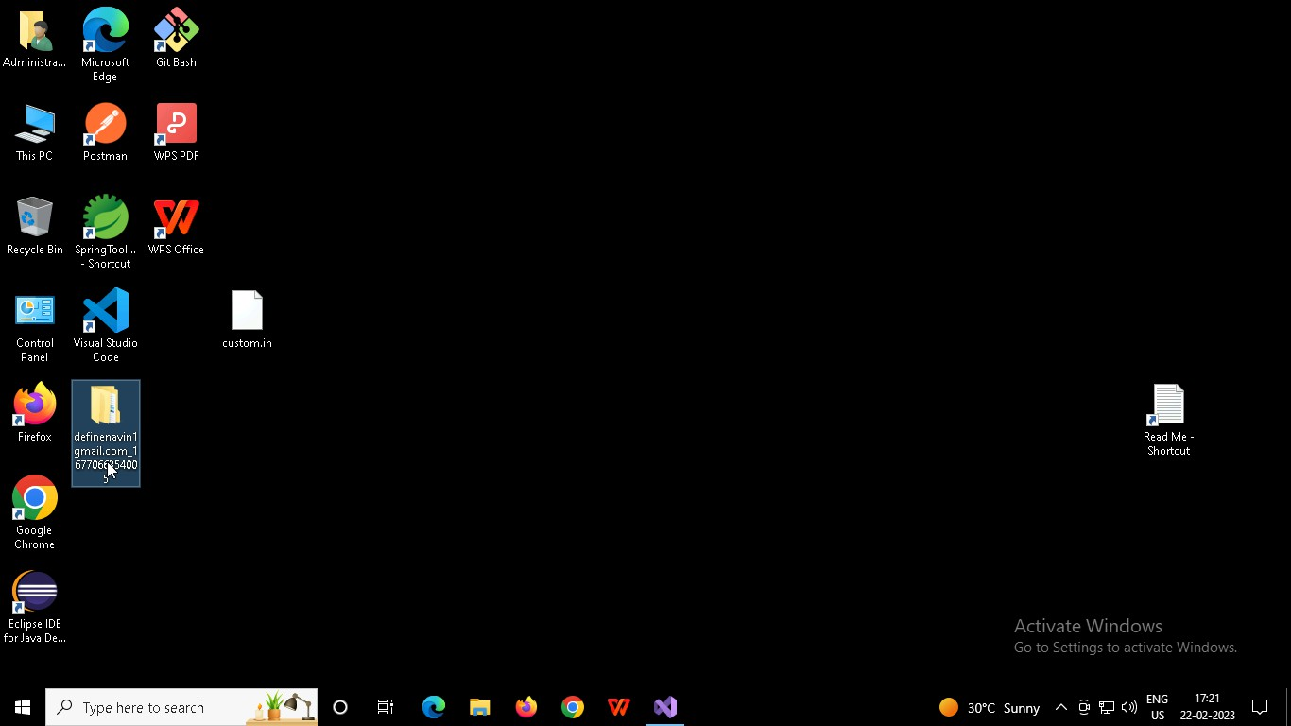

Right click in folder and open Git Bash

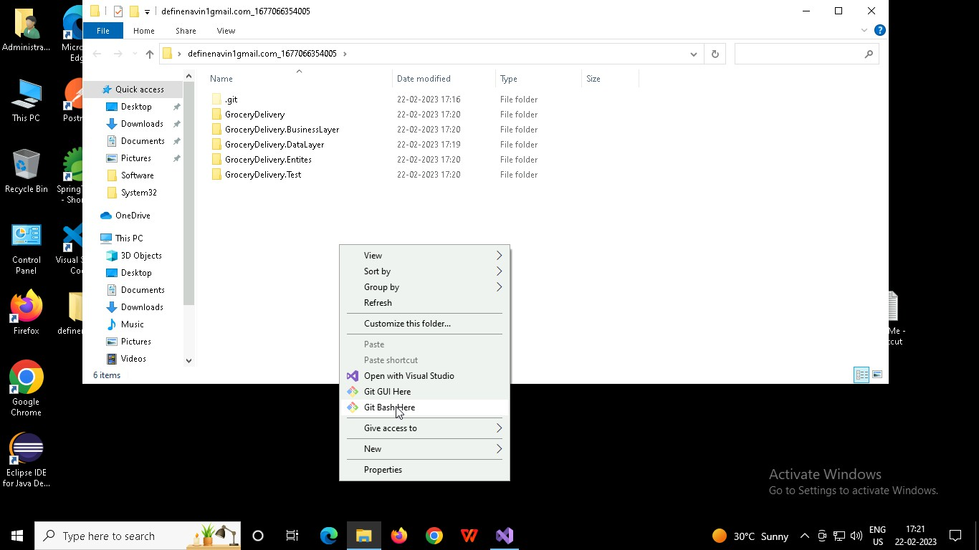

In Git bash terminal, run following commands

* 1. git status
  2. git add .
  3. git commit -m “First commit”

(You can provide any message every time you commit)

* 1. git push

