HealthApp Automation- Maternity Module

Pre-requisite:

As soon as you import project in eclipse, update the project using maven update option as below. This is to resolve issue if any maven dependency not downloaded properly:

1. Right click on project : Go to “Maven” : Select “Update Project”

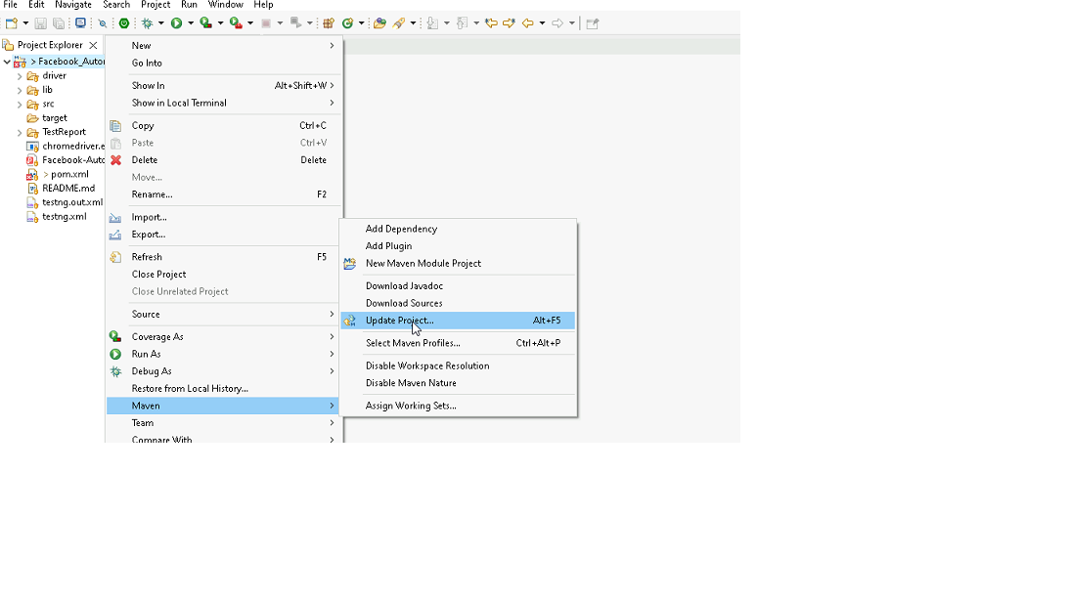

1. In Update Maven Project Box Select “Force Update of Snapshots/Releases” and click OK

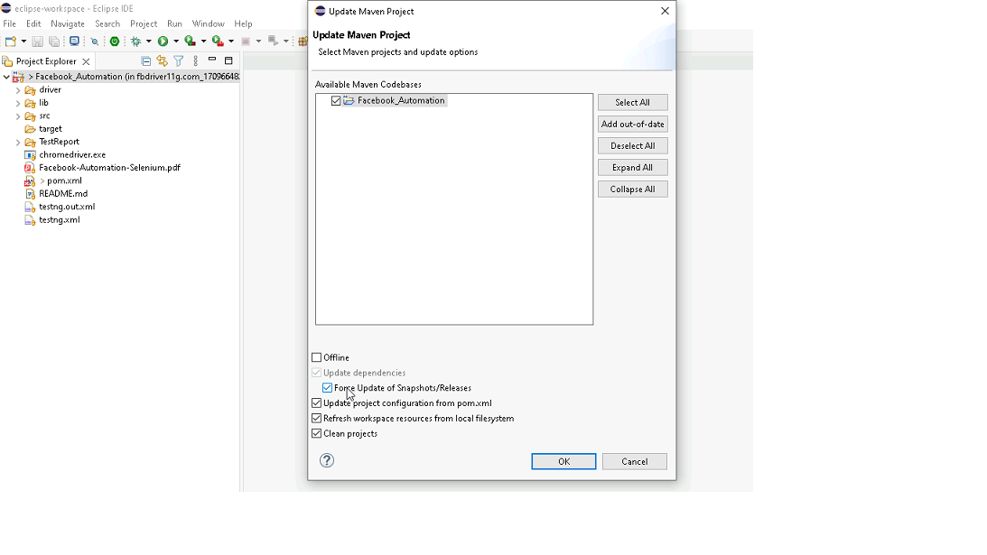

Template Code Structure:

1. Below are the packages and files you will be required to work upon.
2. Other Files and packages you can ignore.
3. In other Files and packages do not do any changes. It would affect your evaluation.
4. You are not required to work in “Test” Folder. Files there are non-editable. Editing those files and trying to save them will throw error and would affect your evaluation.

|  |  |  |
| --- | --- | --- |
| **Package** | **Class/File** | **Description** |
| src/main/java/coreUtilities/utils/ | FileOperations.java | 1. Contains methods to read from json file. 2. Method is in templated form. 3. **You will be required to implement these methods as very first activity, because even URL to navigate to, is read using these methods.** |
| /src/main/java/pages | maternity_page.java | 1. All core activities (mentioned in list above) to be performed here. 2. The comments associated with each templated method here describe the expectation. 3. You can define locators and xpath here. 4. Declare any variable/object you need to share data/status between different methods. 5. Do not modify the signature of methods declared here. 6. You can create additional supportive common methods in CommonEvents class. |
| /src/main/resources/ | Config.json | URL to navigate to. Already URL is defined here |
|  | expected_data.json | Contains data to fill in form |
| /src/main/java/coreUtilities/utils | CommonEvents.java | 1. Contains all common activities. 2. Certain templated common method declared here. 3. You implement them as per your need. 4. You can add any additional method for common activity here |
|  | Testng.xml | Execution needs to kick started from TestNG xml |

PROBLEM STATEMENT

Need to automate the following activities using Selenium + Java.

Key Activities to implement:

|  |  |  |  |
| --- | --- | --- | --- |
| **Sl No.** | **Summary** | **Action** | **Expected Result** |
| **1** | Verify the Maternity module is present or not | 1. Login in the healthapp application 2. Scroll down menu till Maternity  3. Click on the Maternity | Maternity module should be present |
| **2** | Verify all sub-modules are displayed correctly after Clicking on the "Maternity " Module. | Pre condition: User should be logged in and it is on Maternity module 1. Click on the Maternity Module drop-down arrow | All sub-modules should be displayed correctly. Expected Sub modules are : Maternity List , Payments , Reports |
| **3** | Verify to navigate to each sub-module which are present in the "Maternity" module | Pre condition: User should be logged in and it is on Maternity module  1. Naviagte to the "Maternity List" sub-module 2. Click on the "Payments" sub-module  3. Click on the "Reports" sub-module  4. Naviaget back to the "Maternity" sub-module | Ensure that it should navigate to each sub-module which are present in the "Maternity" module |
| **4** | Verify the presence of Maternity list with all fields | Pre condition: User should be logged in and it is on Maternity module 1. Navigate to "Maternity list" sub-module | Maternity lit sub-module should be present  Expected value that are present in "Maternity list" sub-module are   1. Buttons: First, Previous, Next, Last,Ok, Print, View 2. Fields: search bar, Edit Information Of 3. Drop down: Date range, "..."(3 dots) 4. Check-box: View all Maternity Patient 5. Date Picker: From, To 6. Tooltip: Star figure |
| **5** | Create Maternity record in the "Maternity"list by enter existing patient name in "Edit Information of" field | Pre condition: User should be logged in and it is on Maternity module 1. Navigate to "Maternity list" sub-module 2. Enter the Existing patient name in the "Edit Information of" field  3. Select the patient name by the dropdown 4. Enter the neccessay field in the "New Patient Registration" page (Husband's Name, Patient Height(in cm), Patient Weight(in kg), 1st dayOf Last Menstruation ,Expected Date of Delivery) 5. Click on "Register" button | Ensure that female patient names are displayed in the list.   After clicking the "Register" button, a success message should appear: "Success: Patient details updated successfully." |
| **6** | Verify to search the data by apply the date filter | Pre condition: User should be logged in and it is on Maternity module 1. Click on the "From" date 2. Select the "Jan 2020" date 3. Click on the "To" date 4. Select "July 2024" date 5. Click on "OK" button | Data should be present as per the selected date range  The "EDD" column date must fall within the selecetd date. |
| **7** | Verify to data range by select "one week" option from drop down | Pre condition: User should be logged in and it is on Maternity module 1. Navigate to "Maternity list" sub-module 2. Click on the data range button 3. select "one week" option from the drop down 4. Click on "OK" button | Data should be present as per the selected date range using dropdown The "EDD" columns date must fall within the "one week". |
| **8** | Verify the functionality of the "View All Maternity Patients" checkbox | Pre condition: User should be logged in and it is on Maternity module 1. Navigate to "Maternity list" sub-module  2. Clcik on the "View All Maternity Patients" checkbox | Ensure that all relevant records become visible as expected. |
| **9** | Verify that entering a keyword matching existing records in the search bar returns the corresponding data. | Pre condition: User should be logged in and it is on Maternity module 1. Navigate to "Maternity list" sub-module  2. Enter the keywords | Data should be present for the search |
| **10** | Verify the tooltip and it's text present on hover the mouse on "Star" | Pre condition: User should be logged in and it is on Maternity module 1. Navigate to "Maternity list" sub-module  2. Hover the mouse in start | Tooltip should be present when hover the mouse on star with text "Remember this date" |
| **11** | Verify the presence of "View" button | Pre condition: User should be logged in and it is on Maternity module 1. Navigate to "Maternity list" sub-module  2. Click on the "View" button of a specific records 3. Click on " Updated Patient" button | Update any of these fields and click on "Update Patient."  Verify that a success message, "Patient details updated successfully," appears. |
| **12** | Verify the presence of "ANC" button | Pre condition: User should be logged in and it is on Maternity module 1. Navigate to "Maternity list" sub-module  2. Click on the "ANC" button of a specific records 3. Click on " Updated Patient" button | Ensure that any updates made on the "Update Details" page are accurately reflected in the record of the specific patient. |
| **13** | Verify the presence of "Mat - Register" in the "..." drop down | Pre condition: User should be logged in and it is on Maternity module 1. Navigate to "Maternity list" sub-module  2. Click on the "..." button of a specific records 3. Click on " Mat - Register" option from a specfic record 4. Fill all necessary field present in the "Maternity Register" page 5. Click on "Save" button | Ensure that after clicking the "Save" button, a success message "Registered successfully." appears.  After completing all steps, verify the details by selecting the "Mat- Register" option and ensure the information is visible in the "Child Details of Patient" table. |
| **14** | Verify the presence of "Conclude" in the "..." drop down | Pre condition: User should be logged in and it is on Maternity module 1. Navigate to "Maternity list" sub-module  2. Click on the "..." button of a specific records 3. Click on " Conclude" option from a specfic record 4. Click on the "Confirm" button | Ensure that after clicking the "Conclude" option, an alert box appears.  Verify that upon clicking "Confirm" in the alert box, a success message "Successfully Concluded." is displayed. |
| **15** | Verify the presence of "Remove" in the "..." dropdown | Pre condition: User should be logged in and it is on Maternity module 1. Navigate to "Maternity list" sub-module  2. Click on the "..." button of a specific records 3. Click on "Remove" option from a specfic record 4. Click on the "Remove" button | Ensure that after clicking the "Remove" option, an alert box appears.  Verify that upon clicking "Remove" in the alert box, a success message "Successfully Removed.." is displayed.  After completing these steps, confirm that specific record no longer visible |
| **16** | Verify the view of all the columns of table after stretching any column | Pre condition: User should be logged in and it is on Maternity module 1. Navigate to the "Maternity List" sub module 2. Stretch the column by Click on the line present between 2 columns | The column should be expand |
| **17** | Verify the functionality of "Next" page navigator | Pre-condition: user should be logged in and it is on Maternity module 1. Navigate to the "Maternity List" sub-module 2. Select "Jan 2024" from the "From" field  3. Select "August 2024" from the "To" field  4. Scroll all the way to the botton of the page  5. Click on "Next" button | the bottom of the newly loaded page displays  the text "Page 2 of n". |
| **18** | Verify the presence "Payments" sub-module with all fields | Pre condition: User should be logged in and it is on Maternity module 1. Navigate to "Payments" sub-module | Paymemts sub-module should be present  Expected value that are present in "Paymnets" sub-module are   1. Buttons: First, Previous, Next, Last, Print, Payment 2. Fields: search bar 3. Check-box: Search From All Patients |
| **19** | Verify the functionality of "Search from All Patient" checkbox | Pre condition: User should be logged in and it is on Maternity module 1. Navigate to "Payments" sub-module 2. Click on the "Search from All Patient" checkbox | Ensure that record should visble with all colums  (Hospital.No, Patinet name , Age/Sex, Contact No  , Address, IP Number, Discharge Date, Actions) |
| **20** | Verify the presence of "Reports" sub- module with all fields | Pre condition: User should be logged in and it is on Maternity module 1. Navigate to "Reports" sub-module 2. Click on "Maternity Allowance Reports" sub-modal | Reports sub-module should be present  Expected value that are present in "Reports" sub-module are   1. Buttons: Show Reports 2. Drop down: Date range, Select user 3. Date Picker: From, To 4. Tooltip: Star figure |
| **21** | Verify the presence of "Export" present in the Report sub- modules | Pre condition: User should be logged in and must be on the "Maternity" modules 1. Navigate to the "Report" sub-modules 2. Click on the" show Report" button 3. Click on the "Export" button | Ensure that the exported file is in the correct format and contains the data as displayed in the report. |

NOTE: "Please do not delete any file in the src folder.  But you are free to add any other file".

Expectations:

1. Learners should write automation script using Java and selenium to automate all the steps in the above question. In other words, automation script should perform all mentioned steps.
2. Learners should not use any tools to create the xpath. They should develop the xpath/cssselector on their own.

IMPLEMENTATION/FUNCTIONAL REQUIREMENT

* 1. **CODE QUALITY/OPTIMIZATIONS**
     1. Associates should have written clean code that is readable.
     2. Associates need to follow SOLID programming principles.

EXECUTION STEPS TO FOLLOW

1. **You are mandatory required to run test cases for applications before final submission. Without which project evaluation will not happen.**
2. **You can launch test cases any time as follows: Right click on testng.xml and run TestNGSuite**

1. **Before final submission, you are also required to push your code to GIT. Following are the steps to follow:**

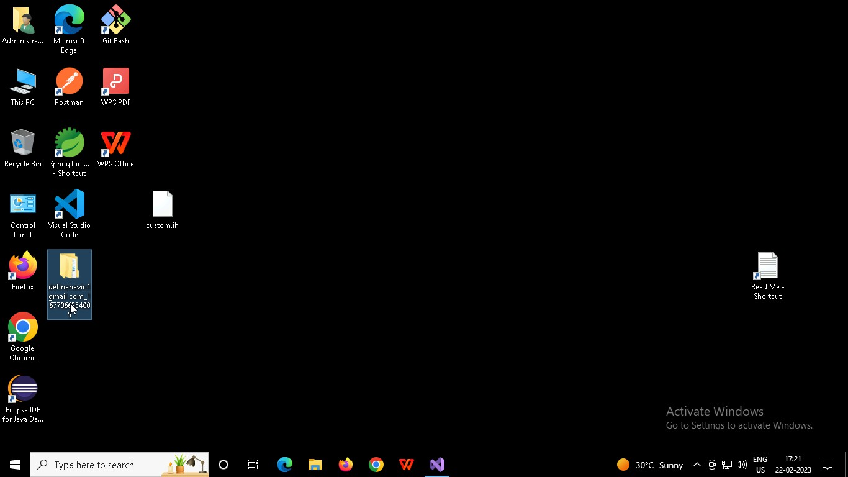

Right-click in the folder and open Git Bash

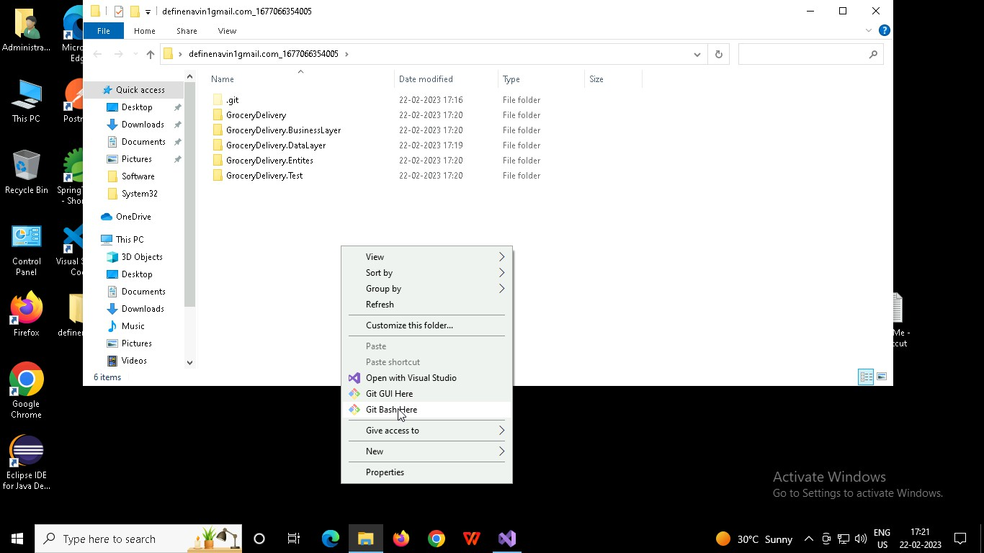

In Git bash terminal, run following commands

* 1. git status
  2. git add .
  3. git commit -m “First commit”

(You can provide any message every time you commit)

* 1. git push

