HealthApp Automation-MedicalRecord Module

Pre-requisite:

As soon as you import project in eclipse, update the project using maven update option as below. This is to resolve issue if any maven dependency not downloaded properly:

1. Right click on project : Go to “Maven” : Select “Update Project”

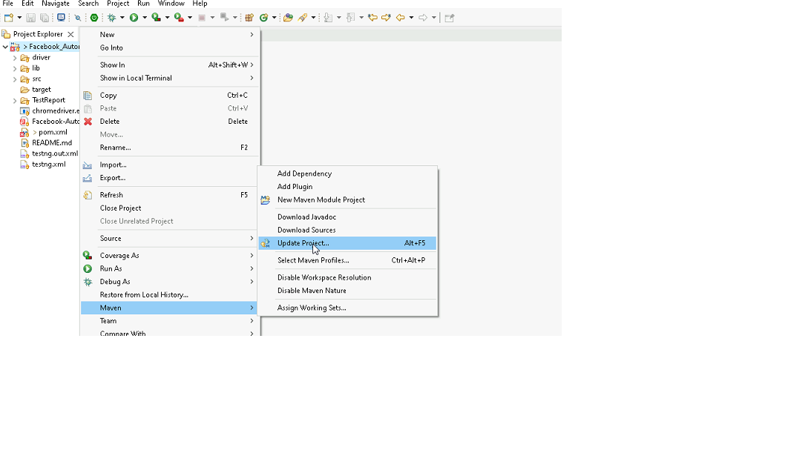

1. In Update Maven Project Box Select “Force Update of Snapshots/Releases” and click OK

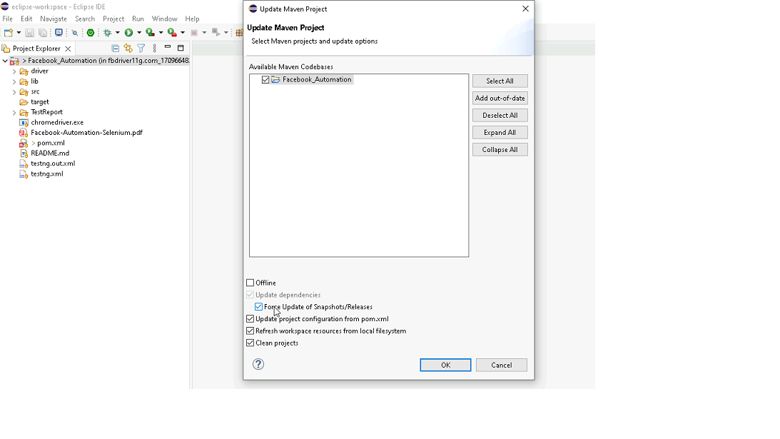

Template Code Structure:

1. Below are the packages and files you will be required to work upon.
2. Other Files and packages you can ignore.
3. In other Files and packages do not do any changes. It would affect your evaluation.
4. You are not required to work in “Test” Folder. Files there are non-editable. Editing those files and trying to save them will throw error and would affect your evaluation.

|  |  |  |
| --- | --- | --- |
| **Package** | **Class/File** | **Description** |
| src/main/java/coreUtilities/utils/ | FileOperations.java | 1. Contains methods to read from json file. 2. Method is in templated form. 3. **You will be required to implement these methods as very first activity, because even URL to navigate to, is read using these methods.** |
| /src/main/java/pages | medicalRecord_page.java | 1. All core activities (mentioned in list above) to be performed here. 2. The comments associated with each templated method here describe the expectation. 3. You can define locators and xpath here. 4. Declare any variable/object you need to share data/status between different methods. 5. Do not modify the signature of methods declared here. 6. You can create additional supportive common methods in CommonEvents class. |
| /src/main/resources/ | Config.json | URL to navigate to. Already URL is defined here |
|  | expected_data.json | Contains data to fill in form |
| /src/main/java/coreUtilities/utils | CommonEvents.java | 1. Contains all common activities. 2. Certain templated common method declared here. 3. You implement them as per your need. 4. You can add any additional method for common activity here |
|  | Testng.xml | Execution needs to kick started from TestNG xml |

PROBLEM STATEMENT

Need to automate the following activities using Selenium + Java.

Key Activities to implement:

|  |  |  |  |
| --- | --- | --- | --- |
| **Sl No.** | **Summary** | **Action** | **Expected Result** |
| **1** | Verify the Medical Records module is present | 1. Login in the healthapp application 2. Scroll down menu till Medical Records 3. Click on the Medical Records | Medical Records module should be present |
| **2** | Verify all sub-modules are displayed correctly after Clicking on the "Medical Records " Module. | Pre condition: User should be logged in and it is on Medical Records module 1. Click on the Medical Records Module drop-down arrow | All sub-modules should be displayed correctly.  Expected Sub modules are : MR Outpatient List, MR Inpatient List, Birth List, Death List, Reports, Emergency Patient List |
| **3** | Verify URL of the Medical Records module | Pre condition: User should be logged in  1. Click on the Medical Records | By default url will open MR Inpatient List module |
| **4** | Verify the presence of MR Outpatient section in Medical Records module with all fields | Pre condition: User should be logged in and it is on Medical Records module 1. Click on the Medical Records module drop-down arrow  2. Click on MR Outpatient section | MR Outpatient section in Medical Records should be present  Expected value that are present in MR Outpatient section are  1. Buttons: First, Previous, Next, Last,Add Final Diagnosis, Edit Final Diagnosis 2. Fields: search bar 3. Drop down: Doctor Filter, Select Disease Category, Department Filter, Select Diagnosis, Date range[-] 4. Checkbox: ALL, Diagnosis Added, Diagnosis Pending  5. Date Picker: From, To 6. Tooltip: Star figure |
| **5** | Verify to navigate on another sub module after open the MR Outpatient section | Pre condition: User should be logged in and it is on Medical Records module 1. Click on the MR Outpatient  2. Click on the Reports 3. Click on the Birth List 4. Click on the Death List 5. Click on the Emergency Patient List  6. Clcik on the MR Inpatient List | User should navigate to the all section from the MR Outpatient section and should navigate back to MR Outpatient section |
| **6** | Verify that entering a keyword matching existing records in the search bar returns the corresponding data. | Pre condition: User should be logged in and it is on MR Outpatient section 1. Enter the keywords "Female" | Data should be present for the search, and the 'Gender' column should contain only patients in the "Female" category. |
| **7** | Verify to search the data by apply the date filter | Pre condition: User should be logged in and it is on MR Outpatient section  1. Click on the "From" date 2. Select the "Jan 2020" date 3. Click on the "To" date 4. Select "July 2024" date 5. Click on "OK" button | Data should be present as per the selected date range  The 'Appointment Date' column date must fall within the selecetd date. |
| **8** | Verify to data range by select "one week" option from drop down | Pre condition: User should be logged in and it is on MR Outpatient section  1. Click on the data range button 2. select "one week" option from the drop down 3. Click on "OK" button | Data should be present as per the selected date range using dropdown The 'Appointment Date' column date must fall within the "one week". |
| **9** | Verify the presence of "Doctor filter" drop down by selecting "Dr. ALEX OKELLO ONYIEGO" option | Pre condition: User should be logged in and it is on Medical Records module 1. Naviaget to MR Outpatient sub-module 2. Select "Dr. ALEX OKELLO ONYIEGO" in doctor filter drop down | Data should be present as per the selected doctor from the dropdown The 'Doctor Name' column only the selecetd doctor name |
| **10** | Verify the presence of "Department Filter" drop down by selecting "Cardiology" option | Pre condition: User should be logged in and it is on MR Outpatient section 1. select "Cardiology" in select disease category drop down | Data should be present as per the selected department from the dropdown The 'Department" column only the selecetd department |
| **11** | Verify the functionality of "Next" page navigator | Pre-condition: user should be logged in  1. Navigate to the Medical record module 2. Click on MR Outpatient sub module 3. Select "Jan 2024" from the "From" field  4. Select "August 2024" from the "To" field  5. Scroll all the way to the botton of the page  6. Click on "Next" button | the bottom of the newly loaded page displays the text "Page 2 of n". |
| **12** | Verify the presence of "Select Diagnosis" drop down by selecting "Malignant neoplasms of stomach" option | Pre condition: User should be logged in and it is on MR Outpatient section 1. Enter the "2B72" in the " select disease" field  2. select "Malignant neoplasms of stomach" in select disease category drop down | Data should be present as per the selected Diagnosis from the dropdown Ensure that the "ICD Code" column is correctly updated based on changes in the selected diagnosis. ICD CODE -> "2B72" |
| **13** | Verify the presence of "Diagnosis Added" checkbox | Pre condition: User should be logged in and it is on MR Outpatient section 1. Click on "Diagnosis Added" checkbox | Data should be present according to the status, and after clicking the checkbox, only the records with "Edit Final Diagnosis" in the "Action" column should be displayed. |
| **14** | Verify the presence of "Add Final Diagnosis" button | Pre condition: User should be logged in and it is on MR Outpatient section 1. Click on "FROM" and select "Jan 2020" 2. Click on "TO" and selct "march 2024" 3. Click on "OK" button 4. Click on "Add Final Diagnosis" button | Data should be present as per status and after Clicking it "Add Final Diagnosis" should display Add Final Diagnosis page  message should pop ip "Success Added Sucessfully" |
| **15** | Verify the presence of "Edit Final Diagnosis" button | Pre condition: User should be logged in and it is on MR Outpatient section 1. Click on "FROM" and select "July 2024" 2. Click on "TO" and selct "march 2024" 3. Click on "OK" button 4. Click on "Edit Final Diagnosis" button | Data should be present according to the status, and after clicking, "Edit Final Diagnosis" should display the Add Final Diagnosis page, with the "Final Diagnosis" column updated according to the modifications. |

NOTE: "Please do not delete any file in the src folder.  But you are free to add any other file".

Expectations:

1. Learners should write automation script using Java and selenium to automate all the steps in the above question. In other words, automation script should perform all mentioned steps.
2. Learners should not use any tools to create the xpath. They should develop the xpath/cssselector on their own.

IMPLEMENTATION/FUNCTIONAL REQUIREMENT

* 1. **CODE QUALITY/OPTIMIZATIONS**
     1. Associates should have written clean code that is readable.
     2. Associates need to follow SOLID programming principles.

EXECUTION STEPS TO FOLLOW

1. **You are mandatory required to run test cases for applications before final submission. Without which project evaluation will not happen.**
2. **You can launch test cases any time as follows: Right click on testng.xml and run TestNGSuite**

1. **Before final submission, you are also required to push your code to GIT. Following are the steps to follow:**

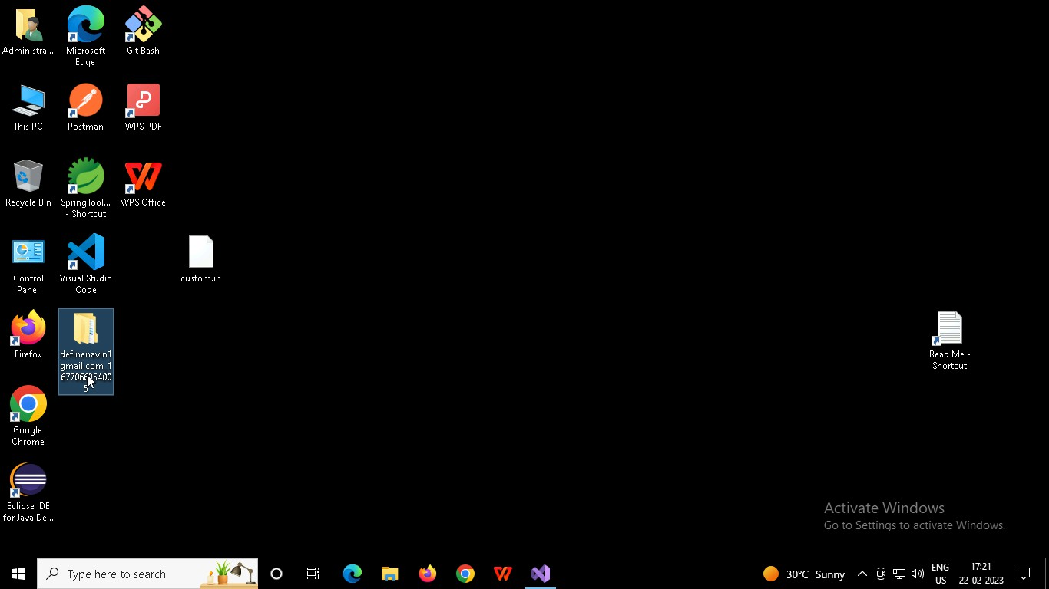

Right click in folder and open Git Bash

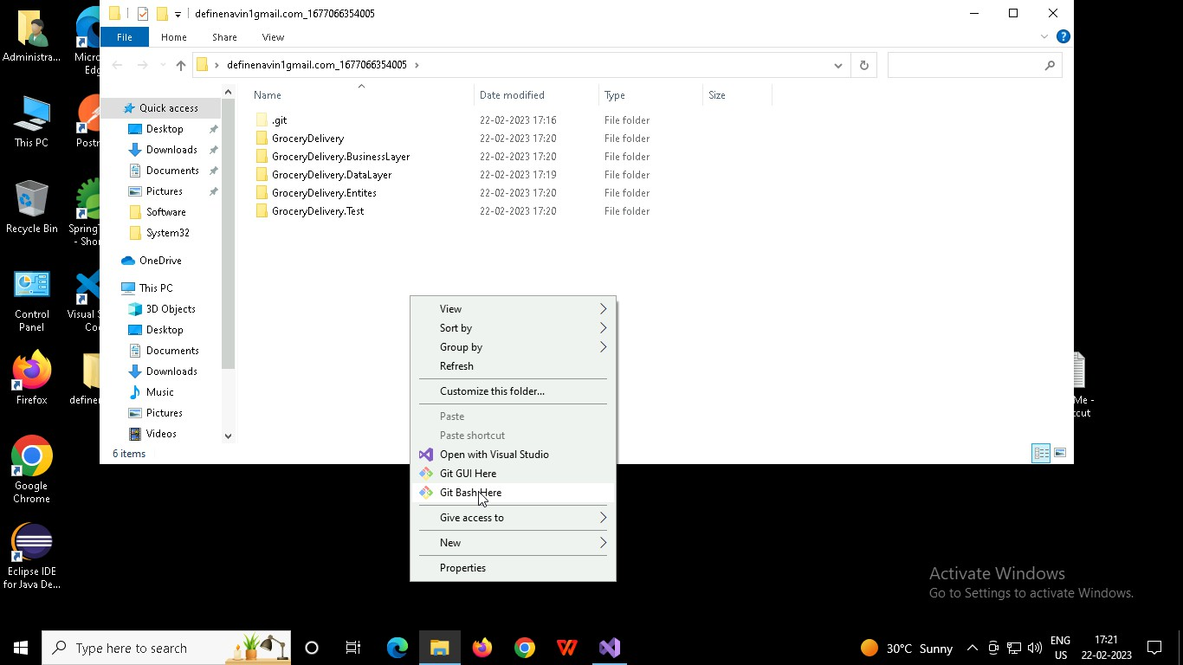

In Git bash terminal, run following commands

* 1. git status
  2. git add .
  3. git commit -m “First commit”

(You can provide any message every time you commit)

* 1. git push

