HealthApp Automation-MedicalRecord Module

Pre-requisite:

As soon as you import project in eclipse, update the project using maven update option as below. This is to resolve issue if any maven dependency not downloaded properly:

1. Right click on project : Go to “Maven” : Select “Update Project”

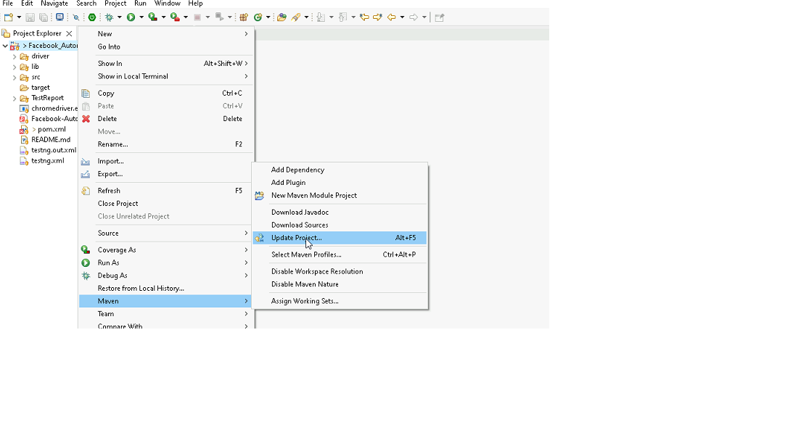

1. In Update Maven Project Box Select “Force Update of Snapshots/Releases” and click OK

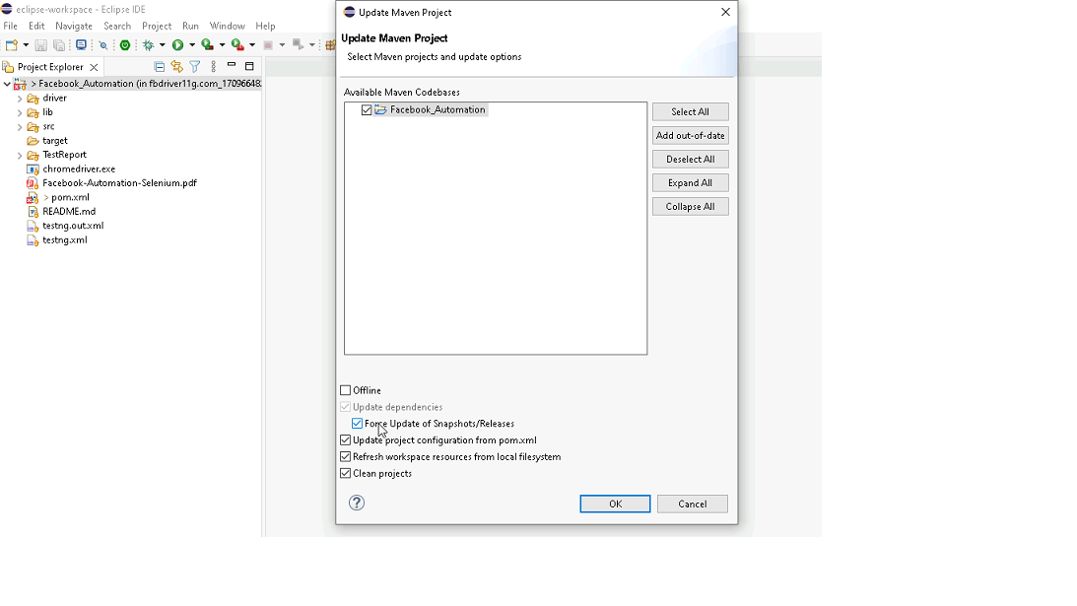

Template Code Structure:

1. Below are the packages and files you will be required to work upon.
2. Other Files and packages you can ignore.
3. In other Files and packages do not do any changes. It would affect your evaluation.
4. You are not required to work in “Test” Folder. Files there are non-editable. Editing those files and trying to save them will throw error and would affect your evaluation.

|  |  |  |
| --- | --- | --- |
| **Package** | **Class/File** | **Description** |
| src/main/java/coreUtilities/utils/ | FileOperations.java | 1. Contains methods to read from excel file. 2. Method is in templated form. 3. **You will be required to implement these methods as very first activity, because even URL to navigate to, is read using these methods.** |
| /src/main/java/pages | medicalRecord_page.java | 1. All core activities (mentioned in list above) to be performed here. 2. The comments associated with each templated method here describe the expectation. 3. You can define locators and xpath here. 4. Declare any variable/object you need to share data/status between different methods. 5. Do not modify the signature of methods declared here. 6. You can create additional supportive common methods in CommonEvents class. |
| /src/main/resources/ | Config.xlsx | URL to navigate to. Already URL is defined here |
|  | expected_data.xlsx | Contains data to fill in form |
| /src/main/java/coreUtilities/utils | CommonEvents.java | 1. Contains all common activities. 2. Certain templated common method declared here. 3. You implement them as per your need. 4. You can add any additional method for common activity here |
|  | Testng.xml | Execution needs to kick started from TestNG xml |

PROBLEM STATEMENT

Need to automate the following activities using Selenium + Java.

Key Activities to implement:

|  |  |  |  |
| --- | --- | --- | --- |
| **Sl No.** | **Summary** | **Action** | **Expected Result** |
| **1** | Verify the Medical Records module is present | 1.  go to URL :[**https://healthapp.yaksha.com/**](https://healthapp.yaksha.com/)  2. login as valid credential **(username : admin , password : pass123)** and click on "**SignIn**" Button  3. Scroll down menu till Medical Records 4. Click on the Medical Records | Medical Records module should be present |
| **2** | Verify all sub-modules are displayed correctly after Clicking on the "Medical Records " Module. | Pre-condition: User should be logged in and it is on Medical Records module 1. Click on the Medical Records Module drop-down arrow | All sub-modules should be displayed correctly.  Expected Sub modules are : MR Outpatient List, MR Inpatient List, Birth List, Death List, Reports, Emergency Patient List |
| **3** | Verify URL of the Medical Records module | Pre-condition: User should be logged in  1. Click on the Medical Records | By default URL will open MR Inpatient List module |
| **4** | Verify the presence of MR Outpatient section in Medical Records module with all fields | Pre-condition: User should be logged in and it is on Medical Records module 1. Click on the Medical Records module drop-down arrow  2. Click on MR Outpatient section | MR Outpatient section in Medical Records should be present  Expected value that are present in MR Outpatient section are  1. Buttons: First, Previous, Next, Last, Add Final Diagnosis, Edit Final Diagnosis 2. Fields: search bar 3. Drop down: Doctor Filter, Select Disease Category, Department Filter, Select Diagnosis, Date range[-] 4. Checkbox: ALL, Diagnosis Added, Diagnosis Pending  5. Date Picker: From, To 6. Tooltip: Star figure |
| **5** | Verify to navigate on another sub module after open the MR Outpatient section | Pre-condition: User should be logged in and it is on Medical Records module 1. Click on the MR Outpatient  2. Click on the Reports 3. Click on the Birth List 4. Click on the Death List 5. Click on the Emergency Patient List  6. Clcik on the MR Inpatient List | User should navigate to the all section from the MR Outpatient section and should navigate back to MR Outpatient section |
| **6** | Verify that entering a keyword matching existing records in the search bar returns the corresponding data. | Pre-condition: User should be logged in and it is on MR Outpatient section 1. Enter the keywords "Female" | Data should be present for the search, and the 'Gender' column should contain only patients in the "Female" category. |
| **7** | Verify to search the data by apply the date filter | Pre-condition: User should be logged in and it is on MR Outpatient section  1. Click on the "From" date 2. Select the "Jan 2020" date 3. Click on the "To" date 4. Select "July 2024" date 5. Click on "OK" button | Data should be present as per the selected date range  The 'Appointment Date' column date must fall within the selected date. |
| **8** | Verify to data range by select "one week" option from drop down | Pre-condition: User should be logged in and it is on MR Outpatient section  1. Click on the data range button 2. select "one week" option from the drop down 3. Click on "OK" button | Data should be present as per the selected date range using dropdown The 'Appointment Date' column date must fall within the "one week". |
| **9** | Verify the presence of "Doctor filter" drop down by selecting "Dr. ALEX OKELLO ONYIEGO" option | Pre-condition: User should be logged in and it is on Medical Records module 1. Navigate to MR Outpatient sub-module 2. Select "Dr. ALEX OKELLO ONYIEGO" in doctor filter drop down | Data should be present as per the selected doctor from the dropdown The 'Doctor Name' column only the selected doctor name |
| **10** | Verify the presence of "Department Filter" drop down by selecting "Cardiology" option | Pre-condition: User should be logged in and it is on MR Outpatient section 1. select "Cardiology" in select disease category drop down | Data should be present as per the selected department from the dropdown The 'Department" column only the selected department |
| **11** | Verify the functionality of "Next" page navigator | Pre-condition: user should be logged in  1. Navigate to the Medical record module 2. Click on MR Outpatient sub module 3. Select "Jan 2024" from the "From" field  4. Select "August 2024" from the "To" field  5. Scroll all the way to the bottom of the page  6. Click on "Next" button | the bottom of the newly loaded page displays the text "Page 2 of n". |
| **12** | Verify the presence of "Select Diagnosis" drop down by selecting "Malignant neoplasms of stomach" option | Pre-condition: User should be logged in and it is on MR Outpatient section 1. Enter the "2B72" in the " select disease" field  2. select "Malignant neoplasms of stomach" in select disease category drop down | Data should be present as per the selected Diagnosis from the dropdown Ensure that the "ICD Code" column is correctly updated based on changes in the selected diagnosis. ICD CODE -> "2B72" |
| **13** | Verify the presence of "Diagnosis Added" checkbox | Pre-condition: User should be logged in and it is on MR Outpatient section 1. Click on "Diagnosis Added" checkbox | Data should be present according to the status, and after clicking the checkbox, only the records with "Edit Final Diagnosis" in the "Action" column should be displayed. |
| **14** | Verify the presence of "Add Final Diagnosis" button | Pre-condition: User should be logged in and it is on MR Outpatient section 1. Click on "FROM" and select "Jan 2020" 2. Click on "TO" and select "march 2024" 3. Click on "OK" button 4. Click on "Add Final Diagnosis" button | Data should be present as per status and after Clicking it "Add Final Diagnosis" should display Add Final Diagnosis page  message should pop ip "Success Added Successfully" |
| **15** | Verify the presence of "Edit Final Diagnosis" button | Pre-condition: User should be logged in and it is on MR Outpatient section 1. Click on "FROM" and select "July 2024" 2. Click on "TO" and select "march 2024" 3. Click on "OK" button 4. Click on "Edit Final Diagnosis" button | Data should be present according to the status, and after clicking, "Edit Final Diagnosis" should display the Add Final Diagnosis page, with the "Final Diagnosis" column updated according to the modifications. |
| **16** | Verify the tooltip and it's text present on hover the mouse on "Star" | Pre-condition: User should be logged in and it is on Medical Records module 1. Hover the mouse in start | Tooltip should be present when hover the mouse on star with text "Remember this date" |
| **17** | Create MR Outpatient Record for Patient | Pre-condition: User should be logged in  1. Navigate to appointment module 2. click on "New Visit" sub-module 3. Search the register patient 4. Click on "Check In" button of that patient 5. Click on "Doctor" field and select "Dr. Amit Shah" 6. Observe that it will automatically fill the "Department" field  7. Click on "Print Invoice" button 8. Confirm box should pop  9. Click on "Confirm" button 10. Close the invoice page | Ensure that the patient’s details, including the doctor and department, are correctly reflected in the MR Outpatient record. |
| **18** | Verify Alert Message on "Add Birth Details" After Clicking "Submit" button Without Filling in Details | Pre-condition: User should be logged in and must be on the "Medical Records" module. 1. Navigate to Birth List sub- Module 2. Click on "Add New Birth Certificate" button 3. Do Not Fill in Any Details 4. Click on "submit" Button | Confirm that the alert message appears with message "warning Please fill the birth details first!!!! " |
| **19** | Verify the presence of the "Certificate" button in the action column of the "Birth" sub module | Pre-condition: User should be logged in and must be on the "Medical Records" module. 1. Navigate to "Birth List" sub- Module 2. Click on "Certificate" button | Ensure that Birth Report is generated correctly based on the saved birth certificate details. |
| **20** | Verify "Birth List" on "Add Birth Details" Page for an Existing Mother | Pre-condition: User should be logged in and must be on the "Medical Records" module. 1. Navigate to "Birth List" Sub-Module 2. Click on the "Add New Birth Certificate" Button 3. Enter the Name of an Existing Mother in the "Mother’s Name" Field 4. Verify the "Birth List" Table on the "Add Birth Details" Page | The "Birth List" table should properly filter and display only the relevant records for the entered mother’s name. If there are any new records or updates to existing records, they should be reflected in the "Birth List" table upon entering the mother’s name. |
| **21** | Verify the presence of "Export" present in the Report sub- modules | Pre-condition: User should be logged in and must be on the "Medical Records" modules 1. Navigate to the "Report" sub-modules 2. Click on the" show Report" button 3.Scroll to the Bottom of the Page 4. Click on the "Export" button | Ensure that the exported file is in the correct format and contains the data as displayed in the report. |

NOTE: "Please do not delete any file in the src folder.  But you are free to add any other file".

Expectations:

1. Learners should write automation script using Java and selenium to automate all the steps in the above question. In other words, automation script should perform all mentioned steps.
2. Learners should not use any tools to create the xpath. They should develop the xpath/cssselector on their own.

IMPLEMENTATION/FUNCTIONAL REQUIREMENT

* 1. **CODE QUALITY/OPTIMIZATIONS**
     1. Associates should have written clean code that is readable.
     2. Associates need to follow SOLID programming principles.

EXECUTION STEPS TO FOLLOW

1. **You are mandatory required to run test cases for applications before final submission. Without which project evaluation will not happen.**
2. **You can launch test cases any time as follows: Right click on testng.xml and run TestNGSuite**

|  |
| --- |
|  |

1. **Before final submission, you are also required to push your code to GIT. Following are the steps to follow:**

|  |
| --- |
|  |

In your project folder, you will find a batch file named git_commands

|  |
| --- |
|  |

Double-click the batch file to run it. It will run the commands to push your code to GIT.

|  |
| --- |
|  |

===============================================================================

All the Best