HealthApp Automation-Operation Theatre Module

Pre-requisite:

As soon as you import project in eclipse, update the project using maven update option as below. This is to resolve issue if any maven dependency not downloaded properly:

1. Right click on project : Go to “Maven” : Select “Update Project”

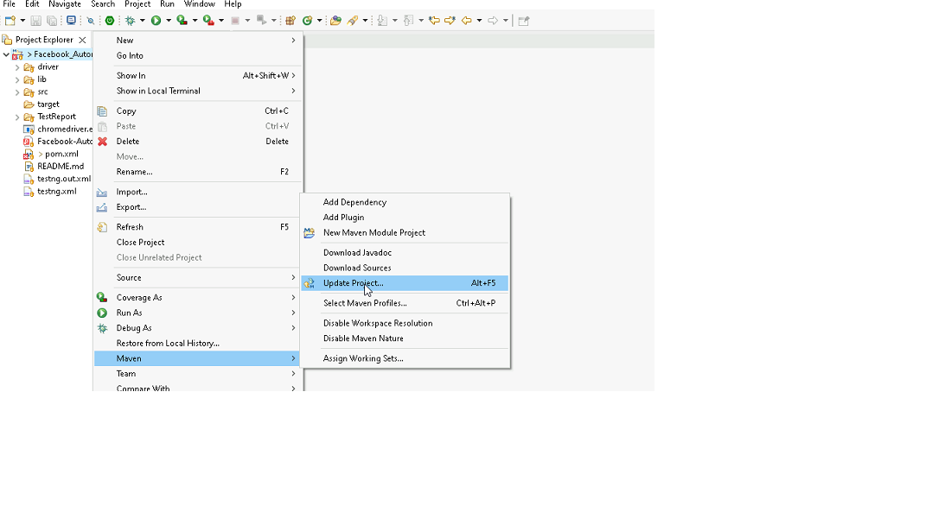

1. In Update Maven Project Box Select “Force Update of Snapshots/Releases” and click OK

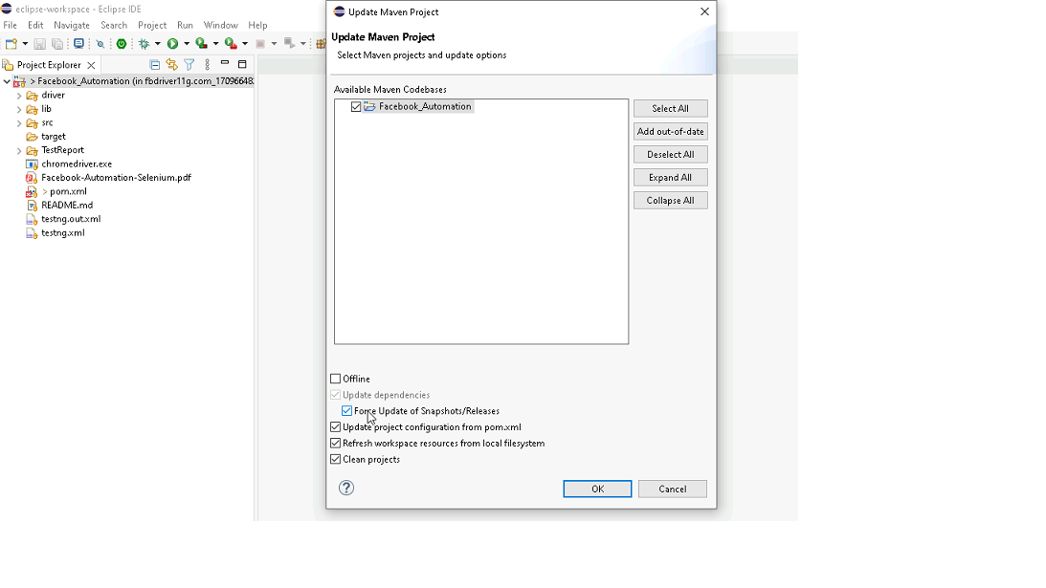

Template Code Structure:

1. Below are the packages and files you will be required to work upon.
2. Other Files and packages you can ignore.
3. In other Files and packages do not do any changes. It would affect your evaluation.
4. You are not required to work in “Test” Folder. Files there are non-editable. Editing those files and trying to save them will throw error and would affect your evaluation.

|  |  |  |
| --- | --- | --- |
| **Package** | **Class/File** | **Description** |
| src/main/java/coreUtilities/utils/ | FileOperations.java | 1. Contains methods to read from excel file. 2. Method is in templated form. 3. **You will be required to implement these methods as very first activity, because even URL to navigate to, is read using these methods.** |
| /src/main/java/pages | operationTheatre_Pages.java | 1. All core activities (mentioned in list above) to be performed here. 2. The comments associated with each templated method here describe the expectation. 3. You can define locators and xpath here. 4. Declare any variable/object you need to share data/status between different methods. 5. Do not modify the signature of methods declared here. 6. You can create additional supportive common methods in CommonEvents class. |
| /src/main/resources/ | Config.xlsx | URL to navigate to. Already URL is defined here |
|  | expected_data.xlsx | Contains data to fill in form |
| /src/main/java/coreUtilities/utils | CommonEvents.java | 1. Contains all common activities. 2. Certain templated common method declared here. 3. You implement them as per your need. 4. You can add any additional method for common activity here |
|  | Testng.xml | Execution needs to kick started from TestNG xml |

PROBLEM STATEMENT

Need to automate the following activities using Selenium + Java.

Key Activities to implement:

|  |  |  |  |  |
| --- | --- | --- | --- | --- |
| **Sl No.** | **Summary** | **Action** | **Expected Result** | **Validation Rules** |
| **1** | • Navigate to the URL. • Retrieve Title and URL of the current page. • Verify Title & URL: Check if the title & URL matches the expected title. | 1. Go to url : https://healthapp.yaksha.com/ 2. login as valid credential (username : admin , password : pass123) and click on "SignIn" Button  3. get the title and url of the current page 4. validate the title and url of the current page | Title should be : **DanpheHealth**  Url should be : **https://healthapp.yaksha.com/Home/Index#/** | Validate the title of the web page & Validate the URL of the web page |
| **2** | Verify that **OperationTheatre** module is present or not ?  If OperationTheatre Module is present, then go to OperationTheatre Page and check whether the "Hospital Number" header text is present or not in the given table | 1. user must be logged in 2. Check **OperationTheatre** module **is present** in left navigation 3. Click on the **OperationTheatre** Module  4. Check whether the "Hospital Number" header text is present or not in the given table ? | User successfully navigate to the **OperationTheatre** page and also should be read the data from the table | **validate link text:** Validate existency (Presence/Visibility) and operation (Click) **Table** : Validate existency (Presence/Visibility) and operation (Read Data) |
| **3** | • On the operation theatre modules, verify that New OT Booking button is present? • If New OT Booking button is presenrt then clicking it popups "Booking OT Schedule | New Patient" form. | 1.User must be on **OperationTheatre** page 2. validate "**New OT Booking"** button is present 3. Verify the clicking "New OT Booking" button and popup form **"Booking OT Schedule| New Patient"** | --> user should found the "**New OT Booking**" button, --> clicking on it and open the "**Booking OT Schedule | New Patient**" form.  --> Form title /name should be **"Booking OT Schedule | New Patient"** | **validate button** : { Validate existency (Presence/Visibility) and operation (Click)} **Text** : Validate existency (Presence/Visibility) and operation (Read Text) |
| **4** | On the **"Booking OT Schedule | New Patient"** form's validate that **Select Patient, Diagnosis & Type of Surgery** Textbox are present or not ? If present then fill the below textbox : **Select Patient textbox Diagnosis textbox  Type of Surgery textbox**  Check the data which we are entered are present in **Select Patient** textbox or not ? | 1. User must be On the "Booking OT Schedule | New Patient" form's 2. Verify the Select Patient, Diagnosis & Type of Surgery are present ? 3. If Present then Enter data in the Select Patient textbox 4.Enter data in the Diagnosis textbox. 5.Enter data in the Type of Surgery textbox. 6. then verify the value which is present in Select Patient textbox. | On the **"Booking OT Schedule | New Patient"** form's below textbox should be present: **Select Patient Diagnosis Type of Surgery**  The entered data should be correctly displayed in Select Patient textbox on "Booking OT Schedule | New Patient" form. | Validate attributes value of textfield {  1. **TextBox** : Validate existency (Presence/Visibility) and operation (Click, Enter Text) 2. **Test Data Reading/Writing** : Validate the ability to read from and write to various data sources (Excel, DB, JSON).  3. validate Attributes value |
| **5** | On the "Booking OT Schedule | New Patient" form's validate that Remarks field is present or not ? Verify "**Remarks**" Text area is enable and verify the placeholder name of "**Remarks**" text area. | 1. User must be On the "Booking OT Schedule | New Patient" form's 2. Verify the **Remarks** field is present ? 3.Verify the Remarks field is Enable 3.Then get the place holder name of "Remarks" text field  4.Verify that place holder name and print on console. | Placeholder name should be "**Remarks**" and then print on console | Validate existency (Presence/Visibility) and verify field is enabled and validate the placeholder name. |
| **6** | On the "Booking OT Schedule | New Patient" form's, type **"Dr. Pooja Mishra** " in surgen Name textfield and verify the Dr. pooja mishra button is present or not ? | 1. type Dr. pooja Mishra in surgen textfield 2. Then click on "Remark" textfield 3. then verify that Dr. pooja mishra button is present or not. | Dr. Pooja mishra button should be appear below the Surgen Textbox | textbox : Validate existency (Presence/Visibility) and operation (Click, Enter Text) Text : Validate existency (Presence/Visibility) and operation (Read Text) |
| **7** | On the "Booking OT Schedule | New Patient" form's, click on the "**External?"** checkbox and verify the check box is selected or not ? | 1. user must be "Booking OT Schedule | New Patient" form's  2. click on "external?" check box 3. verify the check box is selected | checkbox should be selected | checkbox : Validate existency (Presence/Visibility) and operation (Check) |
| **8** | On the "Add External Refferal" form's, when we click on add button without filling any information, Verify the error message (Referrer Name is required) | 1. On the "Booking OT Schedule | New Patient" form's , External" checkbox must be selected. 2. Click on "+" icon , it popup the "Add External Referral " form 3. click on "Add" button without filling any information its shows the Error Message. 2. then Validate that error message | Error message should be : **Refferer Name is required.** | validate error message (Verify handling and logging of unexpected behavior in applications) |
| **9** | On the "Booking OT Schedule | New Patient" form's, **External**? Checkbox must be selected. Click on "+" icon to popup the **Add External Referral** form then fill all the details (get the data from excel) , click on all checkbox and then click on "**Add"** button then verify the success notifications message. | 1. User must be on "Booking OT Schedule | New Patient" form's and External? Checkbox must selected. 2. click on external "+" icon 3. fill all the details (get data from excel) 4. click on all check box 5. click on "Add" button 6. verify the "succes notification" message | message should be "**Success update** " | handle notification popups (Validate existency (Presence/Visibility) and operation (Read Data)) |
| **10** | On the "Booking OT Schedule | New Patient" form's, Close the "**Booking OT Schedule | New Patient**" form's by using javaScript. | 1. User must be on "Booking OT Schedule | New Patient" form's 2.Click on the cross / "**X**" button using javaScript | "Booking OT Schedule | New Patient" form's should be closed. | Perform JavaScript Action. |
| **11** | Expand Billing Module, Scroll to the "Handover" Sub module's and then click on "Handover" Sub module again Scroll to the button of the handover page and validate the "Remarks" text field and "Handover To User" button is present | 1. Click on the Expand icon of the "Billing" Modules  2. Scroll to the "Handover" sub module 3. click on the "Handover" sub module 4 again scroll to the button of the handover page  5. validate the "Remarks" text field and "Handover To User" button is present | user should able to scroll to the "Handover" sub module and the again scroll to the buttom of page. | perform scroll to element and validate the given textfield & buttons are present or not |
| **12** | On the Billing module's , buttom of the "Handover" page , locate the "Remarks" textbox and "HandOver To User" button by using "**ID"**  locator and verify taht, the "Remarks" textbox and "HandOver To User" button is present or not ? If the "Remarks" textbox and ""HandOver To User" button is present, then highlight those element. | 1. user must be present on the buttom of "HandOver" page of "Billing" modules 2. locate the "Remarks" textbox and "HandOver To User" button by using "ID" locator 3. then verify the "Remarks" textbox and "HandOver To User" button is present or not  4. if present, then highlight those element. | "Remarks" textbox and "HandOver To User" button should be present, then highlight those element | **Locator Strategy** : Validate the usage of basic element properties (ID, Name, CSS, etc.) for locating element **Highlight the element** : Validate existency (Presence/Visibility) and operation (element should be higlight) |
| **13** | Expand the Vaccination Module's and click on "Patient List" page and perform the keyboard operation ("Alt + N") to open the "**Vaccination Patient Register"** form. Then Validate the **"Vaccination Patient Register"** page Name. | 1. Scroll to the Vaccination Module  2. Expand the Vaccination Module 3. click on "Patient List" sub module 4. Press **"Alt + N"** from the keyboard to open the "**Vaccination Patient Register**" form. 5. Then Validate the "Vaccination Patient Register" page Name. | when user performs the keyboard operation (Alt +N), it opens the "Vaccination Patient Register" form. And Form name should be "Vaccination Patient Register" | keyboard operation (perform the keyboard operation using robort class.) |
| **14** | Expand the "Appointment" module and click on "Book Appointment" Sub module. On the "Book Appointment" page, select the "Month" radio button and verify that the "Month" radio button is selected or not. After the validation deselect the "Month" radio button. Then select the "Follow-up Patient" from the "Select Visit type" dropdown and verify that "Follow-up Patient" is selected or not. | 1. scroll to the "Appointment" module  2. Click on expand icon of "Appointment" module  3. click on "New Patient" button 4. select the "Month" radiod button  5. verify that the "Month" radio button is selected 6. after validation "deselect" the "Month" radio button 7. then select the "Follow-up Patient" from the "Select Visit type" dropdown 8 . verify that the "Follow-up Patient" option is selected or not | "Month" radio button should be selected and after validation should be deselect then "Follow-up Patient" option should be selected from the "Select Visit type" dropdown | **Radio Button** : ( Validate existency (Presence/Visibility) and operation (Select, Deselect) **Dropdown** : Validate existency (Presence/Visibility) and operation (Select Option) |
| **15** | On the Book Appointment submodules of appointment module, clicking on the "Add Appointment" button it will throw an Error Notification popup.  Then Assert that Error Message using hard assert | 1. user must be present on the Book Appointment submodules of appointment module 2. then click on the "Add Appointment" button 3. It will throw an Error Notification Message 4. validate that message using hard assert | Error message should be :  Failed Failed!! Cannot create appointment. Check the Details Correctly. | Assertions : Verify application behavior using Hard and Soft Assertions |

NOTE: "Please do not delete any file in the src folder.  But you are free to add any other file".

Expectations:

1. Learners should write automation script using Java and selenium to automate all the steps in the above question. In other words, automation script should perform all mentioned steps.
2. Learners should not use any tools to create the xpath. They should develop the xpath/cssselector on their own.

IMPLEMENTATION/FUNCTIONAL REQUIREMENT

* 1. **CODE QUALITY/OPTIMIZATIONS**
     1. Associates should have written clean code that is readable.
     2. Associates need to follow SOLID programming principles.

EXECUTION STEPS TO FOLLOW

1. **You are mandatory required to run test cases for applications before final submission. Without which project evaluation will not happen.**
2. **You can launch test cases any time as follows: Right click on testng.xml and run TestNGSuite**

|  |
| --- |
|  |

1. **Before final submission, you are also required to push your code to GIT. Following are the steps to follow:**

|  |
| --- |
|  |

In your project folder, you will find a batch file named git_commands

|  |
| --- |
|  |

Double-click the batch file to run it. It will run the commands to push your code to GIT.

|  |
| --- |
|  |

===============================================================================

All the Best