HealthApp Automation- Patient Module

Pre-requisite:

As soon as you import project in eclipse, update the project using maven update option as below. This is to resolve issue if any maven dependency not downloaded properly:

1. Right click on project : Go to “Maven” : Select “Update Project”

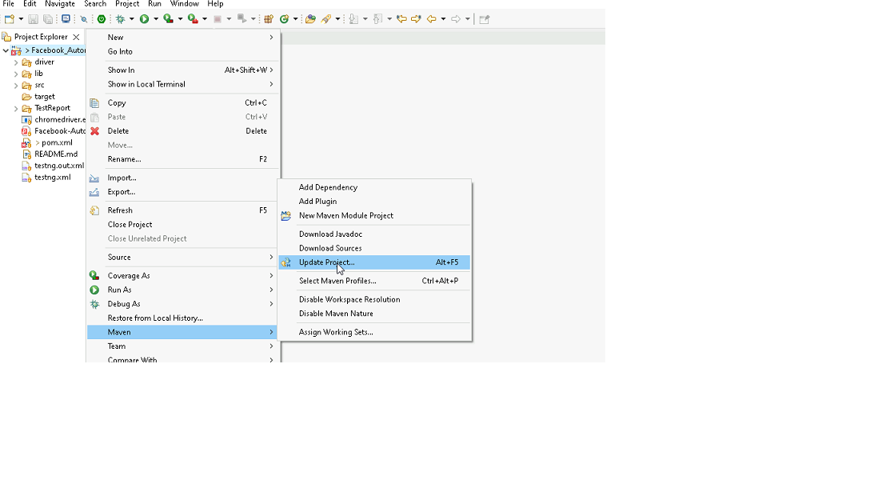

1. In Update Maven Project Box Select “Force Update of Snapshots/Releases” and click OK

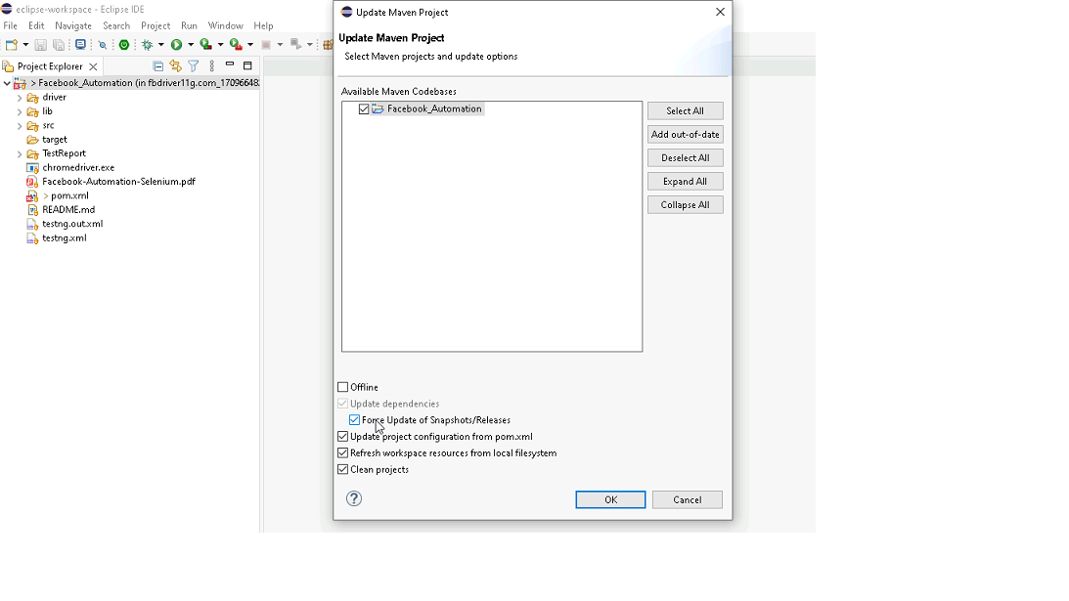

Template Code Structure:

1. Below are the packages and files you will be required to work upon.
2. Other Files and packages you can ignore.
3. In other Files and packages do not do any changes. It would affect your evaluation.
4. You are not required to work in “Test” Folder. Files there are non-editable. Editing those files and trying to save them will throw error and would affect your evaluation.

|  |  |  |
| --- | --- | --- |
| **Package** | **Class/File** | **Description** |
| src/main/java/coreUtilities/utils/ | FileOperations.java | 1. Contains methods to read from json file. 2. Method is in templated form. 3. **You will be required to implement these methods as very first activity, because even URL to navigate to, is read using these methods.** |
| /src/main/java/pages | patient_Pages.java | 1. All core activities (mentioned in list above) to be performed here. 2. The comments associated with each templated method here describe the expectation. 3. You can define locators and xpath here. 4. Declare any variable/object you need to share data/status between different methods. 5. Do not modify the signature of methods declared here. 6. You can create additional supportive common methods in CommonEvents class. |
| /src/main/resources/ | Config.json | URL to navigate to. Already URL is defined here |
|  | expected_data.json | Contains data to fill in form |
| /src/main/java/coreUtilities/utils | CommonEvents.java | 1. Contains all common activities. 2. Certain templated common method declared here. 3. You implement them as per your need. 4. You can add any additional method for common activity here |
|  | Testng.xml | Execution needs to kick started from TestNG xml |

PROBLEM STATEMENT

Need to automate the following activities using Selenium + Java.

Key Activities to implement:

|  |  |  |  |
| --- | --- | --- | --- |
| **Sl No.** | **Summary** | **Action** | **Expected Result** |
| **1** | * Navigate to the URL. * Retrieve Title and URL of the current page. * Verify Title & URL: Check if the title & URL matches the expected title. | 1. Go to url : **https://healthapp.yaksha.com/**  2. login as valid credential (username : **admin** , password : **pass123**) and click on "SignIn" Button  3. get the title and url of the current page 4. validate the title and url of the current page | Title should be : DanpheHealth Url should be : https://healthapp.yaksha.com/ |
| **2** | Verify that Patient module is present or not ? If Present, then expand the Patient module and verify all presence of sub mudules under the patient module. | 1. User must be login the health app 2. verify that, Patient Module is present or not  3. if Patient Module is present, tehn Click on the expand icon of the Patient Module  4. then verify the follwing sub module under the Patient Module Sub modules are :  **Search Patient  Register Patient** | Patient Module should be present in left navigation All sub-modules should be displayed correctly. Expected Sub modules are :  **Search Patient Register Patient** |
| **3** | On the "Patient" Module's "**Search Patient"** page, verify & clicking on the "Search (Minimum 3 Character)" textbox and get the Placeholder name of "Search (Minimum 3 Character)" textbox. Then verify the Placeholder name is **"Search (Minimum 3 Character)".** | 1. User must be present on the **"Search Patient"** page of "Patient" module. 2. verify "Search (Minimum 3 Character)" textbox is present or not and then click on it. 3. then get the Placeholder name of "Search (Minimum 3 Character)" textbox. 4. then verify the Placeholder name is "Search (Minimum 3 Character)". | 1. "Search (Minimum 3 Character)" textbox should be present on "Search Patient" page 2. Placeholder name should be "Search (Minimum 3 Character)". |
| **4** | On the "Patient" Module's, clicking on **"Register Patient"** sub module and verify that the **"+ New Photo"** button is present or not ? After validation of **"+ New Photo"** button, then click on it. Then verify "Take A Snapshot" button is present or not? | 1. User must be present on the "Search Patient" page of "Patient" module. 2. then click on the **"Register Patient"** sub module and it should navigate to the "Basic Information" Page/Tab/Menu of "Register Patient" sub module. 3. then click on profile picture "Camera" Icon /Tab/Menu 4. verify that the "+ New Photo" button is present or not ? 5. after validation of "+ New Photo" button then click on it. 6. Then verify that "Take a Snapshot" button is present or not after clicking on the "+ New Photo" button 7. then click on "**Cancel**" button | 1. "+ New Photo" button should be present 2. "Take a Snapshot" button should present |
| **5** | On the "Patient" Module's "Register Patient" sub module, directly clicking the "Register Patient" button from the "Basic Information" form without filling any information and validate the error message from "Phone Number" textbox from the Besic information form. Error Message : **Primary Phone is required** | 1. User must be present on the "Camera" Icon / Profile picture form of "Register Patient" sub module. 2. then click on "Basic Information" Page Link and it will navigate to the "Basic Information" form 3. then click on "Register Patient" button directly without filling any information in the "Basic Information" form 4. After clicking the "Register Patient" button, then an error message will come  5. Validate the error message from Phone Number textbox **Error Message : Primary Phone is required** | Error Message should be **"Primary Phone is required"** |
| **6** | On the "Basic Information" form of "Register Patient" sub module, Fill the following textbox which are present inside the  **"Basic Information"** form. Validate the entered values. **Note : read & write the data from the JSON** | 1. User must be present on the **"Basic Information"** form of "Register Patient" sub module. 2. then enter the values to the below textbox of "Basic Information" form  **Note : read & write the data from the JSON**  3. Following textboxes are : **-> First Name Textbox -> Middle Name Textbox -> Last Name Textbox -> Age Textbox -> Phone Number Textbox** 4. Validate the entered value in the First Name Textbox | Given textbox value inside the **"Basic Information""** form are filled with appropriate information. The entered data should be correctly displayed in First Name, Middle Name, Last Name, Age and Contact Number Field on "Patient Information" form of New visit page |
| **7** | On the "Basic Information" form of "Register Patient" sub module, scroll to the buttom of the "Basic Information" form. Then verify the "Blood Group" Dropdown is present or not? | 1. User must be present on the "Basic Information" form of "Register Patient" sub module. 2. Scroll to the buttom of the "Basic Information" form. 3. verify the "Blood Group" Dropdown is present or not | user should scroll to the buttom of the "Basic Information" form "Blood Group" Dropdown should be present |
| **8** | On the buttom of the  "Basic Information" form of "Register Patient" sub module, If "Blood Group" Dropdown is present then highlight the "Blood Group" Dropdown | 1. User must be present on the buttom of the  "Basic Information" form of "Register Patient" sub module. 2. If "Blood Group" Dropdown is present then highlight the "Blood Group" Dropdown | "Blood Group" Dropdown should be present and Highlight |
| **9** | On the "Basic Information" form of "Register Patient" sub module, select the "0+" group from the "Blood Group" Dropdown. Then validate "O+" is properly selected or not. | 1. User must be present on the buttom of the  "Basic Information" form of "Register Patient" sub module. 2. Select "O+" group from the "Blood Group" Dropdown. 3. validate "O+" group is properly selected or not. | User should able to select "O+" group from the "Blood Group" dropdown menu. |
| **10** | Go to "**Guarantor**" form of "**Register Patient**" sub module, select the "Male" Radio button form the Gender section Then verify the "Male" radio button is selected or not. After validation, then deselect the "Male" radio button | 1. User must be present on the buttom of the  "Basic Information" form of "Register Patient" sub module. 2. scroll to the top of the "Basic Information" page. 3. click on the "Guarantor" link to navigate to the "Guarantor" page. 4. Select "Male" radio button from the Gender section. 5. verify that the "Male" radio button is selected or not 6. after validation, then deselect the "Male" radio button | Male Radio button should be selected from "Guarantor" form after validation, male radio button should be deselect |
| **11** | On the "Guarantor" form of "Register Patient" sub module, select the "Self" check box and verify that, the "Self" check box is selected or not. After selected the "Self" check box a "Notification" popup message will display on the button of the page and then validate that Notification Popup Message  **(Notice-Message To fill the data by self checkbox, first you have to fill your address )** | 1. User must be present on "Guarantor" form of "Register Patient" sub module. 2. select the "My Self" check box and verift that the checkbox is selected or not. 3. After selected the "Self" check box a "Notification" popup message will display on the button of the page and then validate that Notification Popup Message  **(Notice-Message To fill the data by self checkbox, first you have to fill your address )** | "My Self" check box should be selected  Notiofication popup message should be  **(Notice-Message To fill the data by self checkbox, first you have to fill your address )** |
| **12** | On the "Guarantor" form of "Register Patient" sub module, Click on "Kin/Emergency Contact" link by using javascript and it will navigate to the "Kin/Emergency Contact" form Then send the value by using javascript to the "Commnets" textbox of "Kin/Emergency Contact" form. | 1. User must be present on "Guarantor" form of "Register Patient" sub module. 2. using the javaScript, click on the "Kin/Emergency Contact" link and it will navigate to the "Kin/Emergency Contact" form 3. using the javaScript, send the value to the "Commnets" textbox of "Kin/Emergency Contact" form. | User should navigate to the "Kin/Emergency Contact" form and able to send the value to the "comments" textbox using javaScript" operation |
| **13** | On the "**Kin/Emergency Contact"** form of **"Register Patient"** sub module, clicking and verify the **"Kin/Emergency Contact"** link text is present or not using Hard Assert? | 1. User must be present on **"Kin/Emergency Contact"** form of "Register Patient" sub module. 2. click on **"Kin/Emergency Contact"** link 3. very the text of "Kin/Emergency Contact" link using Hard Assert | Text of the **"Kin/Emergency Contact"** Link should be **"Kin/Emergency Contact".** |
| **14** | On the Patient Module's "Search Patient" sub module, scroll to the buttom of the "Search Patient". Then clicking on "**Last**" button of "Search Patient" table, it will take to you the last pegination and then retrive the first Patient Name for given "Hospital Number : 2311000001 ".  Then verify the Patient Name is : Alexa Alexa | 1. User must be present on "Kin/Emergency Contact" form of "Register Patient" sub module. 2. click on "Search patient" sub module from the "Patient" module 3. scroll to the buttom of the "Search patient" page 4. then click on "Last" button and it will take to you last page 5. then retrive the first Patient Name for given "Hospital Number : 2311000001 ".  6. Then verify the Patient Name is : Alexa Alexa | Patient Name should be Alexa Alexa of the given "Hospital Number : 2311000001 ". |
| **15** | Scroll to the Vaccination Module's and Expand it. Click on "Patient List" page and perform the keyboard operation ("Alt + N") to open the "**Vaccination Patient Register"** form. Then Validate the **"Vaccination Patient Register"** page Name. | 1. Scroll to the Vaccination Module  2. Expand the Vaccination Module 3. "Patient List" sub module must be pre-selected,  if not then click on "Patient List" sub module 4. Press **"Alt + N"** from the keyboard to open the "**Vaccination Patient Register**" form. 5. Then Validate the "Vaccination Patient Register" form Name. 5. then close the "Vaccination Patient Register" form | when user performs the keyboard operation (Alt +N), it opens the "Vaccination Patient Register" form. And Form name should be "Vaccination Patient Register" |
| **16** | On the "Patient" module's "Register Patient" Sub module, Upload the Profile Picture in "Camera/Profile Picture" form. | 1. User must be present on **"Patient List"** Submodule of " **Vaccination"** Module2. Scroll to "Patient" module  3. click on "Register Patient" sub module  **(Note : if "Patient" module not expand, then expand it before click on "Register Patient" sub module or else igone direct click on "Register Patient" sub module )** 4. then click on "Camera Icon /Profile Picture" form 5. then click on "+New Photo" button  6. then click choose file and then handle file upload action  7. then click on done button | Uploaded Image should be displayed. |
| **17** | On the Camera/Profile Picture" form's of "Register Patient" Sub module,Taking screenshot of the current page. | 1.Take a screenshot of the Current page.(Stored in the Screenshot folder) | User should take the screenshot. |
| **18** | On the **"Camera/Profile Picture"** form's of "Register Patient" Sub module, select "**Emergency Contact**" checkbox from the "Kin/Emergency Contact" form. When user trying to clicking on "Insurance" Link then an alert will popups.  Then handle alert popup and verify alert Message : **This page contains unsaved changes. Do you want to continue ? Changes will be discarded.** Then verify that the "Add Insurance" button is present or not | 1. User must be present on "**Camera Icon/Profile Picture**" form's of "Register Patient" Sub module 2. click on "Kin/Emergency Contact" link. 3. then select "Emergency Contact" checkbox 4. clicking on "Insurance" Link then an alert will popups.  5. Then handle alert popup and verify alert Message : **This page contains unsaved changes. Do you want to continue ? Changes will be discarded.** 6. after alert handle, it will navigate to the "Insurance" for and then verify that the "**Add Insurance**" button is present or not | alert popup should be handle and popus message should be This page contains unsaved changes. Do you want to continue ? Changes will be discarded. "Add Insurance" button should be present |
| **19** | On the Appointment module, under the"New visit" tab, verify tooltips which is present on keyboard icon. | 1. "Appointment" module must be expand, if not then expand it.  **(* When user trying to click on expand icon of Appointment Module, If select counter poup is coming then click on "New 1" it will navigate to the "New Visit" page or else ignore and follow step 2 )**  2. Click on "New Visit" sub module, it will navigate to the "New Visit" page. 3. Mouse hover to the keyboard icon of the "New Visit" page. 5. Verify the tooltip message. | Tooltip message should be : **ALT + N = New Patient** |
| **20** | On the Procurement module's Reports Tab, Search for a Select a Item as **Accounts** and select Accounts and validate Accounts is selected or not ? | 1. Click on Procurement module 2. Click on Reports Menu / tab 3. Click on current stock lavel 4. click on stock tab  5. click on the search bar which is under the **Current Stock Level Report** 6. remove any pre selected option  7. Again click on the search bar 8. Search Accounts in search bar 9. select Accounts from the suggestion 10. Validate Accounts is selected | Accounts should be selected from the suggestions. |
| **21** | Expand the Procurement module and click on "Purchase Order" submodule. Then click on "Create Purchase order" button and validate the "Add Purchase Order" page name. On the "Add Purchase Order" page, Scroll to the button of the page then send the value ( using javascript ) to the **"Select Terms & Conditions:" Frame** by handling frames. | 1. User must be present on Procurement module 2.Click on Purchase Order Sub module of Procurement module 3.Click on "Create purchase Order" button, it will navigate to the "Add Purchase Order" page. 4. verify the page Name and Page Name should be "Add Purchase Order".  5. Scroll to the button of the page. 6. Send the value ( send the value Using javascript) to the "Select Terms & Conditions:" Frame | User should navigate to the "Add Purchase Order" page. And able to send the value to frame |

NOTE: "Please do not delete any file in the src folder.  But you are free to add any other file".

Expectations:

1. Learners should write automation script using Java and selenium to automate all the steps in the above question. In other words, automation script should perform all mentioned steps.
2. Learners should not use any tools to create the xpath. They should develop the xpath/cssselector on their own.

IMPLEMENTATION/FUNCTIONAL REQUIREMENT

* 1. **CODE QUALITY/OPTIMIZATIONS**
     1. Associates should have written clean code that is readable.
     2. Associates need to follow SOLID programming principles.

EXECUTION STEPS TO FOLLOW

1. **You are mandatory required to run test cases for applications before final submission. Without which project evaluation will not happen.**
2. **You can launch test cases any time as follows: Right click on testng.xml and run TestNGSuite**

1. **Before final submission, you are also required to push your code to GIT. Following are the steps to follow:**

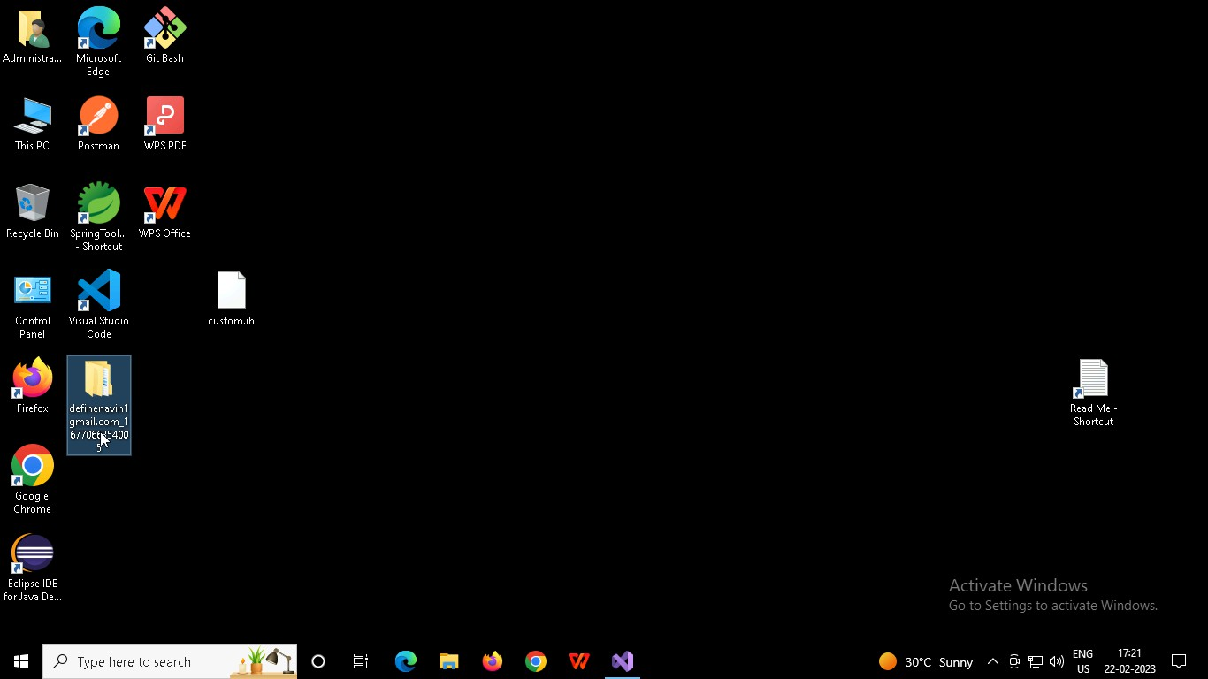

Right click in folder and open Git Bash

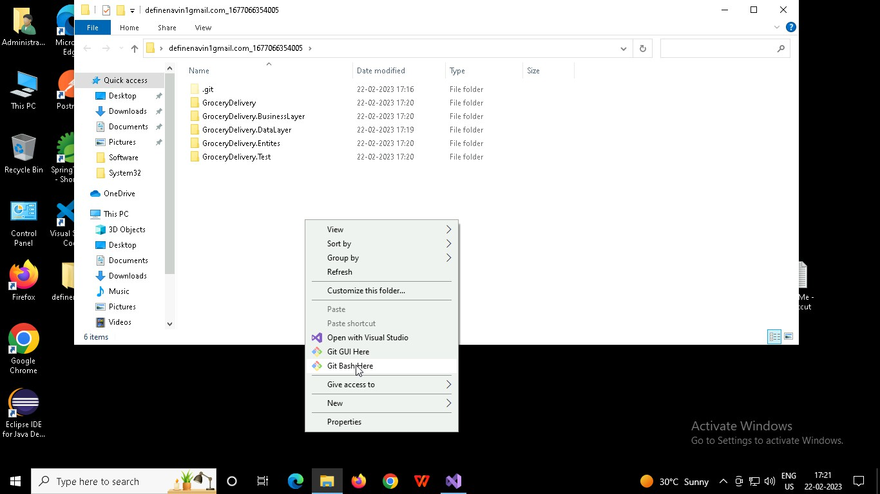

In Git bash terminal, run following commands

* 1. git status
  2. git add .
  3. git commit -m “First commit”

(You can provide any message every time you commit)

* 1. git push

