HealthApp Automation- Pharmacy Module

Pre-requisite:

As soon as you import project in eclipse, update the project using maven update option as below. This is to resolve issue if any maven dependency not downloaded properly:

1. Right click on project : Go to “Maven” : Select “Update Project”

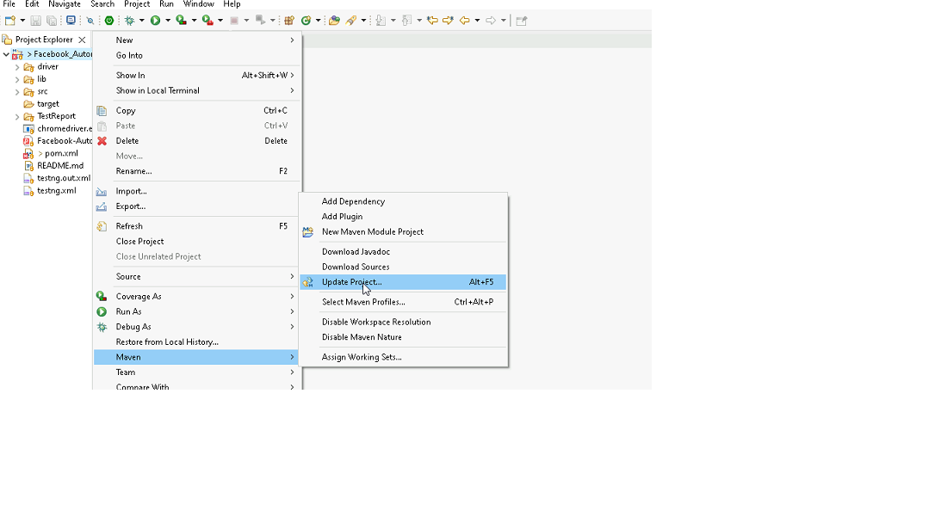

1. In Update Maven Project Box Select “Force Update of Snapshots/Releases” and click OK

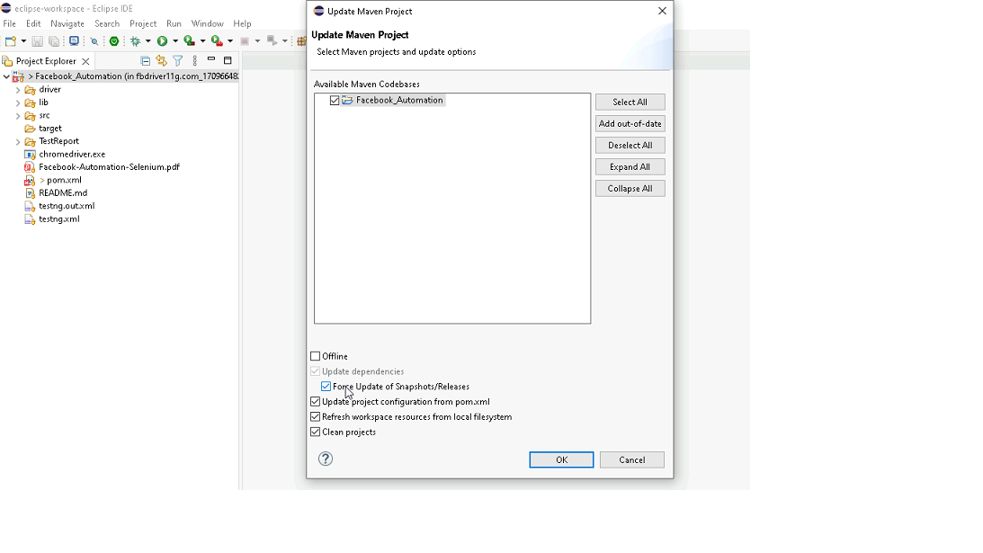

Template Code Structure:

1. Below are the packages and files you will be required to work upon.
2. Other Files and packages you can ignore.
3. In other Files and packages do not do any changes. It would affect your evaluation.
4. You are not required to work in “Test” Folder. Files there are non-editable. Editing those files and trying to save them will throw error and would affect your evaluation.

|  |  |  |
| --- | --- | --- |
| **Package** | **Class/File** | **Description** |
| src/main/java/coreUtilities/utils/ | FileOperations.java | 1. Contains methods to read from excel file. 2. Method is in templated form. 3. **You will be required to implement these methods as very first activity, because even URL to navigate to, is read using these methods.** |
| /src/main/java/pages | pharmacy_Pages.java | 1. All core activities (mentioned in list above) to be performed here. 2. The comments associated with each templated method here describe the expectation. 3. You can define locators and xpath here. 4. Declare any variable/object you need to share data/status between different methods. 5. Do not modify the signature of methods declared here. 6. You can create additional supportive common methods in CommonEvents class. |
| /src/main/resources/ | Config.xlsx | URL to navigate to. Already URL is defined here |
|  | expected_data.xlsx | Contains data to fill in form |
| /src/main/java/coreUtilities/utils | CommonEvents.java | 1. Contains all common activities. 2. Certain templated common method declared here. 3. You implement them as per your need. 4. You can add any additional method for common activity here |
|  | Testng.xml | Execution needs to kick started from TestNG xml |

PROBLEM STATEMENT

Need to automate the following activities using Selenium + Java.

Key Activities to implement:

|  |  |  |  |
| --- | --- | --- | --- |
| **Sl No.** | **Summary** | **Action** | **Expected Result** |
| **1** | Verify the title and URL of the Home page. | 1.  go to url :[**https://healthapp.yaksha.com/**](https://healthapp.yaksha.com/)  2. login as valid credential **(username : admin , password : pass123)** and click on "**SignIn**" Button                                                                               3. get the title and url of the Home page, post login  4. validate the title and url of the Home page | Title should be : **DanpheHealth**  Url should be : **https://healthapp.yaksha.com/Home/Index#/** |
| **2** | Verify the pharmacy module is present or not | 1. Login in the healthapp application 2. Scroll down menu till pharmacy 3. Click on the pharmacy | Pharmacy module should be present |
| **3** | Verify all sub-modules are displayed correctly after clicking on the "Pharmacy" Module. | Pre condition: User should be logged in and it is on Pharmacy section 1. Click on the Pharmacy Module drop-down arrow | All sub-modules should be displayed correctly. Expected Sub modules are : Order, Supplier, report, Setting, Store, Supplier ledger & substore request/dispatch |
| **4** | Verify the presence of order section with all fields | Pre condition: User should be logged in and it is on Pharmacy section 1. Click on the Pharmacy Module drop-down arrow  2. Click on order | Order section should be present  Expected value that are present in order section are  1. Sub modules: "Same as TC_3 Expected" 2. Tab: purchase order, Goods receipt 3. Buttons: Add new good receipt, Show details, Ok, Export, print, First, Previous, Next, Last, View 4. Fields: Aging days, search bar 5. Drop down: Supplier name, Filter, Date range,  6. Status Radio button: Complete, cancel, All |
| **5** | Verify to navigate on another sub module after open the order section | Pre condition: User should be logged in and it is on Pharmacy section 1. Click on the order  2. Click on the supplier | User should navigate to the supplier section from the order section |
| **6** | Verify to get the validation message when click on " print receipt" without filling any details | Pre condition: User should be logged in and it is on Pharmacy section 1. Click on the new good receipt button 2. Scroll to the last of screen  3. Click on "Print Receipt" button | User should get a validation message to fill mandatory fields |
| **7** | Verify to add the new good receipt | Pre condition: User should be logged in and it is on Pharmacy section 1. Click on the new good receipt button | User should able to click on the new good receipt button  User should able to add a new receipt after fill all mandatory fields |
| **8** | Verify to view the added receipt | Pre condition: User should be logged in and it is on Pharmacy section 1. Click on view button | User should able to click on view button  Receipt details should be appear |
| **9** | Verify to search the data by apply the date filter | Pre condition: User should be logged in and it is on Pharmacy section 1. Click on the "From" date 2. Select the "From" date 3. Click on the "To" date 4. Select "To" date 5. Click on "OK" button | Data should be present as per applied date filter |
| **10** | Verify to search the data by enter the keyword which match with the already present records | Pre condition: User should be logged in and it is on Pharmacy section 1. Enter the invoice number in Search field. 2. Click on the 'Show Details' button for a matching record. 3. Verify that the records matching the entered keyword are displayed in the table. 4. Click on the 'View' button for the invoice. 5. Verify the invoice number is present in the printed details. 6. Close the 'Add Good Receipt' modal. | Record should be present as per the entered keywords |
| **11** | Verify the view of all the columns of table after stretching any column | Pre condition: User should be logged in and it is on Pharmacy section 1. Stretch the column by click on the line present between 2 columns | Horizontal scroll should automatically occur User should scroll the page from right to left |
| **12** | Verify the tooltip and it's text present on hover the mouse on "Star" | Pre condition: User should be logged in and it is on Pharmacy section 1. Hover the mouse in start | Tooltip should be present when hover the mouse on star with text "Remember this date" |
| **13** | Verify to apply the filter after select the supplier name from drop down | Pre condition: User should be logged in and it is on Pharmacy section 1. Click on "Select supplier" 2. Select the supplier name 3.Click on show details | The records should be present as per select supplier |
| **14** | Verify to update the existing Good receipt | Pre condition: User should be logged in and it is on Pharmacy section 1. Click on "view" button 2. Click on "Edit GR" button  3. Click on " Edit pencil" icon 4. Make changes 5. Click on "update" button | User should able to update the changes  Changes should be saved |
| **15** | Verify to filter the records by select complete radio button of list status | Pre condition: User should be logged in and it is on Pharmacy section 1. Click on the "Complete" radio button. 2. Verify the "Complete" radio button is selectable. 3. Click on the "Cancelled" radio button. 4. Verify the "Cancelled" radio button is selectable. 5. Click on the "All" radio button. 6. Verify the "All" radio button is selectable. | All Radio button should be present and selectable |

NOTE: "Please do not delete any file in the src folder.  But you are free to add any other file".

Expectations:

1. Learners should write automation script using Java and selenium to automate all the steps in the above question. In other words, automation script should perform all mentioned steps.
2. Learners should not use any tools to create the xpath. They should develop the xpath/cssselector on their own.

IMPLEMENTATION/FUNCTIONAL REQUIREMENT

* 1. **CODE QUALITY/OPTIMIZATIONS**
     1. Associates should have written clean code that is readable.
     2. Associates need to follow SOLID programming principles.

EXECUTION STEPS TO FOLLOW

1. **You are mandatory required to run test cases for applications before final submission. Without which project evaluation will not happen.**
2. **You can launch test cases any time as follows: Right click on testng.xml and run TestNGSuite.**

|  |
| --- |
|  |

1. **Before final submission, you are also required to push your code to GIT. Following are the steps to follow:**

|  |
| --- |
|  |

In your project folder, you will find a batch file named git_commands

|  |
| --- |
|  |

Double-click the batch file to run it. It will run the commands to push your code to GIT.

|  |
| --- |
|  |

===============================================================================

All the Best