HealthApp Automation- Radiology Module

Pre-requisite:

As soon as you import project in eclipse, update the project using maven update option as below. This is to resolve issue if any maven dependency not downloaded properly:

1. Right click on project : Go to “Maven” : Select “Update Project”

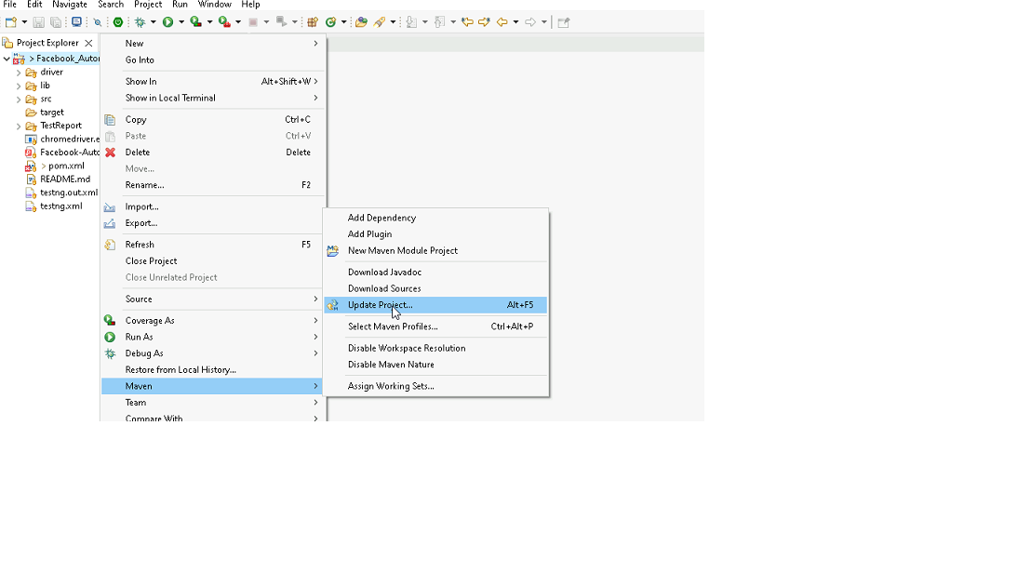

1. In Update Maven Project Box Select “Force Update of Snapshots/Releases” and click OK

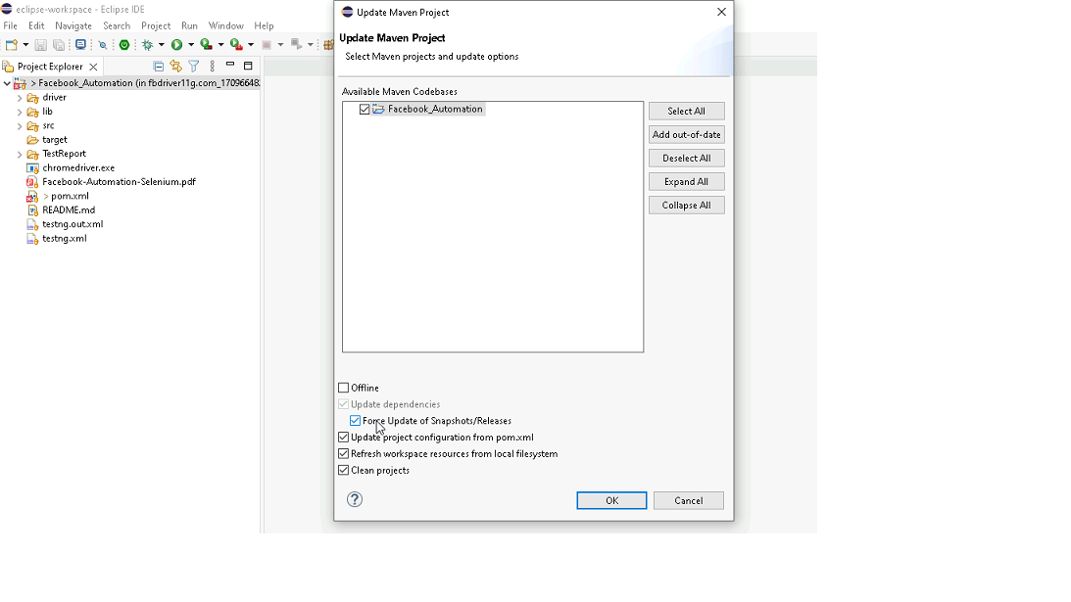

Template Code Structure:

1. Below are the packages and files you will be required to work upon.
2. Other Files and packages you can ignore.
3. In other Files and packages do not do any changes. It would affect your evaluation.
4. You are not required to work in “Test” Folder. Files there are non-editable. Editing those files and trying to save them will throw error and would affect your evaluation.

|  |  |  |
| --- | --- | --- |
| **Package** | **Class/File** | **Description** |
| src/main/java/coreUtilities/utils/ | FileOperations.java | 1. Contains methods to read from excel file. 2. Method is in templated form. 3. **You will be required to implement these methods as very first activity, because even URL to navigate to, is read using these methods.** |
| /src/main/java/pages | radiology_page.java | 1. All core activities (mentioned in list above) to be performed here. 2. The comments associated with each templated method here describe the expectation. 3. You can define locators and xpath here. 4. Declare any variable/object you need to share data/status between different methods. 5. Do not modify the signature of methods declared here. 6. You can create additional supportive common methods in CommonEvents class. |
| /src/main/resources/ | Config.xlsx | URL to navigate to. Already URL is defined here |
|  | expected_data.xlsx | Contains data to fill in form |
| /src/main/java/coreUtilities/utils | CommonEvents.java | 1. Contains all common activities. 2. Certain templated common method declared here. 3. You implement them as per your need. 4. You can add any additional method for common activity here |
|  | Testng.xml | Execution needs to kick started from TestNG xml |

PROBLEM STATEMENT

Need to automate the following activities using Selenium + Java.

Key Activities to implement:

|  |  |  |  |
| --- | --- | --- | --- |
| **Sl No.** | **Summary** | **Action** | **Expected Result** |
| **1** | Verify the radiology module is present or not | 1. go to URL : [**https://healthapp.yaksha.com/**](https://healthapp.yaksha.com/)  2. login as valid credential **(username : admin , password : pass123)** and click on "**SignIn**" Button  3. Scroll down menu till radiology  4. Click on the radiology | Radiology module should be present |
| **2** | Verify all sub-modules are displayed correctly after Clicking on the "radiology" Module. | Pre-condition: User should be logged in  1. Click on the radiology Module drop-down arrow | All sub-modules should be displayed correctly. Expected Sub modules are : List Requests, List Reports, Edit Doctors, Ward Billing |
| **3** | Verify URL of the radiology module | Pre-condition: User should be logged in  1. Click on the radiology | By default URL will open list request module |
| **4** | Verify the presence of List request section in radiology module with all fields | Pre-condition: User should be logged in and it is on radiology module 1. Click on the radiology module drop-down arrow  2. Click on list request section | List request tab in Inventory section should be present  Expected value that are present in List request tab are  1. Buttons: Ok, First, Previous, Next, Last, Scan Done, Add Report, Edit report 2. Fields: search bar 3. Drop down: Filter, Date range 4. Date Picker: From, To 5. Tooltip: Star figure |
| **5** | Verify to navigate on another sub module after open the list requests section | Pre-condition: User should be logged in and it is on radiology module 1. Click on the list requests  2. Click on the edit doctors 3. Click on Ward Billing 4. Click on List Requests | User should navigate to the edit doctors section from the list requests section |
| **6** | Verify the "Next" button is visible after performing a vertical scroll on Radiology module | Pre-condition: User should be logged in 1. Select "All" drop down option from the "Filter" field  2. Scroll all the way to the bottom of the page | The "Next" button should be visible after scrolling vertically. |
| **7** | Verify the tooltip and it's text present on hover the mouse on "Star" | Pre-condition: User should be logged in and it is on list requests section  1. Hover the mouse in star | Tooltip should be present when hover the mouse on star with text "Remember this date" |
| **8** | Verify to star tooltip after refreshing the page | Pre-condition: User should be logged in and it is on Radiology > List Requests section 1. Navigate to the Radiology module. 2. Click on the "List Requests" section. 3. Click on "FROM" and select "Jan 2020" 4. Click on "TO" and select "march 2024" 5. Click on "star" tooltip 6. Click on "OK" button 7. Navigate back to the "List Requests" section of the Radiology module. | After refreshing the page and navigate back to the list section of the radiology module: 1. The "Star" tooltip should remain the same. 2. The dates in the "FROM" field and "TO" field should remain as "Jan 2020" and "March 2024" respectively. |
| **9** | Verify to data range by select "one week" option from drop down | Pre-condition: User should be logged in and it is on list requests section  1. Click on the data range button 2. select "one week" option from the drop down 3. Click on "OK" button | Data should be present as per the selected date range using dropdown The 'Requested on' column date must fall within the "one week". |
| **10** | Verify to filter the records by select "X-RAY" from Filter drop down | Pre-condition: User should be logged in and it is on List requests section  1. Click on Filter drop down 2. Click on "X-RAY" drop down option 3. Click on "FROM" and select "Jan 2020" 4. Click on "TO" and select "march 2024" 5. Click on "OK" button | Record should filter out as per status |
| **11** | Verify to filter the records by select "X-RAY" from Filter drop down | 1. Navigate to the Radiology module 2. Go to Ward Billing 3. Search for Patient 4. Click on the View Details button next to the Test Patient 3 Radiology 5. Click on the Cancel button within the Radiology Ward Billing modal | Clicking the Cancel button within the modal should trigger a popup message stating Please Write Cancellation Remarks. |
| **12** | Verify to search the data by enter the keyword which match with the already present records | Pre-condition: User should be logged in and it is on list requests section 1. Enter the keywords "USG Chest" | Record should be present as per the entered keywords |
| **13** | Verify Imaging Order Creation | Pre-condition: User should be logged in   1. Navigate to the Doctor module 2. Click on "In Patient Department" SECTION 3. Click on "Lab" button of the specific record  4. Click on the "----------" drop down 5. Select the "Imaging" option from the drop down 6. Click on "search order item" field 7. Select "USG Chest" option from the field  8. Click on the "Proceed" button 9. Click on "sign" button which will be on "Imaging Order" page | The imaging order should be created and recorded in the "List request " section in the "Radiology" module without any errors,  and the details of the "USG Chest" order should be visible in the patient's records. |
| **14** | Verify removal of "Selected Order" section after clicking "Cancel" button | Pre-condition: User should be logged in  1. Navigate to the Doctor module 2. Click on "In Patient Department" SECTION 3. Click on "Lab" button of the specific record  4. Click on the "----------" drop down 5. Select the "Imaging" option from the drop down 6. Click on "search order item" field 7. Select "USG Chest" option from the field  8. Click on the "Cancel" button | the "Selected order" section containing "Lab", "Medication", "Imaging", and "Others" fields should disappear , and ensure the "Active order" list is visible. |
| **15** | Verify "Scan Done" Popup and Required Field Message | Pre-condition: User should be logged in   1. Navigate to the "Radiology" section. 2. Go to the "List Requests" sub-section. 3. Click on the "Scan Done" button in the action column for the test patient. 4. Verify that the "Add Scan Done Details of Test Patient 3 Radiology" popup opens. 5. Click the "Done" button without entering any details. | The "Add Scan Done Details of Test Patient 3 Radiology" popup should open. A "Film Type Is Required" message should be displayed on the film type field when attempting to submit without details. |

NOTE: "Please do not delete any file in the src folder.  But you are free to add any other file".

Expectations:

1. Learners should write automation script using Java and selenium to automate all the steps in the above question. In other words, automation script should perform all mentioned steps.
2. Learners should not use any tools to create the xpath. They should develop the xpath/cssselector on their own.

IMPLEMENTATION/FUNCTIONAL REQUIREMENT

* 1. **CODE QUALITY/OPTIMIZATIONS**
     1. Associates should have written clean code that is readable.
     2. Associates need to follow SOLID programming principles.

EXECUTION STEPS TO FOLLOW

1. **You are mandatory required to run test cases for applications before final submission. Without which project evaluation will not happen.**
2. **You can launch test cases any time as follows: Right click on testng.xml and run TestNGSuite.**

|  |
| --- |
|  |

1. **Before final submission, you are also required to push your code to GIT. Following are the steps to follow:**

|  |
| --- |
|  |

In your project folder, you will find a batch file named git_commands

|  |
| --- |
|  |

Double-click the batch file to run it. It will run the commands to push your code to GIT.

|  |
| --- |
|  |

===============================================================================

All the Best