HealthApp Automation

Substore Module

Pre-requisite:

As soon as you import the project in Eclipse, update the project using the maven update option as below. This is to resolve the issue if any Maven dependency not downloaded properly:

1. Right-click on the project: Go to “Maven” and select “Update Project”

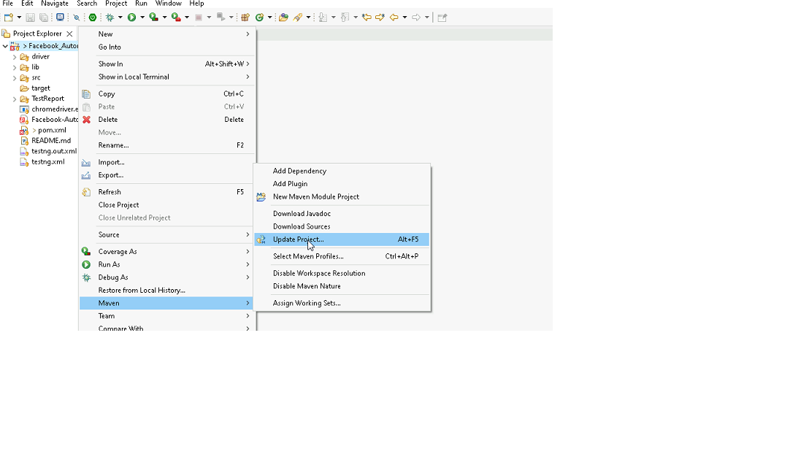

1. In Update Maven Project Box Select “Force Update of Snapshots/Releases” and click OK

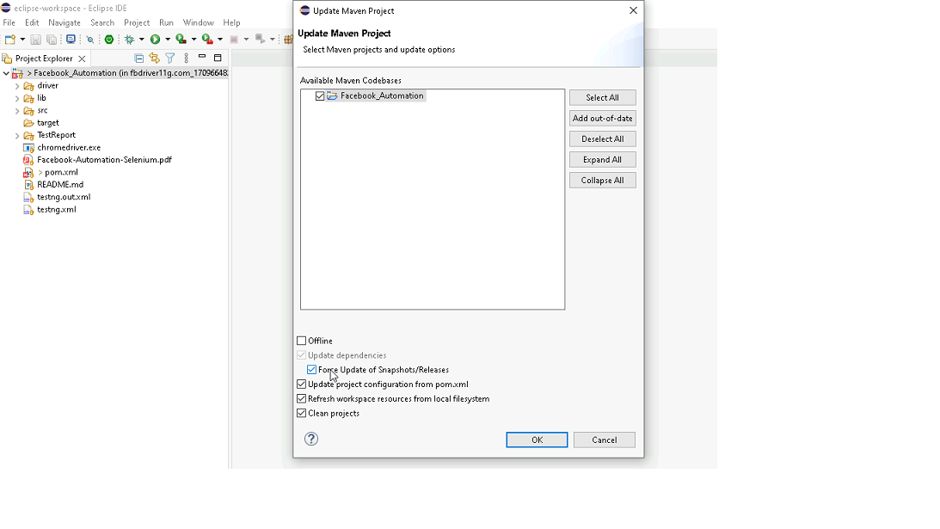

Template Code Structure:

1. Below are the packages and files you will be required to work on.
2. Other Files and packages you can ignore.
3. In other Files and packages do not make any changes. It would affect your evaluation.
4. You are not required to work in the “Test” Folder. The files there are non-editable. Editing those files and trying to save them will throw errors and affect your evaluation.

|  |  |  |
| --- | --- | --- |
| **Package** | **Class/File** | **Description** |
| src/main/java/coreUtilities/utils/ | FileOperations.java | 1. Contains methods to read from excel file. 2. Method is in templated form. 3. **You will be required to implement these methods as very first activity, because even URL to navigate to, is read using these methods.** |
| /src/main/java/pages | substore_page.java | 1. All core activities (mentioned in list above) to be performed here. 2. The comments associated with each templated method here describe the expectation. 3. You can define locators and xpath here. 4. Declare any variable/object you need to share data/status between different methods. 5. Do not modify the signature of methods declared here. 6. You can create additional supportive common methods in CommonEvents class. |
| /src/main/resources/ | Config.xlsx | URL to navigate to. Already URL is defined here |
|  | expected_data.xlsx | Contains data to fill in form |
| /src/main/java/coreUtilities/utils | CommonEvents.java | 1. Contains all common activities. 2. Certain templated common method declared here. 3. You implement them as per your need. 4. You can add any additional method for common activity here |
|  | Testng.xml | Execution needs to kick started from TestNG xml |

PROBLEM STATEMENT:

Need to automate the following activities using Selenium + Java.

Key Activities to implement:

|  |  |  |  |
| --- | --- | --- | --- |
| **Sl No.** | **Summary** | **Action** | **Expected Result** |
| **1** | Verify the SubStore module is present or not | 1. go to URL : https://healthapp.yaksha.com/  2. login as valid credential (username : admin , password : pass123) and click on "SignIn" Button  3. Scroll down menu till SubStore  4. Click on the SubStore | SubStore module should be present |
| **2** | Verify the sub-module buttons present in Select your Substore modal | Pre-condition: User should be logged in 1. Click on the substore module | "Select your Substore" heading should be present on the page. Expected sub-module Card/Tiles must be present. |
| **3** | Verify that the "Accounts' sub-module is clickable | Pre-condition: User must be logged in and on the substore module  1. Click on the “Account” substore  2. Hover on substore switch button(Arrow icon) located at top left of page and get tooltip text | Verify text on hover contains "To change, you can always click here." |
| **4** | Verify all sub-modules are displayed correctly after Clicking on the "SubStore " Module. | Pre-condition: User should be logged in and it is on SubStore module 1. Login in the healthapp application 2. Click on the Substore 3. "Select your Substore" pop up  4. Click on "Account" sub-modal 5. Click on the "Inventory" sub-module 6. Click on" Pharmacy" sub-module | All sub-modules should be displayed correctly.  Expected Sub modules are : Pharmacy, Inventory |
| **5** | Verify all section are displayed correctly after Clicking on the "Inventory " Sub-Module. | Pre-condition: User should be logged in and it is on SubStore module 1. Click on the SubStore Module drop-down arrow  2. Click on "Accounts" from the "Select your Subdtore"  3. Click on the "Inventory" 4. Navigate to "Stock" section 5. Click on the all the section of the "inventroy" sub-module 6. Navigate back to "Stock" section | All section should be displayed correctly. Expected Sub modules are : Stock, Inventory Requisition, Consumption, Reports, Patient Consumption, Return |
| **6** | Verify to navigate to each sections which are present in the "Inventory" sub-module | Pre-condition: User should be logged in and it is on Inventory sub-module 1. Navigate to the "Inventory" sub-module 2. Click on the "Inventory Requisition" section 3. Click on the "Stock" 4. Click on the "Consumption" 5. Click on the " Reports" 6. Click on the "Patient Consumption" 7. Click on the "Return" 8. Navigate back to the "Inventory Requisition" section | Ensure that it should navigate to each sections of the "Inventory" module |
| **7** | Take Screenshot of the current page | Under Substore module > Inventory Section Take the screenshot of the current page | Screenshot shot of the page should be saveed under screenshot folder |
| **8** | Verify the presence of Inventory Requisition section in Inventory sub-module with all fields | Pre-condition: User should be logged in and it is on SubStore module 1. Click on the SubStore module drop-down arrow  2. Click on Inventory sub-module 3. Click on Inventory Requisition section | Inventory Requisition section in Inventory sub-module should be present  Expected value that are present in Inventory Requisition section are   1. Buttons: First, Previous, Next, Last, Create Requisition, Ok, Print, View. Receive items 2. Fields: search bar 3. Drop down: Filter by Store, Date range, "..."(3 dots) 4. Radio-button: All, Pending, Completed, Cancelled, Withdrawn  5. Date Picker: From, To 6. Tooltip: Star figure |
| **9** | Creating and Verifying "Create Requisition" button | Pre-condition: User should be logged in and it is on Inventory sub-module 1. Click on "Inventory Requisition" section 2. Click on "Create Requisition" button 3. Click on "Target Inventory " field and Select "GENERAL-INVENTORY" option 4. Click on "Item Category" drop down and select " Consumables" option 5. Enter "tissue" in ItemName field 6. Enter the "Required Quantity" field  7. Click on "Request" button 8. Click on "Close" icon | The requisition should be successfully created and saved. It should then be visible in the list of Inventory Requisition page with the details entered.  after Clicking on the "Request" button this successful message should pop up "success Requisition is Generated and Saved" |
| **10** | Verify to search the data by picking the date filter | Pre-condition: User should be logged in and it is on Inventory Sub-module 1. Navigate to "Inventory Requisition" section 2. Click on the "From" date and select the "Jan 2022" date 3. Click on the "To" date and Select "Current date"  4. Click on "OK" button | The 'Date' column date must fall within the selected date |
| **11** | Verify data range by Select "one week" option from drop down | Pre-condition: User should be logged in and it is on Inventory sub-module 1. Click on the data range button 2. select "one week" option from the drop down 3. Click on "OK" button | The 'Date' column date must fall within the selected date range of "one week" |
| **12** | Verify the presence of Filter by Store drop down | Pre-condition: User should be logged in and it is on Inventory sub-module 1. Navigate to "Inventory Requisition" section 2. Select option ar per the choice | The 'Requested To' column data must fall within the selected option from the dropdown |
| **13** | Verify the presence of List by Requisition Status radio button | Pre-condition: User should be logged in and it is on Inventory sub-module 1. Navigate to "Inventory Requisition" section 2. Select "Pending" radio button 3. Select "Complete" radio button 4. Select "Cancelled" radio button 5. Select "Withdrawn" radio button 6. Select "All" radio button | Ensure that all radio buttons in the "List by Requisition Status" field are functional and clickable. Verify that the "Status" column data updates correctly based on the selected radio button. |
| **14** | Verify that search field returns records matching the entered keyword. | Pre-condition: User should be logged in and it is on Inventory sub-module 1. Navigate to the "Inventory Requisition" section 2. Click on "all" radio button 3. Enter the 'pending' keyword in the search bar | Record should be present as per the entered keywords |
| **15** | Verify the presence of "View" button | Pre-condition: User should be logged in and it is on Inventory sub-module 1. Navigate to " Inventory Requisition" section 2. Click on "View" button of the specific record 3. Click on "Close" icon button | After Clicking "View" button, "REQUISITION DETAILS PRINT" page should pop up and by Clicking on close icon, user should navigate back to the Inventory Requisition page |

NOTE: “Please do not delete any file in the src folder.  But you are free to add any other file".

Expectations:

1. Learners should write automation script using Java and selenium to automate all the steps in the above question. In other words, automation script should perform all mentioned steps.
2. Learners should not use any tools to create the xpath. They should develop the xpath/cssselector on their own.

IMPLEMENTATION/FUNCTIONAL REQUIREMENT

* 1. **CODE QUALITY/OPTIMIZATIONS**
     1. Associates should have written clean code that is readable.
     2. Associates need to follow SOLID programming principles.

# EXECUTION STEPS TO FOLLOW:

# **You are required to run test cases for applications before final submission, without which project evaluation will not happen.**

1. **You can launch test cases any time as follows: Right-click on testng.xml and run TestNGSuite**

|  |
| --- |
|  |

1. **Before final submission, you are also required to push your code to GIT. Following are the steps to follow:**

|  |
| --- |
|  |

In your project folder, you will find a batch file named git_commands

|  |
| --- |
|  |

Double-click the batch file to run it. It will run the commands to push your code to GIT.

|  |
| --- |
|  |

===============================================================================

All the Best