HealthApp Automation-verification Module

Pre-requisite:

As soon as you import project in eclipse, update the project using maven update option as below. This is to resolve issue if any maven dependency not downloaded properly:

1. Right click on project : Go to “Maven” : Select “Update Project”

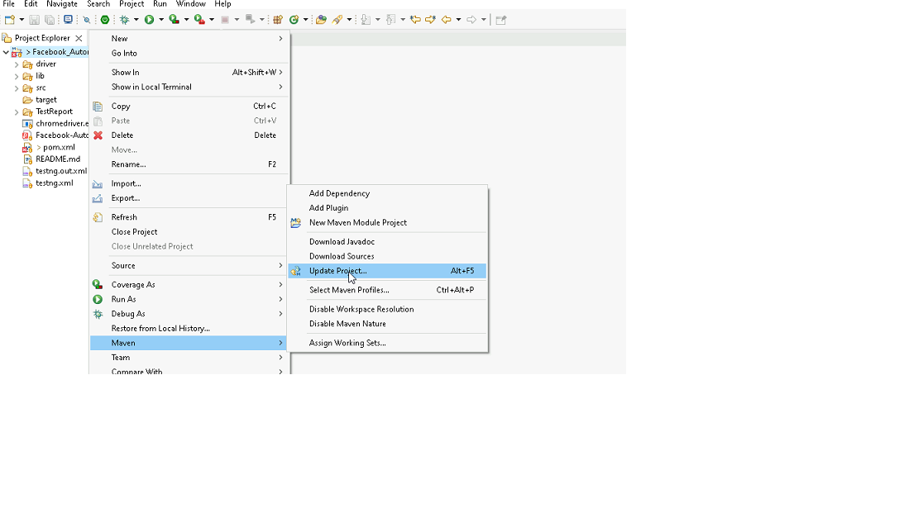

1. In Update Maven Project Box Select “Force Update of Snapshots/Releases” and click OK

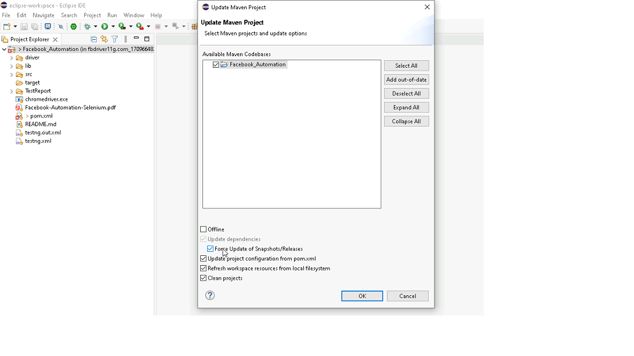

Template Code Structure:

1. Below are the packages and files you will be required to work upon.
2. Other Files and packages you can ignore.
3. In other Files and packages do not do any changes. It would affect your evaluation.
4. You are not required to work in “Test” Folder. Files there are non-editable. Editing those files and trying to save them will throw error and would affect your evaluation.

|  |  |  |
| --- | --- | --- |
| **Package** | **Class/File** | **Description** |
| src/main/java/coreUtilities/utils/ | FileOperations.java | 1. Contains methods to read from excel file. 2. Method is in templated form. 3. **You will be required to implement these methods as very first activity, because even URL to navigate to, is read using these methods.** |
| /src/main/java/pages | verification_page.java | 1. All core activities (mentioned in list above) to be performed here. 2. The comments associated with each templated method here describe the expectation. 3. You can define locators and xpath here. 4. Declare any variable/object you need to share data/status between different methods. 5. Do not modify the signature of methods declared here. 6. You can create additional supportive common methods in CommonEvents class. |
| /src/main/resources/ | Config.xlsx | URL to navigate to. Already URL is defined here |
|  | expected_data.xlsx | Contains data to fill in form |
| /src/main/java/coreUtilities/utils | CommonEvents.java | 1. Contains all common activities. 2. Certain templated common method declared here. 3. You implement them as per your need. 4. You can add any additional method for common activity here |
|  | Testng.xml | Execution needs to kick started from TestNG xml |

PROBLEM STATEMENT

Need to automate the following activities using Selenium + Java.

Key Activities to implement:

|  |  |  |  |
| --- | --- | --- | --- |
| **Sl No.** | **Summary** | **Action** | **Expected Result** |
| **1** | Verify the verfication module is present or not | 1. Login in the healthapp application 2. Scroll down menu till verification 3. Click on the verfication | Verfication module should be present |
| **2** | Verify all sub-modules are displayed correctly after Clicking on the "verification" Module. | Pre condition: User should be logged in and it is on verification module 1. Click on the verification Module drop-down arrow | All sub-modules should be displayed correctly. Expected Sub modules are : Inventory, Pharmacy |
| **3** | Verify the presence of Requisition tab in inventory section with all fields | Pre condition: User should be logged in and it is on verification module 1. Click on the verification Module drop-down arrow  2. Click on inventory  3. Click on Requisition tab | Requisition tab in Inventory section should be present  Expected value that are present in Requisition tab are  1. Sub modules: "Same as TC_3 Expected" 2. Tab: Requisition, Purchase Request, Purchase Order, GR Quality Inspection 3. Buttons: Ok, print, First, Previous, Next, Last,view 4. Fields: search bar 5. Drop down: Requisition Status, Date range, menu bar 6. Status Radio button: Pending ,Approved ,Rejected ,All  7. Date Picker: From, To 8. Tooltip: Star figure |
| **4** | Verify to navigate on another sub module after open the inventory module | Pre condition: User should be logged in and it is on verification module 1. Click on the inventory  2. Click on the pharmacy | User should navigate to the pharmacy section from the inventory section |
| **5** | Verify to navigate on another sub tab after open the Requisition tab | Pre condition: User should be logged in and it is on verification module 1. Click on the Requisition  2. Click on the purchase order | User should navigate to the purchase order tab from the requisition tab |
| **6** | Verify to search the data by picking the date filter | Pre condition: User should be logged in and it is on verification module 1. Click on the "From" date 2. Select the "Jan 2022" date 3. Click on the "To" date 4. Select "July 2024" date 5. Click on "OK" button | The 'Requested on' column date must fall within the date selected by the user. |
| **7** | Verify the tooltip and it's text present on hover the mouse on "Star" | Pre condition: User should be logged in and it is on Verification module 1. Hover the mouse in star | Tooltip should be present when hover the mouse on star with text "Remember this date" |
| **8** | Verify dates are remembered correclty | Pre condition: User should be logged in and it is on verification module 1. Click on "FROM" and Select "Jan 2020" 2. Click on "TO" and selct "march 2024" 3. Click on "star" tooltip 4. Click on "OK" button 5. Navigate to the "Pharmacy" tab. 6. Navigate back to the "Inventory" tab. | Upon returning to the "Inventory" tab from the "Pharmacy" tab, the previously selected dates ("FROM" and "TO") should be remembered and displayed correctly. |
| **9** | Verify data range by Select "one week" option from drop down | Pre condition: User should be logged in and it is on verification module 1. Click on the data range button 2. Select"one week" option from the drop down 3. Click on "OK" button | The 'Requested on' column date must fall within the date range Selected by the user. |
| **10** | Verify following radio buttons are selectable: -Pending -Approved -Rejected -All | Pre condition: User should be logged in and it is on Verification module 1. Click on the "Pending " Radio button from List by Verification Status 2. Click on the "Approved " Radio button from List by Verification Status 3. Click on the "Rejected " Radio button from List by Verification Status 4. Click on the "All " Radio button from List by Verification Status | The "Pending" radio button should be Selectable The "Approved" radio button should be Selectable The "Rejected" radio button should be Selectable The "All" radio button should be Selectable |
| **11** | Verify to filter the records by Select active drop down from Requisition Status | Pre condition: User should be logged in and it is on Verification module 1. Click on drop down 2. Click on "Active" drop down option | The 'Req. Status' column should match the option Selected from the dropdown menu. |
| **12** | Verify the presence of view button | Pre condition: User should be logged in and it is on Verification module 1. Select "All" radio button 2. Select "All" drop down option 3. Click on "FROM" and Select "Jan 2020" 4. Click on "TO" and selct "march 2024" 5. Click on "OK" button 6. Click on "View" button from action column of specific row | User should navigate to the Check and Verify Requisition page of that Selected specific row |
| **13** | Verify Record Count Matches in Purchase Request | Pre condition: User should be logged in and it is on Requisition tab in verification module  1. Click on inventory section  2. Click on the "Purchase Request" sub-tab. 3. Find and select the "All" radio button to view all records. 4. Fetch and Verify Result Counts: | The result count displayed at the bottom of the page should match the total record count. |
| **14** | Verify to scrolling of page | Pre condition: User should be logged in 1. Verify "Pending" radio button is visible 2. Scroll all the way to the bottom of the page 3. Verify "Previous" button is visible 4. Scroll all the way to the top of the page 5. Verify "Pending" radio button is visible | The user should be able to scroll up and down |
| **15** | Verify the required "Item" field in the Purchase Request  section under the Inventory module. | Precondition: User should be logged in and on the Verification module 1. Navigate to the "Internal" section under Inventory. 2. Click on "Purchase Request". 3. Click on the "Create Purchase Request" button. 4. Click on the "Request" button. | The 'Item Name' field should display a red border along with a warning message beneath it stating, 'Item is required.' |

NOTE: "Please do not delete any file in the src folder.  But you are free to add any other file".

Expectations:

1. Learners should write automation script using Java and selenium to automate all the steps in the above question. In other words, automation script should perform all mentioned steps.
2. Learners should not use any tools to create the xpath. They should develop the xpath/cssselector on their own.

IMPLEMENTATION/FUNCTIONAL REQUIREMENT

* 1. **CODE QUALITY/OPTIMIZATIONS**
     1. Associates should have written clean code that is readable.
     2. Associates need to follow SOLID programming principles.

EXECUTION STEPS TO FOLLOW

1. **You are mandatory required to run test cases for applications before final submission. Without which project evaluation will not happen.**
2. **You can launch test cases any time as follows: Right click on testng.xml and run TestNGSuite**

|  |
| --- |
|  |

1. **Before final submission, you are also required to push your code to GIT. Following are the steps to follow:**

|  |
| --- |
|  |

In your project folder, you will find a batch file named git_commands

|  |
| --- |
|  |

Double-click the batch file to run it. It will run the commands to push your code to GIT.

|  |
| --- |
|  |

===============================================================================

All the Best