| REST-ASSURED  ( API - AUTOMATION PROJECT – PL2) |  |
| --- | --- |

Pre-requisite:

Before you start working on your project, execute the runner file present in your project folder (Simply by double click). This is mandatory.

|  |
| --- |

This will launch a command terminal for you where it will keep on pushing your updated code to GIT on regular intervals. Keep that command terminal open at backend and you can continue working on your project.

|  |
| --- |

As soon as you import project in eclipse, update the project using maven update option as below. This is to resolve issue if any maven dependency not downloaded properly:

1. Right click on project : Go to “Maven” : Select “Update Project”

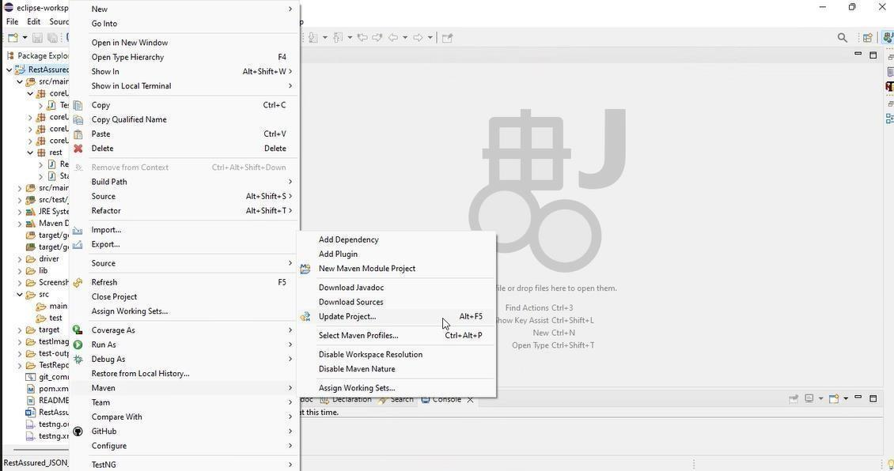

1. In Update Maven Project Box Select “Force Update of Snapshots/Releases” and click OK

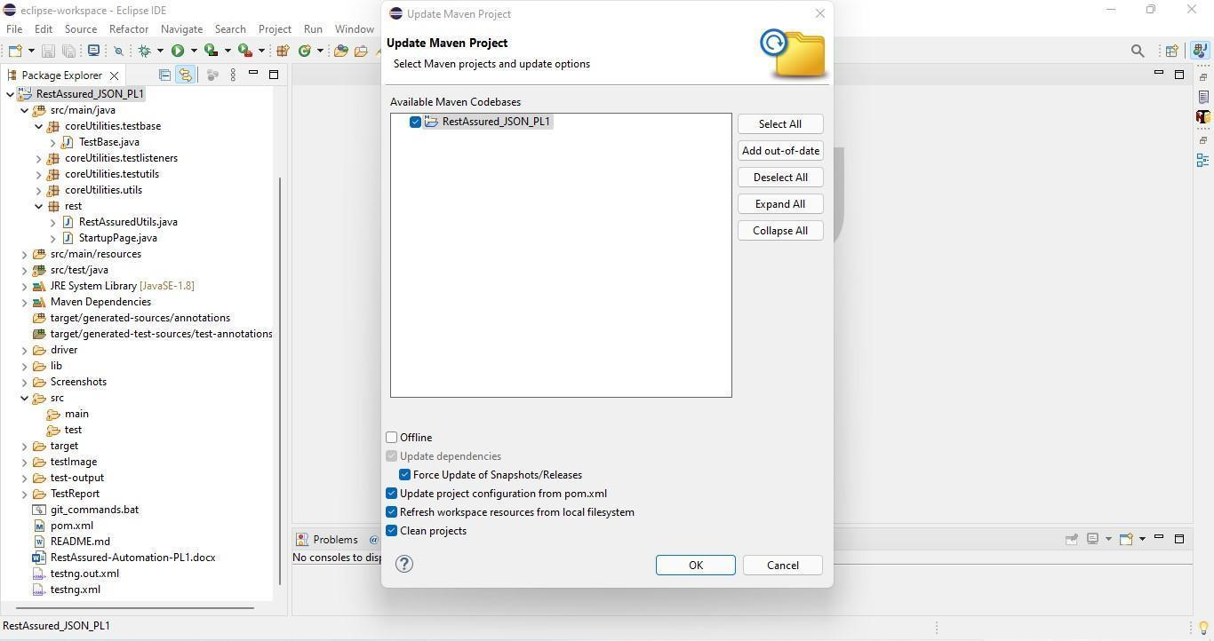

Template Code Structure:

* Below are the packages and files you will be required to work upon.
* Other Files and packages you can ignore.
* In other Files and packages do not do any changes. It would affect your evaluation.
* You are not required to work in “Test” Folder. Files there are noneditable. Editing those files and trying to save them will throw error and would affect your evaluation.

| **Package** | **Class/File** | **Description** |
| --- | --- | --- |
| src/main/java/coreUtilities/utils/ | FileOperations.java | 1. It contains methods to read data from Excel files. 2. The method is in templated form. 3. You will be required to implement these methods as the first activity, because even the URL to navigate to is read using these methods. |
| /src/main/java/pages | ApiUtil.java | 1. All core activities to be performed here. 2. The comments associated with each templated method here describe the expectation. 3. Declare any 4. variable/object you need to share data/status between different methods. 5. Do not modify the signature of methods declared here. 6. You can create additional supportive common methods in 7. CommonEvents class. |
| /src/main/resources/ | Config.xlsx | 1. Data present to be used in creating a new Post. |
|  | expected_data.xlsx | 1. Contains data to fill in the form |
| /src/main/java/coreUtilities/utils | CommonEvents.java | 1. Contains all common activities. 2. Certain templated common methods are declared here. 3. You implement them as per your needs. 4. You can add any additional method for common activity here |
|  | Testng.xml | Execution needs to be kick-started from TestNG.xml |

PROBLEM STATEMENT

Need to automate the following activities using RestAssured.

Key Activities to implement:

| # | **Summary** | **Action** | **Expected Result** |
| --- | --- | --- | --- |
| **1** | Perform login with Cookie Authentication using method:  getSubunitsTree(String endpoint, String cookieValue, Map<String, String> body) | 1. Construct the final URL by combining the BASE_URL and the provided endpoint parameter:    1. https://yakshahrm.makemylabs.in/orangehrm-5.7/web/index.php/api/v2/admin/subunits?mode=tree 2. Initialize a RequestSpecification using RestAssured:    1. Add a cookie with name "orangehrm" and the value passed as cookieValue.    2. Set the "Content-Type" header to "application/json". 3. Trigger a GET request to the above URL. 4. Create a CustomResponse object with:    1. Full Response    2. Extracted statusCode    3. Extracted statusLine    4. id    5. unitId    6. name    7. level    8. children 5. Return the CustomResponse object. | 1. Method should return a fully initialized CustomResponse object with:    1. statusCode = 200    2. status = OK (or valid status line like "HTTP/1.0 200 OK")    3. The complete raw Response object    4. List<Object> ids    5. List<Object> unitIds    6. List<Object> names    7. List<Object> levels    8. List<Object> children |
| **2** | Retrieve action summary using session cookie authentication through method:  getAdminSkills(String endpoint, String cookieValue, Map<String, String> body) | 1. Construct the complete URL by concatenating the BASE_URL and the provided endpoint:    1. https://yakshahrm.makemylabs.in/orangehrm-5.7/web/index.php/api/v2/admin/skills?limit=50&offset=0 2. Create a RequestSpecification using RestAssured:    1. Add a session cookie named "orangehrm" with the provided cookieValue.    2. Add a header "Content-Type" with the value "application/json". 3. If a request body is provided (not null), attach it to the request using .body(). 4. Send a GET request to the constructed URL. 5. Create and return a CustomResponse object initialized with:    1. The complete Response    2. Extracted statusCode    3. Extracted statusLine    4. id    5. name    6. description | 1. The method should return a CustomResponse object with:    1. statusCode = 200    2. status equal to a valid HTTP status line like "HTTP/1.0 200 OK"    3. The complete raw Response object    4. List<Object> ids    5. List<Object> names    6. List<Object> descriptions |
| **3** | Retrieve dashboard shortcut access permissions using session-based authentication through the method: **getAdminEdu(String endpoint, String cookieValue, Map<String, String> body)** | 1. Construct the final URL by combining the BASE_URL and the provided endpoint:    * https://opensource-demo.orangehrmlive.com/web/index.php/api/v2/admin/educations?limit=50&offset=0 2. Create a RequestSpecification using RestAssured:    * Add a session cookie named "orangehrm" using the provided cookieValue.    * Set the request header "Content-Type" to "application/json". 3. If a request body (body) is provided (i.e., not null), attach it using .body() method. 4. Wrap each of these fields into separate List<Object> collections:    * leaveAssignLeave, leaveLeaveList, leaveApplyLeave, leaveMyLeave, timeEmployeeTimesheet, timeMyTimesheet 5. Create a CustomResponse object using:  * The complete Response object * Extracted statusCode and statusLine * id * name  1. Return the populated CustomResponse object. | 1. The method should return a CustomResponse object containing:    * statusCode = 200    * A valid status line such as "HTTP/1.0 200 OK"    * The complete Response object from the API call    * List<Object> ids    * List<Object> names |
| **4** | Retrieve employee leaves information using session-based authentication through method:  **getAdminLicenses(String endpoint, String cookieValue, Map<String, String> body)** | 1. Construct the final URL by combining the BASE_URL and the provided endpoint:    * https://yakshahrm.makemylabs.in/orangehrm-5.7/web/index.php/api/v2/admin/licenses?limit=50&offset=0 2. Create a RequestSpecification using RestAssured:    * Add a session cookie named "orangehrm" using the provided cookieValue.    * Set the request header "Content-Type" to "application/json". 3. If a request body (body) is provided (i.e., not null), attach it using .body() method. 4. Create a CustomResponse object using:  * The complete Response object * Extracted statusCode and statusLine  1. Return the populated CustomResponse object. 2. id 3. name | * Method must return a valid CustomResponse object containing:   + statusCode = 200   + status like "HTTP/1.0 200 OK"   + The full raw Response object   + List<Object> ids   + List<Object> names |
| **5** | Retrieve employee subunit using session-based cookie authentication via method:  **getAdminLanguages(String endpoint, String cookieValue, Map<String, String> body)** | 1. Construct the final URL by combining the BASE_URL and the provided endpoint:    * /web/index.php/api/v2/dashboard/employees/subunit 2. Create a RequestSpecification using RestAssured:    * Add a session cookie named "orangehrm" using the provided cookieValue.    * Set the request header "Content-Type" to "application/json". 3. If a request body (body) is provided (i.e., not null), attach it using .body() method. 4. Create a CustomResponse object using:  * The complete Response object * Extracted statusCode and statusLine * id * name  1. Return the populated CustomResponse object. | * The method must return a CustomResponse containing:   + statusCode = 200   + A valid status line like "HTTP/1.0 200 OK"   + An Data object with non-null and non-empty lists for:     - int subUnitId     - String subUnitName     - int subUnitCount   + The full raw Response object   + List<Object> ids   + List<Object> names |
| **6** | Retrieve employee Location using session-based cookie authentication via method:  **getMembershipdetails(String endpoint, String cookieValue)** | 1. Construct the complete URL by appending the endpoint to the base URL:   https://yakshahrm.makemylabs.in/orangehrm-5.7/web/index.php/api/v2/admin/memberships?limit=50&offset=0   1. Initialize a **RequestSpecification** using **RestAssured**:    * Add the session cookie "orangehrm" with the provided cookieValue.    * Set the header "Content-Type" to "application/json". 2. If a request body (body) is provided (not null), include it in the request using .body(). 3. Trigger a **GET** request to the constructed URL and extract the **Response**. 4. Wrap all extracted values into individual List<Object> collections. 5. Create and return a **CustomResponse** object containing:    * The full Response    * The extracted statusCode and statusLine    * id    * name    * The Meta Map to map the JSON | * The method should return a CustomResponse object with:   + statusCode = 200   + A valid status string (e.g., "HTTP/1.0 200 OK")   + List<Object> ids   + List<Object> names   + The complete raw Response object |
| **7** | Retrieve Admin Users using session-based cookie authentication via method:  **getNationalities(String endpoint,String cookieValue)** | 1. Construct the complete URL by appending the endpoint to the base URL:   https://yakshahrm.makemylabs.in/orangehrm-5.7/web/index.php/api/v2/admin/nationalities?limit=50&offset=0   1. Initialize a **RequestSpecification** using **RestAssured**:    * Add the session cookie "orangehrm" with the provided cookieValue.    * Set the header "Content-Type" to "application/json". 2. If a request body (body) is provided (not null), include it in the request using .body(). 3. Trigger a **GET** request to the constructed URL and extract the **Response**. 4. Wrap all extracted values into individual List<Object> collections. 5. Create and return a **CustomResponse** object containing:    * The full Response    * The extracted statusCode and statusLine    * id    * name    * The Meta Map to map the JSON | * The method should return a valid CustomResponse containing:   + statusCode = 200   + A valid HTTP status (e.g., "HTTP/1.0 200 OK")   + List<Object> ids   + List<Object> names   + Map<String, Object> meta   + The complete raw Response object |
| **8** | Retrieve Job Titles using session-based cookie authentication via method:  **getTheme(String endpoint, String cookieValue)** | 1. Construct the complete URL by appending the endpoint to the base URL:   https://yakshahrm.makemylabs.in/orangehrm-5.7/web/index.php/api/v2/admin/theme   1. Initialize a **RequestSpecification** using **RestAssured**:    * Add the session cookie "orangehrm" with the provided cookieValue.    * Set the header "Content-Type" to "application/json". 2. If a request body (body) is provided (not null), include it in the request using .body(). 3. Trigger a **GET** request to the constructed URL and extract the **Response**. 4. Wrap all extracted values into individual List<Object> collections. 5. Create and return a **CustomResponse** object containing:    * The full Response    * The extracted statusCode and statusLine    * primaryColor    * primaryFontColor    * secondaryColor | * The method should return a valid CustomResponse containing:   + statusCode = 200   + A valid HTTP status (e.g., "HTTP/1.0 200 OK")   + String primaryColor   + String primaryFontColor   + String secondaryColor   + The complete raw Response object   + Meta map should not be null |
| **9** | Retrive email configuration using session-based authentication through method: **getemailConfiguration(String endpoint, String cookieValue)** | 1. Compose the full URL by appending the endpoint to the base URL:   https://yakshahrm.makemylabs.in/orangehrm-5.7/web/index.php/api/v2/admin/email-configuration   1. Initialize a **RequestSpecification** using **RestAssured**:    * Add a session cookie named "orangehrm" with the provided cookieValue    * Set the "Content-Type" header to "application/json" 2. Attach the constructed requestBody to the request. 3. Send a **GET** request to the full URL and extract the **Response** object. 4. Return a **CustomResponse** object with:    * The full Response object    * Extracted statusCode and statusLine    * mailType    * sentAs    * smtpAuthType    * smtpHost    * smtpUsername | * The method should return a valid CustomResponse containing:   + statusCode = 200   + A valid HTTP status (e.g., "HTTP/1.0 200 OK")   + Non-empty string values for:     - List<Integer> empStatusIdList     - List<String> empStatusNameList   + The complete raw Response object   + String mailType   + String mailType   + String sentAs   + String smtpAuthType   + String smtpHost   + String smtpUsername |
| **10** | Retrieve Pay Grades using session-based cookie authentication via method:  **getEmailSubscription(String endpoint, String cookieValue)** | 1. Construct the complete URL by appending the endpoint to the base URL:   https://yakshahrm.makemylabs.in/orangehrm-5.7/web/index.php/api/v2/admin/email-subscriptions?limit=50&offset=0   1. Initialize a **RequestSpecification** using **RestAssured**:    * Add the session cookie "orangehrm" with the provided cookieValue.    * Set the header "Content-Type" to "application/json". 2. If a request body (body) is provided (not null), include it in the request using .body(). 3. Trigger a **GET** request to the constructed URL and extract the **Response**. 4. Wrap all extracted values into individual List<Object> collections. 5. Create and return a **CustomResponse** object containing:    * The full Response    * The extracted statusCode and statusLine    * id    * name    * isEnabled | * The method should return a valid CustomResponse object containing:   + statusCode = 200   + A valid status string like "HTTP/1.0 200 OK"   + List<Integer> idList   + List<String> nameList   + List<Boolean> isEnabledList   + The full Response object |
| **11** | Post Caption using session-based cookie authentication via method:  **PostCaption(String endpoint, String cookieValue, String requestBody)** | 1. Construct the complete URL by appending the endpoint to the base URL: https://yakshahrm.makemylabs.in/orangehrm-5.7/web/index.php/api/v2/buzz/posts 2. fetch the id from helper method :getPayGradeid() and put it in the url 3. create a requestbody in json format: {“name”:<unique name>} 4. Wrap all extracted values into individual List<Object> collections. 5. Create and return a **CustomResponse** object containing:    * The full Response    * The extracted statusCode and statusLine    * id    * employee | * The method should return a valid CustomResponse object containing:   + statusCode = 200   + A valid status string like "HTTP/1.0 200 OK"   + int postId   + Map<String, Object> employeeDetails   + The full Response object   + The response body should contain the added paygrade |
| **12** | Post Photo using session-based cookie authentication via method: **PostPhoto(String endpoint, String cookieValue, File photoFile, String caption)** | 1. Construct the complete URL by appending the endpoint to the base https://yakshahrm.makemylabs.in/orangehrm-5.7/web/index.php/api/v2/buzz/posts 2. create a requestbody in json format:    1. Map<String, Object> photoMeta = new HashMap<>();    2. photoMeta.put("name", photoFile.getName());    3. photoMeta.put("type", mimeType);    4. photoMeta.put("size", photoFile.length());    5. photoMeta.put("base64", base64Image);    6. Map<String, Object> payload = new HashMap<>();    7. payload.put("type", "photo");    8. payload.put("text", caption);    9. payload.put("photos", Collections.singletonList(photoMeta)); 3. Create and return a **CustomResponse** object containing:    1. The full Response    2. The extracted statusCode and statusLine 4. post.id 5. employee | * The method should return a valid CustomResponse object containing:   + statusCode = 200   + A valid status string like "HTTP/1.0 200 OK"   + String id   + Map<String, Object> employee   + The full Response object   + The response body should contain the added emp status   + status name list should not be null |
| **13** | Retrieve Likes using session-based cookie authentication via method:  **GetLike(String endpoint, String cookieValue)** | 1. Construct the complete URL by appending the endpoint to the base URL: https://yakshahrm.makemylabs.in/orangehrm-5.7/web/index.php/api/v2/buzz/shares/" + id + "/likes 2. fetch the id from helper method :getFirstEmploymentStatus() and put it in the url 3. create a requestbody in json format: {“name”:<unique name>} 4. Wrap all extracted values into individual List<Object> collections. 5. Create and return a **CustomResponse** object containing:    1. The full Response    2. The extracted statusCode and statusLine | * The method should return a valid CustomResponse object containing:   + statusCode = 200   + A valid status string like "HTTP/1.0 200 OK"   + The full Response object   + The response body should contain the added emp status |
| **14** | Delete Share using session-based authentication through method: **DeleteShare(String endpoint, String cookieValue)** | 1. Compose the full URL by appending the endpoint to the base URL: https://yakshahrm.makemylabs.in/orangehrm-5.7/web/index.php/api/v2/buzz/shares/"+ id 2. Initialize a **RequestSpecification** using **RestAssured**:    1. Add a session cookie named "orangehrm" with the provided cookieValue    2. Set the "Content-Type" header to "application/json" 3. Attach the constructed requestBody to the request. 4. Send a **DELETE** request to the full URL and extract the **Response** object. 5. Return a **CustomResponse** object with:    1. The full Response object    2. Extracted statusCode and statusLine | * The method should return a valid CustomResponse containing:   + statusCode = 200   + A valid HTTP status (e.g., "HTTP/1.0 200 OK")   + The complete raw Response object   + not null response body |
| **15** | Create a new Job Category using session-based cookie authentication via method: **updatePost(String endpoint, String cookieValue, String requestBody)** | 1. Construct the complete URL by appending the endpoint to the base URL:https://yakshahrm.makemylabs.in/orangehrm-5.7/web/index.php/api/v2/buzz/posts/"+postId +"?model=detailed 2. create a requestbody in json format: {“name”:<unique name>} 3. Wrap all extracted values into individual List<Object> collections. 4. Create and return a **CustomResponse** object containing:    1. The full Response    2. The extracted statusCode and statusLine | * The method should return a valid CustomResponse object containing:   + statusCode = 200   + A valid status string like "HTTP/1.0 200 OK"   + The full Response object |

NOTE: "Please do not delete any file in the src folder. But you are free to add any other file".

Expectations:

* + 1. **Learners should write automation scripts using Java and REST Assured to automate the API testing for all the provided methods (e.g., GET, POST, PUT, DELETE).** In other words, the automation script should perform all mentioned API interactions, including validation of responses.
    2. **Learners should not use any pre-built libraries or tools to validate API responses (e.g., JSON schema validation tools).** They should manually validate the response content (e.g., status codes, response body, etc.) by writing their own logic for assertion.



IMPLEMENTATION/FUNCTIONAL REQUIREMENT

**1.1 CODE QUALITY/OPTIMIZATIONS**

* + - 1. Associates should have written clean code that is readable.
      2. Associates need to follow SOLID programming principles.

EXECUTION STEPS TO FOLLOW



1. **You are mandatory required to run test cases for applications before final submission. Without this project evaluation will not happen.**
2. **You can launch test cases any time as follows: Right-click on testng.xml and run TestNGSuite.**

1. To do the final submission of the assessment :
   1. Press escape to come out of Fullscreen mode.
   2. Submit the assessment.

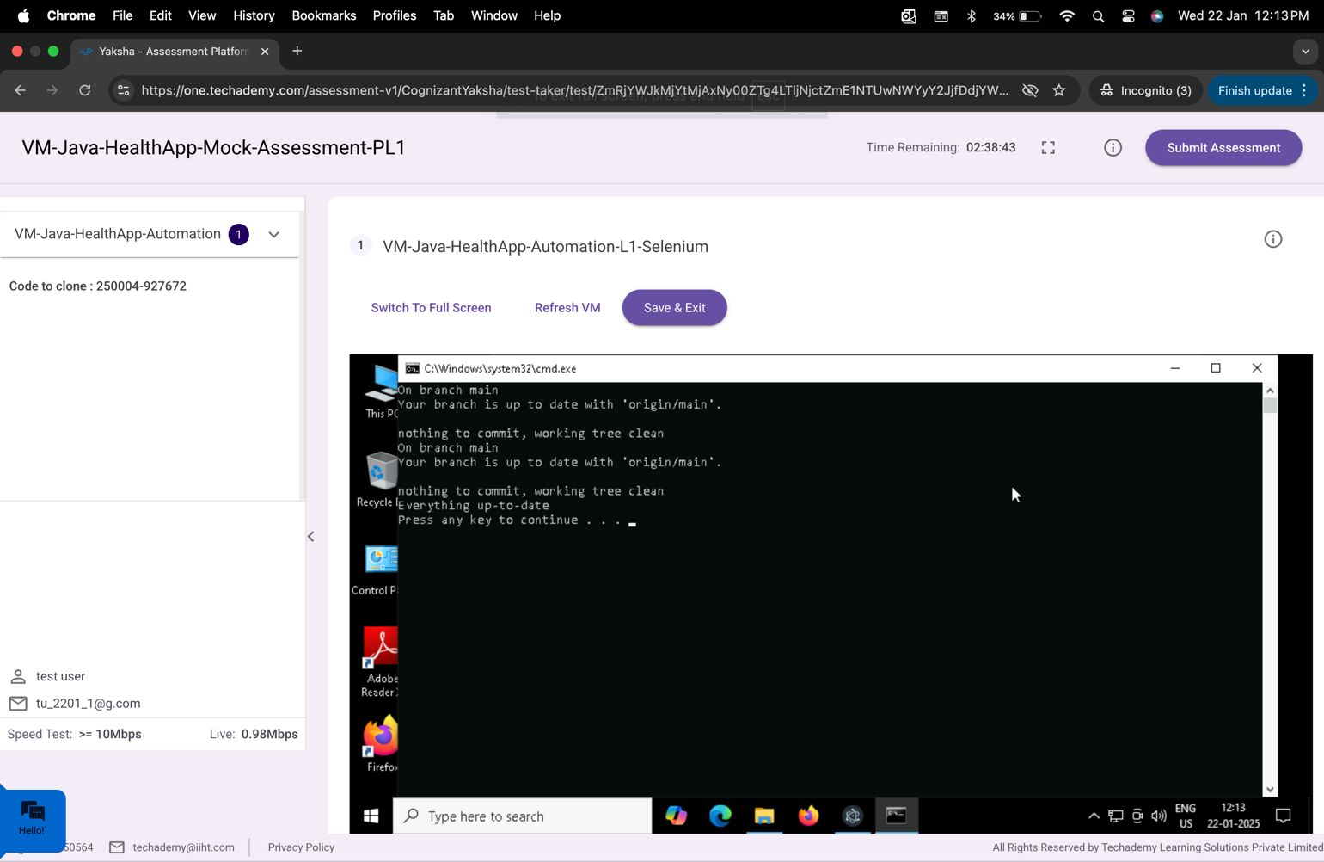

After the successful submission of the assessment, you will get a confirmation message displayed on your screen.

===============================================================================

All the Best