YAKSHA HEALTH APP WITH TYPESCRIPT AND PLAYWRIGHT

**Usecase summary**

**Project Name:**opensource-demo.orangehrmlive.com app – HR management system.

**Use Case Summary:** opensource-demo.orangehrmlive.com is designed to manage Employee record.

Records (HRMS). It allows users to view, search, and manage employee records. It features functionality such as adding/editing employee details, filtering data by department and role, and exporting records. The primary use case is to automate the process of employee data management, ensuring efficient and reliable operations for human resources teams in organizations

**Technology Stack:**

* **Automation Tool:** Playwright (for testing)

**Key Features:**

* **Patient Record Management:** Add, edit, and delete Employee records.
* **Filtering and Search:** Search Employee records by date range, name, department, and more.
* **Export Functionality:** Export records for offline access.

**Expected Outcomes:**

* Automate key HR operations like employee record handling, filtering, and validation.
* Ensure the accurate retrieval and modification of employee records, enhancing operational efficiency.

**Overview of the application**

**Pages/Features that are to be focused for the application**

Please use the Application URL [https:/opensource-demo.orangehrmlive.com](https://healthapp.yaksha.com/)

PROBLEM STATEMENT

Need to automate the following activities using playwright+typescript

**You will be given few Json files in Data folder like login.json, testData.json.**

|  |  |  |
| --- | --- | --- |
| **Path** | **File** | **Description** |
| src\data | login.json  TestData.json | 1. Contains data to read from json file. |

|  |  |  |
| --- | --- | --- |
| src\ pages | * AdminPage * BuzzPage * LoginPage * MyInfoPage | 1. All core activities are to be performed here. 2. The comments associated with each templated method here describe the expectation. 3. Declare any variable/object you need to share data/status between different methods. 4. Do not modify the signature of methods declared here. |

**Here’s a detailed table format for the test cases to be tested**

|  |  |  |  |  |
| --- | --- | --- | --- | --- |
| **Test Case No.** | **Test Case Name** | **Test Steps to be performed** | **Path & Method Used** | **Expected Result** |
| 1 | Verify Image  could be  Uploaded as profile Pic | 1. The application should read the data from login.json file and fetch the user’s name and password. 2. It should be called the method performLogin() and myinfo(). 3. Perform the myinfo method from MyInfoPage and perform the pic upload and set as profile pic. 4. Verify profile pic should be updated.   **It is must implement this login**  **functionality at first and then implement any other test case.** | **Reference path**  \src\pages\**MyInfoPage**  **methods**  performLogin(), myInfo()  **You can use highlightElement method present in CommonMethods file to highlight the element before performing any action on it. It takes locator as a parameter.** | image should get replaced |
|  |  |  | **Reference path** |  |
| 2 | Verify Admin can edit record | 1. Login using valid credentials 2. Click on "Admin" tab in sidebar 3. Click on "edit" button | \src\ pages\**AdminPage methods**  performLogin(), AdminEdit()  **You can use highlightElement method present in CommonMethods file to highlight the element before performing any action on it. It takes locator as a parameter.** | Verify edit user form appears |
|  |  | 1.Login using valid credentials | **Reference path** |  |
| 3 | Verify the Admin can sort the records | 1. Click on "Admin" tab in sidebar 2. Click on "sort" button | \src\ pages\**AdminPage**  **methods**  performLogin(), adminSort() | List should get sorted accordingly |
|  |  |  | **You can use highlightElement method present in** |  |

|  |  |  |  |  |  |
| --- | --- | --- | --- | --- | --- |
| **Test Case No.** | **Test Case Name** | **Test Steps to be performed** | | **Path & Method Used** | **Expected Result** |
|  |  |  | | **CommonMethods file to highlight the element before performing any action on it. It takes locator as a parameter.** |  |
|  |  |  | | **Reference path** |  |
|  |  | \src\ pages\**AdminPage** |  |
| 4 | Verify new Tab opens on clicking the "Upgrade" button | **Methods:**  performLogin(), upgrade()  **You can use highlightElement method present in CommonMethods file to highlight the element before performing any action on it. It takes locator as a parameter.** | PicUpgrade to advance tab should open |
|  |  |  | | **Reference path** |  |
| 5 | PicUpgr ade to advance tab should open. | 1. Login using valid credentials 2. Click on "Admin" button in sidebar 3. Hover upon "?" button | | \src\ pages\**MyinfoPage**  **methods**  PerformLogin()*,*HelpHover  **You can use highlightElement method present in CommonMethods file to highlight the element before performing any action on it. It takes locator as a parameter.** | Help" should be displayed on hovering over the "?" button in top right |
| 6 | Verify admin Seaarch Functionality | 1. Login using valid credentials 2. Click on "Admin" button in sidebar 3. Enter the user role as admin from dropdown. 4. Click on "Search" button | | Reference path  \src\pages\**AdminPage**  methods : performLogin(), Adminsearchh() | List having role "admin" should be displayed. |
| 7 | verify Image could be dragged and dropped in buzz tab | 1. Login using valid credentials 2. Click on "Buzz" tab in sidebar 3. Click on share photo button 4. Click on image area to up 5. drag & drop image> Click on Share button | | **Reference path**  \PageObjects\Pages\**BuzzPage methods** PerformLogin(),SharePhotoPost() | Image should get uploaded |
| 8 | Verify Like button is Functional | 1. Login using valid credentials   [2. Click on "Buzz" tab in sidebar](https://healthapp.yaksha.com/Home/Index%23/Appointment/ListAppointment) | | **Reference path**    \src\pages\**LoginPage** | Heart count should increase by 1 on clicking the like button |
|  |  |

|  |  |  |  |  |
| --- | --- | --- | --- | --- |
| **Test Case No.** | **Test Case Name** | **Test Steps to be performed** | **Path & Method Used** | **Expected Result** |
|  |  | 3. Click on Like button on any post in the List | **methods**  perfromLogin(), BuzzPage()  **You can use highlightElement method present in CommonMethods file to highlight the element before performing any action on it. It takes locator as a parameter.** |  |
|  |  | 1. Login using valid credentials 2. Click on "Buzz" tab in sidebar 3. Click on Comment button on any post in the List 4. Enter a message and press enter key | **Reference path** |  |
|  |  | \src\ pages\**BuzzPage** |  |
|  |  | **methods** |  |
| 9 | Verify the Comment could be added to a post | PerformLogin(), addCommentToPo st().  **You can use highlightElement method present in CommonMethods file to highlight the element before performing any action on it. It takes locator as** | comment should added post. |
|  |  | 1. Login using valid credentials 2. Click on "Buzz" tab in sidebar. 3. Click on Edit button on any post of user in the List 4. Enter a message and Click on Post button | **a parameter.**  **Reference path**  \src\pages\**BuzzPage** |  |
| 10 | Verify "Edit Post" Functionality. |  | **methods**  PerformLogin(), editPost() | post message should get edited |
|  |  | **Note :- If you cannot find the locator for “Proceed” button, please try to keep the page at 75%-80%.** | **You can use highlightElement method present in CommonMethods file to highlight the element before performing any action on it. It takes locator as a parameter.** |  |
|  |  |  |  |  |

Learners will gain experience in building strongly typed applications using React.js and managing data flow with **TypeScript**. They'll learn how to define interfaces, use types for error prevention, and improve code maintainability. URL https:/opensource-demo.orangehrmlive.com

App. Key skills include:

* **Browser Automation**: Interacting with web elements and testing multiple browsers.
* **Assertions & Validations**: Ensuring app behavior meets expected results.
* **End-to-End Testing**: Automating real user interactions and validating overall app functionality.

# IMPLEMENTATION/FUNCTIONAL REQUIREMENT

* 1. **Code Quality/Optimizations**

# Associates should have written clean code that is readable.

* + 1. Associates need to follow SOLID programming principles.

**Execution Steps:**

**Steps for Execution:**

1. **Please open the folder created on desktop with the email name you used to login.**

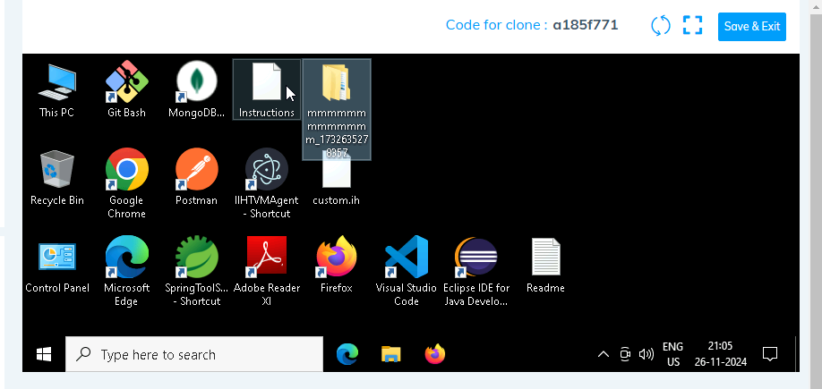

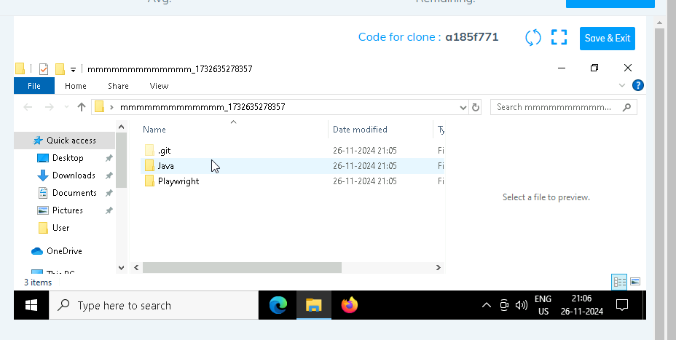

1. **Go into the Playwright folder and execute this “runner” file. This will keep pushing the code at**

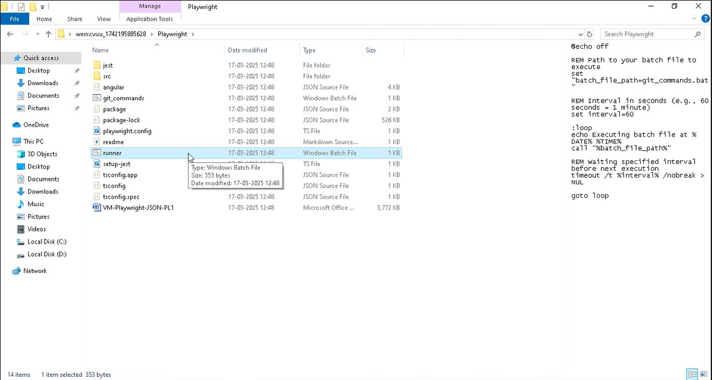

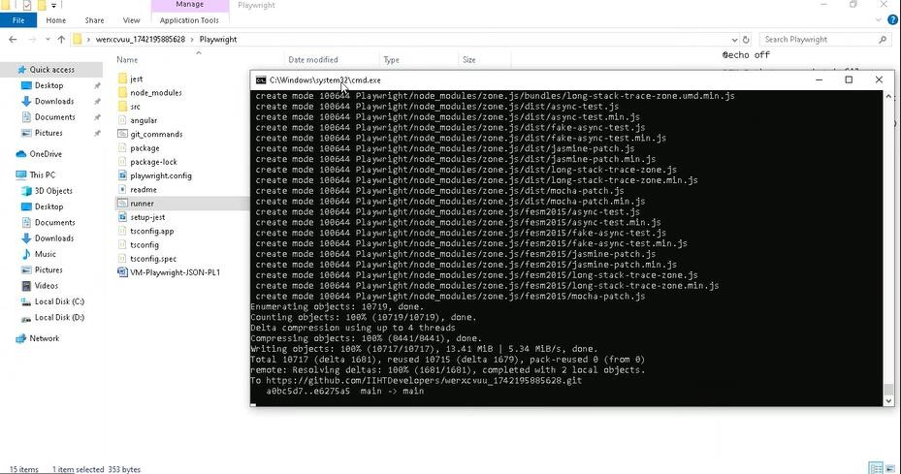

1. **Open command prompt with its location and use the command below: code .**

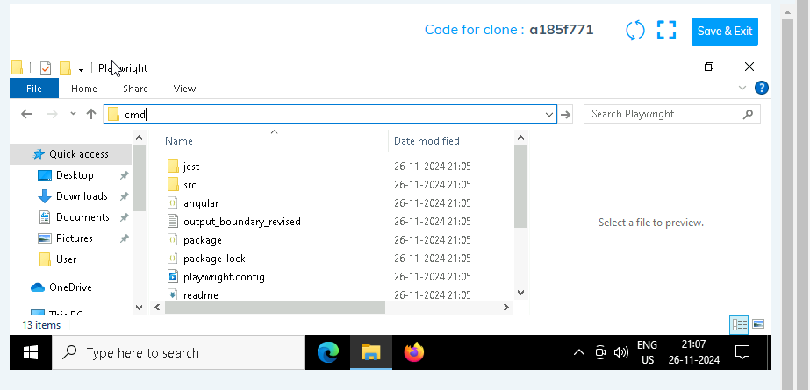

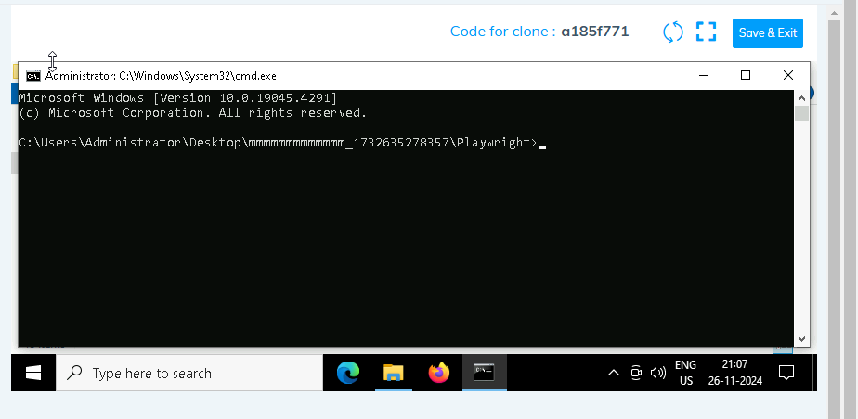

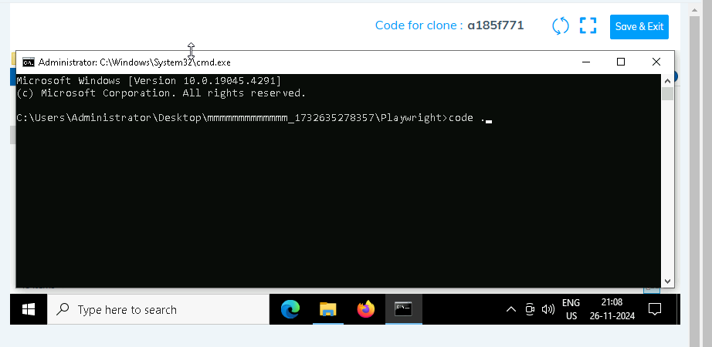

1. **Once VsCode is open. Please open the terminal in Playwright folder:**

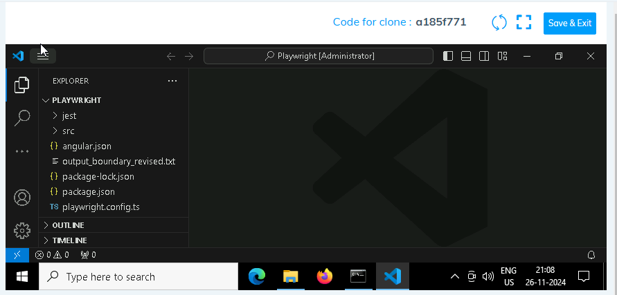

1. **Install all dependencies in the Playwright folder path using: npm install**
2. **Install playwright in the Playwright folder path: npx playwright install**
3. **Run the Tests in the Playwright folder path**:

**npx playwright test ./src/tests/PL1_testcases/yaksha.spec.ts**

1. **Once you have executed the test cases. Now it is necessary to push your code to git. For this, please go inside the folder created on desktop with the email id you have used to login and then:**
   1. **Open gitbash**

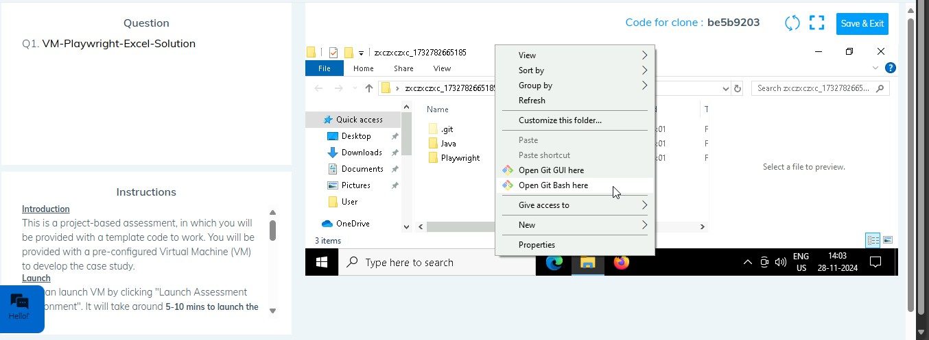

* 1. **Add all files**

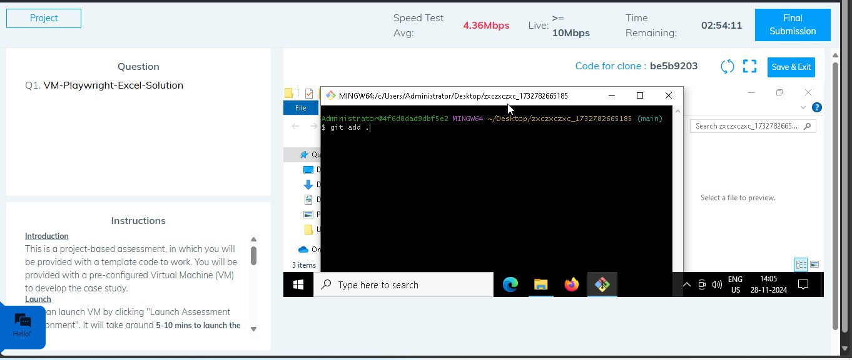

* 1. **Commit the changes**

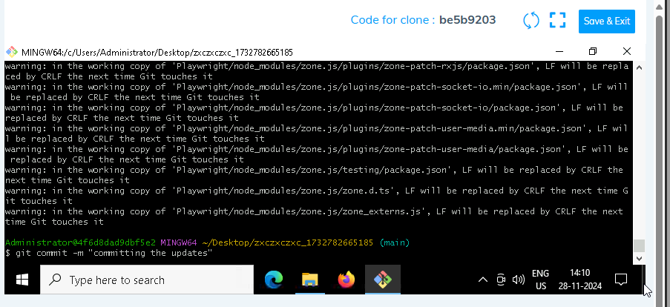

* 1. **Push the changes**

