YAKSHA HEALTH APP WITH TYPESCRIPT AND PLAYWRIGHT

**Usecase summary**

**Project Name:**opensource-demo.orangehrmlive.com app – HR management system.

**Use Case Summary:** opensource-demo.orangehrmlive.com is designed to manage Employee record.

Records (HRMS). It allows users to view, search, and manage employee records. It features functionality such as adding/editing employee details, filtering data by department and role, and exporting records. The primary use case is to automate the process of employee data management, ensuring efficient and reliable operations for human resources teams in organizations

**Technology Stack:**

* **Automation Tool:** Playwright (for testing)

**Key Features:**

* **Patient Record Management:** Add, edit, and delete Employee records.
* **Filtering and Search:** Search Employee records by date range, name, department, and more.
* **Export Functionality:** Export records for offline access.

**Expected Outcomes:**

* Automate key HR operations like employee record handling, filtering, and validation.
* Ensure the accurate retrieval and modification of employee records, enhancing operational efficiency.

**Overview of the application**

**Pages/Features that are to be focused for the application**

Please use the Application URL [https:/opensource-demo.orangehrmlive.com](https://healthapp.yaksha.com/)

PROBLEM STATEMENT

Need to automate the following activities using playwright+typescript

**You will be given few Json files in Data folder like Login.json and TestData.Json**

|  |  |  |
| --- | --- | --- |
| **Path** | **File** | **Description** |
| src\data | login.json  TestData.json | 1. Contains data to read from json file. |

|  |  |  |
| --- | --- | --- |
| src\ pages | * LoginPage * MyInfoPage | 1. All core activities are to be performed here. 2. The comments associated with each templated method here describe the expectation. 3. Declare any variable/object you need to share data/status between different methods. 4. Do not modify the signature of methods declared here. |

**Here’s a detailed table format for the test cases to be tested**

|  |  |  |  |  |
| --- | --- | --- | --- | --- |
| **Test Case No.** | **Test Case Name** | **Test Steps to be performed** | **Path & Method Used** | **Expected Result** |
| 1 | **Verify New 'Qualification' could be added to the record of user** | Login using valid credentials   1. Click on "My Info" tab 2. Click 'Qualification' from the sidebar 3. Click on 'Add' work experience button | **Reference path**  \src\pages\MyinfoPage  **methods**  performLogin(),addQualification()  **You can use highlightElement method present in CommonMethods file to highlight the element before performing any action on it. It takes locator as a parameter.** | **Verify the new qualification gets added to the list of records** |
|  |  |  | **Reference path** |  |
| 2 | Verify New 'Qualification' added could be edited from the record of use | 1. Login using valid credentials  2. Click on "My Info" tab  3. Click 'Qualification' from the sidebar  4. Click on 'edit icon' button  5. Fill the new record to the company and job title | \src\ pages\**MyinfoPage methods**  performLogin(), editQualification()  **You can use highlightElement method present in CommonMethods file to highlight the element before performing any action on it. It takes locator as a parameter.** | Verify the New record from the list of records |
|  |  |  | **Reference path** |  |
| 3 | Verify the qualification could be deleted | 1. Login using valid credentials  2. Click on "My Info" tab  3. Click 'Qualification' from the sidebar  4. Click on 'delete icon' button  5. Confirm the Delete | \src\ pages\**MyInfoPage**  **methods**  performLogin(), deleteQualification() | **Verify the qualification gets deleted from the record** |
|  |  |  | **You can use highlightElement method present in** |  |

|  |  |  |  |  |  |
| --- | --- | --- | --- | --- | --- |
| **Test Case No.** | **Test Case Name** | **Test Steps to be performed** | | **Path & Method Used** | **Expected Result** |
|  |  |  | | **CommonMethods file to highlight the element before performing any action on it. It takes locator as a parameter.** |  |
|  |  | 1. Login using valid credentials  2. Click on "My Info" tab  3. Click 'Qualification' from the sidebar  4. Select top 3 from the list  5. Click select deleted and confirm delete | | **Reference path** |  |
|  |  | \src\ pages\**MyInfoPage** |  |
| 4 | Verify the qualification select delete functionality | **methods**  performLogin(), deleteMultiple()  **You can use highlightElement method present in CommonMethods file to highlight the element before performing any action on it. It takes locator as a parameter.** | Verify the selected qualification gets delted succesfully |
|  |  |  | | **Reference path** |  |
| 5 | Verify New 'Education' could be added to the record of user. | 1. Login using valid credentials  2. Click on "My Info" tab  3. Click 'Qualification' from the sidebar  4. Click the 'Add' button  5. Fill the form and click save button | | \src\ pages\**MyinfoPage**  **methods**  PerformLogin()*,* addEducation()  **You can use highlightElement method present in CommonMethods file to highlight the element before performing any action on it. It takes locator as a parameter.** | Verify the newly added education gets displayed in the records |
| 6 | Verify New 'Education' added could be edited from the record of user | 1. Login using valid credentials  2. Click on "My Info" tab  3. Click 'Qualification' from the sidebar  4. Click the 'Edit' icon button for desired entry  5. Fill the form(year) and hit save | | Reference path  \src\pages\**MyinfoPage**  methods : editEducation(), performLogin() | Verify the year field gets replaced in the records |
| 7 | Verify New 'Language' could be added to the record of user | 1. Generate a unique comment. 2. Navigate to Language section. 3. Select options from dropdowns. 4. Enter comment and save. 5. Assert comment appears in table. | | **Reference path**  \PageObjects\Pages\**MyinfoPage methods:** PerformLogin(),  addLanguage() | Verify add language should appears |
| 8 | Verify the language should be delete |  | | **Reference path**    \src\pages\**MyInfoPage** | Language should be deleted. |
|  |  |

|  |  |  |  |  |
| --- | --- | --- | --- | --- |
| **Test Case No.** | **Test Case Name** | **Test Steps to be performed** | **Path & Method Used** | **Expected Result** |
|  |  | 1. Add a new language entry with a unique comment. 2. Delete the entry using the comment as reference. 3. Retrieve updated language comments. 4. Verify the comment is no longer present. | **methods**  perfromLogin(), deleteLanguage()  **You can use highlightElement method present in CommonMethods file to highlight the element before performing any action on it. It takes locator as a parameter.** |  |
|  |  | 1. Login using valid credentials  2. Click on "My Info" tab  3. Click 'Qualification' from the sidebar  4. Click on 'add' skill button  5. Fill the details and hit save button | **Reference path** |  |
|  |  | \src\ pages\**MyinfoPage** |  |
|  |  | **methods** |  |
| 9 | Verify the 'Skills' could be added to the record | PerformLogin(), addSkills().  **You can use highlightElement method present in CommonMethods file to highlight the element before performing any action on it. It takes locator as** | Verify 'Skills' gets added to the list of records |
|  |  | 1. Login using valid credentials  2. Click on "My Info" tab  3. Click 'Qualification' from the sidebar  4. Click on 'edit' icon on desired skill  5. Fill the Form and hit save butto | **a parameter.**  **Reference path**  \src\pages\**MyInfoPage** |  |
| 10 | Verify the 'Skills' could be edited from the record |  | **methods**  PerformLogin(), editSkills() | Verify 'skill' gets edited succesfully from the list of records |
|  |  | **Note :- If you cannot find the locator for “Proceed” button, please try to keep the page at 75%-80%.** | **You can use highlightElement method present in CommonMethods file to highlight the element before performing any action on it. It takes locator as a parameter.** |  |
|  |  |  |  |  |

Learners will gain experience in building strongly-typed applications using React.js and managing data flow with **TypeScript**. They'll learn how to define interfaces, use types for error prevention, and improve code maintainability. URL https:/opensource-demo.orangehrmlive.com

app. Key skills include:

* **Browser Automation**: Interacting with web elements and testing multiple browsers.
* **Assertions & Validations**: Ensuring app behaviour meets expected results.
* **End-to-End Testing**: Automating real user interactions and validating overall app functionality.

# IMPLEMENTATION/FUNCTIONAL REQUIREMENT

* 1. **Code Quality/Optimizations**

# Associates should have written clean code that is readable.

* + 1. Associates need to follow SOLID programming principles.

**Execution Steps:**

**Steps for Execution:**

1. **Please open the folder created on desktop with the email name you used to login.**

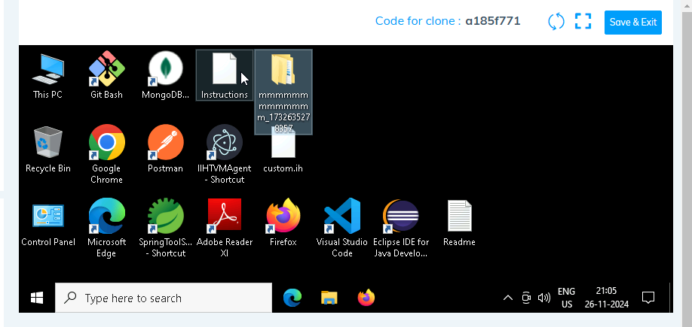

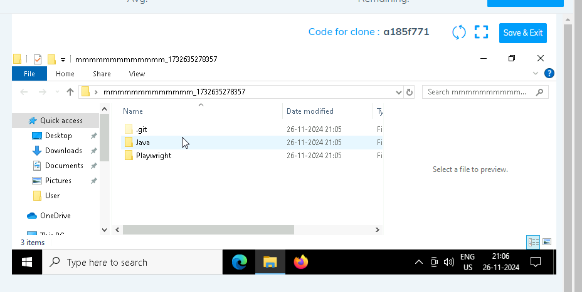

1. **Go into the Playwright folder and execute this “runner” file. This will keep pushing the code at regular intervals**

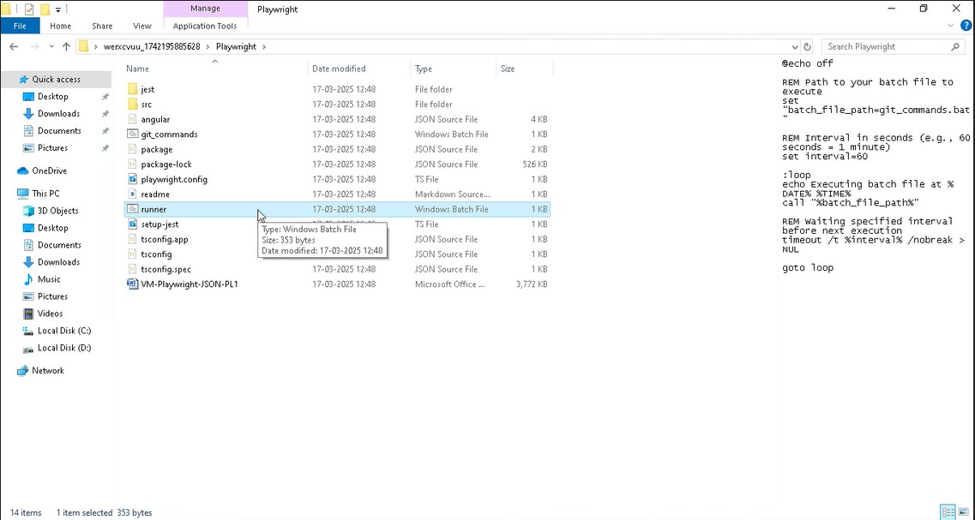

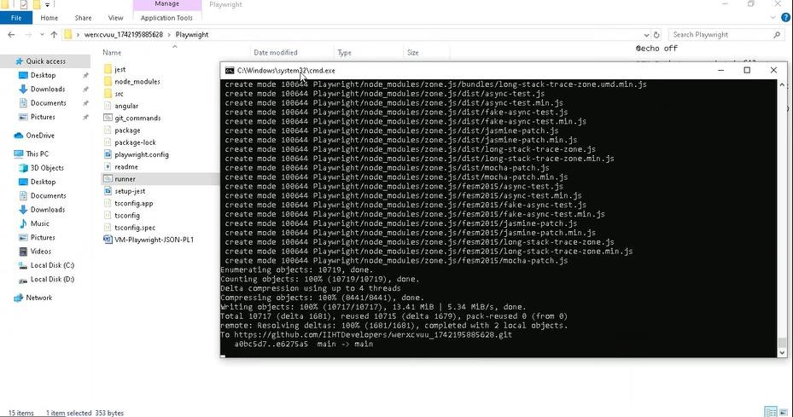

1. **Open command prompt with its location and use below command: code .**

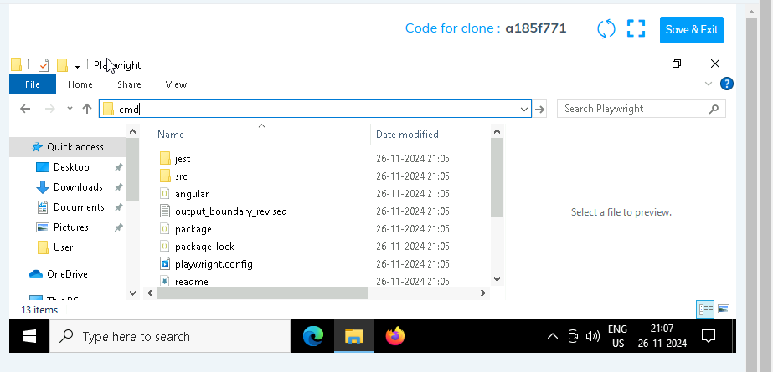

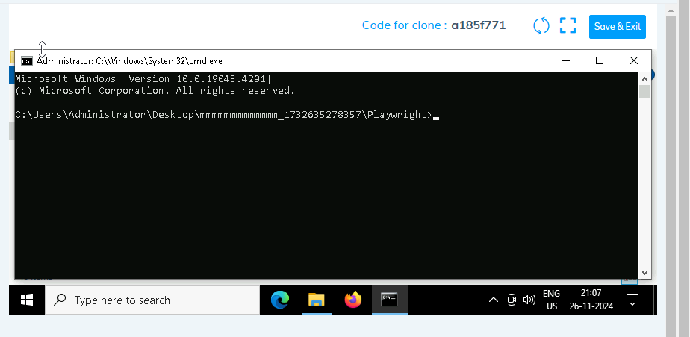

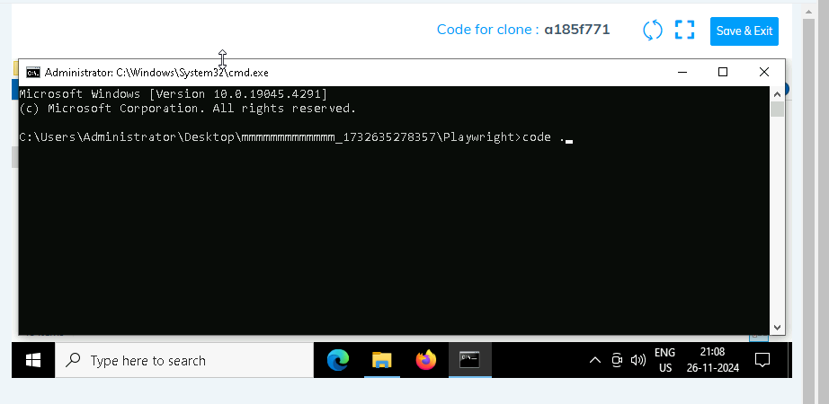

1. **Once VsCode is open. Please open the terminal in Playwright folder:**

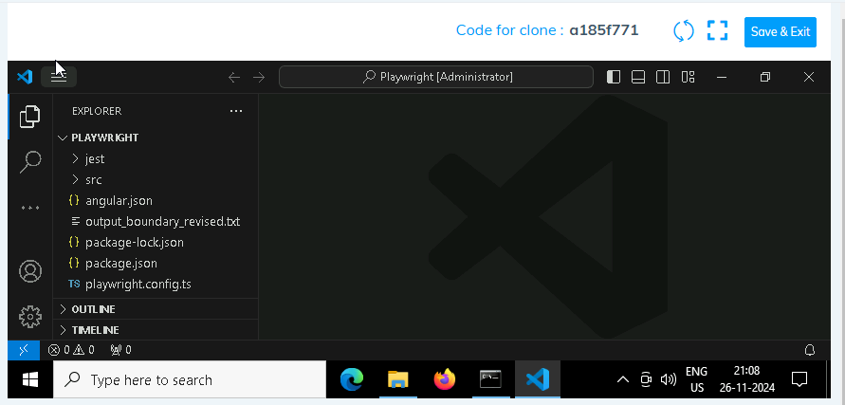

1. **Install all dependencies in the Playwright folder path using: npm install**
2. **Install playwright in the Playwright folder path: npx playwright install**
3. **Run the Tests in the Playwright folder path**:

**npx playwright test ./src/tests/PL1_testcases/yaksha.spec.ts**

1. **Once you have executed the test cases. Now it is necessary to push your code to git. For this, please go inside the folder created on desktop with the email id you have used to login and then:**
   1. **Open gitbash**

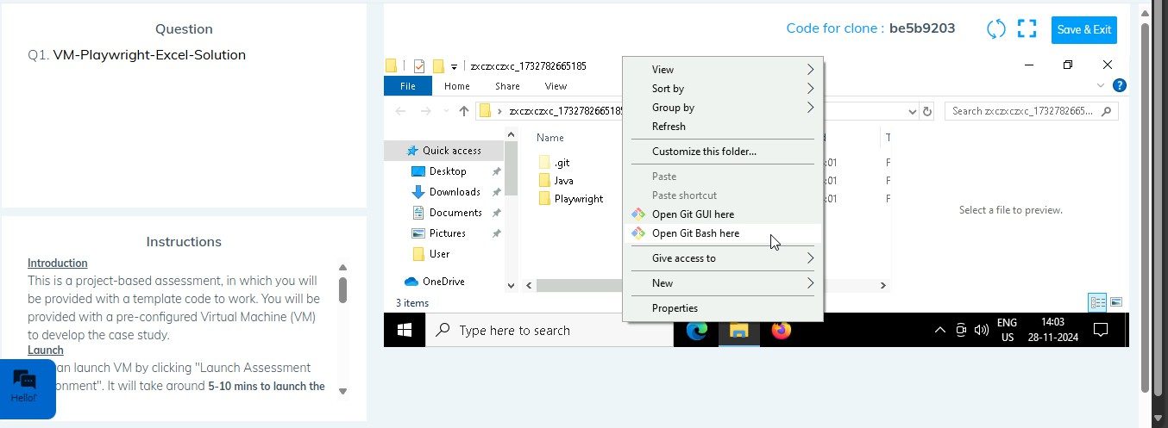

* 1. **Add all files**

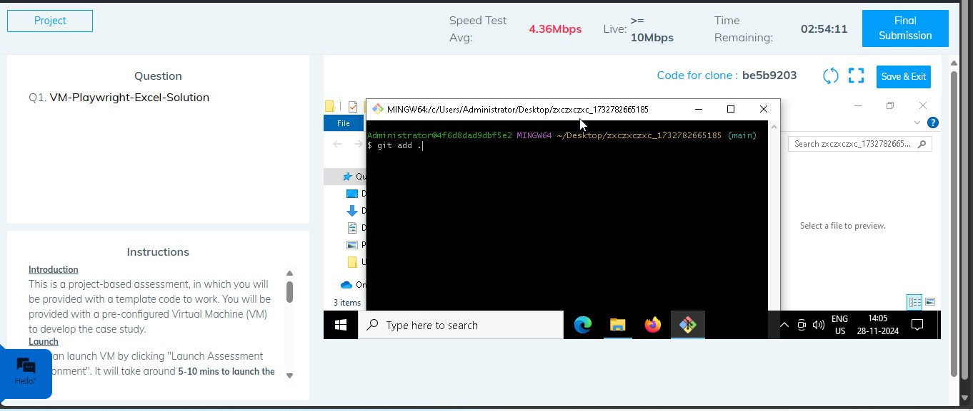

* 1. **Commit the changes**

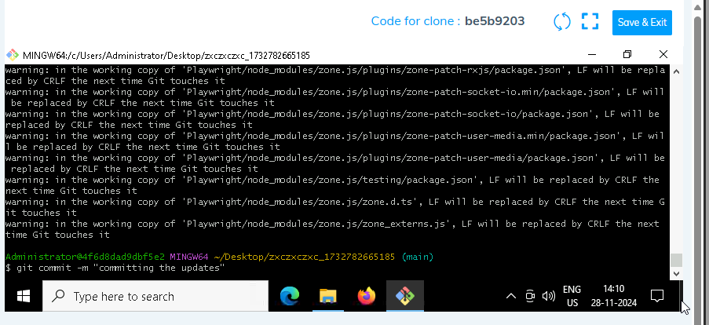

* 1. **Push the changes**

