# System Requirements Specification Index

For

## Python ML

## Diabetes Prediction System L2

1.0

## IIHT Pvt. Ltd.

[fullstack@iiht.com](mailto:fullstack@iiht.com)

**Step to access the work environment**

Step 1 use the URL to login provide the username and password

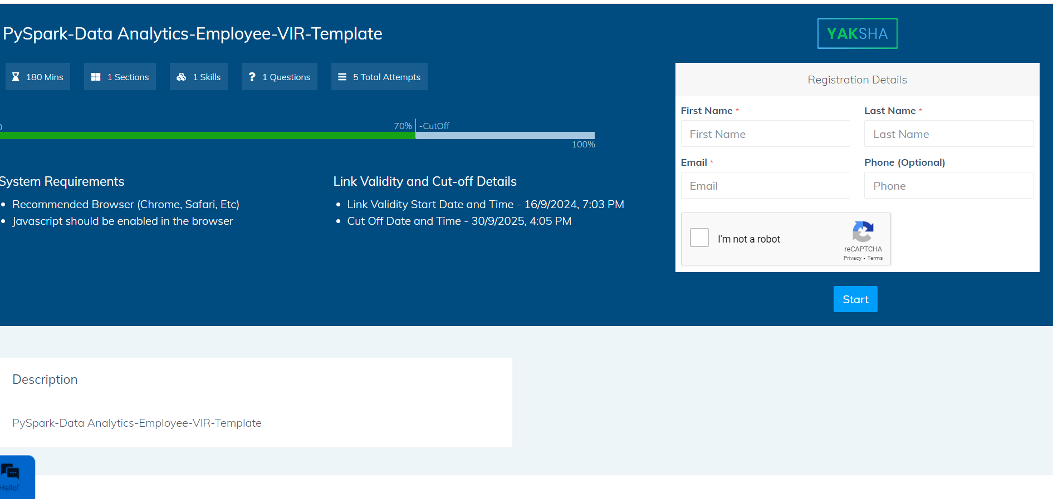

Step 2 Click on the launch assessment Environment

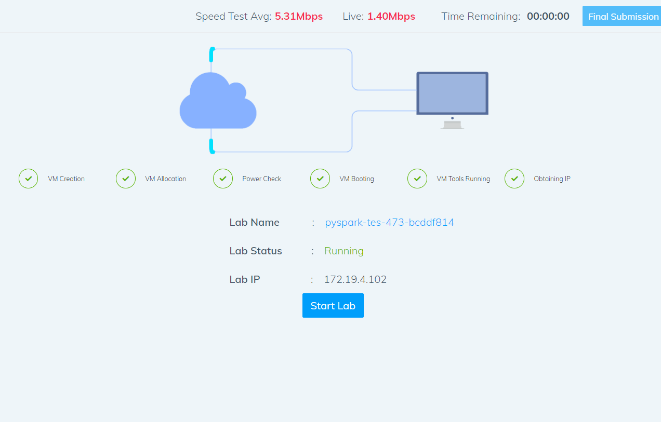

Step 3 Click on the start lab button

Step 4 you will get a window you need to type the code from that top corner

* You need to type the code in the window . It will take few minutes to start the window

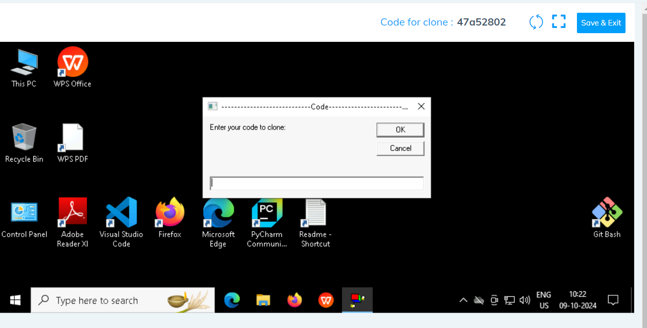

Click on ok

Step 5 after few seconds we can see that the your folder is cloned in the desktop .

Folder cloned

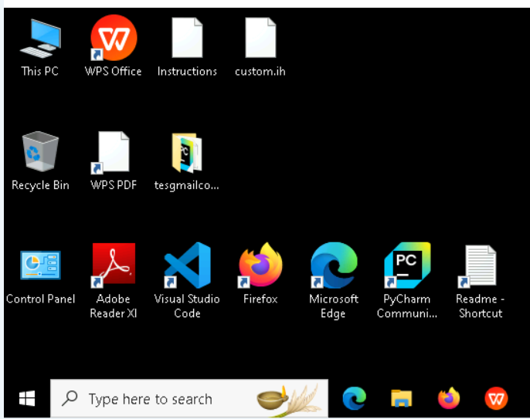

Step 6 go inside the folder type cmd in the top of the file explorer

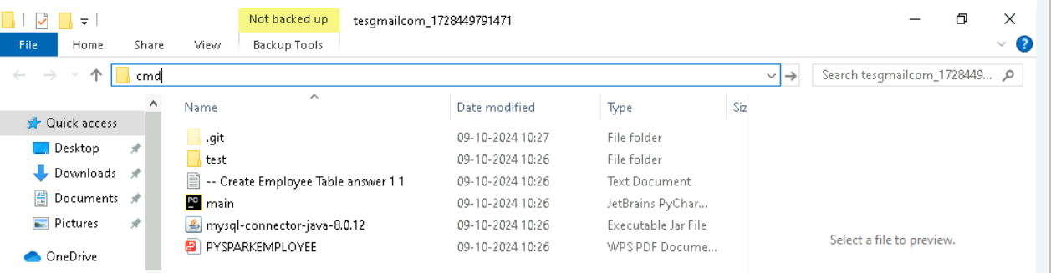

* Type code. And hit enter you can see that workspace is opened in the visual code

* You can see that workspace is ready to code

Note Please only work with visual code not with any other IDE

* In the folder cloned you will have all the project files needed .

Problem Statement : **Diabetes Prediction System**

Description : Use relevant methods operations toperform specified activities which are given in the instructions.

**Objective**

To build, train, and test a machine learning model that predicts diabetes status based on individual features. The project also includes functional and boundary testing.

Imagine you are part of a healthcare team in a bustling city where diabetes is becoming a growing public health concern. Early detection is critical for managing diabetes effectively and improving patient outcomes. However, limited resources and overburdened healthcare systems make it challenging to screen every individual.

To address this challenge, the hospital's research division has decided to develop an **AI-driven Diabetes Prediction System**. This system aims to predict whether a person is diabetic based on their lifestyle and medical history, enabling early intervention.

Your team, composed of data scientists and software engineers, is tasked with creating this prediction system. The system will use patient data such as age, BMI, blood glucose levels, and smoking history to predict diabetes risk. The project will also include rigorous testing to ensure reliability and robustness.

Healthcare startup has partnered with hospitals to leverage technology for public health. Rising diabetes rates have led to an urgent need for solutions that go beyond manual screening processes.

1. **Historical patient data** for training the model.
2. A **dataset of individuals** for testing the model predictions.

**Project Structure**

The project contains the following files:

1. **data_preprocessing.py**: Handles data preprocessing tasks like missing value imputation, scaling, and encoding.
2. **model_training.py**: Trains the machine learning model and evaluates its performance.
3. **prediction.py**: Makes predictions for new individuals using the trained model and preprocessor.
4. **main.py**: Combines all the steps: preprocessing, training, and predictions.
5. **test_functional.py**: Functional tests for key project components.

**Dataset Requirements**

1. **Training Dataset (diabetes_prediction_dataset.csv)**:
   * Includes columns such as age, bmi, HbA1c_level, blood_glucose_level, gender, smoking_history, and diabetes.
2. **Prediction Dataset (persons_for_prediction.csv)**:
   * Includes individual details with columns such as name, age, bmi, HbA1c_level, blood_glucose_level, gender, and smoking_history.

**Steps to Execute**

**1. Data Preprocessing**

* The data_preprocessing.py script:
  + Handles missing data.
  + Scales numerical columns.
  + Encodes categorical columns.
  + Splits data into training and testing sets.

**2. Model Training**

* The model_training.py script:
  + Trains a Random Forest classifier.
  + Saves the trained model as diabetes_model.pkl.

**3. Prediction**

* The prediction.py script:
  + Uses the saved model and preprocessor to make predictions.
  + Outputs predictions for individuals in the persons_for_prediction.csv file.

**Solve these Questions**

1. Create a predictive model using the RandomForestClassifier
2. Ensure the model achieves an accuracy of 0.97.
3. Classify predictions for ten patients provided in the persons_for_prediction.csv file.
4. Include precision, recall, f1-score, and support as part of the model evaluation metrics.

**Execution Steps to Follow:**

1. All actions like build, compile, running application,running test cases will be through Command Terminal.
2. To open the command terminal the test takers, need to go to Application menu (Three horizontal lines at left top) -> Terminal -> New Terminal
3. This editor Auto Saves the code
4. If you want to exit(logout) and continue the coding later anytime (using Save & Exit option on Assessment Landing Page) then you need to use CTRL+Shift+B-command compulsorily on code IDE. This will push or save the updated contents in the

internal git/repository. Else the code will not be available in the next login.

1. These are time bound assessments the timer would stop if you logout and while logging in back using the same credentials the timer would resume from the same time it was stopped from the previous logout.
2. To setup environment:

You can run the application without importing any packages

1. To launch application:

python main.py

1. To run Test cases:

python -m unittest

Before Final Submission also, you need to use CTRL+Shift+B-command compulsorily on code IDE. This will push or save the updated contents in the internal git/repository for code

**Screen shot to run the program**

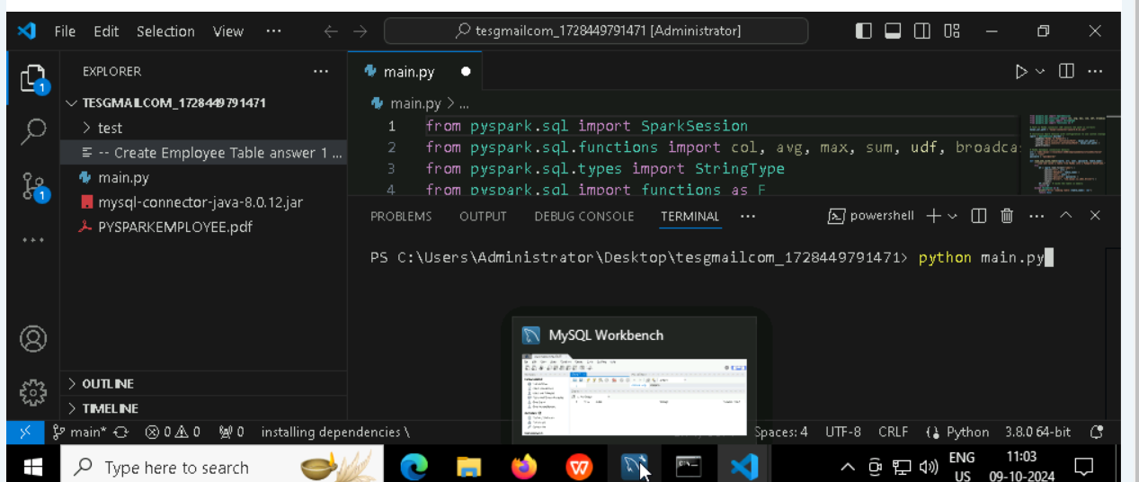

**To run the application**

* **Python main.py**

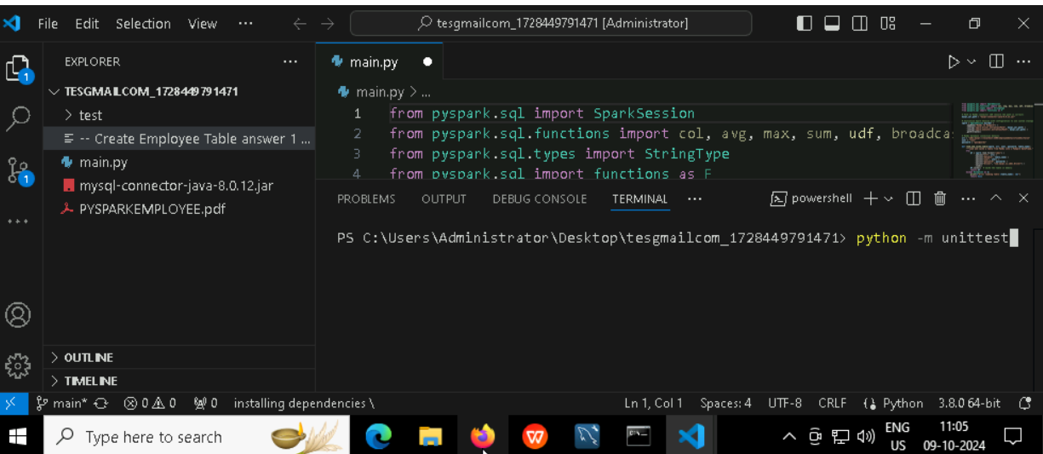

**To run the testcase**

* **Python -m unittest**

**Screenshot to push the application to github**

### -----x-----

#### You can run test cases as many numbers of times and at any stage of Development, to check how many test cases are passed/failed and accordingly refactor your code.

* 1. **Make sure before final submission you commit all changes to git**. For that open the project folder available on desktop

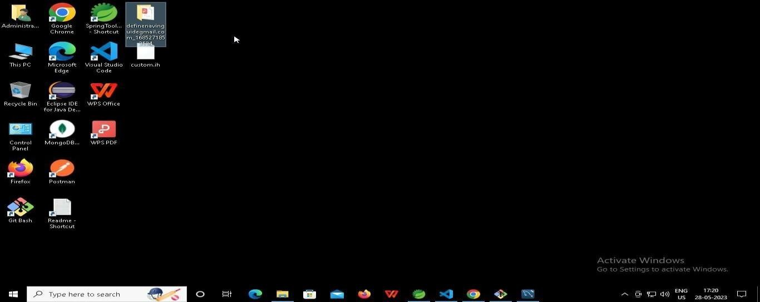

* + 1. **Right click in folder and open Git Bash**

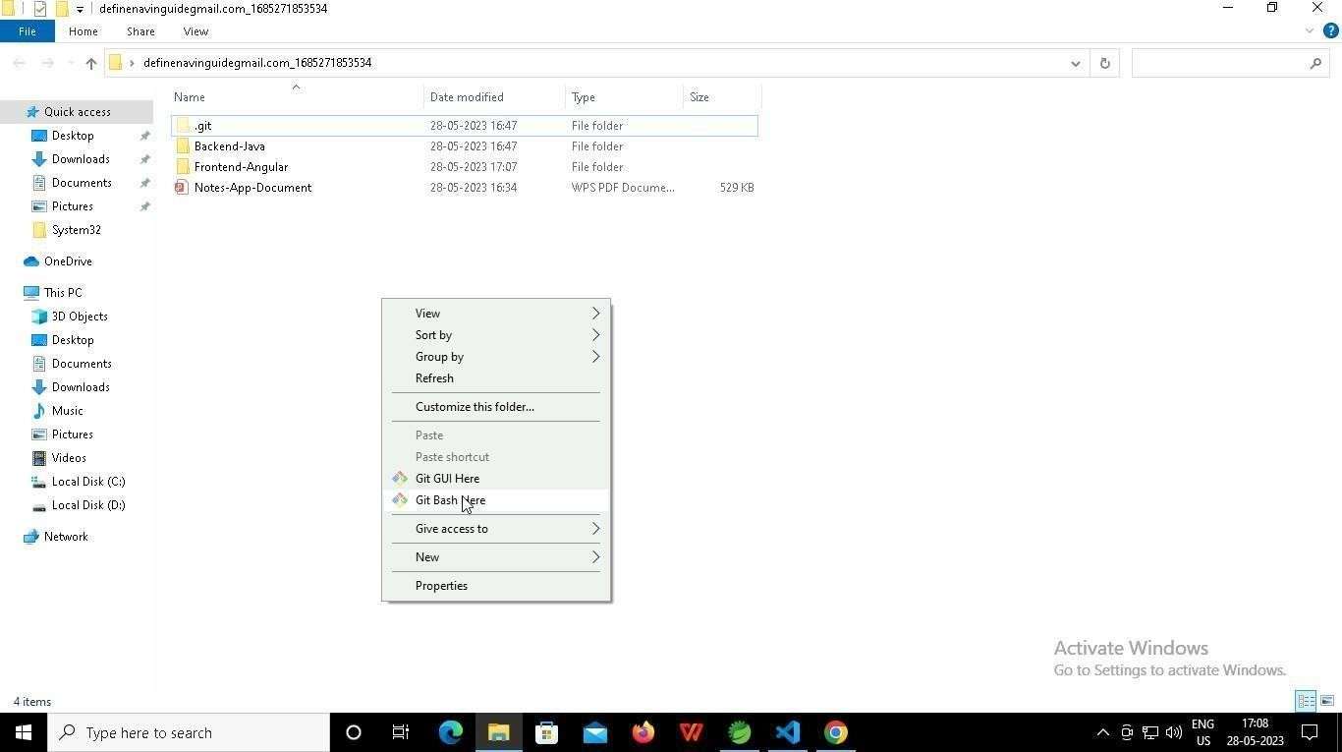

* + 1. **In Git bash terminal, run following commands**
    2. **git status**

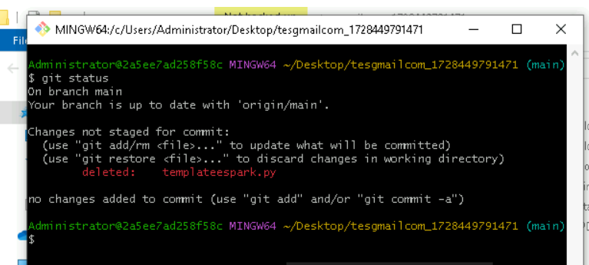

* + 1. **git add .**

* + 1. git commit -m “First commit”

(You can provide any message every time you commit)

* + 1. **git push**

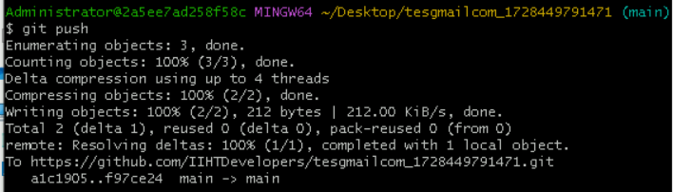

### After you have pushed your code Finally click on the final submission button

### 

### You should see a screen like this you will have to wait for the results . after getting this page you can leave the system

### -----x-----