RestAssured API Automation Project

Pre-requisite:

As soon as you import project in eclipse, update the project using maven update option as below. This is to resolve issue if any maven dependency not downloaded properly:

1. Right click on project : Go to “Maven” : Select “Update Project”

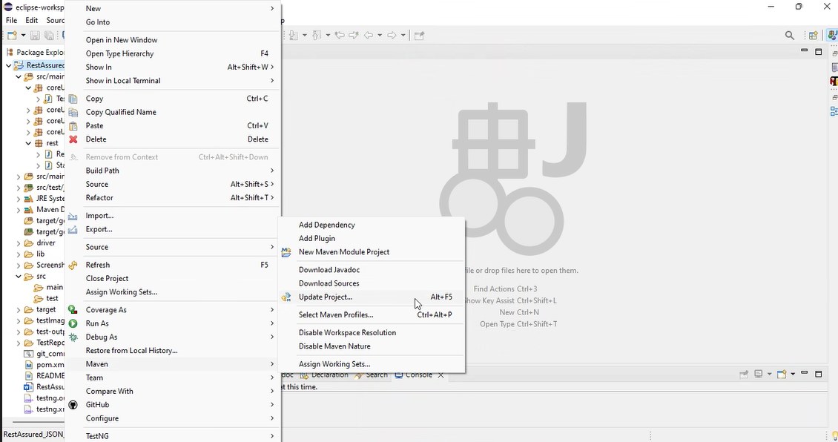

1. In Update Maven Project Box Select “Force Update of Snapshots/Releases” and click OK

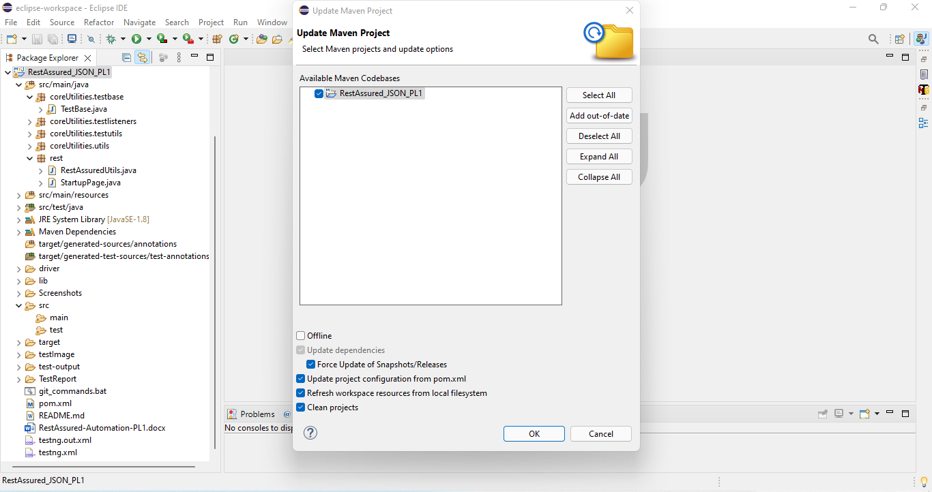

Template Code Structure:

1. Below are the packages and files you will be required to work upon.
2. Other Files and packages you can ignore.
3. In other Files and packages do not do any changes. It would affect your evaluation.
4. You are not required to work in “Test” Folder. Files there are non-editable. Editing those files and trying to save them will throw error and would affect your evaluation.

|  |  |  |
| --- | --- | --- |
| **Package** | **Class/File** | **Description** |
| src/main/java/coreUtilities/utils/ | FileOperations.java | 1. Contains methods to read from excel file. 2. Method is in templated form. 3. **You will be required to implement these methods as very first activity, because for creating post the data should be read from excel.** |
| /src/main/java/rest | RestAssuredUtils.java | 1. All core activities to be performed here. 2. The comments associated with each templated method here describe the expectation. 3. Declare any variable/object you need to share data/status between different methods. 4. Do not modify the signature of methods declared here. 5. You can create additional supportive common methods in CommonEvents class. |
| /src/main/resources/ | Config.xlsx | Data present to be used in creating a new Post. |
| /src/main/java/coreUtilities/utils | CommonEvents.java | 1. Contains all common activities. 2. Certain templated common method declared here. 3. You implement them as per your need. 4. You can add any additional method for common activity here |
|  | Testng.xml | Execution needs to kick started from TestNG xml |

PROBLEM STATEMENT

Need to automate the following activities using RestAssured.

Key Activities to implement:

|  |  |  |  |
| --- | --- | --- | --- |
| **Sl No.** | **Summary** | **Action** | **Expected Result** |
| **1** | Retrieve Comments for a Post and validate the response in method:  getCommentsForPost(int postId) | 1. Call the GET **https://jsonplaceholder.typicode.com**  **/posts/{postId}/comments** endpoint 2. Pass the postId as a parameter  3. Check if the response body contains an array of comments 4. Validate each comment has a postId, id, name, email, and body properties | Returns a 200 OK status with a list of comments related to the specified post.  Response body contains an array of comments with the specified properties |
| **2** | Delete a Post and validate the deletion in method:  deletePost(int id) | 1. Call the DELETE **https://jsonplaceholder.typicode.com**  **/posts/{id}** endpoint. 2. Pass the id of the post to delete. 3. Call GET /posts/{id} to verify the post no longer exists. | Returns a 200 OK status code if the post is successfully deleted. The post should not be found in the subsequent GET request, returning 404 Not Found. |
| **3** | Update an existing post and validate the update in method:  updatePost(int id, String newTitle, String newBody, int userId) | 1. Call the PUT **https://jsonplaceholder.typicode.com**  **/posts/{id}** endpoint. 2. Provide newTitle, newBody, and userId in the request body. 3. Validate the response contains the updated title, body, and userId fields. | Returns a 200 OK status code with the updated post. Response body contains the updated title, body, userId, and id. |
| **4** | Create a new post and validate the creation in method:  addPost(Map<String, String> data) | 1. Call the POST **https://jsonplaceholder.typicode.com**  **/posts** endpoint. 2. Provide title, body, and userId in the request body fetched from passed data arguement (data to be read from the config.xlsx file). 3. Validate the response contains the created post | Returns a 201 Created status code. Response body contains the created title, body, userId, and auto-generated id. |
| **5** | Retrieve a post by ID and validate the response in method:  getPostById(int id) | 1. Call the GET **https://jsonplaceholder.typicode.com**  **/posts/{id}** endpoint. 2. Pass the id of the post to retrieve. 3. Validate the response body contains the correct post details. | Returns a 200 OK status code. Response body contains the correct title, body, userId, and id. |

NOTE: "Please do not delete any file in the src folder.  But you are free to add any other file".

Expectations:

1. **Learners should write automation scripts using Java and REST Assured to automate the API testing for all the provided methods (e.g., GET, POST, PUT, DELETE).** In other words, the automation script should perform all mentioned API interactions, including validation of responses.
2. **Learners should not use any pre-built libraries or tools to validate API responses (e.g., JSON schema validation tools).** They should manually validate the response content (e.g., status codes, response body, etc.) by writing their own logic for assertion.

IMPLEMENTATION/FUNCTIONAL REQUIREMENT

* 1. **CODE QUALITY/OPTIMIZATIONS**
     1. Associates should have written clean code that is readable.
     2. Associates need to follow SOLID programming principles.

# EXECUTION STEPS TO FOLLOW

1. **You are mandatory required to run test cases for applications before final submission. Without which project evaluation will not happen.**
2. **You can launch test cases any time as follows: Right click on testng.xml and run TestNGSuite**

|  |
| --- |
|  |

1. **Before final submission, you are also required to push your code to GIT. Following are the steps to follow:**

|  |
| --- |
|  |

In your project folder, you will find a batch file named git_commands

|  |
| --- |
|  |

Double-click the batch file to run it. It will run the commands to push your code to GIT.

|  |
| --- |
|  |

===============================================================================

All the Best