**System Requirements Specification Index**

**For**

**API FLASK USECASE**

**IIHT Pvt. Ltd.**

**fullstack@iiht.com**

### **Scenario**

* app.py exposes /status (GET) and /submit (POST). Missing or invalid parameters lead to **500 Internal Server Error**.

### **Objective**

* Add **input validation** and friendly error responses (400 Bad Request) so the API never throws unhandled exceptions.
* Sample code is given in the template you need to modify the sample code to pass the testcase

**\*\*To execute the code \*\***

* run the command pip install flask
* After the user has written the correct code in the app.py

Execution Steps to Follow:

● All actions like build, compile, running application, running test cases will be through Command Terminal.

● To open the command terminal the test takers, need to go to Application menu (Three horizontal lines at left top) -> Terminal -> New Terminal

● This editor Auto Saves the code

● If you want to exit(logout) and continue the coding later anytime (using Save & Exit option on Assessment Landing Page) then you need to use CTRL+Shift+B -command compulsorily on code IDE. This will push or save the updated contents in the internal git/repository. Else the code will not be available in the next login.

● These are time bound assessments the timer would stop if you logout and while logging in back using the same credentials the timer would resume from the same time it was stopped from the previous logout.

● To launch application: python3 filename.py

● To run Test cases: python3 -m unittest

● Before Final Submission also, you need to use CTRL+Shift+B - command compulsorily on code IDE, before final submission as well. This will push or save the updated contents in the internal git/repository, and will be used to evaluate the code quality.

Screen shot to run the program

To run the application

Python3 filename.py

To run the testcase python -m unittest

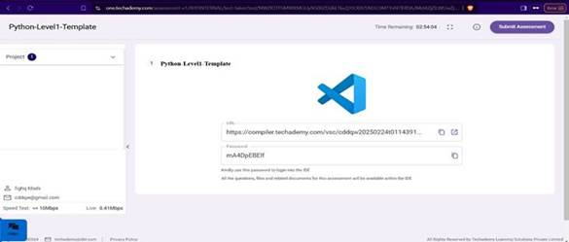

● Once you are done with development and ready with submission, you may navigate to the previous tab and submit the workspace. It is mandatory to click on “Submit Assessment” after you are done with code.