yaksha health app with javascript and

cypress

**Usecase summary**

**Project Name:** healthapp.yaksha app – Medical Record Management System

**Use Case Summary:** healthapp.yaksha is a healthcare application designed to manage Electronic Medical Records (EMR). it allows users to view, search, and manage patient records. It features functionality such as adding/editing patient records, filtering data by doctor and department, and exporting records. The primary use case is to automate the process of medical record management, ensuring efficient and reliable operations for healthcare providers.

**Technology Stack:**

* **Automation Tool:** Cypress (for testing)

**Key Features:**

* **Patient Record Management:** Add, edit, and delete patient records.
* **Filtering and Search:** Search medical records by date range, doctor, department, and more.
* **Export Functionality:** Export records for offline access.

**Expected Outcomes:**

* Automate key healthcare operations like patient record handling, filtering, and validation.
* Ensure the accurate retrieval and modification of medical records, enhancing operational efficiency.

**Overview of the application**

**Pages/Features that are to be focused for the application**

Please use the Application URL <https://healthapp.yaksha.com>

PROBLEM STATEMENT

Need to automate the following activities using cypress+javascript

**You will be given few Json files in Data folder like doctor.json, login.json, maternity.json, medicalRecord.json, patientName.json, pharmacy.json, radiology.json, settings.json and subStore.json.**

|  |  |  |
| --- | --- | --- |
| **Path** | **File** | **Description** |
| e2e\data | doctor.json  login.json  maternity.json  medicalRecord.json  patientName.json  pharmacy.json  radiology.json  settings.json  subStore.json | 1. Contains data to read from json file. |
| PageObjects\Pages | * DoctorsPage * IncentivePage * LoginPage * MaternityPage * MedicalRecordsPage * PharmacyPage * RadiologyPage * SettingsPage * SubStorePage | 1. All core activities to be performed here. 2. The comments associated with each templated method here describe the expectation. 3. Declare any variable/object you need to share data/status between different methods. 4. Do not modify the signature of methods declared here. |

**Here’s a detailed table format for the test cases to be tested**

| **Test Case No.** | **Test Case Name** | **Test Steps to be performed** | **Path & Method Used** | **Expected Result** |
| --- | --- | --- | --- | --- |
|  | Verify Login with Valid Credentials | 1.The application should read the data from login.json file and fetch the user’s name and password.  2. It should call the method performLogin() 3. Perform login method will perform authentication with the username and password.  4. Verify admin name is visible on the home page.  **It is must to implement this login functionality at first and then implement any other test case.** | **Reference path**  \PageObjects\Pages\**LoginPage**  **methods**  performLogin() | Successfully logs in with provided credentials. The user is logged in the admin page. |
| 1 | Handle Alert on Pharmacy Module | 1. Navigate to “Pharmacy” module and select “Order” tab.  2. Click on “Add New Good Receipt” button.  3. Without adding any details, click on “Print Receipt” button.  4. 2 alert boxes should appear with messages as “Please select supplier” and “Please enter Invoice no.”. | **Reference path**  \PageObjects\Pages\**PharmacyPage**  **methods**  handlingAlertOnRadiology() | Handles alerts during the Good Receipt print process, and ensures the modal is visible before performing further actions. |
| 2 | Verify to get the validation message when click on "Print Receipt" without filling any details | 1. Navigate to “Pharmacy” module and select “Order” tab.  2. Click on “Add New Good Receipt” button.  3. Click on “Add New Item” button and fill details like “Item Name”, “Batch no”, “Item Qty” and “Rate” with data read from pharmacy.json file.  4. Add details to “Supplier Name” and “Invoice” as data read data from pharmacy.json file and any 3-digit random number like “777” respectively.  5. Click on “Print Receipt” button.  6. Verify the success message in pop-up at bottom right side as “**Goods Receipt is Generated and Saved.**” | **Reference path**  \PageObjects\Pages\**PharmacyPage**  **methods**  verifyPrintReceipt() | Verify success message popup - "**Goods Receipt is Generated and Saved.**" |
| 3 | Verify to data range by select "Last 3 months" option from drop down | 1. Use verifyDataWithinLastThreeMonths().  2. Navigate to “Radiology” module.  3. Select “List Requests” tab.  4. Click on “-” button (present at left side of “OK” button) and select “Last 3 Months” option.  5. Click “Ok” button. | **Reference path**  \PageObjects\Pages\**RadiologyPage**  **methods**  verifyDataWithinLastThreeMonths() | Data should be present as per the selected date range using dropdown The 'Requested on' column date must fall within the "Last 3 months". |
| 4 | Verify that entering a keyword matching existing records in the search bar returns the corresponding data. | 1. Navigate to “Medical Records” module.  2. Select “MR Outpatient List” tab.  3. Enter data to be read from medicalRecord.json file in “From” field.  4. Click on “Ok” button.  5. Enter gender data to be read from medicalRecord.json file in search field. | **Reference path**  \PageObjects\Pages \**MedicalRecordsPage**  **methods**  keywordMatching() | Data should be present for the search, and the 'Gender' column should contain only patients in the "Female" category. |
| 5 | Verify the presence of "Doctor filter" drop down by selecting "Dr. ALEX OKELLO ONYIEGO" option. | 1. Navigate to “Medical Records” module.  2. Select “MR Outpatient List” tab.  3. Enter from data to be read from medicalRecords.json file in “From” field.  4. Click on “Ok” button.  5. Select doctor name to be read from medicalRecords.json file in doctor filter drop down. | **Reference path**  \PageObjects\Pages \**MedicalRecordsPage**  **methods**  presenceOfDoctorFilter() | Data should be present as per the selected doctor from the dropdown the 'Doctor Name' column only the selected doctor name. |
| 6 | Add and Verify a New Dynamic Template in Settings Module. | 1. Navigate to “Settings” module and select "Dynamic Templates" tab.  2. Click on “Add Template” button. 3. Add template modal opens and fill all the mandatory details like Template Type, Template Name, Template Code to be read from settings.json file. 4. Read TextFiled data from settings.json file to place in text area field. 5. Click on "Add" button. | **Reference path**  \PageObjects\Pages\**SettingsPage**  **methods**  verifyDynamicTemplates() | A success confirmation popup with the message: "**Template Saved.**" should appear, indicating that the template has been added successfully. |
| 7 | Create and Verify Inventory Requisition in Substore Module | 1. Navigate to “Substore” module.  2. Click on the “Account” button and then “Inventory” tab. 3. Click on “Inventory Requisition” tab. 4. Click on “Create Requisition” button. 5. Fill requisition details: 6. Select “Target Inventory” and “Item name” data from substore.json file. 7. Enter required quantity as "1". 8. Click on "Request" button. | **Reference path**  \PageObjects\Pages\**SubstorePage**  **methods**  createInventoryRequisition() | A success confirmation popup with the message: "**Requisition is Generated and Saved**" should appear. |
| 8 | Verify maternity allowance report is visible. | 1. Navigate to “Maternity” module. 2. Click on “Reports” tab. 3. Click on “MaternityAllowance” button. 4. Enter date in “From”’ field to be read from maternity.json file and click on "Show Report" button. | **Reference path**  \PageObjects\Pages\**MaternityPage**  **methods**  verifyMaternityAllowanceReport() | Report should be visible when click on show more button. |
| 9 | Verify imaging and lab order add successfully. | 1. Navigate to the “Doctor” module and then “In Patient Department” tab. 2. Click on the search bar and search patient with filed name as patientName read from doctor.json file. 3. Click on “Imaging” icon under the action column. 4. Select “imaging” option from drop down in “New Order” section. 5. Select searchOrderItem data read from doctor.json file in the search order item. 6. Click on “Proceed” button. 7. Click on “Sign” button. | **Reference path**  \PageObjects\Pages\**DoctorPage**  **methods**  performInpatientImagingOrder() | A success confirmation popup with the message: "**Imaging and lab order add successfully**" should appear. |
| 10 | Verify to filter the records by select "X-RAY" from Filter drop down. | 1. Navigate to “Radiology” module.  2. Read “filter” data from radiology.json file and select that option from “Filter” drop down.  3. Read “from” and “to” data from radiology.json file and put in "From" and add “To” fields.  4. Click on "Ok" button. | **Reference path**  \PageObjects\Pages\**RadiologyPage**  **methods**  filterListRequestsByDateAndType() | Record should filter out as per status. |
| 11 | Verify and creating the "Consumption" section of the "Inventory" module | 1. Navigate to “Substore” module.  2. Click on the “Account” button and then “Inventory” tab. 3. Click on “Consumption” sub-tab.  4. Click on “New Consumption” button.  5. Read the itemName from substore.json file and add it in ItemName field.  6. Click on “Save” button. | **Reference path**  \PageObjects\Pages\**SubstorePage**  **methods**  creatingConsumptionSection() | Upon clicking the "Save" button, a success message saying "Consumption completed" should be displayed, and the data should be accurately reflected in the record. |
| 12 | Verify and creating the "Reports" section of the "Inventory" module | 1. Navigate to “Substore” module.  2. Click on “Accounts” button. 3. Select “Reports” sub section inside “Inventory” tab.  4. Click on “Consumption Report” button.  5. Enter itemName data which to be read from substore.json file and put it in “Search” field. | **Reference path**  \PageObjects\Pages\**SubstorePage**  **methods**  creatingReportSection() | After generating the report, the function verifies if the selected item name is displayed in the report grid |
| 13 | Verify and check the presence of supplier name on table. | 1. Navigate to “Pharmacy” module.  2. Click on “Order” tab. 3. Read the supplier’s name from pharmacy.json file and put it in SupplierName field.  4. Click on show details button. 4. Verify the supplier’s name with the table data. | **Reference path**  \PageObjects\Pages\**PharmacyPage**  **methods**  verifypresenceOfSupplierName() | The expected result is that written supplier’s name should appear in the table after clicking "Show Details." |
| 14 | Verify logout functionality from Admin dropdown | 1. Navigate to index page i.e  [https://healthapp.yaksha.com/Home/Index#/](https://healthapp.yaksha.com/Home/Index#/Appointment/ListAppointment)  2. Click on the “Admin” dropdown 3. Click on “Log Out” option. 4. Verify the user is redirected to the login page. | **Reference path**  \PageObjects\Pages\**LoginPage**  **methods**  verifyLogoutFunctionality() | User is logged out successfully and the login page is displayed. |

Learners will gain experience in building strongly-typed applications using React.js and managing data flow with **JavaScript**. They'll learn how to define interfaces, use types for error prevention, and improve code maintainability.

With **Cypress**, learners will learn to write and execute automated tests for the <https://healthapp.yaksha.com>

  app. Key skills include:

* **Browser Automation**: Interacting with web elements and testing multiple browsers.
* **Assertions & Validations**: Ensuring app behaviour meets expected results.
* **End-to-End Testing**: Automating real user interactions and validating overall app functionality.

IMPLEMENTATION/FUNCTIONAL REQUIREMENT

* 1. **CODE QUALITY/OPTIMIZATIONS**
     1. Associates should have written clean code that is readable.
     2. Associates need to follow SOLID programming principles.

**Execution Steps:**

**Steps for Execution:**

1. **Please open the folder created on desktop with the email name you used to login.**

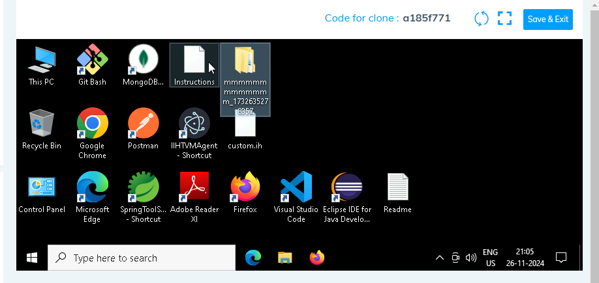

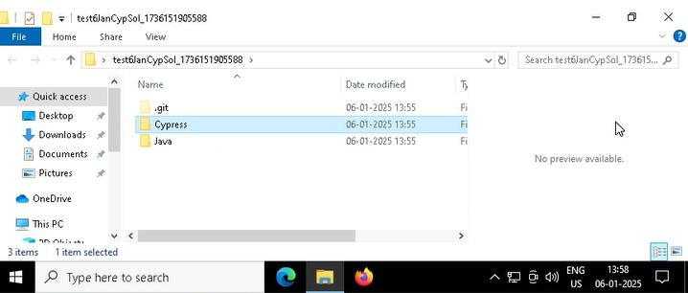

1. **Go into the Cypress folder**
2. 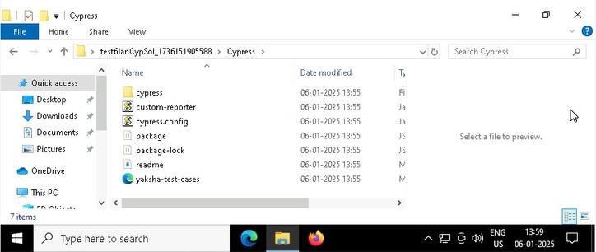
3. **Open command prompt with its location and use below command:**

**code .**

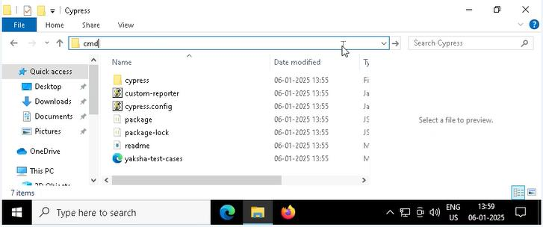

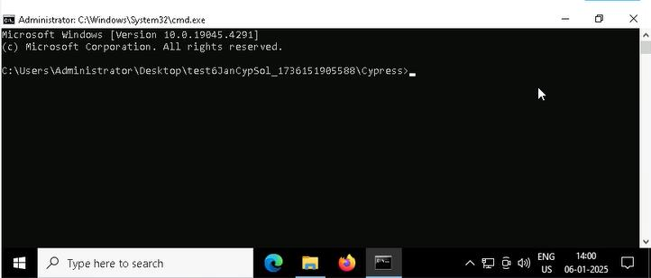



1. **Once VsCode is open. Please open the terminal in Cypress folder:**
2. 
3. **Install all dependencies in the Cypress folder path using:**

**npm install**

1. **Run the following command to open the interactive Cypress Test Runner in the Cypress folder path:**

**npx cypress open**

1. **Run the following command to run test cases in headless mode in the Cypress folder path:**

**npx cypress run**

There is total 15 test cases.

1. **Once you have executed the test cases. Now it is necessary to push your code to git. For this, please go inside the folder created on desktop with the email id you have used to login and then:**
   1. **Open gitbash**

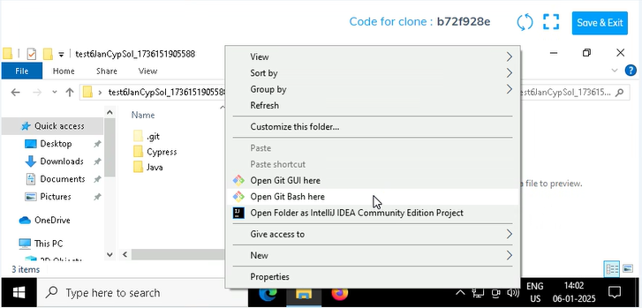

* 1. **Add all files**

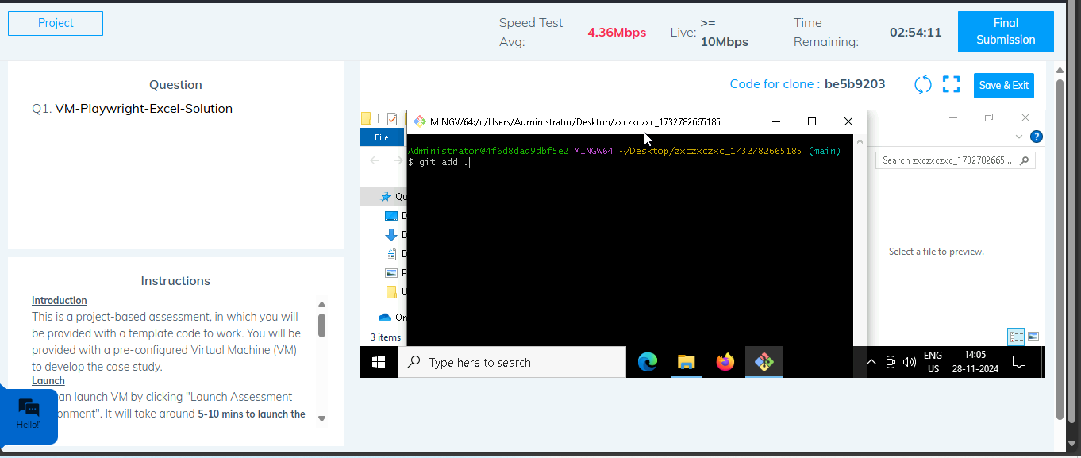

* 1. **Commit the changes**

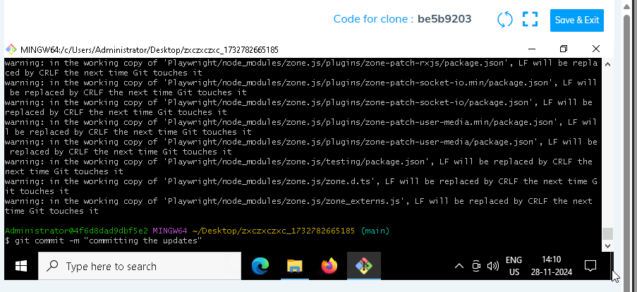

* 1. **Push the changes**

