RestAssured API Automation Project

Pre-requisite:

As soon as you import a project in eclipse, update the project using the maven update option as below. This is to resolve issue if any maven dependency not downloaded properly:

1. Right click on project : Go to “Maven” : Select “Update Project”

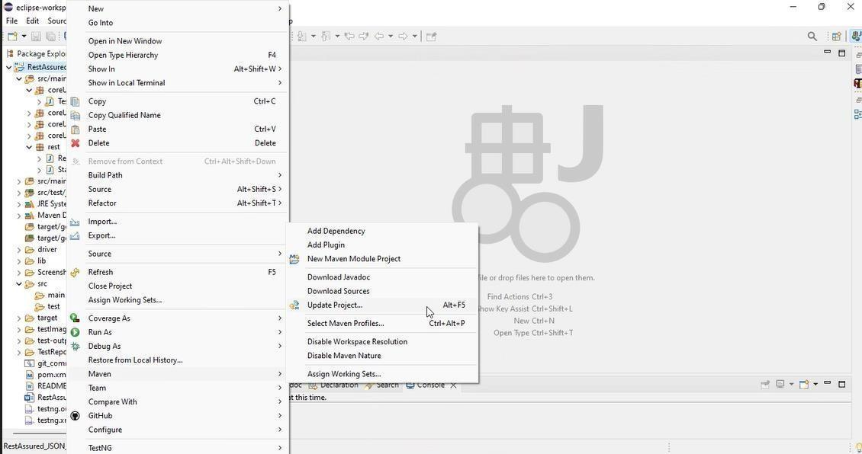

1. In Update Maven Project Box Select “Force Update of Snapshots/Releases” and click OK

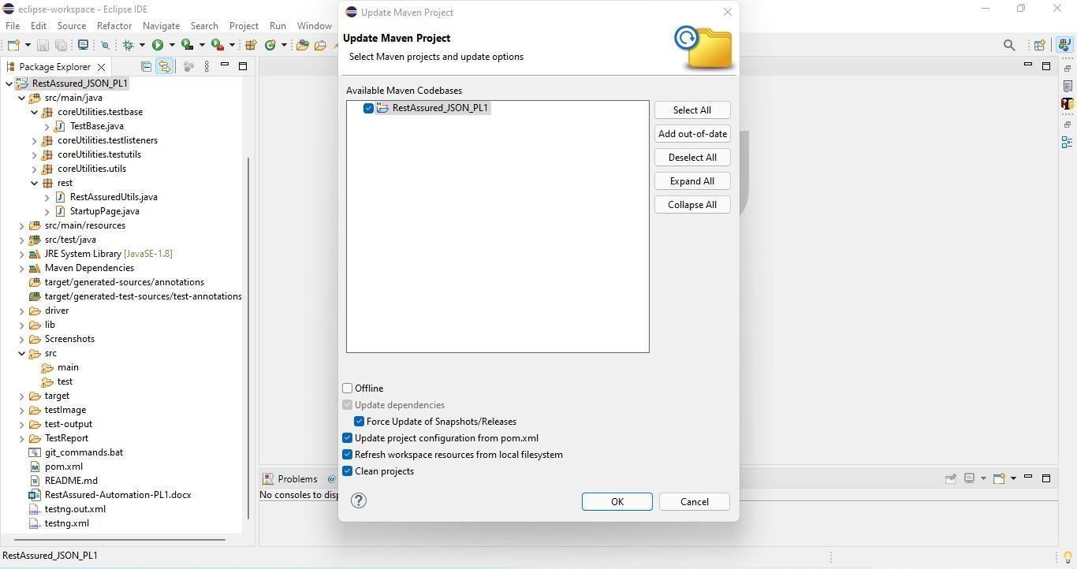

Template Code Structure:

1. Below are the packages and files you will be required to work upon.
2. Other Files and packages you can ignore.
3. In other Files and packages do not do any changes. It would affect your evaluation.
4. You are not required to work in “Test” Folder. Files there are non- editable. Editing those files and trying to save them will throw error and would affect your evaluation.

| **Package** | **Class/File** | **Description** |
| --- | --- | --- |
| src/main/java/coreUtilities/utils/ | FileOperations.java | 1. Contains methods to read from excel file. 2. Method is in templated form. 3. **You will be required to implement these methods as very first activity, because for creating post the data**   **should be read from excel.** |
| /src/main/java/rest | ApiUtil.java | 1. All core activities to be performed here. 2. The comments associated with each templated method here describe the expectation. 3. Declare any variable/object you need to share data/status between different methods. 4. Do not modify the signature of methods declared here. 5. You can create additional supportive common methods in   CommonEvents class. |
| /src/main/java/rest | AuthUtil.java | 1. Class already defined to read and return bearer   token from |

|  |  | config.properties file. |
| --- | --- | --- |
| /src/main/java/rest | CustomResponse | We have already created custom response object class. You need to use this and use it as return type from ApiUtil.java class methods. |
| /src/main/resources/ | Config.xlsx | Data present to be used in Implementing functions. |
| /src/main/java/coreUtilities/utils | CommonEvents.java | 1. Contains all common activities. 2. Certain templated common methods declared here. 3. You implement them as per your need. 4. You can add any additional   method for common activity here |
|  | Testng.xml | Execution needs to kick started from TestNG xml |

PROBLEM STATEMENT

Need to automate the following activities using RestAssured.

# Key Activities to implement:

Below activities need to be implemented in the ApiUtil.java file present in src/main/java/rest package.

| **Sl No.** | **Summary** | **Action** | **Expected Result** |
| --- | --- | --- | --- |
| **1** | Retrieve list of stocks in Method:  getAllStocks(String endpoint, Object body) | 1. Create an URL by combining the BASE_URL (already declared) and path parameter(provided as an argument in method). The final URL becomes: **https://healthapp.yaksha.com/api/PharmacyStock/AllStockDetails.** 2. Include a bearer token for authentication in authorization header. 3. Trigger a GET call to the specified endpoint. 4. Create an object of type CustomResponse and initialize it with values extracted from the Response object:  * Response * statusCode (extracted from Response object) * Results (extracted from Response object) * Status (extracted from Response object)  1. Return the CustomResponse object from the method. | - Returns an object of type CustomResponse containing statusCode, status, Results list, and the complete Response object.  - StatusCode should be 200.  - Status should be OK.  - Results should not be null and should not be empty. |
| **2** | Retrieve main store details in Method:  getMainStore(String endpoint, Object body) | 1. Create an URL by combining the BASE_URL (already declared) and path parameter(provided as an argument in method). The final URL becomes: **https://healthapp.yaksha.com/api/PharmacySettings/MainStore** 2. Include a bearer token for authentication in authorization header. 3. Trigger a GET call to the specified endpoint. 4. Create an object of type CustomResponse and initialize it with values extracted from the Response object:  * Response * statusCode (extracted from Response object) * Results (extracted from Response object) * Status (extracted from Response object)  1. Return the CustomResponse object from the method. | - Returns an object of type CustomResponse containing statusCode, status, Results map, and the complete Response object.  - StatusCode should be 200.  - Status should be OK.  - Results should not be null. |
| **3** | Get Requisition List by Date Range in Method:  getRequisitionByDateRange(String endpoint, Object body) | 1. Create an URL by combining the BASE_URL (already declared) and path parameter(provided as an argument in method). The final URL becomes: **https://healthapp.yaksha.com/api/DispensaryRequisition/Dispensary/1?FromDate=" + fromDate + "&To** 2. Include a bearer token for authentication in authorization header. 3. Trigger a GET call to the specified endpoint. 4. Create an object of type CustomResponse and initialize it with values extracted from the Response object:  * Response * statusCode (extracted from Response object) * Results (extracted from Response object) * Status (extracted from Response object)  1. Return the CustomResponse object from the method. | - Returns an object of type CustomResponse containing statusCode, status, Results.requisitionList, and the complete Response object  - StatusCode should be 200.  - Status should be OK.  - Requisition list should not be empty.  - Requisition IDs should be unique.  - Results should have non-null values for RequistionNo and RequisitionStatus. |
| **4** | Get Patient Consumptions List in Method:  getPatientConsumptions(String endpoint, Object body) | 1. Create an URL by combining the BASE_URL (already declared) and path parameter(provided as an argument in method). The final URL becomes: **https://healthapp.yaksha.com/api/PatientConsumption/PatientConsumptions** 2. Include a bearer token for authentication in authorization header. 3. Trigger a GET call to the specified endpoint. 4. Create an object of type CustomResponse and initialize it with values extracted from the Response object:  * Response * statusCode (extracted from Response object) * Results (extracted from Response object) * Status (extracted from Response object)  1. Return the CustomResponse object from the method. | - Returns an object of type CustomResponse containing statusCode, status, Results list, and the complete Response object.  - StatusCode should be 200.  - Status should be OK.  - Results should not be empty. |
| **5** | Retrieve patient consumption info in Method:  getPatientConsumptionInfoByPatientIdAndVisitId(String endpoint, Object body) | 1. Create an URL by combining the BASE_URL (already declared) and path parameter(provided as an argument in method). The final URL becomes: **https://healthapp.yaksha.com/api/PatientConsumption/PatientConsumptionInfo?PatientId=114&patientVisitId=53"** 2. Include a bearer token for authentication in authorization header. 3. Trigger a GET call to the specified endpoint. 4. Create an object of type CustomResponse and initialize it with values extracted from the Response object:  * Response * statusCode (extracted from Response object) * Results (extracted from Response object) * Status (extracted from Response object)  1. Return the CustomResponse object from the method. | - Returns an object of type CustomResponse containing statusCode, status, Results map, and the complete Response object.  - StatusCode should be 200.  - Status should be OK. |
| **6** | Retrieve Billing Scheme by Scheme ID in Method:  getBillingSchemeBySchemeId(String endpoint, Object body) | 1. Create an URL by combining the BASE_URL (already declared) and path parameter(provided as an argument in method). The final URL becomes: **https://healthapp.yaksha.com/api/PatientConsumption/PharmacyIpBillingScheme?schemeId=" + schemeId** 2. Include a bearer token for authentication in authorization header. 3. Trigger a GET call to the specified endpoint. 4. Create an object of type CustomResponse and initialize it with values extracted from the Response object:  * Response * statusCode (extracted from Response object) * Results (extracted from Response object) * Status (extracted from Response object)  1. Return the CustomResponse object from the method. | - Returns an object of type CustomResponse containing statusCode, status, Results map, and the complete Response object.  - StatusCode should be 200.  - Status should be OK. |
| **7** | Retrieve Billing Summary By Patient ID in Method:  getBillingSummaryByPatientId(String endpoint, Object body) | 1. Create an URL by combining the BASE_URL (already declared) and path parameter(provided as an argument in method). The final URL becomes: **https://healthapp.yaksha.com/api/PharmacySales/PatientBillingSummary?patientId=" + patientId** 2. Include a bearer token for authentication in authorization header. 3. Trigger a GET call to the specified endpoint. 4. Create an object of type CustomResponse and initialize it with values extracted from the Response object:  * Response * statusCode (extracted from Response object) * Results (extracted from Response object) * Status (extracted from Response object)  1. Return the CustomResponse object from the method. | - Returns an object of type CustomResponse containing statusCode, status, Results map, and the complete Response object.  - StatusCode should be 200.  - Status should be OK. |
| **8** | Retrieve Consumptions List of a Patient By ID in Method:  getConsumptionsListOfAPatientById(String endpoint, Object body) | 1. Create an URL by combining the BASE_URL (already declared) and path parameter(provided as an argument in method). The final URL becomes: **https://healthapp.yaksha.com/api/PatientConsumption/ConsumptionsOfPatient?patientId=" + patientId + "&patientVisitId=" + patientVisitId** 2. Include a bearer token for authentication in authorization header. 3. Trigger a GET call to the specified endpoint. 4. Create an object of type CustomResponse and initialize it with values extracted from the Response object:  * Response * statusCode (extracted from Response object) * Results (extracted from Response object) * Status (extracted from Response object)  1. Return the CustomResponse object from the method. | - Returns an object of type CustomResponse containing statusCode, status, Results list, and the complete Response object.  - StatusCode should be 200.  - Status should be OK.  - Results should have non-null values for TotalAmount.  - PatientConsumptionId values should be unique. |
| **9** | Retrieve Return Consumptions List in Method:  getReturnConsumptionsList(String endpoint, Object body) | 1. Create an URL by combining the BASE_URL (already declared) and path parameter(provided as an argument in method). The final URL becomes: **https://healthapp.yaksha.com/api/PatientConsumption/Returns** 2. Include a bearer token for authentication in authorization header. 3. Trigger a GET call to the specified endpoint. 4. Create an object of type CustomResponse and initialize it with values extracted from the Response object:  * Response * statusCode (extracted from Response object) * Results (extracted from Response object) * Status (extracted from Response object)  1. Return the CustomResponse object from the method. | - Returns an object of type CustomResponse containing statusCode, status, Results list, and the complete Response object.  - StatusCode should be 200.  - Status should be OK.  - Results should have non-null values for ConsumptionReturnReceiptNo and PatientId.  - ConsumptionReturnReceiptNo values should be unique. |
| **10** | Retrieve Discharged Patients List in Method:  getDischargedPatients(String endpoint, Object body) | 1. Create an URL by combining the BASE_URL (already declared) and path parameter(provided as an argument in method). The final URL becomes: **https://healthapp.yaksha.com/api/Admission/DischargedPatients?admissionStatus=discharged&FromDate=" + fromDate + "&ToDate=" + toDate** 2. Include a bearer token for authentication in authorization header. 3. Trigger a GET call to the specified endpoint. 4. Create an object of type CustomResponse and initialize it with values extracted from the Response object:  * Response * statusCode (extracted from Response object) * Results (extracted from Response object) * Status (extracted from Response object)  1. Return the CustomResponse object from the method. | - Returns an object of type CustomResponse containing statusCode, status, Results list, and the complete Response object.  - StatusCode should be 200.  - Status should be OK.  - Results should have non-null values for PatientVisitId, PatientAdmissionId, and PatientId.  - PatientVisitId and PatientAdmissionId values should be unique. |
| **11** | Retrieve Admitted Patients List in Method:  getAdmittedPatients(String endpoint, Object body) | 1. Create an URL by combining the BASE_URL (already declared) and path parameter(provided as an argument in method). The final URL becomes: **https://healthapp.yaksha.com/api/IpBilling/AdmittedPatients** 2. Include a bearer token for authentication in authorization header. 3. Trigger a GET call to the specified endpoint. 4. Create an object of type CustomResponse and initialize it with values extracted from the Response object:  * Response * statusCode (extracted from Response object) * Results (extracted from Response object) * Status (extracted from Response object)  1. Return the CustomResponse object from the method. | - Returns an object of type CustomResponse containing statusCode, status, Results list, and the complete Response object.  - StatusCode should be 200.  - Status should be OK.  - Results should have non-null values for PatientId and VisitId.  - DischargeDate should be null for admitted patients.  - PatientId and VisitId values should be unique. |
| **12** | Retrieve IPD Patients By Patient ID in Method:  searchIpdPatientByPatientId(String endpoint, Object body) | 1. Create an URL by combining the BASE_URL (already declared) and path parameter(provided as an argument in method). The final URL becomes: **https://healthapp.yaksha.com/api/Patient/IPDPatientSearch?search=" + patientName** 2. Include a bearer token for authentication in authorization header. 3. Trigger a GET call to the specified endpoint. 4. Create an object of type CustomResponse and initialize it with values extracted from the Response object:  * Response * statusCode (extracted from Response object) * Results (extracted from Response object) * Status (extracted from Response object)  1. Return the CustomResponse object from the method. | - Returns an object of type CustomResponse containing statusCode, status, Results list, and the complete Response object.  - StatusCode should be 200.  - Status should be OK. |
| **13** | Retrieve Patients' Provisional Information in Method:  getPatientProvisionalInfo(String endpoint, Object body) | 1. Create an URL by combining the BASE_URL (already declared) and path parameter(provided as an argument in method). The final URL becomes: **https://healthapp.yaksha.com/api/Billing/PatientsProvisionalInfo** 2. Include a bearer token for authentication in authorization header. 3. Trigger a GET call to the specified endpoint. 4. Create an object of type CustomResponse and initialize it with values extracted from the Response object:  * Response * statusCode (extracted from Response object) * Results (extracted from Response object) * Status (extracted from Response object)  1. Return the CustomResponse object from the method. | - Returns an object of type CustomResponse containing statusCode, status, Results list, and the complete Response object.  - StatusCode should be 200.  - Status should be OK. |
| **14** | Retrieve Provisional Items List for a specific Patient ID and Scheme ID in Method:  getProvisionalItemsListByPatientIdAndSchemeId(String endpoint, Object body) | 1. Create an URL by combining the BASE_URL (already declared) and path parameter(provided as an argument in method). The final URL becomes: **https://healthapp.yaksha.com/api/Billing/ProvisionalItemsByPatientId?patientId=" + patientId + "&schemeId=" + schemeId** 2. Include a bearer token for authentication in authorization header. 3. Trigger a GET call to the specified endpoint. 4. Create an object of type CustomResponse and initialize it with values extracted from the Response object:  * Response * statusCode (extracted from Response object) * Results (extracted from Response object) * Status (extracted from Response object)  1. Return the CustomResponse object from the method. | - Returns an object of type CustomResponse containing statusCode, status, Results.ProvisionalItems, and the complete Response object.  - StatusCode should be 200.  - Status should be OK.  - ProvisionalItems list should not be null and should not be empty.  - PatientId in ProvisionalItems should match the requested PatientId. |
| **15** | Retrieve Billing Invoices By Date Range in Method:  getInvoicesByDateRange(String endpoint, Object body) | 1. Create an URL by combining the BASE_URL (already declared) and path parameter(provided as an argument in method). The final URL becomes: **https://healthapp.yaksha.com/api/Billing/Invoices?FromDate=" + fromDate + "&ToDate=" + toDate** 2. Include a bearer token for authentication in authorization header. 3. Trigger a GET call to the specified endpoint. 4. Create an object of type CustomResponse and initialize it with values extracted from the Response object:  * Response * statusCode (extracted from Response object) * Results (extracted from Response object) * Status (extracted from Response object)  1. Return the CustomResponse object from the method. | - Returns an object of type CustomResponse containing statusCode, status, Results list, and the complete Response object.  - StatusCode should be 200.  - Status should be OK.  - Results should not be null and should contain valid InvoiceNumber and InvoiceCode.  - Results list should not be null and should contain at least one invoice. |
| **16** | Retrieve Provider List in Method:  getProviderList(String endpoint, Object body) | 1. Create an URL by combining the BASE_URL (already declared) and path parameter(provided as an argument in method). The final URL becomes: **https://healthapp.yaksha.com/api/Billing/GetProviderList** 2. Include a bearer token for authentication in authorization header. 3. Trigger a GET call to the specified endpoint. 4. Create an object of type CustomResponse and initialize it with values extracted from the Response object:  * Response * statusCode (extracted from Response object) * Results (extracted from Response object) * Status (extracted from Response object)  1. Return the CustomResponse object from the method. | - Returns an object of type CustomResponse containing statusCode, status, Results list, and the complete Response object.  - StatusCode should be 200.  - Status should be OK.  - Results should have non-null values for EmployeeId and EmployeeName.  - Results list should not be null and should contain at least one provider. |
| **17** | Retrieve Users List in Method:  getUserslist(String endpoint, Object body) | 1. Create an URL by combining the BASE_URL (already declared) and path parameter(provided as an argument in method). The final URL becomes: **https://healthapp.yaksha.com/api/Billing/ListUsers** 2. Include a bearer token for authentication in authorization header. 3. Trigger a GET call to the specified endpoint. 4. Create an object of type CustomResponse and initialize it with values extracted from the Response object:  * Response * statusCode (extracted from Response object) * Results (extracted from Response object) * Status (extracted from Response object)  1. Return the CustomResponse object from the method. | - Returns an object of type CustomResponse containing statusCode, status, Results list, and the complete Response object.  - StatusCode should be 200.  - Status should be OK.  - Results should have non-null values for UserId, ShortName, and DepartmentName.  - UserId should be unique.  - Results list should not be null and should contain at least one user. |
| **18** | Retrieve Current Fiscal Year Details in Method:  getCurrentFiscalYearDetails(String endpoint, Object body) | 1. Create an URL by combining the BASE_URL (already declared) and path parameter(provided as an argument in method). The final URL becomes: **https://healthapp.yaksha.com/api/Billing/CurrentFiscalYear** 2. Include a bearer token for authentication in authorization header. 3. Trigger a GET call to the specified endpoint. 4. Create an object of type CustomResponse and initialize it with values extracted from the Response object:  * Response * statusCode (extracted from Response object) * Results (extracted from Response object) * Status (extracted from Response object)  1. Return the CustomResponse object from the method. | - Returns an object of type CustomResponse containing statusCode, status, Results map, and the complete Response object.  - StatusCode should be 200.  - Status should be OK.  - Results should not be null. |

NOTE: "Please do not delete any file in the src folder. But you are free to add any other file".

Expectations:

* 1. **Learners should write automation scripts using Java and REST Assured to automate the API testing for all the provided methods (e.g., GET, POST, PUT, DELETE).** In other words, the automation script should perform all mentioned API interactions, including validation of responses.
  2. **Learners should not use any pre-built libraries or tools to validate API responses (e.g., JSON schema validation tools).** They should manually validate the response content (e.g., status codes, response body, etc.) by writing their own logic for assertion.

IMPLEMENTATION/FUNCTIONAL REQUIREMENT

* 1. **Code Quality/Optimizations**
     1. Associates should have written clean code that is readable.
     2. Associates need to follow SOLID programming principles.

# Execution Steps to Follow

1. **You are mandatorily required to run test cases for applications before final submission. Without which project evaluation will not happen.**
2. **You can launch test cases any time as follows: Right click on testng.xml and run TestNGSuite**



1. **Before final submission, you are also required to push your code to GIT. Following are the steps to follow:**

In your project folder, you will find a batch file named git_commands



Double-click the batch file to run it. It will run the commands to push your code to GIT.



===============================================================================

All the Best