RestAssured API Automation Project

Pre-requisite:

As soon as you import a project in eclipse, update the project using the maven update option as below. This is to resolve issue if any maven dependency not downloaded properly:

1. Right click on project : Go to “Maven” : Select “Update Project”

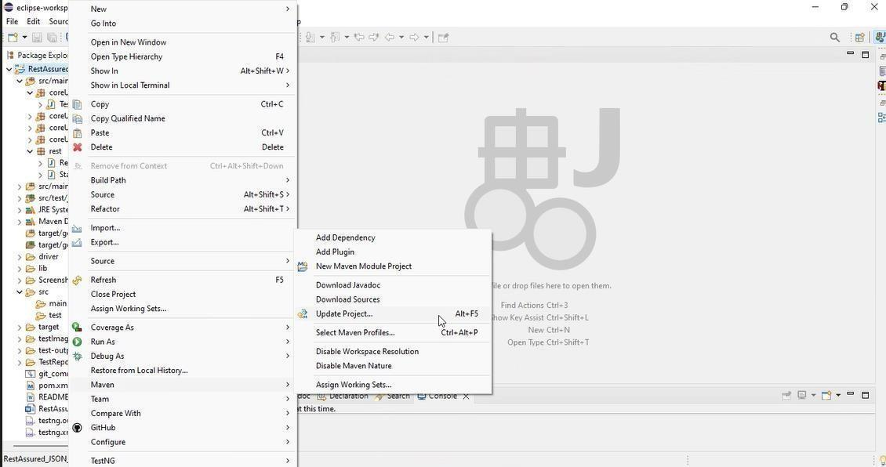

1. In Update Maven Project Box Select “Force Update of Snapshots/Releases” and click OK

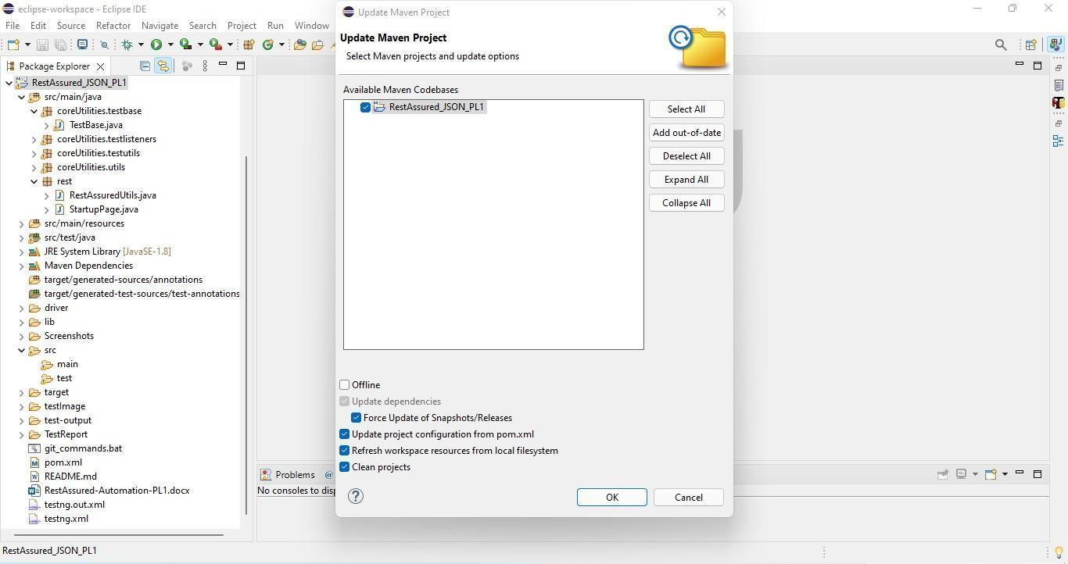

Template Code Structure:

1. Below are the packages and files you will be required to work upon.
2. Other Files and packages you can ignore.
3. In other Files and packages do not do any changes. It would affect your evaluation.
4. You are not required to work in “Test” Folder. Files there are non- editable. Editing those files and trying to save them will throw error and would affect your evaluation.

|  |  |  |
| --- | --- | --- |
| **Package** | **Class/File** | **Description** |
| src/main/java/coreUtilities/utils/ | FileOperations.java | 1. Contains methods to read from excel file. 2. Method is in templated form. 3. **You will be required to implement these methods as very first activity, because for creating post the data**   **should be read from excel.** |
| /src/main/java/rest | ApiUtil.java | 1. All core activities to be performed here. 2. The comments associated with each templated method here describe the expectation. 3. Declare any variable/object you need to share data/status between different methods. 4. Do not modify the signature of methods declared here. 5. You can create additional supportive common methods in   CommonEvents class. |
| /src/main/java/rest | AuthUtil.java | 1. Class already defined to read and return bearer   token from |

|  |  |  |
| --- | --- | --- |
|  |  | config.properties file. |
| /src/main/java/rest | CustomResponse | We have already created custom response object class. You need to use this and use it as return type from ApiUtil.java class methods. |
| /src/main/resources/ | Config.xlsx | Data present to be used in Implementing functions. |
| /src/main/java/coreUtilities/utils | CommonEvents.java | 1. Contains all common activities. 2. Certain templated common methods declared here. 3. You implement them as per your need. 4. You can add any additional   method for common activity here |
|  | Testng.xml | Execution needs to kick started from TestNG xml |

PROBLEM STATEMENT

Need to automate the following activities using RestAssured.

# Key Activities to implement:

Below activities need to be implemented in the ApiUtil.java file present in src/main/java/rest package.

|  |  |  |  |
| --- | --- | --- | --- |
| **Sl No.** | **Summary** | **Action** | **Expected Result** |
| **1** | Retrieve list of stocks in Method:  getAllStocks(String endpoint, Object body) | 1. Create an URL by combining the BASE_URL (already declared) and path parameter (provided as an argument in method). The final URL becomes: **https://healthapp.yaksha.com/api/PharmacyStock/AllStockDetails.** 2. Include a bearer token for authentication in authorization header. 3. Trigger a GET call to the specified endpoint. 4. Create an object of type CustomResponse and initialize it with values extracted from the Response object:  * Response * statusCode (extracted from Response object) * Status (extracted from Response object) * ItemId list (extracted from Response object) * ItemName list (extracted from Response object) * GenericName list (extracted from Response object)  1. Return the CustomResponse object from the method. | - Returns an object of type CustomResponse containing statusCode, status, ItemId list, ItemName list, GenericName list and the complete Response object.  - StatusCode should be 200.  - Status should be OK.  - ItemId, ItemName and GenericName should not be null and should not be empty. |
| **2** | Retrieve main store details in Method:  getMainStore(String endpoint, Object body) | 1. Create an URL by combining the BASE_URL (already declared) and path parameter (provided as an argument in method). The final URL becomes: **https://healthapp.yaksha.com/api/PharmacySettings/MainStore** 2. Include a bearer token for authentication in authorization header. 3. Trigger a GET call to the specified endpoint. 4. Create an object of type CustomResponse and initialize it with values extracted from the Response object:  * Response * statusCode (extracted from Response object) * Status (extracted from Response object) * StoreId object (extracted from Response object) * Category object (extracted from Response object) * IsActive object (extracted from Response object)  1. Return the CustomResponse object from the method. | - Returns an object of type CustomResponse containing statusCode, status, StoreId, Category, IsActive, and the complete Response object.  - StatusCode should be 200.  - Status should be OK.  - StoreId, Category and IsActive should not be null. |
| **3** | Get Requisition List by Date Range in Method:  getRequisitionByDateRange(String endpoint, Object body) | 1. Create an URL by combining the BASE_URL (already declared) and path parameter (provided as an argument in method). The final URL becomes: **https://healthapp.yaksha.com/api/DispensaryRequisition/Dispensary/1?FromDate=" + fromDate + "&To** 2. Include a bearer token for authentication in authorization header. 3. Trigger a GET call to the specified endpoint. 4. Create an object of type CustomResponse and initialize it with values extracted from the Response object:  * Response * statusCode (extracted from Response object) * RequistionNo list (extracted from Response object) * RequisitionStatus list (extracted from Response object) * RequisitionId list (extracted from Response object) * Status (extracted from Response object)  1. Return the CustomResponse object from the method. | - Returns an object of type CustomResponse containing statusCode, status, RequistionNo list, RequisitionStatus list, RequisitionId list and the complete Response object  - StatusCode should be 200.  - Status should be OK.   * RequisitionNo, RequisitionStatus and RequisitionId lists should not be empty. * RequisitionNo, RequisitionStatus and RequisitionId lists should have non-null values. |
| **4** | Get Patient Consumptions List in Method:  getPatientConsumptions(String endpoint, Object body) | 1. Create an URL by combining the BASE_URL (already declared) and path parameter (provided as an argument in method). The final URL becomes: **https://healthapp.yaksha.com/api/PatientConsumption/PatientConsumptions** 2. Include a bearer token for authentication in authorization header. 3. Trigger a GET call to the specified endpoint. 4. Create an object of type CustomResponse and initialize it with values extracted from the Response object:  * Response * statusCode (extracted from Response object) * PatientId list (extracted from Response object) * HospitalNo list (extracted from Response object) * PatientVisitId list (extracted from Response object) * Status (extracted from Response object)  1. Return the CustomResponse object from the method. | - Returns an object of type CustomResponse containing statusCode, status, PatientId list, HospitalNo list, PatientVisitId list and the complete Response object  - StatusCode should be 200.  - Status should be OK.   * PatientId, HospitalNo and PatientVisitId lists should not be empty.   PatientId, HospitalNo and PatientVisitId lists should have non-null values. |
| **5** | Retrieve patient consumption info in Method:  getPatientConsumptionInfoByPatientIdAndVisitId(String endpoint, Object body) | 1. Create an URL by combining the BASE_URL (already declared) and path parameter (provided as an argument in method). The final URL becomes: **https://healthapp.yaksha.com/api/PatientConsumption/PatientConsumptionInfo?PatientId=114&patientVisitId=53"** 2. Include a bearer token for authentication in authorization header. 3. Trigger a GET call to the specified endpoint. 4. Create an object of type CustomResponse and initialize it with values extracted from the Response object:  * Response * statusCode (extracted from Response object) * PatientName object (extracted from Response object) * HospitalNo object (extracted from Response object) * StoreId object (extracted from Response object) * Status (extracted from Response object)  1. Return the CustomResponse object from the method. | - Returns an object of type CustomResponse containing statusCode, status, PatientName, HospitalNo, StoreId, and the complete Response object.  - StatusCode should be 200.  - Status should be OK.  - PatientName object, HospitalNo object and StoreId object should not be null. |
| **6** | Retrieve Billing Scheme by Scheme ID in Method:  getBillingSchemeBySchemeId(String endpoint, Object body) | 1. Create an URL by combining the BASE_URL (already declared) and path parameter (provided as an argument in method). The final URL becomes: **https://healthapp.yaksha.com/api/PatientConsumption/PharmacyIpBillingScheme?schemeId=" + schemeId** 2. Include a bearer token for authentication in authorization header. 3. Trigger a GET call to the specified endpoint. 4. Create an object of type CustomResponse and initialize it with values extracted from the Response object:  * Response * statusCode (extracted from Response object) * SchemeCode object (extracted from Response object) * SchemeName object (extracted from Response object) * SchemeId object (extracted from Response object) * Status (extracted from Response object)  1. Return the CustomResponse object from the method. | - Returns an object of type CustomResponse containing statusCode, status, SchemeCode object, SchemeName object, SchemeId object, and the complete Response object.  - StatusCode should be 200.  - Status should be OK.   * SchemeCode object, SchemeName object and SchemeId object should not be null. |
| **7** | Retrieve Billing Summary by Patient ID in Method:  getBillingSummaryByPatientId(String endpoint, Object body) | 1. Create an URL by combining the BASE_URL (already declared) and path parameter (provided as an argument in method). The final URL becomes: **https://healthapp.yaksha.com/api/PharmacySales/PatientBillingSummary?patientId=" + patientId** 2. Include a bearer token for authentication in authorization header. 3. Trigger a GET call to the specified endpoint. 4. Create an object of type CustomResponse and initialize it with values extracted from the Response object:  * Response * statusCode (extracted from Response object) * PatientId object (extracted from Response object) * TotalDue object (extracted from Response object) * Status (extracted from Response object)  1. Return the CustomResponse object from the method. | - Returns an object of type CustomResponse containing statusCode, status, PatientId object, TotalDue object and the complete Response object.  - StatusCode should be 200.  - Status should be OK.   * PatientId object, TotalDue object should not be null. |
| **8** | Retrieve Consumptions List of a Patient By ID in Method:  getConsumptionsListOfAPatientById(String endpoint, Object body) | 1. Create an URL by combining the BASE_URL (already declared) and path parameter (provided as an argument in method). The final URL becomes: **https://healthapp.yaksha.com/api/PatientConsumption/ConsumptionsOfPatient?patientId=" + patientId + "&patientVisitId=" + patientVisitId** 2. Include a bearer token for authentication in authorization header. 3. Trigger a GET call to the specified endpoint. 4. Create an object of type CustomResponse and initialize it with values extracted from the Response object:  * Response * statusCode (extracted from Response object) * PatientConsumptionId list (extracted from Response object as list) * ConsumptionReceiptNo list (extracted from Response object as list) * TotalAmount list (extracted from Response object as list) * Status (extracted from Response object)  1. Return the CustomResponse object from the method. | - Returns an object of type CustomResponse containing statusCode, status, PatientConsumptionId list, ConsumptionReceiptNo list, TotalAmont list, and the complete Response object.  - StatusCode should be 200.  - Status should be OK.  - PatientConsumptionId list, ConsumptionReceiptNo list and TotalAmont list should not be null and should not be empty. |

NOTE: "Please do not delete any file in the src folder. But you are free to add any other file".

Expectations:

* 1. **Learners should write automation scripts using Java and REST Assured to automate the API testing for all the provided methods (e.g., GET, POST, PUT, DELETE).** In other words, the automation script should perform all mentioned API interactions, including validation of responses.
  2. **Learners should not use any pre-built libraries or tools to validate API responses (e.g., JSON schema validation tools).** They should manually validate the response content (e.g., status codes, response body, etc.) by writing their own logic for assertion.

IMPLEMENTATION/FUNCTIONAL REQUIREMENT

* 1. **Code Quality/Optimizations**
     1. Associates should have written clean code that is readable.
     2. Associates need to follow SOLID programming principles.

# Execution Steps to Follow

1. **You are mandatorily required to run test cases for applications before final submission. Without which project evaluation will not happen.**
2. **You can launch test cases any time as follows: Right click on testng.xml and run TestNGSuite**

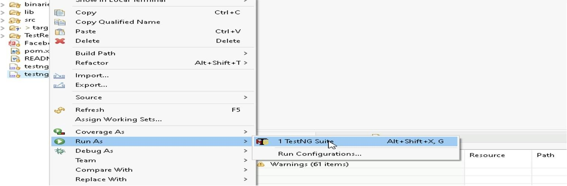

1. **Before final submission, you are also required to push your code to GIT. Following are the steps to follow:**

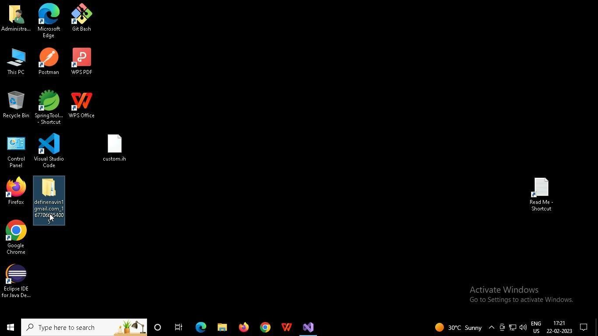

In your project folder, you will find a batch file named git_commands

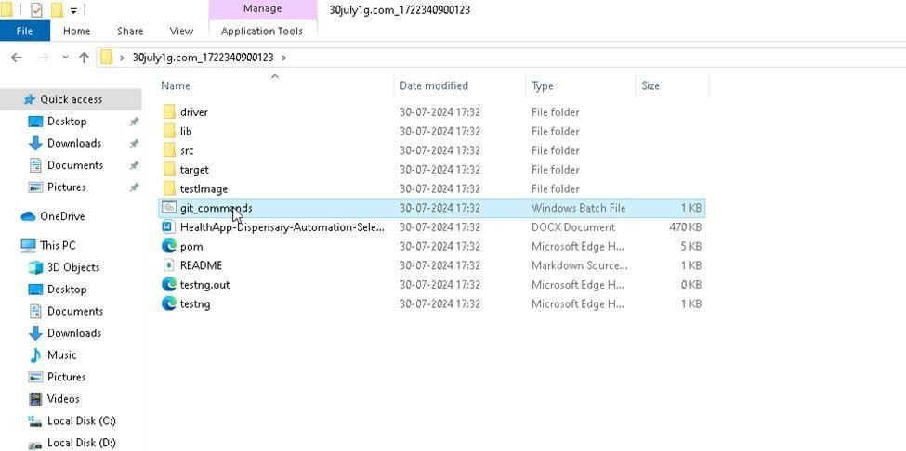

Double-click the batch file to run it. It will run the commands to push your code to GIT.

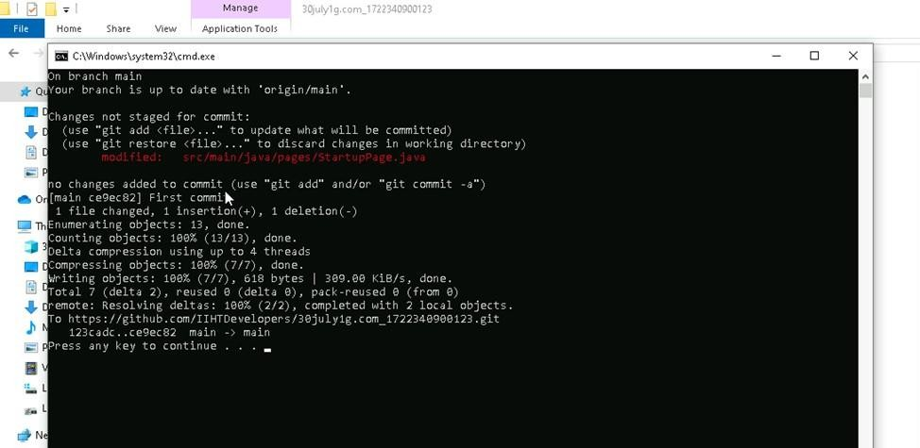

===============================================================================

All the Best