# System Requirements Specification Index

For

# Machine learning Usecase

## Bank fraud detection with ML L2

1.0

## IIHT Pvt. Ltd.

[fullstack@iiht.com](mailto:fullstack@iiht.com)

**Step to access the work environment**

Step 1 use the URL to login provide the username and password

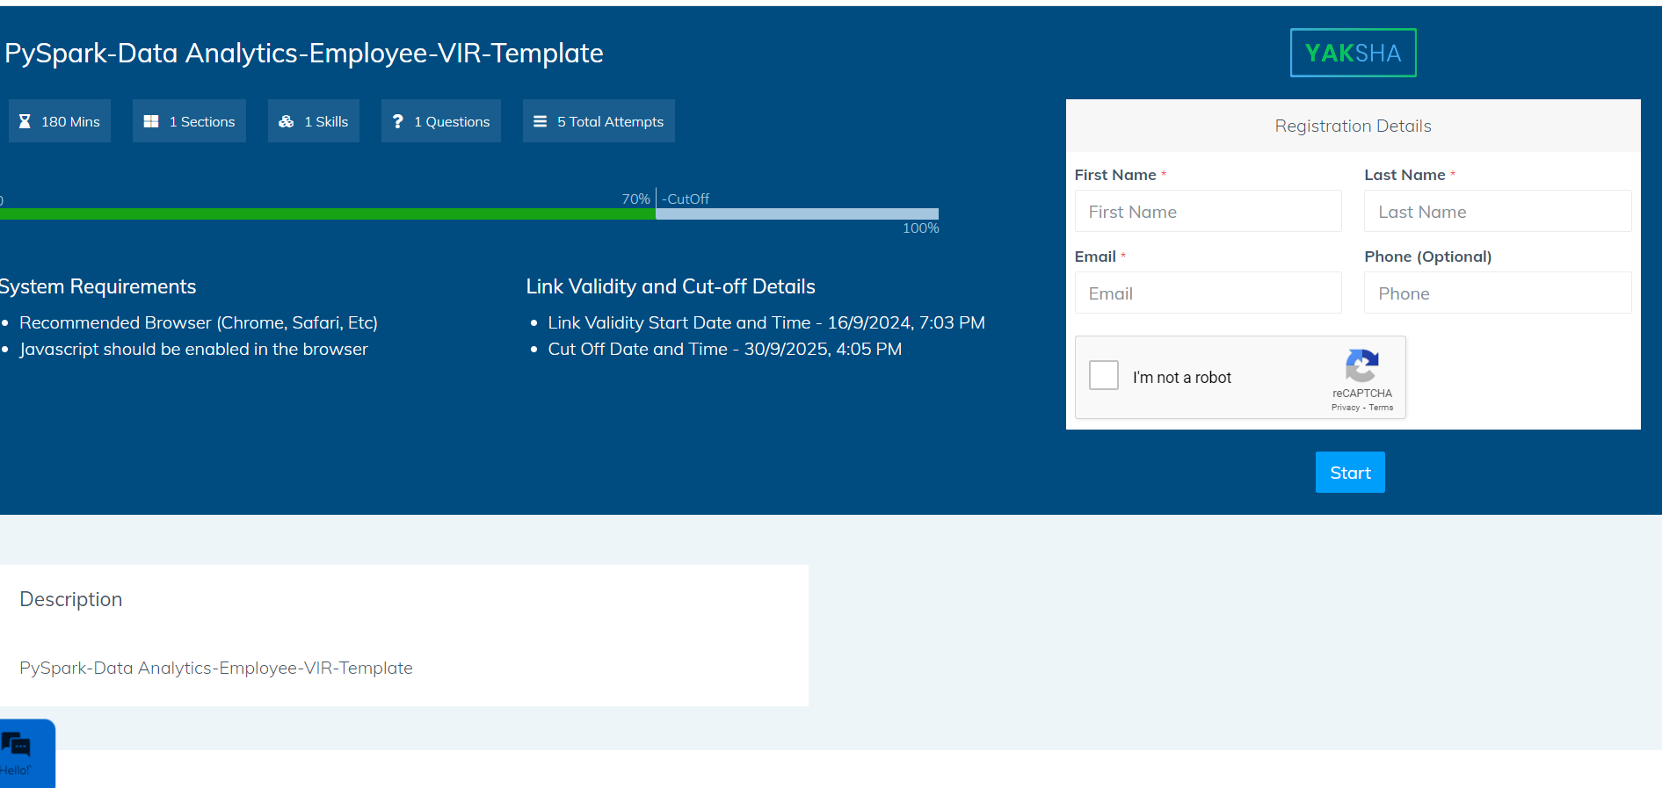

Step 2 Click on the launch assessment Environment

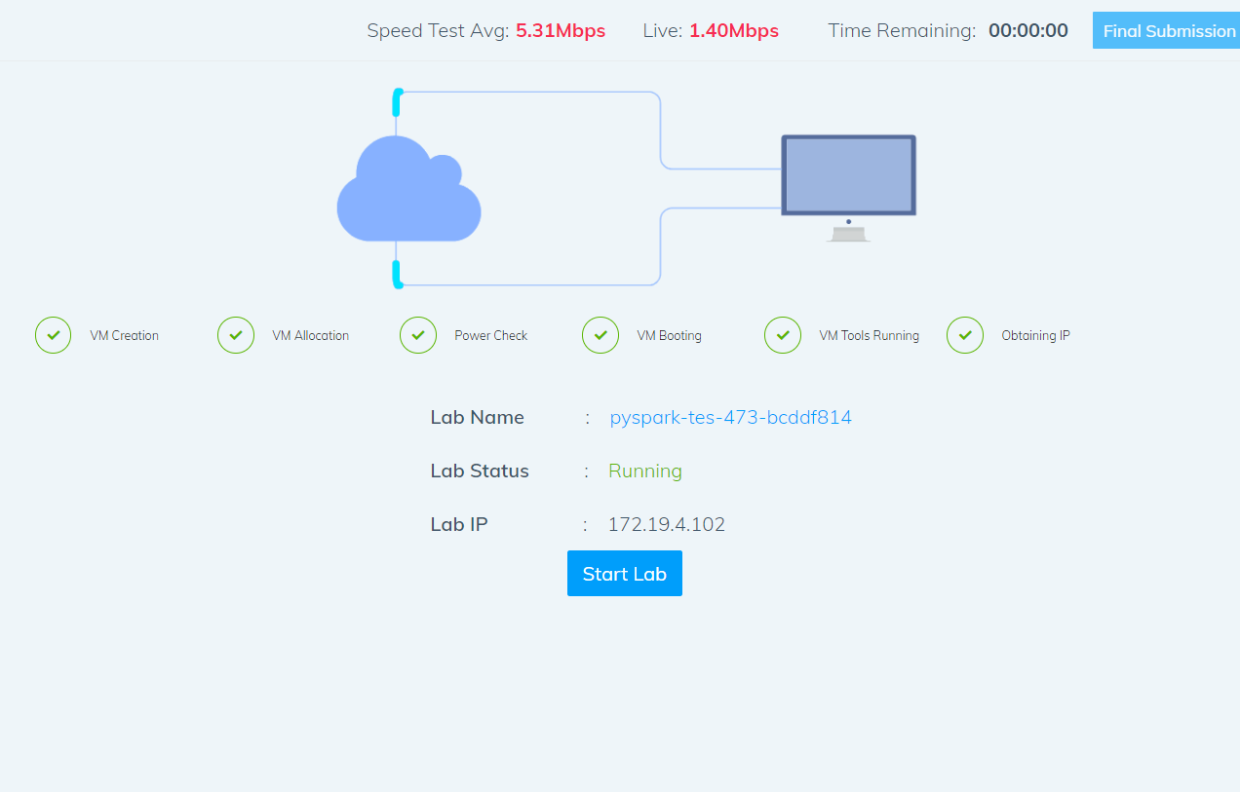

Step 3 Click on the start lab button

Step 4 you will get a window you need to type the code from that top corner

* You need to type the code in the window . It will take few minutes to start the window

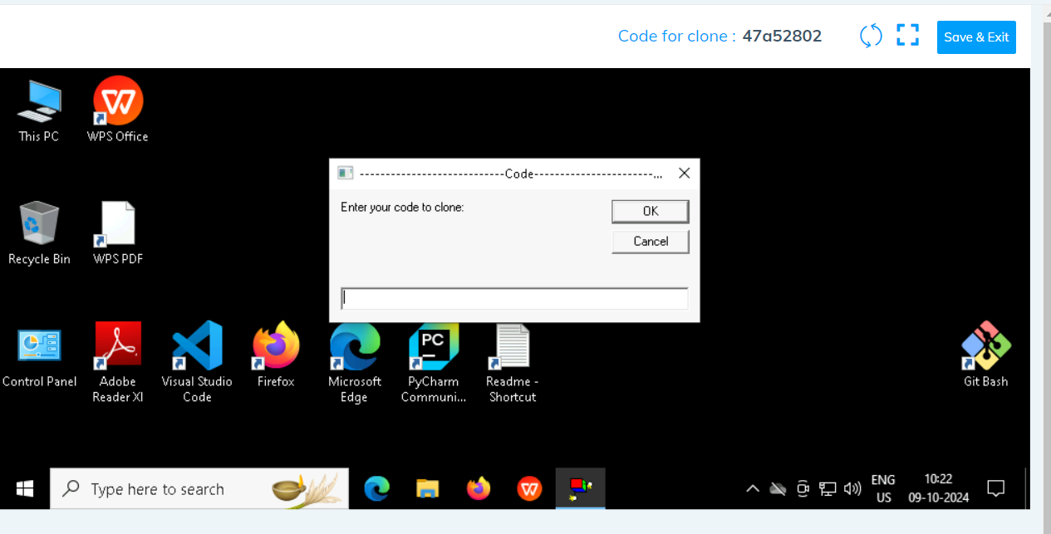

Click on ok

Step 5 after few seconds we can see that the your folder is cloned in the desktop .

Folder cloned

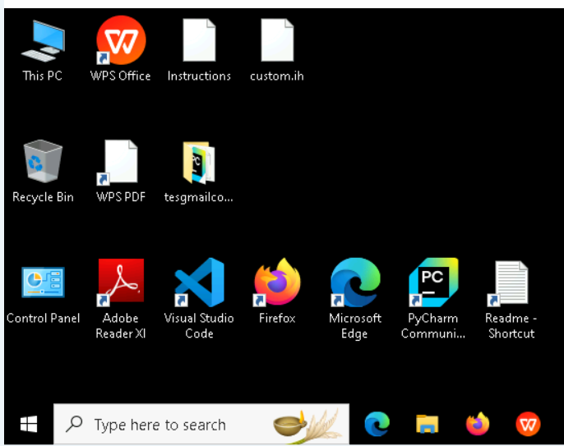

Step 6 go inside the folder type cmd in the top of the file explorer

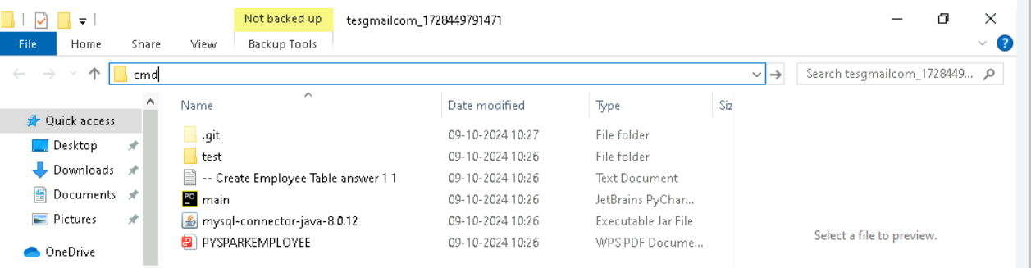

* Type code. And hit enter you can see that workspace is opened in the visual code

* You can see that workspace is ready to code

Note Please only work with visual code not with any other IDE

* In the folder cloned you will have all the project files needed .

Problem Statement : **Bank fraud detection**

Description : Use relevant methods operations to perform specified activities which are given in the instructions.

Introduction

A large retail bank with millions of customers experiences a rising number of fraud cases involving unauthorized transactions, phishing attacks, and account takeovers. To mitigate these risks, the bank deploys an AI-powered Fraud Detection System integrated with transaction monitoring and behavioral analysis.

They begin their journey with a dataset containing transaction details, carefully preprocessing it to ensure accuracy and reliability. By encoding categorical features and scaling numerical data, they prepare the foundation for robust model training.

Next, they address the critical issue of class imbalance, where fraudulent transactions represent only a small fraction of the data. Using SMOTE, the scientist balances the dataset, ensuring the model can detect fraud effectively. With the preprocessed and balanced data, they train an XGBoost classifier, fine-tuning it to identify subtle patterns indicative of fraudulent behavior. After training, the model is evaluated, revealing its ability to distinguish fraud with high precision and recall, backed by a strong ROC-AUC score.

**Objective**

To detect fraudulent transactions using machine learning, preprocess data for model training, and perform analytical reporting based on fraud data.

**preconditions**

1. Dataset available in CSV format.
2. Python environment set up with the required libraries installed:
   * pandas
   * numpy
   * sklearn
   * xgboost
   * imbalanced-learn
   * joblib

**Postconditions**

* Trained XGBoost model saved as a file.
* Analytical insights on fraudulent transactions available

**Dataset Information**

The dataset used for this use case is a fictionalized credit card transaction dataset designed for fraud detection. It contains the following key attributes:

* **TransactionID:** A unique identifier for each transaction.
* **AccountID:** A unique identifier for the account involved in the transaction.
* **TransactionType:** The type of transaction (e.g., "Online", "POS").
* **Location:** The geographical location where the transaction occurred.
* **Merchant:** The merchant involved in the transaction.
* **TransactionAmount:** The monetary value of the transaction.
* **IsFraud:** A binary flag indicating whether the transaction is fraudulent (1) or not (0).

#### Steps to follow

1. Load and Preprocess Data

- Load the dataset from a CSV file.

- Encode categorical features and standardize numerical features.

2. Balance Data

- Use SMOTE to address class imbalance.

3. Train Model

- Train an XGBoost classifier on the balanced dataset.

4. Evaluate Model

- Generate performance metrics: Confusion Matrix, Classification Report, and ROC-AUC score.

5. Save Model

- Save the trained model using joblib for future use.

6. Perform Analytics

- Analyze the dataset for key insights such as high-risk locations and transaction types.

**Solve these Questions**

1. How many unique accounts are associated with fraudulent transactions?
2. What is the total number of fraudulent transactions in the dataset?
3. Which location has the highest number of fraudulent transactions?
4. What is the most common transaction type involved in fraud?
5. Which merchant has the highest number of fraudulent transactions?
6. What is the average transaction amount for fraudulent activities?
7. What is the total monetary amount of all fraudulent transactions?
8. How many unique fraudulent transactions are present in the dataset?

**Execution Steps to Follow:**

1. All actions like build, compile, running application,running test cases will be through Command Terminal.
2. To open the command terminal the test takers, need to go to Application menu (Three horizontal lines at left top) -> Terminal -> New Terminal
3. This editor Auto Saves the code
4. If you want to exit(logout) and continue the coding later anytime (using Save & Exit option on Assessment Landing Page) then you need to use CTRL+Shift+B-command compulsorily on code IDE. This will push or save the updated contents in the

internal git/repository. Else the code will not be available in the next login.

1. These are time bound assessments the timer would stop if you logout and while logging in back using the same credentials the timer would resume from the same time it was stopped from the previous logout.
2. To setup environment:

You can run the application without importing any packages

1. To launch application:

Python banktemplate.py

1. To run Test cases:

python -m unittest

Before Final Submission also, you need to use CTRL+Shift+B-command compulsorily on code IDE. This will push or save the updated contents in the internal git/repository for code

**Screen shot to run the program**

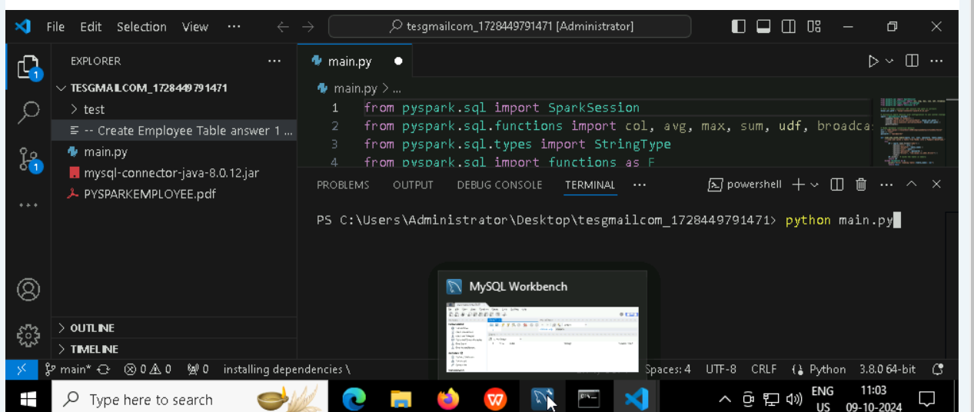

**To run the application**

* **Python templatebank.py**

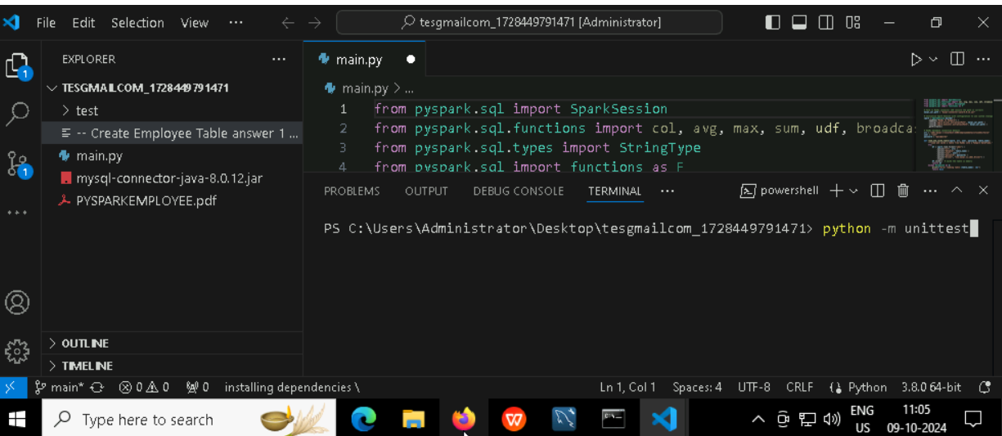

**To run the testcase**

* **Python -m unittest**

**Screenshot to push the application to github**

### -----x-----

#### You can run test cases as many numbers of times and at any stage of Development, to check how many test cases are passed/failed and accordingly refactor your code.

* 1. **Make sure before final submission you commit all changes to git**. For that open the project folder available on desktop

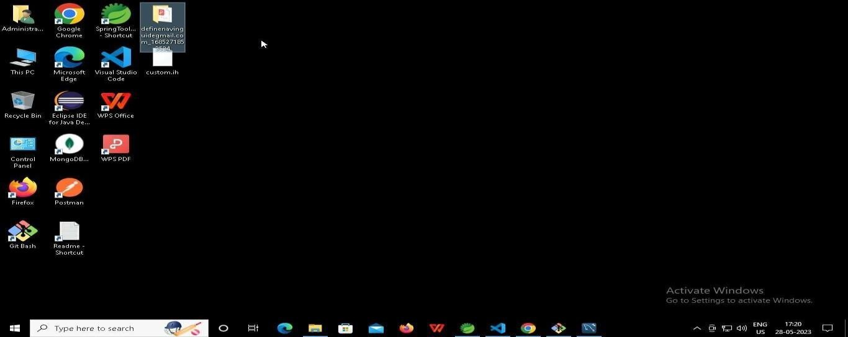

* + 1. **Right click in folder and open Git Bash**

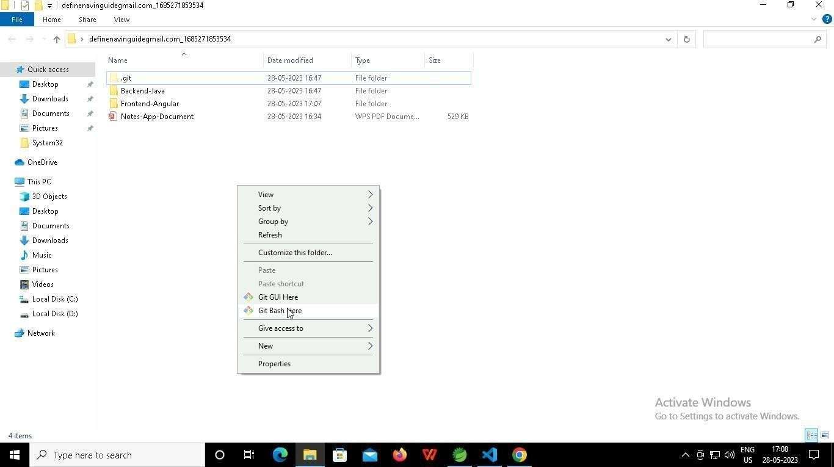

* + 1. **In Git bash terminal, run following commands**
    2. **git status**

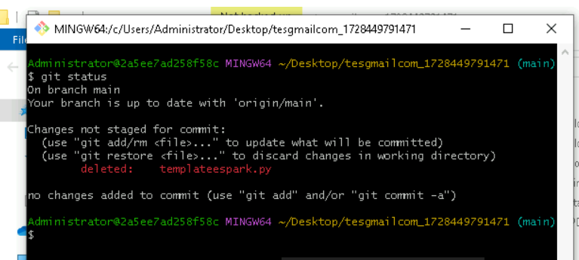

* + 1. **git add .**

* + 1. git commit -m “First commit”

(You can provide any message every time you commit)

* + 1. **git push**

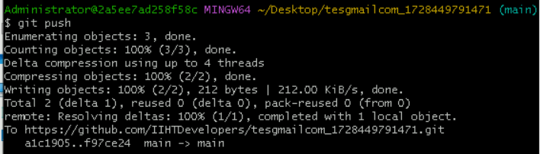

### After you have pushed your code Finally click on the final submission button

### 

### You should see a screen like this you will have to wait for the results . after getting this page you can leave the system

### -----x-----