

Ha npaKTVl4eCKOe 3aHSITVle no TeMe

«C4eT4VIK KaK npocTe111wV1111 asToMaT Mypa»

U,e/151Mll'I 3aH51Tll'l51 51B/151eTC51
- noH1t1MaH1t1e cryp,eHTaMlt1 np1t1HL.j1t1na p,ei-1CTBlt1$l KOHeYHOro aBTOMaTa
Ill no11yYeH111e CTy,qeHTaMll'I HaBblKOB no:
- nocrpoeH1t110 p,v1arpaMMbl nepexop,oB;
- Cv1HTe3y KOM61t1Hal..j1t10HHblX cxeM no C,[\HC!J lt1Jllt1 Ta6J11t1Lje lt1CTv1HHOCTv1;
- Mop,env1poBaH1t110 nocnep,OBareJ16Hb1x cxeM.

Xo,q BblnOJ1HeHll'l51 3a,qaH11151:
- nonyY1t1Tb ltlH/J,lt1Blt1/J,YaJ16Hbll-1 Bap1t1aHT 3ap,aHlt1$1 na6. pa60Tbl (CM. Ta6J11t1Ljy Bap1t1aHTOB).
- B cpep,e CircuitVerse KJ1OH1t1poBaTb npoeKT BOCbM1t16v1rnoro cYeTY1t1Ka (CircuitVerse - 8-bit Asynchronous Counter with Hex Display) B cBoi-1 aKKayHT.
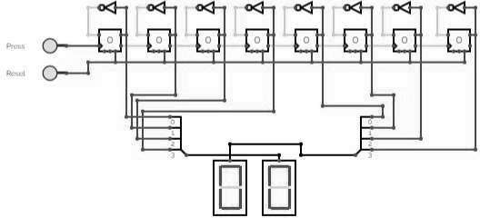

- Pa3o6parbC$1 c nOH$1Tlt1eM KOHeYHoro aBTOMara Mypa (cM. reMy Learn "Introduction to State Machines")

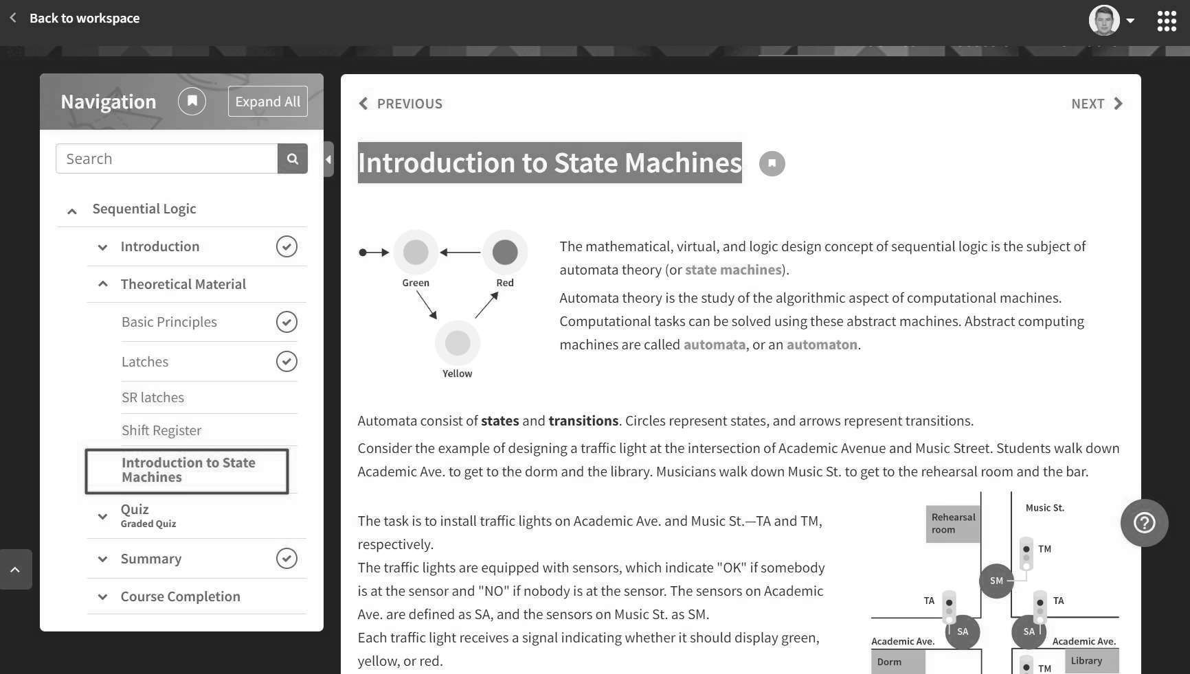

- YnpOCH1Tb cxeMy CL1eTL11!1Ka {J.,0 AOCTaTOYHOVI pa3p$1,l\HOCH1 aBTOMaTa.
- CoCTaBl!1Tb Ta6Jll!1Ljy nepeXOAOB 1,1 COCT0,1Hl,1Vi pa3pa6aTblsaeMoro aBTOMaTa. CoCTO>IHl,1,1 aBTOMaTa Cfle,l\yeT 6paTb 1,13 Ta6Jll!1Ljbl sap111aHTOB B COOTBeTCTBl,11,1 co CBOl,1M 3aAaHHblM sap111aHTOM (OA111H 1,13
sap111aHTOB Ta6Jlll1Ljbl np111BeAeH Hll1>Ke).

Ha4aflbHOe  COCTORHHe | -> | -> | KoHe4HOe  COCTORHHe
5 | 3 | C | 8

np111Mep np111BeAeHHOro sap111aHTa CJle,l\yeT TpaKTOBaTb CJleAYIOll.\111M o6pa30M:
-np1,1 Ha>t<an11,1 KHOnKl!1 Reset aBTOMaT AOJl>KeH nepevirn B HaYaJlbHOe COCTO>IHl!1e 1,1 orn6pa31!1Tb Ha Lj1!1(pp0BOM 111HAl!1KaTOpe Lj1!1cppy 5.
-np1,1 Ha>Kan11,1 KHOnKl!1 Press aBTOMaT AOJl>KeH nepevirn B nocJleAYIOll.\ee COCTO>IHl!1e
OTHOCl!1TeJlbHO TeKyll.\ero, T.e. 1,13 COCTO>IHl,1,1 5 - B COCTO>IHll1e 3, 1,13 COCTO>IHl,1,1 3 - B COCTO>IHll1e C, 1,13 COCTO,IHl,1,1 C - B COCTO>IHll1e 8, 1,13 COCTO,IHl,1,1 8 - B COCTO>IHll1e 5 1,1 T.,l\.

- CoCTaBl!1Tb KOM6111Hal..jl!10HHYIO cxeMy, aKH1B111PYIOll.\YIO COOTBeTCTBYIOll.\111e cerMeHTbl Lj1!1cpposoro 111H,l\111KaTOpa, Afl>I orn6pa>KeHll1>1 TeKyll.\ero COCTO>IHl,1,1 aBTOMaTa.
np111Mep KOA111posaH111>1 ceM111cerMeHTHoro 111HA111Karnpa MO>KHO Havirn s Learn s TeMe "Designing a logic scheme":

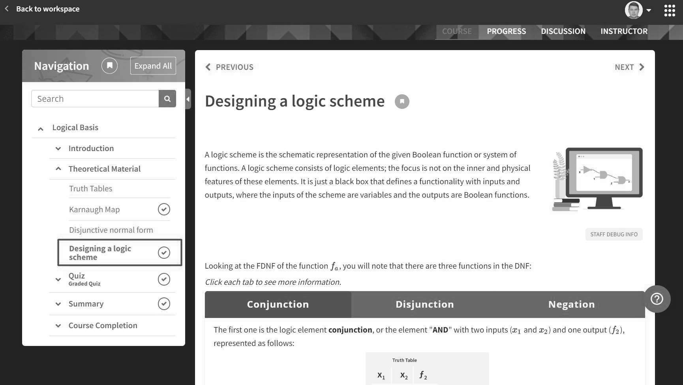
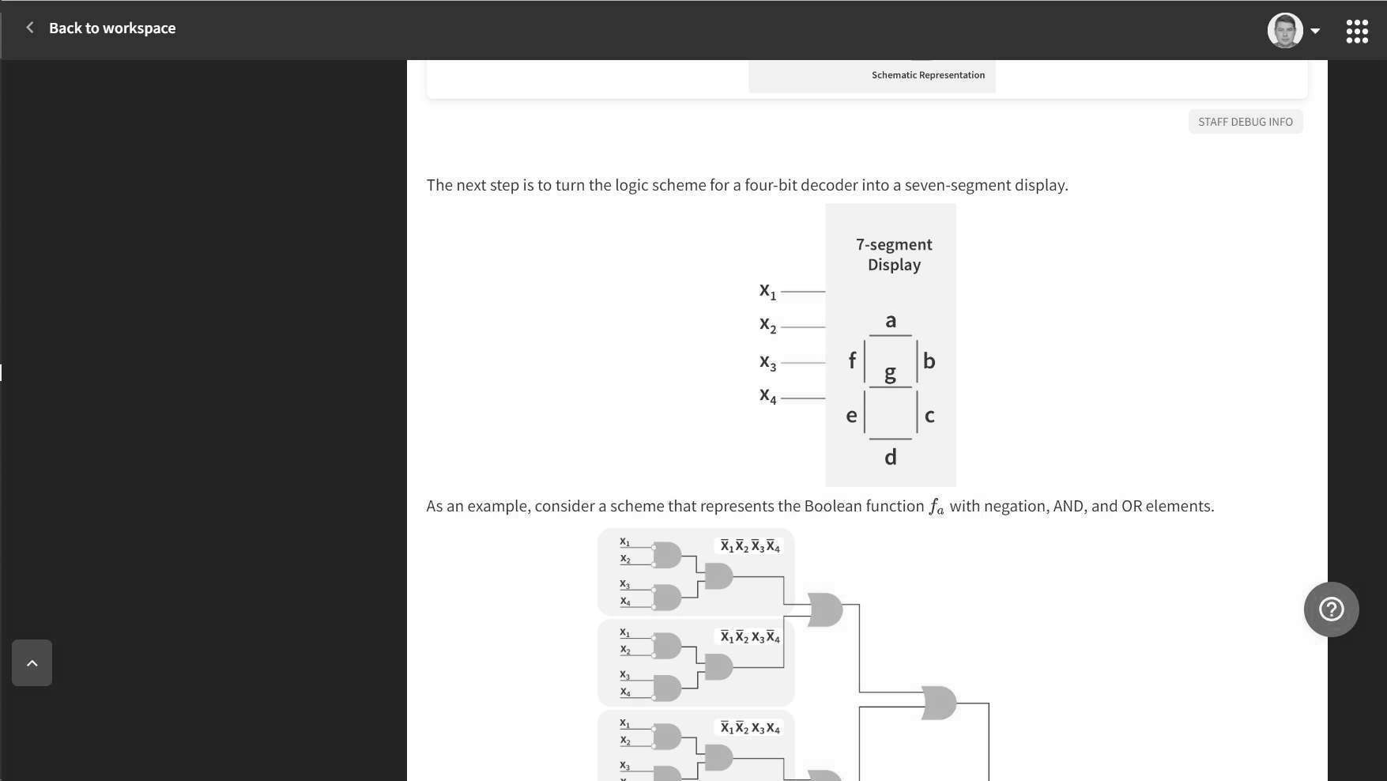

- BHeCTVl COOTBeTCTBYIOll.\Vle V13MeHeHV1 B npoeKT V1 npOMO,[\eJJVlpOBaTb pa6ory aBTOMara.

04eHKa pa60Tbl:
  - KaYecrneHHO BblnOJJHeHHblt1 B cpoK AO nepsoro ,[\e,[\Jlat1Ha BapVlaHT 3a,[\aHV1 Ol.jeHVlBaerc B 9
6annos;
  - O,[\VlH 6aJJJl MO>t<eT 661Tb BblYTeH 1/13 MaKCV1MaflbHOt1 Ol.jeHKVl B CJlyYae BHOt1 V136blTOYHOCTV1 cxeMbl (no KOJ1V1Yecrny seHrnJJet1);
  - cxeMa c HeKoppeKrnot1 pa6orot1 asroMara J1V160 c pa6orot1, Hecoornercrny10ll_\et1 Bbl,[\aHHOMY

Bapv1aH-ry, Ol..j8Hl,1BaeTC>i B HOJlb 6aJlJlOB.

- Yc/lO)l(HifHHb/11 ypoBeHb:
  - ,[\OnOJlHv1T8Jl6Hbl O,[\vlH 6aJlJl HaYv1CJl>l8TC>i 3a peaJ1v13al..jv1IO cxeMbl, OCYLl.\8CTBJl>IIOLl.\8 KaK
«np>iMO ». TaK v1 «o6paTHbl XO,[\» aBTOMaTa B COOTBeTCTBvlvl c noJlyYeHHblM Bapv1aHTOM.

,[\fl>i 3TOro B npoeKT ,[\OJl>KHa 661Tb ,[\06aBJleHa KHOnKa Back, npv1 Ha>KaTvlvl Ha KOTOPYIO aBTOMaT nepeXO,[\vlT B npe,[\bl,l\Yll.\88 COCTO>IHvle OTHOCv1T8JlbHO TeKyll,\ero. 8 Bapv1aHTe, npv1Be,[\eHHOM Bbl We, o6paTHbl XO,[\ 6y,[\eT BblrJl>l,[\8Tb CJl8,[\YIOLl.\v1M o6pa30M:

HaYa/lbHOe  COCTORH'1e | -> | -> | I | KoHe4HOe  COCTORH'1e
5 | 3 | C | I | 8

  - v13 COCTO>IHvl>l 5 - B COCTO>IHvle 8, v13 COCTO>lHvl>I 8 - B COCTO>IHvle C, v13 COCTO>IHvl>l C - B COCTO>IHvle 3, v13 COCTO>IHvl>i 3 - B COCTO>IHvle 5 v1 T.,[\.

