EcoTwin: Ecosystem Analog Search and Forecasting Using
Geospatial Foundation Models

Department of Computer Science and Engineering
International Institute of Information Technology Hyderabad

Vikash Kumar (2025201012)
Peeyush Prashant (2025201102)
Ankit Kumar (2025201022)

Project Report
Ramachandra Prasad P

2026

Abstract
Freshwater lakes and wetlands are among the fastest-degrading ecosystems on Earth (Ramsar Convention on Wetlands, 2018), yet most of them are never monitored on the ground. For the great majority of the world’s lakes there is no long-term field record and no ecological model, so managers learn that a lake is in decline only after the damage is visible. Satellites now observe every lake every few days, but imagery alone does not answer the question a manager actually faces: what is likely to happen to this lake next, and what has happened to lakes like it?
We address this by treating ecosystems as analogs of one another. Instead of building a model for each lake, we ask which other lakes have already passed through the same condition the target lake is in now, and use their recorded histories as evidence about its future. Using a pretrained Earth-observation foundation model, we describe each lake’s recent five-year trajectory from satellite imagery alone, search a decade-long library of lakes for those with the most similar trajectories, and turn their observed changes into a transparent directional outlook for the target lake. The method abstains when the evidence is weak rather than guessing.
Demonstrated on 829 Indian lakes and five Ramsar wetlands, the approach recovered ecologically meaningful matches without any location information. For example, it paired Tso Morari with Pangong Tso, its high-altitude twin in Ladakh. It also produced trends consistent with independently documented change at Chilika. EcoTwin offers a low-cost, scalable early-warning aid for lakes that would otherwise go unmonitored.
Keywords: Geospatial Foundation Models, Prithvi, Remote Sensing, Sentinel-2, HydroLAKES, Ecosystem Analogs, Vector Search, pgvector, NDCI, Red-Edge Indices, Ramsar Wetlands, Trajectory Similarity

Introduction
Background and Problem Statement
Earth observation satellites provide repeated measurements of ecosystems at scales infeasible through field observation alone, and Sentinel-2's multispectral imagery suits vegetation, water, and surface-condition analysis. Rather than beginning with a specific question such as vegetation change, EcoTwin treats ecosystem comparison as a retrieval problem: satellite observations are converted into learned feature vectors and indexed, so a lake can be compared against a large reference collection without reprocessing raw imagery each time, asking whether another ecosystem looks similar in its spatial-spectral representation.
Several engineering constraints shape the solution: lake boundaries are irregular polygons rather than fixed-size squares, so large ecosystems require multiple image tiles; historical Sentinel-2 collections do not expose identical quality bands across all years, so cloud masking must be collection-aware; every embedding must stay associated with its source geometry and lake/year metadata; and similarity search must be substantially cheaper than recomputing embeddings from scratch.
Core EcoTwin Hypothesis
EcoTwin is based on the operational hypothesis: “Ecosystems elsewhere that are structurally similar in geospatial feature space can provide useful analogs for understanding the spatial and historical behaviour of a target ecosystem.”
The hypothesis separates two tasks. The first is analog discovery: finding ecosystems that resemble the target in the learned spatial-spectral representation. The second is trajectory analysis: comparing the historical environmental indicators of the target against those of its discovered analogs.
Project Evolution and Contributions
The implementation evolved from standardized 5×5 km ecosystem blocks toward a lake-centred buffered imagery stage, local raster merging, and 1×1 km analysis cells, letting large lakes be processed without forcing the foundation model onto irregular polygons. A further pivot shaped the final system: snapshot similarity gave way to trajectory similarity - comparing single embeddings proved too weak a notion of resemblance, since two lakes can coincide in one year and diverge over a decade, so the system instead compares a five-year trajectory against every sliding window in each candidate's history (see Trajectory Similarity Search, below).
The project's contribution is the resulting end-to-end lake-to-embedding-to-analog pipeline, executed over an 829-lake, ten-year cohort with no residual failures: Earth-Engine-based satellite acquisition with polygon-aware subdivision; Prithvi-based six-band representations with coverage-weighted pooling, persisted as 768-dimensional vectors; the forecasting method described later in this report; a band-honest ecological index set; and a FastAPI/React-Leaflet application with automated PDF reporting, evaluated on five Ramsar-designated wetlands and reservoirs.
Related Work
EcoTwin combines three established but, to the authors' knowledge, not previously combined threads. Analog-based forecasting is classically meteorological: Lorenz (1969) matched historical pressure-field states as analog pairs, and van den Dool (1989) extended this to operational forecasting, later estimating how vast a library true analogs require (van den Dool, 1994) - the same problem EcoTwin's trajectory matching and cross-lake pooling (828 candidate histories, not one lake's own past) are structural attempts to work around. Outside meteorology, the same idea is formalised as structured analogies, in which several historical cases are matched and combined by rule (Green & Armstrong, 2007). Geospatial foundation models: Prithvi-EO-2.0 reports state-of-the-art downstream performance across benchmark tasks (Szwarcman et al., 2024), an independent evaluation found the original Prithvi model competitive on benchmark image-analysis tasks (Hsu et al., 2024), and recent work using Google DeepMind's AlphaEarth embeddings as features for supervised wetland classification supports the premise that a modern GeoFM's embedding space encodes ecologically meaningful structure, though without forecasting or trajectory matching (Ryan et al., 2026). Index validation: NDCI, EcoTwin's chlorophyll-a proxy, was developed for turbid, productive waters (Mishra & Mishra, 2012), so it is less reliable in clear, oligotrophic lakes such as Tso Morari. NDVI and NDWI rest on the older, widely adopted vegetation-index literature (Huete et al., 2002; Pettorelli et al., 2005). None of this validates EcoTwin's forecasts directly - that requires the hindcasting protocol described in the Hindcasting Protocol section - but it grounds the two components the forecast is built from: analog reasoning as an established paradigm, and the foundation model and index formulas as independently vetted.

Data Sources and Data Engineering
Overview
EcoTwin combines static geographic information (HydroLAKES polygons and metadata; Messager et al., 2016) with repeated satellite observations (Sentinel-2): the static layer defines where an ecosystem is, the satellite layer defines what it looks like through time. The database retains the fields needed downstream - identifier, name, country, geometry, area, elevation, pour-point, type, depth, volume, and watershed area (Table 1) - and the pipeline was narrowed from the full HydroLAKES inventory to a selected 829-lake cohort so multi-year imagery and embeddings could be generated within storage, Earth Engine, and compute budgets.
Table 1
HydroLAKES-derived information used by EcoTwin.
Field | Type | Role in EcoTwin
Lake ID | Integer | Primary ecosystem identifier
Lake name | Text | Human-readable identification
Country | Text | Geographic filtering
Lake area | Numeric | Size and metadata analysis
Elevation | Numeric | Environmental context
Pour latitude/longitude | Numeric | Geographic reference
Geometry | PostGIS geometry | Spatial processing and mapping
Lake type | Categorical | Ecosystem metadata
Average depth | Numeric | Descriptive context
Total volume | Numeric | Descriptive context
Watershed area | Numeric | Catchment context

Figure 1
Stage 1 (Sync Lakes): HydroLAKES import and the 829-lake processing cohort.
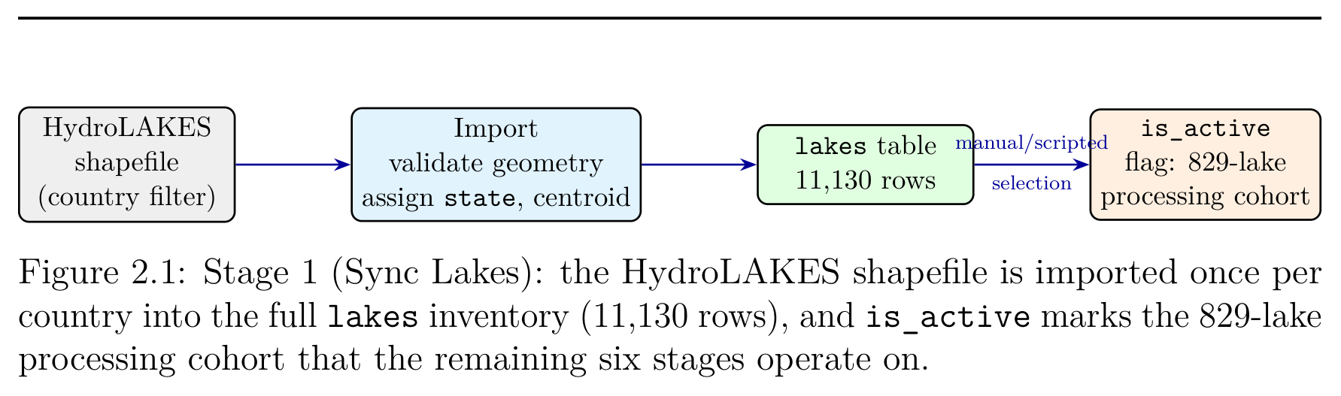
Note. The HydroLAKES shapefile is imported once per country into the full lakes inventory (11,130 rows), and is_active marks the 829-lake processing cohort that the remaining six stages operate on.

Sentinel-2 and Temporal Coverage
Sentinel-2 multispectral imagery (European Space Agency, n.d.), filtered, composited, and exported through Google Earth Engine (Gorelick et al., 2017), is the primary remote-sensing input, using the harmonized surface-reflectance collection with a Level-1C fallback for early years.
Ingestion was extended from an initially planned 2018–2025 window back to 2016, giving ten consecutive years. Table 2 shows the result: from 2018 onward every one of the 829 active lakes has a complete record, while 2016–2017 fall slightly short because Sentinel-2B did not launch until March 2017, leaving some lakes without enough cloud-free acquisitions for a usable composite.
Table 2
Achieved temporal coverage across the 829-lake cohort.
Year | Lake-years | Embeddings | Features
2025 | 829 | 829 | 829
2024 | 829 | 829 | 829
2023 | 829 | 829 | 829
2022 | 829 | 829 | 829
2021 | 829 | 829 | 829
2020 | 829 | 829 | 829
2019 | 829 | 829 | 829
2018 | 829 | 829 | 829
2017 | 808 | 808 | 808
2016 | 787 | 787 | 787
Total | 8,227 | 8,227 | 8,227
Note. Every retained lake-year carries both an embedding and a completed feature record; there are no partial rows.

The 42 absent lake-years are recorded as such rather than interpolated, since the similarity layer requires five consecutive years to form a comparison window. The embedding input uses six bands, B2–B7 (blue, green, red, narrow near-infrared, and two short-wave infrared channels).
Environmental Indices: A Band-Honest Index Set
The merged lake imagery used for Prithvi inference contains only B2–B7, not B8 (broad NIR), so the textbook NDVI/NDWI forms could not initially be computed. EcoTwin substituted the narrow-NIR red-edge channel B7 for B8 and recorded the substitution in the index names (NDVI-B7) rather than concealing it. That gap has since closed: the server-side B8 pipeline described in Server-Side B8 Acquisition now populates lake_features.b8_mean for every lake-year (8,227/8,227) without downloading a raster, so NDVI and NDWI are now computed against true NIR; NDCI, Turbidity, and Red-Edge Slope never needed NIR and are unaffected. All five indices are computed from per-band mean reflectance over the lake polygon: NDCI for chlorophyll-a/algal bloom; NDVI for vegetation vigor, tracking macrophytes and floating weed; NDWI, the standard McFeeters water index, falling as vegetation raises B8 (McFeeters, 1996); Turbidity, the Normalized Difference Turbidity Index (NDTI), for suspended sediment (Lacaux et al., 2007); and Red-Edge Slope for pigment concentration and canopy density.
Table 3
Implemented ecological index set and ecological meaning.
Index | Formula | Ecological interpretation
NDCI | (B5−B4)/(B5+B4) | Chlorophyll-a; eutrophication and algal bloom intensity
NDVI | (B8−B4)/(B8+B4) | Vegetation vigor (standard formula); macrophyte and floating-weed encroachment
NDWI | (B3−B8)/(B3+B8) | Open-water extent (standard McFeeters formula); falls as vegetation colonises the surface
Turbidity (NDTI) | (B4−B3)/(B4+B3) | Suspended sediment load and water clarity
Red-edge slope | (B7−B5)/78 nm | Pigment concentration and canopy density trend (project-defined; reflectance × 10⁴ per nm)

All five are computed in app/services/index_calculator.py, which returns None for any index whose input bands are missing rather than substituting a default. NDTI is a relative, qualitative turbidity indicator rather than a calibrated sediment measurement, and is meaningful only over water. Red-Edge Slope is a project-defined indicator rather than a published index; because Earth Engine's surface-reflectance bands are scaled by 10,000, its values are in units of reflectance × 10⁴ per nm (a value of 2.62 corresponds to 0.000262 reflectance per nm).
Figure 2
Stage 6 (Generate Lake Fe--atures): per-band statistics and on-demand index computation.
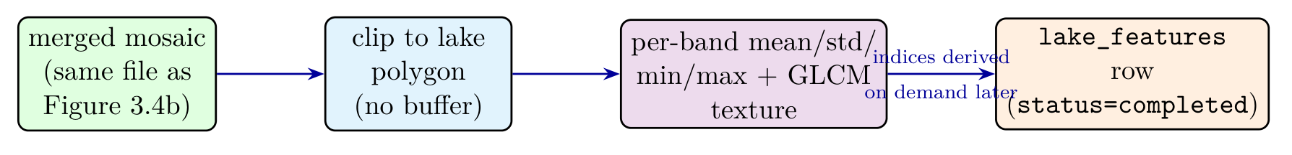
Note. Unlike Prithvi inference, this stage clips the merged mosaic to the bare lake polygon (no buffer, no cell grid) and computes per-band statistics and GLCM texture directly; only the band means are persisted, and each index of Table 3 is recomputed on demand.

B8 is deliberately excluded from the Prithvi input, whose band count is fixed by the model's training configuration, but is acquired separately and stored alongside the other band statistics. A valid ecosystem record requires a valid polygon and year, a usable composite, valid exported raster data, valid cells after coverage filtering, and a successful embedding per cell; the pipeline distinguishes successful, failed, skipped, and already-completed work so long-running jobs can be resumed.

Detailed EcoTwin Methodology
End-to-End Pipeline
The implemented workflow is: Lake Inventory → Boundary Validation → Buffering → Imagery Tiling → Sentinel-2 Composite → GeoTIFF → Local Mosaic → 1 km Cells → Coverage Filter → Prithvi → 768D Embeddings → pgvector → Cosine Search → Analogs → Temporal Profiles → Forecast
Data-Fetching Workflow and Imagery Acquisition
The seventeen-step pipeline above is what EcoTwin computes; Figure 3 shows how an operator actually runs it, as seven sequential stages, each a separate API call, background job, and database write, so a failure at stage 4 leaves stages 1–3 intact and does not require re-fetching imagery already on disk.
Figure 3
The seven-stage data-fetching workflow.
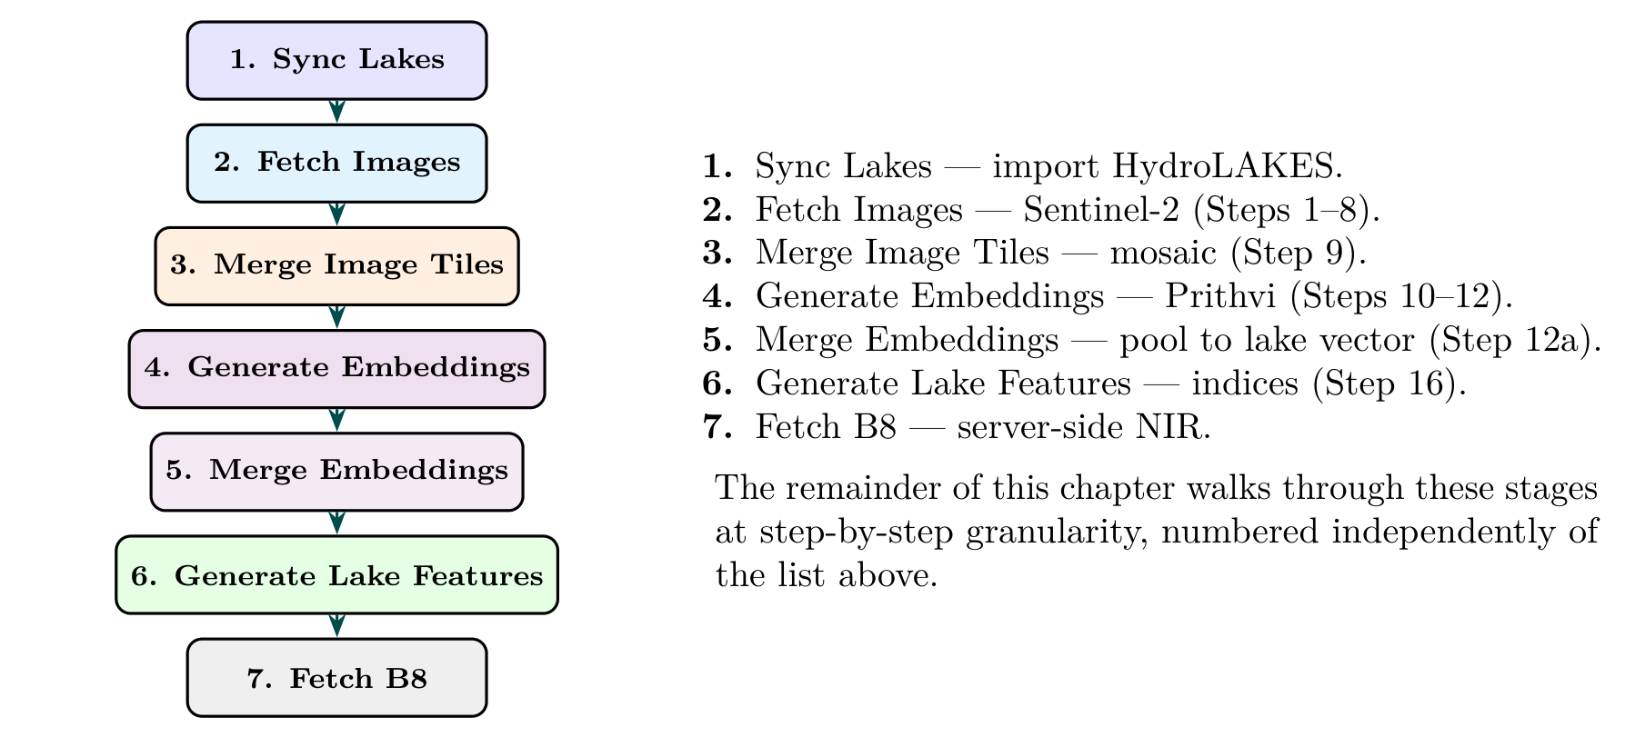
Note. Each stage reads the previous stage's database output, never the raw upstream source directly and also idempotent at the row level: each writes a status column before doing any work, and a re-run skips rows already completed.
Steps 1–2 (Boundary Retrieval and Buffering): the pipeline reads the target lake polygon from PostGIS, validates it, and transforms it into a projected CRS, then expands it with a configurable buffer (1200 m during development), since the ecosystem representation is not restricted to the water polygon itself: surrounding shoreline and vegetation contribute to the spatial-spectral signature.
Figure 4
Step 2 (Buffering): expansion of the lake polygon by a fixed margin.
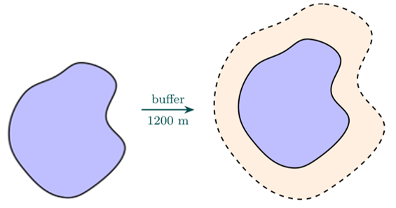
Note. The original polygon (a) is expanded by a fixed 1200 m buffer (b); everything between the two boundaries is retained as part of the ecosystem representation.

Step 3 (Projected Grid Generation): the buffered polygon is projected into a metric CRS, and a regular imagery grid - deliberately coarser than the final analysis grid, at an 8500 m tile size chosen to balance Earth Engine request size, memory use, and local processing cost - is generated around it. A lake may therefore produce one, two, or several imagery tiles depending on its size and shape.
Figure 5
Step 3 (Imagery Tiling): tile grid overlay and per-tile Earth Engine request.
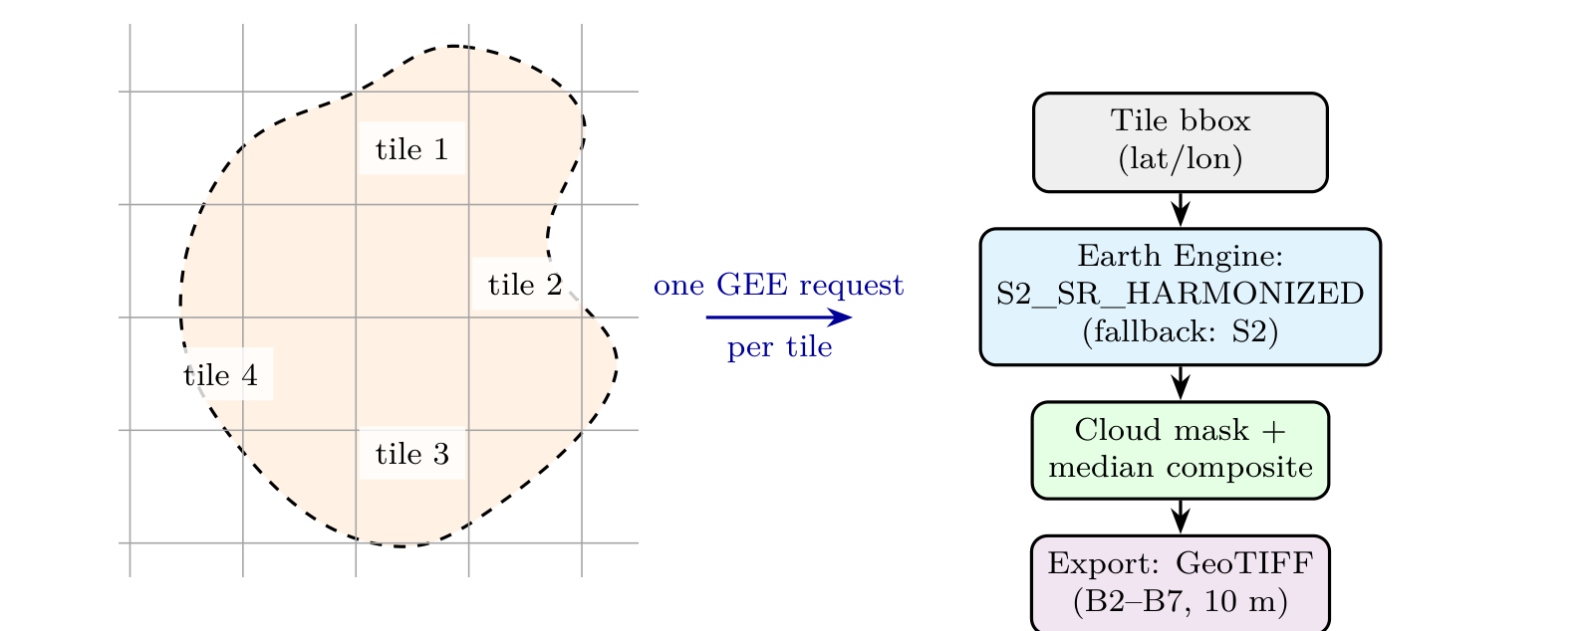
Note. The buffered extent (a) is clipped against a ~8.5 km grid (here four tiles); each tile drives one Earth Engine request (b) - the “Fetch Images” data-fetching stage.

Steps 4–8 (Sentinel-2 Compositing, Export, and Resumability): for each lake-year combination, the pipeline first queries the preferred surface-reflectance collection (S2_SR_HARMONIZED); if no usable observation exists, it falls back to the Level-1C collection (S2), a decision recorded in the processing metadata before export. Scenes with cloud cover exceeding 20% are excluded, and unusable pixels are masked using cloud-probability and class-based information where available. The filtered observations are then combined into an annual per-pixel, per-band median composite,
I_annual(p, b) = median( I₁(p, b), I₂(p, b), …, Iₙ(p, b) ) (1)
clipped to the requested extent, and exported as local GeoTIFF at 10 m resolution. Each tile carries status metadata (lake ID, year, tile index, bounding box, local path), checked before starting a new Earth Engine request for the same tile: a batch interrupted partway through a lake resumes from its first incomplete tile.
Step 9 (Local Raster Merging): after all tiles belonging to a lake-year are available, rasterio merges them into a single raster mosaic, reprojecting and writing with compression settings that reduce storage while preserving the numerical precision inference needs. The merged image becomes the stable source from which analysis cells are extracted.
Figure 6
Step 9 (Local Raster Merging): independent tile GeoTIFFs mosaicked into one raster.
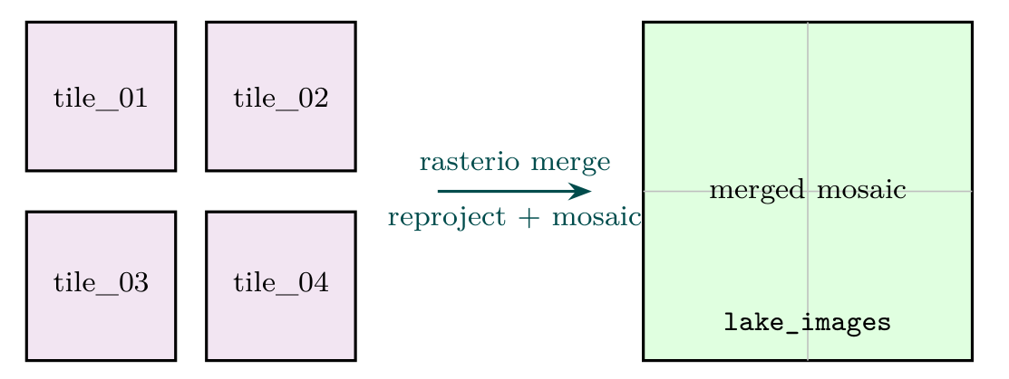
Note. Independent tile GeoTIFFs (a) are mosaicked by rasterio.merge into one seamless lake-year raster (b), recorded in lake_images - the “Merge Image Tiles” stage.

Embedding Generation: Analysis Cells through Pooling
Step 10 (Analysis-Cell Generation): the merged lake image is intersected with a regular 1×1 km analysis grid, and for each cell the lake coverage is computed,
Coverage(c) = [ Area(c ∩ Lake) / Area(c) ] × 100 (2)
with only cells above a 15% threshold retained, preventing cells that merely touch a lake's corner from being treated as representative.
Figure 7
Step 10 (Analysis-Cell Generation): coverage-based retention of 1 km cells.

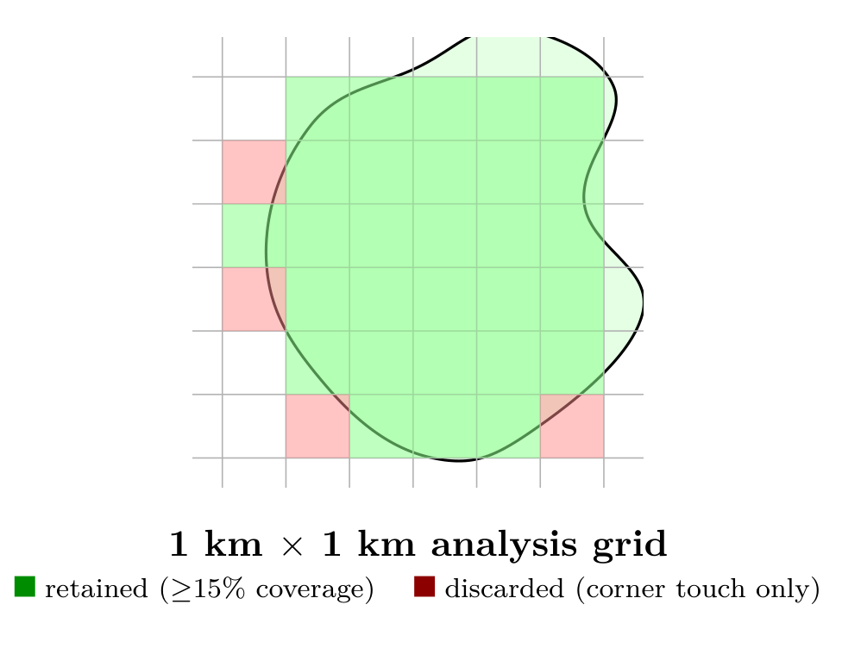
Note. The merged mosaic is intersected with a 1 km grid; cells with substantial coverage (green) are retained as embedding units, corner-touch cells below 15% (red) are discarded.

Steps 11–12 (Model Input Preparation and Prithvi Embedding Generation): each retained analysis cell is read from the local merged GeoTIFF and its six selected bands are converted into the model's expected tensor layout, numerical range, and spatial dimensions - kept as a distinct stage from inference so the model can be changed without re-downloading satellite data. Prithvi, the geospatial foundation model (NASA and IBM, n.d.), then transforms each six-band B2–B7 cell image X into a fixed-length feature vector f(X) → z ∈ ℝ⁷⁶⁸, batched eight at a time (EMBEDDING_GPU_BATCH_SIZE) on CPU inference. Every output vector is L2-normalised, so cosine similarity reduces exactly to the inner product and the entire similarity search can be executed as matrix multiplication.
Figure 8
Steps 11–12: cell tensor preparation and Prithvi embedding.
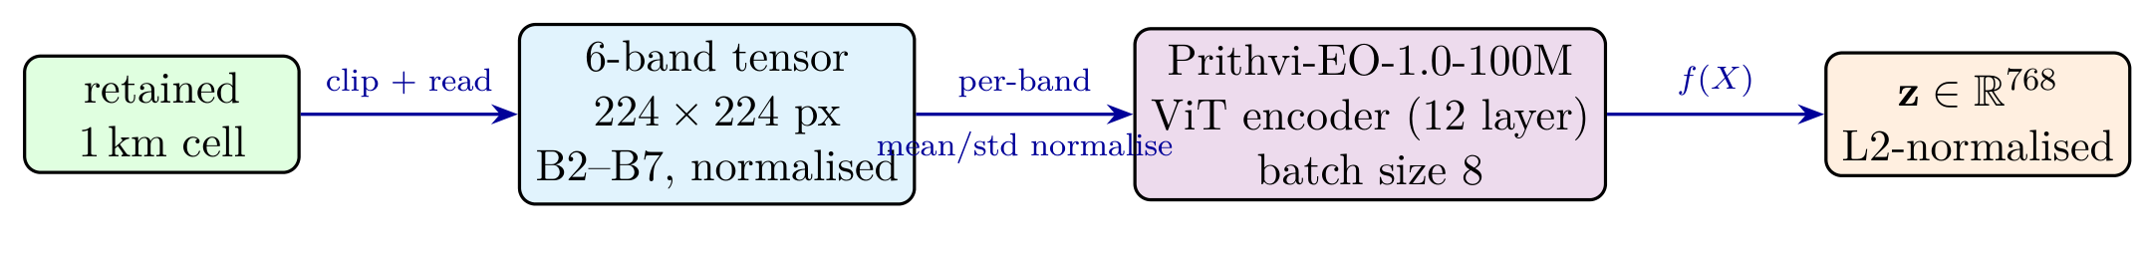
Note. Each retained cell is clipped and read as a 224×224-pixel, six-band tensor, normalised using Prithvi's own per-band mean/std, then batched into the Prithvi-EO-1.0-100M encoder - the only stage where the foundation model is invoked - producing a 768-d, L2-normalised vector.

Step 12a (Coverage-Weighted Lake-Level Pooling): cell-level embeddings preserve spatial detail, but retrieval and forecasting operate on lakes. For a lake-year with cells c₁,…,c_N having embeddings eᵢ and lake-coverage percentages wᵢ, the lake embedding is the coverage-weighted mean, re-normalised:
z_lake = ( Σᵢ wᵢ eᵢ ) / ‖ Σᵢ wᵢ eᵢ ‖₂ (3)
so a cell almost entirely filled by the lake contributes more than one that merely clips its margin; cells with zero coverage, zero vectors, or the wrong dimensionality are excluded before pooling. Across the cohort this reduces 233,002 cell embeddings to 8,227 lake-year vectors, an average of 28.3 cells per lake-year, with the cell-level vectors retained as the underlying evidence for any result the pooled vector produces.
Figure 9
Step 12a (Coverage-Weighted Pooling): weighted contribution of cell embeddings.
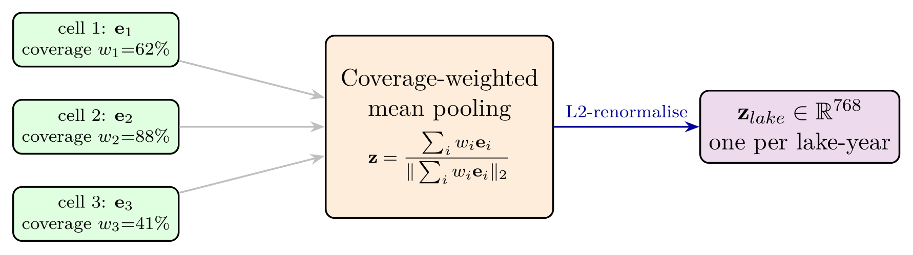
Note. Each cell embedding contributes in proportion to its coverage wᵢ (e.g. 88% outweighs 41%), and the weighted sum is L2-renormalised.

Before insertion, every embedding is checked for expected dimensionality, missing values, numerical validity, and correct lake/year/cell association, then stored in PostgreSQL via pgvector under the relationship Lake → Year → Spatial Cell → Embedding, preserving the provenance needed to explain why an ecosystem was retrieved as an analog.
Trajectory Similarity Search
Comparing one query embedding against one candidate asks only which lake looked like this lake, in this year? - too weak a question for forecasting, since two lakes can coincide in a single year and diverge over the following decade. EcoTwin instead asks which lake has been moving through the representation space the way this lake has been moving: a shared five-year path is a far better basis for projecting the next three.
For a query lake with embeddings ordered by year, EcoTwin forms the trajectory ending at anchor year t₀ with window size W = 5,
Q = ( q_(t₀−4), q_(t₀−3), q_(t₀−2), q_(t₀−1), q_(t₀) ) (4)
and each candidate lake with at least W years of history is expanded into every contiguous five-year window (ten years of data yields six windows),
C⁽ʲ⁾ = ( c_(yⱼ), …, c_(yⱼ+4) ), j = 1, …, n − W + 1 (5)
which need not align in calendar time with the query: a lake that underwent in 2017–2021 the transition another lake is undergoing in 2021–2025 is precisely the analog sought. Each window is scored as the mean of the year-by-year cosine similarities between corresponding positions,
S(Q, C⁽ʲ⁾) = (1/W) Σᵢ₌₁^W [ qᵢᵀ cᵢ⁽ʲ⁾ / (‖qᵢ‖₂ ‖cᵢ⁽ʲ⁾‖₂) ] (6)
which reduces to a mean of inner products, and each candidate lake is represented by its single best window,
S_lake = maxⱼ S(Q, C⁽ʲ⁾), j = argmaxⱼ S(Q, C⁽ʲ⁾) (7)
whose end year yⱼ+4 is the pivot on which the forecasting layer turns: the analog's observed behaviour after* that year is the evidence used to project the target's future.
Because every vector is unit-norm and drawn from one model, raw cosine scores cluster tightly just below 1.0 (measured top analogs span roughly 0.986–0.999 in the Ramsar case-study chapter), which would read as “99% similar” if displayed directly. EcoTwin therefore linearly rescales [φ, 1.0] → [0,1] with floor φ = 0.5,
S_display = clip₍₀,₁₎( (S* − φ) / (1 − φ) ) (8)
a monotone transform that changes no ranking; raw scores are reported alongside the rescaled ones in the Ramsar chapter so the distinction stays visible. Two further metrics are implemented and selectable per query (Euclidean distance mapped by 1/(1+d), and inner-product mapped by (⟨a,b⟩+1)/2), though cosine is the default.
The current implementation compares in Python across all candidate windows: with L lakes, n years, and dimension d, the cost is O(L·(n−W+1)·W·d), roughly 829×6×5×768 ≈ 1.9×10⁷ multiply-accumulates per query - measured at 141–172 ms in the Ramsar chapter, comfortably interactive but linear in lake count, motivating the pgvector ANN migration under future work.
Temporal Profiles and Directional Ecological Forecasting
Step 16 (Temporal Profile Generation): for the query lake and its retrieved analogs, the stored band statistics are assembled into per-year index series using the formulas of Table 3, computed on demand from the persisted band means rather than stored pre-computed, so a change to an index definition takes effect everywhere at once.
Step 17 (Directional Ecological Forecasting): the forecasting layer transfers measured change from the analogs onto the target. The most recent completed feature row for the target lake fixes the anchor year t₀ and anchor values v_k(t₀) for each index k; forecasts are produced for t₀+1, t₀+2, t₀+3. The trajectory search described above then runs with an enlarged candidate pool, walked in rank order: a candidate is admitted as a twin only if it is a different lake than the target, has a completed feature row at its matched window end year, and has at least one usable year after that, so the five twins that emerge are the five best usable analogs rather than merely the five highest-scoring rows.
For twin i with matched window ending at year mᵢ, the change transferred at offset h is δ_(i,k,h) = v_(i,k)(mᵢ+h) − v_(i,k)(mᵢ) - not the analog's absolute index value, which reflects its own climate and catchment, but the change it underwent, comparable across lakes in a way absolute values are not. Twins receive fixed weights by rank rather than weights derived from similarity scores,
ω₁ = 0.28, ω₂ = 0.24, ω₃ = 0.20, ω₄ = 0.16, ω₅ = 0.12 (9)
precisely because raw similarity scores compress into a narrow band near 1.0, where score-proportional weights would be nearly uniform. Twins do not all have data at every offset, so with A_(k,h) the set of twins with a usable delta for index k at offset h, weights are renormalised over exactly that set,
ω̃_(i,k,h) = ωᵢ / Σ_(j∈A(k,h)) ωⱼ, i ∈ A_(k,h) (10)
so a year with only two twins does not silently shrink toward “stable”; the twin count is reported separately as confidence. The score for index k at offset h is
Σ_(k,h) = Σ_(i∈A(k,h)) ω̃_(i,k,h) · δ_(i,k,h) (11)
classified against threshold τ = 0.005:
D_(k,h) = uncertain (?) if |A_(k,h)| < 2; up (↑) if Σ_(k,h) > +τ; down (↓) if Σ_(k,h) < −τ; stable (→) otherwise (12)
with uncertain checked first and kept distinct from stable: stable is a positive finding that the twins agree little changes, while uncertain admits too few twins had data to support any claim. An indicative magnitude v̂_k(t₀+h) = v_k(t₀) + Σ_(k,h) accompanies each direction, reported as an expected value rather than a calibrated point prediction. Every forecast returns a complete audit report - anchor values, weight scheme, classification rule, and each twin's identity, matched window, and weighted contribution - so any published direction can be recomputed by hand.
Unlike a parametric time-series model, whose prediction runs through learned parameters difficult to connect to a particular ecosystem, EcoTwin provides an explicit, inspectable chain: Target → Retrieved Twin → Similarity → Historical Trajectory → Projected Trajectory, with no learned parameter anywhere: every quantity is either a measured reflectance-derived index or a fixed, disclosed constant (ω₁..₅ and τ). An interval-based uncertainty measure (the spread across twin predictions) was considered and rejected in favour of the simpler twin count |A_(k,h)|, since a naive dispersion measure over a small, unevenly-weighted set is not a stable confidence signal, while the count drops to zero exactly when a forecast should not be trusted.
Why Not an LSTM-Based Forecast?
A recurrent-neural-network forecast was considered and rejected. Reddy and Prasad (2018) report strong LSTM accuracy for one-week MODIS NDVI prediction, but trained on 861 weekly observations per site. EcoTwin has only ten annual observations per lake across 829 lakes, a 1–3 year horizon (not one week), and a requirement that every forecast be traceable to specific evidence rather than trained weights - three conditions under which an LSTM would fit noise, cannot be individually retrained per lake, and (like decoding a predicted embedding) offers no correspondence back to a particular ecosystem. The rank-weighted transfer used instead needs no training data beyond the twins themselves.
Hindcasting Protocol
A rigorous accuracy evaluation requires hindcasting: hide each lake's final h_max years, run the identical pipeline using only years before the cutoff, and score the forecast against the held-out observations. For cutoff year t_c ∈ {2019,…,2022}, both the query trajectory and every candidate's embedding history are restricted to years ≤ t_c, producing v̂_k(t_c+h) for h = 1,2,3 compared against the actual recorded v_k(t_c+h). The protocol reports, per index and per horizon, both a magnitude metric and a directional hit rate:
MAE_(k,h) = (1/n) Σᵢ₌₁ⁿ | v_(k,i)(t_c+h) − v̂_(k,i)(t_c+h) | (13)
HitRate_(k,h) = (1/n) Σᵢ₌₁ⁿ 𝟙[ sign(Σ) = sign(Δ_actual) ] (14)
Running this at t_c = 2022 requires three held-out years (2023–2025) plus five years of prior history - exactly the ten years this project has, so a single cutoff gives only one evaluation point per lake, too coarse for a defensible aggregate accuracy figure. This protocol is therefore documented here as the immediate next step (see Future Work) rather than executed prematurely on insufficient data.

System Architecture and Implementation
Architecture Overview
EcoTwin is implemented as a multi-component system. The offline pipeline performs the computationally expensive work, while the online application retrieves precomputed data. Figure 10 shows the pipeline control strip from the deployed application: each button triggers one of the seven offline stages independently, which is what makes the pipeline resumable - a failure in one stage does not require re-running the stages before it.
Figure 10
The deployed pipeline control strip.
Note. Each stage (lake sync, imagery fetch, tile merge, embedding generation, embedding merge, feature generation, B8 fetch) is independently triggerable and independently resumable.

Technology Stack
Table 4
EcoTwin implementation stack.
Layer | Technology | Responsibility
Frontend | React 18, Vite, TypeScript | Interactive application
Mapping | Leaflet / React-Leaflet | Spatial visualization
Charts | Recharts | Index trajectory plots
Client state | Zustand, TanStack Query | Local state and server cache
Backend | FastAPI, Python 3.12 | REST services and orchestration
ORM / migrations | SQLAlchemy 2 (async), Alembic | Schema and access
Database | PostgreSQL 16 | Relational persistence
Spatial database | PostGIS 3.4 | Polygon and spatial queries
Vector search | pgvector | Embedding storage and similarity search
Remote sensing | Google Earth Engine | Satellite filtering/compositing
Raster processing | Rasterio, NumPy, Shapely | Local GeoTIFF processing
ML inference | Prithvi-EO-1.0-100M, PyTorch | Geospatial embeddings
Background work | FastAPI BackgroundTasks | Long-running pipelines
Logging | structlog | Structured pipeline logs
Reporting | Jinja2 + WeasyPrint | PDF report generation
Administration | pgAdmin | Database administration
Containerization | Docker Compose | Reproducible local deployment

Component Communication Workflow
Figure 11 traces how the five principal components exchange data, distinguishing offline-only calls (dashed, orange) from live user-request calls (solid, blue).
Figure 11
Component communication: online and offline data paths.
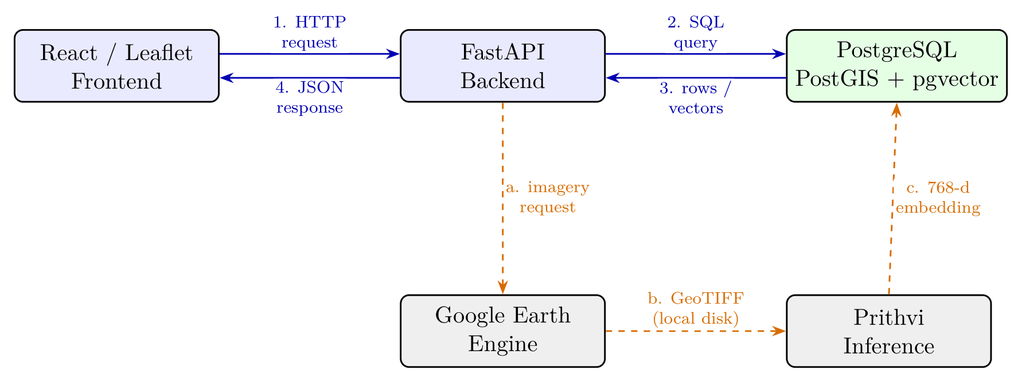
Note. Solid blue is the online request path (frontend → backend → database, serving every request from precomputed rows); dashed orange is the offline pipeline path (backend → Earth Engine → Prithvi → database), triggered by the pipeline control strip as BackgroundTasks.

Neither path bypasses the backend: every cross-component call passes through FastAPI, enforcing the offline/online separation in one place, so Earth Engine and the foundation model never run during a user request.
PostgreSQL, PostGIS, and pgvector
PostgreSQL is the central persistent store. PostGIS keeps lake and analysis-cell geometry in the database itself, so intersection, containment, area, and map-query operations run directly as SQL. The pgvector extension stores the 768-dimensional Prithvi vectors alongside this spatial data, maintaining the association Embedding ↔ Subregion ↔ Lake ↔ Year so similarity operations execute directly against the indexed database.
Core Database Entities
The deployed schema, reached after nineteen Alembic migrations, consists of the tables in Table 5.
Table 5
Deployed database tables and current row counts.
Table | Rows | Role
lakes | 11,130 | HydroLAKES inventory with PostGIS geometry; is_active marks the 829-lake processing cohort
lake_tiles | 19,046 | Earth Engine export tiles per lake-year
lake_images | 8,227 | Merged lake-year mosaics with path and status
sub_regions | 233,002 | 1 km analysis cells with geometry and coverage
regions | 8,227 | Pooled lake-year vector(768) embeddings
lake_features | 8,227 | Band statistics, indices, and texture per lake-year
india_states | 36 | State boundaries for spatial attribution
reports | - | Generated PDF report records

regions stores exactly one pooled 768-dimensional embedding per lake-year, enforced by a unique constraint on (lake_id, year). lake_features, the widest table in the schema, is the source of truth for measured reflectance: per-band statistics, pixel/coverage counts, cloud percentage, and GLCM texture, from which the forecasting layer derives indices on demand. Keeping embeddings and measured reflectance in separate tables is what makes the decoder-free forecast possible: the embedding space answers which lakes are analogs, the feature table answers what measurably happened to them.
Backend and Frontend
The FastAPI backend provides services for lake metadata lookup, analog similarity search, temporal feature retrieval, forecast retrieval, report generation, and system status, separating cheap data retrieval from heavy batch processing. The frontend, built on React/Vite/TypeScript with Leaflet mapping, lets a user select a lake, view its boundary, request analogs, visualize their locations and scores, and inspect historical profiles alongside the forecast; displayed geometry is drawn from the same PostGIS source used for the analysis itself, avoiding disagreement between result and map.
Asynchronous Processing and Progress Tracking
Imagery download, raster merging, and model inference all take far longer than an acceptable HTTP request, so each runs through FastAPI's BackgroundTasks and returns immediately. A distributed task queue was considered and not adopted: the durable state it would provide already exists in the database, where every row carries its own status. Progress is exposed through module-level state guarded by a lock (counts, elapsed time, throughput, projected completion), polled by the frontend; long jobs are also cancellable, stopping after the current lake-year rather than mid-write.
Server-Side B8 Acquisition
Unlike B2–B7, which must be downloaded as pixels for Prithvi inference, B8 is needed only as summary statistics, so the B8 pipeline performs the reduction entirely on Earth Engine's servers using Image.reduceRegions(): lake polygons are batched fifteen at a time and reduced against a single annual composite, so only the resulting numbers are transferred and no imagery is downloaded. A separate b8_status column tracks this pipeline independently, completed for all 8,227 lake-years.
Figure 12
Stage 7 (Fetch B8): server-side zonal reduction with no local raster.
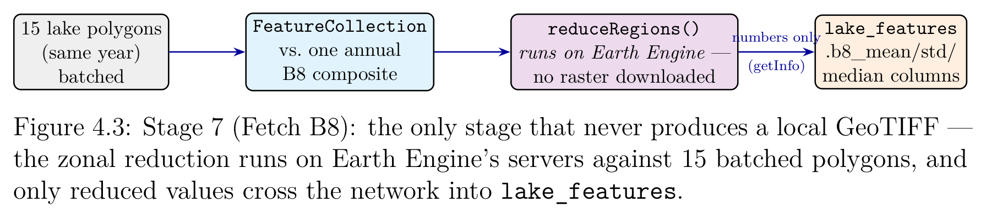
Note. The only stage that never produces a local GeoTIFF - the zonal reduction runs on Earth Engine's servers against 15 batched polygons, and only reduced values cross the network into lake_features.

Automated PDF Report Generation
The application generates a per-lake PDF report through a Jinja2 template rendered by WeasyPrint, assembling lake metadata, a map of the lake and its analogs, historical index trajectories, the ranked analog table, and the directional forecast with its audit trail - an offline deliverable for users who need a citable artifact.
Configuration Management
The processing pipeline reads experiment-specific values - Earth Engine credentials, date ranges, cloud thresholds, buffer/tile/cell sizing, coverage threshold, storage paths, and worker/batch settings - from environment configuration rather than hard-coding them.

Experimental Results and Engineering Evaluation
Deployed Processing Cohort
The HydroLAKES-derived inventory holds 11,130 Indian lakes. Of these, 829 are flagged is_active and constitute the fully processed cohort; the remainder are retained as inventory and map context but were not put through the expensive imagery and embedding stages. Selection favoured lakes large enough to yield meaningful multi-cell coverage at 10 m resolution, with a minimum area of 2 km².
Table 6
Deployed EcoTwin processing configuration.
Parameter | Value
Lake source | HydroLAKES
Active processing cohort | 829 lakes, 26 states
Cohort area range | 2.00–843.22 km² (mean 19.06)
Cohort elevation range | −6 – 4,985 m
Imagery window | 2016–2025 (10 years)
Primary Sentinel collection | S2 SR Harmonized
Fallback collection | S2 Level-1C
Scene cloud-cover limit | 20%
Composite method | Annual median
Imagery buffer | 1,200 m
Imagery tile size | 8,500 m
Analysis cell | 1,000 m × 1,000 m
Coverage threshold | 15%
Spatial resolution | 10 m
Embedding model | Prithvi-EO-1.0-100M
Embedding dimension | 768
Input bands | B2–B7 (6 bands)
Auxiliary band | B8 (statistics only)
Pooling | Coverage-weighted mean, L2-normalised
Similarity metric | Cosine over 5-year trajectories
Forecast horizon | 3 years

Similarity Search Performance
Table 7 reports measured search performance over the five Ramsar queries of the applied-analysis chapter, each executed against the full deployed index.
Table 7
Measured trajectory-similarity search performance.
Query lake | Candidates | Best raw cosine
Chilika | 828 | 0.99691
Maharana Pratap Sagar (Beas) | 828 | 0.99884
Tawa Reservoir | 828 | 0.99936
Tso Morari | 828 | 0.99720
Sasthamcotta | 828 | 0.99784
Mean | 828 | 0.99803

Each query evaluates roughly 4,900 candidate windows at 768 dimensions, comfortably interactive, and the index is fully scanned rather than approximated, so the returned ranking is exact.
The Score Compression Problem
Measured raw cosine scores across all five queries fall between 0.9969 and 0.9987, with the tenth-ranked analog typically within 0.005 of the first - expected since every vector shares one encoder and describes the same general scene type, so the absolute score is close to uninformative and only the ordering carries signal. Ecological interpretation therefore requires additional evidence from lake metadata, spatial maps, and temporal indicators (see the applied-analysis chapter); a meaningful absolute scale would require calibration against labelled ecosystem pairs (see Future Work).
Temporal Profile Results
The temporal layer provides a second, independent axis of validation alongside spatial similarity: EcoTwin presents the full ten-year series of all five indices, observation availability, and the directional forecast with its contributing twins. Its value is demonstrated concretely in the applied-analysis chapter, where several sites' top analogs are geographically unrelated to the query lake yet still share its independently measured historical trend.
Processing Reliability
The system tolerates partial failure by design: a lake-year can be pending, processing, completed, failed, or skipped because its output already exists, making large multi-year jobs restartable instead of requiring a complete restart after one failed request.
Engineering Problems Encountered
Several recurring problems shaped the implementation. Large Earth Engine requests sometimes produced memory-limit errors, solved by reducing export region size and moving processing locally; parallel workers caused HTTP 429 and connection-pool errors, pushing the pipeline toward smaller controlled worker counts and resumable jobs. The early Sentinel-2 Level-1C fallback exposed different quality bands than other collections, leading to collection-aware preprocessing rather than a hard-coded cloud mask. Merged rasters can become much larger than individual tiles, making compression and tiled GeoTIFF writing important; the local filesystem once reached 100% utilization, demonstrating that the pipeline must account for intermediate storage, not only final dataset size. Finally, Earth Engine authentication depends on external network services, so authentication is kept separate from per-lake processing and failures are recorded rather than silently producing incomplete data.
Because the project was developed by multiple team members, a database consolidation procedure was also designed: each developer's PostgreSQL dump is restored into a temporary database, validated, and merged into production, preserving PostGIS geometries and pgvector embeddings in a way CSV-based migration could not.

Applied Analysis: Five Ramsar Wetlands and Reservoirs
Purpose and Site Selection
This chapter runs the system end to end on five Ramsar-designated sites, including inconclusive results: Chilika, Tso Morari, Maharana Pratap Sagar (Pong Dam, on the Beas), Tawa Reservoir, and Sasthamcotta. Ramsar designation does not by itself supply a checkable public condition report, so each site closes with a Documented Condition subsection that searches for one and reports the match honestly - ranging from Chilika's renewed-weed-growth reports lining up with the measured signal, through Beas and Tawa (no published directional trend to check against), to Sasthamcotta, whose documented pressures the measured signal only partly matches. Tso Morari additionally offers the chapter's strongest independent corroboration via its Pangong Tso analog pairing (see Discussion). The five sites, all with complete ten-year records, span a deliberately wide range of climate, altitude, and water-body type.
Table 8
The five Ramsar-designated sites analysed.
Site | State | Area (km²) | Elev. (m) | Type
Chilika | Odisha | 843.22 | 1 | Brackish coastal lagoon
Tso Morari | Ladakh | 141.25 | 4522 | High-altitude cold desert
Tawa Reservoir | Madhya Pradesh | 101.61 | 348 | Irrigation reservoir (Ramsar site, 2024)
Maharana Pratap Sagar (Beas) | Himachal Pradesh | 189.40 | 407 | Himalayan-foothill reservoir (Pong Dam)
Sasthamcotta | Kerala | 3.19 | 4 | Freshwater lake, drinking-water reservoir
Note. All five have complete 2016–2025 embedding and feature coverage.

The spread - sea level to 4522 m, tropical estuary to Trans-Himalayan cold desert, two orders of magnitude in area - is deliberate: a system that only worked on lakes resembling one another would be exposed by it.
Every site was analysed under an identical protocol: a five-year query trajectory (2021–2025), a sliding-window search over all 828 other lakes, selection of the top five usable twins, delta extraction, fixed rank weights with per-year renormalization, and classification at τ = 0.005, with anchor year 2025 and forecasts covering 2026–2028.
Chilika Lagoon, Odisha
Chilika is Asia's largest brackish-water lagoon and the largest lake in the cohort (843 km²), separated from the Bay of Bengal by a barrier spit.
Figure 13
Chilika's lake boundary in the live application.
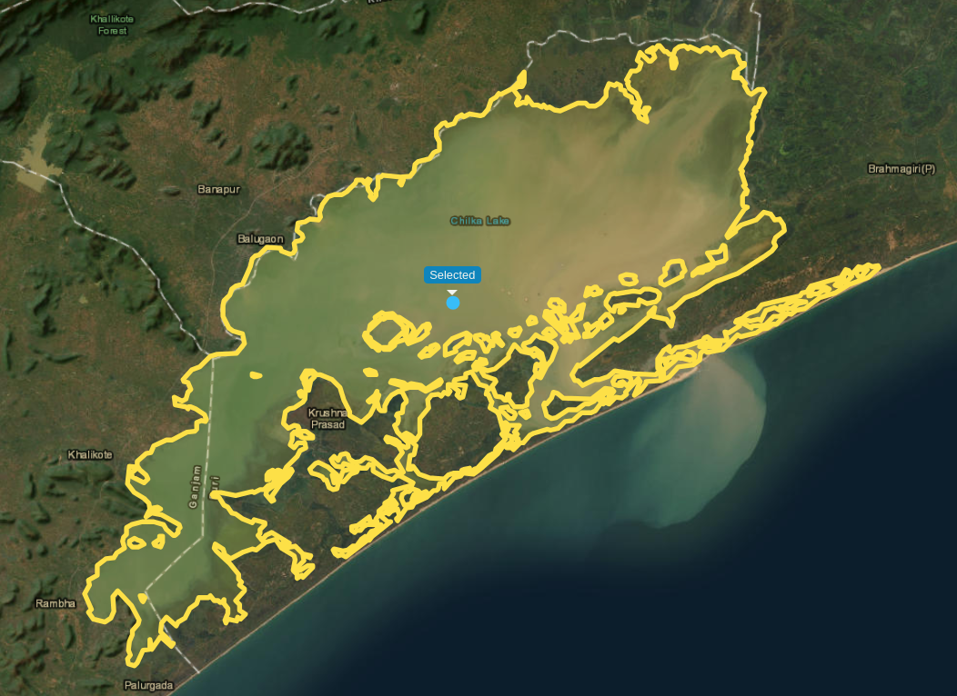

Retrieved Analogs
Table 9
Chilika - top five analogs (828 candidates, 146 ms).
# | Lake | State | Area | Raw cos. | Window
1 | 15704 | Andhra Pradesh | 12.28 | 0.99691 | 2017–2021
2 | Govind Ballabh Pant | Uttar Pradesh | 398.80 | 0.99646 | 2021–2025
3 | 177805 | Gujarat | 6.90 | 0.99554 | 2019–2023
4 | 15714 | Telangana | 27.56 | 0.99550 | 2018–2022
5 | 1509 | Telangana | 335.78 | 0.99536 | 2020–2024

Three of the five matched windows are time-shifted: the top analog matched on 2017–2021, so its 2022–2024 behaviour is already-observed evidence about a trajectory Chilika is only now traversing.
Figure 14
Chilika's retrieved analogs in the live application.
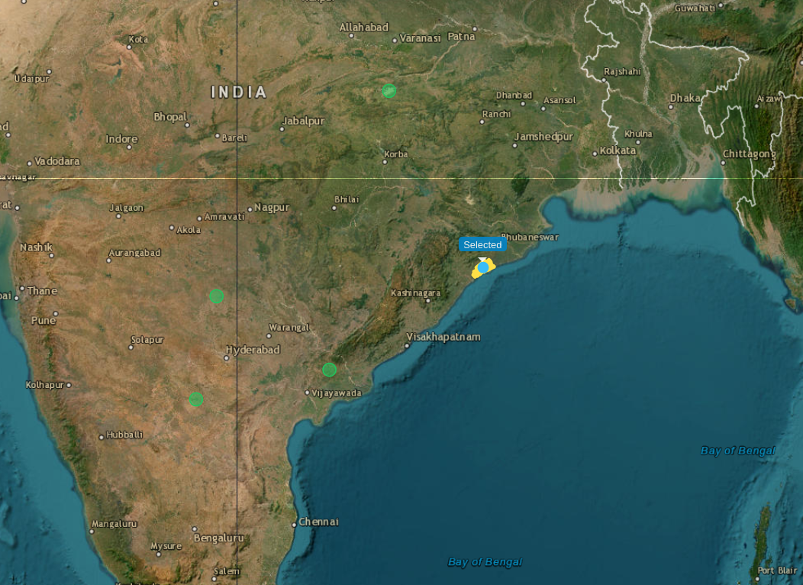

Measured History
Table 10
Chilika - measured index history, 2016–2025.
Index | 2016 | 2018 | 2020 | 2022 | 2024 | 2025
NDCI | 0.0360 | 0.0323 | 0.0463 | 0.0518 | 0.0527 | 0.0415
NDVI | −0.0773 | −0.1893 | −0.1410 | −0.1246 | −0.1092 | −0.1280
NDWI | 0.1231 | 0.3170 | 0.2688 | 0.2258 | 0.2161 | 0.2441
Turbidity | −0.0463 | −0.1359 | −0.1328 | −0.1041 | −0.1095 | −0.1198
Red-edge slope | −2.3037 | −2.9020 | −2.5017 | −2.7318 | −2.2062 | −2.3865

Figure 15
Chilika - measured index trajectory, 2016–2025.
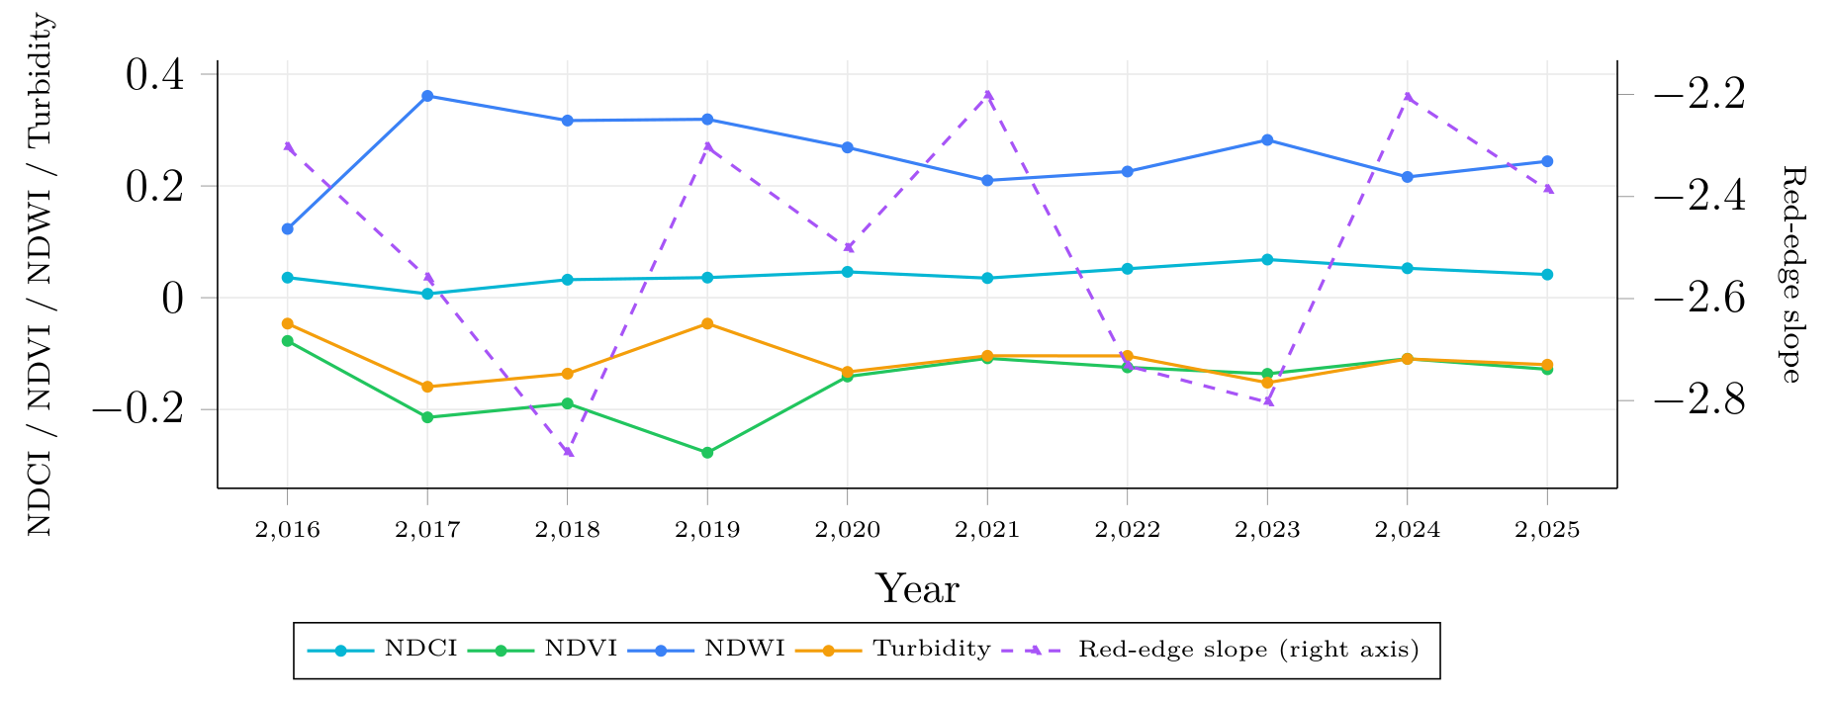

The persistently negative NDVI and positive NDWI are the expected signature of a large, genuinely open water body.
Forecast
Table 11
Chilika - directional forecast 2026–2028.
Index | 2026 | 2027 | 2028
NDCI | → (+0.0029, n=5) | → (+0.0008, n=4) | ↑ (+0.0391, n=3)
NDVI | ↑ (+0.0253, n=5) | ↑ (+0.0420, n=4) | ↑ (+0.0730, n=3)
NDWI | ↓ (−0.0219, n=5) | ↓ (−0.0578, n=4) | ↓ (−0.0986, n=3)
Turbidity | → (−0.0032, n=5) | ↑ (+0.0219, n=4) | ↑ (+0.0333, n=3)
Red-edge | ↑ (+0.2800, n=5) | ↑ (+0.3180, n=4) | ↑ (+0.2312, n=3)

Figure 16
Chilika - projected index trajectory, 2025–2028.
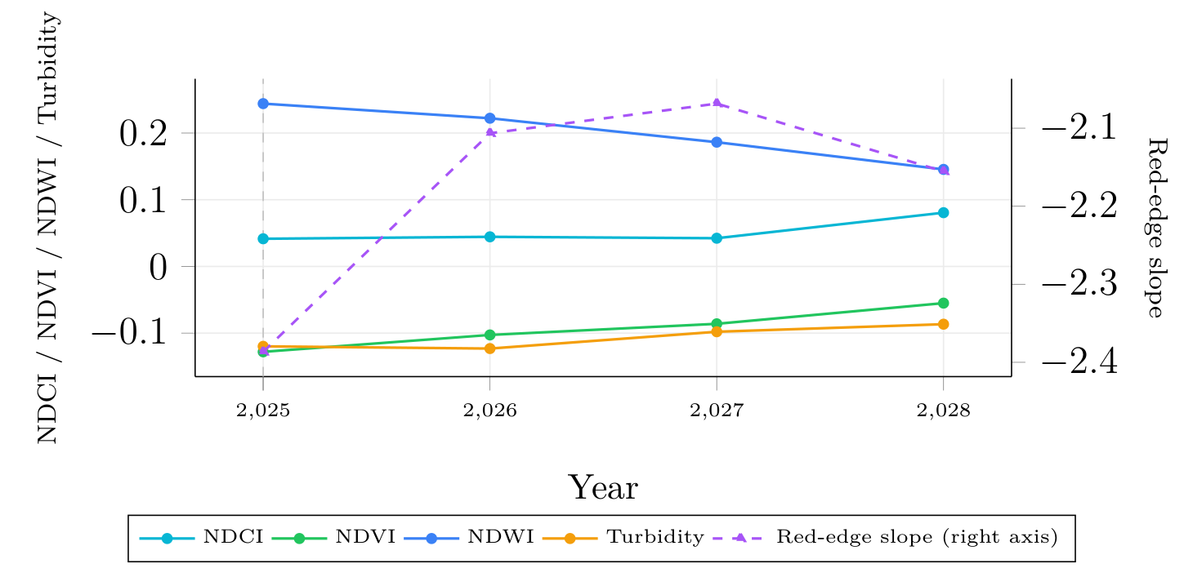
The forecast is internally coherent: NDVI rises while NDWI falls by a comparable magnitude every year (both share B8), and rising red-edge slope and turbidity reinforce the same reading - gradual vegetative encroachment and reduction of open water - with the declining twin count (5, 4, 3) signalling 2028 should be read more cautiously than 2026.
Documented Condition
Chilika's weed cover exploded from ~20 to ~685 km² between 1972 and 2000 as siltation reduced salinity, prompting the 2000 sea-mouth reopening that sharply cut weed cover (Chilika Development Authority, n.d.). Since then, the reed Phragmites karka (locally Nala dala) has spread across the lagoon's northern sector, from 76.4 to 105.1 km² between 2000 and 2010, affecting fisheries (Kumar et al., 2011) - consistent with the gradual encroachment signal measured here, a real but far milder trend than the pre-2000 crisis.
Maharana Pratap Sagar (Beas), Himachal Pradesh
Maharana Pratap Sagar - the reservoir impounded by the Pong Dam on the Beas River, a Ramsar site since 2002 and a major wintering ground for migratory waterfowl in the western Himalayan foothills - is identified in the dataset by its source river, Beas (lake_id 1423). Unlike the natural wetlands elsewhere in this chapter, it is a dam-regulated reservoir, so its surface extent and shoreline vegetation respond to reservoir operations (drawdown and refill) as much as to natural hydrology or ecological succession.
Figure 17
Beas (Maharana Pratap Sagar)'s lake boundary in the live application.
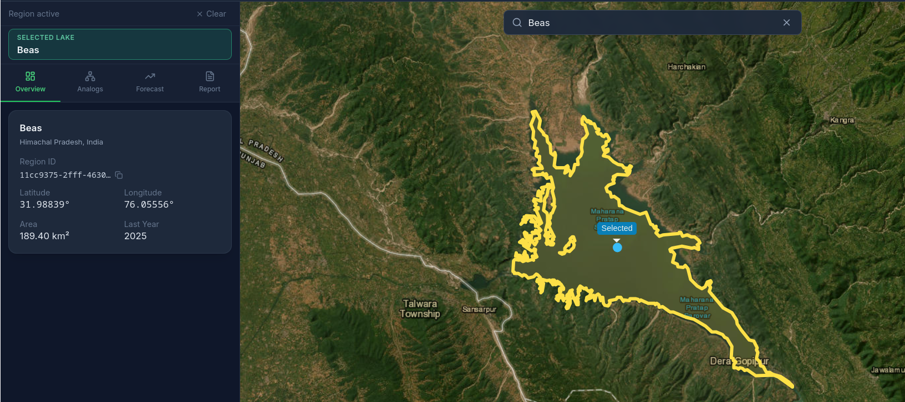

Retrieved Analogs
Table 12
Beas - top five analogs (828 candidates).
# | Lake | State | Area | Raw cos. | Window
1 | Gandhisagar Reservoir | Madhya Pradesh | 523.51 | 0.99884 | 2021–2025
2 | 15581 | Chhattīsgarh | 28.46 | 0.99824 | 2021–2025
3 | 15672 | Telangana | 49.45 | 0.99816 | 2020–2024
4 | 178210 | Chhattīsgarh | 8.75 | 0.99812 | 2020–2024
5 | 15727 | Andhra Pradesh | 19.52 | 0.99810 | 2016–2020

The top analog is itself another large dam reservoir (Gandhisagar, on the Chambal), sharing Beas's man-made, regulated character. The two top-ranked analogs' matched windows both end at 2025 (the anchor year), so neither has an observed future to contribute; the twins actually used for forecasting are drawn from further down the ranked pool.
Figure 18
Beas's retrieved analogs in the live application.
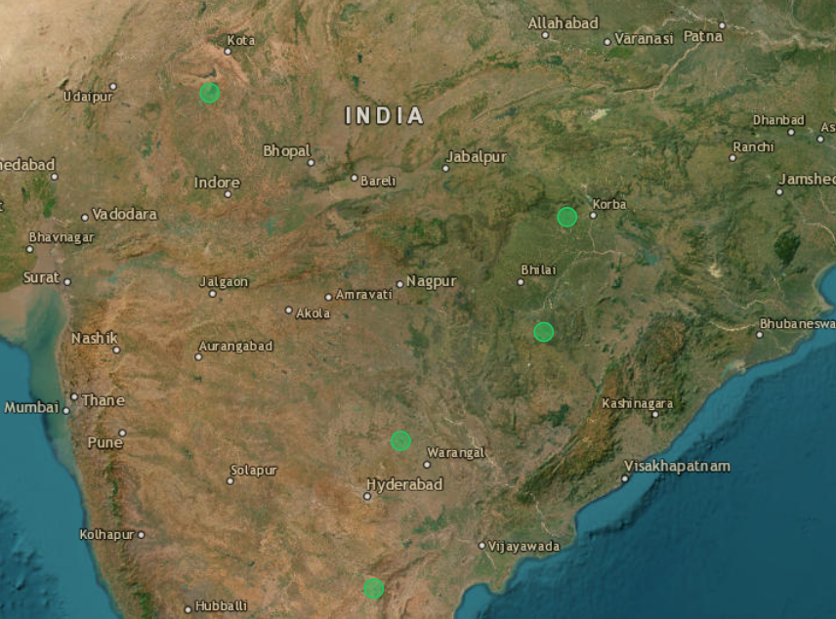

Measured History
Table 13
Beas - measured index history, 2016–2025.
Index | 2016 | 2018 | 2020 | 2022 | 2024 | 2025
NDCI | −0.0039 | −0.0061 | −0.0231 | 0.0589 | −0.0021 | 0.0208
NDVI | −0.0996 | −0.0818 | −0.1595 | 0.0749 | −0.1185 | −0.2293
NDWI | 0.2673 | 0.2647 | 0.3680 | 0.1325 | 0.2746 | 0.3733
Turbidity | −0.1723 | −0.1870 | −0.2215 | −0.2054 | −0.1614 | −0.1574
Red-edge slope | −0.8025 | −0.7993 | −0.5696 | 0.2272 | −0.9782 | −2.8268

Figure 19
Beas - measured index trajectory, 2016–2025.
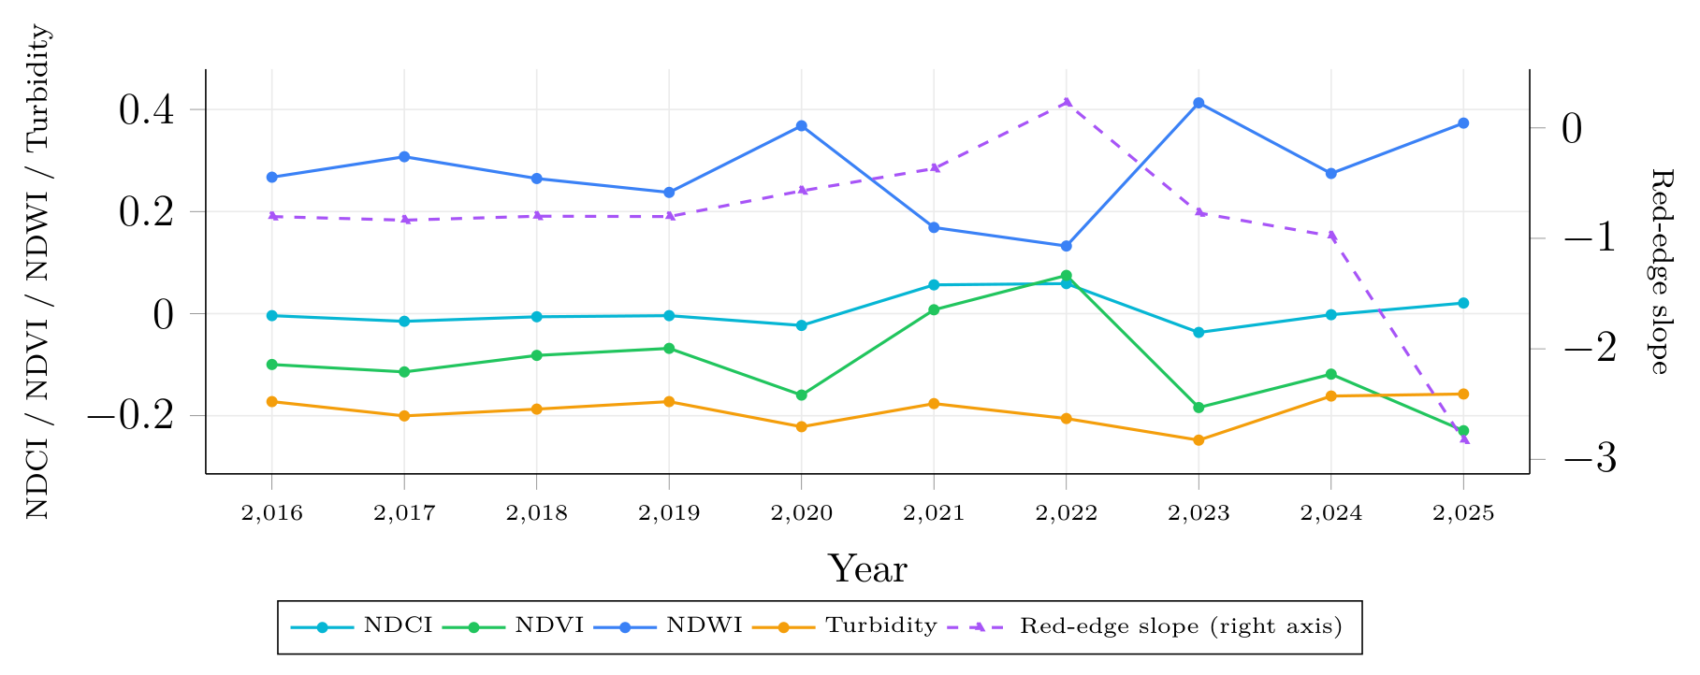

Beas shows no sustained directional trend: NDVI oscillates between roughly −0.23 and +0.07 and NDWI between 0.13 and 0.41 with no monotone drift, consistent with a reservoir whose surface extent is driven by dam operations (seasonal drawdown and refill for irrigation and hydropower) rather than by a one-way ecological process. The red-edge slope is the most volatile series measured anywhere in this study, swinging from +0.23 in 2022 to −2.83 in 2025 - a signal to read cautiously rather than as a pigment trend, since it is exactly the kind of index a fluctuating reservoir shoreline can perturb independently of vegetation health.
Forecast
Table 14
Beas - directional forecast 2026–2028.
Index | 2025 | 2026 | 2027 | 2028
NDCI | 0.0208 | ↓ (−0.0276, n=5) | ? (n=1) | ? (n=1)
NDVI | −0.2293 | ↑ (+0.0123, n=5) | ? (n=1) | ? (n=1)
NDWI | 0.3733 | → (−0.0006, n=5) | ? (n=1) | ? (n=1)
Turbidity | −0.1574 | ↓ (−0.0118, n=5) | ? (n=1) | ? (n=1)
Red-edge | −2.8268 | ↑ (+0.5993, n=5) | ? (n=1) | ? (n=1)

Figure 20
Beas - projected index trajectory, 2025–2028.
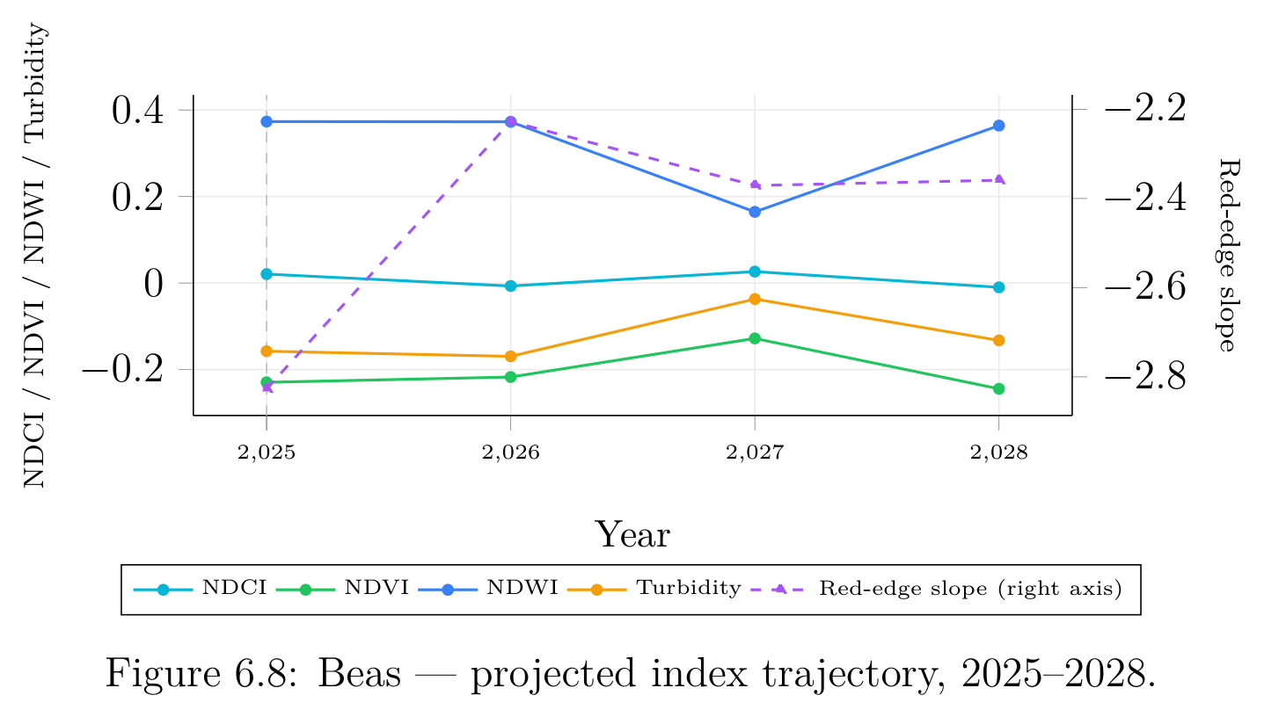

Interpretation
Beas shows the most confidence degradation in the study: four of its five twins matched on windows ending in 2024, leaving only 2026 (h=1) with all five contributing (n=5,1,1), so 2027/2028 are correctly reported as uncertain rather than resting on one lake's trajectory. The 2026 read is mild: NDCI down, NDVI and red-edge up, NDWI essentially flat.
Documented Condition
Public documentation of Maharana Pratap Sagar (Pong Dam Lake) centres on its status as a Ramsar-designated bird sanctuary and a multi-use reservoir combining fishery and hydroelectric generation (Ramsar Convention Secretariat, 2002a). No published account of a directional trend specific to this reservoir was found - consistent with, but not confirmation of, the oscillating, no-sustained-trend signal measured here.
Tawa Reservoir, Madhya Pradesh
Tawa Reservoir is a large irrigation and flood-control reservoir on the Tawa River, a tributary of the Narmada, in Madhya Pradesh's Narmadapuram district, within the Satpura Tiger Reserve - notified as a Ramsar site of international importance in 2024. It is included here as a second dam-regulated freshwater comparison point alongside Beas, replacing Loktak, which turned out not to be identifiable with confidence in the active processing cohort (there is no lake named “Loktak” in the underlying HydroLAKES-derived table; the earlier identification of lake_id 15510 with Loktak was an unverified inference from area and state alone).
Figure 21
Tawa Reservoir's lake boundary in the live application.
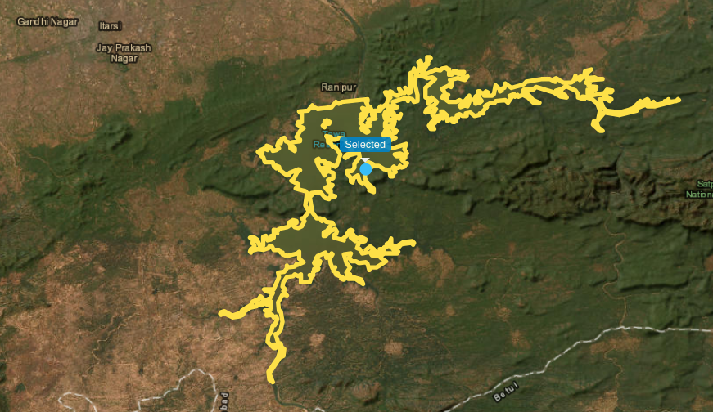

Retrieved Analogs
Table 15
Tawa Reservoir - top five analogs (828 candidates).
# | Lake | State | Area | Raw cos. | Window
1 | 15544 | Madhya Pradesh | 15.03 | 0.99936 | 2021–2025
2 | 15634 | Maharashtra | 15.54 | 0.99931 | 2019–2023
3 | 15616 | Maharashtra | 39.91 | 0.99926 | 2017–2021
4 | 178333 | Telangana | 5.12 | 0.99921 | 2019–2023
5 | 15577 | Madhya Pradesh | 36.00 | 0.99913 | 2021–2025

The top and fifth-ranked analogs both match on windows ending at 2025 and so carry no observed future, so the forecast twins used below are drawn from ranks 2–4 plus two further candidates.
Figure 22
Tawa Reservoir's retrieved analogs in the live application.
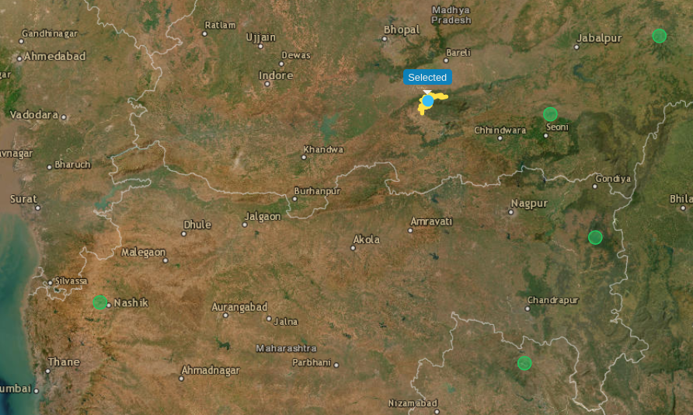

Measured History
Table 16
Tawa Reservoir - measured index history, 2016–2025.
Index | 2016 | 2018 | 2020 | 2022 | 2024 | 2025
NDCI | −0.0874 | 0.0479 | 0.0011 | 0.0009 | −0.0107 | −0.0423
NDVI | −0.2939 | 0.0681 | −0.1323 | −0.0890 | −0.1606 | −0.1918
NDWI | 0.4824 | 0.0059 | 0.2650 | 0.2450 | 0.3178 | 0.3701
Turbidity | −0.2197 | −0.0739 | −0.1375 | −0.1595 | −0.1657 | −0.1920
Red-edge slope | −1.3090 | 0.2360 | −1.1605 | −0.5719 | −0.9505 | −0.9585

Figure 23
Tawa Reservoir - measured index trajectory, 2016–2025.
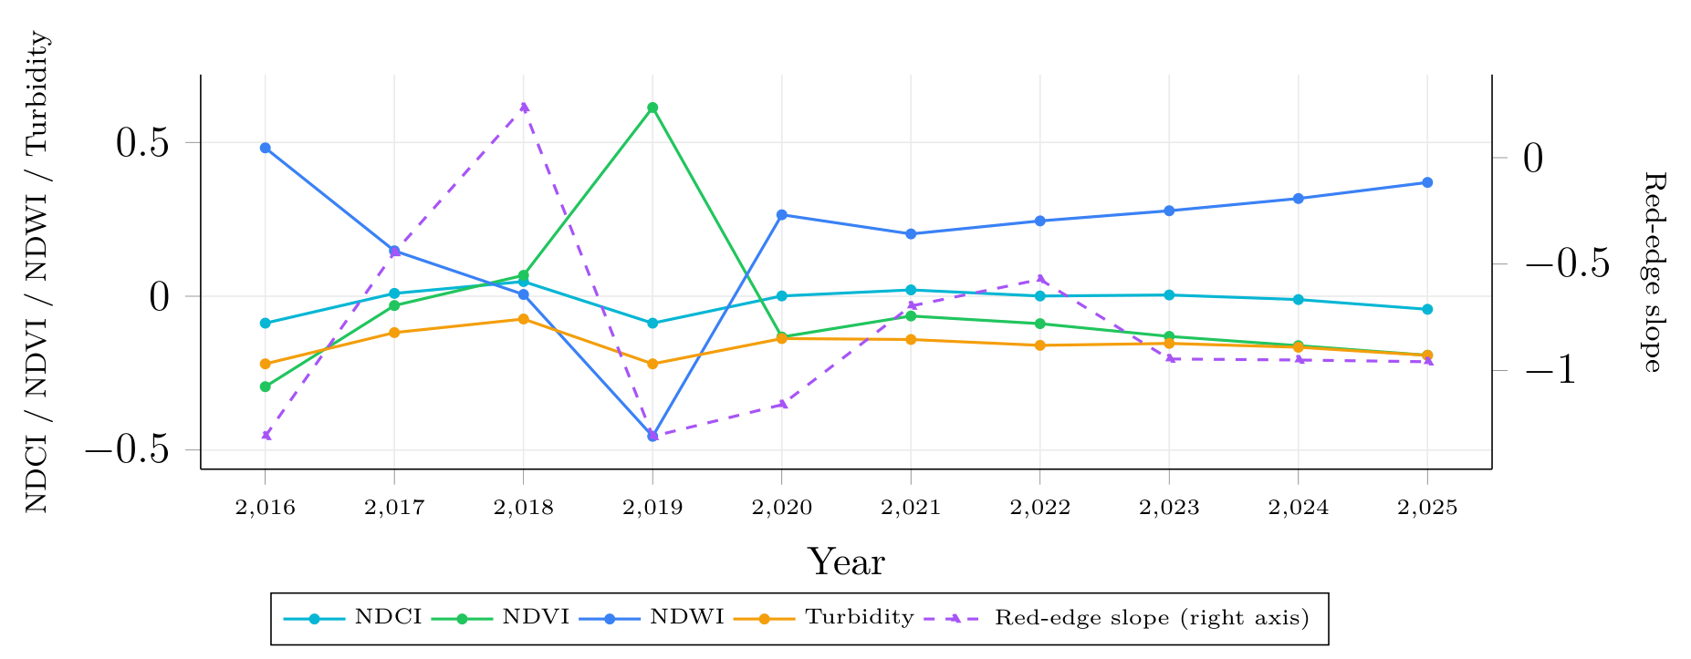

Like Beas, Tawa shows no sustained one-way trend - every index oscillates across the decade rather than drifting monotonically, consistent with a managed reservoir where surface water extent tracks irrigation releases and monsoon refill rather than a directional ecological process. 2018 stands out as a local extremum across all five indices simultaneously (least negative NDCI/NDVI, lowest NDWI, least negative turbidity, only positive red-edge slope value in the series) - most plausibly a single unusually dry or low-water year rather than a data artifact, though it was not independently cross-checked against reservoir operation records.
Forecast
Table 17
Tawa Reservoir - directional forecast 2026–2028.
Index | 2025 | 2026 | 2027 | 2028
NDCI | −0.0423 | ↑ (+0.0129, n=5) | ↓ (−0.0158, n=5) | ↑ (+0.0200, n=2)
NDVI | −0.1918 | ↑ (+0.0207, n=5) | ↓ (−0.0071, n=5) | ↑ (+0.0056, n=2)
NDWI | 0.3701 | ↓ (−0.0420, n=5) | ↑ (+0.0132, n=5) | ↓ (−0.0348, n=2)
Turbidity | −0.1920 | ↑ (+0.0249, n=5) | ↓ (−0.0075, n=5) | ↑ (+0.0316, n=2)
Red-edge | −0.9585 | ↓ (−0.0282, n=5) | ↑ (+0.0673, n=5) | ↓ (−0.1696, n=2)

Figure 24
Tawa Reservoir - projected index trajectory, 2025–2028.
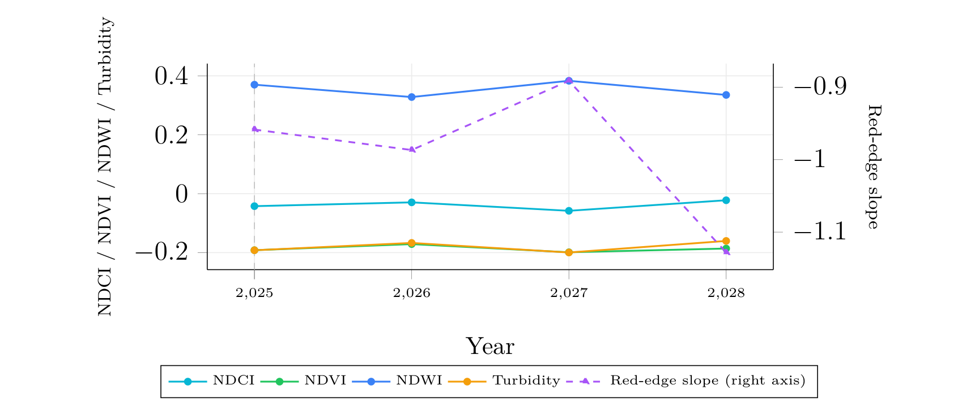

Interpretation
Every index alternates direction year over year, an oscillatory forecast that mirrors the oscillation already visible in the measured decade rather than projecting a new one-way trajectory. Confidence holds at n=5 for 2026–2027 before dropping to n=2 in 2028; the 2028 red-edge score (−0.1696) is the largest-magnitude cell in this table but rests on only two twins, so it should be read as suggestive, not calibrated.
Documented Condition
Tawa Reservoir was designated a Ramsar site on 8 January 2024, an addition announced by the Ministry of Environment, Forest and Climate Change (MoEFCC, 2024) that August, on the strength of its biodiversity: 57 fish species, 21 mammals, and over 280 migratory birds (Ramsar Sites Information Service, 2024). As with Beas, no documented one-way ecological trend was found to check the measured oscillation against - the designation reflects current ecological richness rather than a published condition trajectory.
Tso Morari, Ladakh
Tso Morari is a high-altitude brackish lake at 4522 m in the Trans-Himalayan cold desert - the cohort's environmental extreme, with minimal vegetation and glacial meltwater input.
Figure 25
Tso Morari's lake boundary in the live application.
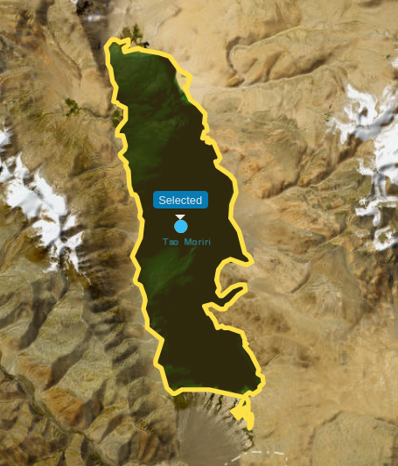
Retrieved Analogs - The Strongest Validation
Table 18
Tso Morari - top five analogs (828 candidates, 160 ms).
# | Lake | State | Area | Raw cos. | Window
1 | Pangong Tso | Ladakh | 285.46 | 0.99720 | 2021–2025
2 | 178351 | Maharashtra | 8.52 | 0.98816 | 2021–2025
3 | 15661 | Maharashtra | 10.12 | 0.98781 | 2021–2025
4 | 178391 | Maharashtra | 3.06 | 0.98769 | 2021–2025
5 | 15828 | Kerala | 26.07 | 0.98599 | 2021–2025

This is the single most convincing retrieval result in the study. Out of 828 candidates spanning 26 states, the top-ranked analog for Tso Morari is Pangong Tso - the other great high-altitude brackish lake of Ladakh, roughly 120 km away - recovered from reflectance alone, with no coordinates or lake-type metadata supplied. The score gap makes it stronger still: 0.99720 against rank 2's 0.98816, five times the spread between ranks 2 and 5, indicating the embedding space genuinely isolates high-altitude cold-desert lakes as a distinct class.
Figure 26
Tso Morari's ranked analogs in the live application; Pangong returns at rank 1.
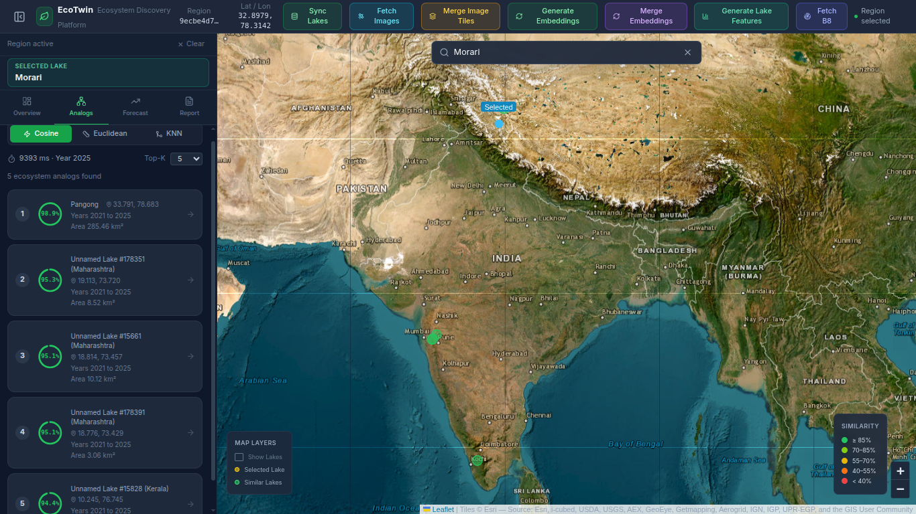

Measured History
Table 19
Tso Morari - measured index history, 2016–2025.
Index | 2016 | 2018 | 2020 | 2022 | 2024 | 2025
NDCI | −0.0396 | −0.0212 | −0.0417 | −0.0450 | −0.0337 | −0.0376
NDVI | −0.1584 | −0.1030 | −0.1000 | −0.0926 | −0.0501 | −0.0510
NDWI | 0.5315 | 0.2805 | 0.4086 | 0.3934 | 0.2849 | 0.3371
Turbidity | −0.4074 | −0.1828 | −0.3217 | −0.3121 | −0.2382 | −0.2912
Red-edge slope | −0.0893 | −0.2676 | −0.1009 | −0.0617 | −0.0007 | −0.0446
Figure 27
Tso Morari - measured index trajectory, 2016–2025.
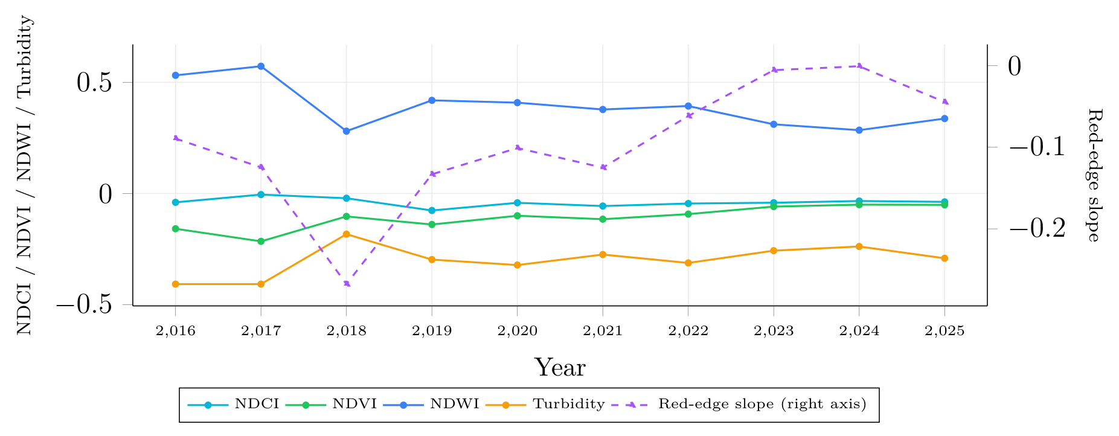

Tso Morari records the highest NDWI (0.53) and most negative turbidity (−0.41) in the study - the signature of exceptionally clear, vegetation-free, glacier-fed water, and the opposite extreme from Sasthamcotta's vegetation-heavy 2016 reading.
Forecast
Table 20
Tso Morari - directional forecast 2026–2028.
Index | 2025 | 2026 | 2027 | 2028
NDCI | −0.0376 | ↑ (+0.0204, n=5) | → (+0.0046, n=5) | ↓ (−0.0057, n=5)
NDVI | −0.0510 | ↑ (+0.0310, n=5) | ↑ (+0.0262, n=5) | ↓ (−0.0145, n=5)
NDWI | 0.3371 | ↓ (−0.0482, n=5) | ↓ (−0.0260, n=5) | ↓ (−0.0062, n=5)
Turbidity | −0.2912 | ↑ (+0.0204, n=5) | ↓ (−0.0058, n=5) | ↑ (+0.0172, n=5)
Red-edge | −0.0446 | ↑ (+0.0499, n=5) | ↑ (+0.2908, n=5) | ↓ (−0.0522, n=5)

Figure 28
Tso Morari - projected index trajectory, 2025–2028.
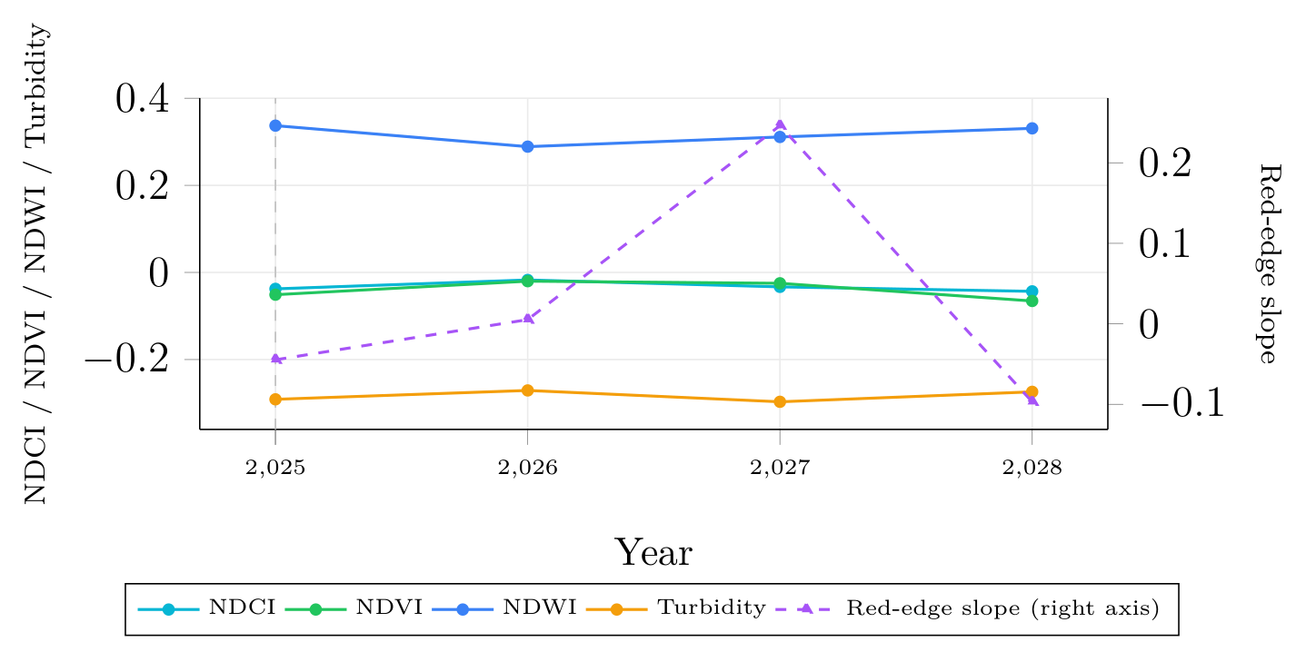

Figure 29
Tso Morari's forecast summary under the earlier B7-proxy implementation.
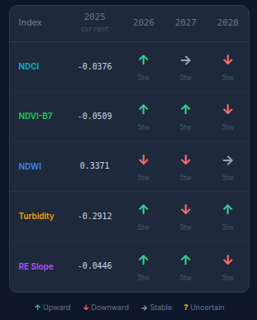
Note. Predates the switch to true-NIR B8.

At the time this screenshot was captured, the live application's Forecast panel agreed with the then-current (B7-proxy) forecast on direction for all fifteen cells, despite drawing on 15 contributing twins rather than the 5 used offline - agreement despite a threefold difference in twin-pool size was evidence the classification was not an artifact of which handful of twins happened to be selected. That agreement has not yet been re-verified against the B8-based numbers above, since 2028's NDWI cell changed direction (→ became ↓) between the two implementations; a fresh capture is listed as follow-up work.
Interpretation
Tso Morari is the only site where all five twins contribute to all three forecast years (n=5 throughout), the best-supported forecast in the study. The projection is mild - modest NDVI/NDCI increases, NDWI declining across all three years without reversal - appropriately undramatic for an ecosystem with no significant vegetation dynamic.
Documented Condition
Tso Moriri is an evaporative lake fed by both snowmelt and summer-monsoon precipitation, with its level set by the balance of that inflow against evaporation (Mishra et al., 2014); separately, glaciers worldwide are losing mass at an accelerating rate (Hugonnet et al., 2021). The near-decade stability measured here is consistent with a lake governed by that inflow-evaporation balance, but cannot speak to slower, longer-term glacial retreat.
Sasthamcotta Lake, Kerala
Sasthamcotta is Kerala's largest freshwater lake and the principal drinking-water source for Kollam district, a Ramsar site since 2002, freshwater despite lying only a few kilometres from the coast and close to the tidally-influenced Vembanad backwater system it replaces in this chapter. It is identified in the dataset as Unnamed Lake #179921 (Kerala), lake_id 179921.
Figure 30
Sasthamcotta's lake boundary in the live application.
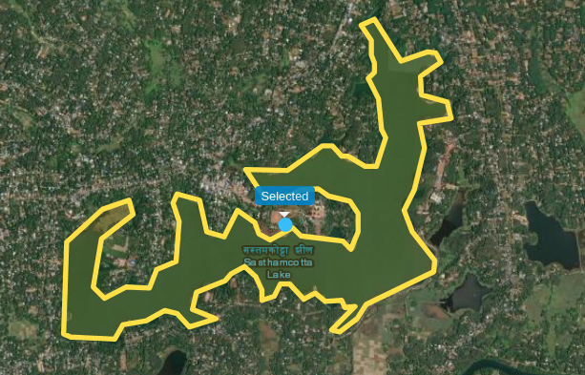
Retrieved Analogs
Table 21
Sasthamcotta - top five analogs (828 candidates).
# | Lake | State | Area | Raw cos. | Window
1 | 179945 | Kerala | 2.50 | 0.99784 | 2019–2023
2 | 179981 | Kerala | 2.59 | 0.99777 | 2016–2020
3 | 180015 | Tamil Nadu | 2.08 | 0.99754 | 2017–2021
4 | 179746 | Kerala | 4.16 | 0.99709 | 2019–2023
5 | 15611 | Maharashtra | 11.75 | 0.99698 | 2019–2023

Unlike every other site in this chapter, all five top-ranked analogs here are directly usable as forecast twins - none matches on a window ending at the 2025 anchor year, so no substitution from further down the ranked pool was needed. Three of the five are other small Kerala water bodies, the closest geographic clustering of analogs seen in this study.
Figure 31
Sasthamcotta's retrieved analogs in the live application.
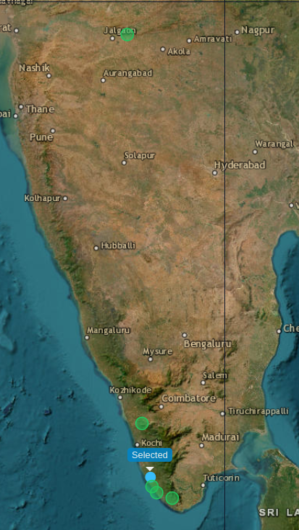
Measured History
Table 22
Sasthamcotta - measured index history, 2016–2025.
Index | 2016 | 2018 | 2020 | 2022 | 2024 | 2025
NDCI | 0.1957 | 0.0952 | 0.0823 | 0.0793 | 0.0928 | 0.0865
NDVI | 0.4520 | 0.2606 | 0.1992 | 0.1006 | 0.1558 | 0.1816
NDWI | −0.2769 | 0.0128 | 0.0172 | 0.1487 | 0.1324 | 0.0731
Turbidity | −0.2002 | −0.2725 | −0.2157 | −0.2456 | −0.2824 | −0.2513
Red-edge slope | 4.9975 | 2.6302 | 1.8539 | 0.7420 | 1.0838 | 1.5259

Figure 32
Sasthamcotta - measured index trajectory, 2016–2025.
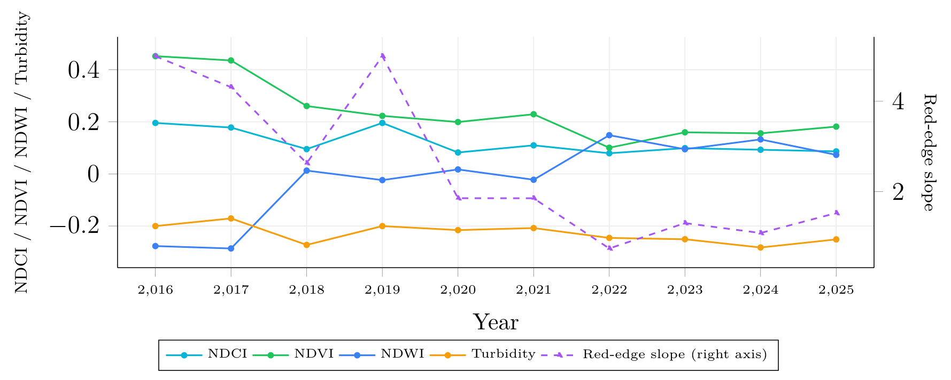

Sasthamcotta's measured decade shows a clear, largely monotone trend: NDVI falls by more than half (0.452 → 0.182), the red-edge slope falls roughly 3.3-fold (5.00 → 1.53), and NDWI moves from strongly negative to positive (−0.277 → 0.073) - a decline in vegetation vigor and pigment signal alongside a widening open-water signature, most pronounced between 2016 and 2020 and comparatively stable since.
Forecast
Table 23
Sasthamcotta - directional forecast 2026–2028.
Index | 2025 | 2026 | 2027 | 2028
NDCI | 0.0865 | → (+0.0009, n=5) | ↑ (+0.0088, n=5) | ↑ (+0.0131, n=2)
NDVI | 0.1816 | ↓ (−0.0083, n=5) | → (−0.0032, n=5) | ↓ (−0.0502, n=2)
NDWI | 0.0731 | → (−0.0046, n=5) | → (+0.0028, n=5) | ↑ (+0.0519, n=2)
Turbidity | −0.2513 | ↑ (+0.0096, n=5) | → (+0.0027, n=5) | ↓ (−0.0059, n=2)
Red-edge | 1.5259 | ↓ (−0.0658, n=5) | ↓ (−0.1167, n=5) | ↓ (−0.5053, n=2)

Figure 33
Sasthamcotta - projected index trajectory, 2025–2028.
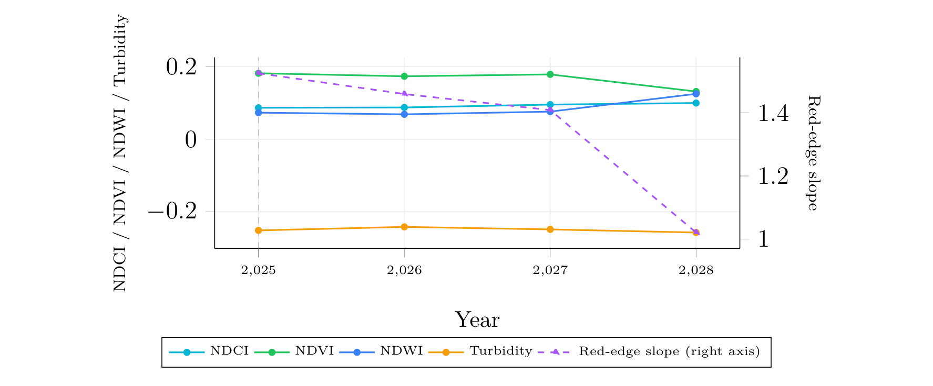

Interpretation
The forecast projects a continuation of the measured decade-long trend: NDVI and red-edge slope keep declining in all three years while NDWI holds flat or rises, directionally consistent with the 2016–2025 history. Confidence follows the familiar pattern of this chapter, n=5,5,2, with 2028's red-edge score (−0.5053) resting on only two twins and thus the least reliable number here; 2026 and 2027 are the rows to trust.
Documented Condition
Sasthamcotta faces documented human pressure: its Ramsar Information Sheet records that a large part of the lake has been reclaimed for agriculture and lists sewage and agrochemical pollution as threats (Ramsar Convention Secretariat, 2002b), and a 2017–2018 survey of 16 water-quality parameters found deteriorating quality in November–December 2017 (Divya Raj & Mophin Kani, 2018). The measured signal fits this only partly: NDVI and red-edge slope decline over the decade while NDWI rises. Because the Ramsar sheet describes the open lake as nearly free of aquatic vegetation, the high early NDVI more likely reflects cultivated shoreline in the lake's edge cells than in-lake vegetation - a hypothesis, not a corroborated finding.
Cross-Site Synthesis
Table 24
Cross-site summary.
Site | Best raw | Dominant measured signal | Conf.
Chilika | 0.99691 | Mild vegetative encroachment | 5,4,3
Maharana Pratap Sagar (Beas) | 0.99884 | No sustained trend; reservoir-driven oscillation | 5,1,1
Tawa Reservoir | 0.99936 | Oscillatory, no net trend | 5,5,2
Tso Morari | 0.99720 | Stable clear cold-desert water | 5,5,5
Sasthamcotta | 0.99784 | Decade-long NDVI/pigment decline | 5,5,2

Four findings emerge from analysing the sites together. The embedding space encodes real ecological structure: the Tso Morari–Pangong pairing, recovered from reflectance alone with a score gap five times the typical inter-rank spread, is not explicable as coincidence. Condition dominates geography in analog retrieval: Beas's top analogs are reservoirs hundreds of kilometres away in entirely different climate zones, matched on hydrological state rather than location, meaning the map view alone can mislead without the index history. The index set discriminates across the full range, from Tso Morari's near-zero vegetation to Sasthamcotta's NDVI of 0.45, preserved even after the B7-to-B8 switch. Forecast confidence is bounded by data recency, not model quality: every degraded forecast traces to twins whose matched windows end near 2025, a limitation that self-corrects as further years are ingested. Finally, the system declines to answer when it should: across 75 forecast cells (5 sites × 5 indices × 3 years), the outcomes divide as shown in Table 25.

Table 25
Distribution of forecast cells across sites.
Classification | Cells | Share
Up (↑) | 30 | 40.0%
Down (↓) | 25 | 33.3%
Stable (→) | 10 | 13.3%
Uncertain (?) | 10 | 13.3%
Total | 75 | 100%

Thirteen percent of cells returned uncertain rather than a direction: a method that always answers cannot be distinguished from one that guesses, so these ten abstentions are evidence the confidence machinery is load-bearing. The near-balance of up and down classifications is also reassuring against directional bias.
Discussion
Strengths and Limitations
The system's central strengths are scalable offline preprocessing executed to completion with zero residual failures; trajectory-based retrieval that matches ecological condition rather than single-year appearance, demonstrated by the Tso Morari–Pangong pairing; and a decoder-free, fully auditable forecasting layer that reports uncertain rather than guessing when evidence is thin (13.3% abstention across 75 forecast cells).
Its limitations are structural. The ten-year window is not uniformly complete, and cloud cover reduces valid Sentinel-2 observations. A high embedding similarity does not guarantee ecological equivalence - only the ranking is meaningful, not the compressed absolute score - and every result is conditional on the fixed configuration reported in the results chapter. A twin whose matched window ends near 2025 has little observed future to transfer, which thinned Beas's and Tawa/Sasthamcotta's later-horizon forecasts to one or two twins - a consequence of dataset extent, not a flaw in the classification rule, which correctly reported uncertain where warranted. Finally, the documented-condition checks are corroborating evidence, not calibrated validation, and their strength varies by site: Chilika's signal lines up with independently reported weed growth, Sasthamcotta's documented pressures only partly match the measured signal, Beas and Tawa have no published trend to check against, and Tso Morari's strongest corroboration is internal to the retrieval method; formal hindcasting is the next step precisely because it does not require external data.
Assumptions
Certain assumptions which we have made to implement this project which are: The selected 829 lakes and their HydroLAKES boundaries are representative of the target ecosystem population. Five consecutive usable years are sufficient to represent a lake's recent ecological trajectory. Similiarity between Prithvi-EO embeddings reflects meaningful similiarity in the spectral and ecological characteristics of lakes. Lakes with similiar historical trajectories are assumed to provide useful evidence for forecasting future changes in the target lake. Historical changes observed in analogous lakes can be transferred despite differences in climate, catchment characteristics and management practices. Forecasts are produced for 3 years only, beyond that signal from analog is assumed to degradeto an unacceptable level given the available data. NDVI, NDWI, NDCI, turbidity and red-edge slope are treated as ecological proxies rather than direct field measurements. Similiarity scores, twin counts and confidence values represent supporting evidence not probabilities of forecast accuracy. The selected case studies demonstrate the workflow but do not replace formal validation through hindcasating and held-out observations.
Conclusion and Future Work
Conclusion
EcoTwin evolved from a conceptual ecosystem-comparison idea into a complete, fully executed geospatial retrieval and forecasting system: HydroLAKES and Sentinel-2 feed a buffered, tiled acquisition pipeline into Prithvi embeddings, coverage-pooled to lake level and indexed in pgvector, from which a five-year sliding-window trajectory search ranks analogs and a decoder-free forecasting layer transfers their measured index changes onto the target with a full audit trail - executed to completion over 829 lakes, ten years, and zero outstanding failures.
The applied-analysis chapter demonstrated the pipeline on five Ramsar wetlands, returning a striking unsupervised validation (Tso Morari's top analog is Pangong Tso, the only other high-altitude Ladakhi lake in the cohort), a measured encroachment signal at Chilika consistent with independently reported weed growth, a decade-long decline at Sasthamcotta that only partly matches its documented pressures, and a forecasting method that correctly declined to predict in 10 of 75 cells rather than manufacturing a confident answer. The project's most significant contribution is the integration of geospatial data engineering, foundation-model inference, vector retrieval, temporal analysis, and visualization into one reproducible workflow carried through to applied results.
Future Work
Priority items are executing the hindcasting protocol once further years extend the dataset past its current single-cutoff limitation; extending ingestion beyond 2025 to resolve uncertain cells; adding independent field-ecological validation; and migrating trajectory search to pgvector's native ANN operators, since the current brute-force scan will not remain interactive as the cohort grows. Further directions include calibrating the similarity display scale against labelled ecosystem pairs, learned-weighted pooling in place of coverage-weighted mean, growing the cohort beyond 829 lakes, and deploying shared production infrastructure.
Final Remarks
EcoTwin's central idea is to use historically observed ecosystems as computationally retrievable analogs rather than treating every ecosystem as an isolated forecasting problem. The Ramsar case studies show that this idea, carried through a fully processed cohort, produces results that are specific, checkable against independent knowledge where it exists, and honest about the limits of what it can currently claim where the evidence ran out.

References
Chilika Development Authority. (n.d.). Visit Chilika. Government of Odisha. https://www.chilika.com/visit-chilika.php
Divya Raj, S., & Mophin Kani, K. (2018). Water quality assessment of Sasthamcotta Lake, Kollam, Kerala. International Journal of Engineering and Advanced Technology, 7(3), 119–129. https://www.ijeat.org/wp-content/uploads/papers/v7i3/C5315027318.pdf
European Space Agency. (n.d.). Sentinel-2 mission. Copernicus SentiWiki. https://sentiwiki.copernicus.eu/web/s2-mission
Gorelick, N., Hancher, M., Dixon, M., Ilyushchenko, S., Thau, D., & Moore, R. (2017). Google Earth Engine: Planetary-scale geospatial analysis for everyone. Remote Sensing of Environment, 202, 18–27. https://doi.org/10.1016/j.rse.2017.06.031
Green, K. C., & Armstrong, J. S. (2007). Structured analogies for forecasting. International Journal of Forecasting, 23(3), 365–376. https://doi.org/10.1016/j.ijforecast.2007.05.005
Hsu, C.-Y., Li, W., & Wang, S. (2024). Geospatial foundation models for image analysis: Evaluating and enhancing NASA-IBM Prithvi's domain adaptability. arXiv. https://doi.org/10.48550/arXiv.2409.00489
Huete, A., Didan, K., Miura, T., Rodriguez, E. P., Gao, X., & Ferreira, L. G. (2002). Overview of the radiometric and biophysical performance of the MODIS vegetation indices. Remote Sensing of Environment, 83(1–2), 195–213. https://doi.org/10.1016/S0034-4257(02)00096-2
Hugonnet, R., McNabb, R., Berthier, E., Menounos, B., Nuth, C., Girod, L., Farinotti, D., Huss, M., Dussaillant, I., Brun, F., & Kääb, A. (2021). Accelerated global glacier mass loss in the early twenty-first century. Nature, 592(7856), 726–731. https://doi.org/10.1038/s41586-021-03436-z
Kumar, R., Pattnaik, A., & Patnaik, P. (2011). Management of Phragmites karka invasion in Chilika Lake, Orissa [Background paper for consultation workshop, 17–18 January 2011, Bhubaneswar]. Chilika Development Authority; Wetlands International – South Asia. https://www.chilika.com/pdf/Macrophytes%20Workshop%2017-18%20Jan%202011%20Background%20Paper.pdf
Lacaux, J.-P., Tourre, Y. M., Vignolles, C., Ndione, J.-A., & Lafaye, M. (2007). Classification of ponds from high-spatial resolution remote sensing: Application to Rift Valley Fever epidemics in Senegal. Remote Sensing of Environment, 106(1), 66–74. https://doi.org/10.1016/j.rse.2006.07.012
Lorenz, E. N. (1969). Atmospheric predictability as revealed by naturally occurring analogues. Journal of the Atmospheric Sciences, 26(4), 636–646. https://doi.org/10.1175/1520-0469(1969)26<636:APARBN>2.0.CO;2
McFeeters, S. K. (1996). The use of the Normalized Difference Water Index (NDWI) in the delineation of open water features. International Journal of Remote Sensing, 17(7), 1425–1432. https://doi.org/10.1080/01431169608948714
Messager, M. L., Lehner, B., Grill, G., Nedeva, I., & Schmitt, O. (2016). Estimating the volume and age of water stored in global lakes using a geo-statistical approach. Nature Communications, 7, Article 13603. https://doi.org/10.1038/ncomms13603
Ministry of Environment, Forest and Climate Change. (2024, August 14). Union Environment Minister Shri Bhupender Yadav says India adds 3 more wetlands to the list of Ramsar sites on the eve of Independence Day 2024 [Press release]. Press Information Bureau, Government of India. https://pib.gov.in/PressReleasePage.aspx?PRID=2045232
Mishra, P. K., Anoop, A., Jehangir, A., Prasad, S., Menzel, P., Schettler, G., Naumann, R., Weise, S., Andersen, N., Yousuf, A. R., & Gaye, B. (2014). Limnology and modern sedimentation patterns in high altitude Tso Moriri Lake, NW Himalaya – implications for proxy development. Fundamental and Applied Limnology, 185(3–4), 329–348. https://doi.org/10.1127/fal/2014/0664
Mishra, S., & Mishra, D. R. (2012). Normalized difference chlorophyll index: A novel model for remote estimation of chlorophyll-a concentration in turbid productive waters. Remote Sensing of Environment, 117, 394–406. https://doi.org/10.1016/j.rse.2011.10.016
NASA and IBM. (n.d.). Prithvi-EO: Geospatial foundation model for Earth observation [Model documentation]. Hugging Face. https://huggingface.co/ibm-nasa-geospatial/Prithvi-EO-1.0-100M
Pettorelli, N., Vik, J. O., Mysterud, A., Gaillard, J.-M., Tucker, C. J., & Stenseth, N. C. (2005). Using the satellite-derived NDVI to assess ecological responses to environmental change. Trends in Ecology & Evolution, 20(9), 503–510. https://doi.org/10.1016/j.tree.2005.05.011
Ramsar Convention on Wetlands. (2018). Global wetland outlook: State of the world’s wetlands and their services to people. Ramsar Convention Secretariat. https://moef.gov.in/uploads/2019/12/gwo_e.pdf
Ramsar Convention Secretariat. (2002a). Pong Dam Lake [Ramsar Information Sheet, site no. 1211]. Ramsar Sites Information Service. https://rsis.ramsar.org/ris/1211
Ramsar Convention Secretariat. (2002b). Sasthamkotta Lake [Ramsar Information Sheet, site no. 1212]. Ramsar Sites Information Service. https://rsis.ramsar.org/ris/1212
Ramsar Sites Information Service. (2024). Tawa Reservoir. https://rsis.ramsar.org/ris/2547
Reddy, D. S., & Prasad, P. R. C. (2018). Prediction of vegetation dynamics using NDVI time series data and LSTM. Modeling Earth Systems and Environment, 4(1), 409–419. https://doi.org/10.1007/s40808-018-0431-3
Ryan, S., Powell, M., Ling, J., & Wen, L. (2026). Streamlining wetland vegetation mapping with AlphaEarth embeddings: Comparable accuracy to traditional methods with cleaner maps and minimal preprocessing. Remote Sensing, 18(2), Article 293. https://doi.org/10.3390/rs18020293
Szwarcman, D., Roy, S., Fraccaro, P., Gíslason, Þ. E., Blumenstiel, B., Ghosal, R., de Oliveira, P. H., de Sousa Almeida, J. L., Sedona, R., Kang, Y., Chakraborty, S., Wang, S., Gomes, C., Kumar, A., Truong, M., Godwin, D., Lee, H., Hsu, C.-Y., Lal, R., . . . Bernabe Moreno, J. (2024). Prithvi-EO-2.0: A versatile multi-temporal foundation model for Earth observation applications. arXiv. https://doi.org/10.48550/arXiv.2412.02732
van den Dool, H. M. (1989). A new look at weather forecasting through analogues. Monthly Weather Review, 117(10), 2230–2247. https://doi.org/10.1175/1520-0493(1989)117<2230:ANLAWF>2.0.CO;2
van den Dool, H. M. (1994). Searching for analogues, how long must we wait? Tellus A, 46(3), 314–324. https://doi.org/10.3402/tellusa.v46i3.15481

