# Ex.No: 4(b)

# Aravind s

# 195002011

**VALIDATE VARIABLE**

**AIM:**

To write a YACC program to recognize that a valid variable which starts with a letter

followed by any number of letters or digits.

# ALGORITHM:

1. Start the YACC Program.
2. Define the Rules, user-defined subroutines and definitions.

{definitions}

%%

{rules}

%%

{user-defined subroutines}

1. yyparse() – implies parsing status if( yyparse()==0 )

Parsing successful elseif( yyparse()==1 )

Parsing failed due to invalid input else( yyparse()==2 )

Parsing failed due to memory exhaustion

1. yylex() – implies the entry point for the lex and reads input to generate tokens. if( yylex()==0)

End of input stream

1. yyerror() – it is called when YACC encounters invalid syntax.
2. Stop the Program.

**CODE:**

**LEX PART:**

%{

#include "y.tab.h"

%}

%%

[a-zA-Z_][a-zA-Z_0-9]* return letter;

[0-9] return digit;

. return yytext[0];

\n return 0;

%%

int yywrap()

{

return 1;

}

**YACC PART:**

%{

#include<stdio.h>

int valid=1;

%}

%token digit letter

%%

start : letter s

s : letter s

| digit s

|

;

%%

int yyerror()

{

printf("\nIts not a identifier!\n");

valid=0;

return 0;

}

int main()

{

printf("\nEnter a name to tested for identifier ");

yyparse();

if(valid)

{

printf("\nIt is a identifier!\n");

}

}

# OUTPUT:

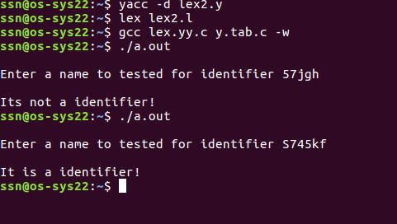

**RESULT:**Thus a YACC Program to recognize that a valid variable which starts with a letter followed by any number of letters or digits is implemented.