**Group 3: Flight Price Predictor**

*Kyle Cielencki, Luis Cerrilla, Ahasan Hossain, Artie Edwards*

Our project aims to provide a price predictor for airline flights based on quarterly flight data from Bureau of Transportation Statistics. A use-case scenario would be a user trying to retrieve an estimate of how much it would cost to travel to a destination based on their origin and destination.

We provide two dashboards in Tableau that allow the user to explore the data further. These are based on a random 5% sample of the last three years of data and combined with an airport city, latitude, and longitude for better visualizations. The first dashboard allows the user to understand how prices have historically differed based on origin. The second dashboard highlights popularity of destinations solely for Q1 2020 (given this is what we based on machine learning model on).

The purpose of the machine learning model is to predict the fare for domestic flights in the US given only two inputs: origin airport code and destination airport code. This was based on a random 5% sample of the Q1 2020 data as this most accurately reflects travel in the current COVID environment. Based on our analysis of potential machine learning models, the Random Forest Regressor provided the best results, thus the model we selected.

The data is visualized with Tableau, the price predictor was made with a D3 event-listener, all hosted on an HTML webpage with a user-friendly layout:

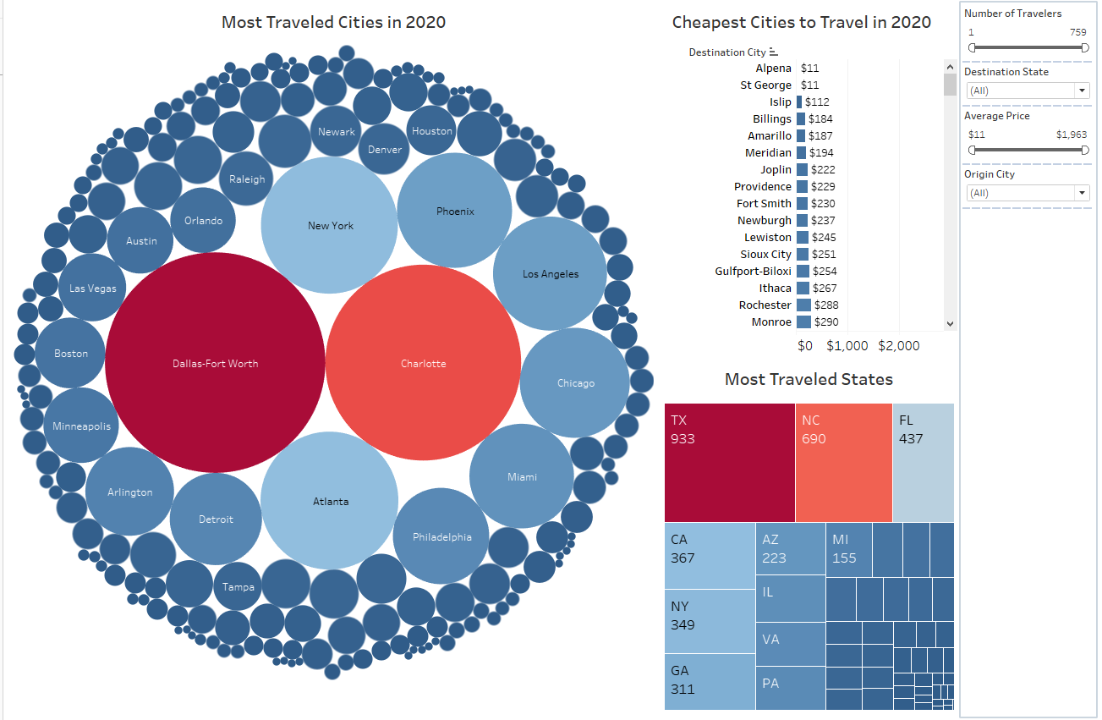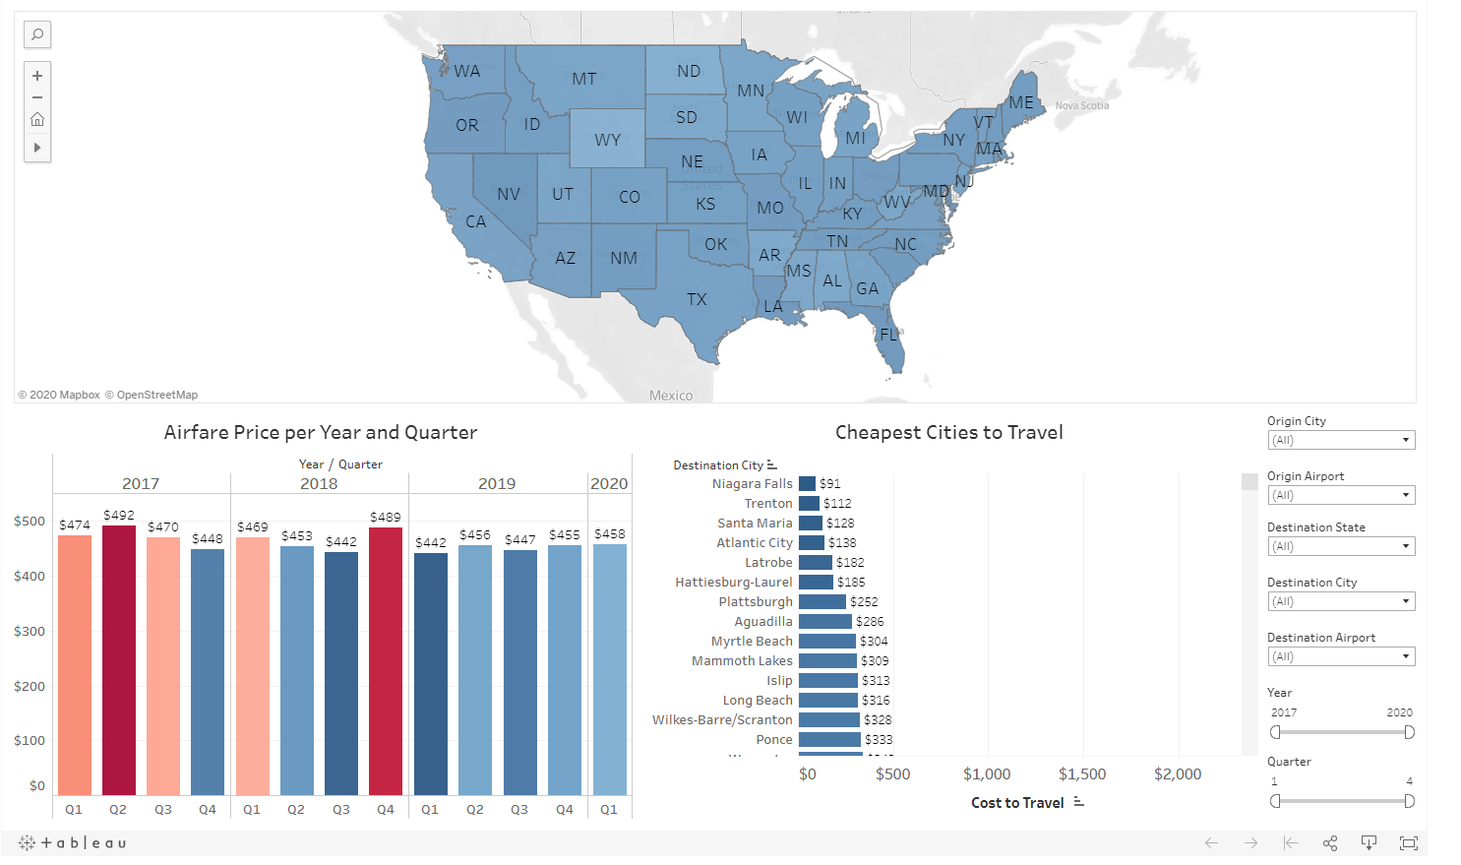

We deployed our site on Heroku and laid out our analysis and prediction model on five pages (Home, Price Predictor, Visualizations, Methodology, About):

