|  |
| --- |
| What Nanomaterials Are Used in Space? |
| Space Isolation  GDD |
| |  |  |  | | --- | --- | --- | | CAYZAC Mariano (LAM) | 5/20/21 | BTSGP | |

Contents

2 Introduction 3

3 Game Overview 3

3.1 Plot 3

3.2 Target Audience 3

3.3 Designer Goals 3

3.4 Tone and Mood 3

3.5 Genre 3

4 Art Direction 4

4.1 Sounds 4

5 Game Design & User Experience 5

5.1 The objective 5

5.2 Lightning 5

5.3 Sound 5

5.4 Audio logs 5

5.4.1 Day one diary 5

5.4.2 Day Ten Diary 6

5.4.3 Day Twenty Diary 6

5.4.4 Day Twenty-Four Diary 6

5.4.5 Day Thirty Day 6

5.5 User Experience 6

5.5.1 Movement 6

5.5.2 UI Tutorials 6

5.6 Feedback Loops 7

5.6.1 Whispers 7

5.6.2 Lights 7

5.6.3 Sound Effect 7

5.6.4 Visual Cues 7

5.6.5 Haptic Cues 7

5.7 Level Design 8

5.7.1 Introduction Area 8

5.7.2 Main Level 9

6 Gameplay 10

6.1 Events 10

6.1.1 E1 10

6.1.2 E2 10

6.1.3 E3 10

6.1.4 E4 10

6.2 Socket System 10

# Introduction

This document specifies a design for the gameplay of a game with the provisional title “Space Isolation”. It includes all of my planning and design choices. The main objective is to have a well-defined structure before the development of the game.

# Game Overview

## Plot

After an unsuccessful launch, the SS-H2 (Surveillance Spacecraft Hound 2) is stranded on space. Awaiting for rescue, the player is set on the feet of Arnold Strider, the only crew member in the space craft. After 1 month of total isolation, Strider has suffered severe damage to his mental health. Things do not end up there, power has shot down in certain areas, including the life support system and it is on Strider’s best interest to get into the reactor room and reset the power before is too late.

## Target Audience

The game would be suited for users above 16 years old. The reason behind my choice is due to the fact this is a horror game that may not be suited for younger audiences.

## Designer Goals

My main goal is to create a memorable horror experience. I aim to put the player in the character’s shoes and make the Strider’s struggles, their struggles.

## Tone and Mood

The game main objective is to create a gloom and claustrophobic atmosphere, it will be achieved by the use of poor lighting and close spaces. Background sound will also help, as well as using fog to set up a cold atmosphere.

## Genre

The game will be utilizing psychological horror theme to tell the story of a stranded human on the vast emptiness of space.

# Art Direction

For the art direction I will be gathering all my assets from the Unity Asset Store. I would be gathering spaceship props and structures, visual effects that will help up set up the atmosphere as well as human models and a wheelchair for the character.

* World Building: <https://assetstore.unity.com/packages/3d/environments/sci-fi/modular-sci-fi-corridor-142811>
* World Building: <https://assetstore.unity.com/packages/3d/environments/sci-fi/sci-fi-styled-modular-pack-82913>
* Human Character: <https://assetstore.unity.com/packages/3d/characters/humanoids/humans/starter-bundle-from-tafi-192235>
* Wheelchair: <https://assetstore.unity.com/packages/3d/props/furniture/sci-fi-chair-116719>
* Bed and room décor: <https://assetstore.unity.com/packages/3d/props/furniture/customizable-bedroom-72562>
* Fuse: <https://assetstore.unity.com/packages/3d/environments/sci-fi/hitech-scifi-energy-cell-154526>
* Skybox: https://assetstore.unity.com/packages/2d/textures-materials/sky/spaceskies-free-80503

## Sounds

* Horror Ambiance: <https://assetstore.unity.com/packages/audio/ambient/horror-and-sci-fi-ambience-loops-lite-99626>

# Game Design & User Experience

## The objective

I aim to make the objective of the game as simple as possible but still enjoyable. The reason behind this is that I will be focusing more on how the game feels rather that the chore mechanics. The best thing about horror games, specially the psychological genre, is that it leaves a lot to the player’s imagination and constantly plays with their expectations. The objective of the game is to gather 4 fuses to power up the reactor door and reset the electricity while they are being haunted by an unknown entity.

## Lightning

Definitely one important pillar for guiding the player and setting up interesting events. Some lights will be placed in specific parts of the ship to guide the player towards their objective. They will also flicker whenever the entity is nearby.

## Sound

Sounds will be extremely important for this game. I will be used recorded audio logs for narrative storytelling, whispers (when player mental health is affected) and sound effects for material interactions.

## Audio logs

### Day one diary



This will be the first audio log which the player can interact with. It will be place in the starting area (Strider’s room), since it is the first item the player will interact with there will be an UI message letting the player know what to do.

This dialog log will be the first of many which will let the players know a bit more about Striker’s psyche. This first dialog log will start by commenting about the fail launch and how he is feeling at the moment.

“ah… Why do I even do this? This is Arnold Striker, only crew member of the Hound 2, after bad calibration of the propellers the spaceship has found itself out of course leading to the empty void of space. I must remain calm and wait for help to arrive.”

Image taken from the game “DreadHalls.

### Day Ten Diary

“It’s been 10 days now, I mean, I only been able to tell by the machine… to be honest it already feels like an eternity. I really do not know what is taking them so long. I am starting to feel like maybe… no, it’s too early to give up.”

### Day Twenty Diary

“20 days, rations are starting to run low, same with oxygen. I… I have 12 maybe 15 days left. Things are only going to get rougher now, but I have to hold on, I must hold on.”

### Day Twenty-Four Diary

“I think this place is making me crazy, I started seeing things… Impossible things. Is that how I die? Crazy and alone? I cannot, not like this. NOT LIKE THIS.”

### Day Thirty Day

“Unrecognizable static”

## User Experience

I aim to make everything possible to make the controls intuitive, quick, and easy to learn without damaging immersion. In order to introduce the player into the game I need to break a bit of the immersion by displaying some tutorial text so they can familiarize with the game. These tutorials will be displayed as world static UI in form of holograms, similarly to the image displayed on the audio logs.

### Movement

Players will be able to rotate left to right by moving the sticks. To avoid any type of nausea, rotations will be instantaneous and 90 degrees towards the inputted direction. To avoid any type of nausea or disorientation the screen will fade in and out. These will keep the immersion as safe as possible without having to have any type of robotic movement. Moving up or down will make it go forward or backwards.

### UI Tutorials

#### Log interaction:

Like explained in point 5.4.1, there will be a message displayed on top of the first log you encounter. This will let the user identify these objects further into the game and how to interact with them.

#### Door opening:

Before leaving the starting room, players must be able to open the door. They will need to place their hand in front of the door and wait for it to be scanned. A UI will be placed next to the door explaining how door scans work.

#### Moving

Before the game starts, the user would definitely like to know how to move around. There will be a UI displayer next to the joystick, explaining how basic movement works.

#### Reactor Door

Right next to the reactor room there will be a fuse box with a UI on top stating that more fuses are needed.

#### Fuse

There will be a fuse placed next to the fuse box, similar to the point 5.5.2.1 it will have a displayed message to let know what kind of object they are staring and how to interact with it.

## Feedback Loops

### Whispers

Whispers will allow the player to know that the entity is manifesting somewhere in the room. It will help to add to the panic factor, since they will not know whether if they are in danger or not and will set up the tone for the interactions.

### Lights

Lights will guide players towards the objective, will flicker when a manifestation happens. It not only serves the purpose of guidance, but it also helps up building the atmosphere.

### Sound Effect

Essential for the environment to react to the player’s involvement. Having sound effects would be essential for immersing the player in the game.

### Visual Cues

Whenever the player does something, they expect the environment to react. Sometimes sound is enough but having visuals to reflect player interactions will let them know that things are going as planned or not.

### Haptic Cues

Whenever the player’s hand is colliding with an interactable or grabbable item, the player will feel a vibration that will simulate real time contact. This will also help understand which items can be interacted with and which ones are just part of the environment.

## Level Design

### Introduction Area

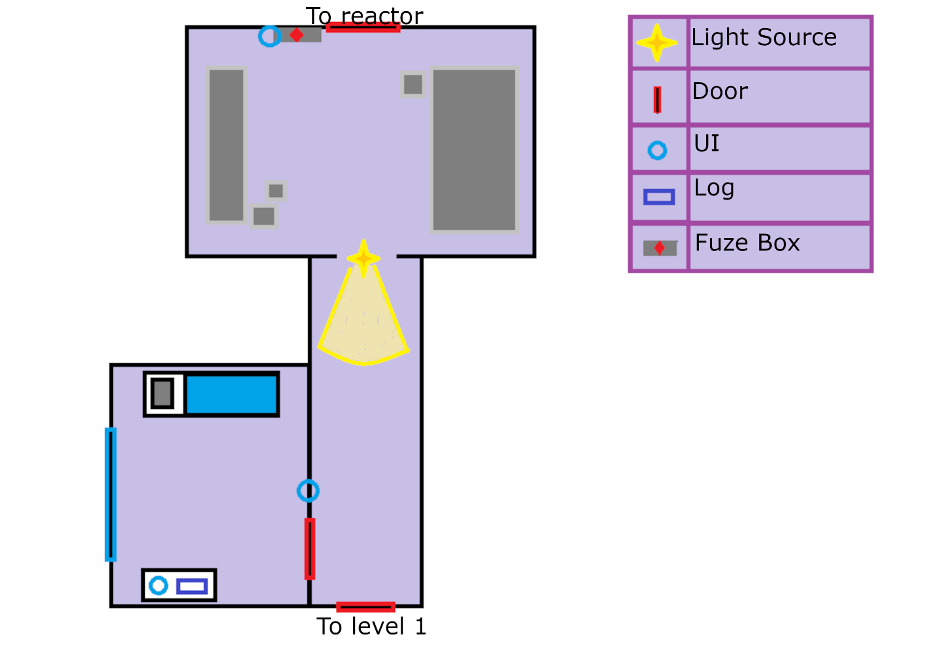

This is the first section of the map. The idea is to have one level which is split between tutorial area and the actual gameplay. Player will start on their room facing towards a desk where you can find the first UI piece (5.5.2.1), and the log. The room itself will be filled with more stuff that will decorate the room to give the feeling necessary to accompany the narrative however those assets will be develop once I start building the map area, as it for now I took my time to think only on the essentials and the space they will occupy.

To their left, they will have a door, with a UI next to it. Letting players know that they must scan their hand to open the door. After the scan is done, the door will open and reveal a corridor which will lead the player towards two directions. One being a close door, the other being an open room with light source coming from it.

This will suggest the player to try the left room before moving forward. Once the player enters the room, they will find themselves with the reactor door, with the fuse box next to it. The UI on the fuse box will let the user know that there are items missing. On the floor next to the fuse box there will be a fuse which will have the same UI that the first log has, letting them know that they can pick up and use it.

Once all this is done, and with the main objective in mind, the player will be ready to take on their journey.

### A picture containing graphical user interface Description automatically generatedMain Level

This is the main playing area. Within this area there will be logs, fuses and events all over. I will go through each event on the gameplay section but to make it concise, events are manifestations of the main character’s psyche and will be responsible for causing interesting scary scenarios for the player.

As you can see, the user layer is able to choose their own path but will need to go through the entire level to experience the full experience. The whole game will not be long, as you can see the map is rather small, as I want to spend more time designing and setting the mood on the level builder.

Not all the doors will be available to open right away as some require an event to happen before the player can go through them.

# Gameplay

## Events

### E1

On the first corridor as you get close to the interception, a box will fall in front of you. Making some glass breaking noise which will alert the player. To make this happen there will need to be a collision box to ensure that the player is nearby, once the collision is activated, force will be added to one of the boxes and the alarming noise will be triggered.

### E2

The first door on the corridor will be close and the player will not be able to open it. However, they will probably try to open the door at the end, however whenever they reach door lights will start flickering, whispers will be triggered, and the first door will open by itself.

### E3

When the player chooses the corridor in the left, there will be flickering lights at the end of the corridor and a human figure will be standing looking at the opposite direction. Whispers will start playing as soon as the user reaches the corner of the left corridor. This effect will stop once the user gets close enough and light will turn off for 5 seconds, then continue working normally. My idea behind this event is to persuade players to choose the corridor on the right before going to the left. If they have no other way to go, they will feel force to go towards the entity even if everything indicates not to.

### E4

Once the player has gathered all the fuses and is heading to the reactor room, all the lights will turn off in front of him, slowly and by sections. The intend behind it is to leave the player stunned and expectant. After the whole hallway runs dark, the whispers will intensify. Lights will then turn back on after a few seconds and the player will be able to go back to the respawn room.

## Socket System

The socket system will implement an easy and intuitive way for the player to hold on to more than one fuse at the same time. The system will include two sockets from which they can store any pickable item to take around with them.

