|  |  |  |  |  |  |  |  |  |  |
| --- | --- | --- | --- | --- | --- | --- | --- | --- | --- |
| Assignment #1  MP-2 | **BE-ME-6B [GROUP 3]**   |  |  | | --- | --- | | Muhammad Hamza Asghar | ME-151074 | | Ibrahim Patel | ME-151095 | | Akbar Hussain | ME-151072 | | Abdul Samad Durvesh | ME-151028 | |

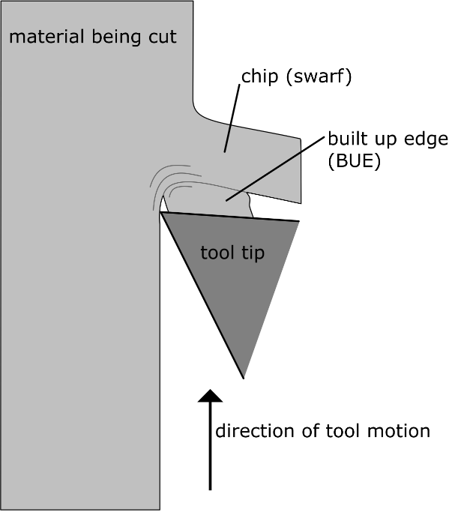**Built-Up Edge (BUE):**

The machined portions of the work material that cling on to the rake face of the tool; due to friction, local high temperature, and pressure, between it and the chip being formed. This new edge then gradually builds/piles up (hence protects the cutting edge, but alters the tool geometry), becomes unstable and mainly breaks off with the chip. Some remains back on the freshly machined work surface, significantly effecting the surface finish.

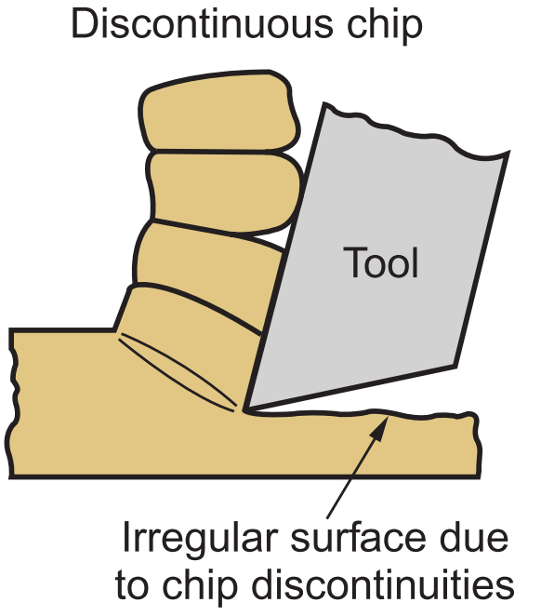**Discontinuous chips:**

In discontinuous chips we make chips by series of sudden breaking chip element which occurs approximately to the tool place face perpendicularly each chip element passing off along the tool face the chip element in the form of small segment may loosely attached to each other and becomes slightly longer.

|  |  |
| --- | --- |
|  | Preferred |
| Workpiece Material | Hard and brittle sometimes ductile (cast iron/bronze) |
| Cutting Speed | Low |
| Cutting Feed | High |
| Depth of Cut | High |
| Rake Angle | Low back rake angle |
| Cutting Fluid | Excess |
| Surface Finish | Better surface finish |

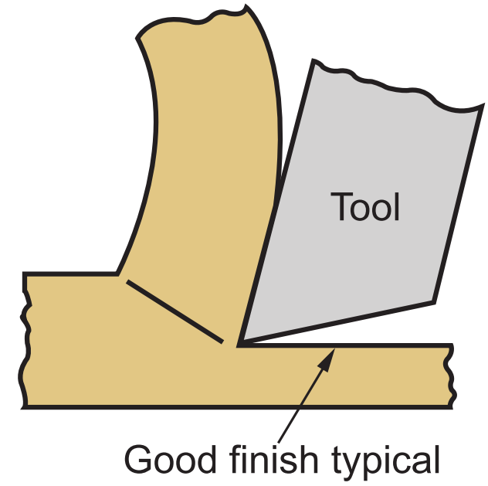**Continuous chips (without BUE):**

These result from plastic deformation of material along a narrow shear zone, called the primary shear zone. Continuous chips may also develop a secondary shear zone, because of high friction at the tool–chip interface. This zone becomes thicker as friction increases.

They curve around and possibly get stuck in the tool holder, in the work-piece and the machining tool. They also interfere with chip-disposal systems.

|  |  |
| --- | --- |
| Parameter | Favouring Condition/Result |
| Workpiece Material | Ductile (usually) |
| Cutting Speed | High |
| Cutting Feed | Small |
| Depth of Cut | Small |
| Rake Angle | Large |
| Cutting Fluid | Soluble Oils |
| Surface Finish | Generally good |

**Continuous chips (with BUE):**

Continuous chips with the addition of the sticking of the chips due to the intense temperature and heat at the cutting edge gives plausible cause of the built up edge condition.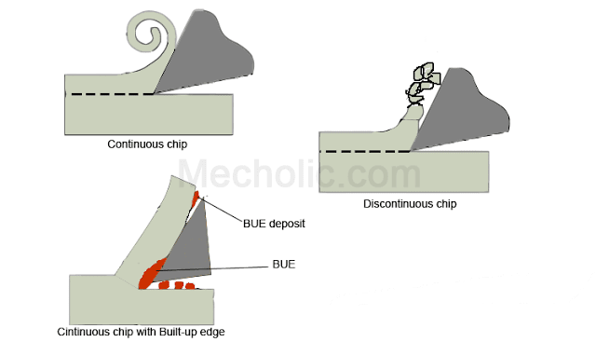 This usually is the product of low speed cutting and low rake angles which does not permit the chips and heat to escape. This results in the welding of the chips to the cutting edge, which at first strengthens the tool but in time causes adhesion wear (this is reduction of the sharpness of the cutting edge and change tool geometry). The degradation of the tool can be reduced by using a tool that does not react with the workpiece and is very strong, like carbide compounds. These types of chips are not preferred since they deem a poor surface finish with high power requirement and the vibrational forced produced by the fluctuating cutting forces.

|  |  |
| --- | --- |
|  | Preferred |
| Workpiece Material | Mild Steel / Copper (ductile material) |
| Cutting Speed | Low |
| Cutting Feed | High/coarse feed rate |
| Depth of Cut | high |
| Rake Angle | Low angle |
| Cutting Fluid | insufficient |
| Surface Finish | Poor |

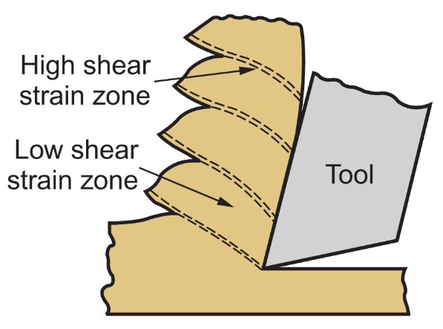**Segmented chips:**

They are semi-continuous chips forms due to non-uniform strain on the material during cutting. It has saw teeth (segments) like appearance due to low and high shear zones.

This type of chip is formed in a material whose mechanical strength decreases with increase in temperature and have low thermal conductivity.

|  |  |
| --- | --- |
|  | Preferred |
| Workpiece Material | Ductile high strength metals (alloys) |
| Cutting Speed | High |
| Cutting Feed | High |
| Depth of Cut | High |
| Rake Angle | Small for big segments and Large for small size segments (with more number of segments) |
| Cutting Fluid | Less to avoid more friction |
| Surface Finish | Poor |