Introduction to

CFD

(Computational Fluid Dynamics)

Assignment # 3

Ibrahim Patel

me151095 BE-ME-8E

Table of Contents

a) Qualitative Flow Description 4

c) Simulation Results 5

Pressure Contour Plots 5

Re = 20 5

Re = 40 7

Re = 60 9

Re = 80 11

Re = 160 13

Velocity Contour Plots 16

Re = 20 16

Re = 40 18

Re = 60 20

Re = 80 22

Re = 160 24

Comparison & Discussion 26

Velocity Vector Plots 26

Re = 20 27

Re = 40 29

Re = 60 31

Re = 80 33

Re = 160 35

Comparison & Discussion 37

Residuals Plots 38

Re = 20 38

Re = 40 39

Re = 60 40

Re = 80 41

Re = 160 42

Comparison & Discussion 43

Coefficients of Drag and Lift 43

Comparison & Discussion 43

d) Velocity Profile Comparison at defined Stream wise Positions* 44

Re = 20 45

Re = 40 47

Re = 60 49

Re = 80 51

Re = 160 53

Comparison & Discussion 55

# a) Qualitative Flow Description

The flow across a square cylinder may be expected to have similar basic features as that over a circular cylinder. After all, a circle is a geometry with infinite vertices and a square is a finite polygon; with four sides and vertices, each. However the total frontal area for a square can be said to be larger than a circle of the same characteristic lengths. Thus implying that the pressure drag would be more than that for a circular geometry.

One can expect stagnation points at the centre of the fore and aft of the cylinder; at the sides that are perpendicular to the flow. Whereas, at the sides parallel to the flow, there would be a symmetric pressure distribution, thus causing no net lift force for low Reynolds numbers and steady state simulations.

Since the no-slip boundary condition exists at the periphery, the viscous/shear effects here would contribute in the total drag force, that is expected at all Reynolds numbers (which is also composed of the pressure drag force); decreasing in magnitude as the Reynolds number increases.

However the pressure drag would increase for higher Reynolds number due to dominance of inertial effects of the fluid to the viscous effects.

One would also expect to see a wake region, downstream, as well a flow separation at the terminal ends of the *parallel-to-flow* faces.

# c) Simulation Results

## Pressure Contour Plots

### Re = 20

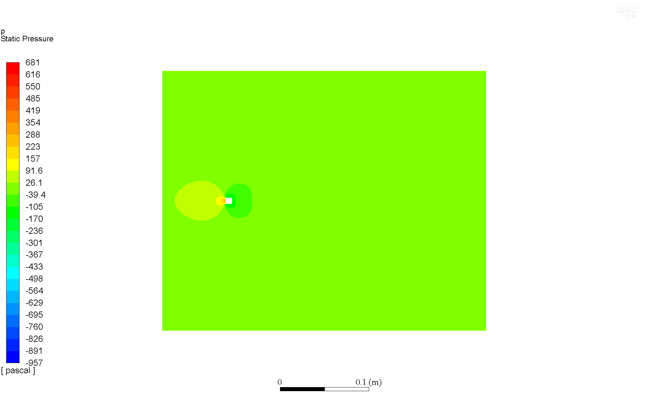

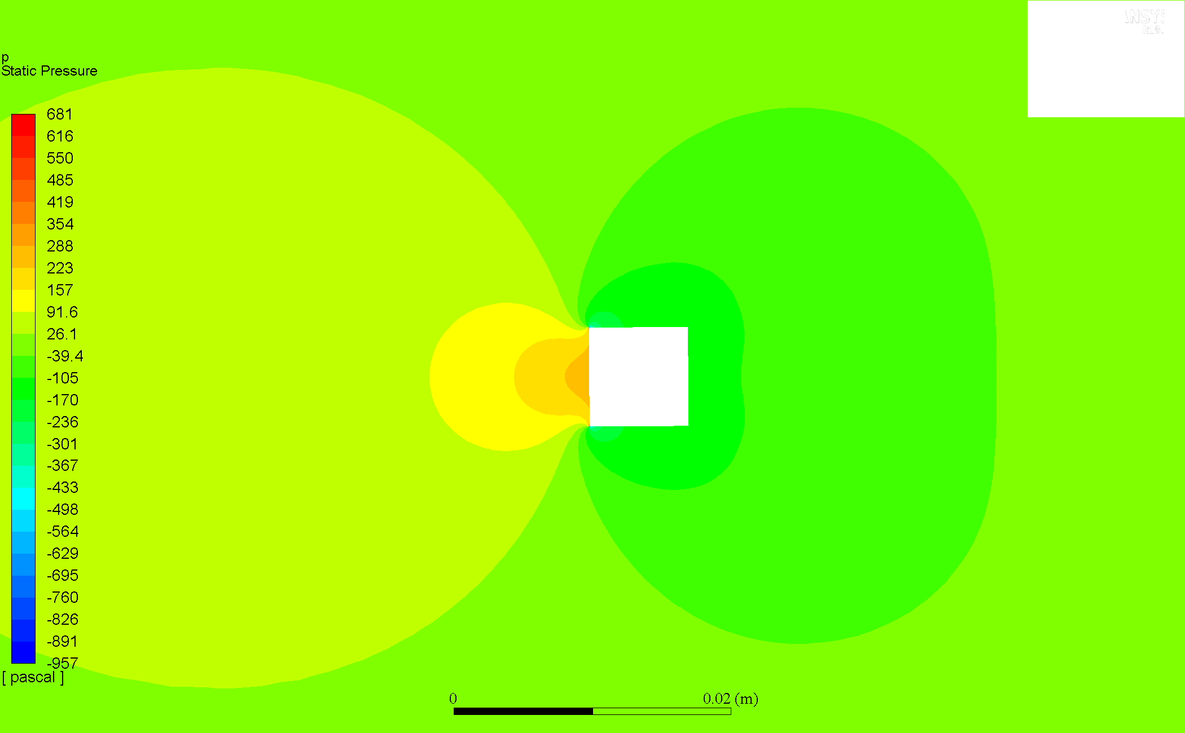

### Re = 40

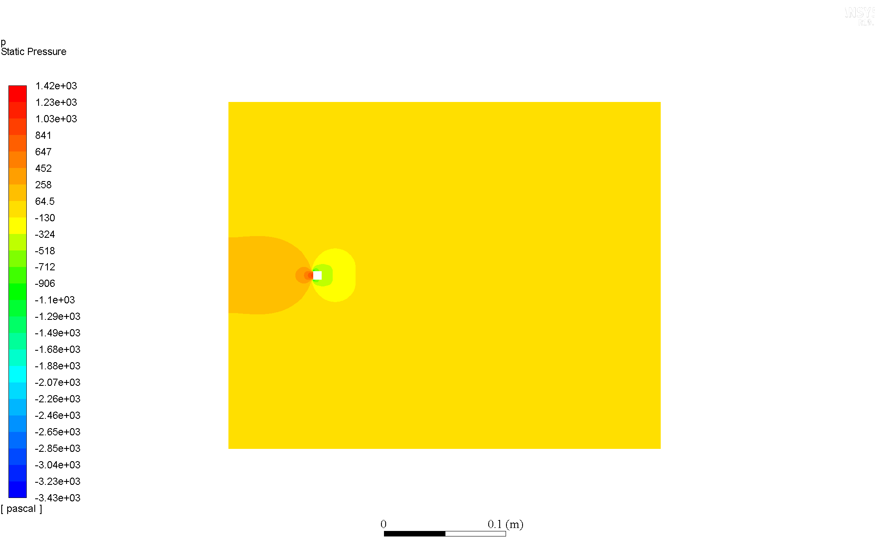

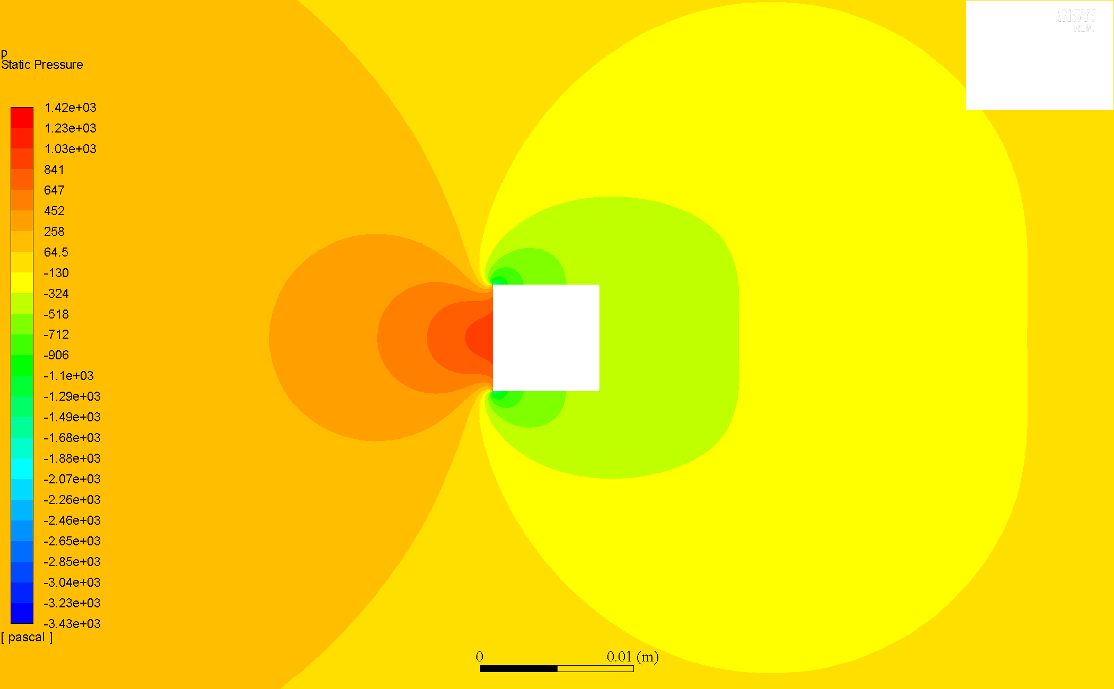

### Re = 60

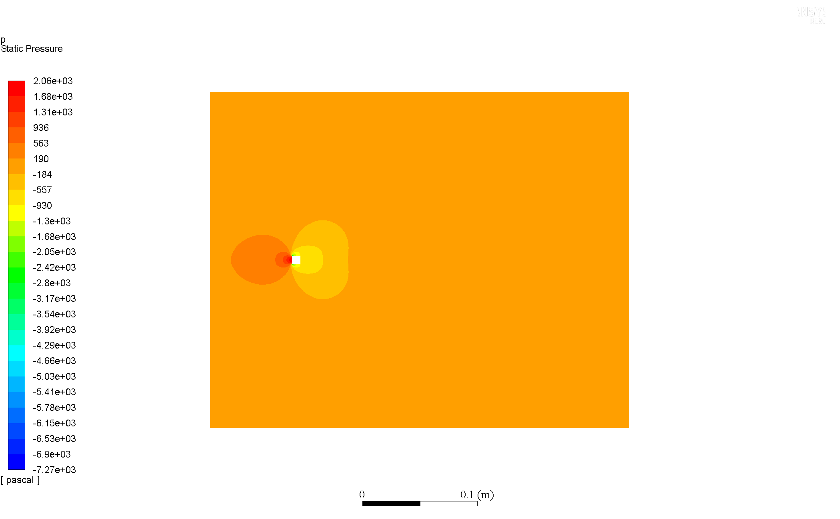

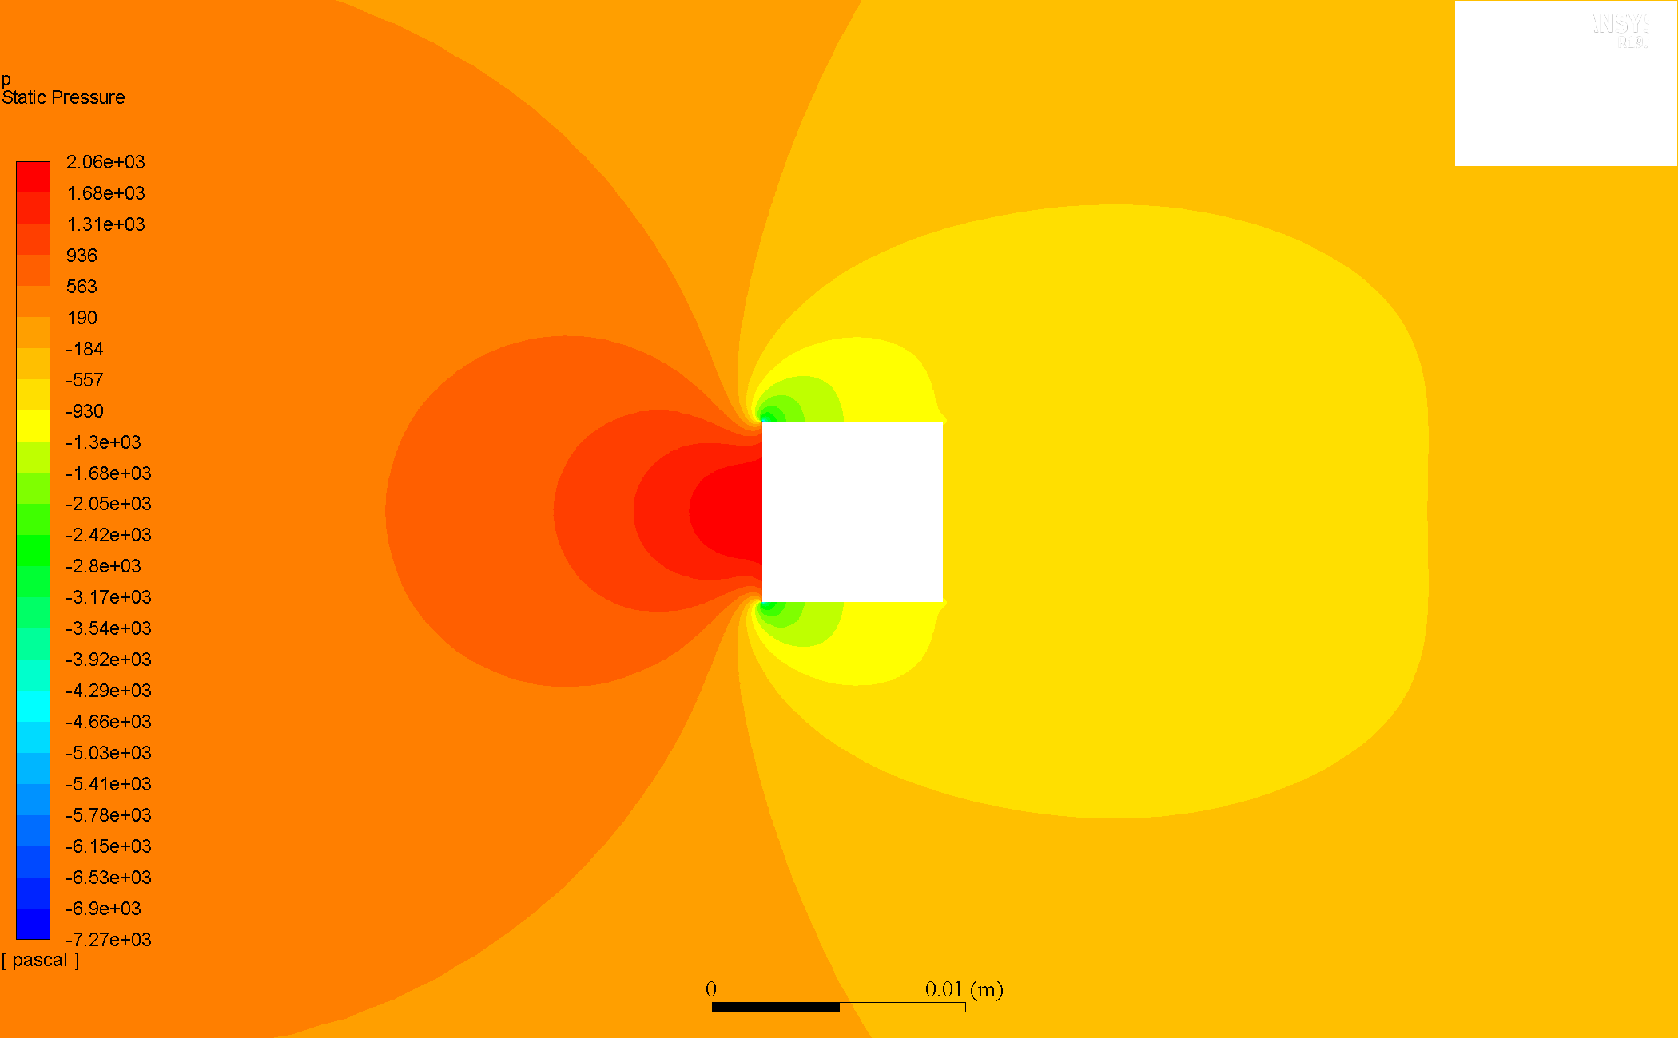

### Re = 80

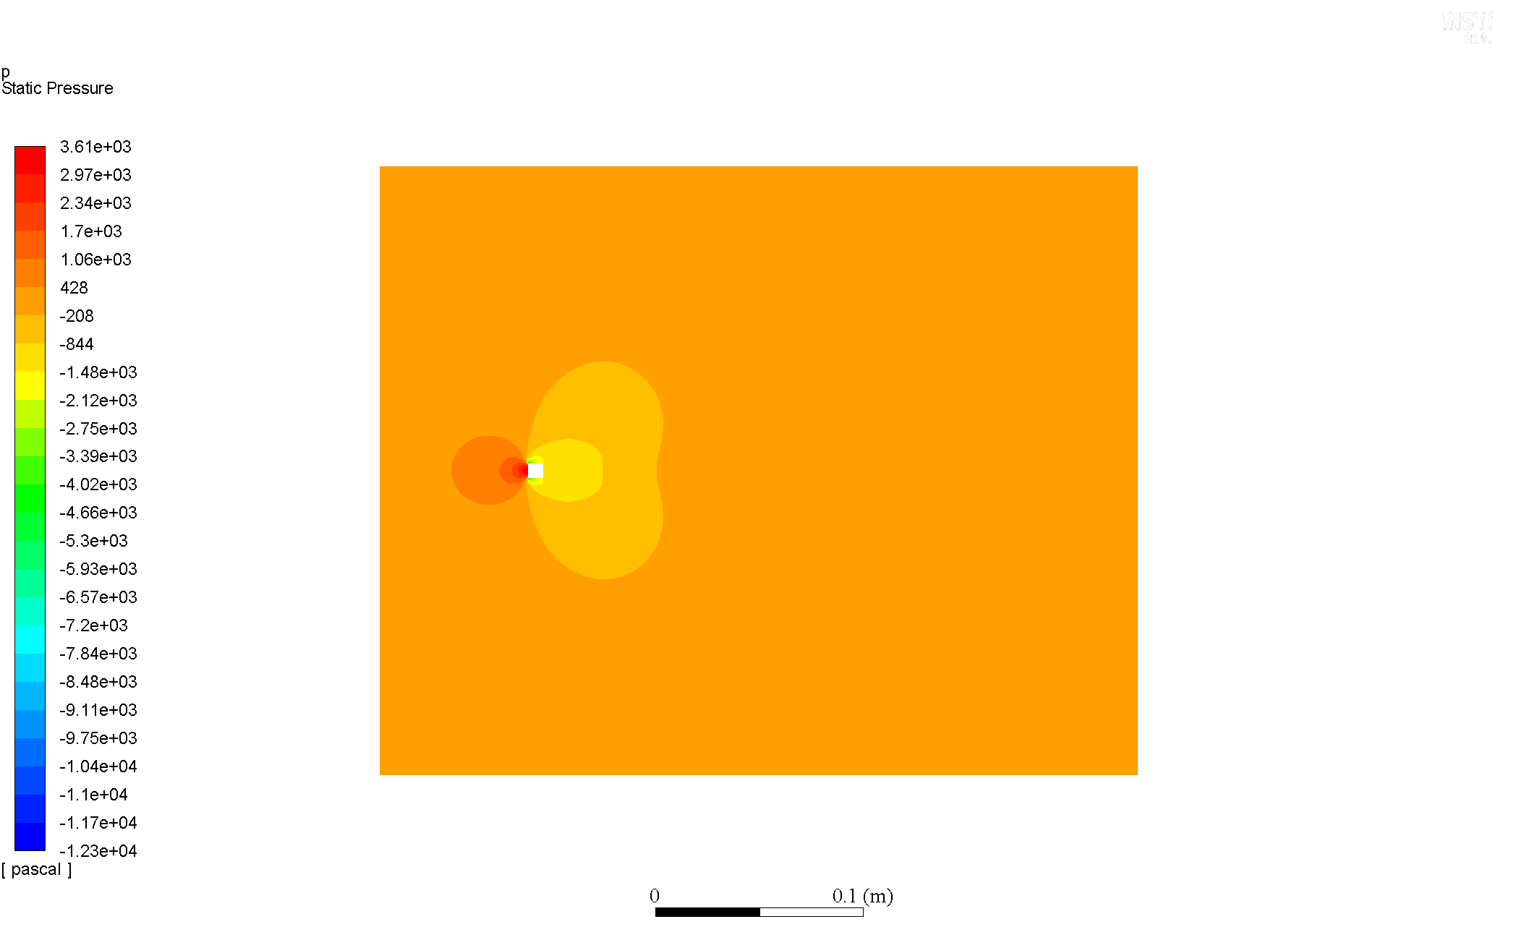

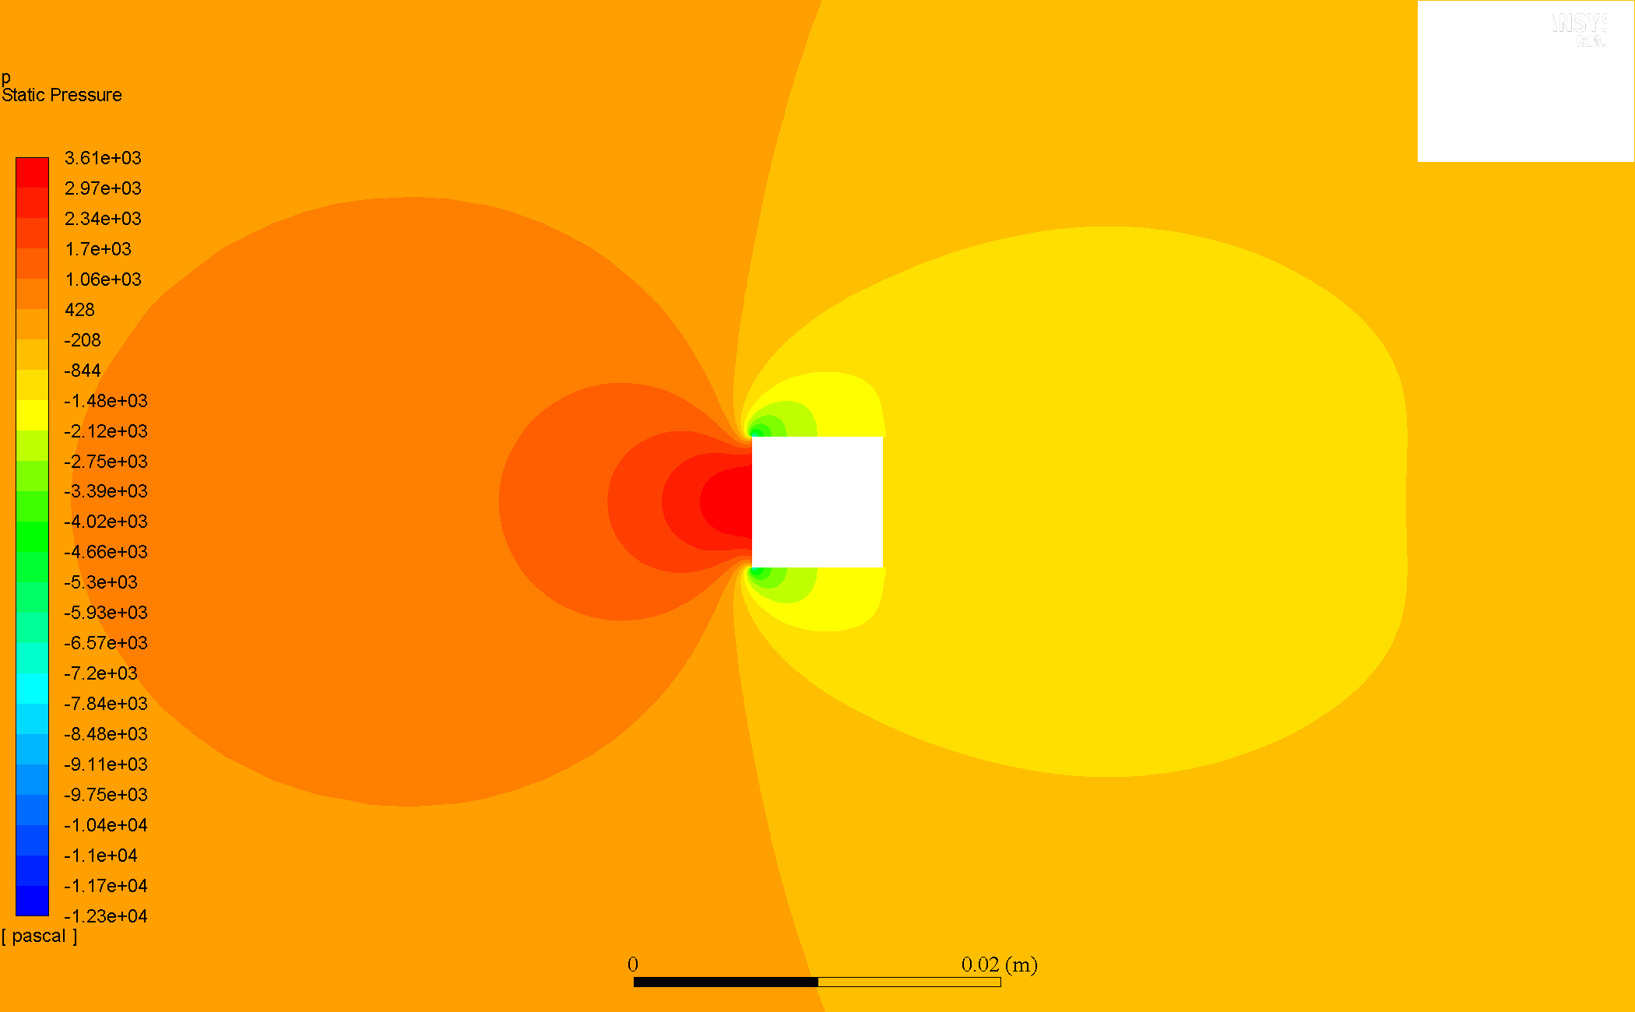

### Re = 160

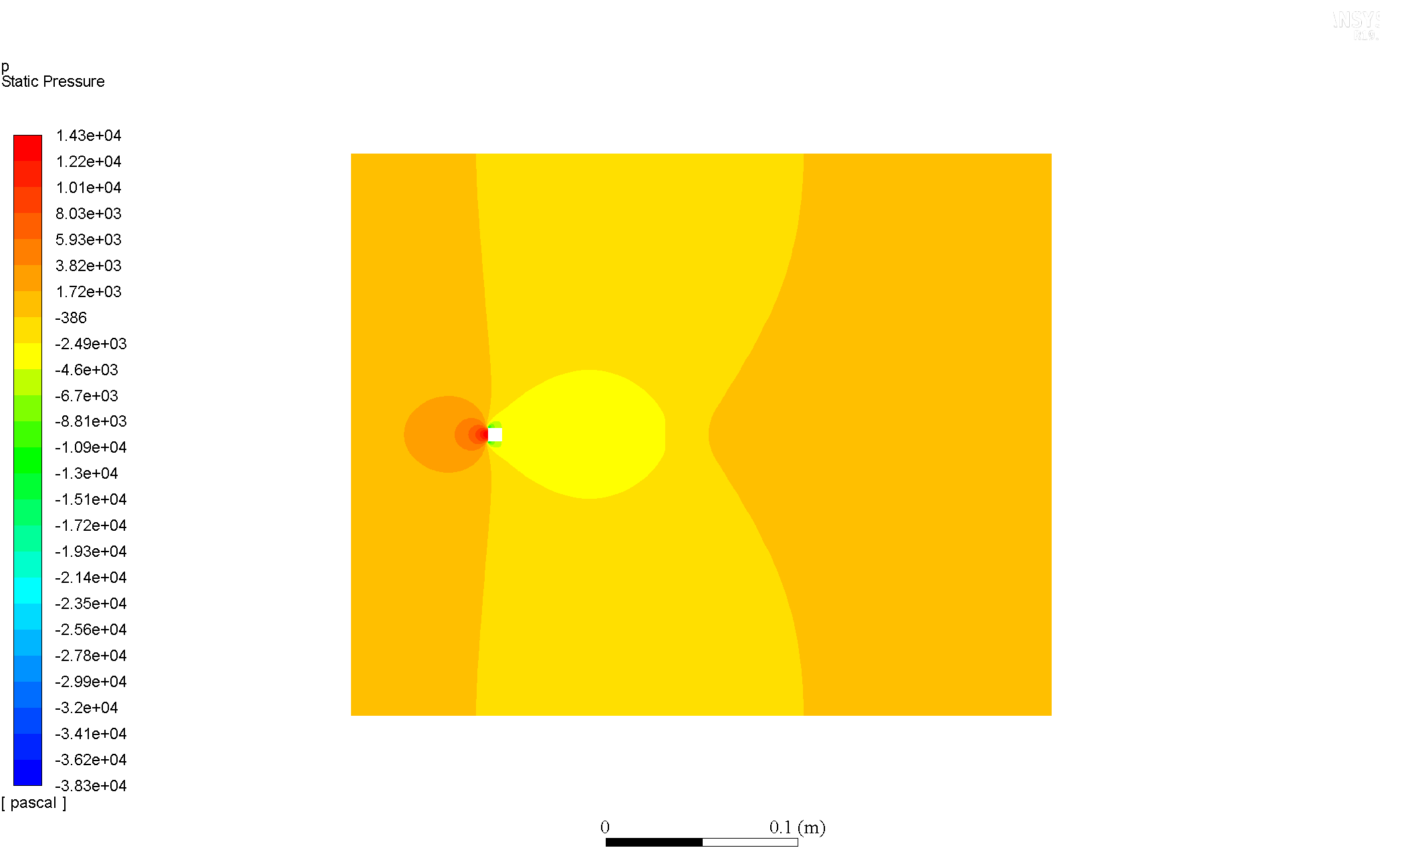

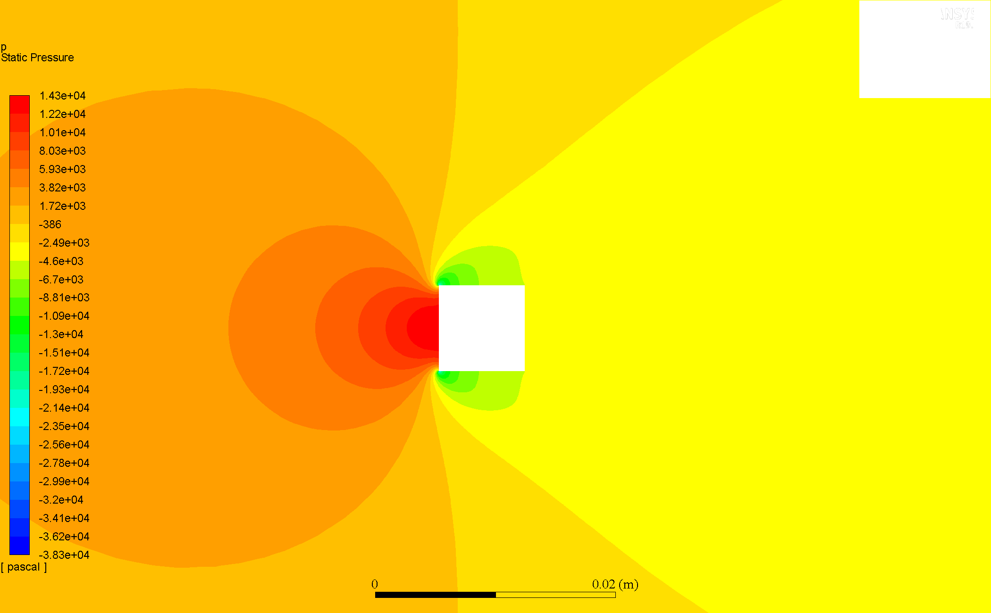

### Comparison & Discussion

At all , the cylinder has positive static pressure in its fore and negative static pressure in its aft region. For increasing , the simulations indicate significant increase in the pressure gradient, that is, the magnitudes at the fore and aft of the cylinder, and hence there variation in the vicinity of the cylinder for static pressure become larger.

Further, as expected_Qualitative_Flow), the pressure contours are symmetric about the axis.

The region of influence of these increasing pressure gradients also become larger for increasing , indicating there may be an onset of instabilities to trigger vortex shedding, hence presenting a need to try transient simulations.

## Velocity Contour Plots

### Re = 20

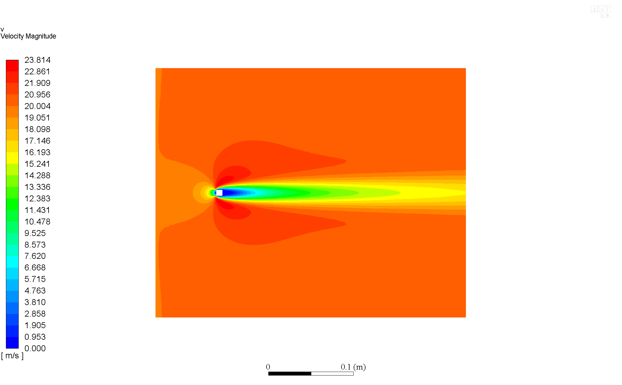

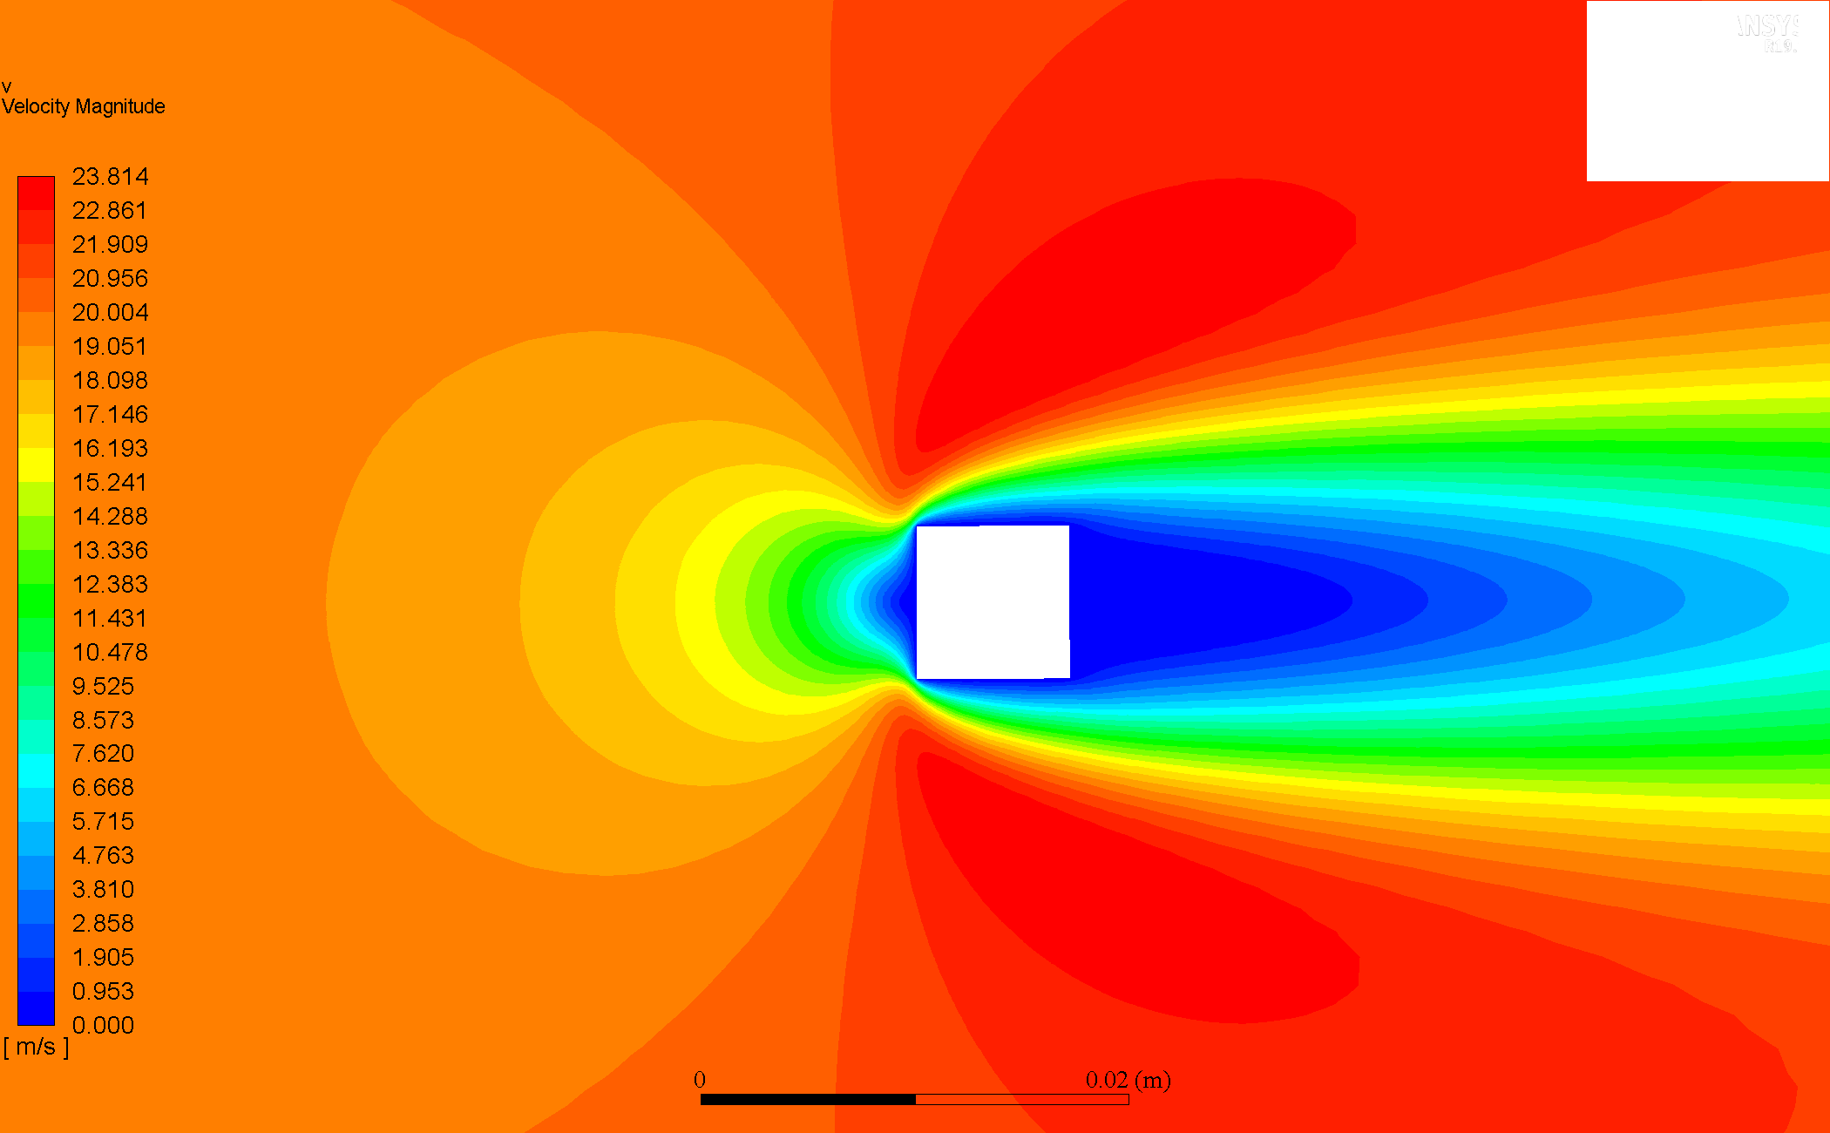

### Re = 40

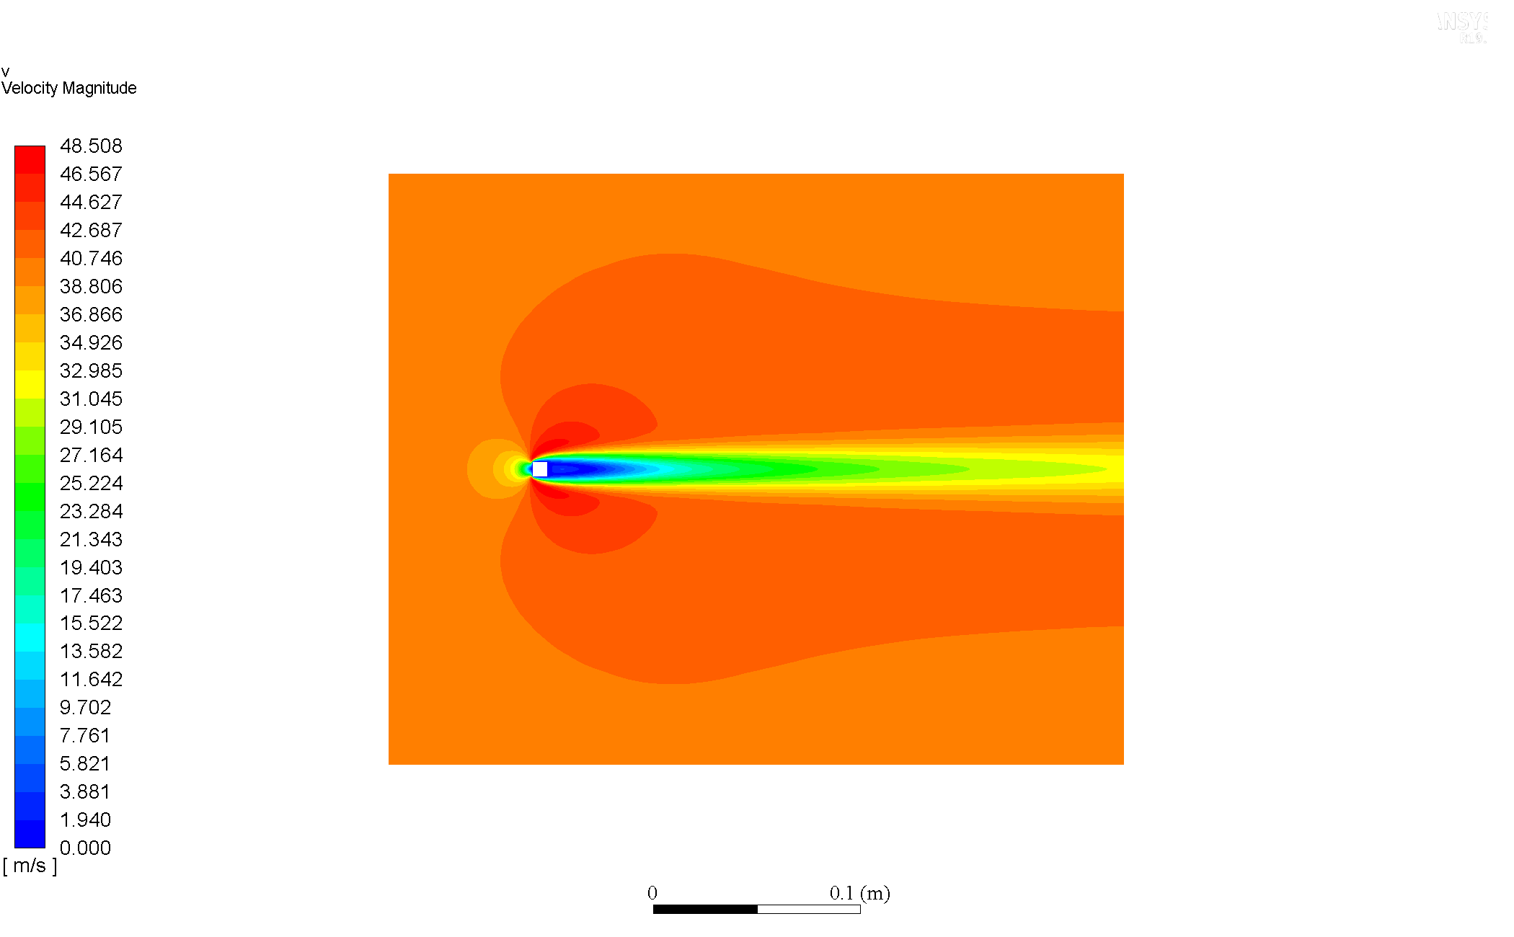

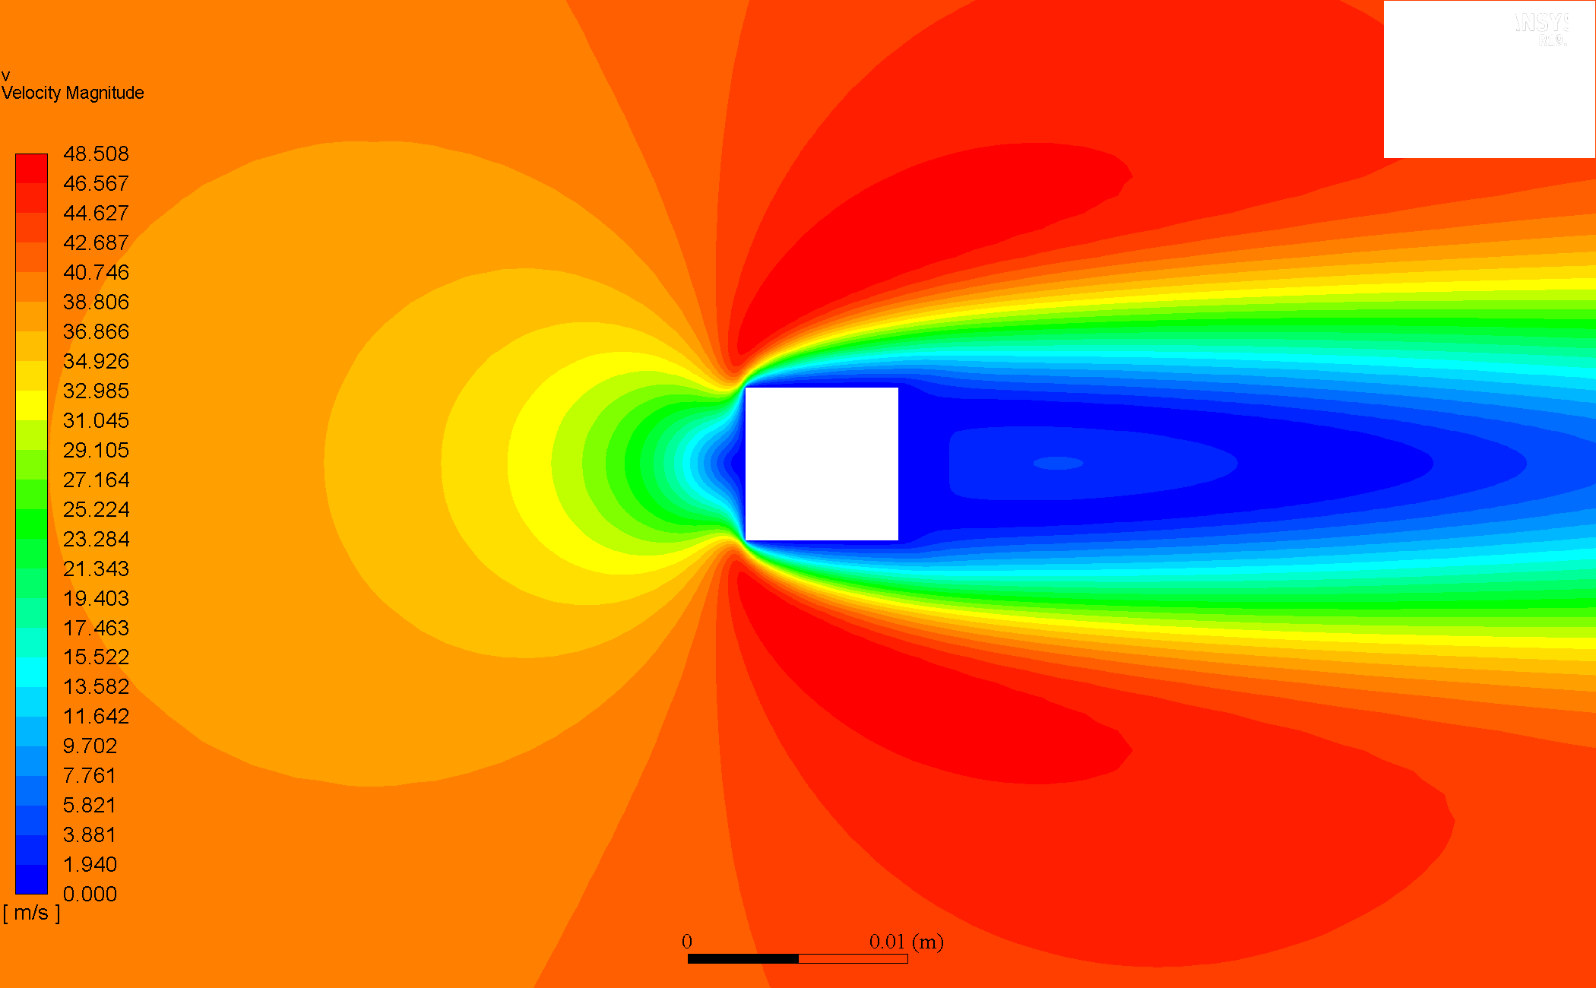

### Re = 60

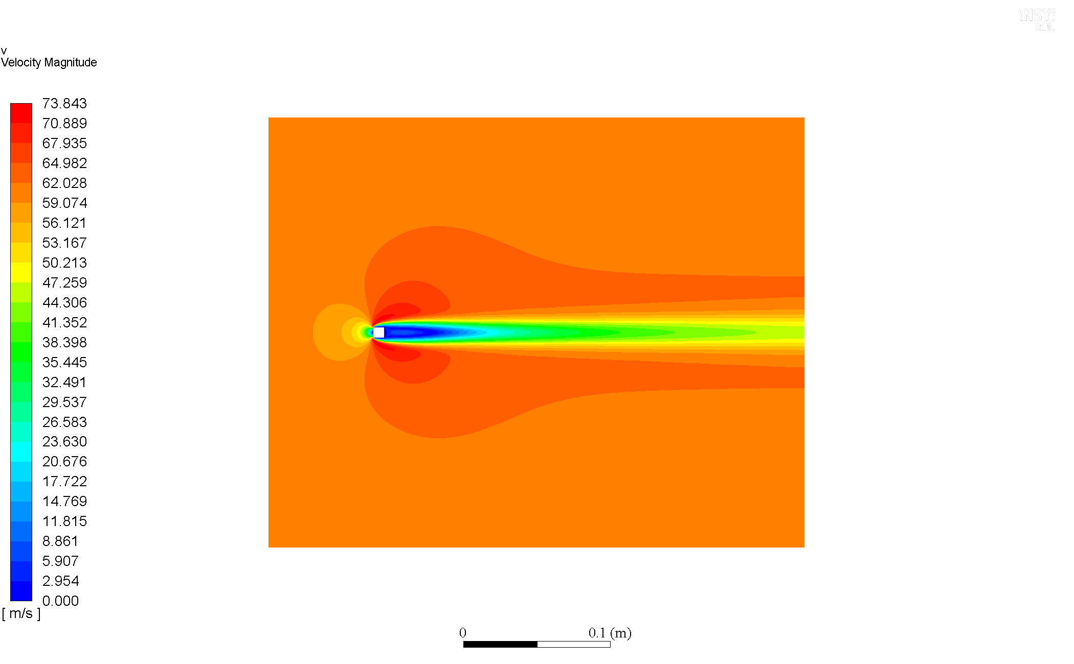

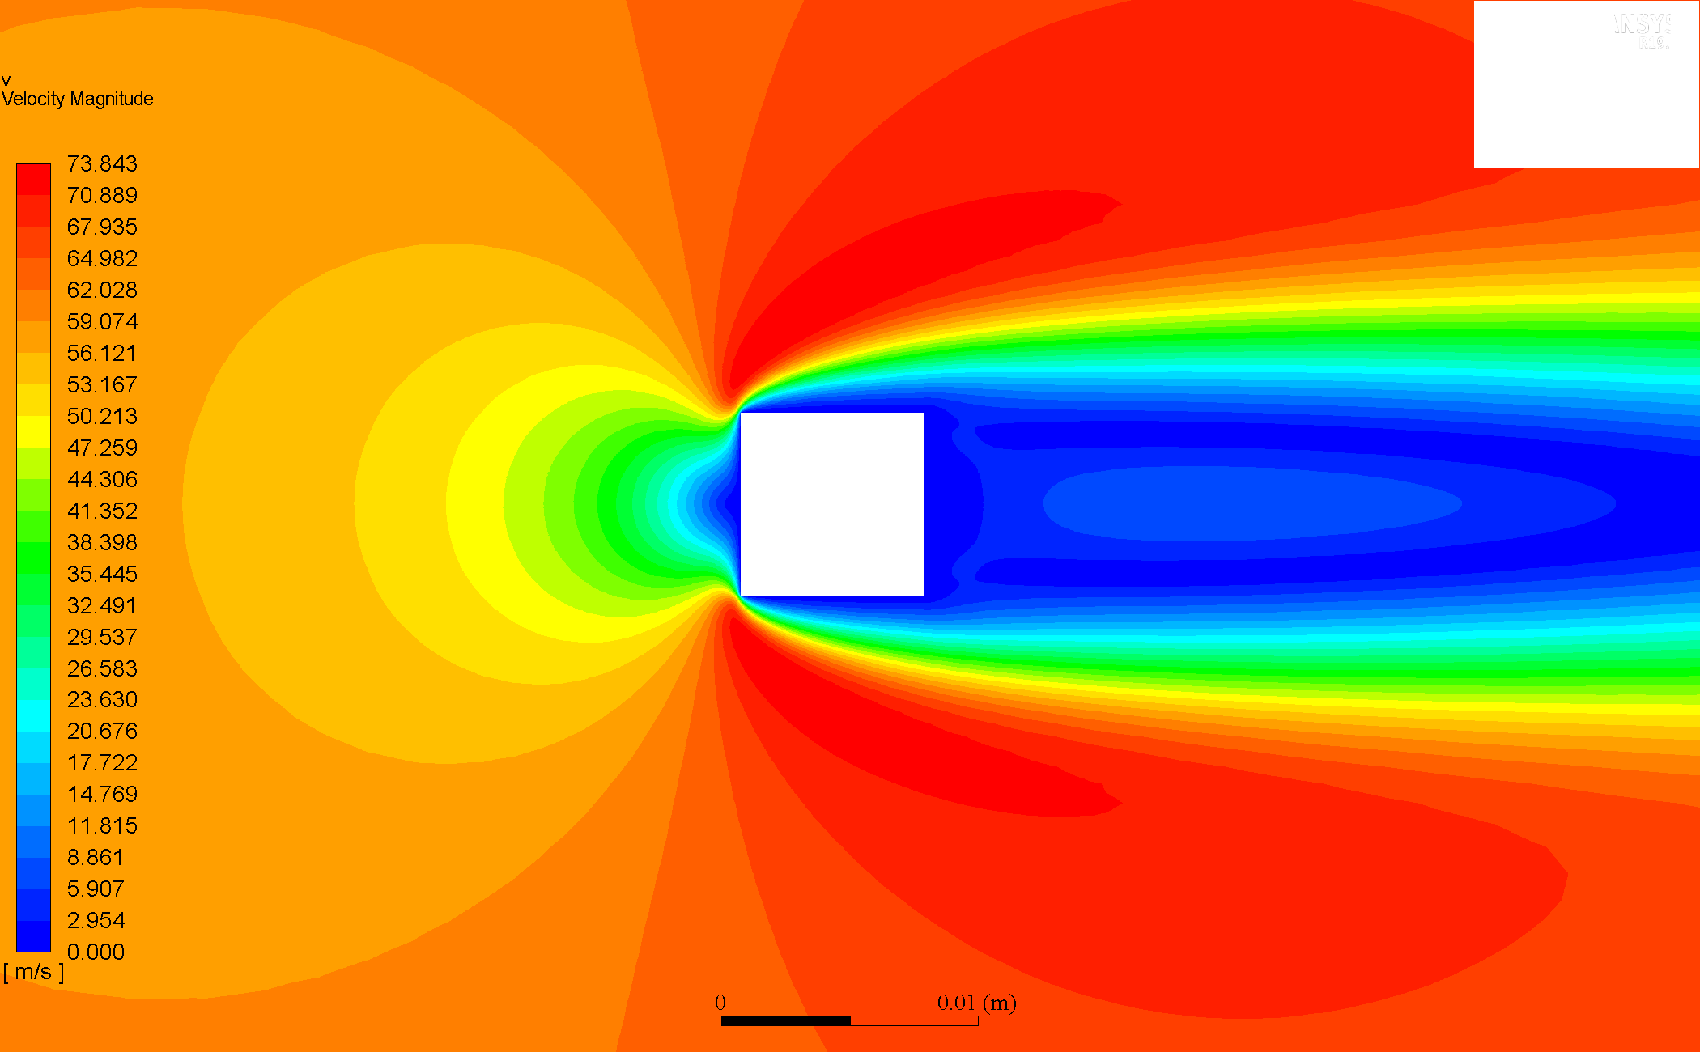

### Re = 80

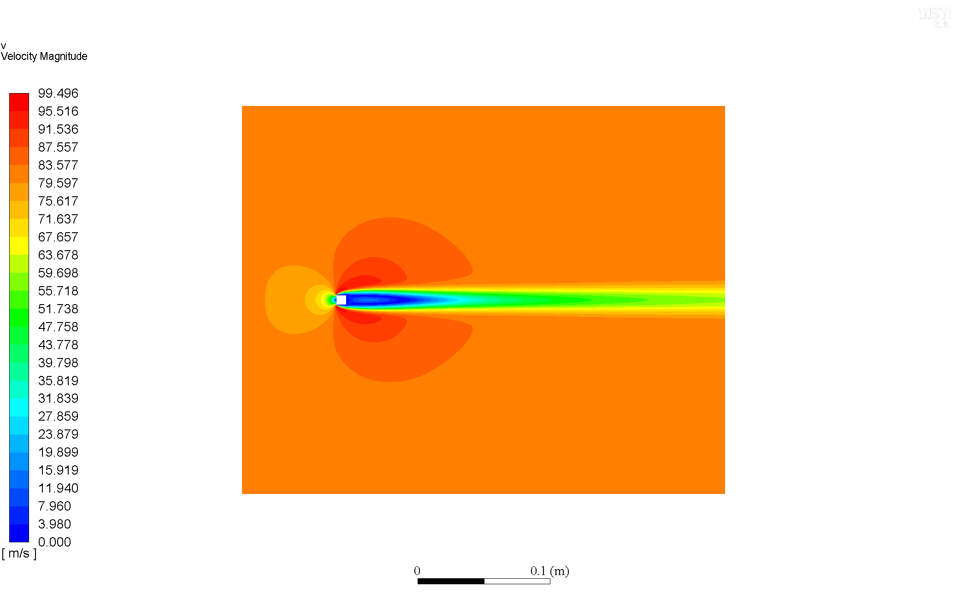

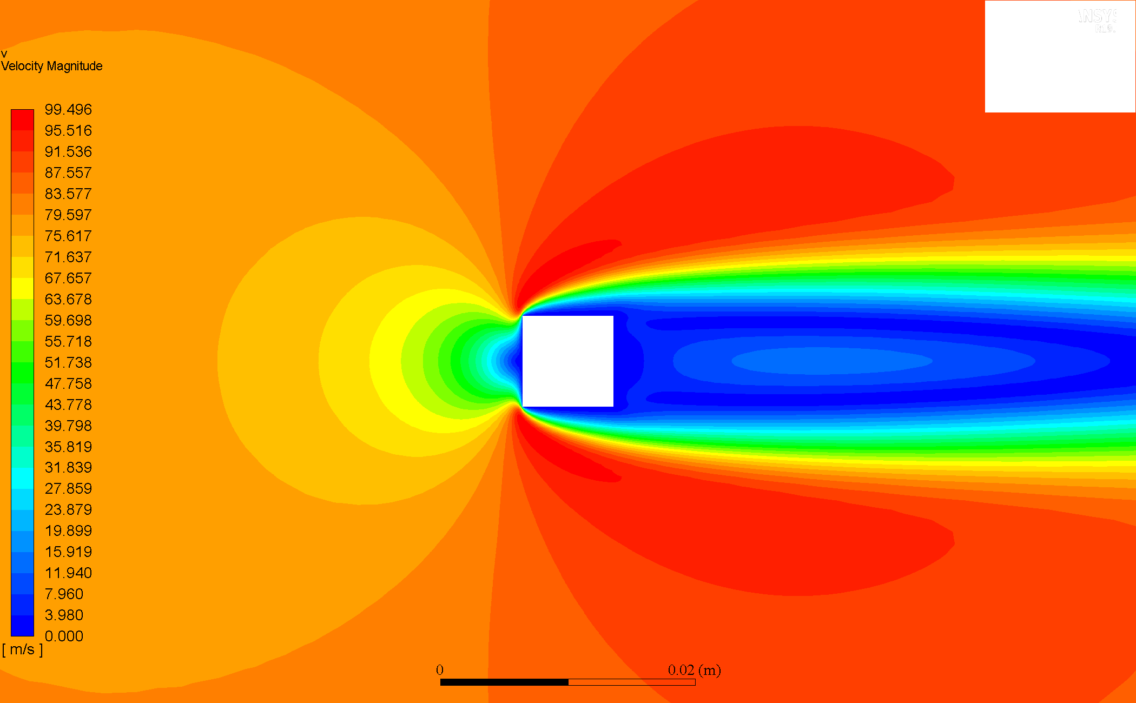

### Re = 160

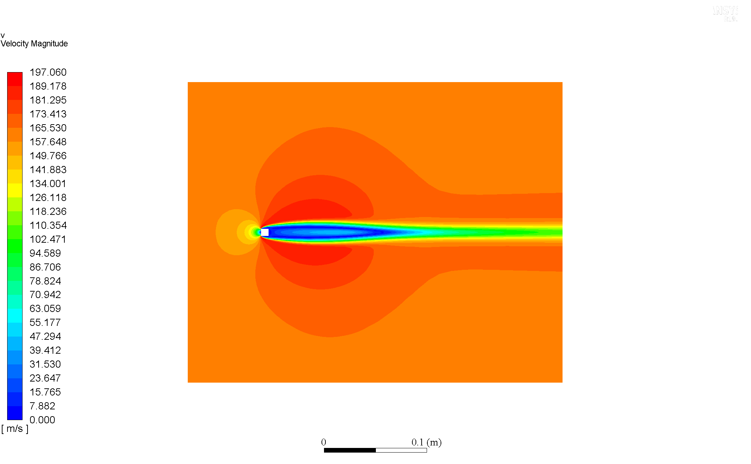

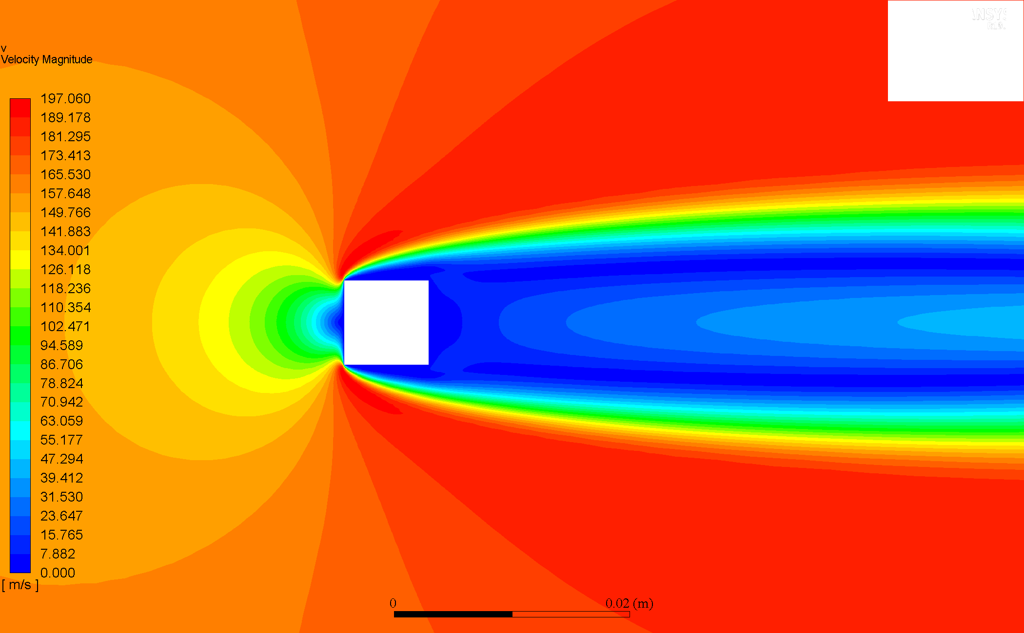

### Comparison & Discussion

At all , the cylinder has stagnation points (zero velocity regions) in its immediate vicinity (fore and aft regions). The flow is seen to separate (that is separation regions form) after the flow crosses the fore vertices of the cylinder for all , as well as wake regions downstream, which are seen to become longer as increases.

For increasing , the simulations indicate significant increase in the velocity gradients, that is, , hence vertically shorter and axially longer boundary layers; indicating the variation in the vicinity of the cylinder become larger.

## Velocity Vector Plots

*Note: All vectors have been scaled by a factor of 100, with no skip.*

### Re = 20

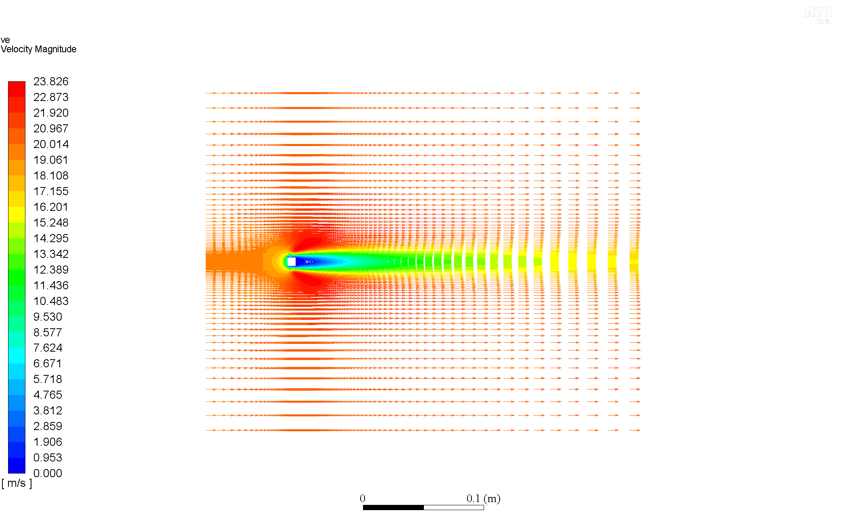

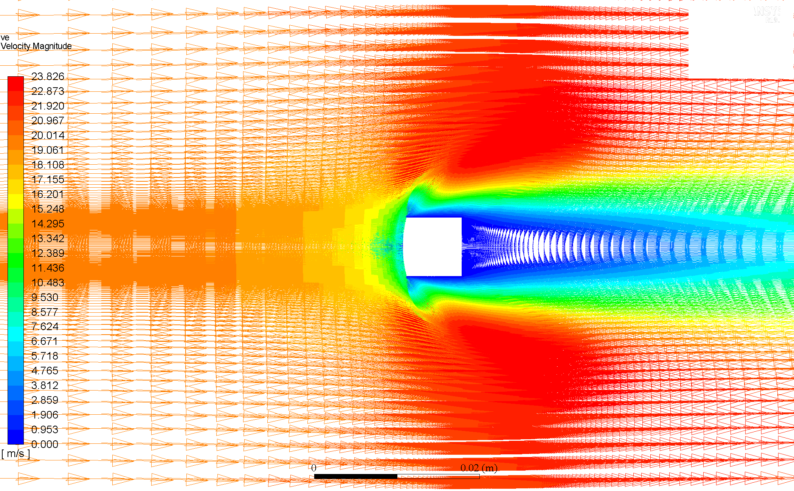

### Re = 40

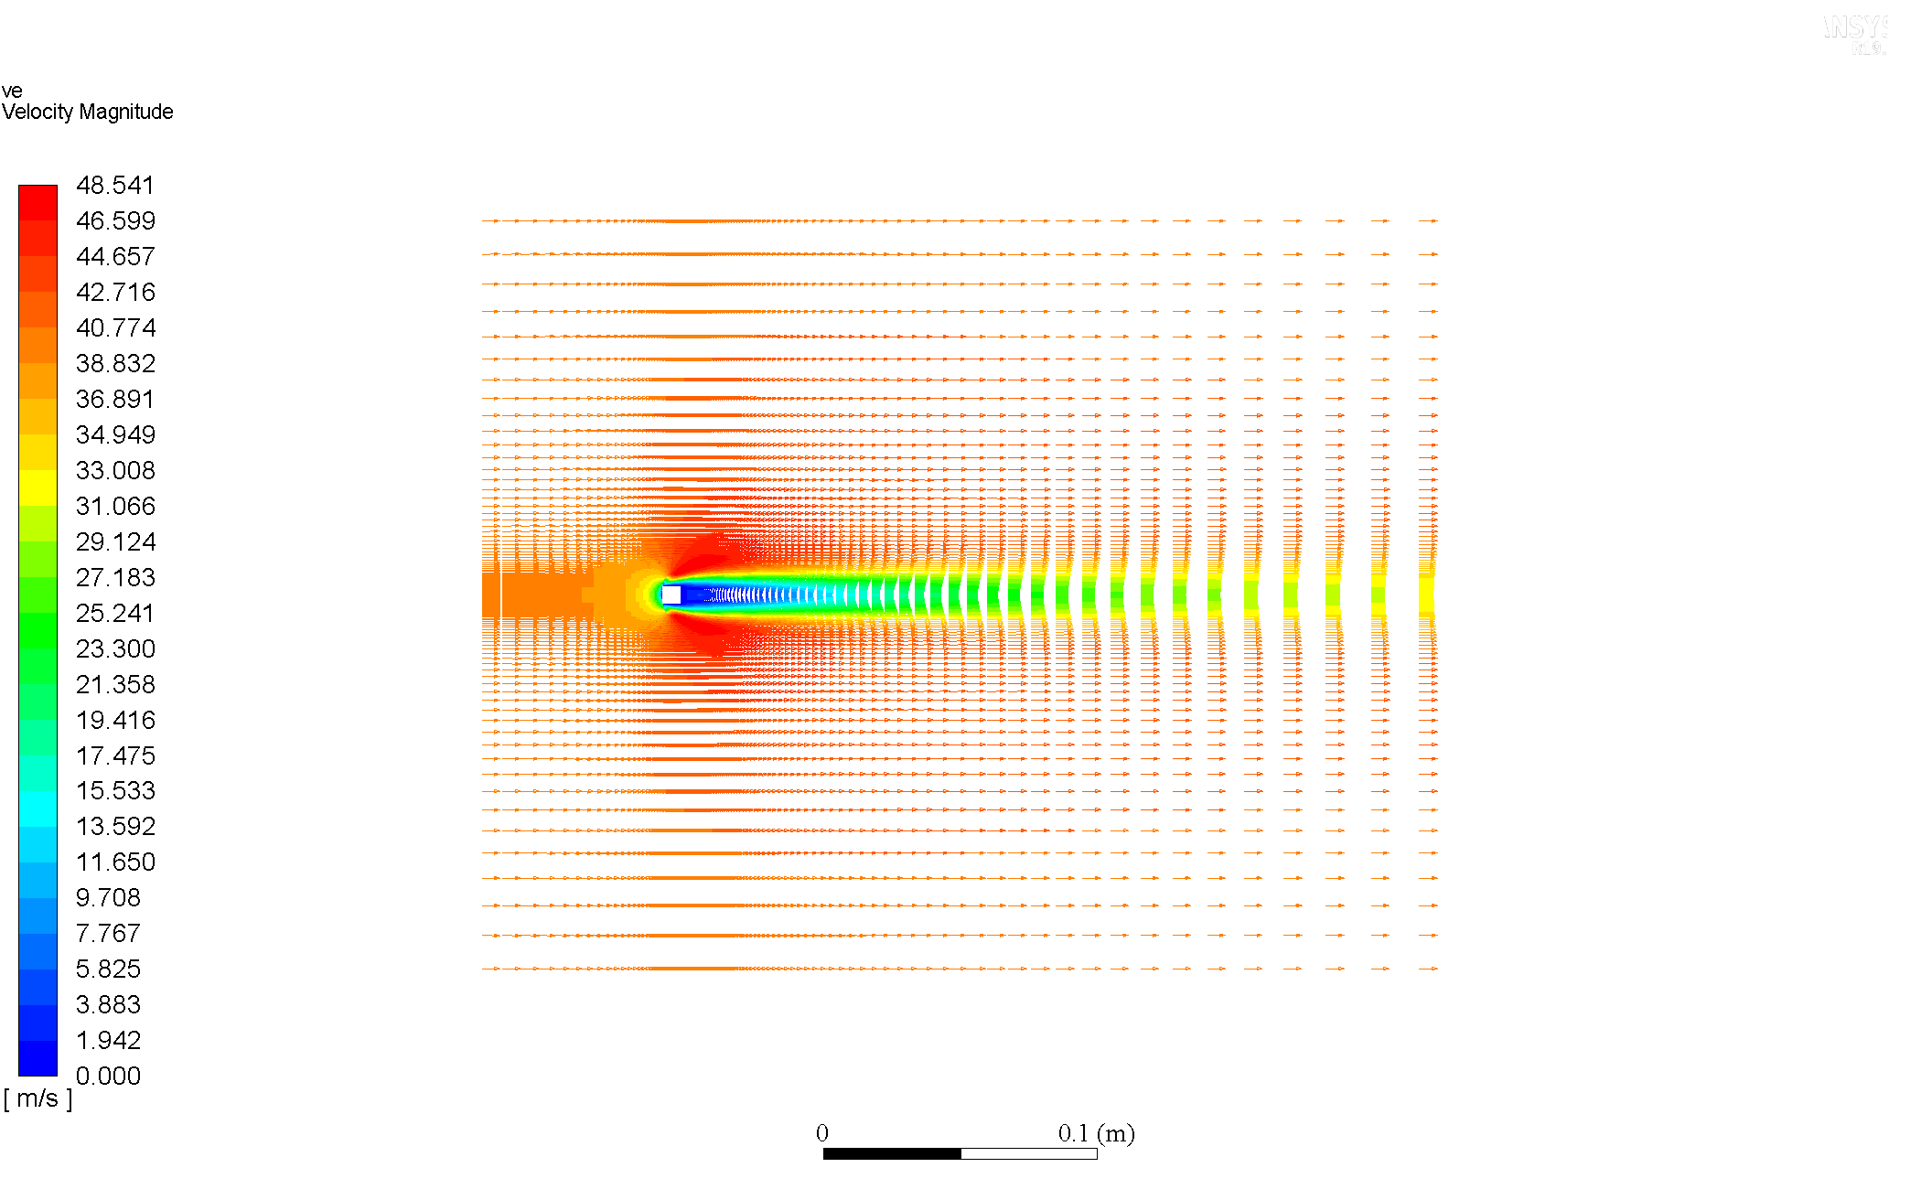

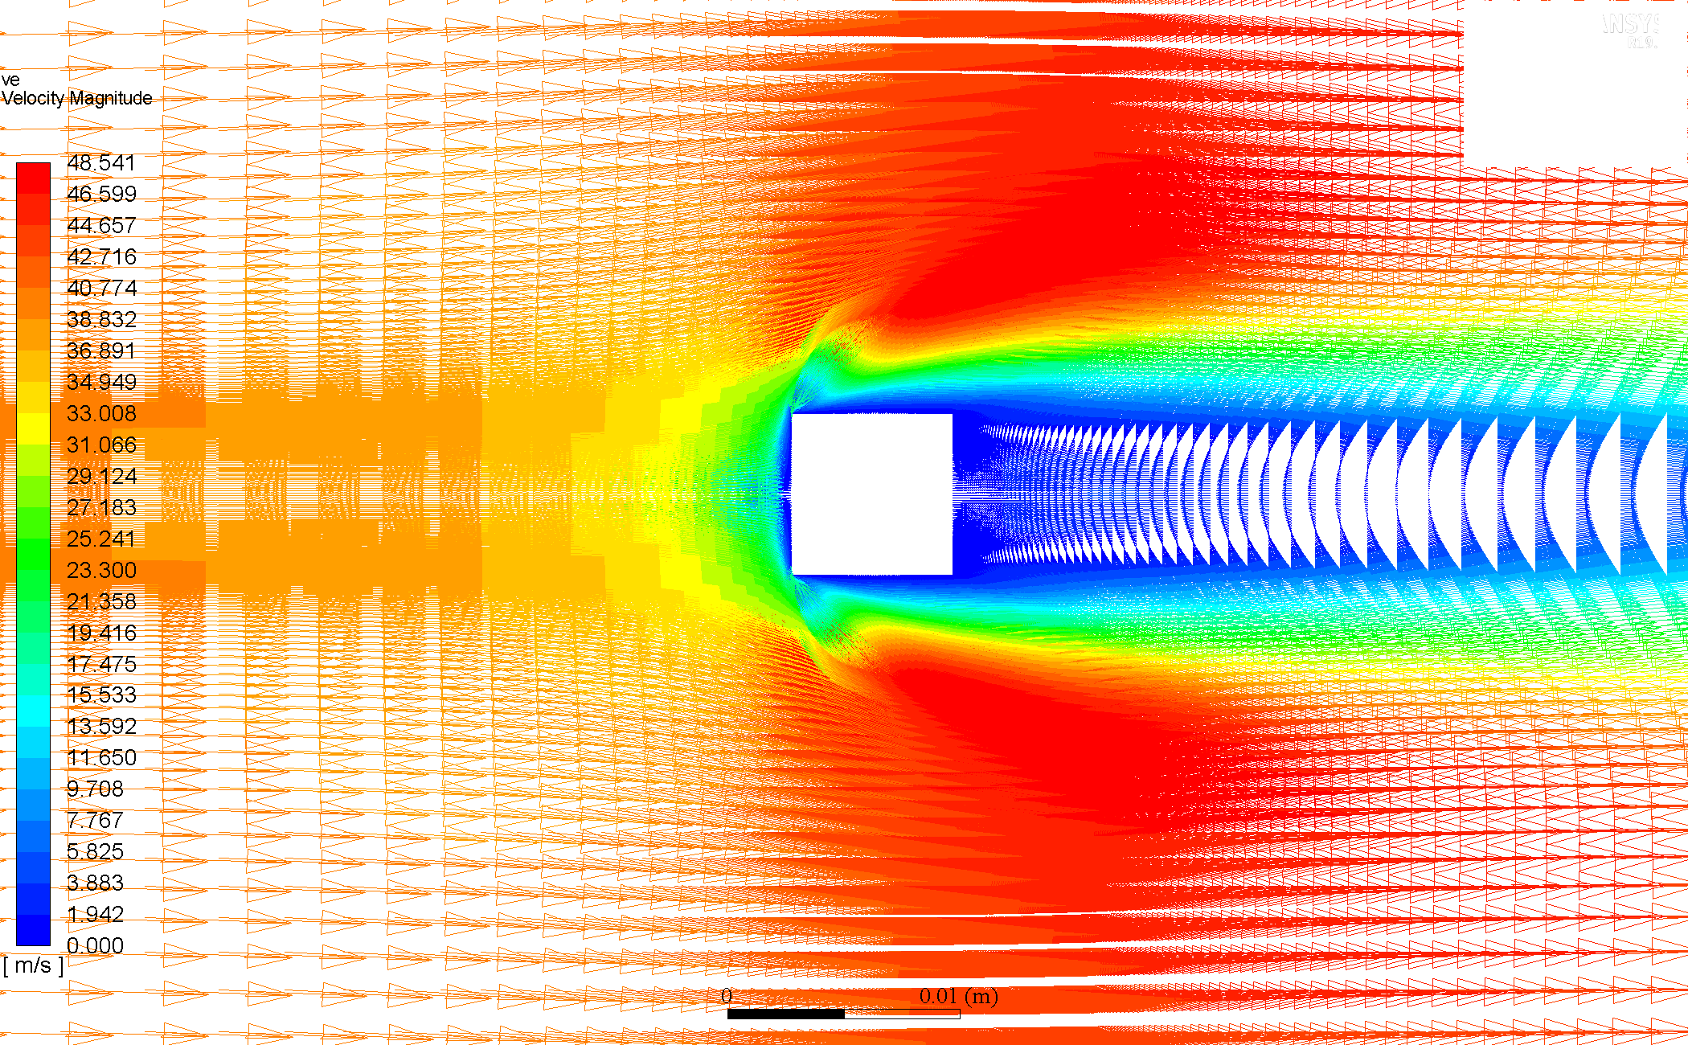

### Re = 60

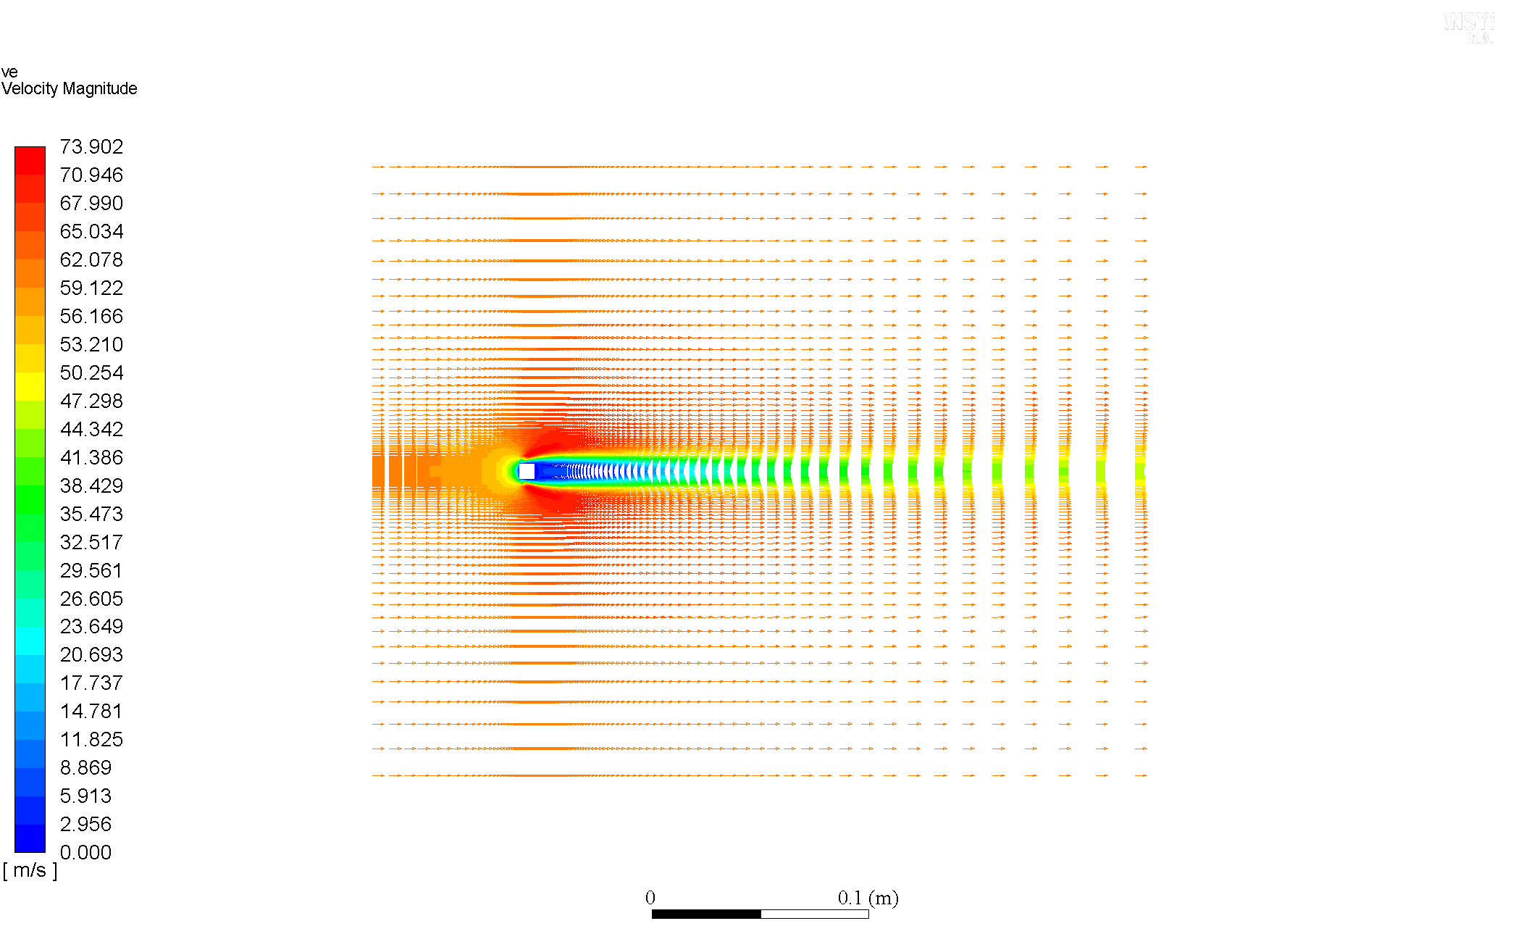

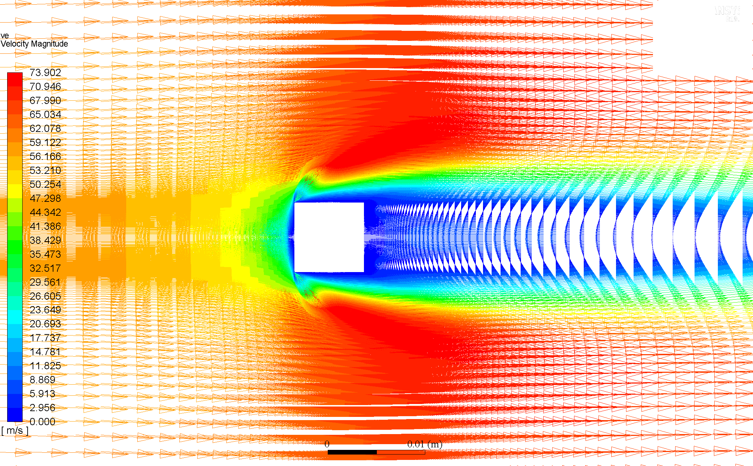

### Re = 80

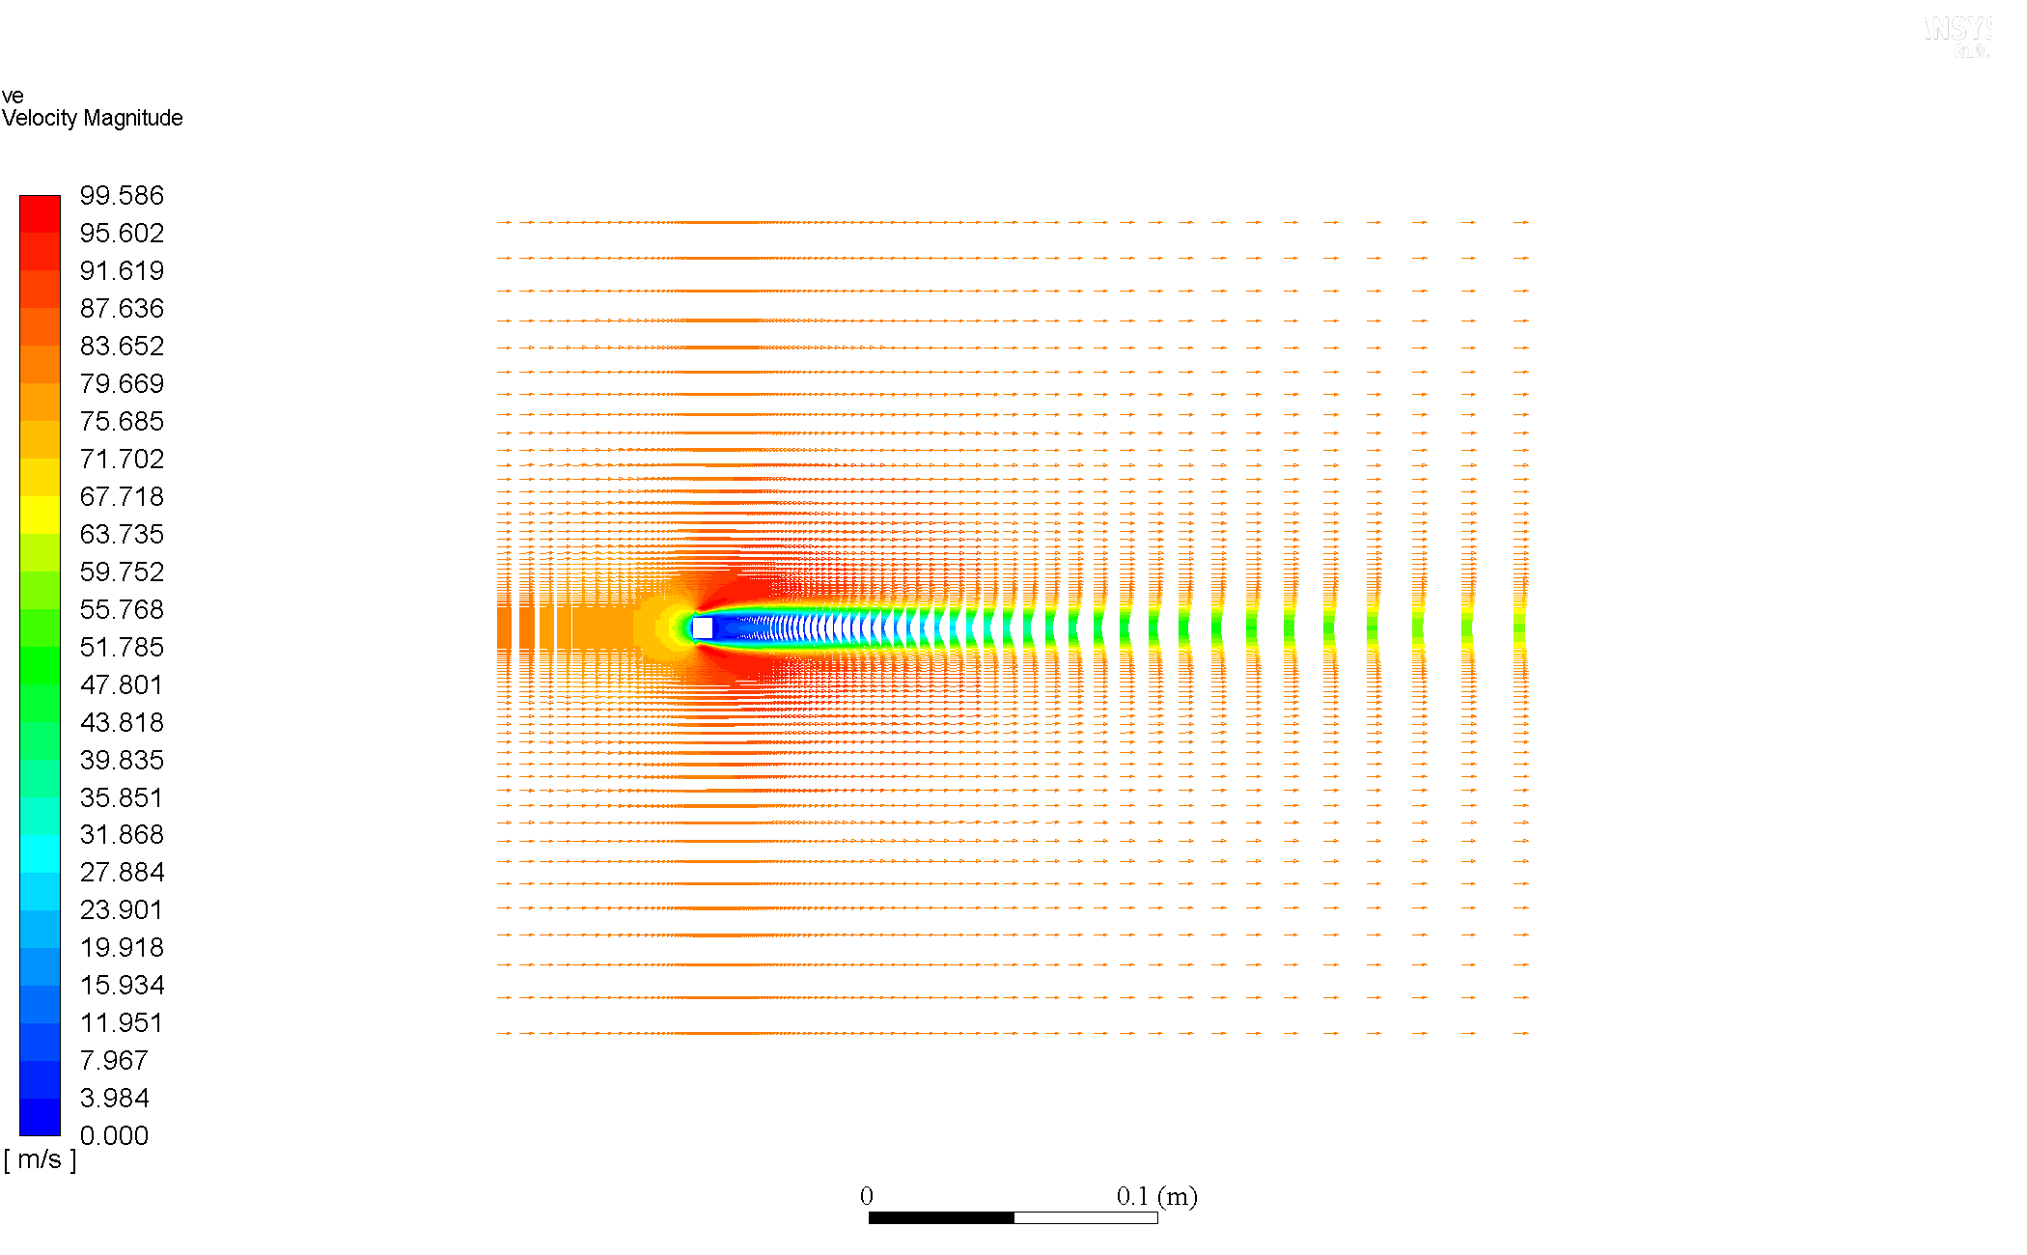

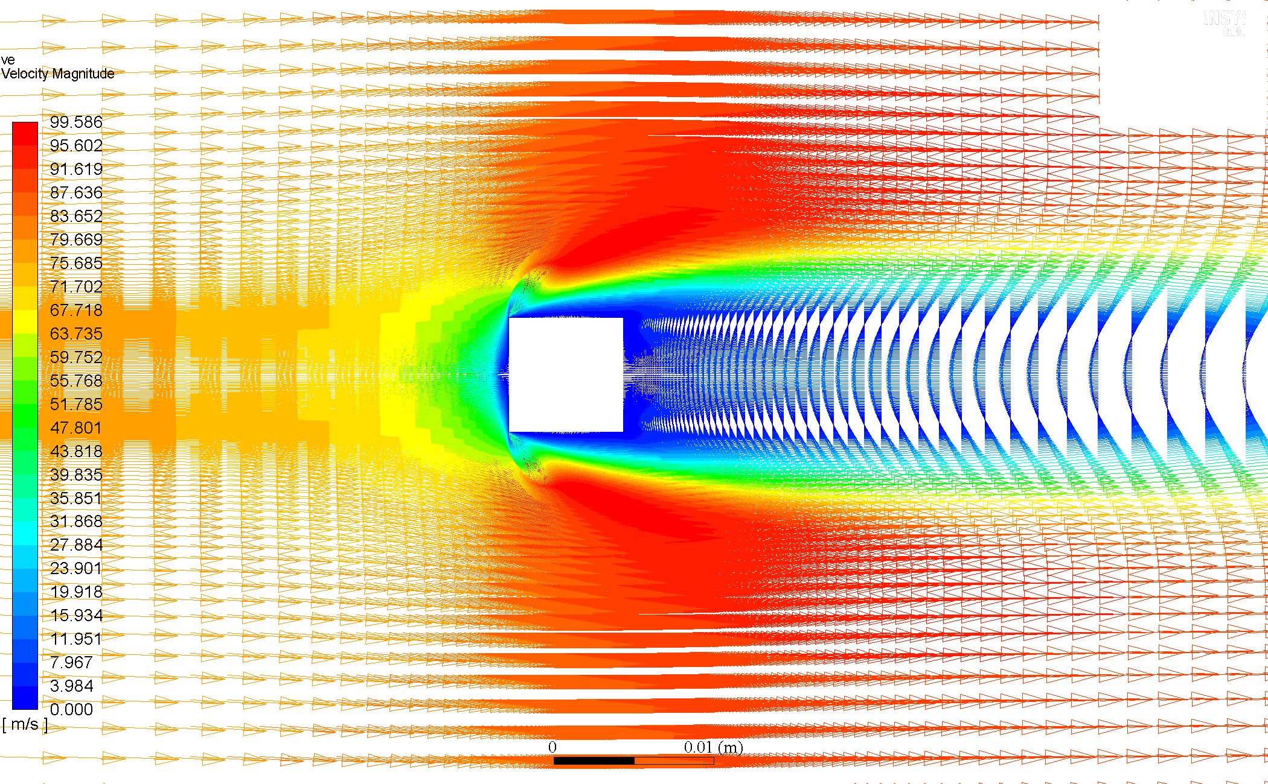

### Re = 160

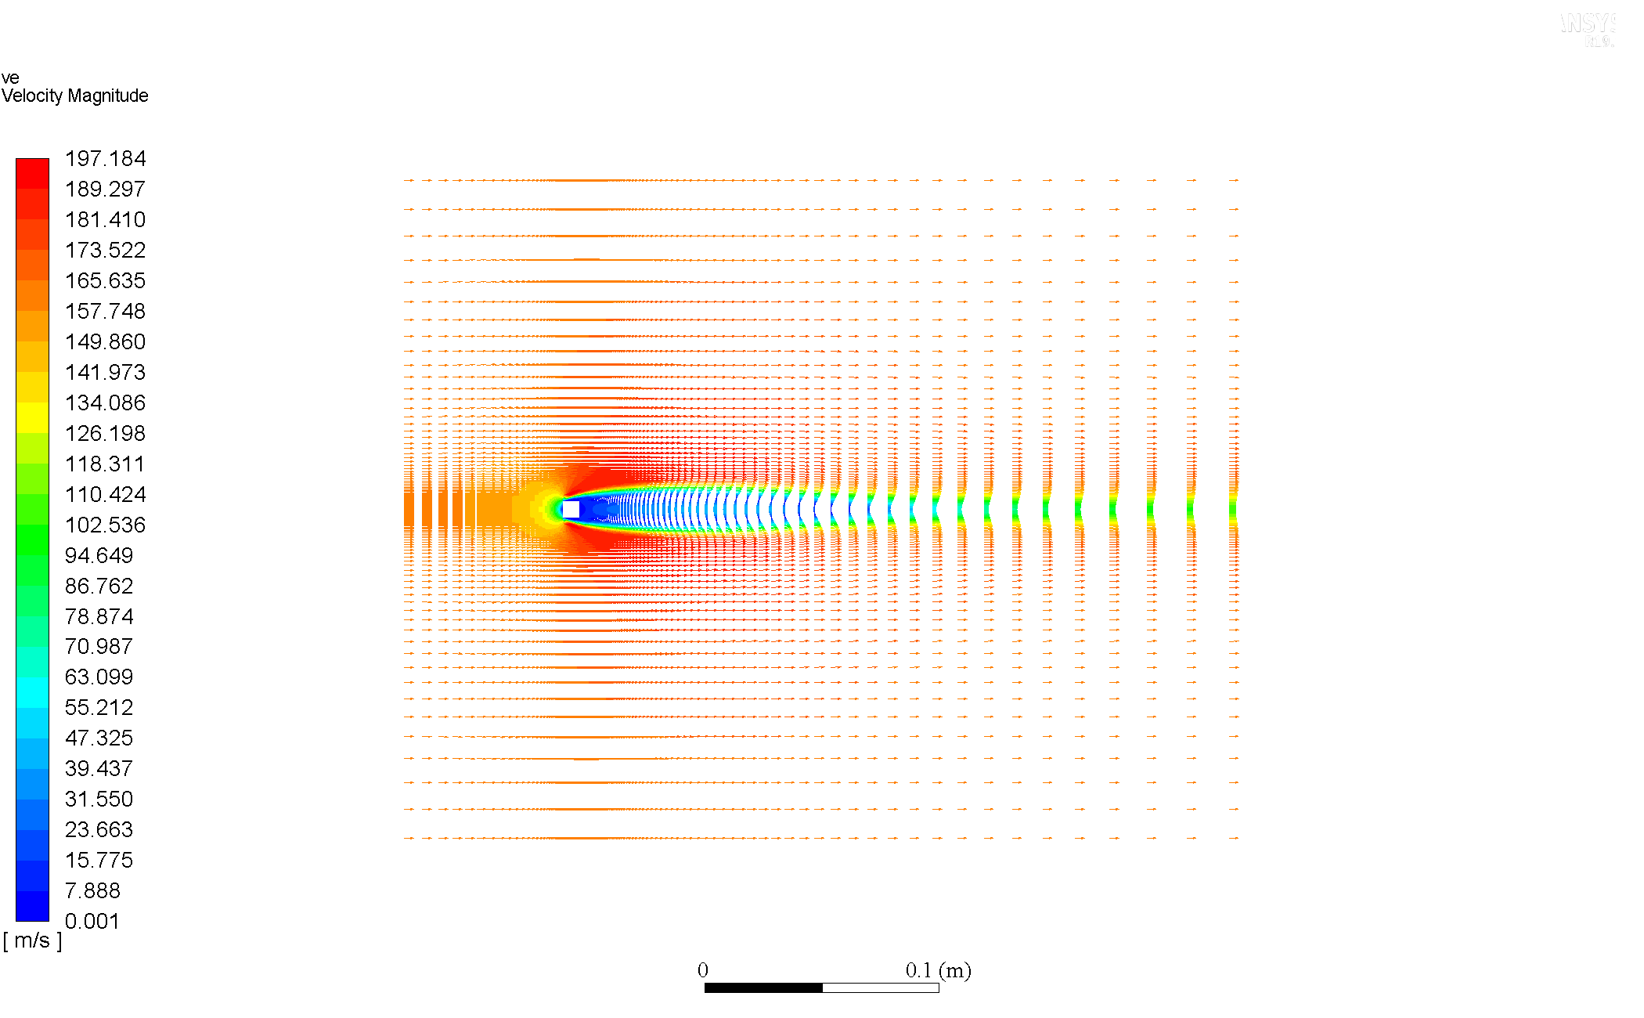

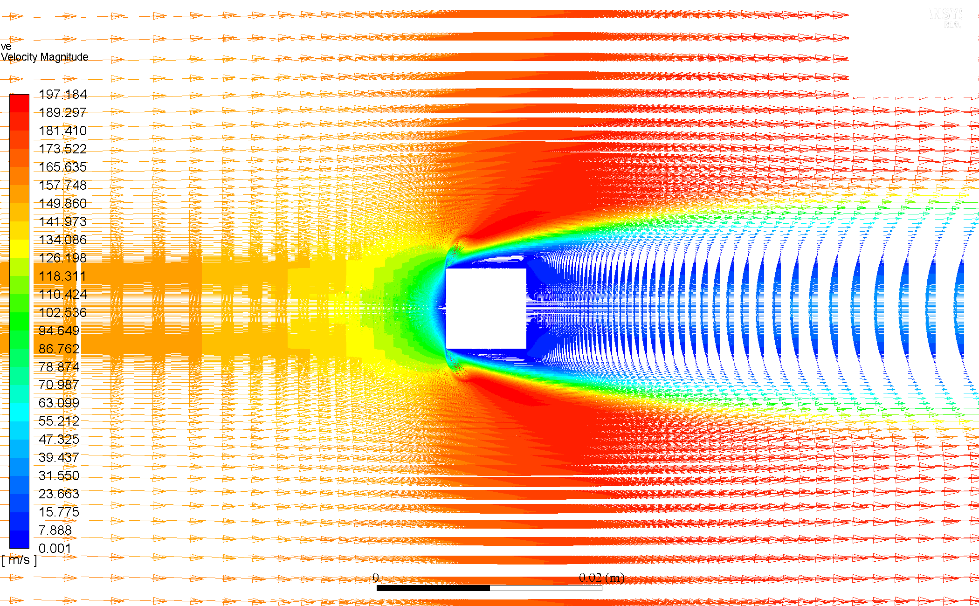

### Comparison & Discussion

The general features discussed before can also be inferred from these vectors. However additional insight is provided in the direction of the velocity vectors.

Negative velocity vectors can be seen in the centre of the wake region for all , the vicinity of the aft region of the cylinder, which gradually diminish and then are in the direction of flow as one looks away from the region of influence.

## Residuals Plots

### Re = 20

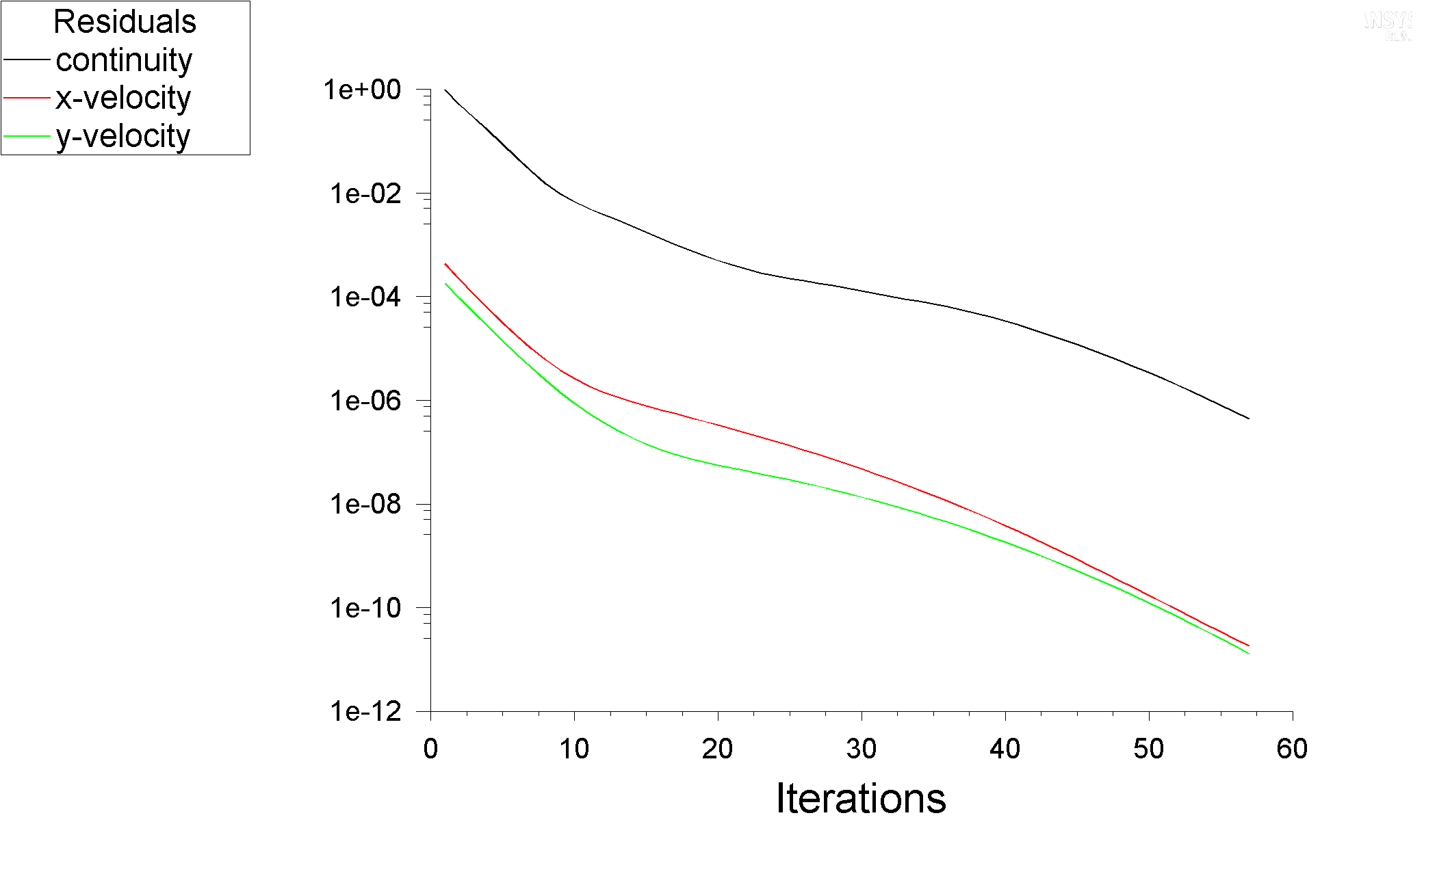

### Re = 40

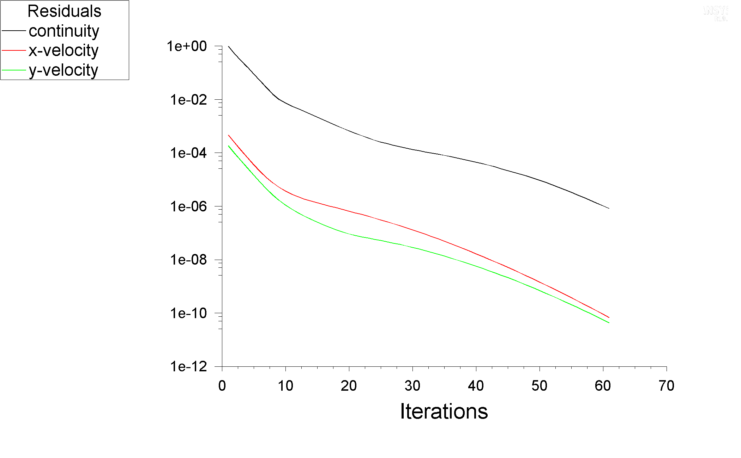

### Re = 60

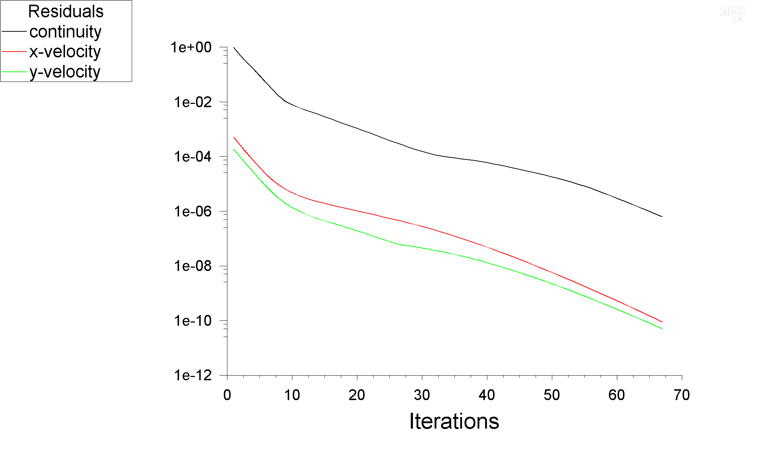

### Re = 80

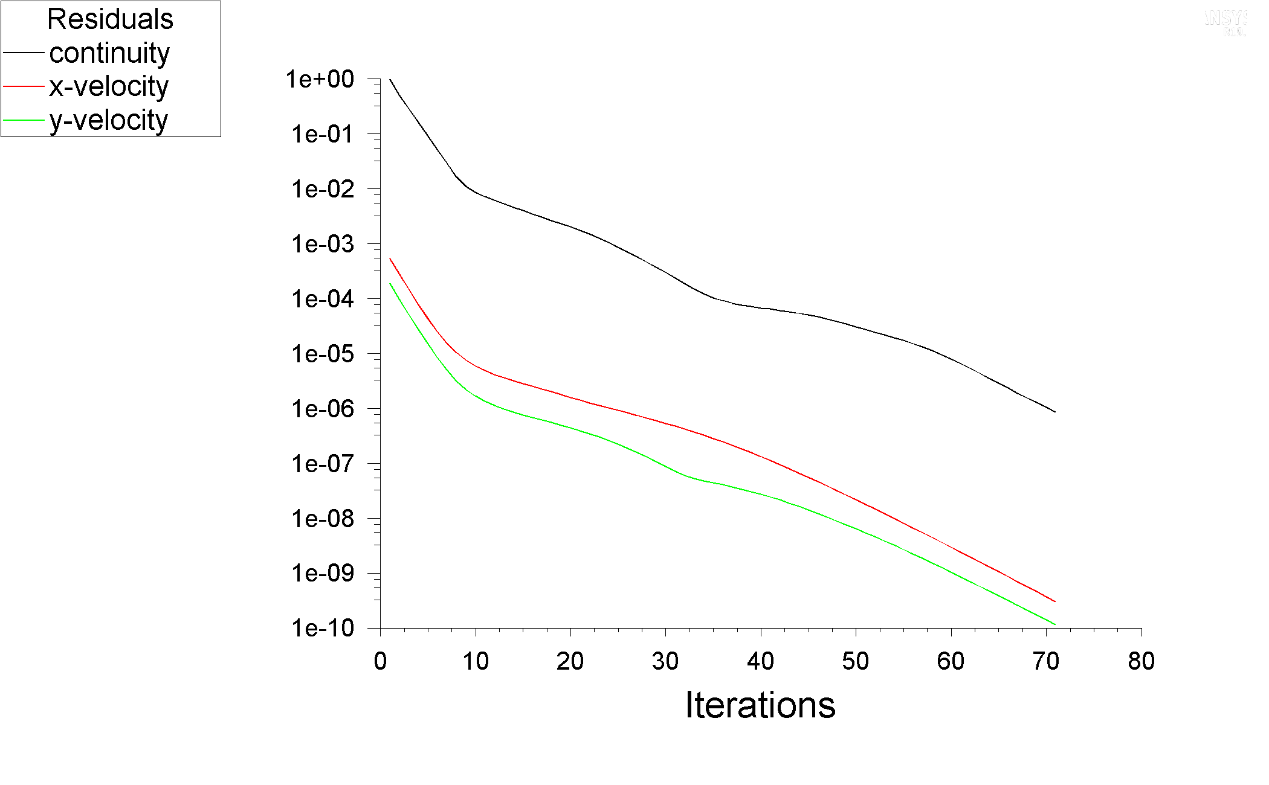

### Re = 160

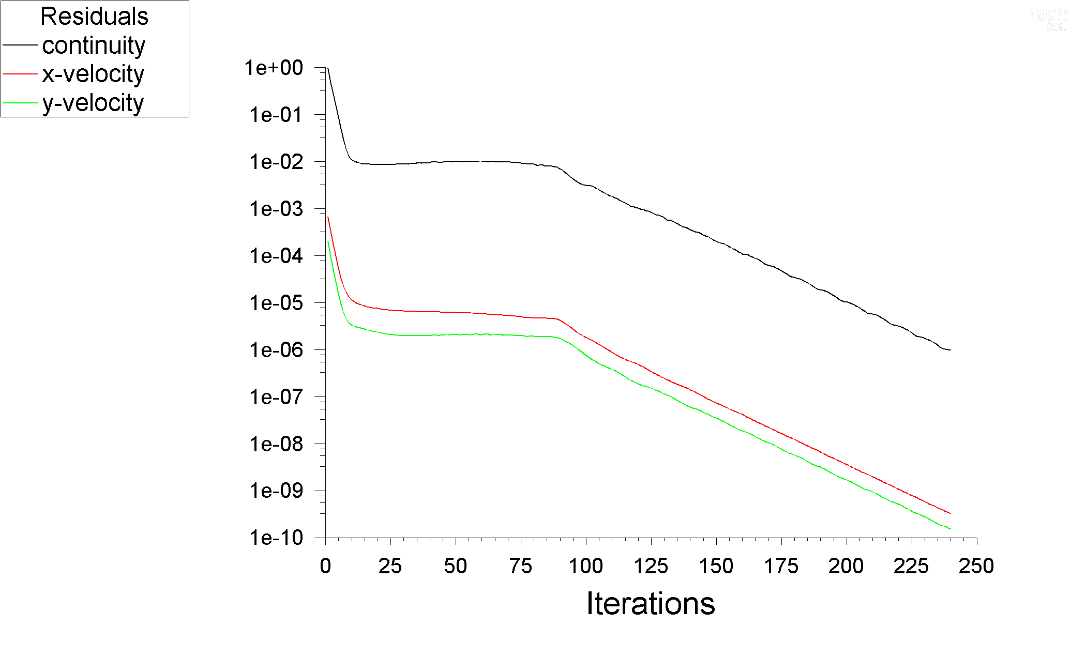

### Comparison & Discussion

The residuals plots indicate that the simulations take longer CPU time (more iterations) as increases. Although the velocity equations converge quickly, the momentum equation largely influences the number of iterations to achieve convergence at the set criterion.

was the most computationally intensive, with a trend of nearly constant residuals from the 10th to 95th iteration, and then heading towards convergence once again (this behaviour was odd from the other simulations).

## Coefficients of Drag and Lift

|  |  |  |  |  |  |
| --- | --- | --- | --- | --- | --- |
|  |  |  |  |  |  |
|  |  |  |  |  |  |
|  |  |  |  |  |  |

### Comparison & Discussion

The Coefficient of Lift, is essentially zero, as expected and mentioned in a)_Qualitative_Flow).

The Coefficient of Drag, , tends to decrease with larger Reynolds Numbers. Looking at the definition of

The implication that comes to mind is that the drag force, is decreasing and the term accounting for fluid momentum (inertial force) is increasing, to lower .

Since the frontal area, and the out-of-plane length, , of the cylinder are essentially constant, as well as the fluid being nearly incompressible (fluid density, , is thus essentially constant), the implication is that the increase in the incoming flow velocity, is determinant for the value of .

Further also has a directly proportional relationship with , since

So, it is no surprise that is decreasing with increasing But the results at higher are still questionable due to transient phenomena, such as Vortex Shedding, occurring in reality (since these results are from a Pseudo Transient initialization, steady state simulation CFD).

# d) Velocity Profiles at defined Stream wise Positions*

* for

*Note: All vectors have been scaled by a factor of 300, with no skip.*

### Re = 20

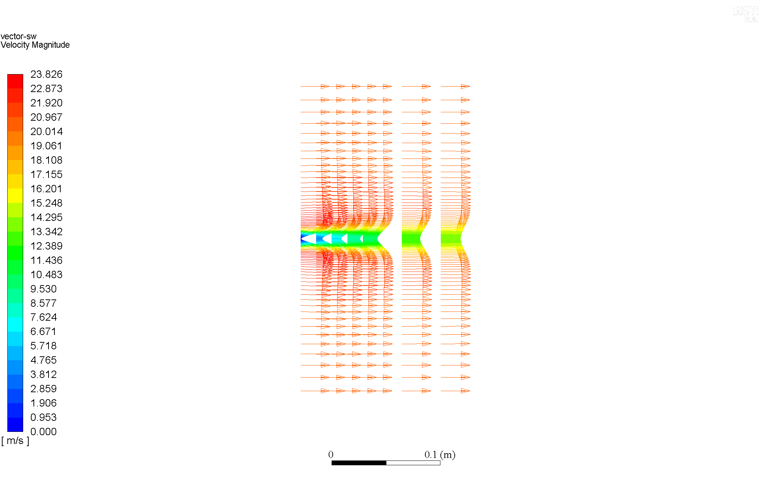

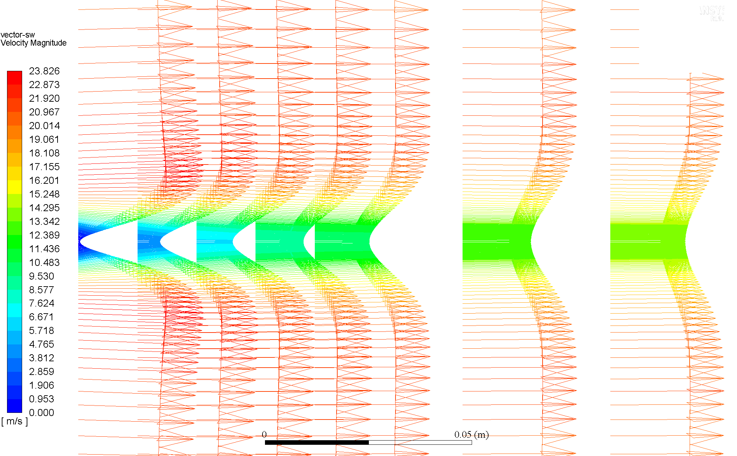

### Re = 40

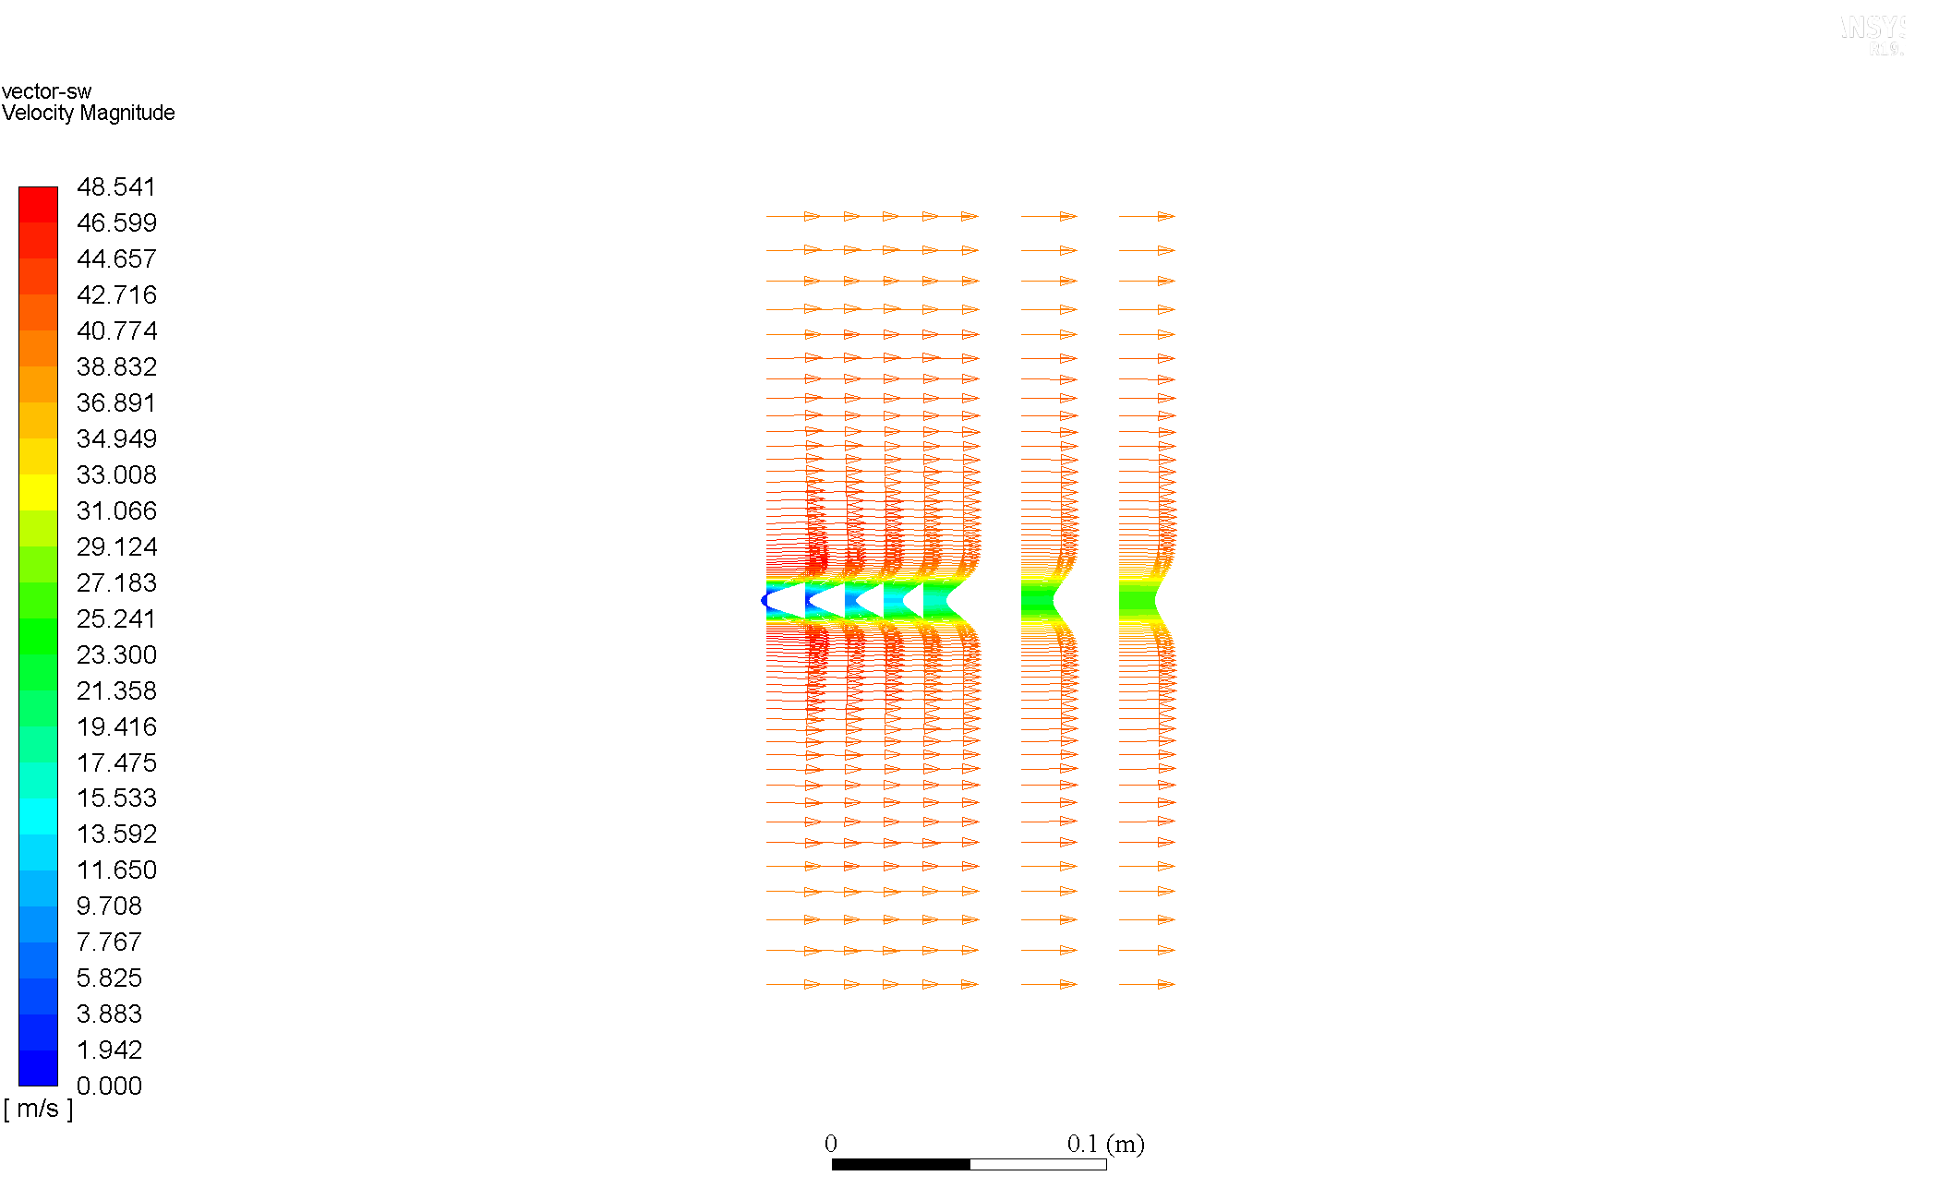

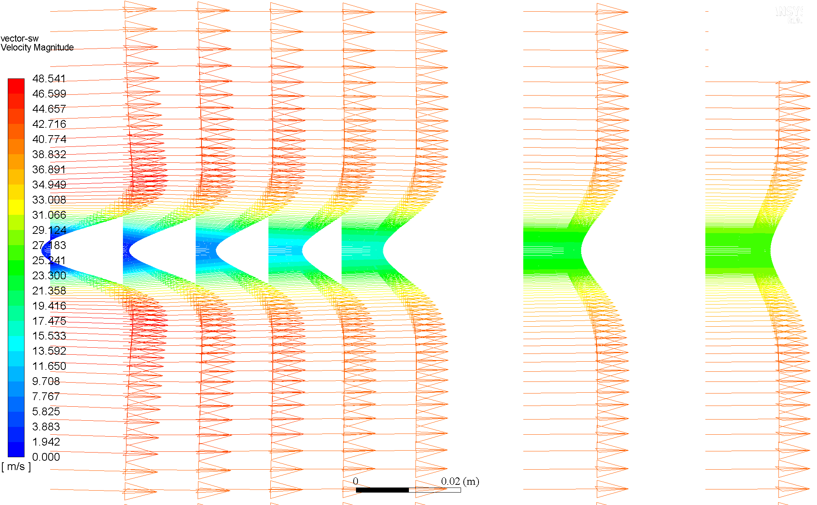

### Re = 60

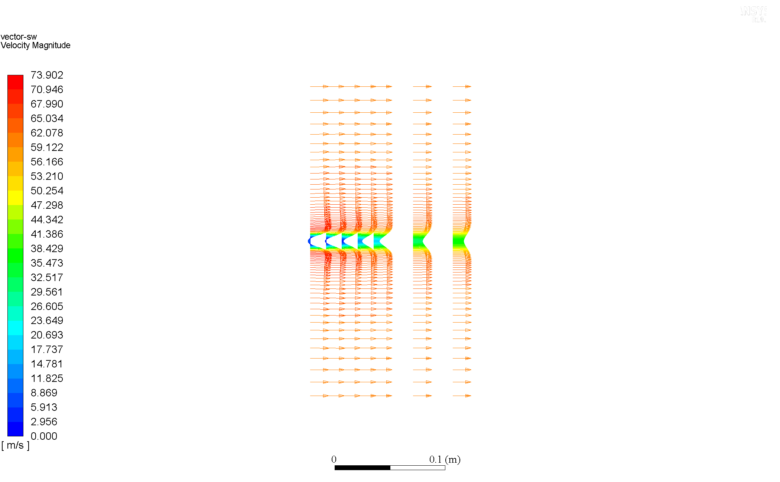

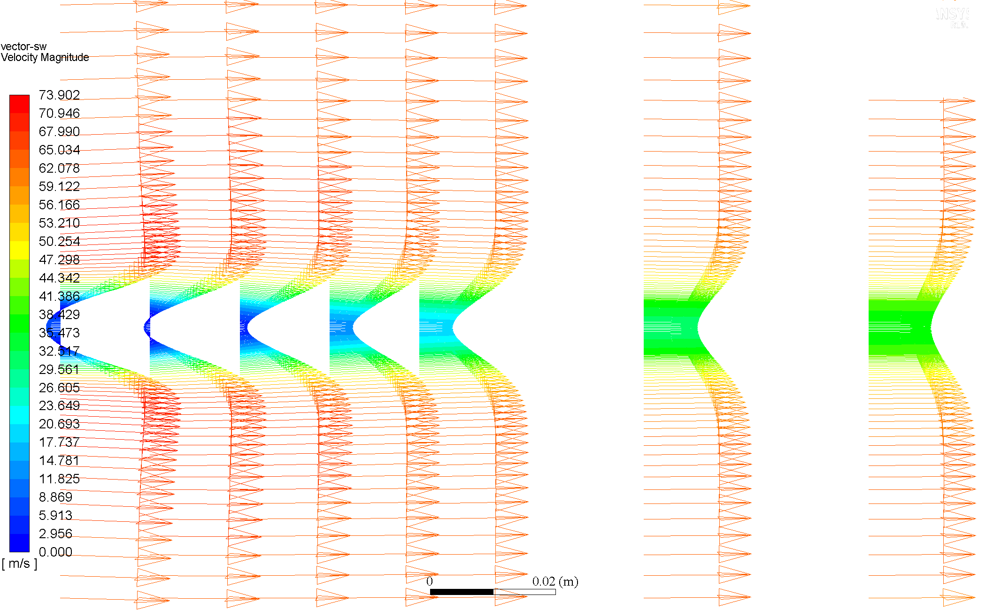

### Re = 80

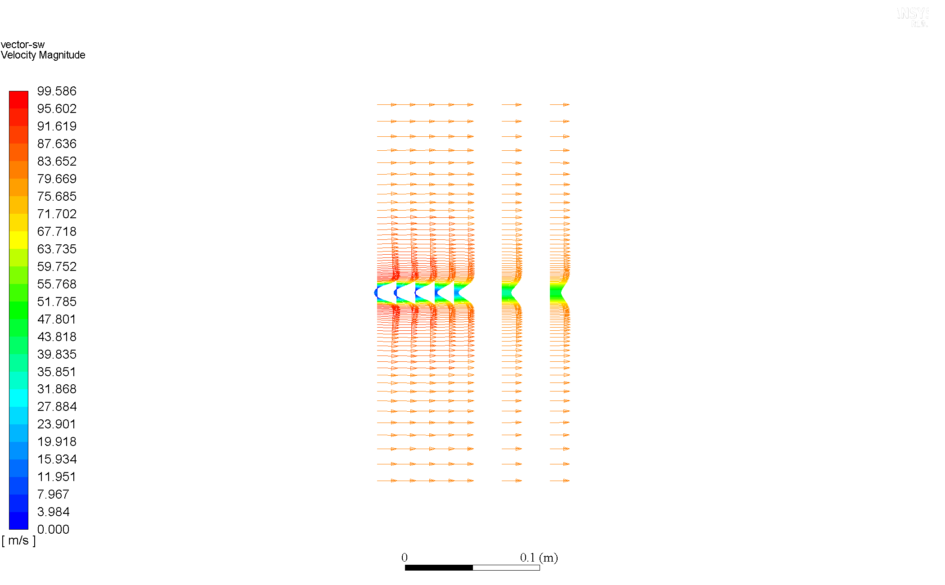

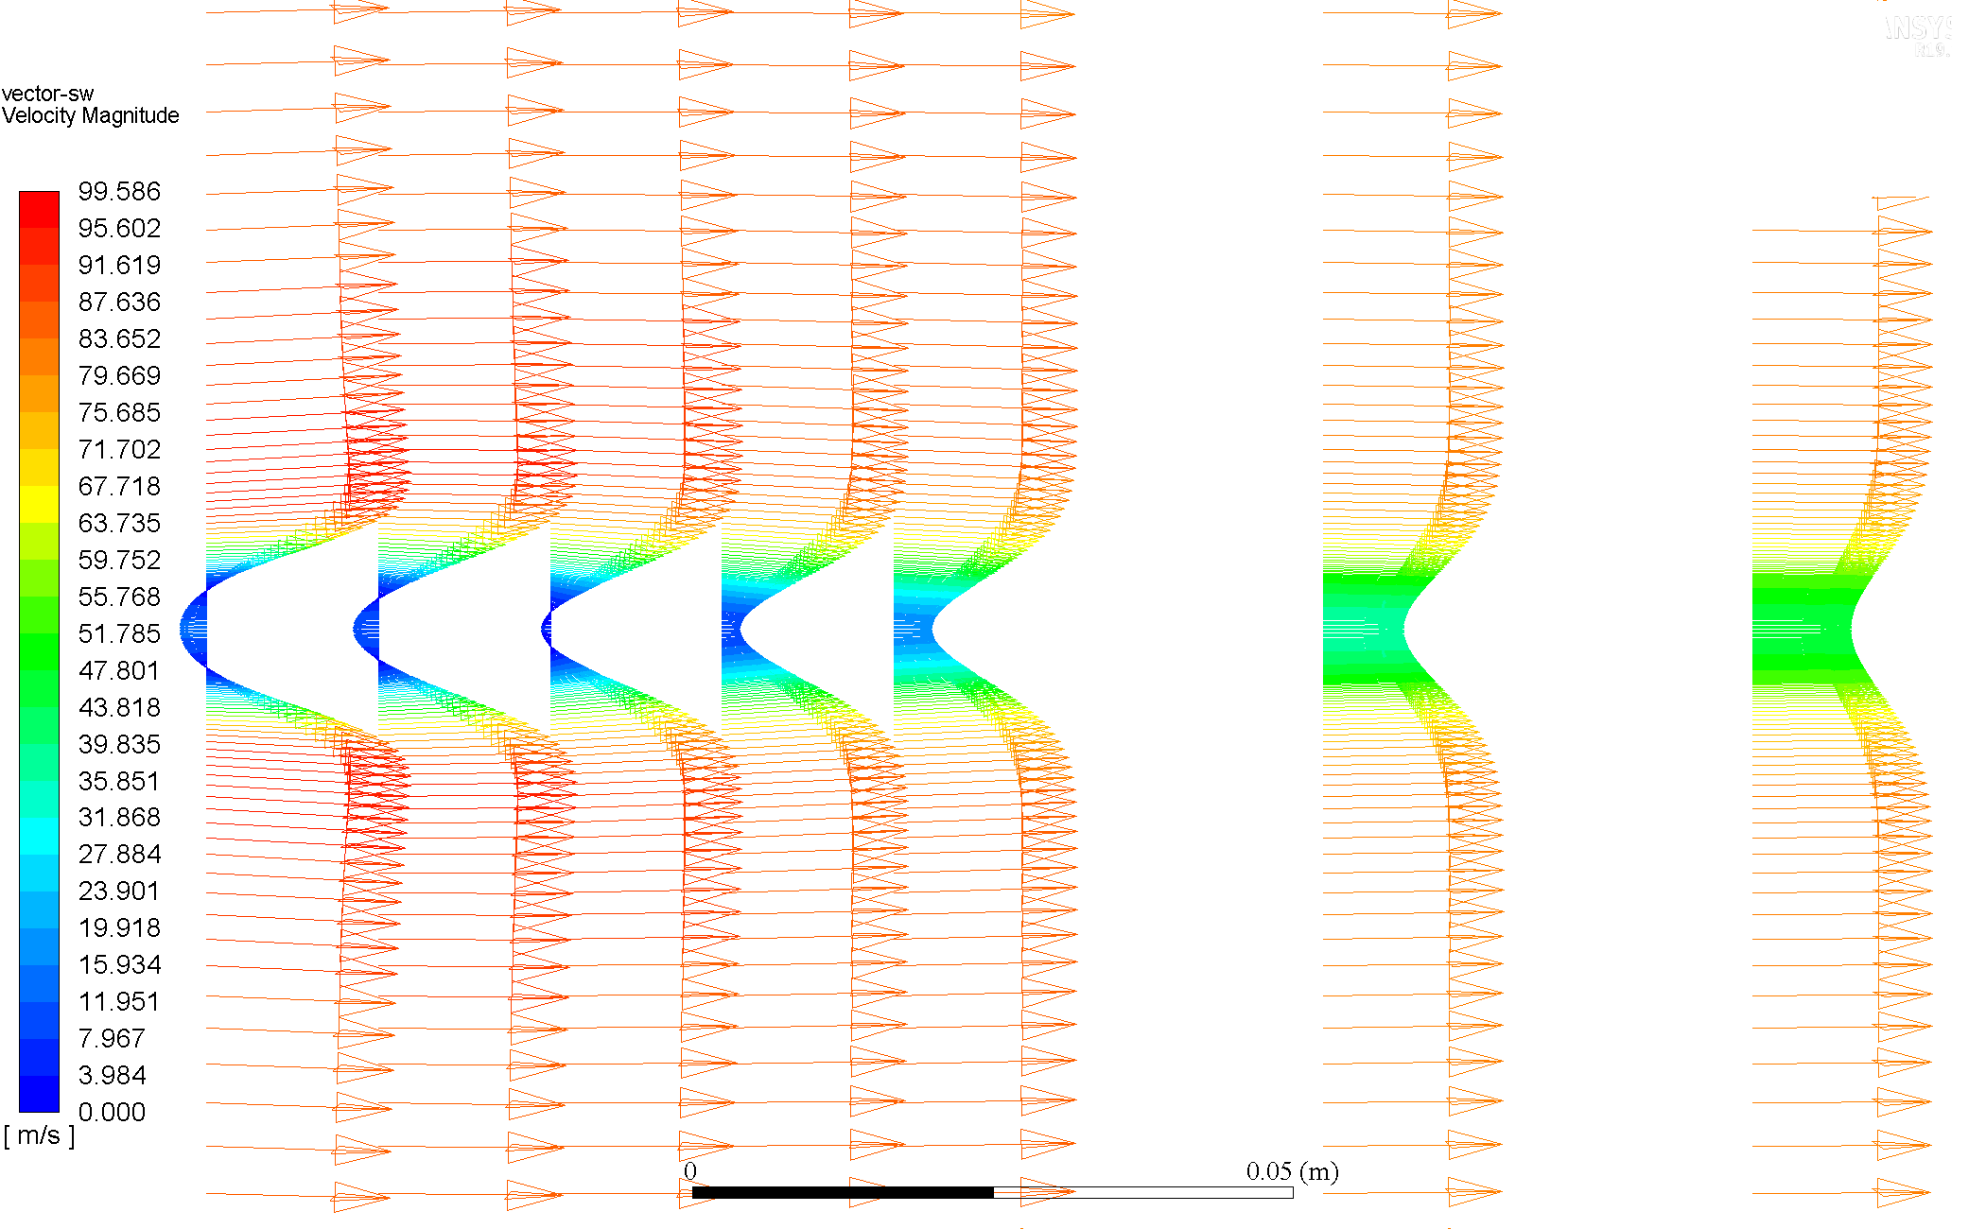

### Re = 160

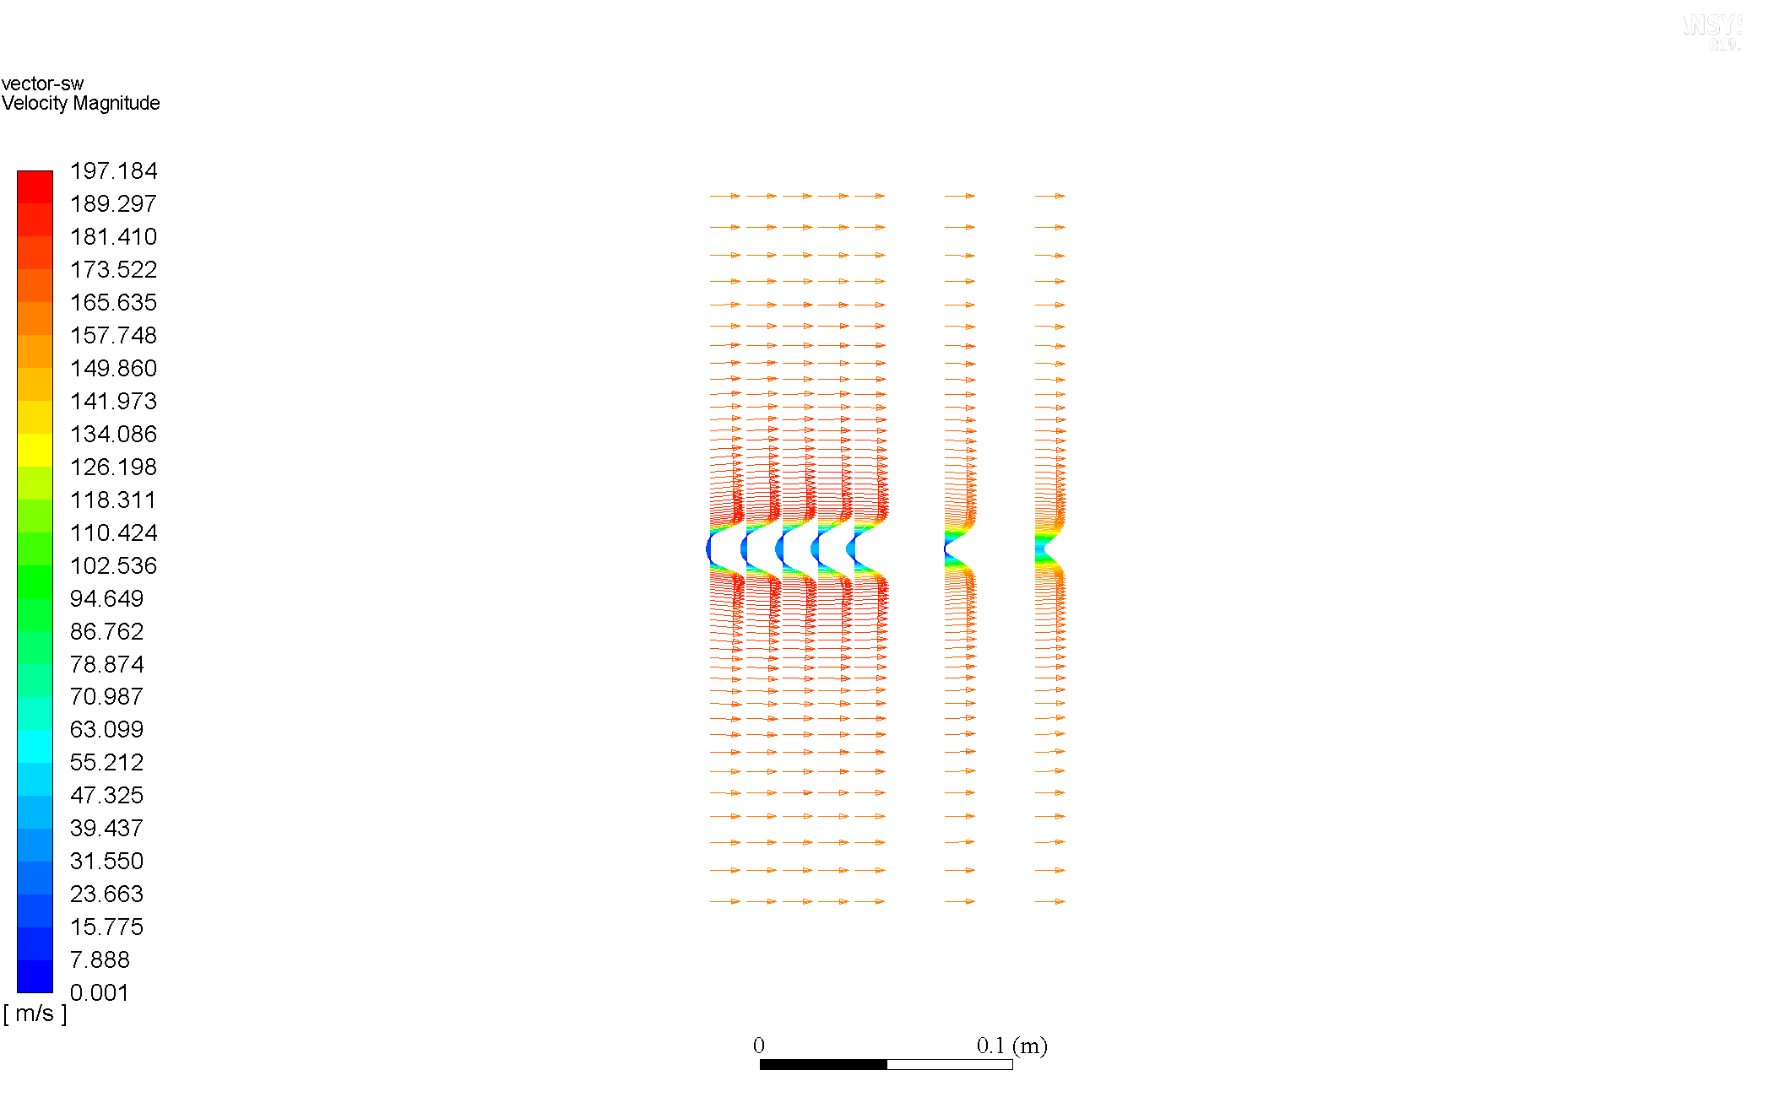

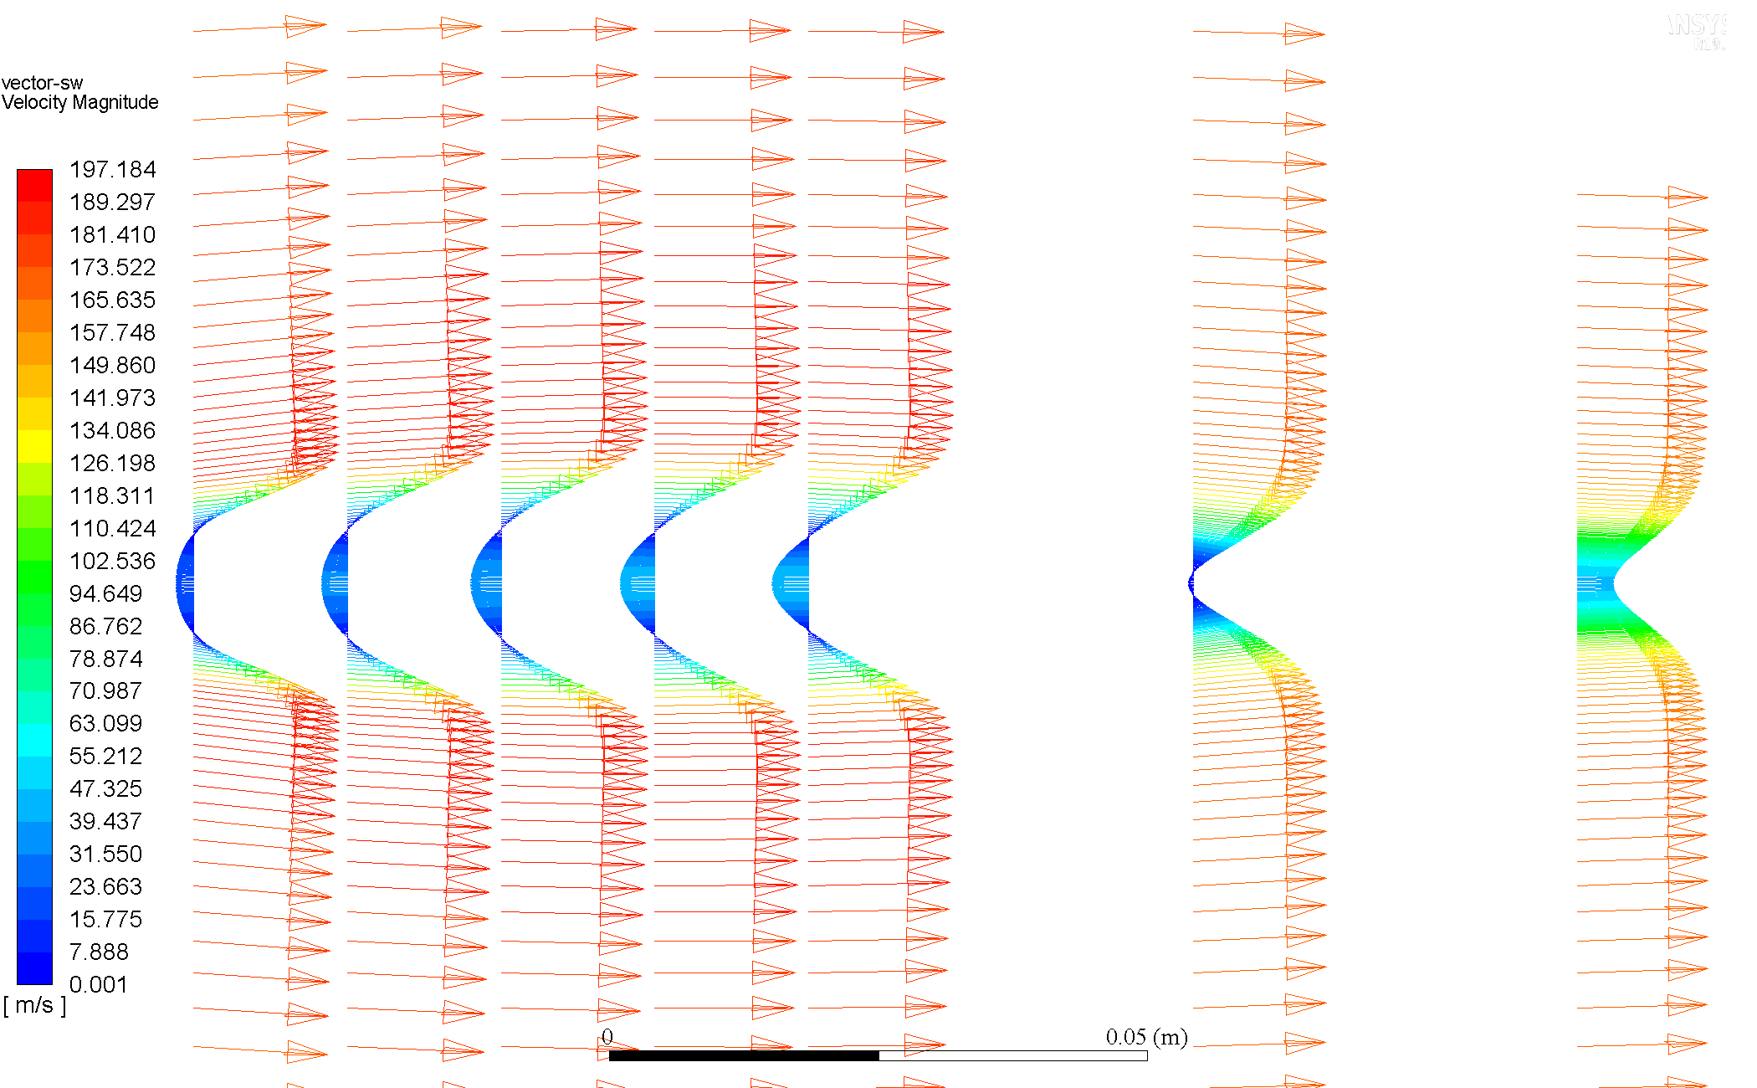

### Comparison & Discussion

The velocity profiles seen here can be thought of been specifically picked results from the velocity vectors shown before. The same conclusions can be inferred, however further insight and better appreciation can be attained for the increasing influence of the wake region with increase in ; the velocity profile develops more later.

For , no backflow (negative velocity) region is seen.