|  |  |
| --- | --- |
| **References used:** | |
| **Book Title** | **Author Name** |
| Fundamentals of Modern Manufacturing | Mikell P. Groover |
| Materials, Processes, and Systems, 5th Edition |  |
| **Website(s):** | |
| https://www.ke.com.pk/customer-services/tariff-structure/ | |
|  | |

Given parameters:

From the experiment

1.

2.

3.

4.

5.

6.

7.

8.

9.

10.

11.

12.

13.

14.

Nominal cost at a fixed rate:

Price range at a Variable rate:

15.

16.

17.

18.

19.

20.

*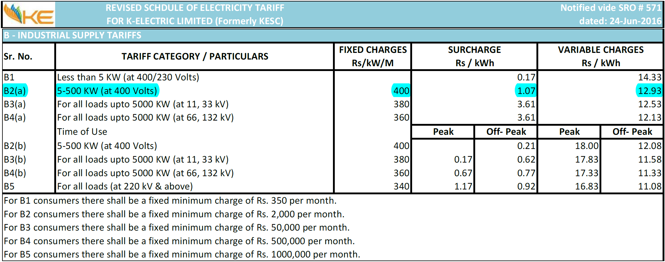

1.a)

Code:

module a(

input A,B,C,

output Y

);

and(p,A,B);

not(q,C);

or(r,p,q);

not(Y,r);

endmodule

RTL Schematic:

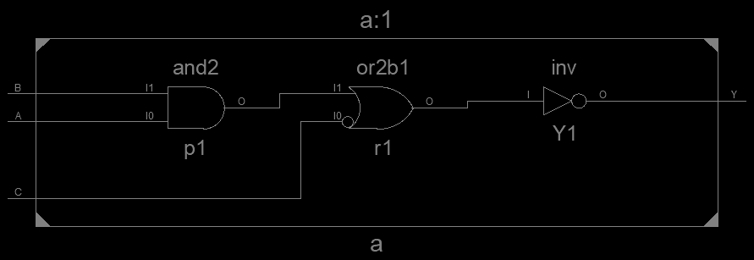

Test Bench Result:

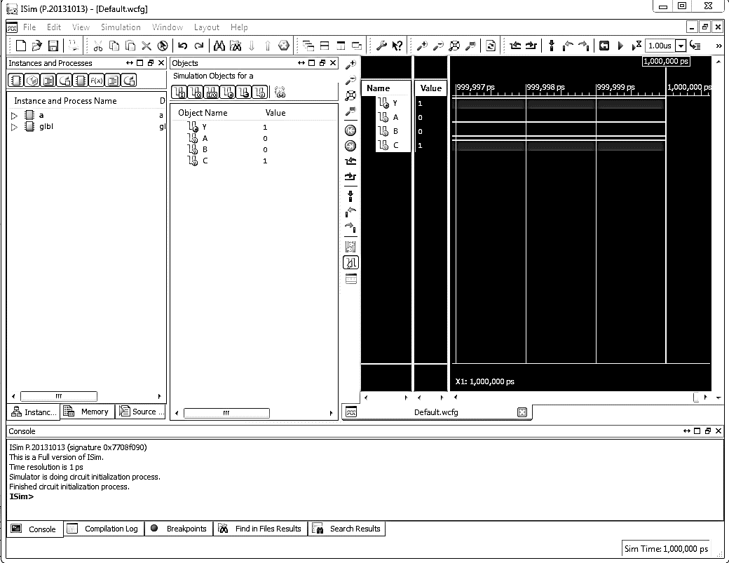

Truth Table:

|  |  |  |  |
| --- | --- | --- | --- |
|  |  |  |  |
|  |  |  |  |
|  |  |  |  |
|  |  |  |  |
|  |  |  |  |
|  |  |  |  |
|  |  |  |  |
|  |  |  |  |
|  |  |  |  |

K-Map:

|  |  |  |  |
| --- | --- | --- | --- |
|  |  |  |  |
|  |  |  |  |

Reduced Expression:

b)

Code:

module b(

input A,B,C,

output Q

);

nor(D,A,B);

and(E,B,C);

or(Q,D,E);

endmodule

RTL Schematic:

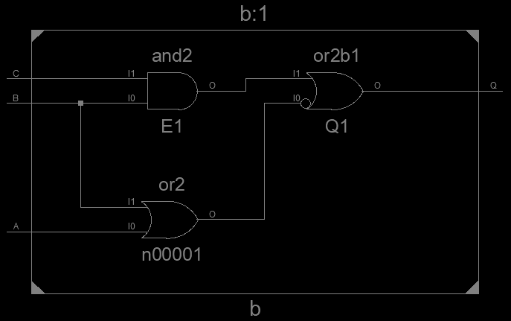

Test Bench Result:

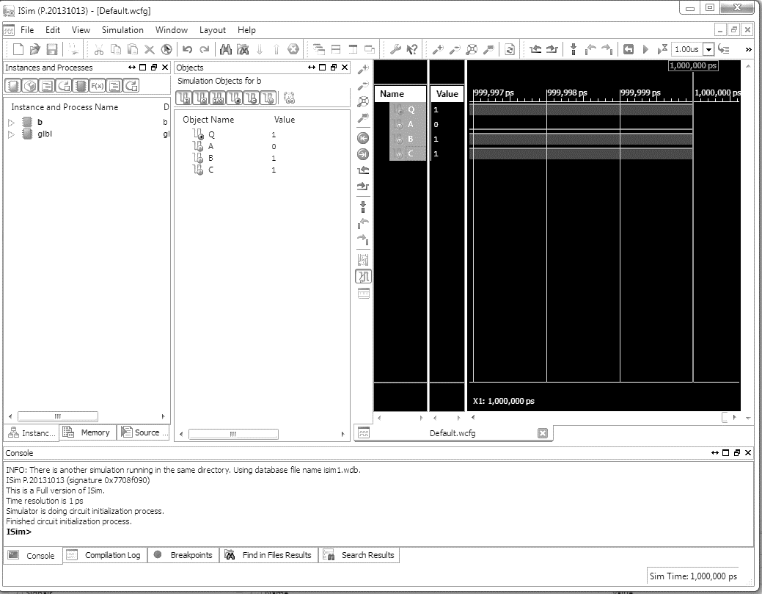

Truth Table:

|  |  |  |  |
| --- | --- | --- | --- |
|  |  |  |  |
|  |  |  |  |
|  |  |  |  |
|  |  |  |  |
|  |  |  |  |
|  |  |  |  |
|  |  |  |  |
|  |  |  |  |
|  |  |  |  |

K-Map:

|  |  |  |  |
| --- | --- | --- | --- |
|  |  |  |  |
|  |  |  |  |

Reduced Expression:

c)

Code:

module c(

input A,B,C,

output Y

);

and(p,A,B);

or(q,B,C);

and(r,B,C);

and(s,q,r);

or(Y,p,s);

endmodule

RTL Schematic:

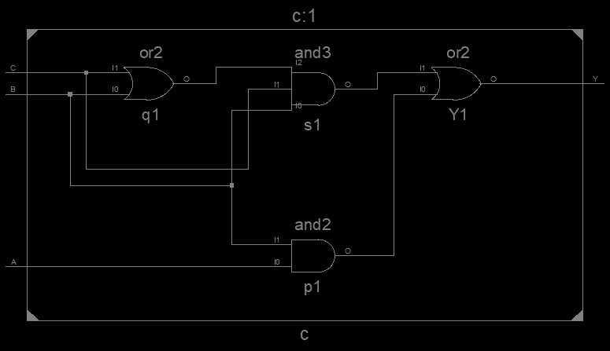

Test Bench Result:

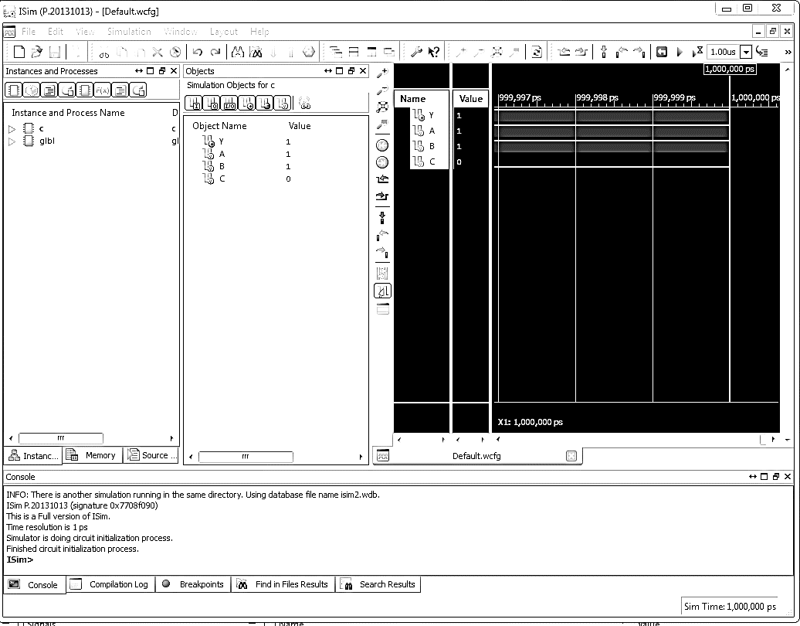

Truth Table:

|  |  |  |  |
| --- | --- | --- | --- |
|  |  |  |  |
|  |  |  |  |
|  |  |  |  |
|  |  |  |  |
|  |  |  |  |
|  |  |  |  |
|  |  |  |  |
|  |  |  |  |
|  |  |  |  |

K-Map:

|  |  |  |  |
| --- | --- | --- | --- |
|  |  |  |  |
|  |  |  |  |

Reduced Expression:

2.

*Half-Adder*

Code:

module HA(

input A,B,

output S,c

);

xor(S,A,B);

and(c,A,B);

endmodule

RTL Schematic:

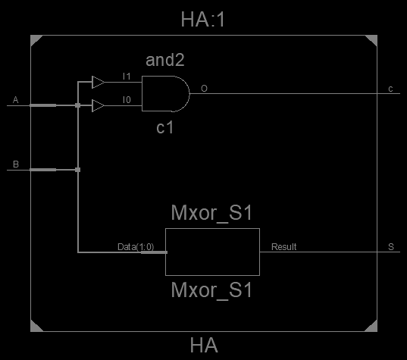

*Full-Adder*

Code:

module FA(

input A,B,Cin,

output S,Cout

);

xor(s,A,B);

xor(S,s,Cin);

and(k,A,B);

and(l,s,Cin);

or(Cout,k,l);

endmodule

RTL Schematic:

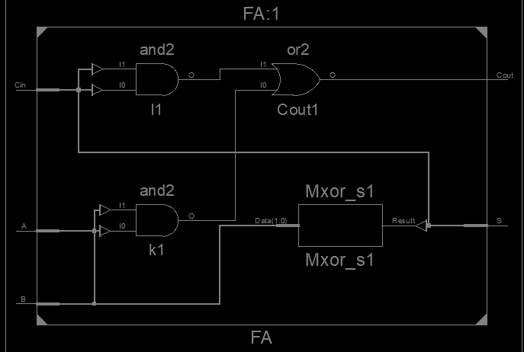

Comparator K-Map

|  |  |  |  |  |  |  |  |  |  |  |  |  |  |  |  |
| --- | --- | --- | --- | --- | --- | --- | --- | --- | --- | --- | --- | --- | --- | --- | --- |
| 1 | 1 | 1 | 1 | 1 | 1 | 1 | 1 | 1 | 1 | 1 | 1 | 1 | 1 | 1 | 1 |
| 1 | 1 | 1 | 1 | 1 | 1 | 1 | 1 | 1 | 1 | 1 | 1 | 1 | 1 | 1 | 1 |
| 1 | 1 | 1 | 1 | 1 | 1 | 1 | 1 | 1 | 1 | 1 | 1 | 1 | 1 | 1 | 1 |
| 1 | 1 | 1 | 1 | 1 | 1 | 1 | 1 | 1 | 1 | 1 | 1 | 1 | 1 | 1 | 1 |
| 1 | 1 | 1 | 1 | 1 | 1 | 1 | 1 | 1 | 1 | 1 | 1 | 1 | 1 | 1 | 1 |
| 1 | 1 | 1 | 1 | 1 | 1 | 1 | 1 | 1 | 1 | 1 | 1 | 1 | 1 | 1 | 1 |
| 1 | 1 | 1 | 1 | 1 | 1 | 1 | 1 | 1 | 1 | 1 | 1 | 1 | 1 | 1 | 1 |
| 1 | 1 | 1 | 1 | 1 | 1 | 1 | 1 | 1 | 1 | 1 | 1 | 1 | 1 | 1 | 1 |
| 1 | 1 | 1 | 1 | 1 | 1 | 1 | 1 | 1 | 1 | 1 | 1 | 1 | 1 | 1 | 1 |
| 1 | 1 | 1 | 1 | 1 | 1 | 1 | 1 | 1 | 1 | 1 | 1 | 1 | 1 | 1 | 1 |
| 1 | 1 | 1 | 1 | 1 | 1 | 1 | 1 | 1 | 1 | 1 | 1 | 1 | 1 | 1 | 1 |
| 1 | 1 | 1 | 1 | 1 | 1 | 1 | 1 | 1 | 1 | 1 | 1 | 1 | 1 | 1 | 1 |
| 1 | 1 | 1 | 1 | 1 | 1 | 1 | 1 | 1 | 1 | 1 | 1 | 1 | 1 | 1 | 1 |
| 1 | 1 | 1 | 1 | 1 | 1 | 1 | 1 | 1 | 1 | 1 | 1 | 1 | 1 | 1 | 1 |
| 1 | 1 | 1 | 1 | 1 | 1 | 1 | 1 | 1 | 1 | 1 | 1 | 1 | 1 | 1 | 1 |
| 1 | 1 | 1 | 1 | 1 | 1 | 1 | 1 | 1 | 1 | 1 | 1 | 1 | 1 | 1 | 1 |
| 0 | 1 | 2 | 3 | 4 | 5 | 6 | 7 | 8 | 9 | 10 | 11 | 12 | 13 | 14 | 15 |

|  |
| --- |
| 0000 |
| 0001 |
| 0010 |
| 0011 |
| 0100 |
| 0101 |
| 0110 |
| 0111 |
| 1000 |
| 1001 |
| 1010 |
| 1011 |
| 1100 |
| 1101 |
| 1110 |
| 1111 |

Key: 1:A>B 1:A=B 1:A<B