1. (a)

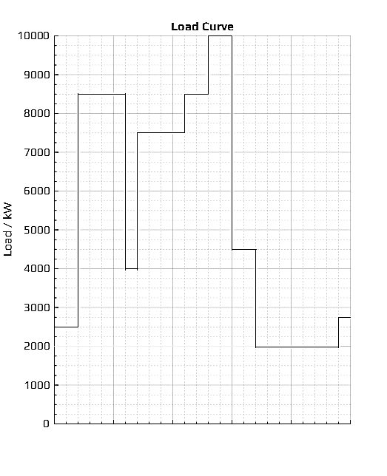

a.m. | p.m. | a.m.

6 11 4 9 2 7

Time of day

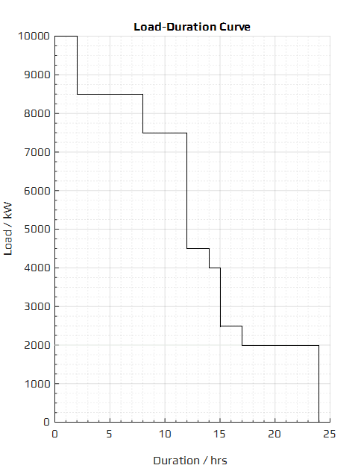

(b) The base load range is 2,000-2,500 kW, thus **one 2,500 kW** unit is chosen.

The intermediate loads range roughly from 4,000 to 4,500 kW, and loads of 8,500 kW are also common, thus **two** (8,500-2,500) **3,000 kW** (for easier maintenance) units should also be installed.

The peak demand, ${\dot{W}}_{peak}$, is 10,000 kW, thus **one** (10,000-8,500) **1,500 kW** unit should be installed as well.

(c) The base unit would operate for 24 hours, meeting the minimum demands of 2,000 to 2,500 kW during 9 hrs.

For the intermediate loads, the 3,000 kW plant would be run for (24-9) 15 hours, with loads up to (2,500+3,000) 5,500 kW being satisfied.

For the second 3,000 kW plant to be in proper use, the loads under or equal to (3,000+5,500) 8,500 kW and above 5,500 kW should exist, which are seen to last for 10 hours from the load duration curve.

Finally for the peak demand of 10,000 kW for 2 hours, the 1,500 kW unit should be run for about 3 hours, as a conservative measure.

The conclusions of the above discussion are summarised in the table below:

|  |  |
| --- | --- |
| Unit Size / kW | Operating Schedule / hrs |
| 2,500 | 24 |
| 3,000 | 15 |
| 3,000 | 10 |
| 1,500 | 3 |

(d) A 3,000 kW plant should be kept as a reserve in cases of failure or maintenance requirements of other power plants, as well as to meet abnormal load demands.

(e) Area under the load/load-demand curves defines the total energy, $E$, to be generated. Thus,

$$E=10,000×2+8,500×6+7,500×4+4,500×2+4,000+2,500×2+2,500×6$$

$$⇒134×{10}^{3} kWh$$

The average load, ${\dot{W}}_{avg}$, is thus

$${\dot{W}}_{avg}=\frac{134 MWh}{24 h}=5,583 kW$$

The peak load, ${\dot{W}}_{peak}$, during 24 hours is 10,000 kW, thus the load factor,

$$m=\frac{E}{{\dot{W}}_{peak}×24 h}=\frac{{\dot{W}}_{avg}}{{\dot{W}}_{peak}}=\frac{134×{10}^{3} kWh}{10,000 kW×24 h}=0.5583$$

The cumulative capacity of the running and reserve units, ${\dot{W}}_{total inst.}$, is 13,000 kW, thus the plant capacity factor,

$$n=\frac{E}{{\dot{W}}_{total inst.}×24 h}=\frac{{\dot{W}}_{avg}}{{\dot{W}}_{total inst.}}=\frac{134×{10}^{3} kWh}{13,000 kW×24 h}=0.4295$$

The plant use factor,

2. (a) the average load,

$${\dot{W}}_{avg}=m{\dot{W}}_{peak}=0.45×30=13.5 MW$$

(b) the energy supplied per year,

$$E={\dot{W}}_{avg}×8760 h {yr}^{-1}=118.26 GWh {yr}^{-1}$$

(c) the diversity factor,

$$div=\frac{15+8.5+10+4.5}{30}=1.27$$

(d) the demand factor,

3. a) The economic loading occurs when

$$\frac{dF_{A}}{dP_{A}}=\frac{dF_{B}}{dP_{B}}=0.06P_{A}+11.4=0.07P_{B}+10=0$$

and required that,

$$P_{A}+P_{B}=150$$

So,

$$9-0.06P_{B}+11.4=0.07P_{B}+10$$

$$⇒P_{B}=80 MW \& P_{A}=70 MW$$

b)

$$\int{{dF}_{A}}=\int{0.06P_{A}+11.4} dP_{A}$$

$$⇒F_{A}=0.03P_{A}^{2}+11.4P_{A}$$

$$\int{{dF}_{B}}=\int{0.07P_{B}+10} dP_{A}$$

$$⇒F_{B}=0.035P_{B}^{2}+10P_{B}$$

[N.B. The arbitrary constants of integration are obviously 0, since fuel costs would be 0 when power generated is 0]

Thus

$$C_{1}=F_{A}+F_{B}=945+1024=1,969 Rs h^{-1}$$

Now if,

$$P_{A}=P_{B}=75 MW$$

Then,

$$C_{2}=F_{A}+F_{B}=1023.75+946.875=1,970.625 Rs h^{-1}$$

So

$$C_{2}-C_{1}=1.625 Rs h^{-1}$$

4.

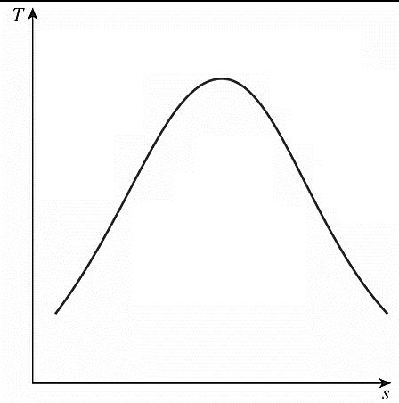

|  |  |  |  |  |  |  |  |
| --- | --- | --- | --- | --- | --- | --- | --- |
| State $i$# | State | $$P_{i}/kPa$$ | $$T_{i}/℃$$ | $$ν_{i}/ m^{3} {kg}^{-1}$$ | $$x_{i}$$ | $$h_{i}/kJ {kg}^{-1}$$ | $$s_{i}/kJ {\left(kg.K\right)}^{-1}$$ |
| $$1$$ | Superheated Vapour | 9,000 | $$500$$ | 0.036793 | 1 | 3387.4 | 6.6603 |
| 2s | Superheated Vapour | 2,250 | 289 | 0.10815 | 1 | 2991.8 | 6.6603 |
| 2 | Superheated Vapour | 2,250 | 303 | 0.11141 | 1 | 3023.4 | 6.7157 |
| $$3$$ | Superheated Vapour | 2,250 | 500 | 0.15585 | 1 | 3465.3 | 7.3764 |
| 4s | Sat. Liquid-Vapour Mixture | 7.3851 | 40 | 17.282 | 0.886 | 2298.2 | 7.3764 |
| 4 | Sat. Liquid-Vapour Mixture | 7.3851 | 40 | 18.229 | 0.934 | 2414.9 | 7.7490 |
| 5 | Saturated Liquid | 7.3851 | 40 | 0.001008 | 0 | 167.53 | 0.5724 |
| 6s | Subcooled Liquid | 9,000 | - | 0.001008 | 0 | 176.59 | 0.5724 |
| 6 | Subcooled Liquid | 9,000 | - | - | 0 | 179.62 | 0.5821 |
| 7 | Subcooled Liquid | 9,000 | 220.02 | - | 0 | 945.66 | - |
| 8 | Saturated Liquid | 2,250 | 218.41 | 0.001187 | 0 | 936.21 | - |
| 9 | Sat. Liquid-Vapour Mixture | 7.3851 | - | - | - | 936.21 | - |

Assuming the Reheat Pressure to be optimum, i.e., one-fourth of the maximum cycle pressure [*Y.A. Cengel and M.A. Boles, Thermodynamics 8th ed., p.566*], i.e., 22.5 bar.

$$η_{T,HP}=0.92=\frac{h_{1}-h_{2}}{h_{1}-h_{2s}};∴h_{2}=3023.45 kJ {kg}^{-1}$$

$$x_{4s}=\frac{s_{4s}-s_{f}}{s_{fg}}=0.88556;∴h_{4s}=h_{f}+x_{4s}h_{fg}=2298.2078 kJ {kg}^{-1}$$

$$η_{T,LP}=0.90=\frac{h_{3}-h_{4}}{h_{3}-h_{4s}};∴h_{4}=2414.91 kJ {kg}^{-1}$$

$$h_{6s}=h_{5}+ν_{5}\left(P_{6}-P_{5}\right)=176.5946 kJ {kg}^{-1}$$

$$η_{P}=0.75=\frac{h_{6s}-h_{5}}{h_{6}-h_{5}};∴h_{6}=179.62 kJ {kg}^{-1}$$

$$TDD=T_{sat. @P_{3}}-T_{7}=-1.6℃;T_{7}=218.42+1.6=220.02℃$$

Energy Balance across the CFWH Control Volume:

$$yh_{2}+h_{6}=h_{7}+yh_{8}$$

$$∴y=\frac{h_{7}-h_{6}}{h_{2}-h_{8}}=0.367$$

a)

$${\dot{W}}_{net}=500 MW=\dot{m}\left(w_{T,HP}+w_{T,LP}-w_{P}\right);$$

$$\dot{m}=\frac{{\dot{W}}_{net}}{\left(h_{1}-h_{2}\right)+\left[\left(1-y\right)\left(h_{3}-h_{4}\right)\right]-(h_{6}-h_{5})}=491.53 kg s^{-1}$$

b)

$$η_{cycle}=\frac{{\dot{W}}_{net}}{{\dot{Q}}_{in}}=\frac{{\dot{W}}_{net}}{\dot{m}\left[\left(h_{1}-h_{7}\right)+(1-y)\left(h_{3}-h_{2}\right)\right]}×100\% =37.4\%$$

c) Cycle Work Ratio:

$$\frac{{\dot{W}}_{net}}{\dot{m}\left(w_{T,HP}+w_{T,LP}\right)}=\frac{{\dot{W}}_{net}}{\dot{m}[\left(h_{1}-h_{2}\right)+\left(1-y\right)\left(h_{3}-h_{4}\right)]}=0.9887$$

5.



|  |  |  |  |  |  |  |
| --- | --- | --- | --- | --- | --- | --- |
| State $i$# | State | $$P_{i}/kPa$$ | $$T_{i}/℃$$ | $$x_{i}$$ | $$h_{i}/kJ {kg}^{-1}$$ | $$s_{i}/kJ {\left(kg.K\right)}^{-1}$$ |
| $$1$$ | Superheated Vapour | 5,000 | 350 | 1 | 3069.3 | 6.4516 |
| 2s | Sat. Liquid-Vapour Mixture | 150 | 111.35 | 0.867 | 2396.5 | 6.4516 |
| 2 | Superheated Vapour | 150 | 111.35 | 0.915 | 2504.2 | 6.7315 |
| $$3$$ | Superheated Vapour | 150 | 250 | 1 | 2972.9 | 7.8451 |
| 4s | Sat. Liquid-Vapour Mixture | 5 | 32.87 | 0.931 | 2392.8 | 7.8451 |
| 4 | Sat. Liquid-Vapour Mixture | 5 | 32.87 | 0.976 | 2503.0 | 8.2052 |
| 5 | Saturated Liquid | 5 | 32.87 | 0 | 137.75 | 0.4762 |

$$x_{2s}=\frac{s_{2s}-s_{f}}{s_{fg}}=0.86674;∴h_{2s}=h_{f}+x_{2s}h_{fg}=2396.4915 kJ {kg}^{-1}$$

$$η_{T,HP}=0.84=\frac{h_{1}-h_{2}}{h_{1}-h_{2s}};∴h_{2}=2504.15 kJ {kg}^{-1}$$

$$x_{4s}=\frac{s_{4s}-s_{f}}{s_{fg}}=0.93070;∴h_{4s}=h_{f}+x_{4s}h_{fg}=2392.8329 kJ {kg}^{-1}$$

$$η_{T,LP}=0.81=\frac{h_{3}-h_{4}}{h_{3}-h_{4s}};∴h_{4}=2503.02 kJ {kg}^{-1}$$

$${\dot{m}}_{total}={\dot{m}}_{bleed}+{\dot{m}}_{retained};{\dot{m}}_{bleed}=12,000 kg h^{-1}=\frac{10}{3} kg s^{-1}$$

$${\dot{W}}_{out}=3750 kW={\dot{m}}_{total}\left(w_{T,HP}+w_{T,LP}\right);$$

$${\dot{m}}_{bleed}+{\dot{m}}_{retained}=\frac{{\dot{W}}_{out}}{\left(h_{1}-h_{2}\right)+\left[\left(\frac{{\dot{m}}_{total}-{\dot{m}}_{bleed}}{{\dot{m}}_{total}}\right)\left(h_{3}-h_{4}\right)\right]}$$

$$⇒{\dot{m}}_{retained}=\frac{{\dot{W}}_{out}}{\left(h_{1}-h_{2}\right)+\left[\left(\frac{3{\dot{m}}_{retained}}{3{\dot{m}}_{retained}+10}\right)\left(h_{3}-h_{4}\right)\right]}-\frac{10}{3}$$

Since this is a non-linear equation in one unknown, graphs are plotted for both sides of the equation and their positive intercept is noted as the solution:

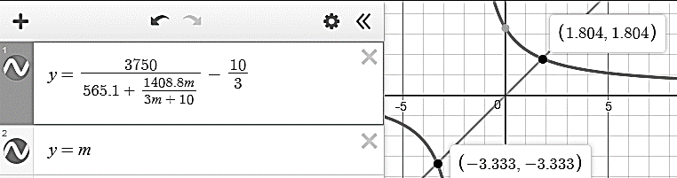

$$∴{\dot{m}}_{retained}=1.804 kg s^{-1}=6494.4 kg h^{-1}$$

Thus the boiler should be sized to

$${\dot{m}}_{total}={\dot{m}}_{bleed}+{\dot{m}}_{retained}=18,494 kg h^{-1}$$

6.

$${\dot{Q}}_{in}=\frac{m_{coal}h_{value}}{t}=\frac{10×{10}^{6} kg×26 MJ {kg}^{-1}}{24 h}=\frac{260×{10}^{6} MJ}{24 h}=3,009.25 MW$$

$${\dot{W}}_{gross gen. out}=1000 MW$$

$${Heat Rate}_{gross station}=\frac{{\dot{Q}}_{in}}{{\dot{W}}_{gross gen. out}}=\frac{260×{10}^{6} MJ}{1,000,000 kW×24 h}=10,833 kJ/kWh$$

$${\dot{W}}_{net station out}=\left(1-0.07\right){\dot{W}}_{gross gen. out}=930 MW$$

$${Heat Rate}_{net station}=\frac{{\dot{Q}}_{in}}{{\dot{W}}_{net station out}}=\frac{{Heat Rate}_{gross station}}{0.93}=11,648 kJ/kWh$$

$$η_{gross}=\frac{{\dot{W}}_{gross gen. out}}{{\dot{Q}}_{in}}×100 \%=\frac{1000}{3,009.25}×100 \%=33.2 \%$$

$$η_{net}=\frac{{\dot{W}}_{net station out}}{{\dot{Q}}_{in}}×100 \%=\frac{930}{3,009.25}×100 \%=30.9\%$$

7.



|  |  |  |  |  |  |  |  |
| --- | --- | --- | --- | --- | --- | --- | --- |
| State $i$# | State | $$P_{i}/kPa$$ | $$T_{i}/℃$$ | $$ν_{i}/ m^{3} {kg}^{-1}$$ | $$x_{i}$$ | $$h_{i}/kJ {kg}^{-1}$$ | $$s_{i}/kJ {\left(kg.K\right)}^{-1}$$ |
| 1 | Superheated Vapour | 10,000 | 550 | 0.035655 | 1 | 3502.0 | 6.7585 |
| 2s | Superheated Vapour | 3632.24 | 381.8 | 0.078624 | 1 | 3178.0 | 6.7585 |
| 2 | Superheated Vapour | 3632.24 | 391.4 | 0.080054 | 1 | 3200.7 | 6.7929 |
| 3s | Superheated Vapour | 966.38 | 208.8 | 0.218672 | 1 | 2851.2 | 6.7585 |
| 3 | Superheated Vapour | 966.38 | 228.6 | 0.229639 | 1 | 2896.8 | 6.8511 |
| 4s | Sat. Liquid-Vapour Mixture | 153.83 | 112.1 | 1.04299 | 0.921 | 2518.6 | 6.7585 |
| 4 | Sat. Liquid-Vapour Mixture | 153.83 | 112.1 | 1.07801 | 0.952 | 2587.4 | 6.9372 |
| 5s | Sat. Liquid-Vapour Mixture | 10 | 45.8 | 11.9509 | 0.814 | 2140.4 | 6.7585 |
| 5 | Sat. Liquid-Vapour Mixture | 10 | 45.8 | 12.5354 | 0.854 | 2235.7 | 7.0573 |
| 6 | Saturated Liquid | 10 | 45.8 | 0.00101026 | 0 | 191.8 | 0.649218 |
| 7s | Subcooled Liquid | 966.38 | 45.8 | 0.00100985 | 0 | 192.8 | 0.649218 |
| 7 | Subcooled Liquid | 966.38 | 45.9 | 0.00100987 | 0 | 192.9 | 0.649834 |
| 8 | Subcooled Liquid | 966.38 | 107.1 | 0.00104873 | 0 | 449.7 | 1.38595 |
| 9 | Saturated Liquid | 966.38 | 178.4 | 0.00112524 | 0 | 756.2 | 2.12407 |
| 10s | Subcooled Liquid | 10,000 | 179.6 | 0.0011195 | 0 | 766.3 | 2.12407 |
| 10 | Subcooled Liquid | 10,000 | 180.1 | 0.00112006 | 0 | 768.1 | 2.12817 |
| 11 | Subcooled Liquid | 10,000 | 244.7 | 0.00122929 | 0 | 1060.5 | 2.73062 |
| 12 | Saturated Liquid | 153.83 | 112.1 | 0.00105337 | 0 | 470.3 | 1.44187 |
| 13s | Subcooled Liquid | 966.38 | 112.2 | 0.00105299 | 0 | 471.2 | 1.44187 |
| 13 | Subcooled Liquid | 966.38 | 112.2 | 0.00105303 | 0 | 471.3 | 1.44237 |
| 14 | Saturated Liquid | 3632.24 | 244.7 | 0.00123969 | 0 | 1060.06 | 2.74497 |
| 15 | Sat. Liquid-Vapour Mixture | 966.38 | 178.4 | 0.0311704 | 0.15 | 1060.06 | 2.7971 |

Since the 3 feed-water heaters are optimally placed, the optimum temperature rise, $ΔT_{opt}$ per heater should be equally divided between the boiler and condenser temperatures[*M.M.Wakil, Powerplant Technology, p.68*], i.e.,

$$ΔT_{opt}=\frac{T_{sat@100bar}-T_{sat@0.1bar}}{4}=\frac{311-45.81}{4}=66.2975℃$$

The pressures at which steam is bled in each FWH is then the saturation pressure at the optimum temperature;

$$∴T_{sat@P_{2s}}=T_{sat@100bar}-ΔT_{opt}=244.7025℃;∴P_{2}=3632.24 kPa$$

$$η_{T,HP}=0.93=\frac{h_{1}-h_{2}}{h_{1}-h_{2s}};∴h_{2}=3200.6893 kJ {kg}^{-1}$$

$$T_{sat@P_{3s}}=T_{sat@P_{2s}}-ΔT_{opt}=178.405℃;∴P_{3}=966.382 kPa$$

$$η_{T,IP}=0.93=\frac{h_{1}-h_{3}}{h_{1}-h_{3s}};∴h_{3}=2896.7653 kJ {kg}^{-1}$$

$$T_{sat@P_{4s}}=T_{sat@P_{3s}}-ΔT_{opt}=112.1075℃;∴P_{4}=153.825 kPa$$

$$x_{4s}=\frac{s_{4s}-s_{f}}{s_{fg}}=0.921;∴h_{4s}=h_{f}+x_{4s}h_{fg}=2518.57 kJ {kg}^{-1}$$

$$η_{T,LP}=0.93=\frac{h_{1}-h_{4}}{h_{1}-h_{4s}};∴h_{3}=2587.4101 kJ {kg}^{-1}$$

$$x_{5s}=\frac{s_{5s}-s_{f}}{s_{fg}}=0.814606;∴h_{5s}=h_{f}+x_{5s}h_{fg}=2140.41 kJ {kg}^{-1}$$

$$η_{T,EXIT}=0.93=\frac{h_{1}-h_{5}}{h_{1}-h_{5s}};∴h_{5}=2235.7213 kJ {kg}^{-1}$$

$$h_{7s}=h_{6}+ν_{6}\left(P_{7}-P_{6}\right)=192.8 kJ {kg}^{-1}$$

$$η_{P,3}=0.85=\frac{h_{7s}-h_{6}}{h_{7}-h_{6}};∴h_{7}=192.92847 kJ {kg}^{-1}$$

For the HP and LP CFWH, assuming a TTD of $0℃$ and $5℃$, [from the typical range of TTD stated by *M.M.Wakil* in *Powerplant Technology, pp.53-*4] respectively. Thus,

$$∵TTD=T_{bleed sat}-T_{exit water}$$

Thus for the HP CFWH

$$T_{exit water}=T_{11}=T_{bleed sat}=T_{14}=244.7025℃$$

$$∴h_{11}=1060.49 kJ {kg}^{-1}\& h_{14}=1060.06 kJ {kg}^{-1}$$

And for the LP CFWH

$$T_{exit water}=T_{8}=T_{bleed sat}-5=107.1075℃$$

$$∴h_{8}=449.738 kJ {kg}^{-1}\&h_{12}=470.29 kJ {kg}^{-1}$$

Further,

$$h_{13s}=h_{12}+ν_{12}\left(P_{13}-P_{12}\right)=471.16 kJ {kg}^{-1}$$

$$η_{P,2}=0.85=\frac{h_{13s}-h_{12}}{h_{13}-h_{12}};∴h_{13}=471.31 kJ {kg}^{-1}$$

$$h_{10s}=h_{9}+ν_{9}\left(P_{10}-P_{9}\right)=766.28 kJ {kg}^{-1}$$

$$η_{P,1}=0.85=\frac{h_{10s}-h_{9}}{h_{10}-h_{9}};∴h_{10}=768.068 kJ {kg}^{-1}$$

$$\begin{aligned}w+x+y+z=1\#\left(1\right)\end{aligned}$$

Energy Balance across the HP CFWH Control Volume:

$$\begin{aligned}xh_{2}+h_{10}={xh}_{14}+h_{11}\#\left(2\right)\end{aligned}$$

$$∴x=\frac{h_{11}-h_{10}}{h_{2}-h_{14}}=0.1366$$

Energy Balance across the IP OFWH Control Volume:

$$\begin{aligned}yh_{3}+xh_{15}+zh_{13}+wh_{8}=h_{9}\#\left(3\right)\end{aligned}$$

Energy Balance across the LP CFWH Control Volume:

$$\begin{aligned}zh_{4}+wh_{7}={wh}_{8}+zh_{12}\#\left(4\right)\end{aligned}$$

$$\begin{aligned}∴w=z\frac{h_{4}-h_{12}}{h_{8}-h_{7}}\#\left(5\right)\end{aligned}$$

Substituting the value of $x$ and equation 5 into equation 1:

$$\begin{aligned}y=0.8634-z\left(\frac{h_{4}-h_{12}}{h_{8}-h_{7}}+1\right)\#\left(6\right)\end{aligned}$$

Substituting the value of $x$ and equations 5 & 6 into equation 3:

$$\left[0.8634-z\left(\frac{h_{4}-h_{12}}{h_{8}-h_{7}}+1\right)\right]h_{3}+0.1366h_{15}+zh_{13}+z\frac{h_{4}-h_{12}}{h_{8}-h_{7}}h_{8}=h_{9}$$

Solving for $z$

$$z=0.0836;∴w=0.6893 \& y=0.0904$$

a)

$${\dot{W}}_{net}=1320 MW=\dot{m}\left(w_{T}-\sum{w_{P}}\right)$$

$$⇒\dot{m}\left\{\left[x\left(h_{1}-h_{2}\right)+y\left(h_{1}-h_{3}\right)+z\left(h_{1}-h_{4}\right)+w(h_{1}-h_{5})\right]-\left[\left(h_{10}-h_{9}\right)+z\left(h_{13}-h_{12}\right)+w\left(h_{7}-h_{6}\right)\right]\right\}$$

$$∴\dot{m}=\frac{{\dot{W}}_{net}}{\left(w_{T}-\sum{w_{P}}\right)}=1278.516 kg s^{-1}=4,602,658 kg h^{-1}$$

b) The mass flow rate to the condenser is

$$\dot{m}w=3,172,612 kg h^{-1}$$

The energy balance across the condenser is, assuming the cooling water is at 1 atm at 25oC

c)

d)

8. For a given time-frame of a load curve, say a day (24 hours), the load duration curve would be plotted for the same time-frame by starting from the peak load. The duration during which each load value lasts would be plotted for that span of time in order of decreasing magnitude of load. Each loads’ hours would cumulate with the previous load’s value.

From the given data:

|  |  |
| --- | --- |
| Load / kW | Duration (h) |
| 2,000-4,000 | 1,760 |
| 4,000-6,000 | 2,620 |
| 6,000-8,000 | 1,752 |
| 8,000-10,000 | 876 |
| 10,000-12,000 | 876 |
| 12,000-15,000 | 789 |
| 15,000 | 87 |

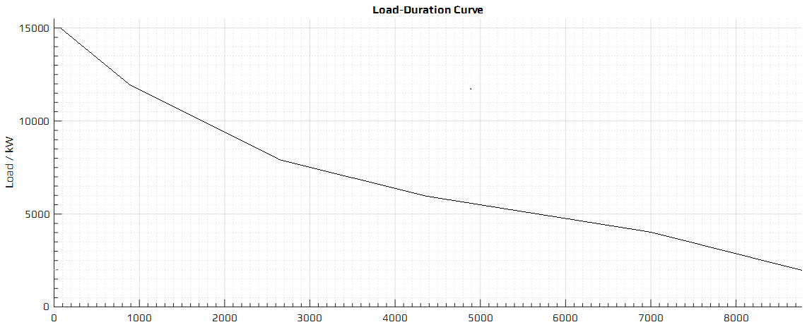

Duration / hrs

Area under the load/load-demand curves defines the total energy, $E$, generated. Thus, each small box represents $50 MWh$ of energy. The load-duration curve plotted bounds about 1200 such boxes, thus

$$E=50 MWh {box}^{-1}×1200 boxes=60×{10}^{6} kWh$$

The average load, ${\dot{W}}_{avg}$, is thus

$${\dot{W}}_{avg}=\frac{60,000,000}{8760}=6,849 kW$$

and the load factor

$$m=\frac{{\dot{W}}_{avg}}{{\dot{W}}_{peak}}=0.457$$