1)

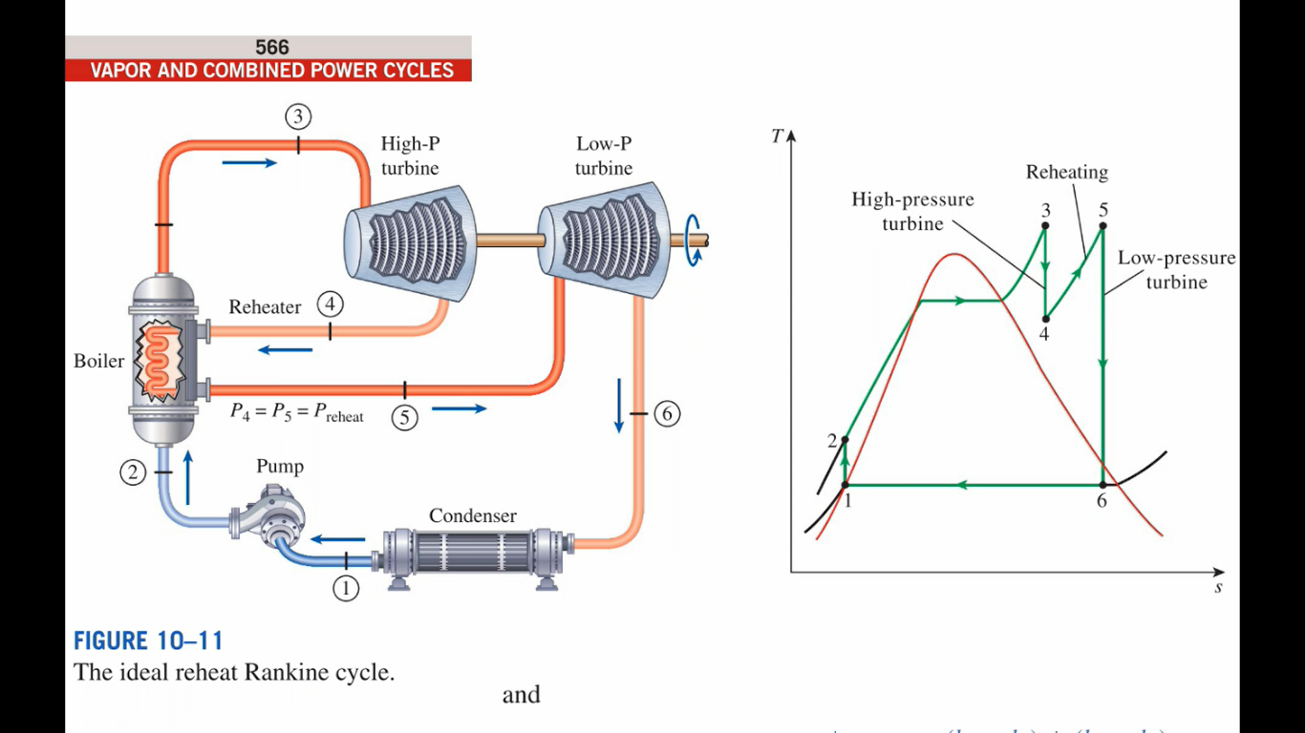

|  |  |  |  |  |  |  |  |
| --- | --- | --- | --- | --- | --- | --- | --- |
| State $i$# | State | $$P_{i}/kPa$$ | $$T_{i}/℃$$ | $$ν_{i}/ m^{3} {kg}^{-1}$$ | $$x_{i}$$ | $$h_{i}/kJ {kg}^{-1}$$ | $$s_{i}/kJ {\left(kg.K\right)}^{-1}$$ |
| 1 | Saturated Liquid | 6 | 36.16 | 0.00100645 | 0 | 151.494 | 0.520873 |
| 2s | Subcooled Liquid | 10.000 | 36.42 | 0.00100215 | 0 | 161.518 | 0.520873 |
| 2 | Subcooled Liquid | 10,000 | - | - | - | 164.024 | - |
| 3 | Superheated Vapour | 10,000 | 480 | 0.0316292 | - | 3322.89 | 6.53096 |
| 4s* | Saturated Liquid-Vapour Mixture | 700 | 164.953 | 0.262622 | 0.962667 | 2685.630 | 6.53096 |
| 4* | Superheated Vapour | 700 | - | - | - | 2813.082 | - |
| 5** | Superheated Vapour | 700 | 480 | 0.493636 | - | 3439.22 | 7.87534 |
| 6s | Saturated Liquid-Vapour Mixture | 6 | 36.16 | 22.3549 | 0.941882 | 2426.3 | 7.87534 |
| 6 | Saturated Liquid-Vapour Mixture | 6 | - | - | - | 2628.884 | - |

i)

$$q_{in}=\left(h_{3}-h_{2}\right)+\left(h_{5}-h_{4}\right)=3785.00 kJ {kg}^{-1}$$

ii)

$$η_{th}=1-\frac{\left(h_{6}-h_{1}\right)}{\left(h_{3}-h_{2}\right)+\left(h_{5}-h_{4}\right)}×100\%=34.547\%$$

iii)



$$q_{w}=h_{6}-h_{1}=2477.39kJ {kg}^{-1}$$

It can be seen that there is an optimum pressure for a given temperature of reheat. Which is 20% of the boiler operating pressure. All pressures higher and lower result in decrease in the cycle efficiency, however the drop is drastic for lower pressures and gradual for higher pressures.



It can be seen that for a given pressure of reheat, the cycle efficiency decreases with increase in the final reheat temperature; up to 250oC, after which there is a roughly linear increase in efficiency for increase in the final reheat temperature, $T_{5}$ at 0.7 MPa.

2)

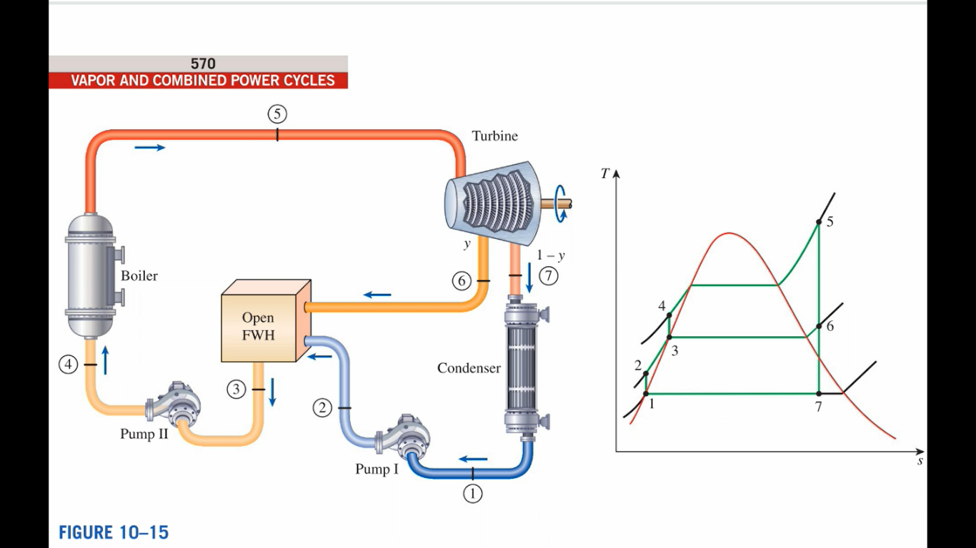

|  |  |  |  |  |  |  |  |
| --- | --- | --- | --- | --- | --- | --- | --- |
| State $i$# | State | $$P_{i}/kPa$$ | $$T_{i}/℃$$ | $$ν_{i}/ m^{3} {kg}^{-1}$$ | $$x_{i}$$ | $$h_{i}/kJ {kg}^{-1}$$ | $$s_{i}/kJ {\left(kg.K\right)}^{-1}$$ |
| 1 | Saturated Liquid | 8 | 41.51 | 0.00100847 | 0 | 173.852 | 0.592532 |
| 2* | Subcooled Liquid | 1000 | 41.54 | 0.00100804 | - | 174.835 | 0.592532 |
| 3* | Saturated Liquid | 1000 | 179.89 | 0.00112723 | 0 | 762.683 | 2.13843 |
| 4 | Subcooled Liquid | 16,000 | 181.96 | 0.00111776 | - | 779.508 | 2.13843 |
| 5 | Superheated Vapour | 16,000 | 560 | 0.0217396 | - | 3467.28 | 6.51637 |
| 6* | Saturated Liquid-Vapour Mixture | 1000 | 179.89 | 0.191367 | 0.98457 | 2746.04 | 6.51637 |
| 7 | Saturated Liquid-Vapour Mixture | 8 | 41.51 | 14.0434 | 0.775891 | 2037.84 | 6.51637 |

i)

$$y=\frac{h_{3}-h_{2}}{h_{6}-h_{2}}=0.2286$$

$${\dot{W}}_{net}={\dot{m}}_{s}\left\{y\left(h_{5}-h_{6}\right)+\left(1-y\right)\left[\left(h_{5}-h_{7}\right)-\left(h_{2}-h_{1}\right)\right]-\left(h_{4}-h_{3}\right)\right\}=149,993 kW$$

ii)

$${\dot{Q}}_{boiler}={\dot{m}}_{s}\left(h_{5}-h_{4}\right)=322,532 kW$$

iii)

$$η_{th}=\frac{{\dot{W}}_{net}}{{\dot{Q}}_{boiler}}×100\%=46.505 \%$$

iv)



$${\dot{m}}_{cw}=\frac{{\dot{m}}_{s}\left[\left(1-y\right)\left(h_{7}-h_{1}\right)\right]}{c_{p}ΔT}=2,293 kg s^{-1}$$

It can be seen that the cycle performance improves with increase in the OFWH operating pressure. The increase is drastic up to 2MPa, after which the increase in cycle efficiency is gradual and roughly linear. The MATLAB code developed is given below.

clc

clear all

close all

format long

ms = 120;

P = [12.5 10 7 5 2 1 0.5 0.1 0.05];%Extraction Pressure

h2 = [186.405 183.895 180.879 178.866 175.844 174.835 174.331 173.927 173.877];

h3 = [1511.46 1407.87 1267.44 1154.5 908.622 762.683 640.185 417.436 340.476];

h6 = [3383.69 3311.93 3204.29 3110.22 2887.09 2746.04 2618.82 2360.92 2263.6];

cp = 4.18;

dT = 18;

i = 1;

while i <= length(P)

%Specific Enthalpies at respective states [kJ/kg]

h = [173.852

h2(i)%h(2) to vary

h3(i)%h(3) to vary

779.508

3467.28

h6(i)%h(6) to vary

2037.84]';

y(i) = (h(3)-h(2))/(h(6)-h(2));

Wnet(i) = ms*(y(i)*(h(5)-h(6))+(1-y(i))*((h(5)-h(7))-(h(2)-h(1)))-(h(4)-h(3)));

Qb(i) = ms*(h(5)-h(4))

eta(i) = (Wnet(i)/Qb(i))*100

mcw(i) = ms*((1-y(i))*(h(7)-h(1)))/(cp*dT)

i = i+1;

end

figure(1)

plot(P,eta)

title('Cycle Performance Variation with OFWH Operating Pressure')

xlabel('OFWH Pressure [MPa]')

ylabel('Cycle Efficieny (\eta_t_h) [%]')

grid on

grid minor

%Pressure Variation

eta = 0.8;

P = [8.5 7 5 3 2 1 0.7 0.5 0.1 0.05];%Reheat Pressure

h4s = [3272.4 3214.39 3119.54 2988.49 2894.65 2752.65 2685.63 2625.02 2366.36 2268.77];

h5 = [3342.96 3362.48 3387.71 3412.1 3424.01 3435.74 3439.22 3441.54 3446.15 3446.73];

h6s = [2039.99 2073.83 2129.73 2210.21 2271.76 2374.31 2426.3 2475.04 2724.16 2860.99];

i = 1;

while i <= length(P)

% Specific Enthalpies at respective states [kJ/kg]

h = [151.494

161.518%2s

0

3322.89

h4s(i)%h(5) to vary

0%h(6) to vary

h5(i)%h(7) to vary

h6s(i)%6s

0]';

h(3) = (h(2)-h(1))/eta+h(1);

h(6) = h(4)-eta*(h(4)-h(5));

h(9) = h(7)-eta*(h(7)-h(8));

qin(i) = (h(4)-h(3))+(h(7)-h(6));

qw(i) = (h(9)-h(1));

etaP(i) = (1-qw(i)/qin(i))*100

i = i+1;

end

figure(2)

plot(P,etaP)

title('Cycle Performance Variation with Reheat Pressure')

xlabel('Reheat Pressure [MPa]')

ylabel('Cycle Efficieny (\eta_t_h) [%]')

grid on

grid minor

%Temperature Variation for P = 0.7 MPa

eta = 0.8;

T = [170 180 200 250 300 350 400 480 550 600];%Reheat Temperature

h5 = [2775.36 2799.38 2845.29 2954.12 3059.5 3164.13 3269.14 3439.22 3590.82 3700.9];

h6s = [2073.77 2090.35 2121.02 2188.68 2248.2 2302.33 2352.47 2426.3 2485.82 2525.98];

i = 1;

while i <= length(T)

% Specific Enthalpies at respective states [kJ/kg]

h = [151.494

161.518%2s

0

3322.89

2685.63

0

h5(i)%h(7) to vary

h6s(i)%6s varies as a result

0]';

h(3) = (h(2)-h(1))/eta+h(1);

h(6) = h(4)-eta*(h(4)-h(5));

h(9) = h(7)-eta*(h(7)-h(8));

qin(i) = (h(4)-h(3))+(h(7)-h(6));

qw(i) = (h(9)-h(1));

etaT(i) = (1-qw(i)/qin(i))*100

i = i+1;

end

figure(3)

plot(T,etaT)

title('Cycle Performance Variation with Reheat Exit Temperature for P = 0.7 MPa')

xlabel('Reheat Exit Temperature (T_5) [^oC]')

ylabel('Cycle Efficieny (\eta_t_h) [%]')

grid on

grid minor