The tree encircled has been sketched using MATLAB’s Image Processing toolbox, by calling the function, roipoly.

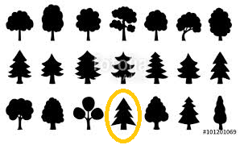

The vertices have been manually plotted to coincide with the vertices of the silhouette.

These output the coordinates required to plot the geometry traced.

A fictitious time domain is defined whose length is set equal to the number of vertices, and the x and y coordinates are plotted against it.



*N.B. The y coordinate points have been negated to rectify the inverted image obtained by the default points.*

Using the Curve Fitting App on MATLAB, the curves defined by x and y as functions of the fictitious time are approximated by the Fourier series. A good fit is obtained for order 7.

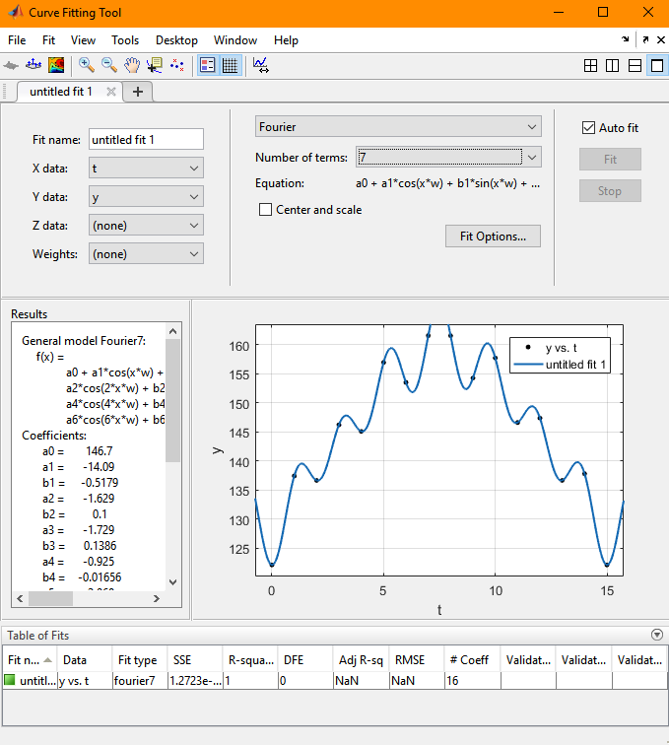

The new X and Y coordinates are obtained from the Fourier approximation, whose parameters are used to form their respective coordinate vectors. These are then plotted, and are seen to be identical to the original.

