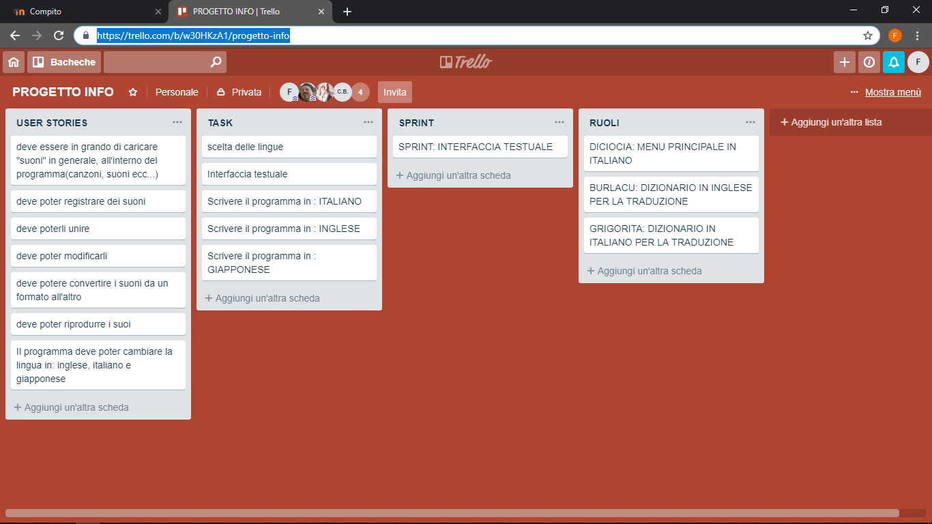

Link: https://trello.com/b/w30HKzA1/progetto-info

