PROTOCOL [CHM112]

* **Determination of strength of Fe in Mohr’s salt by Redox titration with potassium permanganate solution**

1. Preparation of Standard Mohr salt solution of N/20.

**Calculation**

1. Standardization of ~N/20 potassium permanganate solution Mohr Salt.
2. Rinse and fill the glass stoppered burette with KMnO4 solution.
3. Pipette out 10 mL of ferrous ammonium sulphate solution in a clean conical flask and add about 10 mL of dilute H2SO4.
4. Titrate KMnO4 solution from burette and shake the flask until a light pink color just appears and stays for atleast 30 seconds. Repeat each for 3 times.

**Table and Calculation**

**Strength of permanganate**

1. Determine the strength of Fe(II) in unknown Mohr Salt using permanganate.

**Table and Calculation**

**Strength of Fe(II)**

* **Determination of strength of a given solution of Mohr’s salt by titrating it against potassium dichromate solution:**

Unlike permanganate, dichromate titrations require an indicator. The indicator used for this titration, known as redox indicator, is Barium(II) diphenylamine sulfonate or BDS and the color change is green to violet due to the formation of diphenylbenzidine violet. The standard electrode potential for BDS is +0.87 V, which is very close to end-point potential of the titration. Therefore, dichromate oxidizes the BDS almost at the same time with Fe(II).

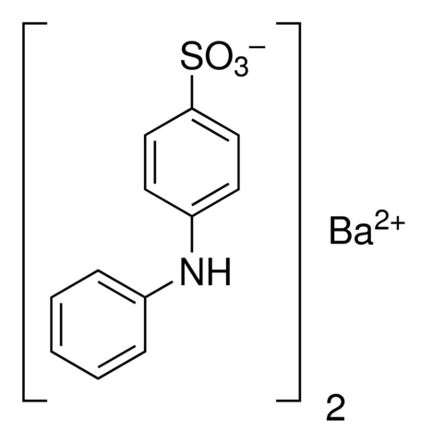

Cr2O72-

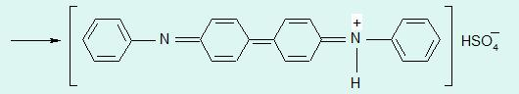

1. Use the previously prepared ferrous ammonium sulphate solution.
2. Determine the strength of Fe(II) in unknown Mohr Salt using dichromate.

* Into a flask, pipette out 10 mL of ferrous ammonium sulphate solution and add about 10 mL dilute H2SO4 solution and 2 drops of BDS indicator.
* Titrate with dichromate till a purple color appears. Determine the strength of dichromate solution.
* Then using the same methodology determine the strength of unknown ferrous ammonium sulphate solution using standardized dichromate solution.

**Table and Calculation**

**Strength of Fe(II)**