1. a) Tetrahedral complexes have more intense absorptions than octahedral complexes. Explain. 2
- in tetrahedral complexes d and p mixing happens. No centrosymmetry present.

b) Why does blood-red coloration appear during the test of Fe(III) with thiocyanate? 1
LMCT is responsible from thiocyanate to Fe(III)-based orbitals (Mentioning complex formation will not get credit)
c) State two relaxation pathways for Laporte-forbidden transition. 2
- in tetrahedral complexes no centre of symmetry, no g→g or u→u transition is happening,
- vibronic coupling
- asymmetric ligand environment in octahedral complexes
2.a) An approximately ‘octahedral’ complex of Co(III) with ammine and chloro ligands give two bands with ε_{max} between 60 and 80 L mol⁻¹ cm⁻¹, one peak with ε_{max} = 2 L mol⁻¹ cm⁻¹, and a strong band at higher energy with ε_{max} = 2x10⁴ L mol⁻¹ cm⁻¹. Suggest the origins of these transitions. 3
ε_{max} between 60 and 80 L mol⁻¹ cm⁻¹ – due to d-d transition (spin allowed but Laporte forbidden)
ε_{max} = 2 L mol⁻¹ cm⁻¹ - due to d-d transition (both Laporte and spin forbidden)
ε_{max} = 2x10⁴ L mol⁻¹ cm⁻¹ – due to charge transfer

b) If the redox reaction proceeds via inner-sphere mechanism, what will be the product for the following reaction: [CoF(NH₃)₅]²⁺ + [Cr(OH₂)₆]²⁺ → 2

[CoF(NH₃)₅]²⁺ + [Cr(OH₂)₆]²⁺ → [Co(OH₂)(NH₃)₅]²⁺ + [CrF(OH₂)₅]²⁺
(Charge of the complex, or oxidation state of metal needs to be correct to get credit)

3.a) The isoelectronic species VO₄³⁻ (amber), CrO₄²⁻ (yellow-orange) and MnO₄⁻ (purple) all show intense transitions in the visible at 445, 525 and 640 nm, respectively. Rationalize the trend in wavelength using a schematic energy level diagram to explain your argument.
All are d⁰ system. Colour arises due to charge transfer transition from ligand to metal. V is in +5, Cr is in +6 and Mn is in +7 oxidation state. Due to higher Z_{eff} (higher positive charge, higher Z_{eff}), the metal-based orbitals energy level of MnO₄⁻ will be lower than that of CrO₄²⁻ , which will be lower than that of VO₄³⁻. Oxide ligand-based orbitals are even lower from where the transitions happens.
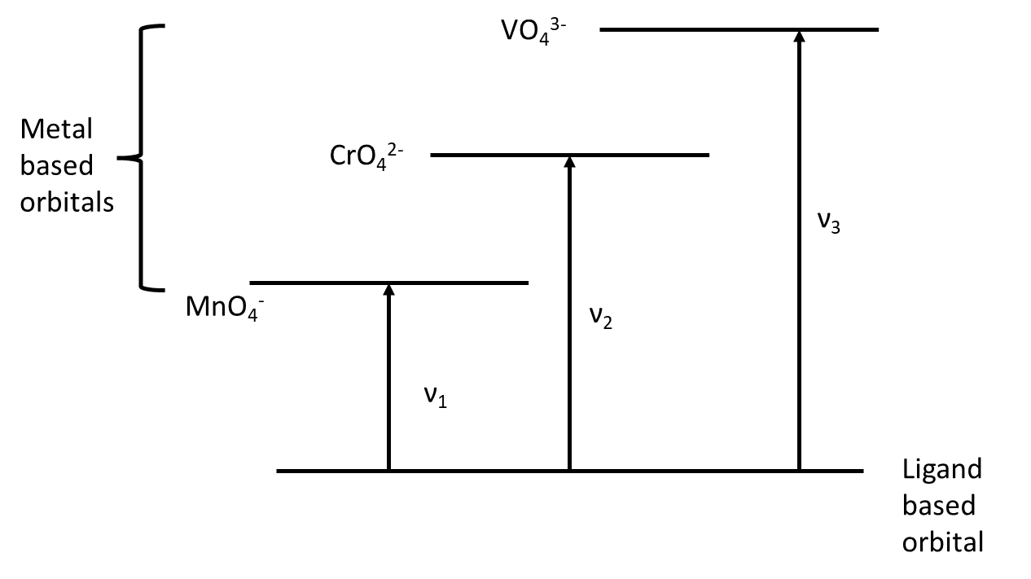
So, ν₁ < ν₂ < ν₃, and λ₁ > λ₂ > λ₃, as we can see VO₄³⁻ absorbs at 445 nm, CrO₄²⁻ absorbs at 525 nm and MnO₄⁻ absorbs at 640 nm.
b) The complexes [Mn(H₂O)₆]²⁺, [Fe(H₂O)₆]³⁺, [MnCl₄]²⁻, and [FeCl₄]⁻ all have magnetic moments nearly 5.92 BM, what does this tell you about the geometric and electronic structures of these complexes. 2
magnetic moment suggests all these complexes have 5 unpaired electrons. All the central metal ions are d⁵ system. So, they are all high spin complexes.
[Mn(H₂O)₆]²⁺, [Fe(H₂O)₆]³⁺ are octahedral with H₂O as weak field ligand, so the electronic configuration will be t_{2g}³ e_{g}².
[MnCl₄]²⁻, and [FeCl₄]⁻ are tetrahedral. Cl⁻ is a weak field ligand and tetrahedral complexes are always high spin with electronic configuration e² t₂³.
4.a) NF₃ boils at -129°C and is a very weak Lewis base. By contrast, the lower molar mass compound NH₃ boils at -33°C and is well known as a Lewis base.
i) Describe the origin of this very large difference in volatility. 2
Due to presence of H-bonding in NH₃, it has higher boiling point.
ii) Describe the probable origins of the difference in basicity. 1
F is the most electronegative atom, pulls the electron density towards it; decreases the electron density around N in NF₃, less basic than NH₃.
b) HF is liquid at room temperature, whereas, HCl, HBr and HI are all gases. Explain. 2
Due to extensive H-bonding in HF, it is liquid and others are gases.
5.a) The bond lengths of O₂, O₂⁺, and O₂²⁻ are 121, 112, and 149 pm, respectively. Describe the bonding in these molecules in terms of MO theory (draw it) and use this theory to rationalize the differences in bond lengths. 2
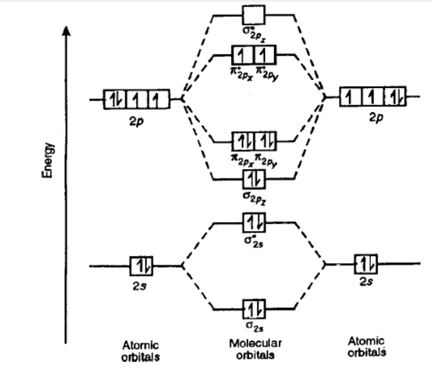
From the MO of O₂, the bond order can be calculated as = (8-4)/2 = 2
For O₂⁺, one of the electron from π* orbital is removed; hence the bond order is increased to (8-3)/2 = 2.5
For O₂²⁻ two more electrons are added to the π* orbital of O₂ and the bond order is decreased to (8-6)/2 = 1
As bond length is inversely proportional to bond order, bond length of O₂⁺ (112 pm) < O₂ (121 pm) < O₂²⁻ (149 pm) (MO order must be correct to get full credit)

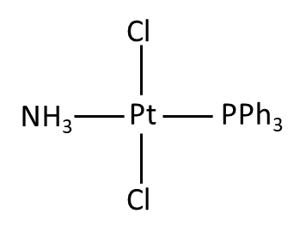
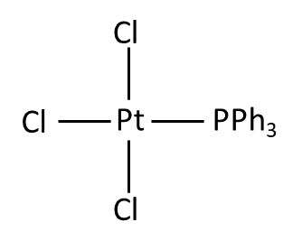
b) Given the reactants PPh₃, NH₃ and [PtCl₄]²⁻ , propose efficient route to trans-[PtCl₂(NH₃)(PPh₃)] 2

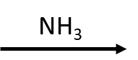
[PtCl₄]²⁻ + PPh₃ →

(No credit, for opposite order of incorporating NH₃ and phosphine ligands, as the trans effect of those ligands will not lead to the desired complex)
6.a) Draw the structure of diborane and discuss its bonding (No explicit MO is required).

Difference in bridging and terminal hydride must be shown. They are in different plane. One B-H-B unit is 3c-2e bond. B-H terminal bonds are regular 2c-2e bonds. If mentioned as banana bond, it is okay.

b) Orthoboric acid can be written as H₃BO₃ or B(OH)₃. In aqueous solution, is it an acid or a base? How does it ionize in water? 1+1
H₃BO₃ is an acid.
H₃BO₃ + 2H₂O → B(OH)₄⁻ + H₃O⁺
c) Discuss the structure of h-BN and mention one similarity and one difference with graphite. 2
both are hexagonal and make layered packing. Both are aromatic
Difference: h-BN packs in eclipsed manner, while graphene layers are off-stack

7. Write down products for the following reaction (with appropriate balance) 5 × 2
- 2Al + Cr₂O₃ → Al₂O₃ + 2Cr
- Na₂S₂O₃ + 4Cl₂ + 5H₂O → 2NaHSO₄ + 8HCl
- BrF₅ + 3H₂O → 5HF + HBrO₃
- (NH₄)₂Cr₂O₇ + heat → N₂ + 4H₂O + Cr₂O₃
- N₂H₄ + 2I₂ → 4HI + N₂
8.a) NH₃ and PH₃ can donate their lone pairs and form numerous complexes. The higher Group 15 hydrides, AsH₃, SbH₃ do not exhibit coordination property. Explain. 2
For NH₃ and PH₃, there are three bond pairs and a lone pair around the central element, giving a slight distorted tetrahedral structure with the lone pair residing in one of the sp³ hybridised orbital. This presence of lone pair causes distortion and the bond angles are reduced from 109.5° to ~107.5° for NH₃ and slightly smaller in case of PH₃. The lone pair in N/ P is used to form the coordinate bond.
Similar structure and hybridization is expected in case of AsH₃ and SbH₃. But here, the bond pair of electrons are much further away from the central atom than they are in NH₃. Thus lone pair causes even greater distortion in AsH₃ and SbH₃. The bond angles decreases to 91°. These bond angles suggest that the orbitals used for bonding are close to pure p orbitals and the lone pair occupy a spherical s orbital. This s orbitals are larger, less directional and hence less effective.
b) In phosphates, a large number of polymeric phosphate exists, but in case of oxyacids of chlorine, no polymerization takes place. Why? 2
The bonds between Cl and O are much shorter than might be expected for a single bond. In addition to σ bond, π bond is formed by the sideways overlap of a p orbital on the oxygen with a d orbital on the Cl, giving a pπ-dπ interaction. Similar pπ-dπ interaction is found in case of the oxides and oxoacids of phosphorus.
To obtain effective pπ-dπ overlap, the size of the d orbital must be similar to the size of the p orbital. On crossing a period in the periodic table the size of the atom and the size of the d orbitals decreases from P to Cl. The decrease in the size of the d orbitals leads to progressively stronger pπ-dπ bonds. Thus in phosphates, π bonding is much weaker leading to polymerization. In case of Cl, pπ-dπ bonding is so strong that no polymerization of oxoanions takes place.
9.a) In titration of I₂ with Na₂S₂O₃, the bluish colour produced by starch indicator with iodine disappears. Why? When the titration flask is allowed to stand for 2-3 min, the blue colour returns. Why? (give chemical equations) 2+2
I₂ in presence of I⁻ forms I₃⁻ which is water soluble and forms a blue complex with the starch indicator. Na₂S₂O₃ reduces I₂ to I⁻ and itself is oxidized to tetrathionate S₄O₆²⁻. Removal of I₂ from the aqueous solution leads to disappearance of blue colour.
2Na₂S₂O₃ + I₂ → Na₂S₄O₆ + 2NaI
Aerial oxygen is capable of oxidizing iodide back to I₂ which can again from the triiodide ion. Triiodide forms the starch complex giving back the blue colour, If the titration flask is allowed to stand for few minutes after the end point is reached.
b) Why nitric acid is stored in an amber (brown) coloured bottle? 1
Pure nitric acid is a colourless liquid, but on exposure to light it turns slightly brown because of slight decomposition into NO₂ and O₂. To avoid the decomposition of nitric acid, it is stored in brown coloured bottle.
4HNO₃ → 4NO₂ + O₂ + 2H₂O
10.a) Comparing Group1 and Group 2 metals, which Group has the higher melting point? 1
Group 2 metals have higher melting point. Since Group 2 metal has 2 valence electrons compared 1 valence electron in Group 1 metals, the metal-metal interactions are much stronger in case of Gr 2 metals leading to higher melting point.
b) What causes temporary and permanent hardness? How is temporary hardness treated? (chemical equation required) 2+1
Temporary hardness is due to the presence of Mg(HCO₃)₂ and Ca(HCO₃)₂.
Permanent hardness is due to MgSO₄ or CaSO₄.
Temporary hardness can be removed by boiling. Bicarbonates decompose into carbonates and gets precipitated which can be removed by filtration.
HCO₃²⁻ ↔ CO₃²⁻ + CO₂ + H₂O
Temporary hardness can also be removed by adding slaked lime Ca(OH)₂ to precipitate CaCO₃.
Ca(HCO₃)₂ + Ca(OH)₂ ↔ 2CaCO₃ + 2H₂O (any one will get credit)
c) Fluorides of Gr II metals have high melting point. Why? 1
Smaller size of fluorides compared to other halides lead to high lattice energy and high melting point. (when compared with other halides of Gr II)
Smaller size and higher charge of Gr II metals compared to Gr I metals lead to high lattice energy and high melting point. (when compared with fluorides of Gr 1 with Gr II)
11.a) To prepare sulphuric acid, SO₃ could be mixed to water to give H₂SO₄; but in industries, an alternative route is followed. Mention the alternative route and also state why the alternative route is followed? 3
SO₃ could be mixed to water to give H₂SO₄, but the reaction is violent and exothermic and produces lots of mist which is difficult to condense.
Instead, the SO₃ is passed into 98% H₂SO₄, forming pyrosulfuric acid H₂S₂O₇, sometimes called oleum or fuming sulphuric acid. This oleum solution when diluted with water gives concentrated suphuric acid which is a 98% mixture with water.
SO₃ + H₂SO₄ → H₂S₂O₇
H₂S₂O₇ + H₂O → 2H₂SO₄
b) What is Haber-Bosch process useful for? Give the equation and conditions for the conversion. 2
In Haber-Bosch process, N₂ and H₂ are combined directly to produce NH₃. This is one of the important commercial processes.
N₂ + 3H₂ → 2NH₃
In practice, the conditions used are 200 atmosphere pressure, a temperature of 380-450°C and a catalyst of iron (heterogeneous).
12.a) In the crystal structure of CuF₂, the Cu²⁺ is six coordinate with four F⁻ at a distance of 1.93 Å and two F⁻ at 2.27 Å. Explain the reason for this. 2
Cu²⁺ is a d⁹ system with t_{2g}⁶ e_{g}³ configuration. Due to asymmetric occupation at e_{g} level, this complex will undergo tetragonal distortion (Jahn-Teller distortion). Here due to distortion the two ligands along the z-axis are pulled away from the central metal ion compared to other four ligands. Hence, four F⁻ are at a shorter distance of 1.93 Å and two F⁻ at longer distance of 2.27 Å (Full credit has been given for drawing the d-orbital splitting under J-T z-out distortion).
b) The complex [Ni(CN)₄]²⁻ is diamagnetic, but [NiCl₄]²⁻ is paramagnetic and has two unpaired electrons. Explain these observations and deduce the structures of these two complexes. 2
In both the complexes, Ni is in +2 oxidation state, d⁸ system. In four coordinate complexes, two geometries are possible; square planar and tetrahedral.
In case of [Ni(CN)₄]²⁻, it is square planar. The d-orbital will split accordingly :
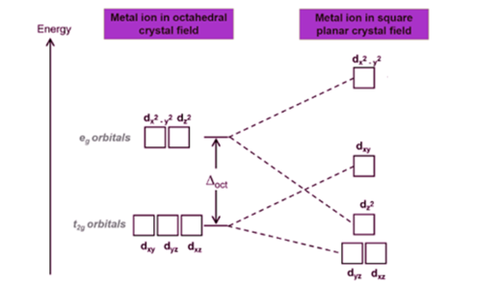
So the electronic configuration will be d_{xz}² d_{yz}² d_{z2}² d_{xy}². Since all the electrons are paired, it is a diamagnetic complex.
In case of [NiCl₄]²⁻, this must be a tetrahedral with electronic configuration e⁴ t₂⁴.
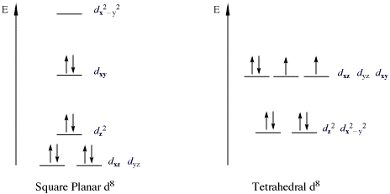
Since in tetrahedral d⁸ system, there are 2 unpaired electrons, [NiCl₄]²⁻ is paramagnetic.
c) Explain why H₂Se is a stronger acid than H₂S. 1
Se-H bond being longer (than S-H) is weaker and is easier to break. Hence H₂Se will give H⁺ easily is stronger acid than H₂S.
13.a) Arrange the following in order of increasing acidity and account for the trend. [Al(OH₂)₆]³⁺, [Fe(OH₂)₆]³⁺, [Fe(OH₂)₆]²⁺ with very brief reasoning. 2
[Al(OH₂)₆]³⁺> [Fe(OH₂)₆]³⁺> [Fe(OH₂)₆]²⁺
The size of the Al in [Al(OH₂)₆]³⁺ is smallest with high charge. So the charge density (charge/size ratio or ionic potential) is highest, can polarize the O-H bond, making it easier to release a proton.
Comparing [Fe(OH₂)₆]³⁺ and [Fe(OH₂)₆]²⁺, [Fe(OH₂)₆]³⁺ has higher charge as well as smaller size making the charge density higher than [Fe(OH₂)₆]²⁺. Hence [Fe(OH₂)₆]³⁺ is a stronger acid than [Fe(OH₂)₆²⁺.
b) The ions Na⁺ and Ag⁺ have similar radii. Which aqua ion is the stronger acid and why? 2
Ag⁺ aqua ion is the stronger acid because it has a higher effective nuclear charge because of the poor shielding of d electrons (this is pseudo-Noble gas configuration), leading to stronger interactions with water molecules and a greater tendency to donate a proton by polarizing the O-H bond (this is the third rules of Fajan).
c) The molecule (CH₃)₂N-PF₂ has two basic atoms, P and N. One is bound to B in a complex with BH₃, the other to B in BF₃. Decide which atom connected to what boron complex and state the reason for your decision. 2
BF₃ is harder Lewis acid than BH₃. N is a harder base than P. Since hard acid prefers to bind to hard base, BF₃ should bound to N donor atom and BH₃ should bound to P donor atom (mention HSAB principle).

