AICE

AI Driven Customer Engagement

**Author**: IISc Group-7

**Version**: 0.1

**Date**: 27-Apr-2024

**Table of Contents**

1. Project Title 2

2. Brief problem statement 3

3. Background information: Include domain information, problem description and analysis, possible applications 3

4. Motivation for selection of the project 4

5. Detailed dataset description and dataset source 4

6. Current benchmark: provide references (if any) 4

7. Proposed Plan: 5

a. Define the methodology, including: 5

b. Approaches 5

c. Packages and tools 5

d. Algorithms 5

e. Metrics 5

f. Outline the stages with defined deliverables. 5

8. Develop a deployment plan, considering options like Gradio, Streamlit, FastAPI Spaces etc. 5

9. Implement MLOps tools for effective management and automation. 5

10. Preliminary Exploratory Data Analysis 5

11. Expected outcomes 5

12. Project demonstration strategy (tentative plans) 5

13. Proposed timeline of project stage executions (eg. Gantt chart): Include 5

14. weekly progress goals for each of the 4 Capstone Project Mentored Sessions. 5

15. Team members’ names 6

16. Designated team coordinator's name(s) 6

# 

# **Project Title**

AICE: AI Driven Customer Engagement

# **Brief problem statement**

Predictive Marketing uses past historical data to provide new context for the marketing. This statistical approach is labour and skill intensive. We plan to build a framework and an application to demonstrate how GenAI can be used to improve and enhance marketing.

# **Background information: Include domain information, problem description and analysis, possible applications**

Marketing has undergone sea change since publication of Marketing Management in 1967 by Prof. Philip Kotler. Prof Kotler himself has written about predictive marketing in his new book Marketing 5.0 (2021)

Prof. Kotler wondered if the neural network based predictive marketing works best for complex predictions.

We would like to demonstrate the suitability of AI or GenAI in marketing analytics, specifically in predictive marketing.

We can create a working model based on various open-source technologies and configure them in a setup which automatically predicts user experience and tweaks the products and services to improve the customer experience.

<https://drive.google.com/file/d/10uqSAa4XoDbSmyxRnFG255vK9Z05ED_Z/view?usp=drive_link>

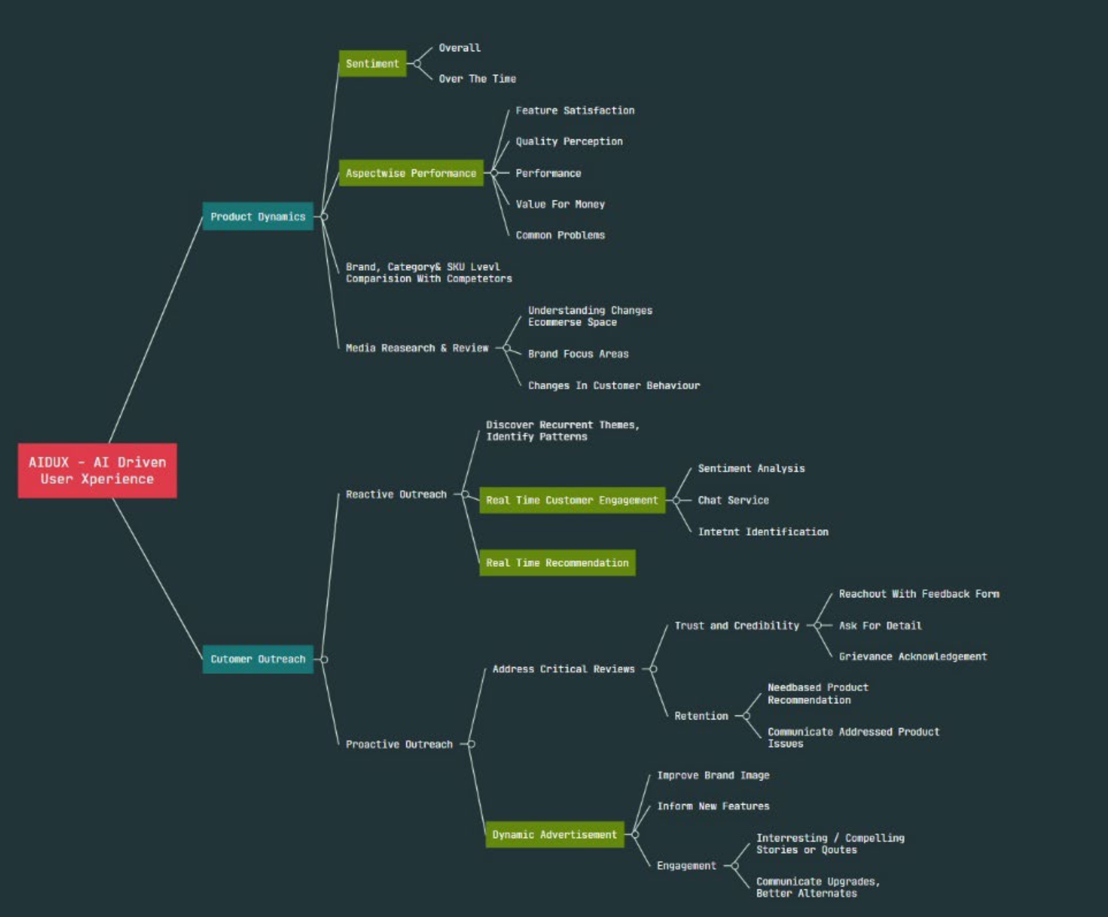

# **Motivation for selection of the project**

<TBD>

# **Detailed dataset description and dataset source**

* 1. <https://www.kaggle.com/datasets/bittlingmayer/amazonreviews>
  2. <https://nijianmo.github.io/amazon/>
  3. <https://huggingface.co/datasets/amazon_us_reviews>
  4. **From TS team:**
     1. <https://www.kaggle.com/datasets/veeralakrishna/relational-strategies-in-customer-servicersics>
     2. <https://www.kaggle.com/datasets/kreeshrajani/3k-conversations-dataset-for-chatbot>
     3. <https://www.kaggle.com/datasets/thoughtvector/customer-support-on-twitter>
  5. If required, we will scrap from web using BS module

# **Current benchmark: provide references (if any)**

* 1. <https://www.meetyogi.com/>
  2. [www.amazon.com](http://www.amazon.com)

# **Proposed Plan:**

<TBD>

## **Define the methodology, including:**

## **Approaches**

## **Packages and tools**

## **Algorithms**

## **Metrics**

## **Outline the stages with defined deliverables.**

# **Develop a deployment plan, considering options like Gradio, Streamlit, FastAPI Spaces etc.**

Gradio + FastAPI

# **Implement MLOps tools for effective management and automation.**

<TBD>

# **Preliminary Exploratory Data Analysis**

<TBD>

# **Expected outcomes**

<TBD>

# **Project demonstration strategy (tentative plans)**

<TBD>

# **Proposed timeline of project stage executions (eg. Gantt chart): Include**

<TBD>

# **weekly progress goals for each of the 4 Capstone Project Mentored Sessions.**

<TBD>

# **Team members’ names**

1. Jatin Goyal [Jt1491995@gmail.com](mailto:Jt1491995@gmail.com)
2. Pankaj kumar soni [soni.pankajkumar@gmail.com](mailto:soni.pankajkumar@gmail.com)
3. Puja Chakraborty [pujachakraborty1810@gmail.com](mailto:pujachakraborty1810@gmail.com)
4. SHIVA C R [shivacr242@gmail.com](mailto:shivacr242@gmail.com)
5. Neelesh Kumar Boddu [neeleshkumar7@gmail.com](mailto:neeleshkumar7@gmail.com)
6. Shaik Athahar Nawaz [Shaikn@microsoft.com](mailto:Shaikn@microsoft.com)
7. Jyotirmoy Patra [jyotirmoy.nsec@gmail.com](mailto:jyotirmoy.nsec@gmail.com)
8. Sajjan Sagar [sajjan.sagar@gmail.com](mailto:sajjan.sagar@gmail.com)
9. Debolina Mahapatra [mahapatradebolina@gmail.com](mailto:mahapatradebolina@gmail.com)
10. Shrikantha Prabhu [shrikantha@shrikanthaprabhu.com](mailto:shrikantha@shrikanthaprabhu.com)
11. Paramashiva B M [parama86@gmail.com](mailto:parama86@gmail.com)

# **Designated team coordinator's name(s)**

1. Jatin Goyal [Jt1491995@gmail.com](mailto:Jt1491995@gmail.com)
2. Pankaj kumar soni [soni.pankajkumar@gmail.com](mailto:soni.pankajkumar@gmail.com)
3. Puja Chakraborty [pujachakraborty1810@gmail.com](mailto:pujachakraborty1810@gmail.com)
4. SHIVA C R [shivacr242@gmail.com](mailto:shivacr242@gmail.com)
5. Neelesh Kumar Boddu [neeleshkumar7@gmail.com](mailto:neeleshkumar7@gmail.com)
6. Shaik Athahar Nawaz [Shaikn@microsoft.com](mailto:Shaikn@microsoft.com)
7. Jyotirmoy Patra [jyotirmoy.nsec@gmail.com](mailto:jyotirmoy.nsec@gmail.com)
8. Sajjan Sagar [sajjan.sagar@gmail.com](mailto:sajjan.sagar@gmail.com)
9. Debolina Mahapatra [mahapatradebolina@gmail.com](mailto:mahapatradebolina@gmail.com)
10. Shrikantha Prabhu [shrikantha@shrikanthaprabhu.com](mailto:shrikantha@shrikanthaprabhu.com)
11. Paramashiva B M [parama86@gmail.com](mailto:parama86@gmail.com)