West Africa Aflatoxin Risk Correlation Analysis

This document covers the correlation analysis across all analyzable Agro-Ecological Zones (SH, SS, NGS, SGS, DS, HF) . MA was excluded because it only has 3 points which were too few for a reliable correlation matrix.

1. Methodology
For each AEZ, a Pearson correlation matrix across all numeric predictors and the aflatoxin outcome variable way computed, then applied the caret package's findCorrelation() function to identify and remove redundant predictors.
The dataset combines two different sources of aflatoxin data. Samples collected in West Africa record a single aflatoxin value (in parts per billion). Samples from Nigeria and Ghana, however, record three related values instead: afl_max, afl_mean, and afl_median, because those samples were grouped and averaged during thinning.
Two zones ,Derived Savanna (DS) and Humid Forest (HF) are made up mostly of Nigeria/Ghana samples, so one of the three afl_* columns had to be chosen instead. All three were tested, and afl_max consistently showed the strongest relationships with the other variables, so it was used for these two zones specifically.

2. Threshold Selection
The findCorrelation() function's own package default is a cutoff of 0.9. However, before committing to 0.7 (which was used by Mudereri et.al.,) across all AEZs, both thresholds (0.9 and 07) were tested on one representative zone (Sahel) to evaluate the practical difference.
Threshold | Variables kept (SH) | Variables removed
0.9 (package default) | 51 | 7
0.7 (chosen) | 20 | 38

At the 0.9 threshold, only 7 of 58 variables were flagged as redundant . The reduced matrix (below) still visibly contains large blocks of highly correlated variables (e.g. the soiltemp_max / tmax / vpd cluster), meaning most real redundancy survives the cut. The stricter 0.7 threshold produces a materially cleaner, more independent predictor set. We proceeded with 0.7 across all AEZs on this basis. Below is a comparison I plotted for the two threshholds using Sahel AEZ as an example.

Plot showing the 0.9 Cutoff (SH AEZ) with 51 variables retained
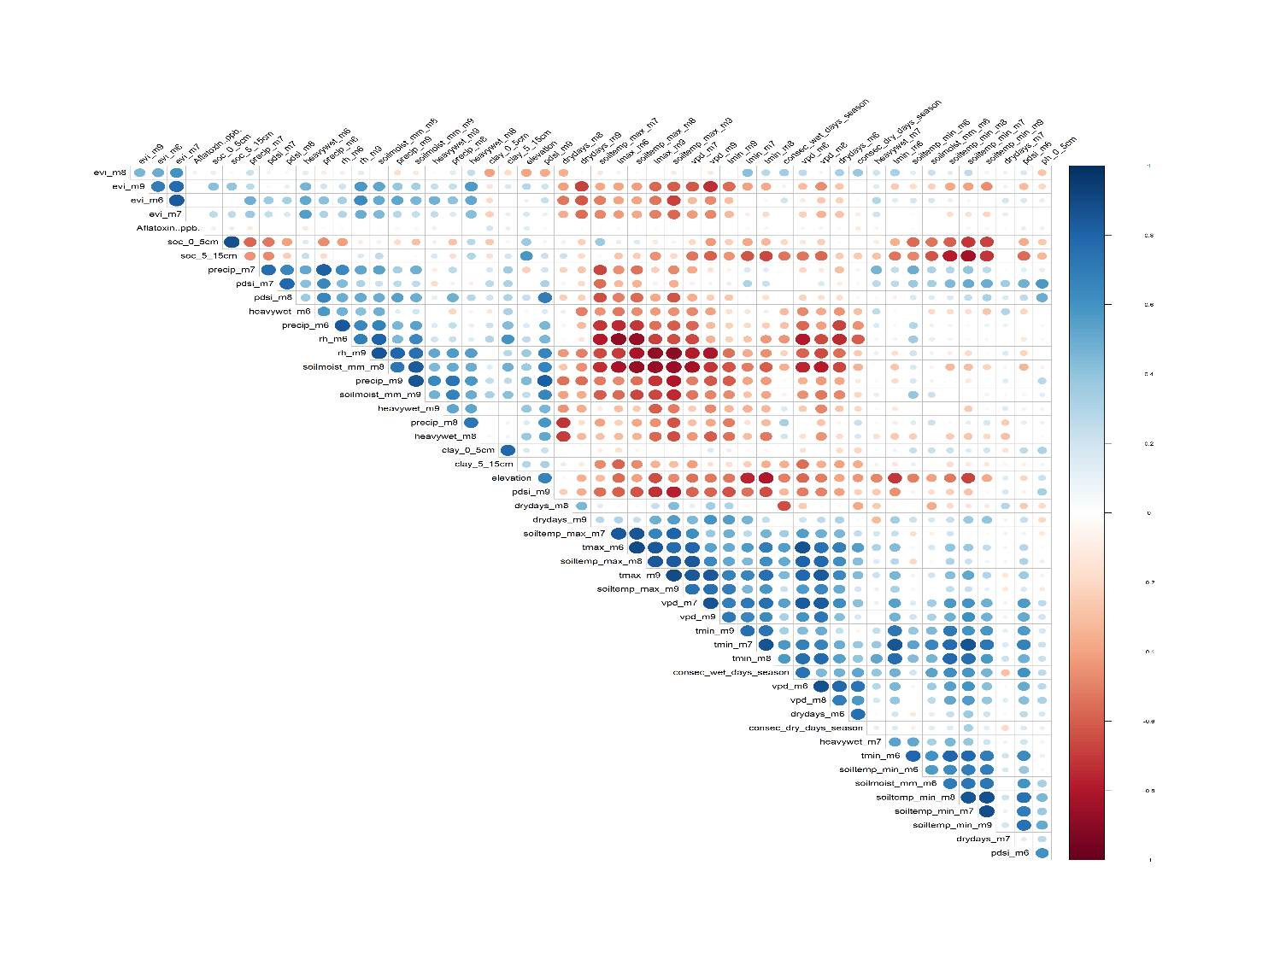

Plot showing 0.7 Cutoff (SH AEZ) with 20 variables retained

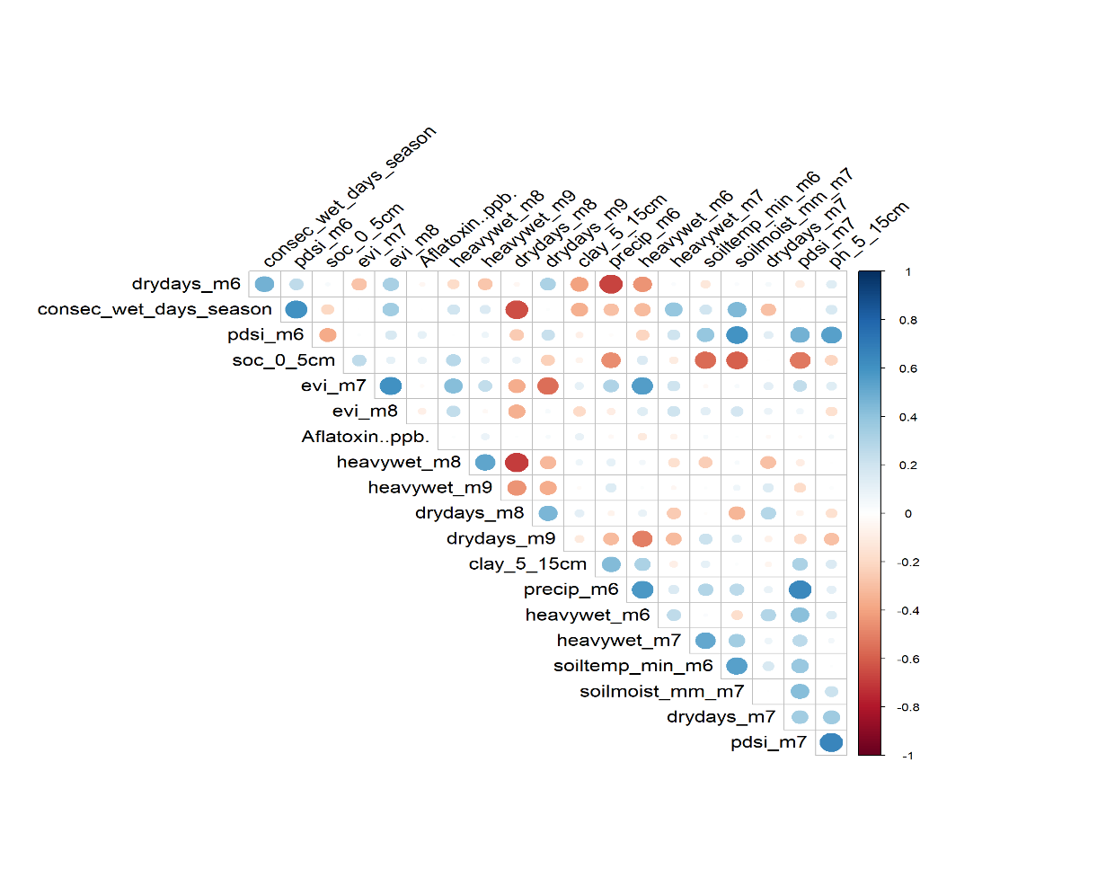

3. Per-AEZ Correlation Analysis
The following sections present each AEZ's full correlation matrix (all predictors, before redundancy removal), the reduced matrix (after applying the 0.7 cutoff), and the five strongest positive and negative correlates with aflatoxin risk.

Sahel
Sample size: 277 rows. Outcome variable used: Aflatoxin..ppb.. Total predictors considered: 58. Flagged as redundant (cutoff = 0.7): 38. Retained: 20.

Full Correlation Matrix (Before Redundancy Removal)
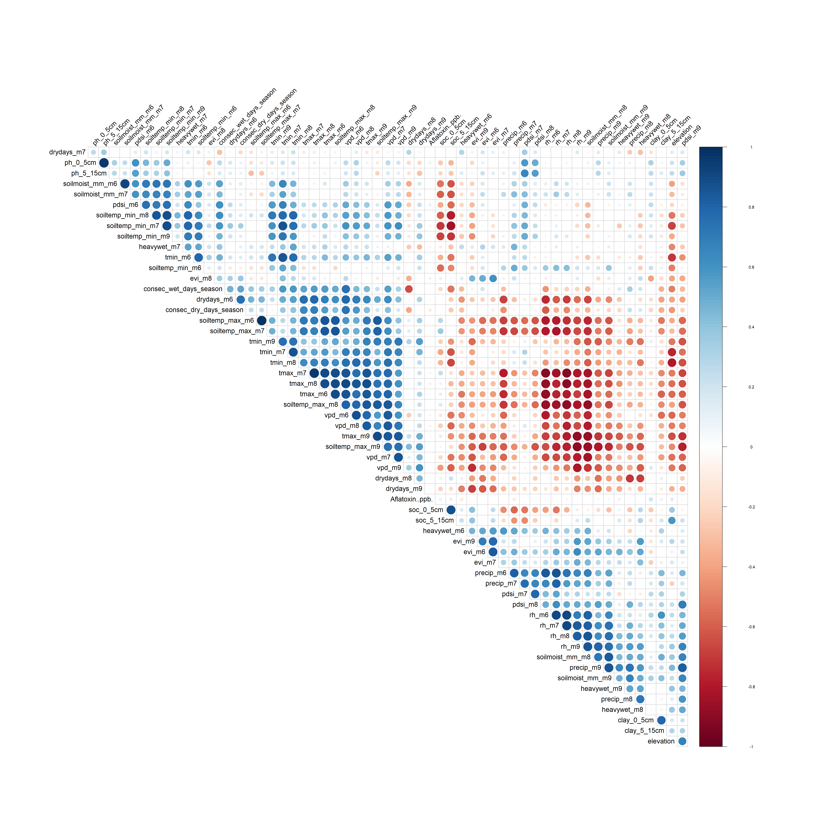
SH: all 58 predictors, hierarchically clustered

Reduced Correlation Matrix (After Redundancy Removal)
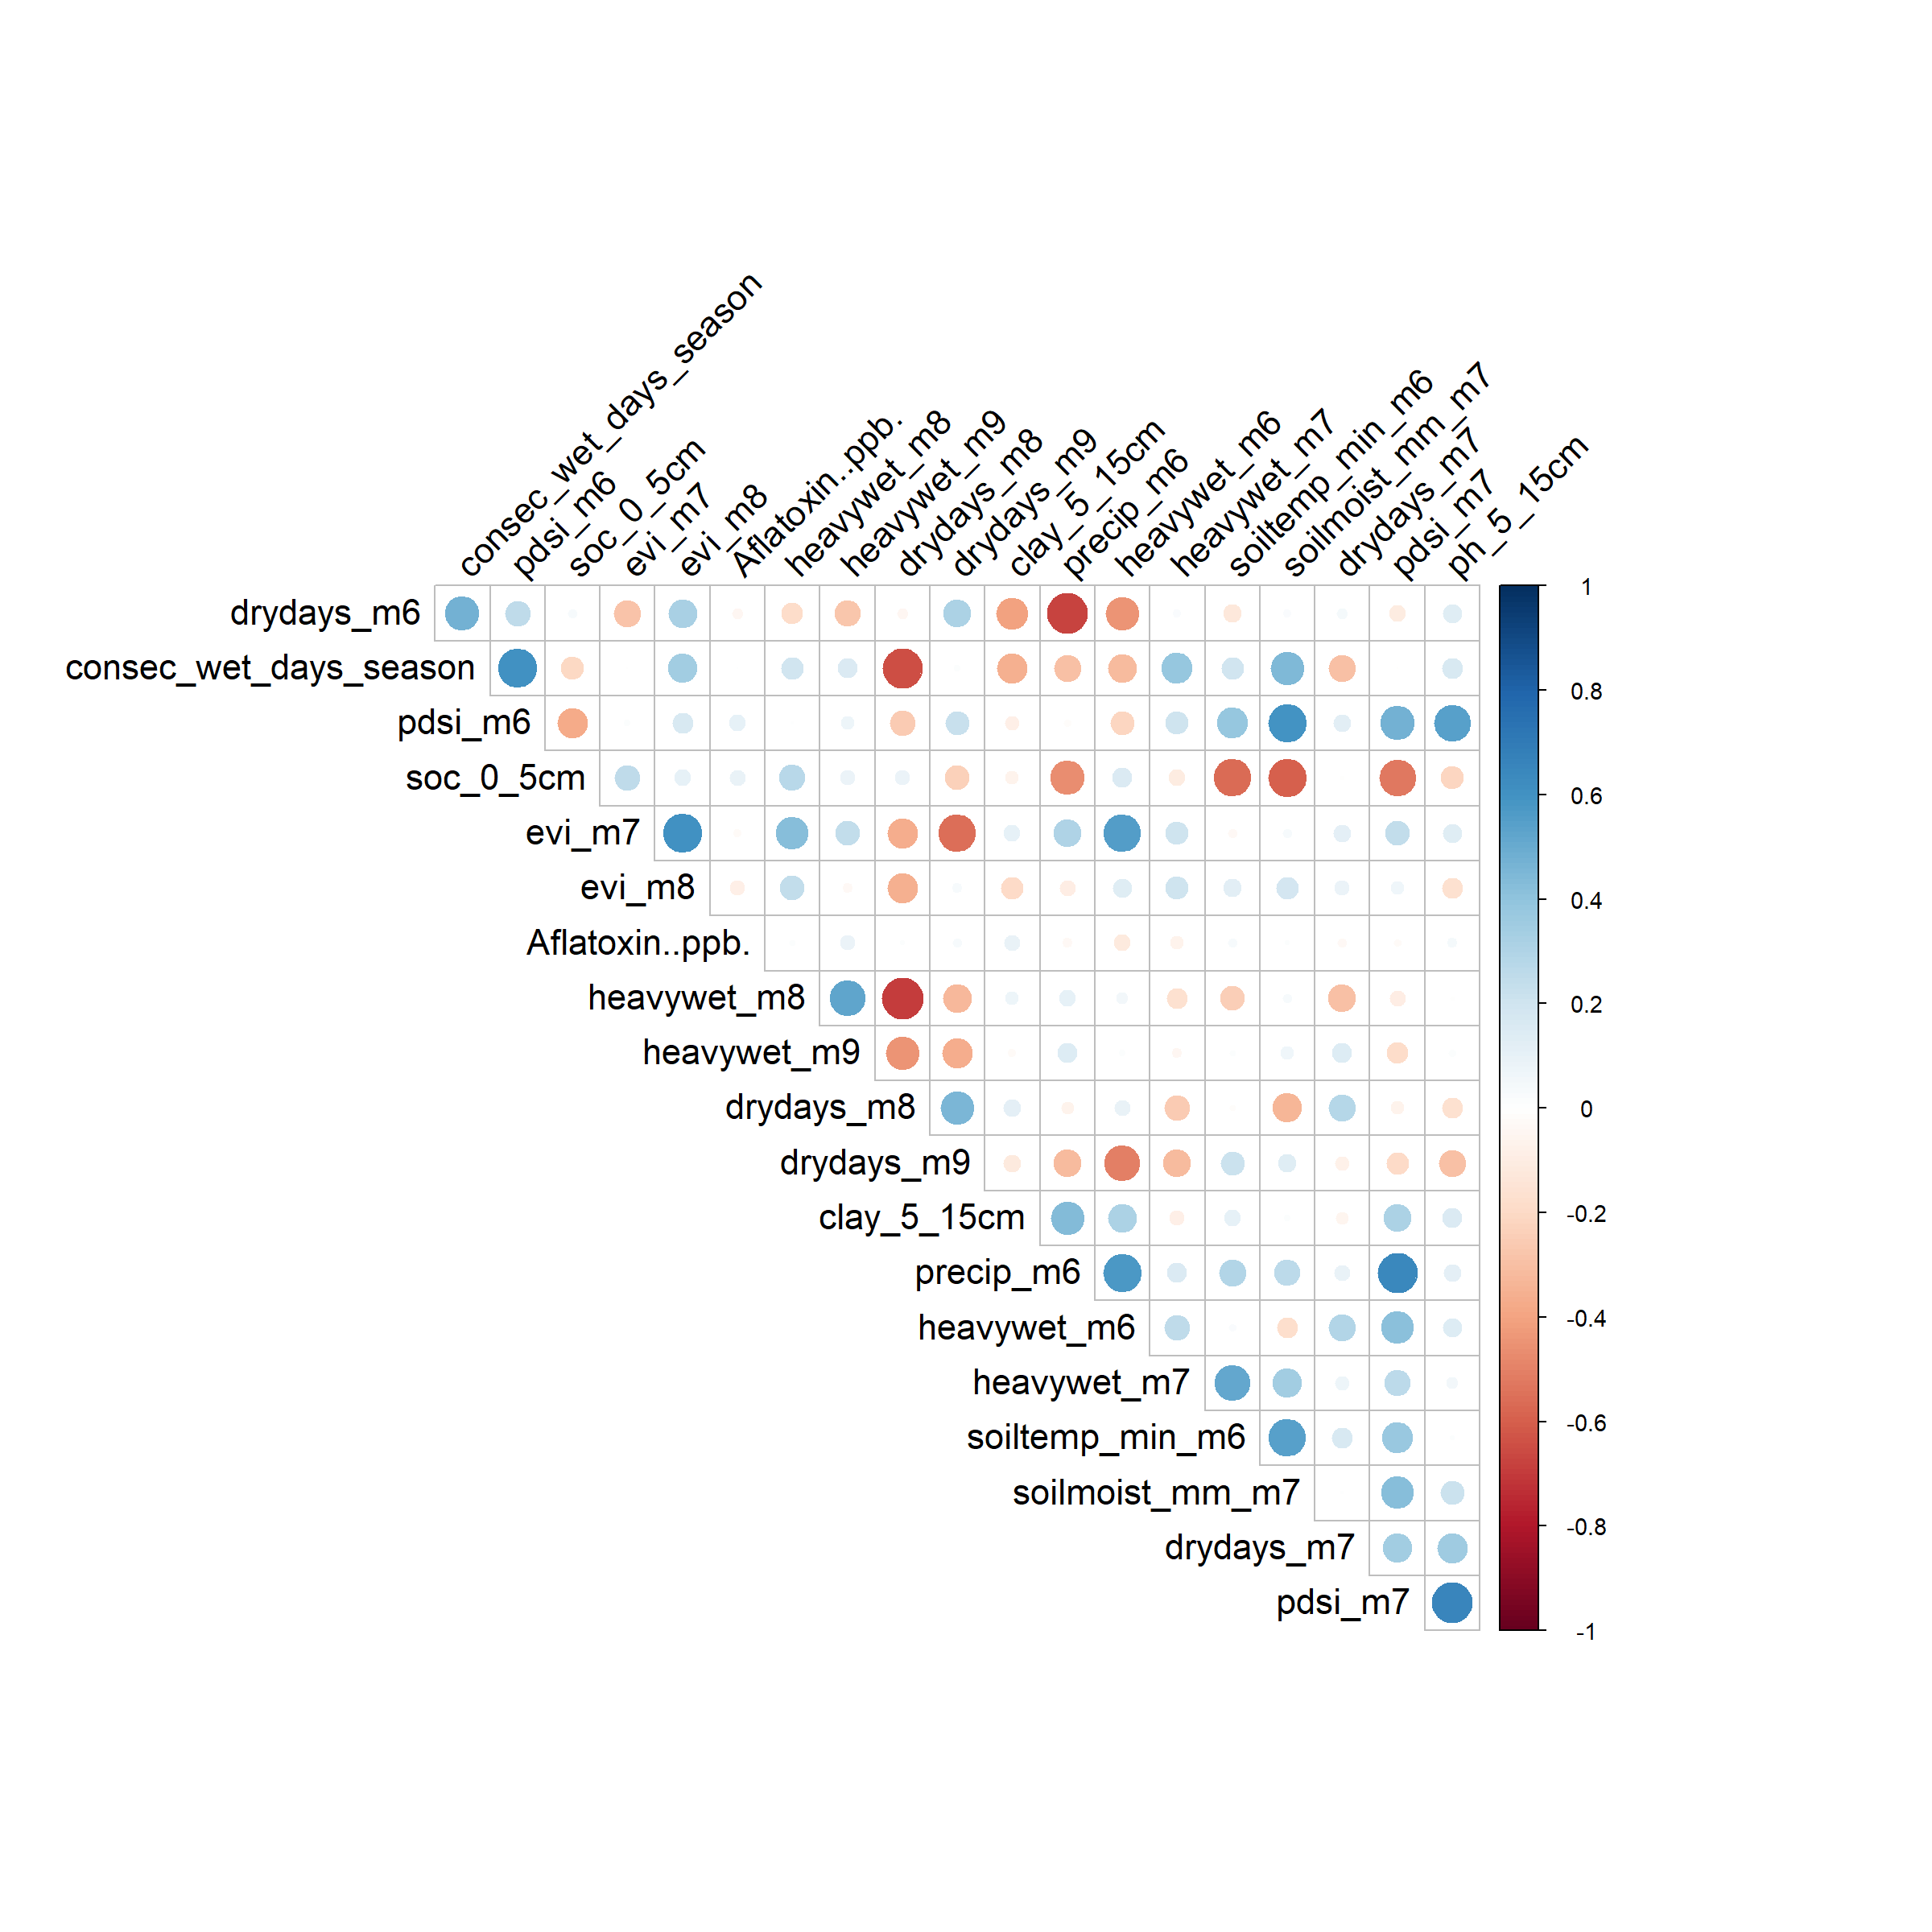
SH: 20 retained predictors, non-redundant

Strongest Correlates with Aflatoxin
Top positive correlate | r | Top negative correlate | r
clay_0_5cm | 0.195 | tmax_m8 | -0.083
elevation | 0.135 | evi_m8 | -0.084
pdsi_m6 | 0.106 | heavywet_m6 | -0.111
soc_5_15cm | 0.101 | precip_m7 | -0.112
soc_0_5cm | 0.098 | consec_dry_days_season | -0.114

Sudan Savanna
Sample size: 712 rows. Outcome variable used: Aflatoxin..ppb. Total predictors considered: 71. Flagged as redundant (cutoff = 0.7): 47. Retained: 24.

Full Correlation Matrix (Before Redundancy Removal)
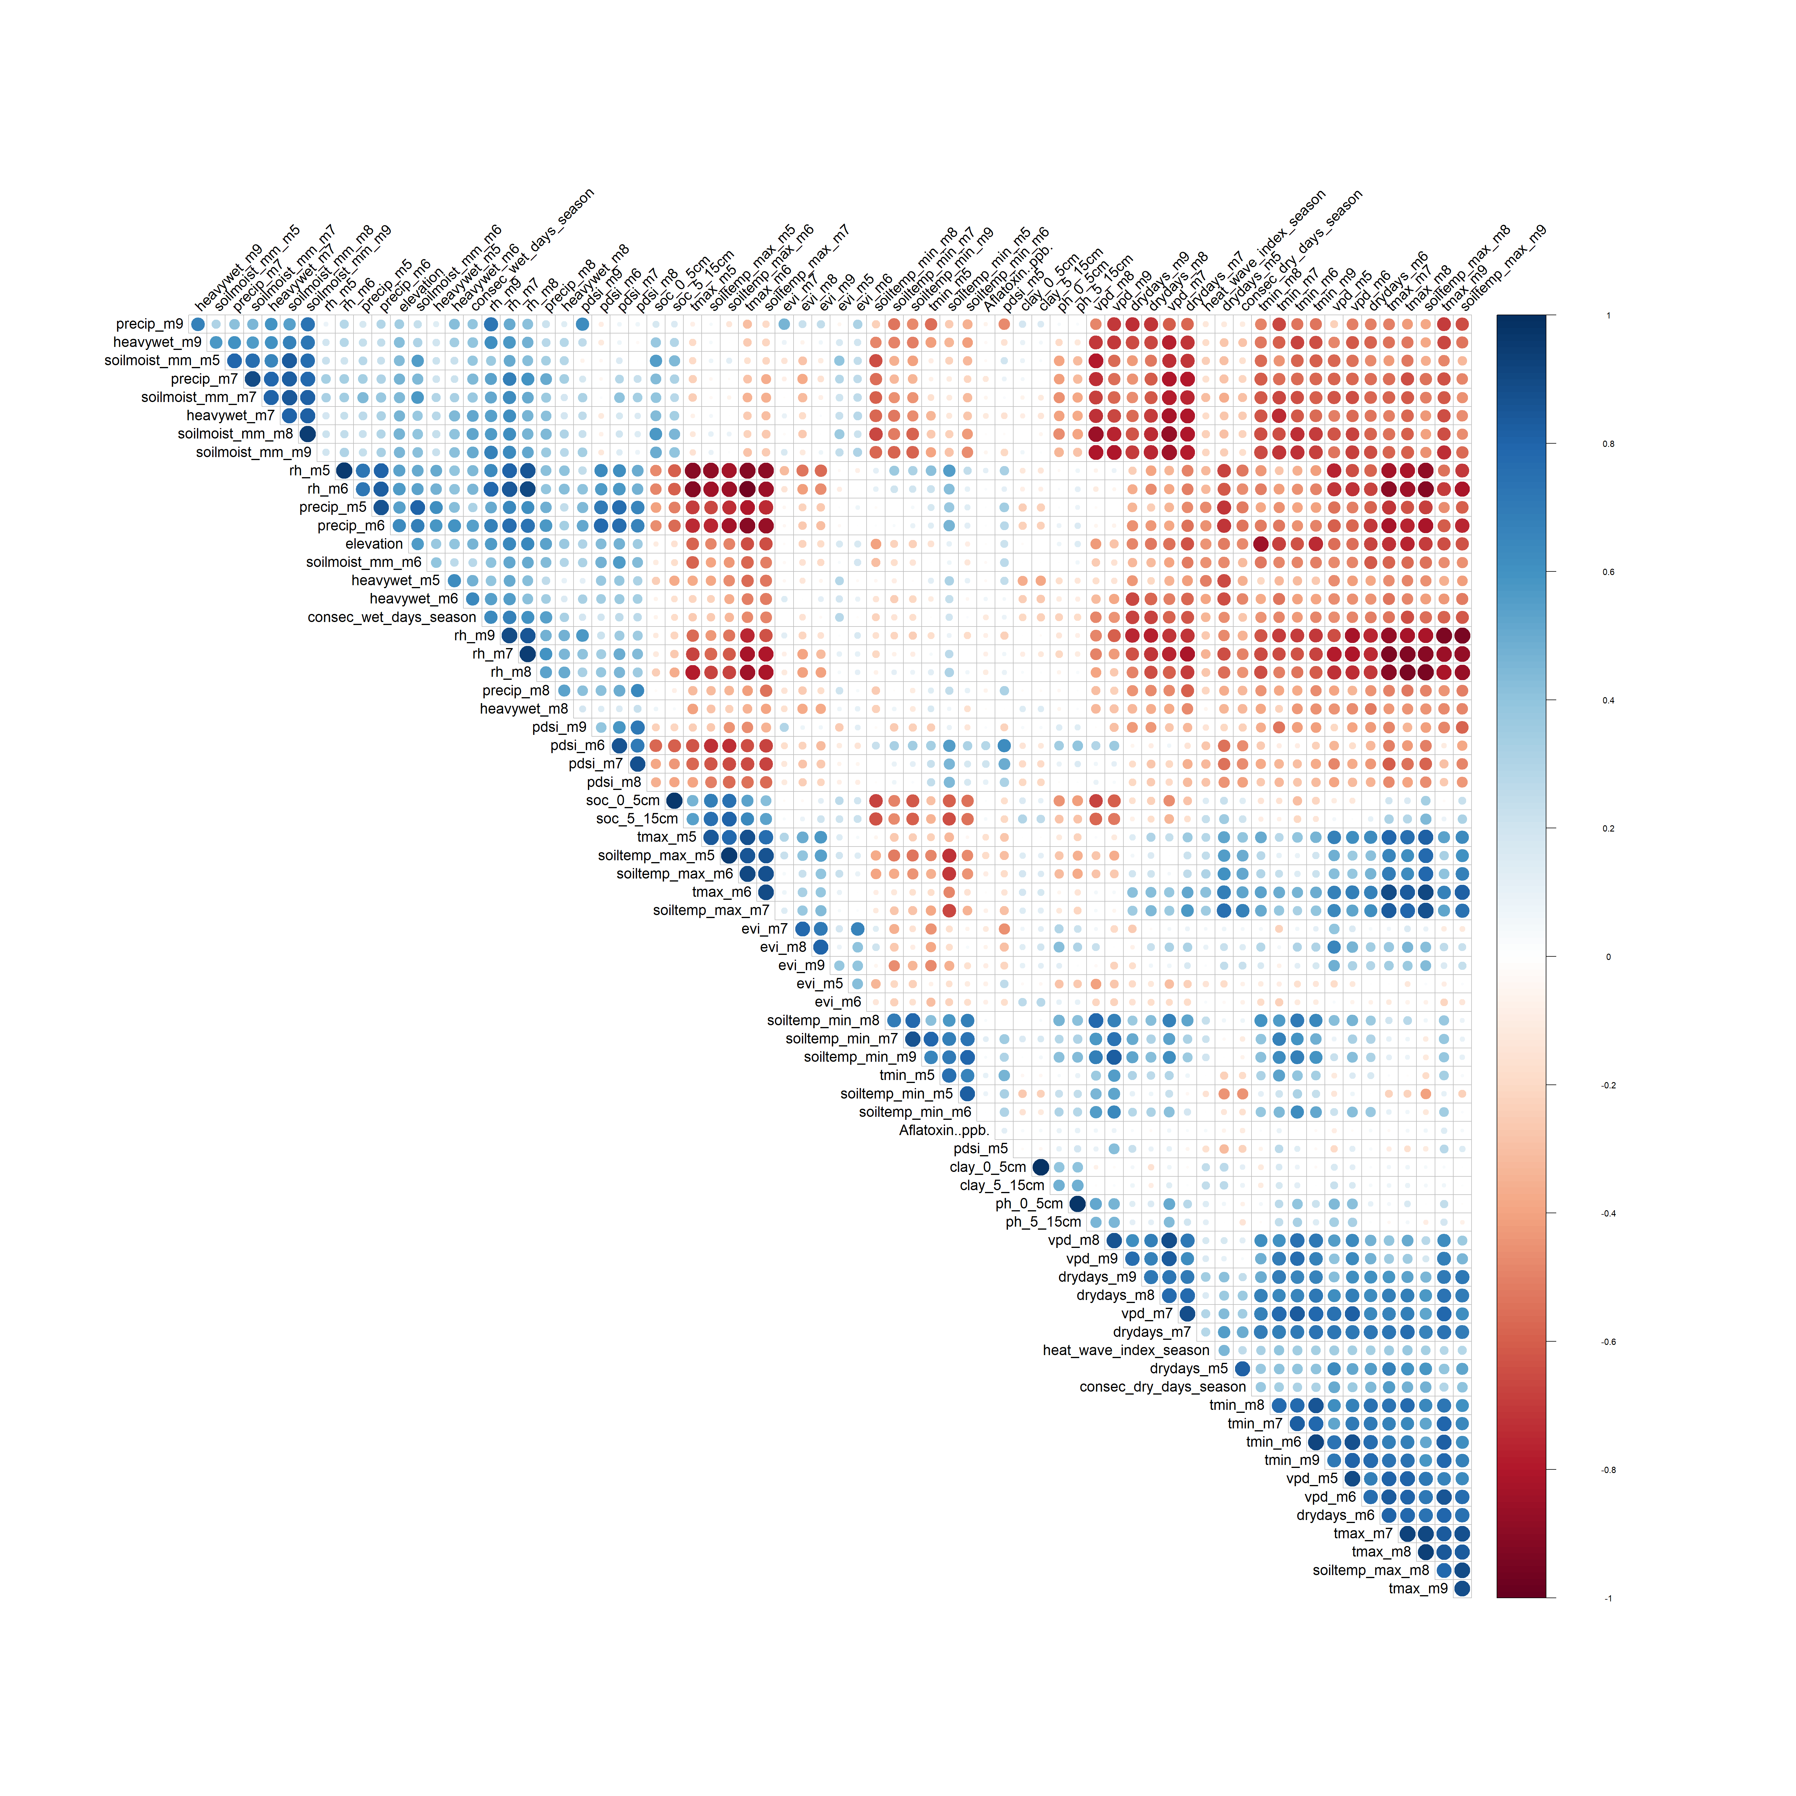
SS: all 71 predictors, hierarchically clustered

Reduced Correlation Matrix (After Redundancy Removal)
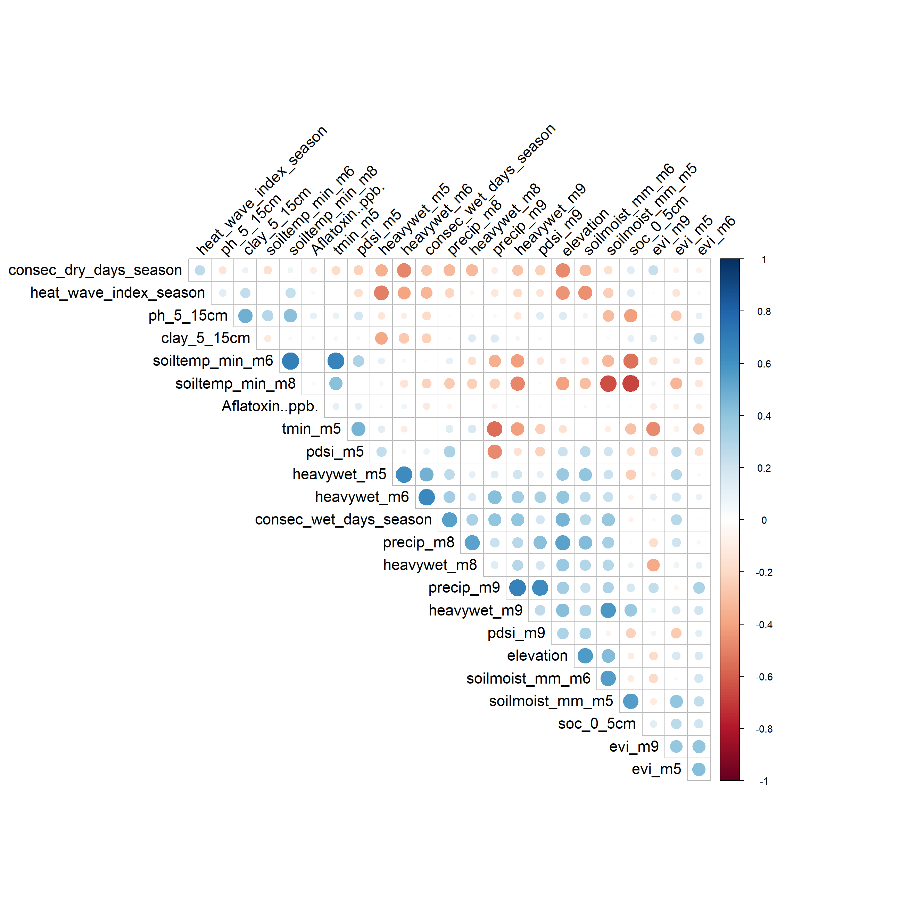
SS: 24 retained predictors

Strongest Correlates with Aflatoxin
Top positive correlate | r | Top negative correlate | r
pdsi_m6 | 0.290 | heavywet_m7 | -0.115
pdsi_m7 | 0.204 | evi_m7 | -0.116
tmax_m9 | 0.141 | precip_m7 | -0.129
soiltemp_min_m7 | 0.122 | tmax_m5 | -0.164
pdsi_m5 | 0.121 | soiltemp_max_m5 | -0.183

Northern Guinea Savanna
Sample size: 529 rows. Outcome variable used: Aflatoxin..ppb. Total predictors considered: 83. Flagged as redundant (cutoff = 0.7): 54. Retained: 29.

Full Correlation Matrix( Before Redundancy Removal)
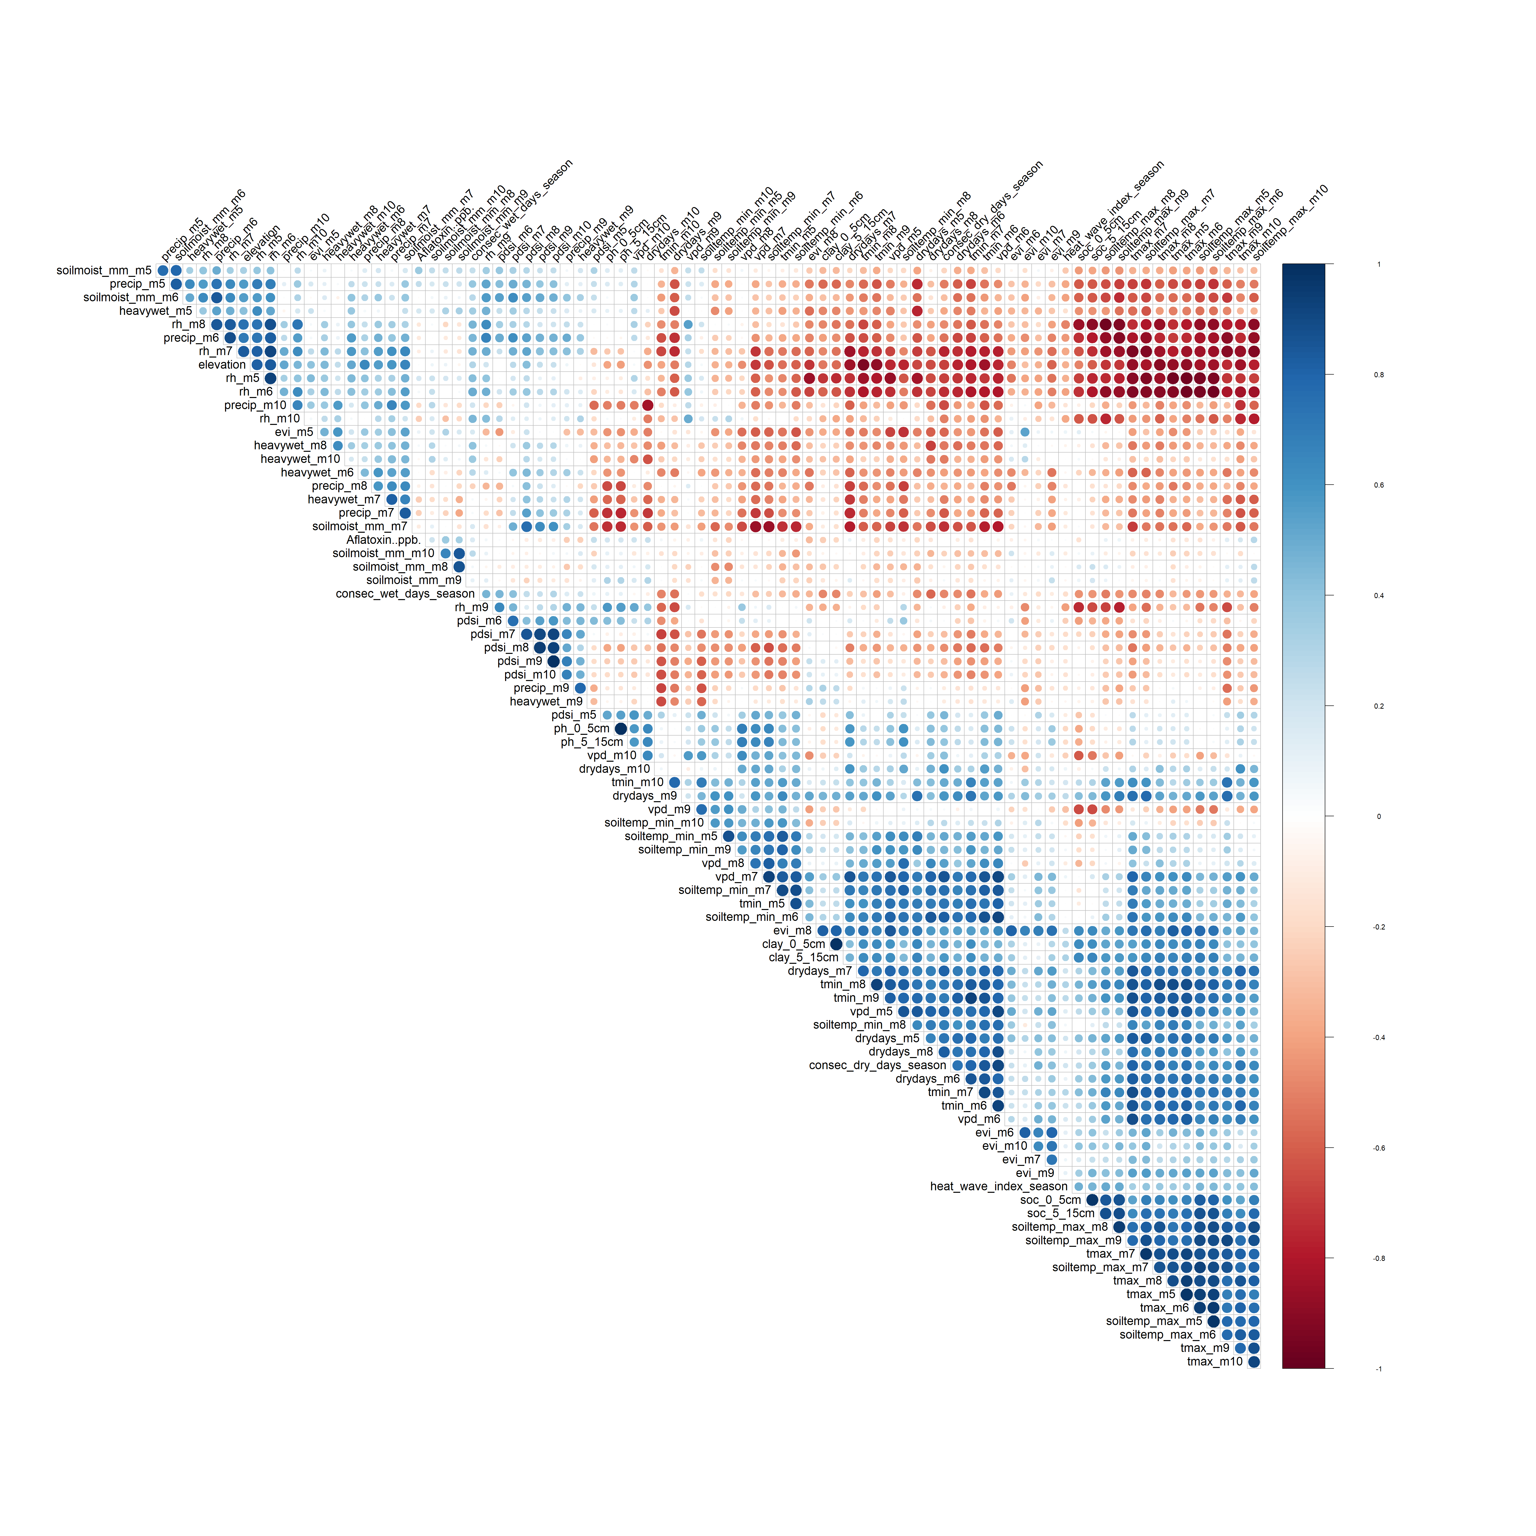
NGS: all 83 predictors, hierarchically clustered

Reduced Correlation Matrix (After Redundancy Removal)
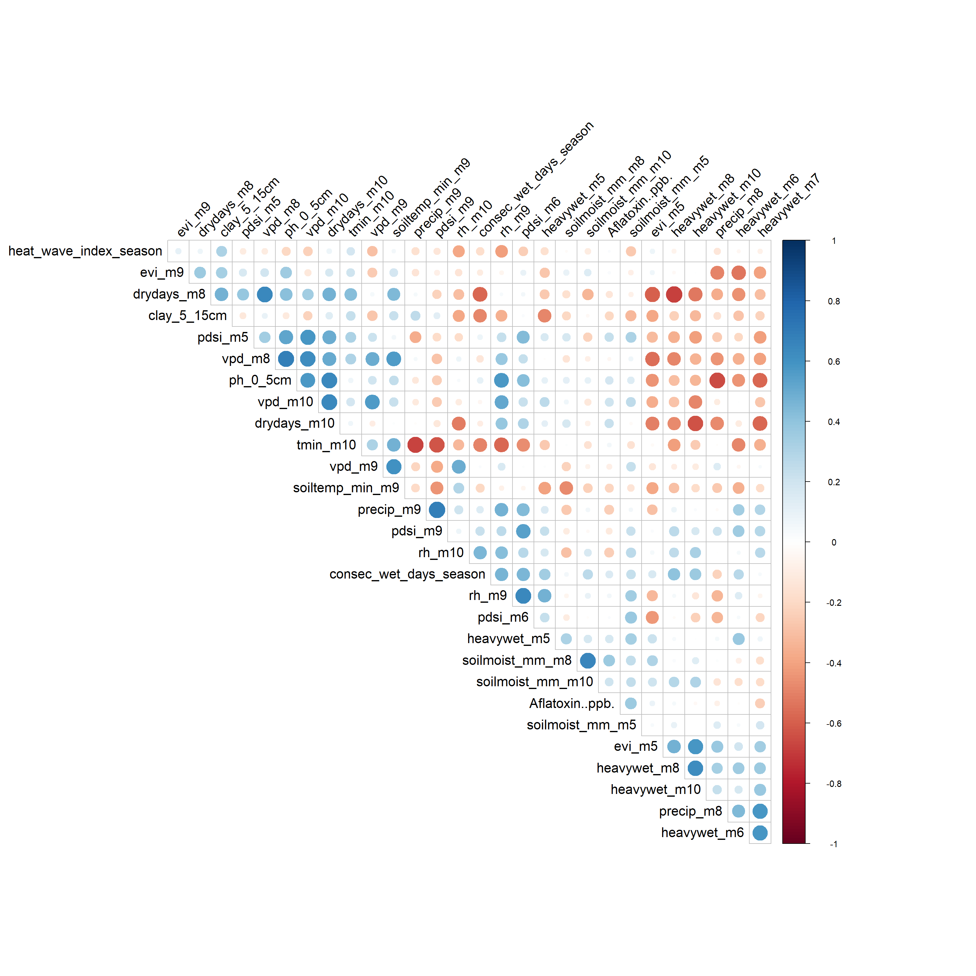
NGS: 29 retained predictors

Strongest Correlates with Aflatoxin
Top positive correlate | r | Top negative correlate | r
soilmoist_mm_m8 | 0.364 | precip_m9 | -0.248
soilmoist_mm_m5 | 0.363 | rh_m10 | -0.249
soilmoist_mm_m9 | 0.330 | heavywet_m7 | -0.249
soiltemp_max_m10 | 0.271 | clay_0_5cm | -0.250
precip_m5 | 0.242 | evi_m8 | -0.316

Southern Guinea Savanna
Sample size: 248 rows with a non-missing outcome value. Outcome variable used: Aflatoxin..ppb.. Total predictors considered: 106. Flagged as redundant (cutoff = 0.7): 76. Retained: 30.

Full Correlation Matrix (Before Redundancy Removal)

SGS: all 106 predictors, hierarchically clustered

Reduced Correlation Matrix (After Redundancy Removal)
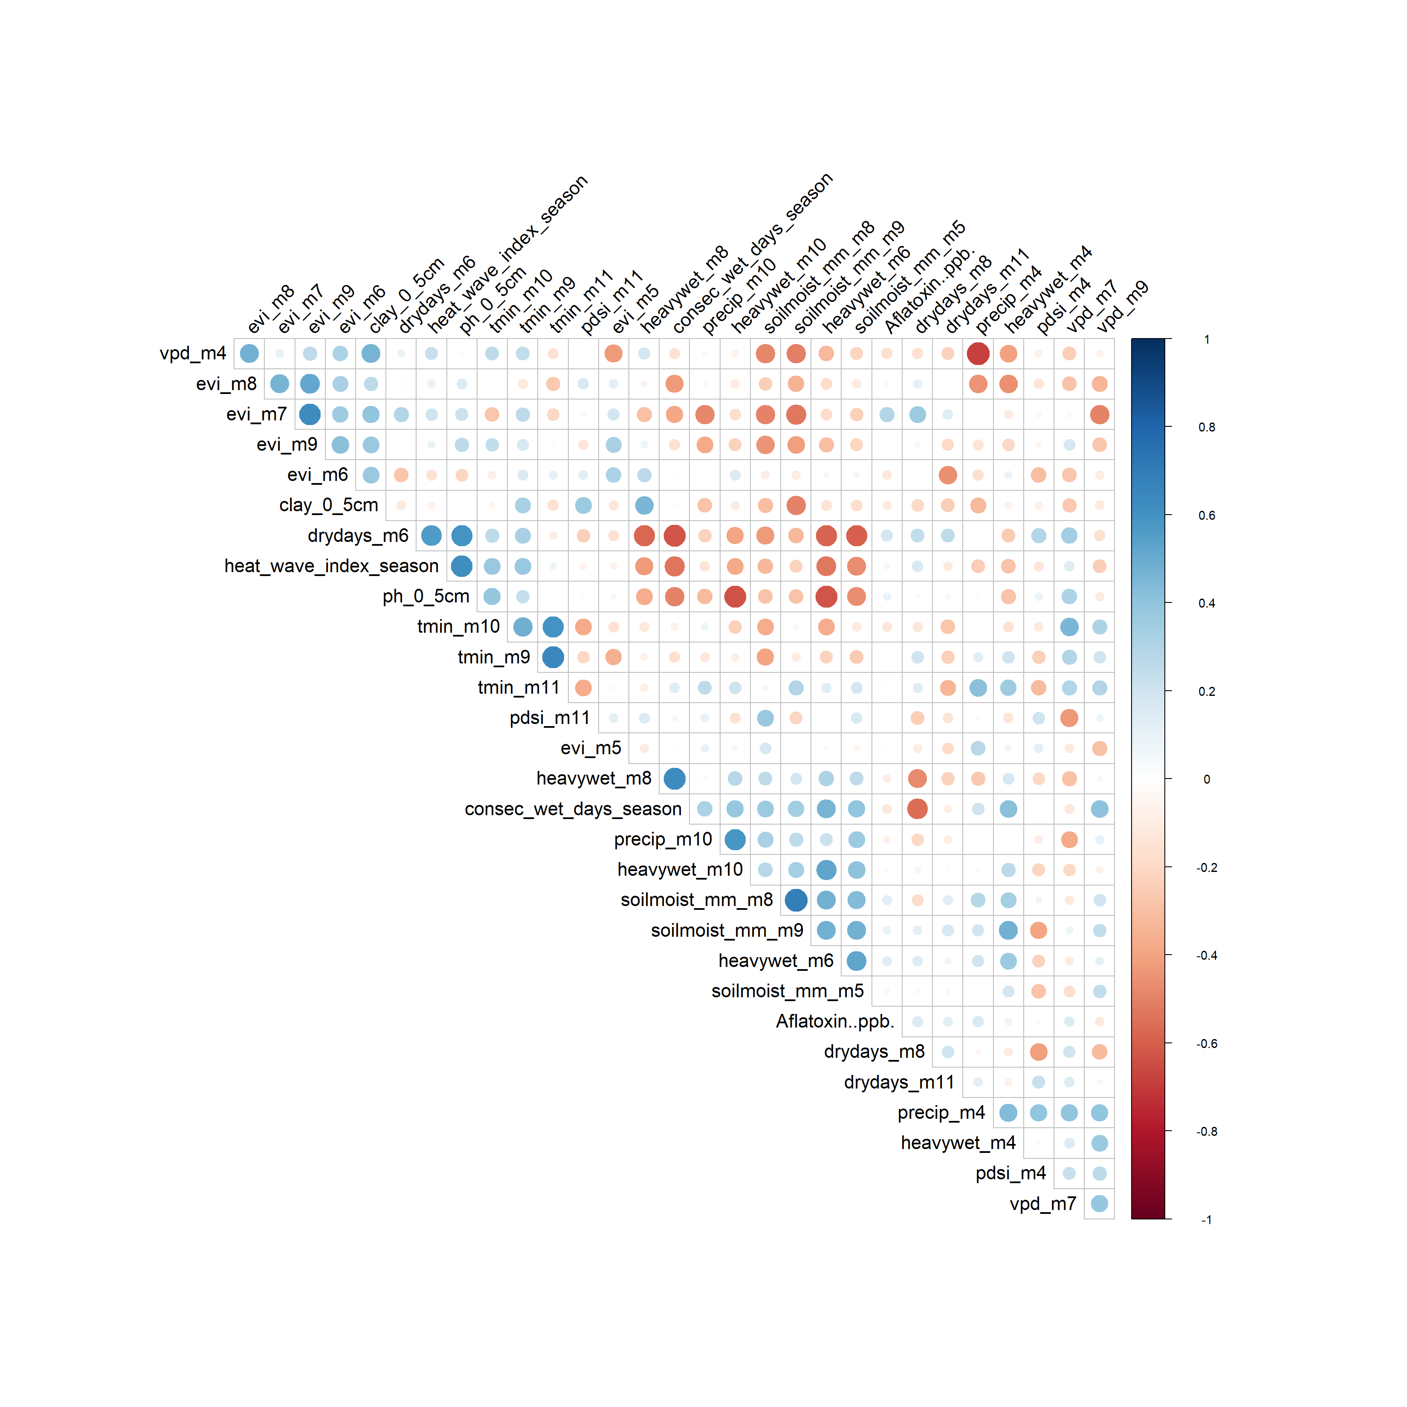
SGS: 30 retained predictors

Strongest Correlates with Aflatoxin
Top positive correlate | r | Top negative correlate | r
evi_m7 | 0.298 | tmax_m4 | -0.149
consec_dry_days_season | 0.210 | soc_0_5cm | -0.161
drydays_m7 | 0.203 | vpd_m4 | -0.162
rh_m4 | 0.201 | elevation | -0.176
vpd_m11 | 0.195 | rh_m11 | -0.189

Derived Savanna
Sample size: 249 rows with a non-missing outcome value. Outcome variable used: afl_max. Total predictors considered: 109. Flagged as redundant (cutoff = 0.7): 76. Retained: 33.

Full Correlation Matrix (Before Redundancy Removal)

DS: all 109 predictors, hierarchically clustered

Reduced Correlation Matrix (After Redundancy Removal)
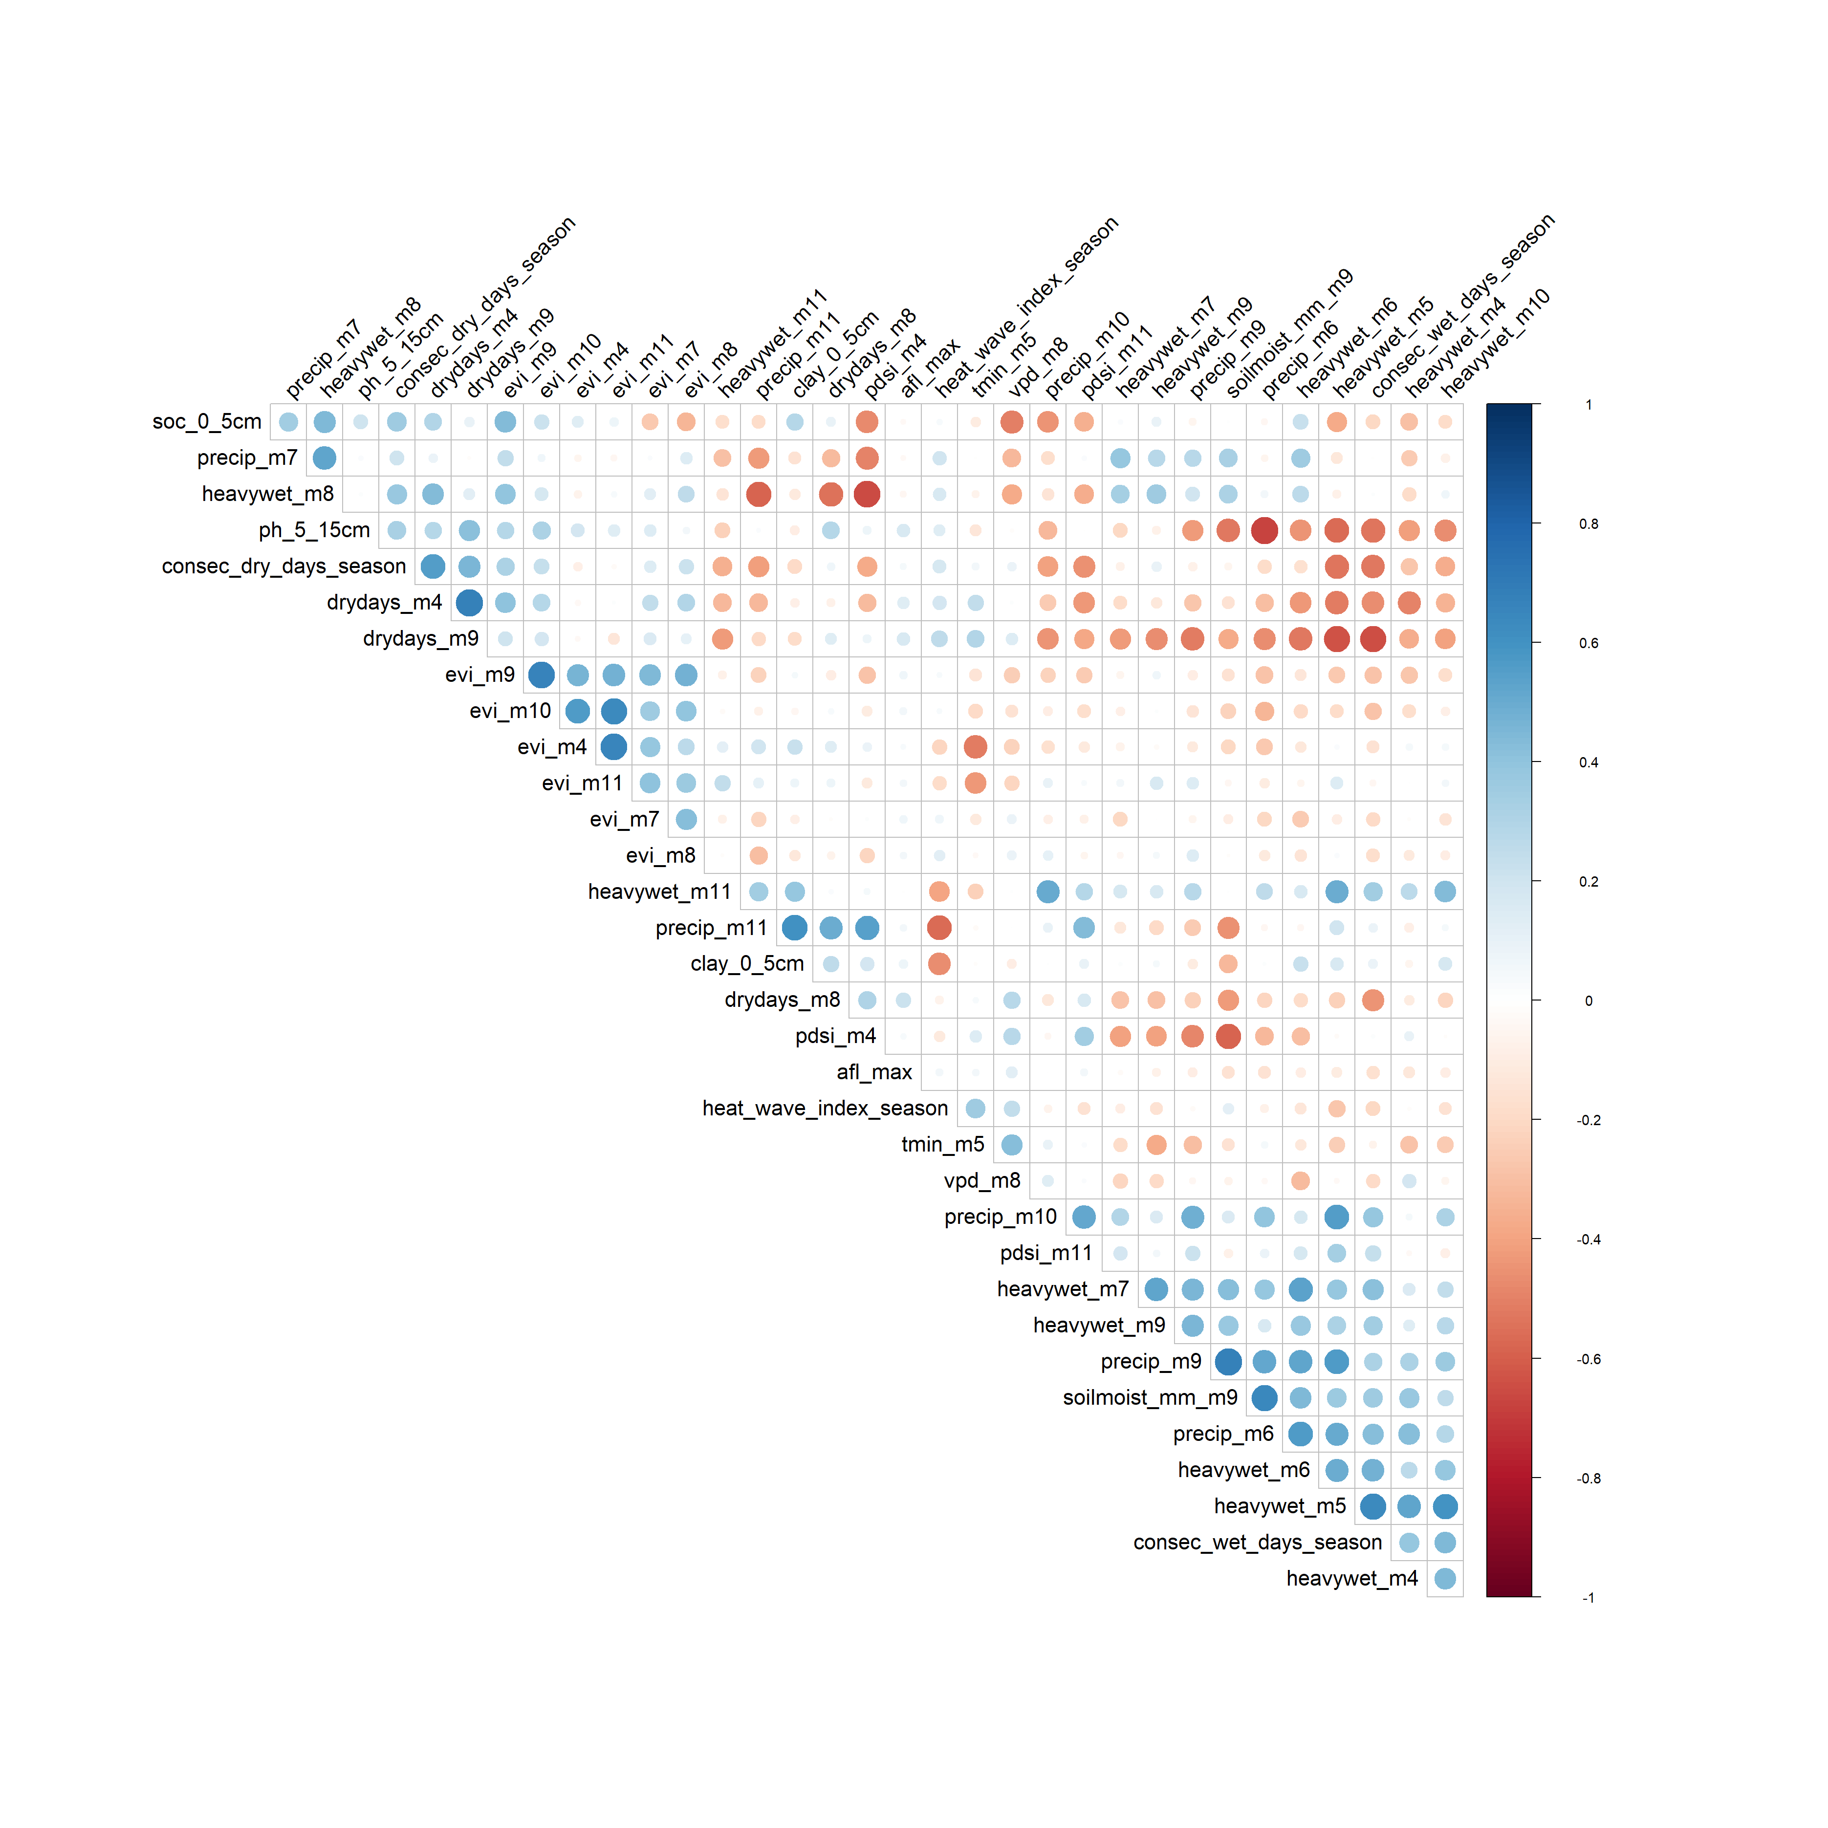
DS: 33 retained predictors

Strongest Correlates with Aflatoxin
Top positive correlate | r | Top negative correlate | r
drydays_m8 | 0.219 | soilmoist_mm_m5 | -0.167
ph_5_15cm | 0.199 | soilmoist_mm_m4 | -0.172
drydays_m7 | 0.191 | soilmoist_mm_m7 | -0.175
ph_0_5cm | 0.190 | soilmoist_mm_m8 | -0.177
drydays_m6 | 0.184 | soilmoist_mm_m6 | -0.182

Humid Forest
Sample size: 220 rows with a non-missing outcome value. Outcome variable used: afl_max. Total predictors considered: 131. Flagged as redundant (cutoff = 0.7): 99. Retained: 32.

Full Correlation Matrix (Before Redundancy Removal)

HF: all 131 predictors, hierarchically clustered

Reduced Correlation Matrix (After Redundancy Removal)
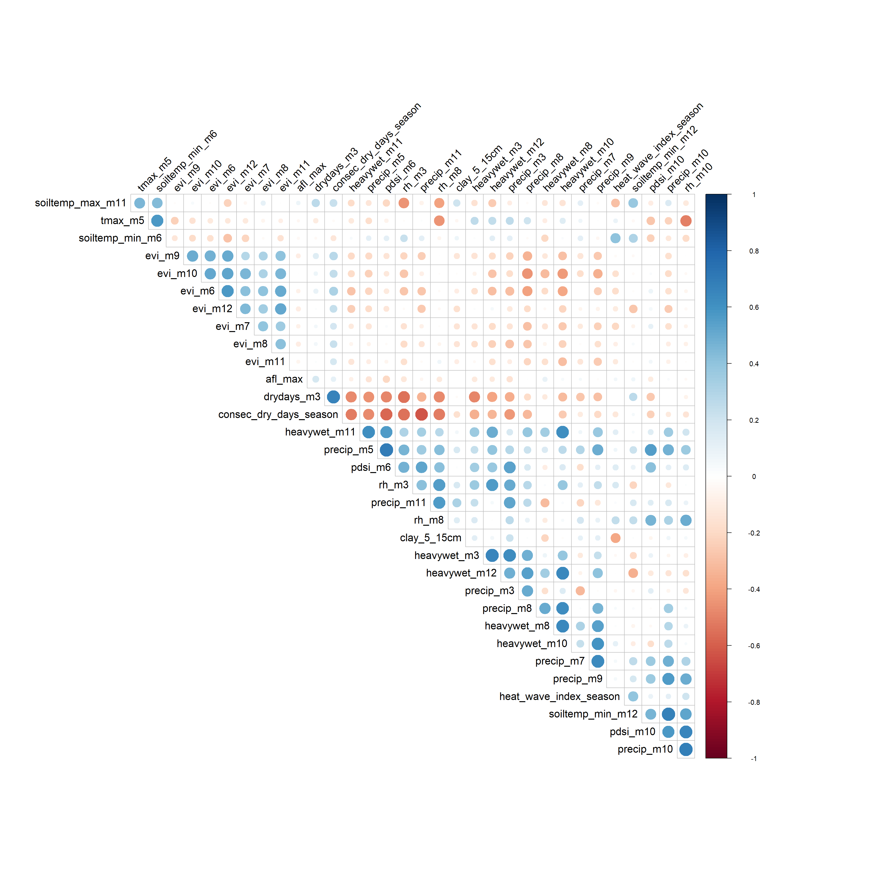
HF: 32 retained predictors

Strongest Correlates with Aflatoxin
Top positive correlate | r | Top negative correlate | r
drydays_m3 | 0.165 | pdsi_m12 | -0.168
soilmoist_mm_m9 | 0.128 | pdsi_m7 | -0.170
soilmoist_mm_m10 | 0.128 | pdsi_m5 | -0.170
tmax_m12 | 0.122 | pdsi_m9 | -0.205
soilmoist_mm_m8 | 0.121 | pdsi_m8 | -0.228

4. Cross-AEZ Summary
AEZ | Outcome used | n | Strongest correlate | Redundant vars removed
SH | Aflatoxin..ppb. | 277 | clay_0_5cm (0.195) | 38 of 58
SS | Aflatoxin..ppb. | 712 | pdsi_m6 (0.290) | 47 of 71
NGS | Aflatoxin..ppb. | 529 | soilmoist_mm_m8 (0.364) | 54 of 83
SGS | Aflatoxin..ppb. | 248 | evi_m7 (0.298) | 76 of 106
DS | afl_max | 249 | drydays_m8 (0.219) | 76 of 109
HF | afl_max | 220 | drydays_m3 (0.165) | 99 of 131

