An Unique Toy for Language Learning using Camera based Image Processing Technology

(Interface Document)
May-2012

Version 2.00

Prepared By: Swapnil Belhe
Atish Vaze

Centre for Development of Advanced Computing
Graphics and Intelligence based Script Technology Group, Pune
Revision History
Version | Date of Release | By | Pages Affected | Reasons for Change
Version 1.00 | 11 May 2012 | Swapnil B., Atish V., Chetan P. | All | First draft version of document
Version 2.00 | 15 June 2012 | Swapnil B., Atish V., Chetan P. | 6,7,8,9,11 | Added a new function fn_InitEngine(), fn_RecognizeChar returns pointer to the structure g_OCRCharInfo ,  fn_EngineVersionInfo returns char pointer and takes void input,added entry of fn_InitEngine in Interface summary,added fn_InitEngine to flow of function calls, changed the datatype of the g_UnicodeChars to wchar_t of g_OCRCharInfo Structure

Table of Contents
1.0 Background 4
2.0 Purpose 4
3.0 Scope 4
4.0 Constraints 4
5.0 Abbreviations and Acronyms 4
6.0 Interface Specifications 5
6.1 Interfaces 6
6.1.1 Initialize Engine Parameters 6
6.1.2 Camera Calibration 6
6.1.3 Recognition 7
6.1.4 Free Engine Parameters 8
6.1.5 Get Engine Version Information 8
6.2 Interfaces Summary 9
7.0 Flow of Function calls 9
8.0 Requirement Specifications 10
8.1 Input Specifications 10
8.2 Output Specifications 10
8.3 Functional Specifications 10
8.4 Input Device Specifications 10
8.5 Environment Requirements 10
9.0 Annexure-I Structures and Headers 11
9.1 g_OCRCharInfo 11
9.2 Resolution 11
10.0 Annexure-II Directory structure for Recognition Engine 12

Background
A unique toy for teaching Indian languages is being developed by IDC, Mumbai. The toy uses camera based image processing technologies to recognize different shapes, characters, numbers etc. These image processing algorithms are required to have robustness under various conditions like changes in illumination, shape, shadows, color, tilt etc. Also, the algorithms should be closely tied with the functioning of the proposed toy. In this document these image processing algorithms are combinedly called as Recognition Engine. CDAC, Pune is developing the above Image processing algorithms and developing the common interfaces. The common interfaces will allow easiness in interfacing any other algorithms with the proposed toy. CDAC-Pune will maintain and upgrade the interfaces as and when required.

Purpose
This document provides description of all the interfaces required for recognition engine(s). The purpose of this document is to provide clear idea about the exported API’s and their adoption by applications developers.

Scope
This documents deals with different interface APIs and structures required for interfacing recognition engine with the Toy Application. However, this document does not include the internals of the recognition engine and its functionality. This document is meant to be used by application and GUI developers.

Constraints
The given interfaces are intended to work for Windows based 32/64 bit system.

Abbreviations and Acronyms

OCR | : | Optical Character Recognition
API | : | Application Program Interface
GIST | : | Graphics and Intelligence based Script Technology, Pune
IDC | : | Industrial Design Center, Mumbai

Interface Specifications
There are 3 main components in the proposed toy,
- Application/GUI Front End
- Recognition Engine
- Physical Hardware and Toy design
This section describes the interface connections between application/GUI and recognition engine
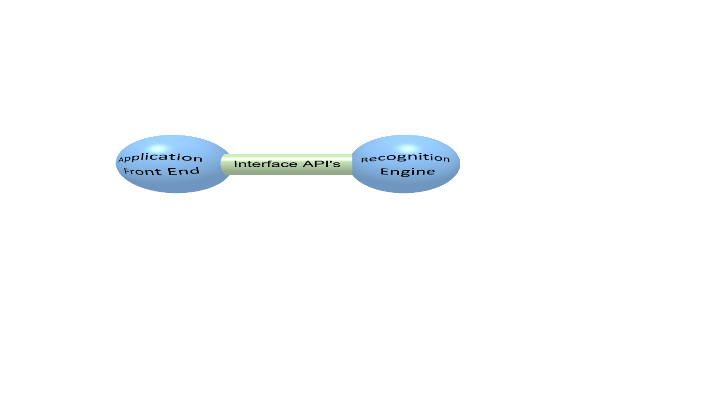

Interface Flow diagram
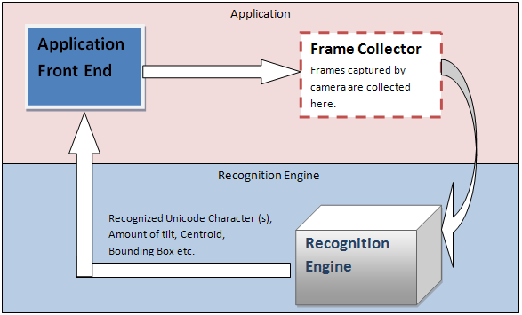
Figure 1: Interface Flow Diagram

  - Interfaces
Following section highlights the main interfaces. The input, output parameters/structures used by these interfaces can be found in Annexure-I (structures and headers).

    - Initialize Engine Parameters
It is used to load all the files which are required for the execution of the engine.

Method Summary: -

fn_InitEngine(void)

Input: void

Returns: returns void
Prototype:
void fn_InitEngine (void);

    - Camera Calibration
It is used to calibrate the camera settings.

Method Summary: -

fn_CaliberateCamera()

Input: 1. Frame captured by the camera IplImage* inputImage. (OpenCV)

2. Resolution of the camera g_Resolution

3. Resolution of the screen g_Resolution

Returns: returns integer
0 : if camera is calibrated correctly
< 0 : if camera is not calibrated correctly

Prototype:
int fn_CaliberateCamera (IplImage* inputImage, g_Resolution cameraReso, g_Resolution screenReso);

    - Recognition
This function will take camera captured image as an input (given by OpenCV interface) and depending upon the flag fAlphaNumeral value, will either return the array of recognized characters with their position information or return array of two numerals with their position information.

Method Summary: -
fn_RecognizeChars()

Input: 1. Frame captured by the camera IplImage* inputImage.
2. Flag indicating whether root characters or Numerals are to be recognized int fAlphaNumeral
0 = Alphabets
1 = Numerals

Returns: 1) A pointer to structure g_OCRCharInfo which gives recognized characters with their arrays of centroids, inclined angles and Bounding Box information.

OCRCharInfo structure given in Annexure – I contains all the return parameters of the recognition engine. At present it is assumed that there will be MAXIMUM SIX shapes (cut outs of characters/numerals) placed on toy. This number can be changed by modifying APP_MAX_SHAPES macro.
g_UnicodeChars[6] contains Unicodes for 6 different shapes.
For Example, for a shape/cut-out of क्ष (ka + halant + Ssa), recognition engine will output क्ष.
Bounding Box:
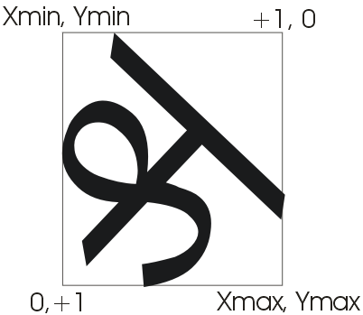

Angle (approximate +/- 10 degrees):

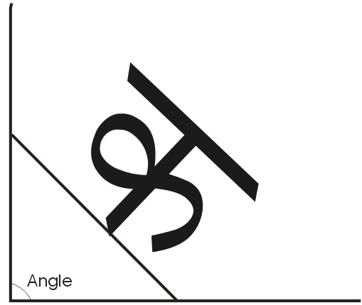

Prototype:
g_OCRCharInfo* fn_RecognizeChars(IplImage* inputImage, int alphaNumeralFlag)

    - Free Engine Parameters

This API is used to free the engine allocated resources. Otherwise, engine has no way of knowing different instances of call and may crash.
Method Summary: This function call takes void. It is used as a signal to the engine to free all the internally allocated resources like memory, file handles etc.
fn_FreeEngine();
Input: None

Returns: void

Prototype:
void fn_FreeEngine(void);

    - Get Engine Version Information

Note that engine version and dll versions may be different.
Method Summary: This Function will be called to know the version of the engine.
fn_EngineVersionInfo()
Input: void.

Output: char pointer to version information string.

Prototype:
char* fn_EngineVersionInfo();

  - Interfaces Summary

Interface Name | Function names | Prototype
Engine Initialization | fn_InitEngine() | void fn_InitEngine ();
Camera  Calibration | fn_CaliberateCamera() | int fn_CaliberateCamera (IplImage* inputImage, g_Resolution cameraReso,g_Resolution screenReso);
Recognition | fn_RecognizeChars() | g_OCRCharInfo * fn_RecognizeChars(IplImage* inputImage, int alphaNumeralFlag)
Free Engine Parameters | fn_FreeEngine() | void fn_FreeEngine(void);
Engine Version Info | fn_EngineVersionInfo() | char* fn_EngineVersionInfo(void);
Figure 2: Interface Summary diagram

Flow of Function calls
- fn_CameraCaliberation()
- fn_InitEngine():Used for initialization of Engine resources.
- fn_RecognizeChars(): Once the Engine resources are successfully initialized call this function after frames are captured by camera .
- fn_FreeEngine(): Once the Recognition job is completed

Requirement Specifications

  - Input Specifications
- Images captured by the camera.

  - Output Specifications
- Unicode Hex values of recognized characters.
- Bounding box parameters
- Angle or tilt of shape
- Centroid of shape

  - Functional Specifications
- Generating log files to keep track of bugs.
- Timing log

  - Input Device Specifications
  - Frame rate:30 frames/sec (maximum)

  - Environment Requirements
- CPU: 1 GHz or more
- Recommended RAM: 100 MB
- Operating System: Windows XP and above
- Hard Disk Space: 200MB

Annexure-I Structures and Headers

#define APP_MAX_SHAPES 6 //Maximum allowed cut-outs/shapes placed on toy

g_OCRCharInfo

This structure is used to save recognized character information.
typedef struct g_OCRCharInfo_Struct
{
float g_Angle[APP_MAX_SHAPES ];//Angle or tilt
g_BoundingBox boundingBoxes[APP_MAX_SHAPES];
//Bounding box around the shape of char/numeral
wchar_t g_UnicodeChars[APP_MAX_SHAPES];
//Array of Unicode chars
g_Centroid centroids[APP_MAX_SHAPES]; // Centroid of each character
} g_OCRCharInfo;

typedef struct g_BoundingBox_Struct
{
unsigned int minX;
unsigned int minY;
unsigned int maxX;
unsigned int maxY;
} g_BoundingBox;

typedef struct g_Centroid_Struct
{
unsigned int x;
unsigned int y;
} g_Centroid;

Resolution

typedef struct g_Resolution_Struct
{
unsigned int width;
unsigned int height;
} g_Resolution;

Annexure-II Directory structure for Recognition Engine
The recognition DLL’s, Log files will be read and written to from this directory.
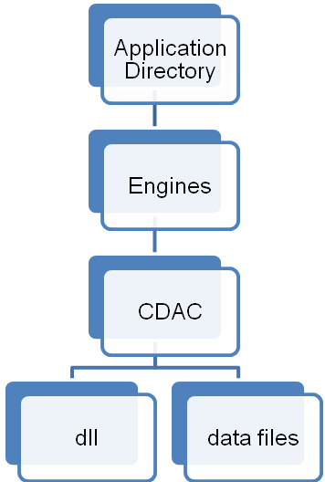
Figure 3: Directory structure of OCR Toy application

