Introduction to Parallel

Scientific Computing

Homework 5

**Loukik Kalbande**

*ME21BTECH11028*

March 29, 2025

Q1 - a

For Parallel, p=2x2 (on left) and Serial (on right):

|  |  |
| --- | --- |
|  |  |
|  |  |

|  |  |
| --- | --- |
|  |  |

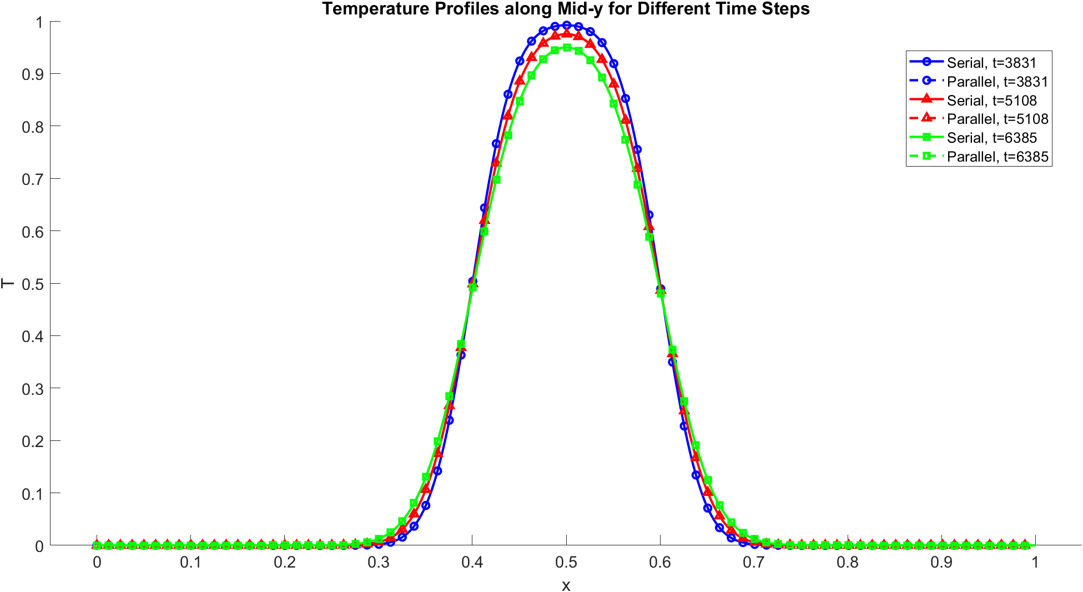

For Parallel, p=2x2 (on left) and Serial (on right):

|  |  |
| --- | --- |
|  |  |
|  |  |
|  |  |



|  |  |
| --- | --- |
|  |  |
|  |  |
|  |  |

For Parallel, p=4x4 (on left) and Serial (on right):



Q1 – b

The tabulation for the difference between serial and parallel at end of 10-timesteps:

|  |  |
| --- | --- |
| Type | Value |
| Maximum Difference | 0.00000000000000000000e + 00 |
| Minimum Difference | 0.00000000000000000000e + 00 |
| Average Difference | 0.00000000000000000000e + 00 |

For all processor distribution: p=2x2, p=2x4 and p=4x4, same result is observed. This shows that the difference is below machine precision.

Q1 – c

The time taken for serial and parallel run per time step:

|  |  |
| --- | --- |
| Processor distribution | Time Taken per time step (s) |
| P = 2x2 | 0.002286 |
| P = 2x4 | 0.001678 |
| P = 4x4 | 0.000962 |
| Serial | 0.005592 |