Autonomous Navigation of TurtleBot3 using Custom Planning and Control (ROS2 + Gazebo + Real Robot)

1. Introduction
Autonomous navigation is a fundamental problem in robotics involving perception, mapping, planning, and control. This project presents the design and implementation of a complete navigation pipeline using ROS2, developed and tested in simulation (Gazebo) and deployed on a real TurtleBot3 platform.
The system integrates:
- SLAM-based mapping
- Custom path planning (A* and GVD-based)
- Path tracking with control and obstacle avoidance
- Localization using AMCL
The goal of this project is to build a modular, extensible navigation framework and analyze the performance of different planning and control strategies.

2. System Overview
The navigation pipeline follows a structured flow:
SLAM → Map → Planner → Path → Controller → Robot Motion

Key Components
Module | Function
SLAM | Generates occupancy grid map
Map Server | Stores and serves map
Planner Server | Computes path (A*, GVD)
Path Follower | Tracks path and avoids obstacles
AMCL | Localization (real robot)
RViz | Visualization

3. Mapping (Week 1)

Objective

To generate a 2D occupancy grid map using LiDAR data.

Methodology
- The TurtleBot3 was manually controlled using keyboard teleoperation and the recorded data was stored as a occupancy grisd as shown in fig 3.1
- A python script was used to generate a configuration space over the occupancy grid as sgown in fig 3.2
- SLAM Toolbox was used in asynchronous mode to build the map in real time. Fig 3.1
- RViz was used to visualize:
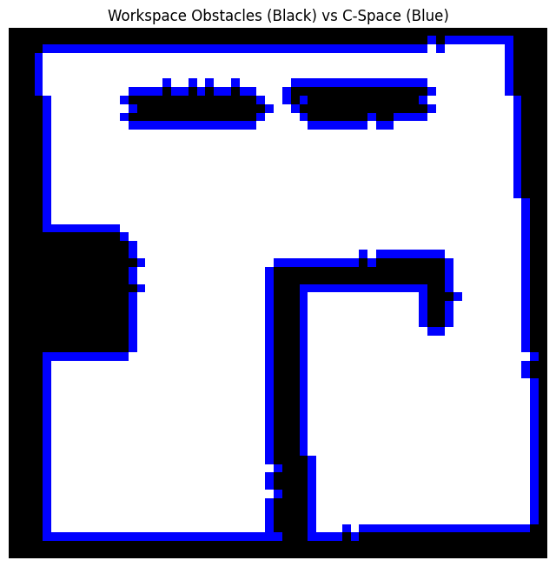
  - Laser scans
  - Occupancy grid
  - Robot pose

Outcome
A map was successfully generated and saved as:
- .pgm (image representation)
- .yaml (metadata and resolution) Fig3.2

4. Path Planning (Week 2)

Objective
To design and implement custom path planning algorithms.

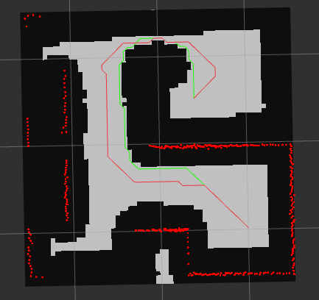
4.1 A Planner*
A grid-based A* algorithm was implemented with:
- 8-connected motion model
- Euclidean / manhattan distance
based Cost function defination

Characteristics
- Finds shortest path
- Efficient computation Fig: 4.1 Path A* : Green , Path GVD: Red
- May pass close to obstacles

4.2 GVD-Based Planning
To improve safety, a clearance-aware planner was implemented using:

Brushfire Algorithm
- Computes distance of each cell from nearest obstacle
- Produces a clearance map

Modified A*
- Adds penalty for low-clearance regions
- Encourages paths away from obstacles

Characteristics
- Safer paths
- Slightly longer paths
- More robust in cluttered environments

4.3 Planner Server Architecture
The planner:
- Subscribes to /map
- Converts world → grid coordinates
- Computes path once
- Publishes:
  - /planned_path_astar
  - /planned_path_gvd
It also republishes paths periodically to support late subscribers.

5. Path Following (Control)

5.1 A-Based Path Follower*
A hybrid control strategy was implemented combining:

(a) Lookahead-Based Tracking
- Selects a target point ahead of current position
- Prevents oscillations and improves smoothness

(b) PID Control
Controls angular velocity based on heading error:
- Proportional: corrects deviation
- Integral: compensates bias
- Derivative: adds damping

(c) Obstacle Avoidance (Reactive)
A 3-zone safety model using LiDAR:
- STOP zone → immediate halt
- SLOW zone → reduced speed
- WARN zone → gradual slowdown
Additionally:
- Side-wall repulsion prevents collision in narrow corridors

5.2 GVD Path Follower
A simpler control strategy:
- Rotate to align with waypoint
- Move forward
- Repeat

Characteristics
- Stable but less smooth
- Relies on planner for safety

6. Localization (Week 3)

Objective
To estimate robot pose on real hardware.

Method
- AMCL (Adaptive Monte Carlo Localization) was used
- Inputs:
  - Laser scan
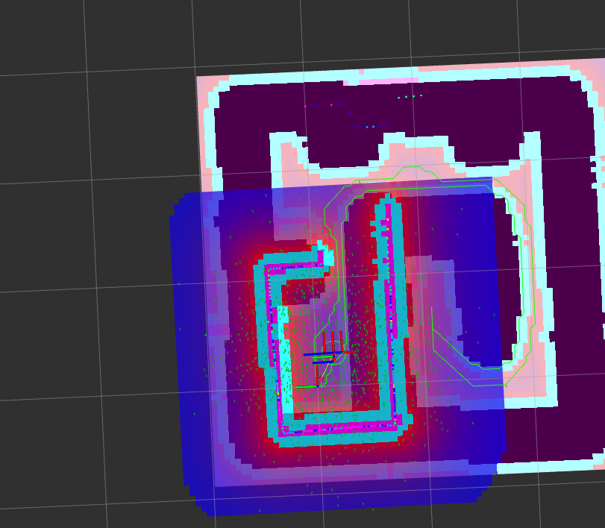
  - Map
- Outputs:
  - Pose estimate in map frame

Important Steps
- Lifecycle activation (configure → activate)
- Initial pose must be set manually

Fig: 6.1 : Map in Rviz2 with Published path and localization as per current scan

7. Real Robot Deployment

Setup
- SSH connection to TurtleBot3
- ROS_DOMAIN_ID configured for communication
- Navigation stack launched on robot

Execution Flow
- Start robot bringup
- Launch AMCL
- Load map
- Start planner
- Run path follower

Challenges Faced
- QoS mismatches (sensor data loss)
- Frame transformations (map ↔ odom)
- Localization initialization
- Controller tuning for real-world noise
A* based follower : https://youtu.be/1sxk2Vhhj7A
GVD based follower : https://youtu.be/z7i_HmjpiU4

8. Trajectory Visualization
A custom node was implemented to:
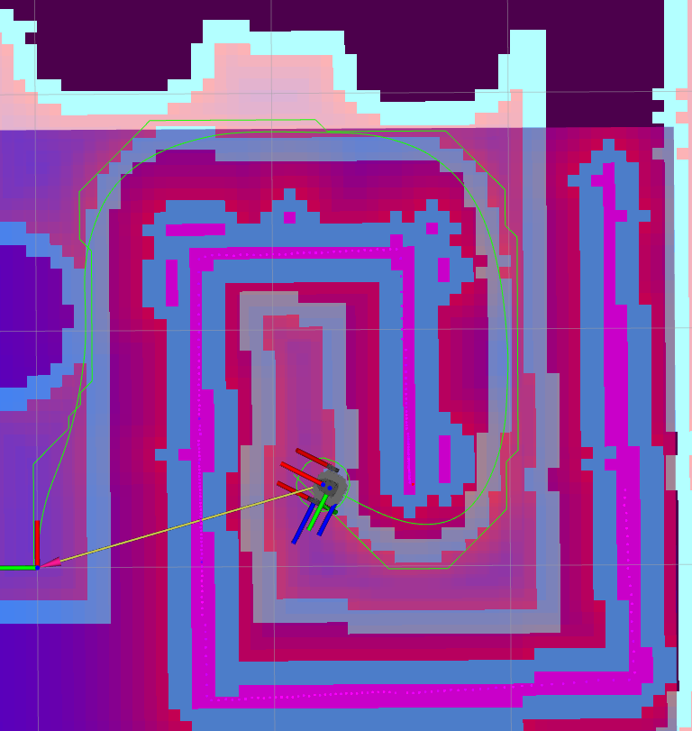
- Subscribe to /odom
- Publish actual path (/robot_trajectory)

Purpose
- Compare planned vs executed trajectory
and improved the controller as error was visually
more easy to to tune PID values
- Analyze tracking performance
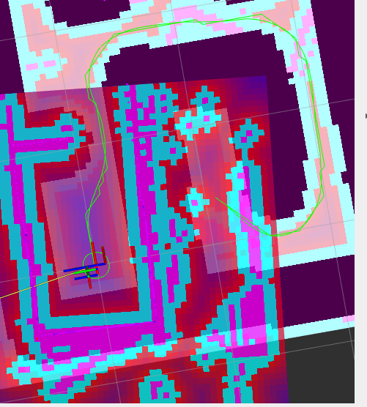
Fig : 8.1 , path followed

9. Results and Observations

A Planner*
- Shorter paths
- Faster computation
- Higher risk near obstacles

GVD Planner
- Safer paths with higher clearance
- Better suited for cluttered environments

Controller Performance
- PID + lookahead provided smooth tracking
- Reactive obstacle avoidance improved safety
- GVD follower was stable but less efficient

Simulation vs Real World
- Real robot exhibited:
  - Sensor noise
  - Odometry drift, Error in AMCL based estimation and Actual Position
  - low frequency data updating and lags
- Required:
  - Parameter tuning, Tuning for gains and handling errors
  - Robust control design

10. Limitations
- No dynamic obstacle handling(only static implemented till now)
- Planner and controller are decoupled
- No uncertainty modeling
- Limited benchmarking

11. Future Work
- Risk-aware planning under uncertainty
- Integration with reinforcement learning
- Dynamic obstacle avoidance (DWA / MPC)
- Controller-aware path planning
- Multi-robot coordination

12. Conclusion
This project successfully demonstrates a full-stack autonomous navigation system integrating mapping, planning, and control in ROS2.
The implementation highlights:
- Trade-offs between optimality and safety (A* vs GVD)
- Importance of control design in real-world deployment
- Challenges in sim-to-real transfer
The system provides a strong foundation for further research in:
- Robust navigation
- Learning-based control
- Autonomous systems design

13. Author
Ayush Bhaskar
IIT Bombay
bhaskarayush2005@gmail.com

14. References
- ROS2 Documentation
- TurtleBot3 e-Manual
- Probabilistic Robotics (Thrun et al.)
- A* Search Algorithm Literature
- https://lavalle.pl/planning/
- Lectures on Robotic Planning and Kinematics by F. Bullo and S.L.Smith (https://fbullo.github.io/lrpk/)
- Lecture Slides from SC 627: Motion Planning & Coordination of Autonomous Vehicles- Prof. Arpita Sinha

