Lab 01

(1) The setup is as below :
Intel x64 HP latop with with Intel Corporation UHD Graphics 620
(2) I have used Capsule, Sphere, Cubes(Multiple) and cylinder for showing the Bouncing effect
(3) I have used different values of Drag
(4) Character and VFX has also been added ( 4 characters)

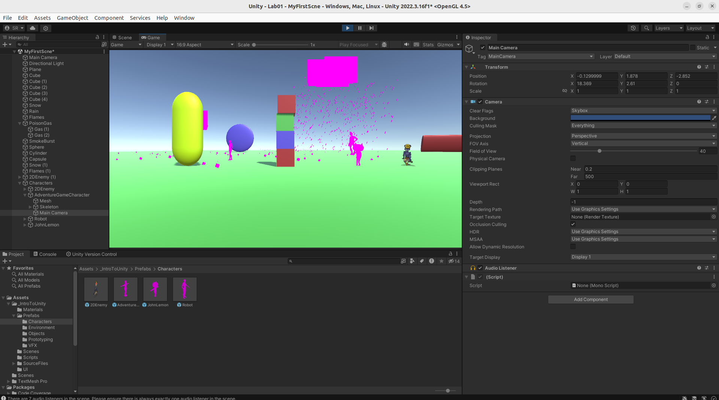

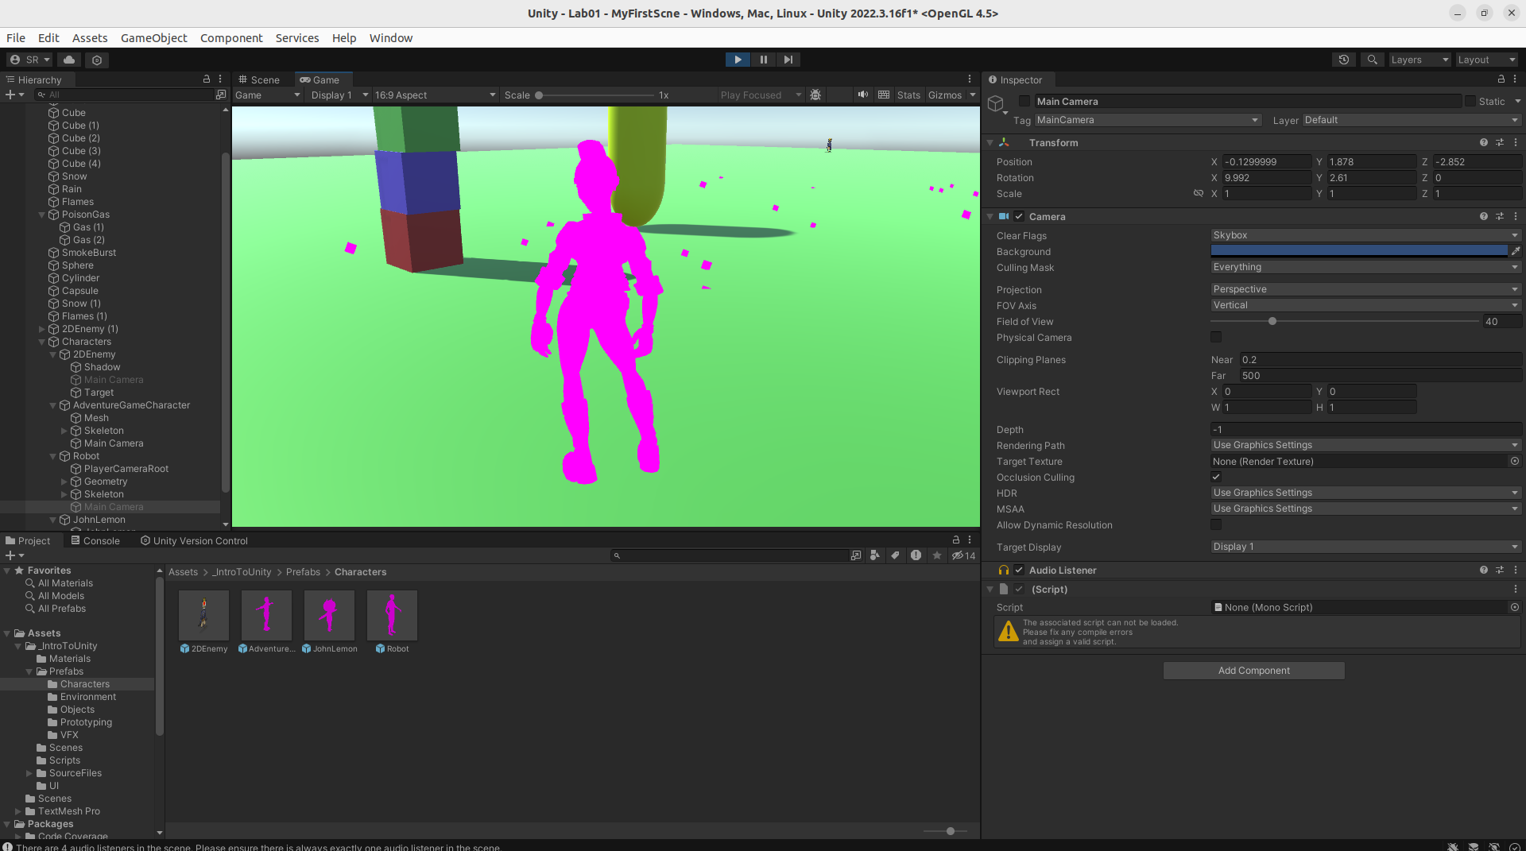

I have added some charcaters and viewed their motion with camera in their view not the main camera )

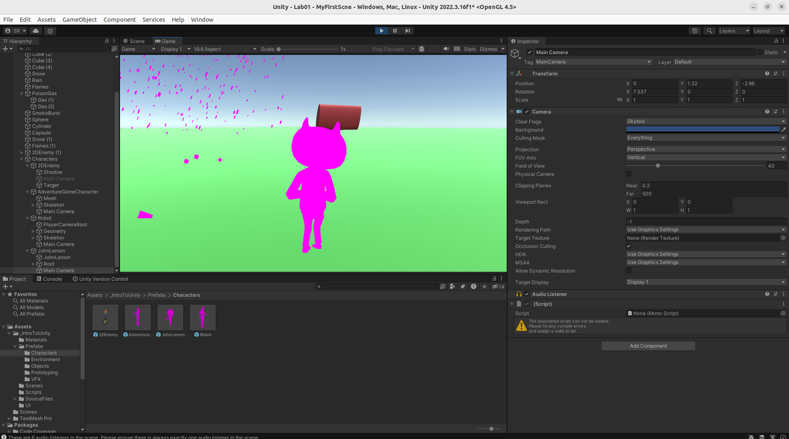

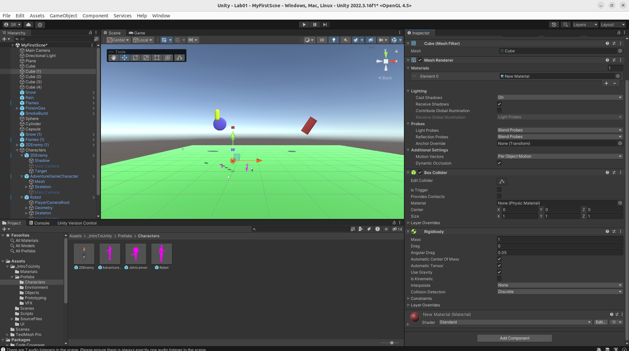

VFX :
Snow, flames and Poisonous Gas

