OPSDESK

Application Overview & Functional Documentation
Updated to the current application build, 28 October 2026

1. Application Overview
OpsDesk is a multi-tenant service-desk and ticket-management application built around ITIL practices. It allows customers to raise support tickets and enables support staff to assign, investigate, approve, resolve, and close them. Tickets may arrive through the self-service portal (a web app that can also be installed on phones), email (inbound webhook or IMAP mailbox), WhatsApp, monitoring alerts, or an API. Each company workspace is isolated from the others: the application filters every query by workspace and the database enforces the same rule with row-level security.
This document describes the application as it is built today. The Service catalog, the Approvals queue, the CMDB Explorer and “Save queue” on the ticket list are currently switched off in the interface; their API and data remain in place and the interface can bring them back with a configuration switch.

2. User Roles and Access
Role | Primary responsibility | Access in the current application
Customer | Raise and follow support requests | Can create Incidents and Service Requests only. Sees the tickets they requested or watch and, by default, the other tickets of their own company account (a workspace setting). Sees public replies only. Can reply, edit a ticket's subject, description and customer-visible fields, reopen or confirm-close resolved tickets, and rate the service. No dashboard, reports or internal notes.
Employee | Work and resolve their own tickets | Sees only the tickets assigned to them, raised by them, or where they are the requester; unassigned tickets and other people's tickets are not visible. The dashboard, reports and exports are limited to those tickets, and the “Accounts this period” and “Open by team” cards are hidden. Can edit ticket fields, add public replies and internal notes, attach files, use AI assistance and manage knowledge-base articles. Cannot perform steps reserved for team leads and managers, and cannot open Administration.
Team lead | Supervise the queue and assign work | Sees every ticket in the workspace, with the full dashboard, reports and exports. Can reassign tickets, declare and coordinate major incidents, and perform lead-level workflow steps such as rejecting service requests and changes and closing resolved problems and changes. Cannot open Administration.
Manager | Top operational role | Has the same ticket visibility and workflow permissions as a Team lead; the differences are limited to a few minor privileges. Cannot open Administration: configuration, user and SLA management belong to the Super admin.
Super admin | Administer the installation | Exactly one account for the whole installation. The only role that can open Administration: users and teams, SLA policies and business hours, the configuration console (workflows, ticket types, priorities, categories, automation rules, accounts, channels, canned responses), the inbound-message outbox and the audit log. Sees all tickets and counts as a Manager in workflow rules. Cannot be created, edited, deactivated, assigned or have its password reset through the application; it is created and recovered only from the command line.
Note: Role names changed from the previous version of this document. Agent is now Employee, the former Manager is now Team lead, the former Admin is now Manager, and the Platform superuser is replaced by the single Super admin. User accounts are created from the command line (create-user); the web console edits, deactivates and resets existing users but has no create-user or invitation flow. Workspace-level platform tasks, such as creating a workspace, also run from the command line.

3. Ticket Types
Type | Purpose | Example
Incident (INC) | Restore a service that is broken or disrupted. | A website is unavailable.
Service Request (REQ) | Provide a standard service or fulfil a user request. | A user requests access to an application.
Problem (PRB) | Investigate the root cause of recurring incidents. | Repeated server crashes need root-cause analysis.
Change (CHG) | Control a planned change to a production environment. | Deploying a new version of an application.
Ticket numbers carry the type prefix (INC, REQ, PRB, CHG). Customers can raise Incidents and Service Requests only; Problems and Changes are staff-only. The default forms ask for Environment and Error message on incidents; Requested for and Needed by on service requests; Root cause and Workaround on problems; and Change type, Risk, Implementation window, Back-out plan and Outcome on changes. Types, prefixes, workflows and custom fields are edited by the Super admin in Configuration.

4. Ticket Lifecycle
- Ticket intake: A ticket arrives through the portal, email (webhook or IMAP mailbox), WhatsApp, a monitoring alert webhook, or the API. Inbound messages are stored first and processed in the background, so a failed delivery can be re-queued from the console. Replies to an existing ticket are added to that ticket where recognised.
- Number and priority: The system assigns a gap-free ticket number with the type prefix. Priority is calculated from impact and urgency using the configured priority matrix; staff can override it, which recalculates the SLA due dates.
- SLA tracking: Incident and Service Request tickets receive SLA timers from the applicable policy: the account's own policy if it has one, otherwise the workspace default. Problems and Changes have no SLA in the default setup.
- Routing and assignment: The system chooses a team using the ticket category, service, or affected configuration item. Automation rules may adjust routing, and the team's assignment method is manual, round-robin or least-loaded; people marked unavailable are skipped. On a ticket, staff choose the Team first; the Assignee list then shows only members of that team.
- Support work and communication: Employees investigate, update ticket details, reply publicly, add internal notes, attach files, and use available AI suggestions. Employees see only their own tickets, so unassigned tickets are assigned to them by a team lead or manager.
- Approval where required: Some service requests and changes can require approval. The workflow step that needs it stays blocked until the requested approvals have been approved. The Approvals screens are currently switched off in the interface (see section 1).
- Resolution and closure: The ticket is resolved or fulfilled, and may then be closed. A resolved ticket closes automatically after five days if it is not reopened (the number of days is a workspace setting, checked hourly). A customer reply on a ticket waiting on the customer moves it back to work, and a satisfaction survey can be sent on resolution.
- History and audit: Ticket changes are recorded in ticket history; edits are also recorded in an append-only audit log (the database blocks updates and deletes) that the Super admin can search.

5. Workflow Summary

5.1 Incident
Typical path: New → In progress → Waiting on customer or Waiting on third party when needed → Resolved → Closed; a ticket can also be Cancelled (employees, team leads and managers, with a comment). Staff can resolve an incident from any open state once a resolution code and resolution notes are supplied. Customers can reopen or confirm-close a resolved incident.

5.2 Service Request
Typical path: New → Awaiting approval (if needed) → In fulfilment → Fulfilled → Closed, with Waiting on customer as needed. A request may enter fulfilment directly without approval. Team leads and managers (and the Super admin) can reject a request at the approval stage, with a comment. Fulfilling a request needs resolution notes, and customers can reopen or close a fulfilled request.

5.3 Problem
Typical path: New → Root cause analysis → Known error (if applicable) → Resolved → Closed. Problems are staff-only; recording a known error or resolving a problem requires the root cause and resolution notes, and closing a resolved problem is restricted to team leads and managers (and the Super admin).

5.4 Change
Typical path: Draft → Assessment → Change-board (CAB) review → Scheduled → Implementing → Post-implementation review → Closed. Required details must be present at the relevant stages: change type, risk and back-out plan to submit for assessment; the implementation window to go to the CAB; and the outcome to complete. Approval is required to approve and schedule. Rejection and closure are team lead and manager actions (the Super admin also qualifies).

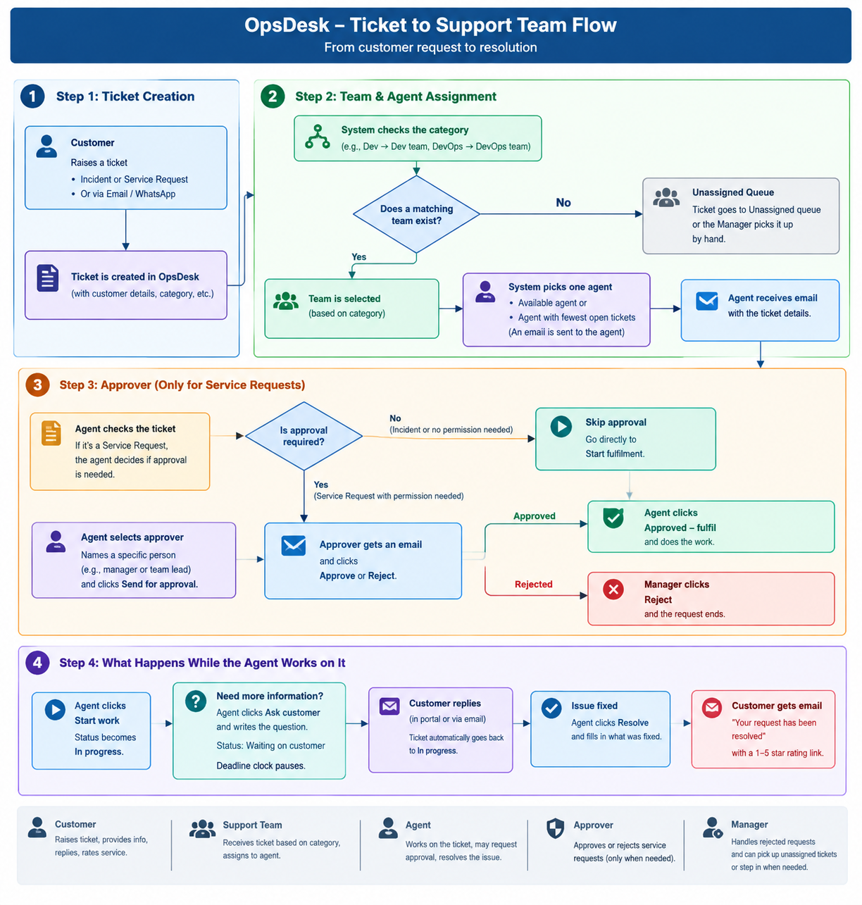
Figure: ticket-to-support-team flow (original diagram). Terminology has changed since it was drawn: “Agent” is now Employee, and “Manager” is now Team lead or Manager. Employees no longer see unassigned tickets, so the unassigned queue is worked by team leads and managers. The approval step is currently switched off in the interface.

6. SLA, Priority and Notifications
Priority is based on impact and urgency (each rated 1–4). The default priority matrix uses these sum-based bands: P1 when the sum is 3 or less; P2 when it equals 4; P3 when it is 5–6; and P4 when it is 7–8. The matrix, the targets below and the business hours (including holidays and time zones) are editable by the Super admin.
Priority | Standard policy (Mon–Fri, 9am–6pm): response / resolution | Premium policy (24×7): response / resolution
P1 | 15 min / 4 h | 10 min / 2 h
P2 | 30 min / 9 h | 30 min / 6 h
P3 | 4 h / 27 h | 2 h / 24 h
P4 | 8 h / 45 h | 4 h / 48 h
The first public staff reply counts as the first response for SLA purposes. Waiting on customer and Awaiting approval pause the SLA clock; Waiting on third party does not. SLA status is checked every minute. An at-risk alert is sent when 75% of the SLA time is used (the threshold is set per policy) and a breach alert when the SLA is breached; both go to the assignee and the team, and the assignee also gets an in-app notification.

7. Automation and Supporting Features
- Automatic assignment: Routes tickets to teams and assigns employees using the team's configured method (manual, round-robin or least-loaded, skipping people marked unavailable). No-code rules can also assign, set priority, add tags, transition, notify or call a signed webhook when a ticket is created, updated, changes state, receives a customer reply, or reaches an SLA risk or breach.
- AI assistance: Finds similar tickets and knowledge articles, flags possible duplicates for one-click merge, suggests category, team, impact and urgency, summarises a ticket and drafts a reply. It works without an external model, using a grounded fallback; an optional LLM improves summaries, drafts and triage, and personal data is masked before any text leaves. Suggestions are advisory unless automatic application is enabled, and acceptance is tracked.
- Approvals: A selected approver receives an email and decides in the application. The workflow step remains blocked until all requested approvals are approved. (Currently switched off in the interface.)
- Knowledge base: Customers can read and vote on published public articles. Staff can create, edit and delete articles and turn resolved tickets into draft articles; articles are also suggested on tickets and while a customer types a new request.
- CMDB / asset inventory: Staff can view services, configuration items (applications, AI models, pipelines, platforms) and their dependencies, including downstream impact. The CMDB Explorer screen is currently switched off in the interface.
- Notifications and surveys: The requester receives acknowledgement and resolution communication; staff receive assignment, SLA and in-app notifications, with a live event stream in the application. Satisfaction (CSAT) surveys, enabled by workspace settings, are answered from a link without signing in.
- Configuration console: The Super admin (Administration) can manage users, teams, SLA policies, business hours and holidays, and the audit log, and configure workflows, statuses, ticket types, custom fields, priorities and the priority matrix, categories, accounts, contact identities, channels, automation rules and canned responses. Sign-in supports optional two-step verification, and login attempts are throttled.

8. Dashboard and Reporting
Every staff role opens on the Dashboard; customers have none. The period (7, 30 or 90 days) and an account can be selected, and every figure respects the viewer's ticket visibility, so an employee sees numbers for their own tickets only.
- Open now / Open and breached / At risk: tickets not yet resolved, and how many of them have breached or are close to breaching their SLA.
- SLA met (resolved): of the tickets resolved in the period that have an SLA, the share that breached neither the first-response nor the resolution target.
- Avg first response: average time from creation to the first public staff reply, shown in minutes when under one hour.
- Mean time to resolve: average time from creation to resolution for tickets resolved in the period.
- CSAT: average satisfaction score and the number of survey responses.
- AI suggestions accepted: share of AI suggestions that staff accepted.
- Charts: Created vs resolved per day, Backlog age, Intake by channel and Open by priority for all staff; Accounts this period and Open by team for team leads, managers and the Super admin only.
Staff can export Overview, Tickets, Major Incidents and Team Workload reports as CSV or PDF; exports follow the same visibility rules.

9. Items for Team Review
The following are potential risks or business-rule questions found when this document was checked against the current application. They should be validated against the intended requirements before being classified as defects.
- Role separation: Team lead and Manager have almost the same permissions, and only the Super admin can open Administration. Decide whether the Manager role needs any configuration or user-management access, or whether both roles are still needed.
- Approver eligibility: Requesting an approval on a ticket accepts any user in the workspace as approver, including a customer; only approvals raised from the service catalog follow the manager and department-head hierarchy. Define eligible approver roles and enforce them.
- Ticket data isolation: Employees now see only tickets assigned to them, raised by them or requested by them, which closes the earlier gap where employees without a team, or on a team covering all companies, saw every ticket. Team leads, managers and the Super admin still see every ticket with no per-company restriction. Because employees cannot see unassigned tickets, someone with wider access must assign work to them; confirm this is the intended working model.
- Change/request authorization: The steps “Approved - fulfil”, “Approve and schedule” and “Start implementation” are not limited to a specific role, so any staff member who can see the ticket can run them once approvals exist. Decide who may execute these actions, particularly for production changes.
- Problem and Change SLAs: No default SLA is applied to these ticket types. Decide whether target response and resolution times are required.
- Customer edits: Customers can still edit the subject, description and customer-visible fields after submission. Each change is recorded in the ticket history and audit log. Decide whether edits should be restricted once work has started.
- Approvals switched off in the interface: The ticket approval card and Approvals screen are hidden, yet the Change step “Approve and schedule” requires an approval to exist, so a change at CAB review may have no way to proceed from the screen. Service requests can still bypass approval with “Start fulfilment”. Decide whether to switch approvals back on or change the Change workflow.
- Administering additional workspaces: Creating a workspace from the command line makes its first administrator a Manager, but only the single installation-wide Super admin can open Administration, and its screens act on that account's own workspace. Confirm how a second workspace is meant to be administered.

