.Fusion of Tire Lateral Force Estimation and Integral Sliding Mode Control for Improved Vehicle Handling

Jinmin Kim1), Hyunseup Jo1) and Sang Won Yoon2)*

1)Department of Automotive Engineering (Automotive – Computer Convergence), Hanyang University, Seoul 04763, Korea

2)Department of Electrical and Computer Engineering, Seoul National University, Seoul 08826, Korea

(Received date ; Revised date ; Accepted date ) * Please leave blank

**ABSTRACT−**Type the abstract here. Type the abstract here. Type the abstract here. Type the abstract here. Type the abstract here. Type the abstract here.Type the abstract here. Type the abstract here. Type the abstract here. Type the abstract here. Type the abstract here. Type the abstract here. Type the abstract here. Type the abstract here. Type the abstract here. Type the abstract here. Type the abstract here. Type the abstract here. Type the abstract here. Type the abstract here. Type the abstract here. Type the abstract here. Type the abstract here. Type the abstract here. Type the abstract here. Type the abstract here. Type the abstract here. Type the abstract here. Type the abstract here. Type the abstract here. Type the abstract here. Type the abstract here. Type the abstract here. Type the abstract here. Type the abstract here. Type the abstract here. Type the abstract here. Type the abstract here. Type the abstract here. Type the abstract here. Type the abstract here. Type the abstract here. Type the abstract here. Type the abstract here. Type the abstract here. Type the abstract here. Type the abstract here. Type the abstract here. Type the abstract here. Type the abstract here. Type the abstract here. Type the abstract here. Type the abstract here. Type the abstract here. Type the abstract here. Type the abstract here. Type the abstract here. Type the abstract here. Type the abstract here. Type the abstract here. Type the abstract here. [Capital letter at the beginning of each sentence, put a period at the end, Please write in 100 ~ 200 words, Times New Roman, 9pt]

**KEY WORDS** : Type key words here, Type key words here, Type key words here, Type key words here [Capital letter at the beginning of each keyword, Do not put a period at the end, Times New Roman, 9pt]

**[Main Body : Times New Roman, 10pt]**

nomenclature

[All should have small letters, Times New Roman, 10pt]

A : area, m2

subscripts

|  |
| --- |
| [All should have small letters, Times New Roman, 10pt]  A,B,C,P : nodal point |
| * *Corresponding author*. e-mail: type e-mail address [Official E-mail Address] |

1. INTRODUCTION [All should have capital letters, Times New Roman, 10pt]

The manuscript elements have been formatted for you through the “styles” capability of the software. To use the styles, select the text you wish to apply a style to, then, using the mouse, point to the style box on the toolbar. Click once on the downward pointing arrow to the right, and select the appropriate style.

2. Estimation of Lateral tire force

In this section, we describe the lateral force estimation process using an Adaptive Extended Kalman Filter (AEKF) and introduce an offline optimization approach for modified corenering stiffness. The estimation process consists of three main parts: the vehicle lateral dynamics model under the planar motion constraints, vertical force calculation and a brief explanation of Dugoff’s tire model. However, Dugoff’s tire model assumes that cornering stiffness is a constant value, which can lead to inaccurate results in lateral tire force estimation as the slip angle increases.

To address this, we propose the offline optimization approach for modified cornering stiffness using an axle distribution-based lateral force calculation. For the vehicle lateral dynamics model, a three degrees of freedom (3-DoF) model is employed which has been widely used for estimating lateral forces and is critical for understanding vehicle stability and handling. The detailed four-wheel vehicle model is illustrated in Figure 1, and the equations of vehicle lateral dynamics are described as follows:

|  |  |
| --- | --- |
|  | (1) |
|  | (2) |
|  | (3) |

where  are the longitudinal velocity, lateral velocity, yaw rate, front left wheel steering angle, front right wheel steering angle, vehicle mass, moment of inertia about yaw axis, distance from front axle to the center of gravity (CG), distance from rear axle to the CG, half of track width and aerodynamic drag coefficient respectively. For the tire forces,  and  (*i* denotes the axle position) represent the longitudinal and lateral forces with the subscript . On the other hand, the lateral slip angle

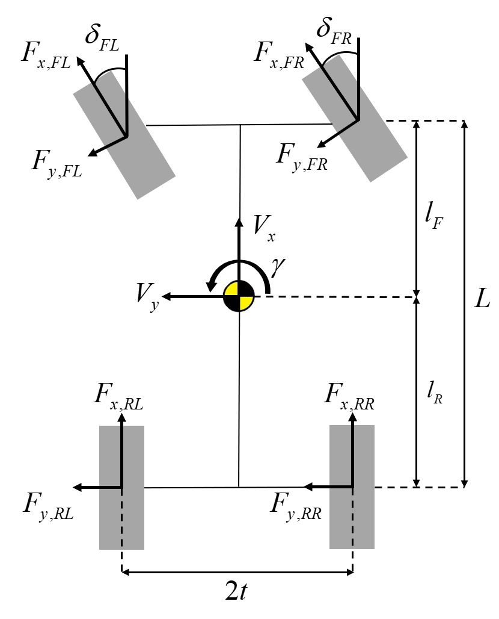

Figure 1. 2D representation of a vehicle motion model

is a critical factor in determining lateral tire forces; this can be calculated as described in Eq. (4).

|  |  |
| --- | --- |
|  | (4) |

where  denotes the front left wheel steering angle and front right wheel steering angle. Compared to , can be directly calculated using drivetrain output, specifically through the wheel torque value. In contrast, estimating  is complex because it is influenced by various factors, including the lateral slip angle, road conditions, vertical tire force and tire characteristics such as cornering stiffness.

2.1. Vertical tire force calculation

The lateral tire force is affected by several factors, but the vertical tire force plays a crucial role in its accurate estimation. It is essential to account for  throguth the equations of considering load transfer and acceleration, as theses forces are directly influcenced by the vehicle’s dynamic behavior, including braking, acceleration and cornering. For simplicity, the coupings between pitch and roll dynamics are neglected, the vertical forces can be simplified and calucatled as outlined in Eq. (5). (Doumiati *et al.*, 2012)

|  |  |
| --- | --- |
|  | (5) |

where are the vehicle mass, gravitational acceleration, distance trom ground to CG, half of track width, wheel base length, x- axis acceleration and y-axis acceleration respectively.

2.2 Axle dristribution based lateral force calculation

The linear tire model in assumes that cornering stiffness represents a linear relationship between the lateral force and slip angle when the tire slip angle is small as described in Eq. (6). However, as it increases, the behavior of the tire becomes nonlinear. In the nonlinear regime, the lateral force no longer increases proportionally with the slip angle; instead, it appeoaches a saturation point where additional increases in slip angle yield diminishing in lateral force. Therefore, predicting the lateral tire force using linear models becomes less accurate.

|  |  |
| --- | --- |
|  | (6) |

To address this, a more effective approach is to predict the lateral tire force directly by considering the distribution of vertical load across the tires relative to the total load on certain axle. The equations of axle distribution based lateral force calculation is described in Eq. (7) and it accounts for the influence of vertical load without relying on filtering-based estimation techniques.

|  |  |
| --- | --- |
|  | (7) |
|  | (8) |

Where represents the lateral tire force,  and  are the total lateral forces on the front and rear axles, respectively.

2.3. Optimization for modified cornering stiffness

|  |  |
| --- | --- |
|  | (9) |

However, Eq. (7) still has an issue with accurately estimating lateral force because it does not fully account for the nonlinear relationship between lateral force and slip angle. Instead, Eq. (9) denotes the cornering stiffness has a quadratic function relationship with the vertical load on lateral force. Through the previous studies, the lateral force has a a quadratic relationship with the vertical load. We used it only as a basis to incorporate the effects of vertical load more accurately and modified Eq. (9) by integrating the initial cornering stiffness  to better capture the nonlinear dynamics of tire’s behavior.

|  |  |
| --- | --- |
|  | (10) |

By considering both the slip angle and vertical load, we performed a least squares optimization to minimize the error between the predicted for modified cornering stiffness and determine the coefficient (*a, b*) of modified cornering stiffness, as described in Eq. (10). From the experiment, the optimal value of *a* is 0.006, and *b* is 3.501 respectively.

2.4. Dugoff’s tire model

In this study, we employed Dugoff tire formula because it provides simplicity and is easy to implement. It calculates tire forces based on the slip ratio of longitudinal forces and the slip angle. Assuming longitudinal slip ratio is negeligible, the simplified Dugoff model for lateral force is described in Eq. (11).

|  |  |
| --- | --- |
|  | (11) |

where represent the corenering stiffness of each axle, and  is the road firction coefficient, which we assume to be 1.0 for a high-friction road surface. With this simplified model, the lateral force is generated with a time lag relative to change in slip angle, it causes transient response of the tire. The dynamic model of lateral force is represented as follows:

|  |  |
| --- | --- |
|  | (12) |

Where denotes the relaxation length, and assumed it as constant value with 0.1 in this study.

2.5. Adaptive extended kalman filter

To estimate the lateral force in state-space model, the AEKF is employed to dynamically adjust the process noise. While the process noise is dynamically adjusted, the measurement noise is kept constant. This is because the measurement noise is primarily influenced by the sensor charactericstics, which remain stable under normal operating conditions. AEKF utilizes 8-dimensional state vector and 5-dimensional control vector  as follows:

|  |  |
| --- | --- |
|  | (13) |
|  | (14) |

Here, longitudinal force of each axle is used as a input control vector and calculated as Eq. (14). Where are the wheel driving torque, wheel bracking torque, and effective radius of tire. Meanwhile, the measurement model is described in Eq. (15)

|  |  |
| --- | --- |
|  | (15) |

And the estimator process is described as follows:

|  |  |
| --- | --- |
|  | (16) |

The nonlinear function of are described as follows:

|  |  |
| --- | --- |
|  | (16) |
|  | (17) |

The nonlinear function of are described as follows:

3. Torque-vectoring

The implementation of Torque Vectoring requires a control strategy capable of accurately distributing torque between individual wheels to achieve the desired yaw rate. A typical driving environment is subject to various disturbances, and due to the inability to fully sense some aspects of driving dynamics in real time, these parts remain uncertain. Therefore, the controller must ensure robustness to maintain performance under these conditions. To satisfy these requirements, this paper employs a Sliding Mode Controller (SMC) to calculate the yaw moment.

3.1. Sliding Mode Controller

A SMC can be developed based on the Eq.(3). This equation can be partitioned into two components: one is , which consis of , and the other is , which consists of . of the  can be predicted with driven motor torque and brake pressure. So we can use this part for the control, as dscribed in the following:

|  |  |
| --- | --- |
|  | (X) |

 of the is estimated by the EKF, as dscribed in the following:

|  |  |
| --- | --- |
|  | (X) |

For torque vectoring, a sliding surface is designed to achieve the desired yaw rate as follows.

|  |  |
| --- | --- |
|  | (X) |

The process of setting the control input involves following two steps. First, establish the equivalnt control, which ensures  under the assumtion of no disturbances and can be determined by imposing . Next, add a switching term to eliminate disturbances

|  |  |  |
| --- | --- | --- |
|  |  | (X) |
|  |  | (X) |
|  |  | (X) |

Where is the control gain for slidng mode control.  is the disturbances, and  is error of the EKF results

To ensure the sliding surface converges in finite time, Lyapunov functions V(s) are used. According to equation (x), control gain must be over the .

|  |  |
| --- | --- |
|  | (X) |

3.2. Torque Distribution

In Section 2.1, the desired momentum is generated by SMC. To achieve this momentum, the vehicle utilizes both steering and torque distribution. However, the maximum momentum is limited by the frictional force between the tires and the road, which is determined by the frictional coefficient and the normal force. As a result various distribution startagies can be employed. [who gonna same, who gonna adaptive, references is here]. In this paper, torque is generally distributed equally, but if the tire force exceeds the maximum force, the excess value is edistributed to the other motor. The maximum force is estimated using Fz derived​ from the EKF and frictional coefficients.

4. Simulation and result

4.1. Simulation setup

This section includeed Simulation setup and

4.2. EKF RESULT MU MU

This section includeed EKF setup and results

4.3. Torque Vectoring

4.3.1 Sliding Mode Control Setup

Robustness of SMC can be guaranteed by adopting an appropriate control gain.

5. CONCLUSION

Type the contents of the conclusion here. Type the contents of the conclusion here. Type the contents of the conclusion here. Type the contents of the conclusion here. Type the contents of the conclusion here. Type the contents of the conclusion here. Type the contents of the conclusion here. Type the contents of the conclusion here. Type the contents of the conclusion here. Type the contents of the conclusion here. Type the contents of the conclusion here.

**ACKNOWLEDGEMENT−**This work was supported by Institute of Information & communications Technology Planning & Evaluation (IITP) grant funded by the Korea government (MSIT) (No.2022-0-01053, Development of Network Load Balancing Techniques Based on Multiple Communication/Computing/Storage Resources)

REFERENCES

* The Harvard System of references is to be used.

* In the body of the text a paper is to be referred to by the author’s Last Name with the year of publication in parentheses.

Example :

-One author (Last Name, Year)

-Two authors (Last Name and Last Name, Year)

-More than three authors (Last Name *et al*., Year)

Example :

-One author : (Huh, 2000)

-Two authors : (Incropera and DeWitt, 1990)

-More than three authors : (Park *et al*., 2002)

* References should be listed together at the end of the paper in alphabetical order by author’s Last Name.

-Type in all Author’s name and Paper title

-Type in reference of this paper in the text.

-Transactions of the Korean Society of Automotive Engineers : *Trans. Korean Society of Automotive*

*Engineers*

IJAT : *Int. J. Automotive Technology*

* Citing a minimum of one citation from the International Journal of Automotive Technology (IJAT) is recommended.

**1. Journals**

All Author(s)(Type Last Name, then first and middle initials). (Year). Paper title(Capital letter at the beginning of sentence). *Journal Name(Italic)* **Volume number(bold)**, **Issue number(bold)**, pp.−pp.

Example :

Huh, H. (2000). Identification of autobody crashworthiness for space- framed vehicle models by finite element limit analysis. *Int. J. Automotive Technology* **1**, **1**, 101−112.

**2. Books**

All Author(s)(Type Last Name, then first and middle initials). (Year). *Book Title(Italic, Capital letter at the beginning of each keyword)*. Edition number. Publisher. The Location of Publisher(City).

Example :

Incropera, F. P. and DeWitt, D. P. (1990*). Fundamentals of Heat and Mass Transfer*. 3rd edn. John Wiley & Sons. New York.

**3. Website**

All Author(s) or Title (Access Year). Detailed Address.

Example :

PermaPure LLC (2006). http://www.permapure.com/

Presentations/Fuel%20Cell%20Humidification%20

presentation.ppt

**4. Reports and User Guide**

All Author/Organization or Title (Year). Title. Organization. Serial number.

Example :

Green, P. (1980). A Computer Simulation of Headlamp Variables and Drivers Sight Distances: Operating Instructions. HSRI Technical Report. UM-HSRI-80-44.

AVL (2006). BOOST Ver. 5.0 User Guide.