Fusion of Lateral Tire Force Estimation and Sliding Mode Control for Torque Vectoring

Jinmin Kim1), Hyunseup Jo1) and Sang Won Yoon2)*

1)Department of Automotive Engineering (Automotive – Computer Convergence), Hanyang University, Seoul 04763, Korea

2)Department of Electrical and Computer Engineering, Seoul National University, Seoul 08826, Korea

(Received date ; Revised date ; Accepted date ) * Please leave blank

**ABSTRACT−**Type the abstract here. Type the abstract here. Type the abstract here. Type the abstract here. Type the abstract here. Type the abstract here.Type the abstract here. Type the abstract here. Type the abstract here. Type the abstract here. Type the abstract here. Type the abstract here. Type the abstract here. Type the abstract here. Type the abstract here. Type the abstract here. Type the abstract here. Type the abstract here. Type the abstract here. Type the abstract here. Type the abstract here. Type the abstract here. Type the abstract here. Type the abstract here. Type the abstract here. Type the abstract here. Type the abstract here. Type the abstract here. Type the abstract here. Type the abstract here. Type the abstract here. Type the abstract here. Type the abstract here. Type the abstract here. Type the abstract here. Type the abstract here. Type the abstract here. Type the abstract here. Type the abstract here. Type the abstract here. Type the abstract here. Type the abstract here. Type the abstract here. Type the abstract here. Type the abstract here. Type the abstract here. Type the abstract here. Type the abstract here. Type the abstract here. Type the abstract here. Type the abstract here. Type the abstract here. Type the abstract here. Type the abstract here. Type the abstract here. Type the abstract here. Type the abstract here. Type the abstract here. Type the abstract here. Type the abstract here. Type the abstract here. [Capital letter at the beginning of each sentence, put a period at the end, Please write in 100 ~ 200 words, Times New Roman, 9pt]

**KEY WORDS** : Type key words here, Type key words here, Type key words here, Type key words here

nomenclature

*Vx* : longitudinal velocity, m/s

*Vy* : lateral velocity, m/s

γ : yaw rate, rad/s

*ax* : longitudinal acceleration, m/s2

*ay* : lateral acceleration, m/s2

*δ* : steering angle, rad

*τd* : wheel driving torque, N·m

*τb* : wheel braking torque, N·m

|  |
| --- |
| subscripts  *FL, FR, RL, RR*: front left, front right, rear left, rear right |
| * *Corresponding author*. e-mail: [swyoon@snu.ac.kr](mailto:swyoon@snu.ac.kr) |

*r* : effective radius of tire, m

*m* : vehicle mass, kg

*Iz* : moment of inertia about z axis, kg·m2

*lF* : distance from front axle to the center of gravity, m

*lR* : distance from rear axle to the center of gravity, m

*L* : wheel base length, m

*t* : half of track width, m

*h* : height from ground to the center of gravity, m

*Cα* : cornering stiffness, N/rad

*σ* : relaxation length, m

*μ* : road friction coefficient, -

1. INTRODUCTION

The manuscript elements have been formatted for you through the “styles” capability of the software. To use the styles, select the text you wish to apply a style to, then,

2. Estimation of Lateral tire force

In this section, we describe the lateral force estimation process using an Adaptive Extended Kalman Filter (AEKF) and introduce an offline optimization approach for modifying cornering stiffness. Lateral forces are influenced by various factors, including slip angle, road conditions, vertical load on the tire, and tire’s cornering stiffness. The estimation process consists of three main parts: (1) the vehicle lateral dynamics model under the three degrees of freedom (3-DoF), (2) vertical force calculation, and (3) a brief explanation of Dugoff’s tire model, which is widely used for its simplicity. However, Dugoff’s tire model assumes that cornering stiffness as a constant value, this can lead to inaccurate results in overall estimation as the slip angle increases.

To address this, an offline optimization approach is utilized to modify cornering stiffness, allowing it to more accurately represent the changing conditions as the slip angle increases. This is achieved through an axle distribution-based lateral force calculation method. The detailed Four-Wheel Vehicle Model (FWVM) is illustrated in Figure 1, and the equations of vehicle dynamics are formulated as follows:

|  |  |
| --- | --- |
|  | (1) |
|  | (2) |
|  | (3) |

where  are the longitudinal velocity, lateral velocity, yaw rate, front left wheel steering angle, front right wheel steering angle, vehicle mass, moment of inertia about yaw axis, distance from front axle to the center of gravity (CG), distance from rear axle to the CG, half of track width and aerodynamic drag resistance, respectively. Tire forces,  and  (*i* denotes the axle position) represent the longitudinal and lateral forces with the subscript .

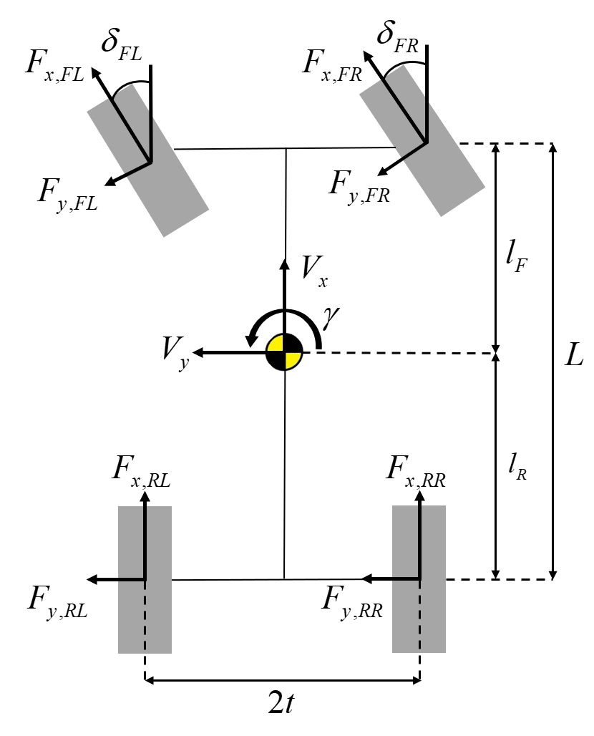

Figure 1. Representation of a four-wheel vehicle model

Lateral forces on the tire generated by the interaction with the road surface are primarily due to the presence of a slip angle. Therefore, calculating the slip angle is critical for determining lateral tire forces; this can be calculated as described in Eq. (4).

|  |  |
| --- | --- |
|  | (4) |

where  denotes the front left wheel steering angle and front right wheel steering angle.

2.1. Vertical tire force calculation

The vertical tire force plays a crucial role in accurately estimating lateral forces. It is essential to account for  through that consider load transfer and acceleration, as these are directly influenced during the vehicle’s dynamic behavior such as cornering, accelerating, and braking.

The couplings between pitch and roll dynamics are neglected in this study, assuming that these have a minimal effect on the overall vertical force calculation. The vertical forces can be simplified and calculated using the approach outlined in Eq. (5). (Doumiati *et al.*, 2012)

|  |  |
| --- | --- |
|  | (5) |

where are the vehicle mass, gravitational acceleration, distance from ground to CG, half of track width, wheelbase length, longitudinal acceleration and lateral acceleration, respectively.

2.2. Dugoff’s tire model

To represent tire forces, Dugoff’s tire model combines both lateral and longitudinal tire forces. It calculates these forces based on the slip ratio of longitudinal forces and the slip angle for lateral forces. By neglecting longitudinal slip ratio, simplified Dugoff’s tire model for lateral force is described in Eq. (6).

|  |  |
| --- | --- |
|  | (6) |

where represent the cornering stiffness of each axle, and  is the tire-road friction coefficient, assumed to be 1.0 for a high-friction road surface. Meanwhile, the lateral force is generated with a time lag relative to change in slip angle, it causes transient response of the tire. The lateral tire force dynamics is first order and represented as follows:

|  |  |
| --- | --- |
|  | (7) |

Here, denotes the relaxation length, which is assumed to be constant value of 0.1m in this study.

2.3 Axle distribution based-lateral force

As mentioned before, the Dugoff’s tire model assumes that the lateral tire force is proportional to slip angle. However, this assumption is valid within a limited small range of slip angle. As slip angle increases, the behavior of the tire becomes nonlinear and no longer increases

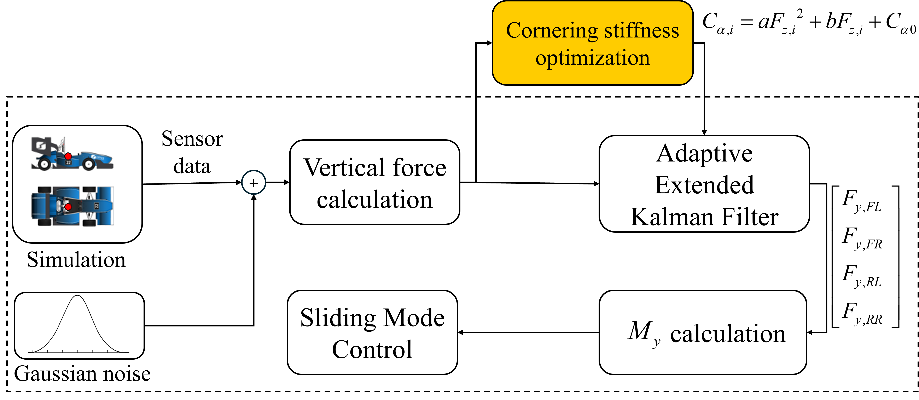

Figure 2. Overall system diagram

proportionally with the slip angle, instead, it approaches a saturation point where additional increases in slip angle yield diminishing in lateral force. Thus, predicting the lateral tire force using linear models becomes less accurate.

On the other hand, an alternative approach is proposed for estimating lateral tire force without relying on tire modeling and filtering methods. Instead, they predict the lateral tire forces directly by focusing on the distribution of vertical load across the tires relative to the total load on certain axle. The equations of the axle distribution based lateral force calculation is described in Eq. (7).

|  |  |
| --- | --- |
|  | (8) |
|  | (9) |

Here,represents the lateral tire force,  and  are the total lateral forces on the front and rear axles, respectively.

2.4. Optimization for modifying cornering stiffness

Previous studies have proposed that load transfer affects cornering stiffness, and this relationship can be presented by a second-order polynomial with respect to vertical force. In this study, the second-order polynomial equation is adjusted by adding a bias term, representing initial cornering stiffness as described in Eq. (10). While the axle distribution-based method does not fully capture the nonlinear relationship between lateral force and slip angle, it remains effective for modifying the cornering stiffness and reflecting nonlinear changes as the slip angle increases.

|  |  |
| --- | --- |
|  | (10) |
|  | (11) |

To further refine cornering stiffness, an optimization problem is then formulated aimed at reflecting the effect of vertical load, as defined in Eq. (12). This involves minimizing the sum of squared error between Eq. (8) and Eq. (11).

|  |  |
| --- | --- |
|  | (12) |

The Levenberg Marquardt method is utilized for this optimization task and the optimal values for the coefficients and as -0.006 and 3.501, respectively.

2.5. Adaptive extended Kalman filter

To estimate the lateral force in state-space model, the AEKF is employed to dynamically adjust the process noise. Unlike the process noise, which is adjusted dynamically to reflect changes in the system state transitions, the measurement noise is kept constant and remain relatively stable under normal operating conditions. The AEKF utilizes 8-dimensional state vector , 5-dimensional input control vector , and 5-dimenstional measurement vector  as follows:

|  |  |
| --- | --- |
|  | (13) |
|  | (14) |

 is excluded from the state vector and used as an input control vector calculated by Eq. (14). It is determined by using the wheel driving torque, wheel braking torque, and the effective radius of the tire denoted as,, respectively. The priori state  of AEKF is calculated by integrating over discrete time deviation  as described in Eq. (15) ~ (16).

|  |  |
| --- | --- |
|  | (15) |

|  |  |
| --- | --- |
|  | (16) |

The measurement model is described in Eq. (17) ~ (18).

|  |  |
| --- | --- |
|  | (17) |
|  | (18) |

where denotes the white gaussian measurement noise and is represented as a nonlinear function of 

The entire estimation process during discrete time deviationis formulated in Eq. (16).

|  |  |
| --- | --- |
|  | (19) |

Here, are the state covariance matrix, system noise covariance, and measurement noise covariance. are the Jacobian matrices of the nonlinear function of Compared to conventional EKF process, AEKF adaptively adjust the system noise covariance matrix , by balancing the weight  between the  and the innovation  term.

3. Torque-vectoring

3.1. Adaptive Sliding Mode Controller Design

In this study, to ensure robustness, a SMC approach is utilized to achieve the desired momentum. Depending on which order of the sliding surface being controlled, it referred to as First-Order Sliding Mode (FOSM) and Second Order Sliding Mode (SOSM). FOSM is simple to design and requires low computational power, but it can cause chattering problems. On the other hand, SOSM effectively mitigates chattering issues and is therefore commonly applied in TV systems (Liang et al., 2020). However, FS vehicles are constrained by limited computational resources. Additionally, FOSM, when combined with methods to reduce chattering, provides sufficient performance for TV (de Carvalho Pinheiro et al, 2023).

There are several techniques to reduce chattering, including adding a low pass filter, replacing the signum function with a saturation function, and using adaptive control gain. while adding low pass filter can reduce chattering, it negatively impacts to controller’s performance. In this paper, the signum function, and adaptive control gain are employed to mitigate chattering.

To establish SMC for torque vectoring, the sliding surface is designed for the vehicle’s yaw rate to track the desired yaw rate. it is expressed as follows:

|  |  |
| --- | --- |
|  | (20) |

The process of setting the control input involves following two steps. First, establish the equivalent control, which ensures  under the assumption of no disturbances and can be determined by imposing .

|  |  |
| --- | --- |
|  | (21) |

Derivation of yaw rate is defined in Eq. (3). This equation can be partitioned into two components: one is , which consist of , as described in the following:

|  |  |
| --- | --- |
|  | (22) |

And the other is , which consists of , as described in the following:

|  |  |
| --- | --- |
|  | (23) |

Using above equations, eq.(X) can be substituted as follows:

|  |  |
| --- | --- |
|  | (24) |

where  is added to represent disturbances. The term, which can be controlled using braking and acceleration, is treated as a control input.  is associated with lateral forces that are difficult to achieve. for getting equivalent control input, neglecting and , the equivalent control input defined Eq. (22) (Liang et al., 2020; de Carvalho Pinheiro et al., 2023; Zhang et al., 2020; Goggia et al., 2014).

|  |  |
| --- | --- |
|  | (25) |

Originally, signum function is incorporated into the control input as a switching term. However, to reduce the chattering phenomenon, the signum function can be replaced by a saturation function (Truong et al., 2013). Consequently, control input is defined as follows:

|  |  |
| --- | --- |
|  | (26) |

where is the control gain for sliding mode control.

To ensure the sliding surface converges in finite time, Lyapunov functions are used. According to Eq. (23). control gain must be over the .

|  |  |
| --- | --- |
|  | (27) |

This paper employs an adaptively adjusted switching gain, which is modified based on the results of the AEKF and the sliding surface. The AEKF results utilized to set the reference value to account for the uncertainties. However, due to the continuous oscillations observed in the AEKF output, there is a risk of using AEKF directly. To address this, the AEKF results are used as indicators that identify intervals where uncertainty is located. The corresponding equation is as follows:

|  |  |
| --- | --- |
|  | (27) |

where is reference value that defines the intervals, is the estimation of using AEKF  is bias term for extra disturbances.

where a is reference value that defines the intervals, my_ is the estimation of my using AEKF B is the bias term accounting for extra disturbances. the method of adjusting switching gain based on the states of sliding variable effectively addressed chattering phenomena near the sliding manifold (Back et al, 2016). To prevent setting the excessive switching gain, a weight that reflects the conditions of the sliding variable is applied to the switching gain. this weight is managed according to the following rules

1. If the sliding variable is smaller than in the previous step, the current gain is appropriate, and no update is made.
2. If the sliding variable is larger than in the previous step, it indicates the need for a higher gain, prompting an increase in the update step.
3. If the sliding variable is smaller than the threshold and its sign has changed compared to the previous step, it suggests system convergence. The weight is updated to smaller
4. If there is a change in E_AKF, it is regarded as a change in the environment. To handle this condition, the weight of switching gain is reset to 1.

|  |  |
| --- | --- |
|  | (27) |

3.2. Torque Distribution

In Section 3.1, the desired momentum is generated using FOSM. To achieve this momentum, the vehicle utilizes both steering and torque distribution. The ratio of torque distribution can be calculated by optimization-based control-allocation to achieve a specific purpose (De Novovellis et al., 2013) or by distributing it equally. While applying optimization-based control-allocation can enhance the vehicle’s performance, this paper distributes torque equally to avoid the additional computational resources. However, the force generated by drivetrain is constrained. Therefore, if the part of more power distribution exceeded its maximum power. It cannot maintain its speed. Due to this constraint, in that case, the excess value is redistributed to the other motor.

4. Experiment and Results

The overall process of lateral force estimation, offline cornering stiffness optimization, and torque-vectoring as illustrated in Figure 2, was tested using the Carmaker simulation environment. The tests were conducted on a Formula Student car model, equipped with virtual GNSS/IMU sensor that had Gaussian noise added to simulate real-world sensor inaccuracies, providing a more realistic evaluation of the proposed method’s performance. Two distinct scenarios were employed to assess its effectiveness in estimating lateral forces and toque vectoring. The two test scenarios include:

1. sinus steer test, which is commonly used to assess the response of a vehicle to rapidly varying steering angles
2. steady steer test, which represents a steady-state cornering condition.

The effectiveness of the proposed AEKF-based lateral force estimation and torque vectoring was assessed by comparing it with reference values from the Carmaker in both test scenarios. During the sinus test, the vehicle was maneuvered at a constant speed of 40km/h, with a sinusoidal steering input ranging from  to  over a 5-second period was adopted as the reference condition. For the steady steer test, the vehicle maintained a speed of 45km/h on circular track. Table 1 shows the RMSE results of estimated lateral forces and *My*during in both test scenarios.

|  |  |  |  |  |  |
| --- | --- | --- | --- | --- | --- |
| RMS | *Fy,FL*  (N) | *Fy,FR*  (N) | *Fy,RL*  (N) | *Fy,RR*  (N) | *My*  (Nm) |
| Sinus | 79.94 | 86.39 | 59.00 | 51.35 | 54.33 |
| Steady | 44.03 | 48.46 | 46.94 | 35.44 | 16.33 |

Table 1. Type the caption here. Type the caption here

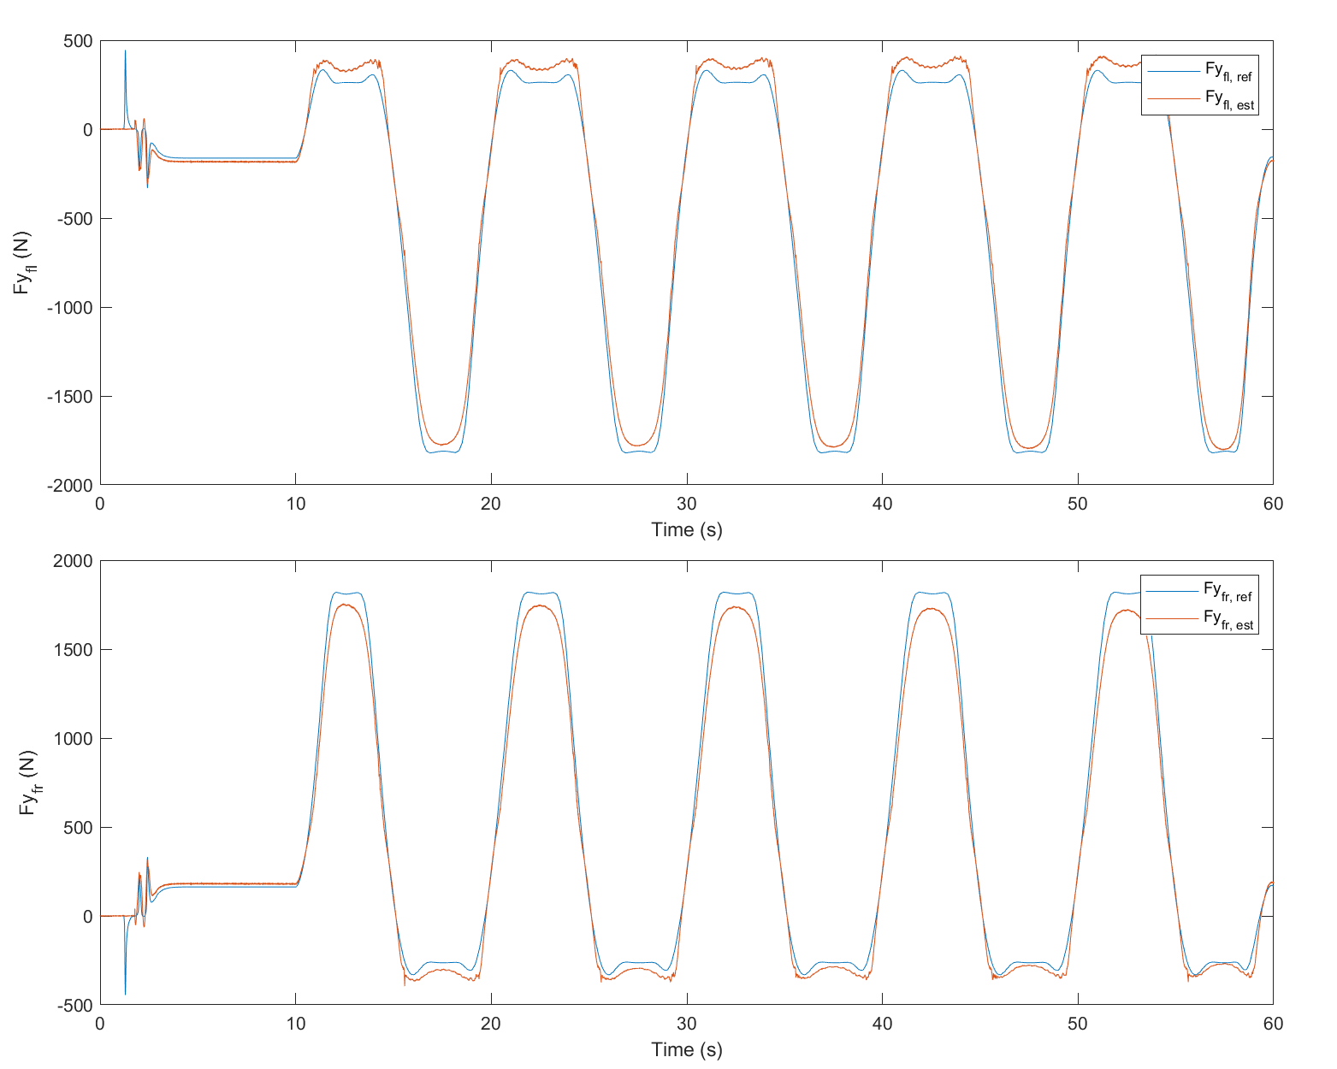

(a) (b)

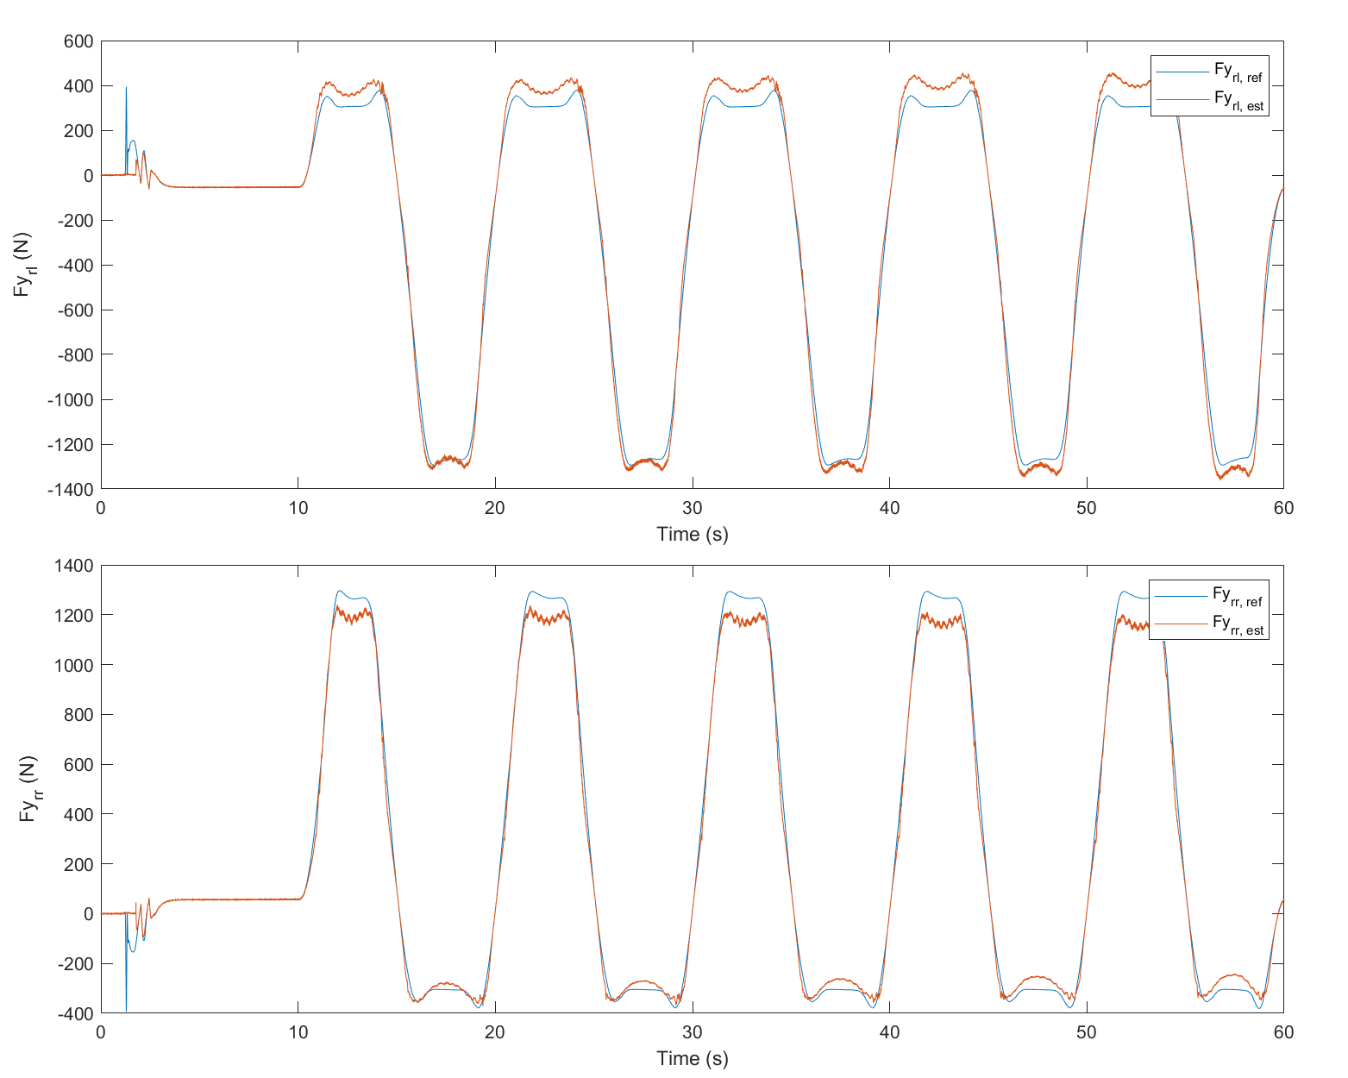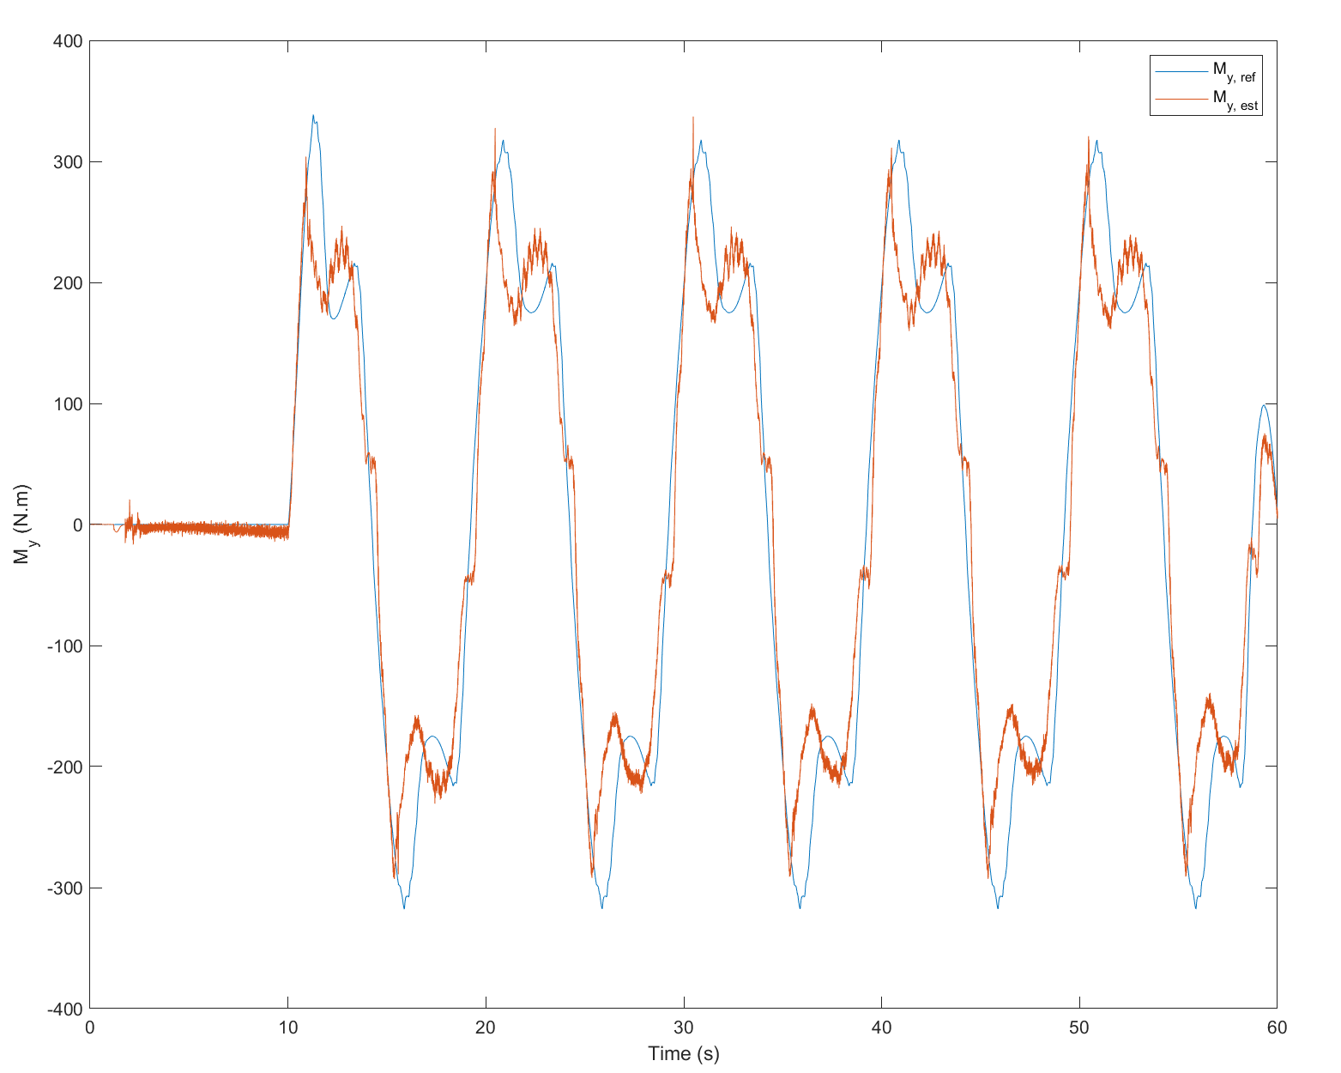

(c)

Figure 3. Estimation results for (a) front lateral force, (b) rear lateral force, and (c) *My* in sinus steer test.

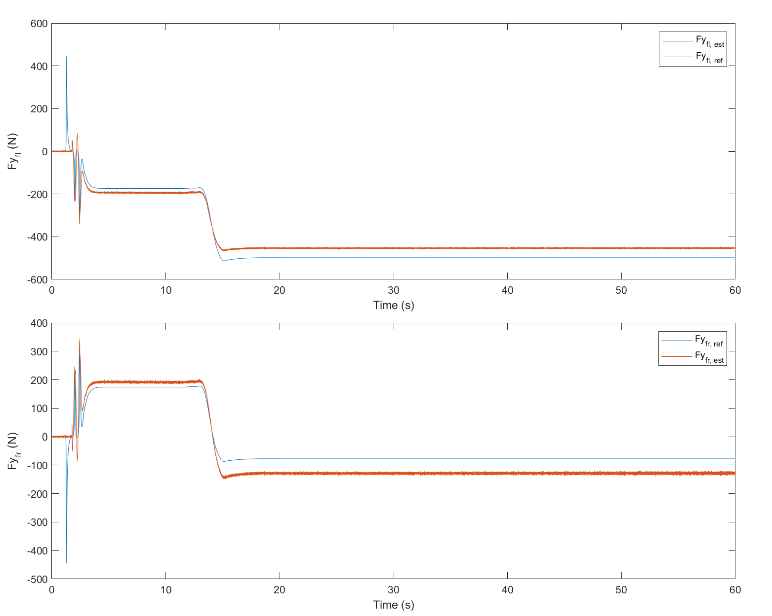

(a)

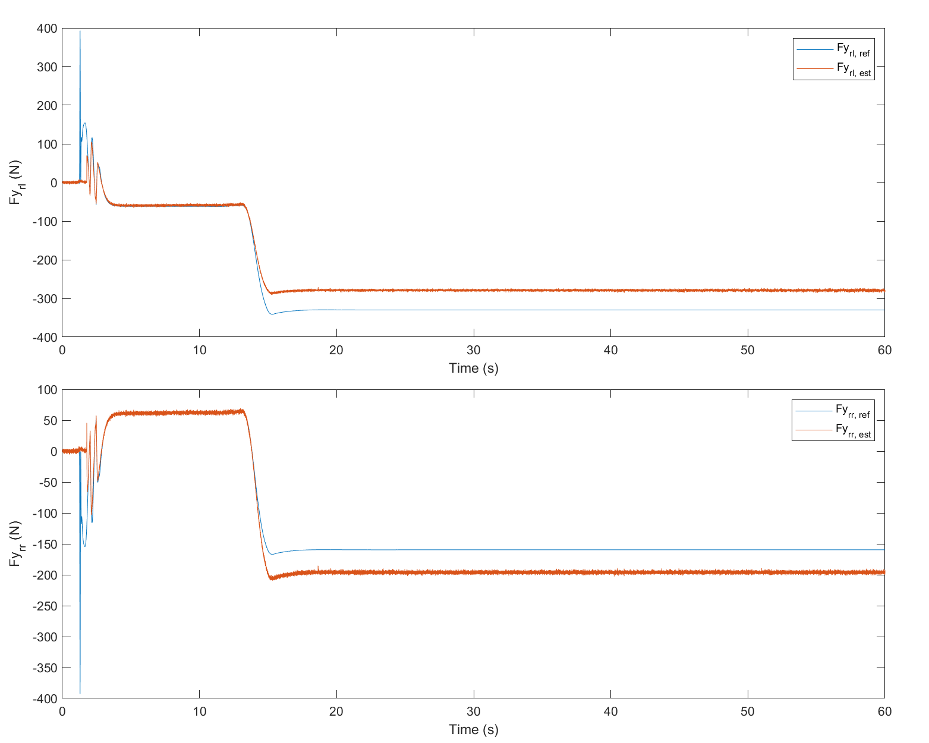

(b)

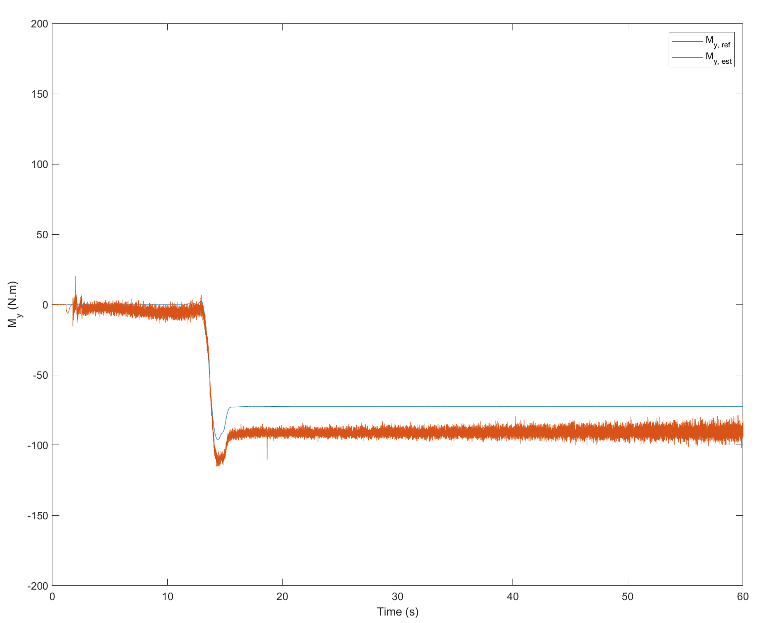

(c)

Figure 4. Estimation results of (a) front lateral force, (b) rear lateral force, (c) *My* in steady steer test.

ssssss

5. CONCLUSION

Type the contents of the conclusion here. Type the contents of the conclusion here. Type the contents of the conclusion here. Type the contents of the conclusion here. Type the contents of the conclusion here. Type the contents of the conclusion here. Type the contents of the conclusion here. Type the contents of the conclusion here. Type the contents of the conclusion here. Type the contents of the conclusion here. Type the contents of the conclusion here.

**ACKNOWLEDGEMENT−**This work was supported by Institute of Information & communications Technology Planning & Evaluation (IITP) grant funded by the Korea government (MSIT) (No.2022-0-01053, Development of Network Load Balancing Techniques Based on Multiple Communication/Computing/Storage Resources)

REFERENCES

[x1] Liang, J., Zhao, J., Dong, Z., Wang, Y. and Ding, Z.(2020). Torque Vectoring and Rear-Wheel-Steering Control for Vehicle's Uncertain Slips on Soft and Slope Terrain Using Sliding Mode Algorithm. IEEE Transactions on Vehicular Technology 69, 4, 3805-3815.

[x2] de Carvalho Pinheiro, H., Carello, M., and Punta, E. (2023). Torque vectoring control strategies comparison for hybrid vehicles with two rear electric motors. Applied Sciences 13, 14, 8109.

[x3] Zhang, L., Ding, H., Shi, J., Huang, Y., Chen, H., Guo, K., and Li, Q. (2020). An adaptive backstepping sliding mode controller to improve vehicle maneuverability and stability via torque vectoring control. IEEE Transactions on Vehicular Technology, 69, 3, 2598-2612.

[x4] Goggia, T., Sorniotti, A., De Novellis, L., Ferrara, A., Gruber, P., Theunissen, J., Steenbeke, D., Knauder,B. and Zehetner, J. (2014). Integral sliding mode for the torque-vectoring control of fully electric vehicles: Theoretical design and experimental assessment. IEEE Transactions on Vehicular Technology, 64(5), 1701-1715.

[x5] Truong, D. T., Meywerk, M., and Tomaske, W. (2013). Torque vectoring for rear axle using Adaptive Sliding Mode Control. 2013 international conference on control, automation and information sciences (ICCAIS), pp. 328-333.

* The Harvard System of references is to be used.

* In the body of the text a paper is to be referred to by the author’s Last Name with the year of publication in parentheses.

Example :

-One author (Last Name, Year)

-Two authors (Last Name and Last Name, Year)

-More than three authors (Last Name *et al*., Year)

Example :

-One author : (Huh, 2000)

-Two authors : (Incropera and DeWitt, 1990)

-More than three authors : (Park *et al*., 2002)

* References should be listed together at the end of the paper in alphabetical order by author’s Last Name.

-Type in all Author’s name and Paper title

-Type in reference of this paper in the text.

-Transactions of the Korean Society of Automotive Engineers : *Trans. Korean Society of Automotive*

*Engineers*

IJAT : *Int. J. Automotive Technology*

* Citing a minimum of one citation from the International Journal of Automotive Technology (IJAT) is recommended.

**1. Journals**

All Author(s)(Type Last Name, then first and middle initials). (Year). Paper title(Capital letter at the beginning of sentence). *Journal Name(Italic)* **Volume number(bold)**, **Issue number(bold)**, pp.−pp.

Example :

Huh, H. (2000). Identification of autobody crashworthiness for space- framed vehicle models by finite element limit analysis. *Int. J. Automotive Technology* **1**, **1**, 101−112.

**2. Books**

All Author(s)(Type Last Name, then first and middle initials). (Year). *Book Title(Italic, Capital letter at the beginning of each keyword)*. Edition number. Publisher. The Location of Publisher(City).

Example :

Incropera, F. P. and DeWitt, D. P. (1990*). Fundamentals of Heat and Mass Transfer*. 3rd edn. John Wiley & Sons. New York.

**3. Website**

All Author(s) or Title (Access Year). Detailed Address.

Example :

PermaPure LLC (2006). http://www.permapure.com/

Presentations/Fuel%20Cell%20Humidification%20

presentation.ppt

**4. Reports and User Guide**

All Author/Organization or Title (Year). Title. Organization. Serial number.

Example :

Green, P. (1980). A Computer Simulation of Headlamp Variables and Drivers Sight Dist