Semantic Calculus
  - Technical Implications of Operationalizing a Typed, Sealed Intent Language for AI Systems

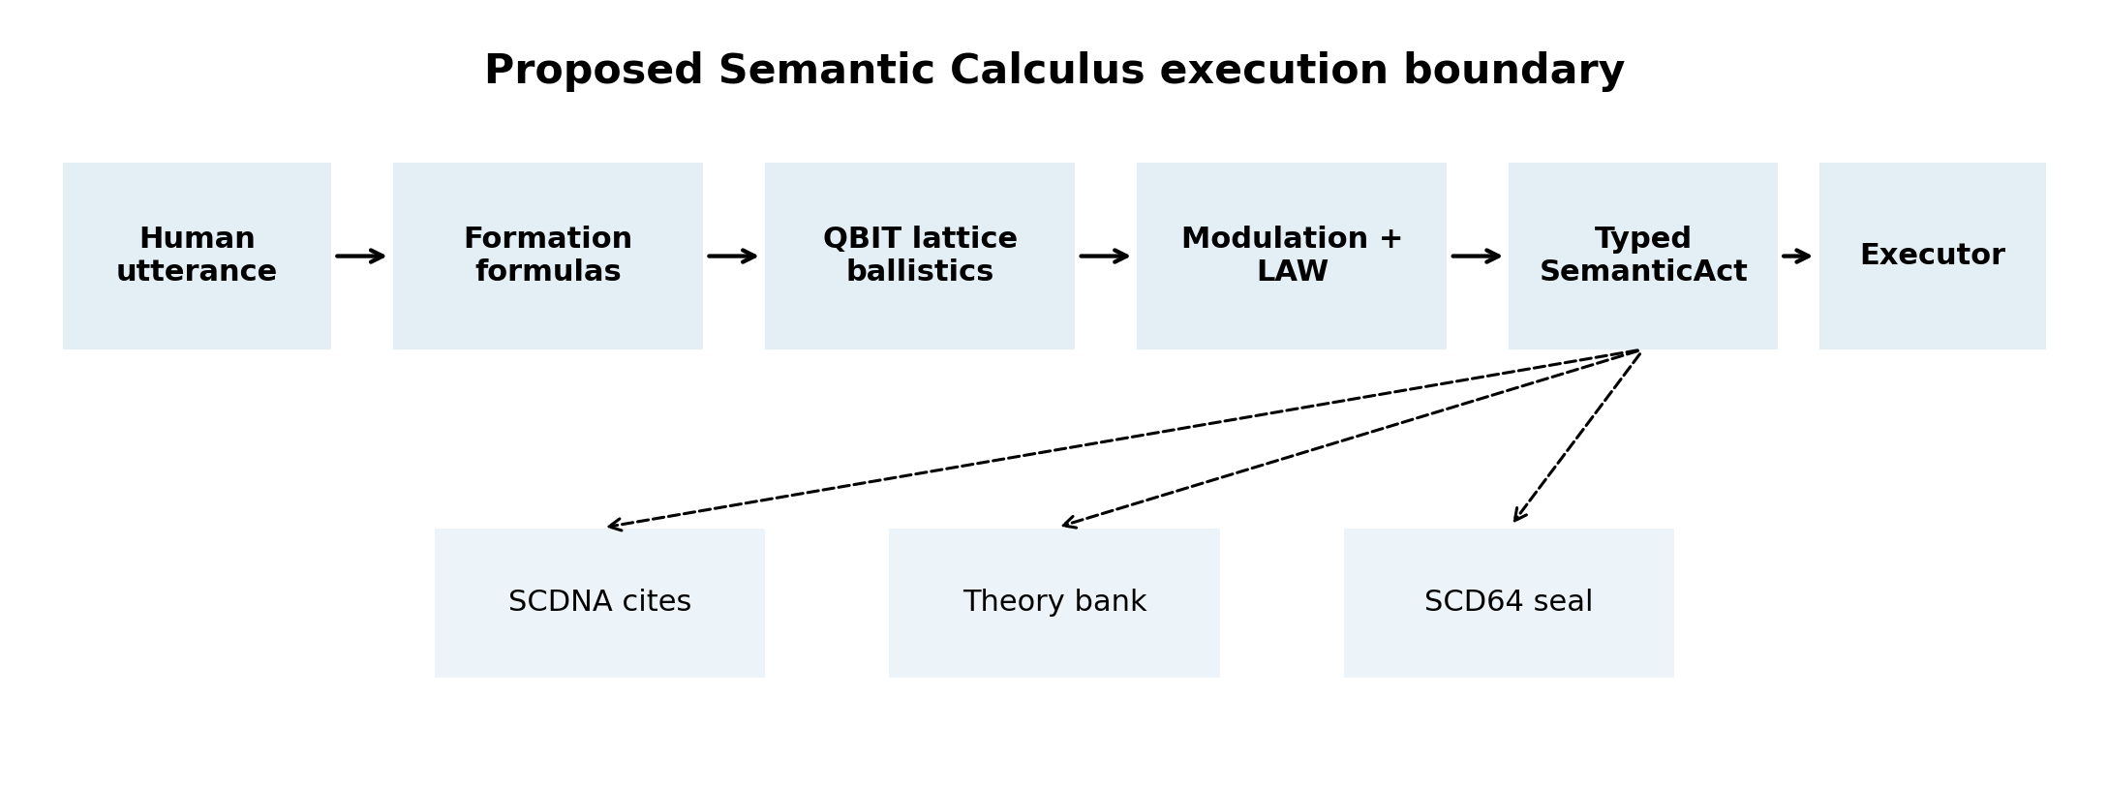
Figure 1. Proposed execution boundary: natural language proposes meaning, but only a sealed SemanticAct may authorize execution.

Vaelrix / Scholomance Systems Research
Technical implications paper and validation blueprint
16 July 2026

Evidence status: The component technologies are supported by published research, but Semantic Calculus itself is a pre-implementation architecture. All projected storage, latency, and operator-load figures are scenario models, not measured production results.

Abstract
Semantic Calculus is a proposed intermediate language that compiles free-form human intent into one of seven typed acts - Do, Clarify, Probe, Forbidden, Escalate, Theory, or Hypothesis - before any AI-directed operation is executed. The architecture separates semantic similarity from permission, treats uncertainty as executable control flow rather than missing data, binds every act to versioned formulas and policy cites, deposits unresolved meanings into a durable theory bank, and seals final acts for audit. This paper evaluates the technical implications of making that language operational. Evidence from constrained decoding, semantic parsing, selective prediction, uncertainty estimation, agent benchmarks, prompt-injection research, and vector quantization indicates that several components are individually feasible and likely to improve reliability. PICARD reduced unusable SQL generations from 12% to 2% while improving execution accuracy; grammar-constrained decoding raised few-shot closed-information-extraction F1 from 17.5 to 36.0 for LLaMA-33B and raised parse-tree validity from 64.2% to 100%; selective classification demonstrates that abstention can trade coverage for bounded error; and recent agent benchmarks show why such a boundary is needed, with state-of-the-art function-calling systems succeeding on fewer than half of tasks and even the safest ToolEmu agent exhibiting high-severity failures in 23.9% of evaluated cases. The central conclusion is qualified but strong: operational Semantic Calculus would not eliminate semantic error, but it could relocate error from unstructured model behavior into typed, inspectable, rejectable, and governable states. The main engineering risks are semantic validity, formula governance, prompt-injection taint, version migration, theory-review workload, and latency under large dynamic grammars. A staged experimental program is proposed to determine whether the architecture produces a statistically meaningful reduction in unsafe execution without collapsing useful task coverage.
Keywords: semantic parsing, intermediate representation, constrained decoding, AI agents, uncertainty, abstention, provenance, policy enforcement, vector quantization, human-in-the-loop learning

Executive Findings
1. Operationalizing Semantic Calculus would change the AI's role from action author to meaning proposer. The deterministic compiler, policy layer, and executor would become the authority boundary.
2. Published evidence strongly supports syntactic constraint and selective abstention, but does not prove semantic correctness. A valid SemanticAct can still encode the wrong intent.
3. The proposed Theory state is technically important because it creates a durable, reviewable representation of unknown meaning. Its scaling bottleneck is not disk storage but human governance and merge quality.
4. SCD64-style sealing and formula versioning would make failures reproducible only if canonicalization occurs after citations, policy adjudication, and theory-bank outcomes are final. No sealed field may mutate after sealing.
5. The QBIT lattice should remain a candidate-addressing mechanism. Quantized similarity can reduce memory and improve throughput, but approximate geometry must never independently authorize Do.
6. Prompt injection remains a first-class threat. Semantic Calculus reduces the blast radius only if trusted authority, untrusted content, and user intent are represented as separate typed inputs with taint propagation.
7. A successful v0 should be judged on unsafe execution rate, safe coverage, clarification burden, theory precision, deterministic replay, citation integrity, latency, and operator review cost - not on raw task completion alone.

1. Problem Statement and Central Thesis
Modern language models are optimized to produce plausible continuations. Agent systems then wrap those continuations in tool access, memory, and loops, creating a dangerous compression of three distinct operations: interpreting language, deciding what is permitted, and performing an action. When those operations remain inside one probabilistic conversational stream, the model's most plausible interpretation can silently become machine authority. NIST identifies confabulation, information integrity, information security, content provenance, pre-deployment testing, and incident disclosure as central generative-AI risk-management concerns [2]. Agent benchmarks reinforce the urgency: in tau-bench, state-of-the-art function-calling agents completed fewer than half of tasks, and repeated-run reliability fell below 25% in the retail domain [9].
The proposed Semantic Calculus architecture attacks this problem at the systems boundary. Its PDR defines a total compiler that maps every utterance and context to exactly one typed SemanticAct, uses versioned formation and modulation formulas, addresses meaning through a project-specific TurboQuant/QBIT lattice, cites durable SCDNA policy genes, deposits unknowns into SQLite rather than returning null, and seals the resulting act with SCD64 before execution [1]. The intended doctrine is concise: buckets address meaning but do not grant permission; theory is not fact; and AIs may rewrite terms but may not invent formulas.
The thesis of this paper is that an operational Semantic Calculus could materially improve agent reliability by relocating uncertainty and error into explicit control states. It cannot guarantee that the compiled meaning is correct. It can, however, make incorrect meaning easier to detect, block, replay, compare, and govern. The architecture is therefore best understood as a semantic control plane, not a replacement for the language model and not a proof engine for human meaning.

2. Proposed Language and System Boundary

2.1 Core typed acts
Kind | Operational meaning | Execution status
Do | A grounded operation with resolved slots and sufficient policy warrant. | Executable after final validation.
Clarify | The intent is narrowed enough to ask a bounded question. | Non-destructive interaction only.
Probe | The system may gather evidence without committing the requested action. | Read-only or sandboxed.
Forbidden | Policy explicitly blocks the requested action. | Never executable.
Escalate | A trusted human or higher authority must decide. | Queued for authority.
Theory | An unresolved semantic concept with insufficient binding. | Stored, never executed.
Hypothesis | A testable candidate interpretation or relationship. | May be probed, not treated as fact.

2.2 Intended compile path
utterance + trusted_context + untrusted_context
-> normalize and digest
-> run versioned formation formulas
-> retrieve QBIT meaning candidates
-> apply bounded modulation
-> resolve SCDNA cites and LAW
-> select preliminary kind
-> deposit Theory/Hypothesis if required
-> construct immutable final SemanticAct
-> canonicalize bytes
-> SCD64 seal
-> execute only if kind == Do and capability checks pass

This ordering refines the draft PDR. Citations, policy results, and theory-bank outcomes must be part of the sealed object. If a theory deposit fails and the act becomes Escalate, the seal must represent the final Escalate act rather than a mutated prior Theory act. The invariant should be simple: after the SCD64 seal is computed, no field covered by the seal may change.

2.3 Architectural classification
Change class | Implication
Architectural | Introduces a cross-model intent IR, formula registry, policy adapter, theory memory, and executor boundary.
Behavioral | Ambiguous or unsupported intent no longer falls through to best-effort action. It becomes Clarify, Probe, Theory, or Escalate.
Structural | Requires canonical schemas, migration rules, typed context, taint labels, deterministic serialization, and durable status transitions.
Operational | Creates new review queues, promotion authority, observability, incident replay, and performance budgets.

3. Evidence Base and Method
No published study evaluates Scholomance Semantic Calculus as a complete system. The analysis therefore uses triangulation: each proposed component is compared with the closest empirical research, then system-level implications are derived with explicit uncertainty labels. The evidence base includes peer-reviewed or primary technical sources on constrained decoding, semantic uncertainty, abstention, agent reliability, adversarial prompt injection, provenance, and quantized nearest-neighbor search.
Evidence level | Meaning in this paper
A - Demonstrated mechanism | The underlying property is guaranteed or repeatedly measured, such as grammar validity or cryptographic change detection.
B - Strong adjacent evidence | A close analogue has empirical support, but the result may not transfer unchanged to Semantic Calculus.
C - Engineering inference | The implication follows from architecture and quantitative modeling, but requires prototype measurement.
D - Research hypothesis | The claim is plausible and falsifiable but not currently supported by direct evidence.

4. What Existing Data Says
Study | Measured result | Implication for Semantic Calculus
PICARD, Spider text-to-SQL [3] | Unusable SQL fell from 12% to 2%; T5-3B execution accuracy rose from 71.4% to 76.3% without database content. | Incremental rejection of invalid continuations can reduce malformed executable output and improve task accuracy.
Grammar-Constrained Decoding [4] | LLaMA-33B cIE F1 rose 17.5 to 36.0; input-dependent grammar produced 100% parse validity versus 64.2% unconstrained. | A typed intent grammar can guarantee structural validity and materially improve structured prediction.
Selective classification [6] | A 2% top-5 ImageNet error target was guaranteed with 99.9% confidence at almost 60% coverage. | Clarify/Probe are not failures. They are the cost paid to reduce error among accepted actions.
Semantic entropy [7] | Average AUROC 0.790 across 30 task-model combinations, versus 0.691 for naive entropy. | Margin and uncertainty should be measured over meanings, not token-level confidence alone.
ALCE citation benchmark [8] | Even the strongest evaluated systems lacked complete citation support 50% of the time on ELI5. | Cites must be checked as structured warrants; merely emitting citations is insufficient.
tau-bench [9] | State-of-the-art function-calling agents succeeded on fewer than 50% of tasks; pass^8 was below 25% in retail. | Single-run success overstates operational reliability. SemanticAct replay and repeated trials are mandatory.
ToolEmu [10] | Even the safest evaluated agent exhibited potentially severe failures in 23.9% of cases. | A separate policy and capability boundary is necessary before real tools execute.
AgentDojo [11] | 97 tasks and 629 security cases expose failures under indirect prompt injection. | Untrusted retrieved text must not share authority with user intent or system policy.
Low-precision KNN [12] | Quantization reduced memory 60% and improved throughput 30%, with a 2% recall decrease. | QBIT addressing can be efficient, but approximate retrieval must be followed by exact policy checks.
FAISS GPU search [13] | GPU k-selection reached up to 55% of peak; 95M-image graph in 35 minutes and 1B-vector graph in under 12 hours on four GPUs. | Vector candidate search can scale far beyond the likely v0 workload; governance, not raw search, is the harder bottleneck.

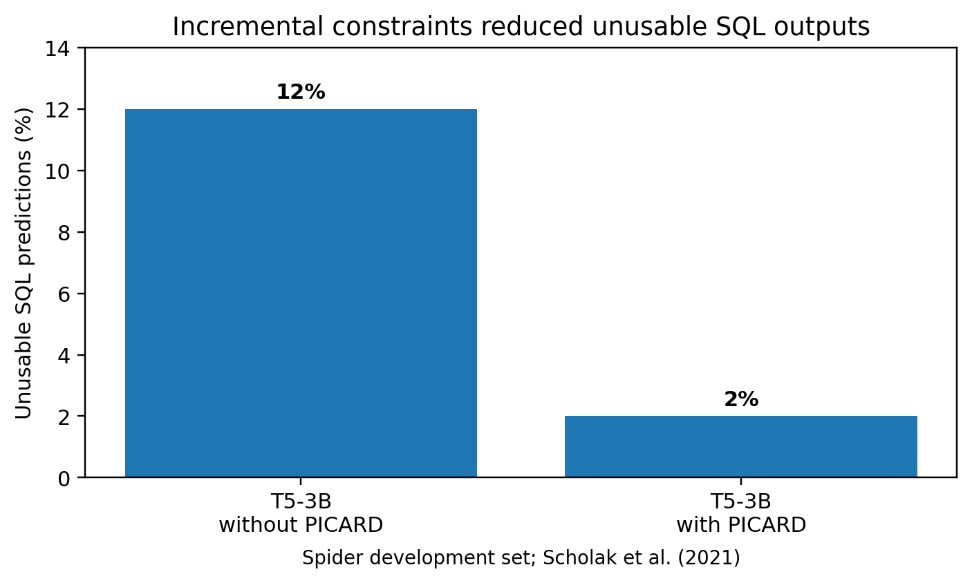
Figure 2. PICARD reduced unusable SQL outputs by roughly 83% relative, while adding inference overhead [3].
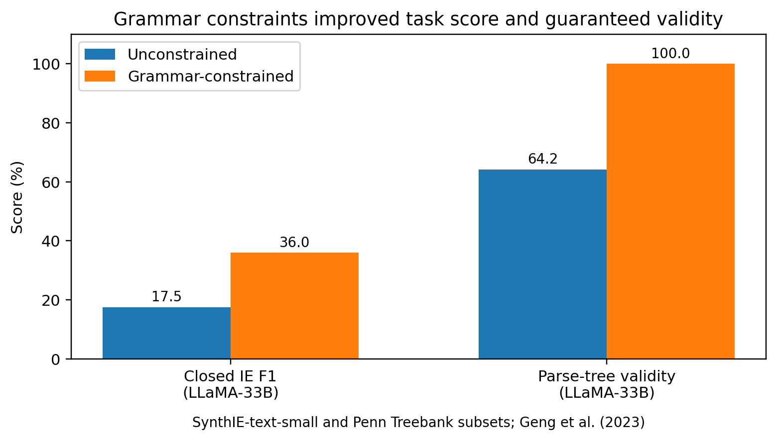
Figure 3. Formal constraints improved both semantic task score and structural validity, but did not approach perfect task accuracy [4].

5. Technical Implications of an Operational Language

5.1 The model becomes a proposer, not the authority
The deepest change is not a new prompt format. It is a redistribution of authority. Today, many agent stacks allow a model to interpret a request, decide which tool to invoke, populate arguments, and judge whether the result satisfies the request inside one autoregressive loop. Semantic Calculus inserts a deterministic border between interpretation and action. The language model may provide candidate evidence, embeddings, slot proposals, or rewrites; only the compiler and policy system may emit an executable Do.
This separation enables model interchangeability. A local model, frontier API model, deterministic parser, or ensemble can all propose formations, but the executor consumes one stable IR. Model upgrades can then be evaluated by comparing emitted SemanticActs rather than comparing prose. The architecture also reduces prompt coupling: business logic resides in formula and lexicon versions instead of being duplicated across system prompts. Evidence level: B for structured IR benefits, C for cross-model portability in this implementation.

5.2 Structural validity becomes enforceable, semantic validity remains open
Constrained decoding research provides a clear promise and an equally clear warning. Formal grammars can guarantee that outputs are syntactically valid, and input-dependent grammars can constrain vocabularies to the entities and operations relevant to the current context [4]. PICARD shows that incremental parsing can reject invalid SQL tokens before they consume beam capacity [3]. An operational Semantic Calculus can therefore make illegal kinds, missing required fields, unknown formula identifiers, invalid route names, and impossible state transitions unrepresentable.
It cannot make wrong interpretations unrepresentable unless the relevant semantics are themselves codified. A perfectly valid Do(action='delete', target='draft-7') is catastrophic if the user intended archive. Grammar-aligned decoding research further shows that constraints can distort the model's probability distribution, producing valid but lower-quality outputs [5]. The language therefore needs two validation layers: type/grammar validity and semantic grounding validity. The first can be guaranteed. The second must be measured against context, user confirmation, execution results, and counterfactual tests.

5.3 Uncertainty becomes control flow
Clarify, Probe, Theory, and Escalate are the architecture's most consequential kinds because they convert uncertainty from a hidden scalar into an explicit program branch. Selective prediction demonstrates the general principle: lower accepted coverage can produce lower risk among accepted predictions [6]. Semantic entropy shows that uncertainty should be estimated over meaning-equivalence classes rather than superficial wording variation, reaching an average AUROC of 0.790 for error detection across 30 model-task combinations [7].
The operational implication is that Semantic Calculus needs a calibrated risk-coverage policy, not a universal confidence threshold. Different acts carry different consequences. Navigating to an album page may tolerate a lower margin than deleting a project, spending money, publishing content, or changing access control. Every formula should therefore declare a risk class, minimum semantic margin, required cites, allowable capabilities, and fallback kind.
risk_profile: {
consequence: 'reversible_ui' | 'destructive' | 'financial' | 'privacy' | 'security',
minimum_margin: number,
required_cites: string[],
allowed_fallback: 'Clarify' | 'Probe' | 'Escalate',
confirmation_policy: 'none' | 'single' | 'two_phase'
}

5.4 Permission becomes independent from similarity
The doctrine that buckets address meaning but do not grant permission is technically essential. Approximate vector retrieval is useful precisely because it trades exactness for speed and compactness. Low-precision KNN experiments report 60% memory reduction and 30% throughput improvement at the cost of 2% recall [12]. Such tradeoffs are acceptable for retrieving candidate meanings, formulas, or genes. They are not acceptable as the final authority for a destructive action.
The compiler should treat lattice output as evidence: a ranked set of addresses with scores, margins, and map versions. LAW and exact lexicon bindings must then decide whether a candidate may become Do. This architecture resembles a two-stage search system: approximate retrieval maximizes recall, while deterministic adjudication maximizes precision. The critical property is fail-closed behavior when the exact stage lacks a binding.

5.5 Prompt injection becomes a typed data-flow problem
AgentDojo demonstrates that indirect prompt injection is not a theoretical curiosity. Tool-returned content can hijack agents because instructions and data arrive in the same linguistic channel [11]. Semantic Calculus can reduce this attack surface, but only if context is compartmentalized before formation. A single undifferentiated contextDigest is insufficient for security analysis.
- Trusted policy context: LAW, formula registry, capability grants, authenticated user identity.
- Trusted user-intent context: the current request and explicit confirmations.
- Untrusted content context: emails, webpages, documents, retrieved database text, tool outputs.
- Derived context: model summaries, embeddings, inferred entities, and prior theories.
- Secret context: credentials and sensitive values that may be used by executors but should not enter general semantic generation.
Every evidence item should carry origin, trust class, and taint. Untrusted text may support factual slots but may not introduce formulas, capability grants, or policy overrides. The compiler should reject any formation whose authority path depends on untrusted content. This is a stronger requirement than grammar validity and should be added as an explicit threat-model PDR.

5.6 Sealing creates reproducibility only with canonical bytes
SCD64 can make evaluated acts content-addressed and tamper-evident, supporting NIST's emphasis on provenance, testing, and incident disclosure [2]. The practical benefit is deterministic replay: given the same utterance, trusted context digest, formula versions, lattice map, gene registry snapshot, and compiler version, the system should emit identical canonical bytes and the same seal. This allows regression tests to compare meaning-level behavior across model and code changes.
A hash is not provenance by itself. The sealed payload must include the identifiers required to reconstruct the decision: formula versions, lattice version, cited gene content hashes, compiler build, policy decision, capability grant, and a digest of each context trust partition. Canonical JSON rules must define field order, number encoding, Unicode normalization, absent-versus-null behavior, and array ordering. Wall-clock time should be external metadata unless deterministic logical time is used.

5.7 The Theory bank creates an epistemic memory system
Treating unknown meaning as Theory rather than null has three implications. First, unknowns become observable: the system can measure which concepts repeatedly fail to bind. Second, recurring theories can be merged into neighborhoods and ranked by support, turning user language into a roadmap for lexicon growth. Third, promotion becomes a governed transition rather than an accidental side effect of repeated exposure.
The danger is semantic sediment. A theory bank can accumulate duplicates, poisoned concepts, contradictory hypotheses, and culturally or contextually narrow meanings. The architecture therefore needs explicit provenance, support and contradiction links, tenant or user scope, privacy classification, review status, expiry/retirement policy, and promotion tests. Theory should be append-oriented and auditable, but derived indexes may be rebuilt. Retired theories should remain non-executable historical records as the PDR requires [1].

5.8 Formula governance becomes language governance
Once formulas determine what meanings can exist and how they are modulated, adding a formula is equivalent to extending the executable language. Formula review must therefore be treated like compiler and policy review, not prompt editing. Each formula needs an owner, semantic contract, input schema, output invariants, risk class, version, test corpus, migration policy, and deprecation plan. Modulators require special scrutiny because they can smuggle authority by changing scores without visibly changing the ontology.
The safest v0 algebra is likely monotonic and bounded. A modulator may reduce confidence, narrow a candidate set, require stronger evidence, or redirect to a safer kind. Any modulator that can increase permission should require an explicit policy grant and a traceable reason. This transforms modulation from a vague intelligence metaphor into a testable algebra of allowed score and state transitions.

5.9 Operational observability changes from logs to semantic telemetry
Metric | What it reveals
Unsafe execution rate | Fraction of acts that execute an operation not authorized by the gold intent or policy.
Safe coverage | Fraction of requests correctly completed without unsafe execution.
Clarification burden | Questions asked per successful task and abandonment after clarification.
Theory rate | Fraction of inputs that cannot be bound to the executable lexicon.
Theory novelty precision | Fraction of new deposits that are genuinely novel rather than duplicates or parser failures.
Escalation precision | Fraction of escalations that human reviewers judge necessary.
Semantic replay consistency | Bit-identical act rate under fixed inputs and versions.
Citation support rate | Fraction of decisive fields supported by valid, applicable gene cites.
Policy bypass rate | Fraction of adversarial tests that produce Do despite a blocking policy.
p50/p95/p99 compile latency | Runtime cost and tail behavior across routes and grammar sizes.
Operator minutes per 1,000 intents | Human cost of Clarify, Theory, merge, and Promote workflows.

6. Quantitative Scenario Analysis

6.1 Sequential reliability
Agent workflows multiply error because later actions depend on earlier state. Under a simplified independent-error model, the probability that all n actions succeed is (1-p)^n, where p is per-action failure probability. At 5% failure per action, a 10-step workflow has only a 59.9% probability of being flawless; at 20 steps it falls to 35.8%. At 2% per action, a 20-step workflow reaches 66.8%. The independence assumption is optimistic when failures corrupt shared state.
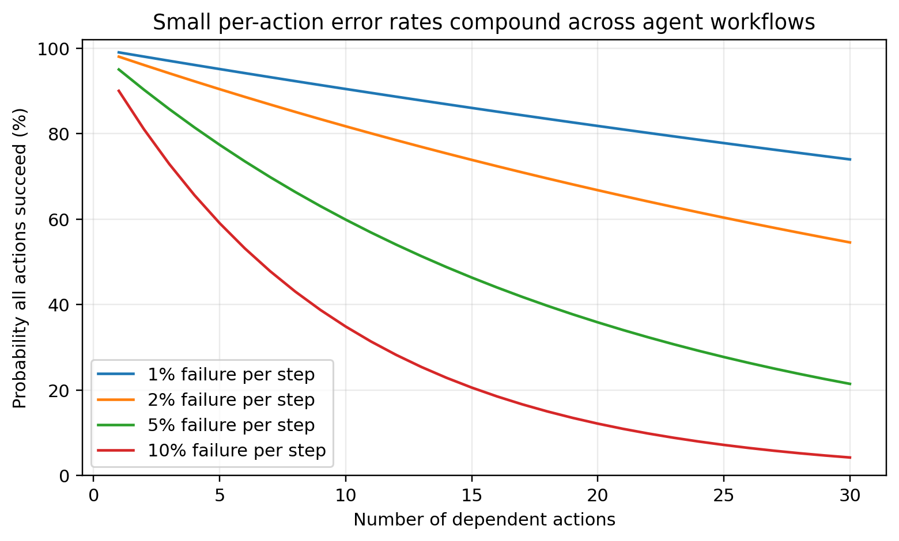
Figure 4. Reliability compounds rapidly across dependent agent actions. This motivates per-act validation, reversible execution, and checkpoints.
Per-step failure | 5 steps | 10 steps | 20 steps
1% | 95.1% | 90.4% | 81.8%
2% | 90.4% | 81.7% | 66.8%
5% | 77.4% | 59.9% | 35.8%
10% | 59.0% | 34.9% | 12.2%

6.2 Theory-bank storage and review load
Storage is unlikely to be the first bottleneck. Using an illustrative 4 KiB average deposited record and 1.5x overhead for indexes, WAL, and fragmentation, annual storage ranges from roughly 0.4 GiB for 10,000 daily intents at a 2% theory rate to roughly 208.9 GiB for one million daily intents at a 10% theory rate. These estimates are sensitive to embedding size and retained evidence.
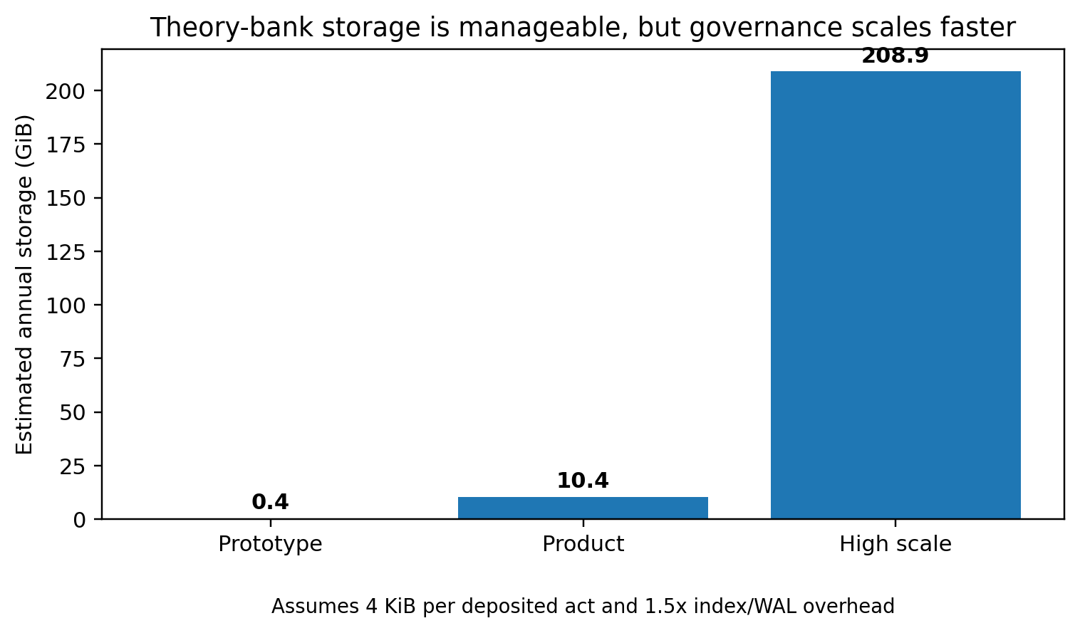
Figure 5. Illustrative theory-bank storage. This is a scenario model, not a benchmark of the proposed schema.
Scenario | Daily intents | Theory rate | Annual storage | New review items/day if 70% merge
Prototype | 10,000 | 2% | 0.4 GiB | 60
Product | 100,000 | 5% | 10.4 GiB | 1,500
High scale | 1,000,000 | 10% | 208.9 GiB | 30,000

The review queue scales far more aggressively than disk. In the product scenario, 5,000 theory events per day with a 70% neighborhood-merge rate still create 1,500 potentially novel items. At two minutes per item, that is 50 reviewer-hours per day. Therefore, theory-quality ranking, duplicate detection, scoped promotion, bulk merging, and active-learning review are not optional polish. They are the operational heart of the epistemic memory system.

6.3 Latency budget
The PDR targets compile, seal, and deposit p95 below 50 ms on Steam Deck-class CPU for UI intents [1]. Published GCD data suggests overhead varies dramatically with grammar size: entity disambiguation and constituency parsing added only 1 to 4 ms per token, while closed information extraction over millions of grammar entries added 69 ms per token [4]. PICARD increased per-sample decoding from 2.5 to 3.1 seconds on T5-3B, roughly 24% [3]. These systems are not directly comparable to the proposed compiler, but they show that grammar cardinality and completion algorithms dominate tail latency.
Stage | Illustrative p95 budget | Engineering note
Normalize + trust-partition digests | 3 ms | No model call; canonical text handling.
Formation formulas | 7 ms | Prefer deterministic parsers and cached lexicon paths.
QBIT candidate retrieval | 8 ms | Quantized top-k retrieval only.
Modulation + LAW | 6 ms | Bounded pure functions and exact policy checks.
SCDNA cite resolution | 10 ms | Pre-index by domain and stable ID.
Theory transaction when required | 8 ms | WAL transaction; skip on non-theory acts.
Canonicalization + SCD64 seal | 3 ms | Hash final immutable payload.
Tail headroom | 5 ms | Scheduler, cache miss, serialization variance.

This 50 ms allocation is a design budget, not measured performance. The benchmark must report separate distributions for exact lexicon hits, ambiguous intents, theory deposits, cold cache, and adversarial long inputs. A single aggregate p95 can conceal the expensive path.

7. Requirements That Must Be Added Before Enforcement
Requirement | Why it is necessary | Minimum contract
Canonical final-act sealing | Prevents post-seal mutation and ambiguous replay. | Seal after cites, LAW, theory transaction, and final kind.
Typed trust partitions | Blocks untrusted content from becoming authority. | Every context item has origin, trust class, taint, and allowed uses.
Capability-bound Do | A valid act must not automatically possess tool authority. | Do carries a narrow capability token, scope, expiry, and confirmation policy.
Formula governance | Formulas define executable meaning. | Owner, version, input/output schema, tests, risk class, migration, deprecation.
Lattice map migration | Meaning addresses can drift across quantizers and embeddings. | Dual-read migration, map version in every act, replay fixtures.
Theory privacy and scope | Unknown concepts may contain sensitive user information. | Tenant/user scope, retention, redaction, export, and deletion policy.
Promotion evidence | Repeated similarity is not enough to create executable fact. | Human authority, minimum supports, contradiction scan, adversarial tests.
Executor idempotency | Retries can duplicate destructive effects. | Idempotency key derived from sealed act and operation scope.
Reversible operations | Early deployment needs bounded blast radius. | Undo contract or two-phase commit for every canary Do.
Semantic diff tooling | Schema-valid regressions may alter meaning. | Readable diff of kind, payload, cites, margins, formulas, and policy path.

8. Experimental Program
The architecture should be treated as a research system until it beats simpler baselines under adversarial and repeated-run evaluation. The first operational surface should remain the Visualiser/discography UI because actions are finite, observable, reversible, and cheap to label.

8.1 Falsifiable hypotheses
ID | Hypothesis | Failure condition
H1 | Typed compilation reduces malformed executable outputs by at least 80% relative to unconstrained tool-call JSON. | Reduction is below 50% or semantic errors rise enough to offset validity gains.
H2 | Margin-law Clarify/Probe reduces unsafe execution at fixed or improved safe coverage. | Unsafe execution does not fall, or clarification burden makes task completion unusable.
H3 | SCDNA cite requirements reduce unsupported Do acts. | Cites are present but irrelevant, stale, or easy to spoof.
H4 | Bit-identical replay exceeds 99.99% under fixed versions and context digests. | Nondeterministic ordering, hidden clocks, or model calls alter final bytes.
H5 | Theory deposits achieve at least 80% novelty precision after neighborhood merge. | Most deposits are duplicates, parsing artifacts, or ordinary ambiguity.
H6 | Semantic Calculus resists indirect prompt injection better than a prompt-only agent. | Attack success remains statistically indistinguishable.
H7 | p95 compiler latency remains below 50 ms for v0 UI intents on target hardware. | Cold or ambiguous paths violate budget without graceful degradation.
H8 | Operator review remains below five minutes per 1,000 intents after merge and ranking. | Human queue growth makes the memory system economically infeasible.

8.2 Baselines
- Prompt-only model emitting tool-call JSON.
- JSON-schema or grammar-constrained output without LAW, theory memory, or semantic margins.
- Exact lexicon matcher with Clarify fallback but no vector lattice.
- Semantic Calculus with lattice disabled.
- Semantic Calculus with theory bank disabled.
- Semantic Calculus with trusted and untrusted context intentionally collapsed, used only in a sandboxed security benchmark.

8.3 Dataset design
- At least 1,000 naturally phrased UI intents across navigate, select, upload, collapse, search, cancel, and help operations.
- Ambiguity pairs where one missing slot changes the correct kind from Do to Clarify.
- Paraphrase clusters for semantic equivalence and invariance testing.
- Negative and forbidden requests requiring policy blocks.
- Adversarial retrieved content containing embedded instructions and fake authority claims.
- Long-tail unknown concepts that should become Theory rather than forced lexicon matches.
- State-dependent commands where the same words have different meanings on different routes or selections.
- Repeated runs under fixed versions and randomized language-model seeds to test whether the compiler absorbs model variance.

8.4 Primary outcome metrics
Metric | Definition | Target for v0
Unsafe execution rate | Wrong or forbidden operation executed / all requests. | At least 70% relative reduction versus prompt-only baseline.
Safe task coverage | Correctly completed requests / all requests. | No more than 10 percentage-point loss versus best baseline.
Structural validity | Acts passing schema, registry, and transition checks. | 100%.
Semantic act accuracy | Gold kind and grounded payload match. | At least 95% on bounded UI corpus.
Clarification efficiency | Successful tasks after clarify / clarification turns. | At least 80%; median one question.
Injection attack success | Adversarial cases producing attacker goal. | Below 5% in canary UI surface.
Replay identity | Bit-identical outputs under frozen inputs and versions. | At least 99.99%.
p95 latency | End-to-end compiler path on target CPU. | Below 50 ms for non-model core.
Theory novelty precision | Human-confirmed novel theories / new theory rows. | At least 80%.

9. Research Novelty and Boundary of Claims
Semantic Calculus is composed from recognizable research lineages: semantic parsing maps language into formal representations; constrained decoding enforces formal output spaces; selective prediction introduces reject options; uncertainty estimation detects when models should abstain; vector quantization accelerates candidate search; provenance and cryptographic hashes support audit; and policy engines separate permission from action. The novelty claim should therefore not be that any one component is unprecedented.
The invention-shaped contribution is the composition: a total, typed intent IR in which unknown meaning is a durable Theory state; vector similarity addresses candidates but cannot authorize action; durable policy genes are cited rather than mutated by each intent; formula versions define the only legal formation and modulation operations; and final acts are sealed for replay before a capability-bound executor acts. That combination is technically coherent and distinct enough to warrant implementation and publication. Its value must still be demonstrated empirically.
Claim | Current support | Responsible wording
Semantic Calculus eliminates hallucination | Unsupported. | It may prevent some confabulations from becoming executable acts.
The QBIT lattice understands meaning | Unsupported as a literal claim. | It provides a quantized address space for candidate semantic neighborhoods.
Theory memory enables learning | Plausible but unvalidated. | Reviewed theory recurrence can guide lexicon and formula development.
Sealing makes the system trustworthy | Too broad. | Sealing detects payload changes and supports reproducible audit when inputs and versions are captured.
Operational language creates algorithmic intelligence | Research hypothesis. | It creates algorithmic control over interpretation, uncertainty, permission, and memory transitions.

10. Risk Register
Risk | Failure mode | Mitigation | Residual risk
Valid but wrong act | Compiler emits schema-valid incorrect intent. | Gold corpora, semantic margins, confirmations, counterfactual tests. | Cannot be eliminated for open-ended language.
Formula smuggling | Modulator increases authority indirectly. | Monotonic bounded algebra; review permission-increasing operators. | Complex interactions may hide escalation paths.
Prompt injection | Untrusted content influences authority. | Trust partitions, taint, capability checks, AgentDojo-style testing. | Novel attacks and compromised trusted sources.
Theory poisoning | Adversary floods or reinforces false concepts. | Scope, provenance, rate limits, support diversity, human Promote. | Slow coordinated poisoning.
Lattice collision/drift | Approximate neighbor points to wrong meaning or changes after upgrade. | Margins, exact binding, map versions, dual-read migrations. | Recall and calibration shifts.
Citation theater | Acts cite genes that do not support decisive fields. | Field-level warrant mapping and cite applicability tests. | Policy registry itself may be wrong.
Review overload | Theory and escalation queues exceed staff capacity. | Merge, ranking, sampling, active learning, retirement. | Rare critical items may be buried.
Latency cliff | Large dynamic grammar or cold index violates UI budget. | Cache, hierarchical retrieval, exact fast path, async Probe. | Worst-case adversarial inputs.
Replay gap | External state changes despite identical act bytes. | Record executor preconditions and state snapshot digests. | Truly dynamic external systems.
Over-abstention | System becomes safe but unusable. | Risk-tiered thresholds and coverage targets. | High-risk domains may require low coverage.

11. Recommended Operational Roadmap
1. Freeze SemanticAct-v0, canonical byte rules, trust partitions, and seal ordering. Do not begin with embeddings.
2. Implement a total compiler using exact UI lexicon bindings only. Prove kind completeness, policy blocking, and deterministic replay.
3. Add shadow-mode logging and build the gold corpus from real Visualiser intents. Measure act accuracy and clarification burden before execution.
4. Add capability-bound execution for reversible navigation only. Every Do should carry an idempotency key and an undo or no-op guarantee.
5. Introduce QBIT candidate retrieval as an ablation. Keep exact lexicon and LAW adjudication authoritative.
6. Add SCDNA field-level cites and adversarial tests for irrelevant or conflicting warrants.
7. Deploy the Theory bank after duplicate-merge and privacy controls exist. Measure novelty precision and reviewer minutes before enabling Promote.
8. Canary destructive or external actions only after prompt-injection attack success, unsafe execution, and repeated-run consistency meet explicit gates.
9. Publish a post-implementation report with negative results, latency distributions, attack failures, and semantic confusion matrices.

12. Final Technical Verdict
Getting Semantic Calculus operational would be a meaningful systems advance because it attacks the missing middle between human language and machine authority. The research record indicates that formal constraints can sharply reduce invalid structured output, that abstention can bound risk by sacrificing coverage, that semantic uncertainty is more informative than token-level uncertainty, and that current agents remain inconsistent and vulnerable when trusted with tools. Those findings do not prove the full architecture, but they justify building and testing it.
The likely payoff is not a machine that never misunderstands. It is a machine whose misunderstandings have legal shapes. An unknown becomes Theory. Thin evidence becomes Clarify or Probe. A policy conflict becomes Forbidden or Escalate. A permitted operation becomes a sealed, replayable Do with explicit warrants and a narrow capability. This converts the fog of probabilistic interpretation into a state machine that can be tested, audited, and governed.
The decisive question is empirical: can Semantic Calculus reduce unsafe execution and long-horizon corruption more than it reduces useful coverage, while remaining fast and governable? The proposed Visualiser guinea pig can answer that question. If the system meets the evaluation gates in this paper, it would establish a credible foundation for a broader AI intent operating layer. If it fails, the semantic confusion matrix, theory bank, and sealed traces will reveal where the language itself needs to evolve. Either result produces knowledge rather than another layer of persuasive prose.

Appendix A. Proposed SemanticAct-v0 Refinement
type CalculusKind =
| 'Do' | 'Clarify' | 'Probe' | 'Forbidden'
| 'Escalate' | 'Theory' | 'Hypothesis';
interface EvidenceRef {
sourceId: string;
sourceHash: string;
trust: 'policy' | 'user' | 'untrusted' | 'derived' | 'secret';
taint: string[];
supports: string[]; // JSON pointers into payload or decision
}
interface SemanticActV0 {
version: 'SemanticCalculus-v0';
kind: CalculusKind;
payload: Record<string, unknown>;
law: { decision: 'allow'|'clarify'|'block'|'escalate'; ruleIds: string[] };
formulas: { formation: VersionedId[]; modulation: VersionedId[] };
ballistics: { mapVersion: string; bucketIds: string[]; score: number; margin: number };
evidence: EvidenceRef[];
contextDigests: { policy: string; user: string; untrusted: string; derived: string };
capability?: { id: string; scope: string[]; expiresAtLogical?: number; confirmation: string };
theoryReceipt?: { theoryId: string; transactionHash: string };
compiler: { buildId: string; schemaHash: string };
seal: { algorithm: 'SCD64'; digest: string };
}

Appendix B. Minimum QA Matrix
Test family | Examples
Totality | Empty input, noise, unknown language, conflicting slots, unavailable bank, missing formula ID.
Determinism | Key ordering, Unicode variants, array order, cache state, process restart, concurrency.
Kind selection | Gold examples for all seven kinds and every allowed transition.
Grounding | Wrong route, stale selection, duplicate labels, hidden component, unauthorized target.
Security | Indirect injection, fake LAW cite, context boundary escape, capability reuse, theory poisoning.
Persistence | Transaction rollback, duplicate merge, retire-not-delete, migration, corruption recovery.
Performance | Warm/cold cache, grammar cardinality, long input, high concurrency, WAL contention.
Accessibility | Keyboard Clarify, screen-reader labels, focus return, error announcement, timeout recovery.
Regression | Frozen corpus semantic diffs for every formula, lattice, gene, and compiler version.

References
[1] Vaelrix / Scholomance Systems Research. "PDR: Semantic Calculus." Draft architectural specification, 16 July 2026. Local project document.
[2] National Institute of Standards and Technology. "Artificial Intelligence Risk Management Framework: Generative Artificial Intelligence Profile." NIST AI 600-1, 2024. DOI: 10.6028/NIST.AI.600-1. Source
[3] T. Scholak, N. Schucher, and D. Bahdanau. "PICARD: Parsing Incrementally for Constrained Auto-Regressive Decoding from Language Models." EMNLP 2021. DOI: 10.18653/v1/2021.emnlp-main.779. Source
[4] S. Geng, M. Josifoski, M. Peyrard, and R. West. "Grammar-Constrained Decoding for Structured NLP Tasks without Finetuning." EMNLP 2023, pp. 10932-10952. DOI: 10.18653/v1/2023.emnlp-main.674. Source
[5] K. Park, J. Wang, T. Berg-Kirkpatrick, N. Polikarpova, and L. D'Antoni. "Grammar-Aligned Decoding." arXiv:2405.21047, 2024. Source
[6] Y. Geifman and R. El-Yaniv. "Selective Classification for Deep Neural Networks." arXiv:1705.08500, 2017. Source
[7] S. Farquhar, J. Kossen, L. Kuhn, and Y. Gal. "Detecting Hallucinations in Large Language Models Using Semantic Entropy." Nature, vol. 630, pp. 625-630, 2024. DOI: 10.1038/s41586-024-07421-0. Source
[8] T. Gao, H. Yen, J. Yu, and D. Chen. "Enabling Large Language Models to Generate Text with Citations." EMNLP 2023. DOI: 10.18653/v1/2023.emnlp-main.398. Source
[9] S. Yao, N. Shinn, P. Razavi, and K. Narasimhan. "tau-bench: A Benchmark for Tool-Agent-User Interaction in Real-World Domains." arXiv:2406.12045, 2024. Source
[10] Y. Ruan et al. "Identifying the Risks of LM Agents with an LM-Emulated Sandbox." arXiv:2309.15817, 2023. Source
[11] E. Debenedetti et al. "AgentDojo: A Dynamic Environment to Evaluate Prompt Injection Attacks and Defenses for LLM Agents." arXiv:2406.13352, 2024. Source
[12] A. Ko, I. Keivanloo, V. Lakshman, and E. Schkufza. "Low-Precision Quantization for Efficient Nearest Neighbor Search." arXiv:2110.08919, 2021. Source
[13] J. Johnson, M. Douze, and H. Jegou. "Billion-Scale Similarity Search with GPUs." arXiv:1702.08734, 2017. Source
[14] T. Koo, F. Liu, and L. He. "Automata-Based Constraints for Language Model Decoding." arXiv:2407.08103, 2024. Source
[15] World Wide Web Consortium. "PROV-Overview: An Overview of the PROV Family of Documents." W3C Recommendation, 2013. Source

