**Project Purpose**

The purpose behind this project it to build a system where people can find various jobs and apply to them. Also, the recruiters can post job ads in the system.

**Project Goals and Objectives**

The goals and objectives are as follows:

1. To have the ability of searching through jobs for the job seekers.
2. Having the ability of managing all the user accounts of all types.
3. To be able to post, update and delete job recruitment ads.
4. Being able to store and retrieve data from the database.

**Project Description**

Job portal is an online application where people can search for various jobs and the employers can post job ads for recruiting people. The application manages all the job applications, information of all users and job searching capability. All the information is stored in the database and can be retrieved when required.

**Scope**

From a larger viewpoint it is an application that makes a connection of people of two categories where on is providing and another is receiving. From that point, this application can also be used for similar categories of purposes like, advertisement, online trading etc.

**System Users**

* **Administrators:** Has full control over the application
* **Employers:** Has the ability of posting, deleting, updating jobs. Also is capable of managing job application**s.**
* **Jobseekers:** Can search through jobs and apply if desired.

**Database**

**ER Diagram:**

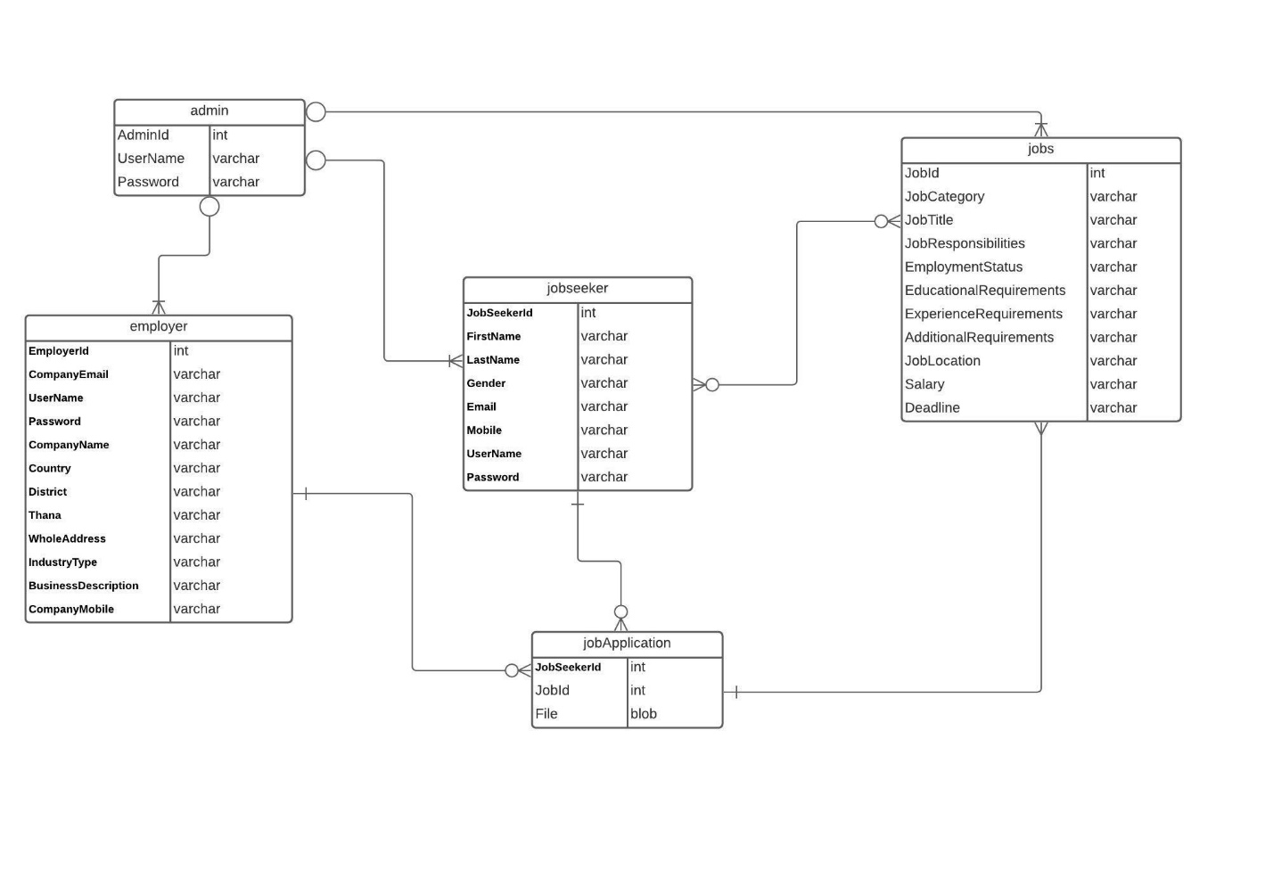

**Processes**

**Authentication:** The system provides security features through username-password matching where only authorized user can access the system with different authorization level.

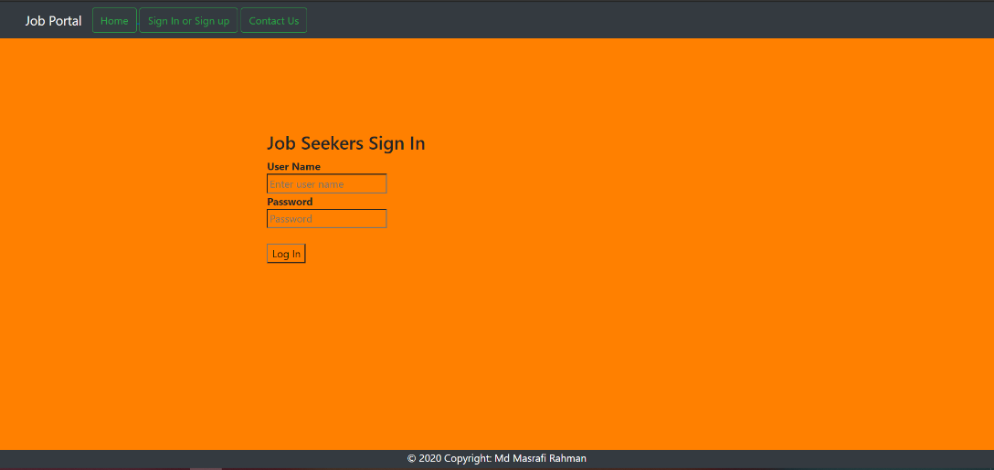

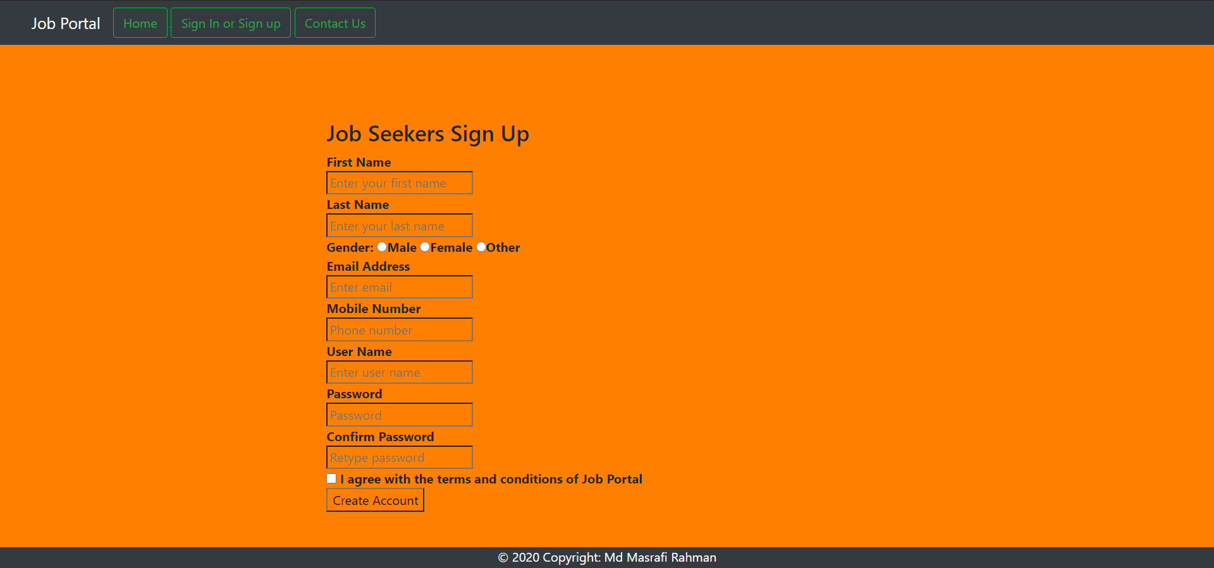

**Account Management:**

There is capability to manage each user accounts. The admin is capable of removing any user.

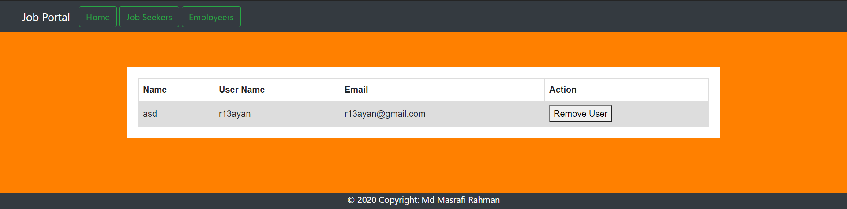

**Job Post Management:**

The employers are able to post jobs and manage them. The admin is also able to remove any job post.

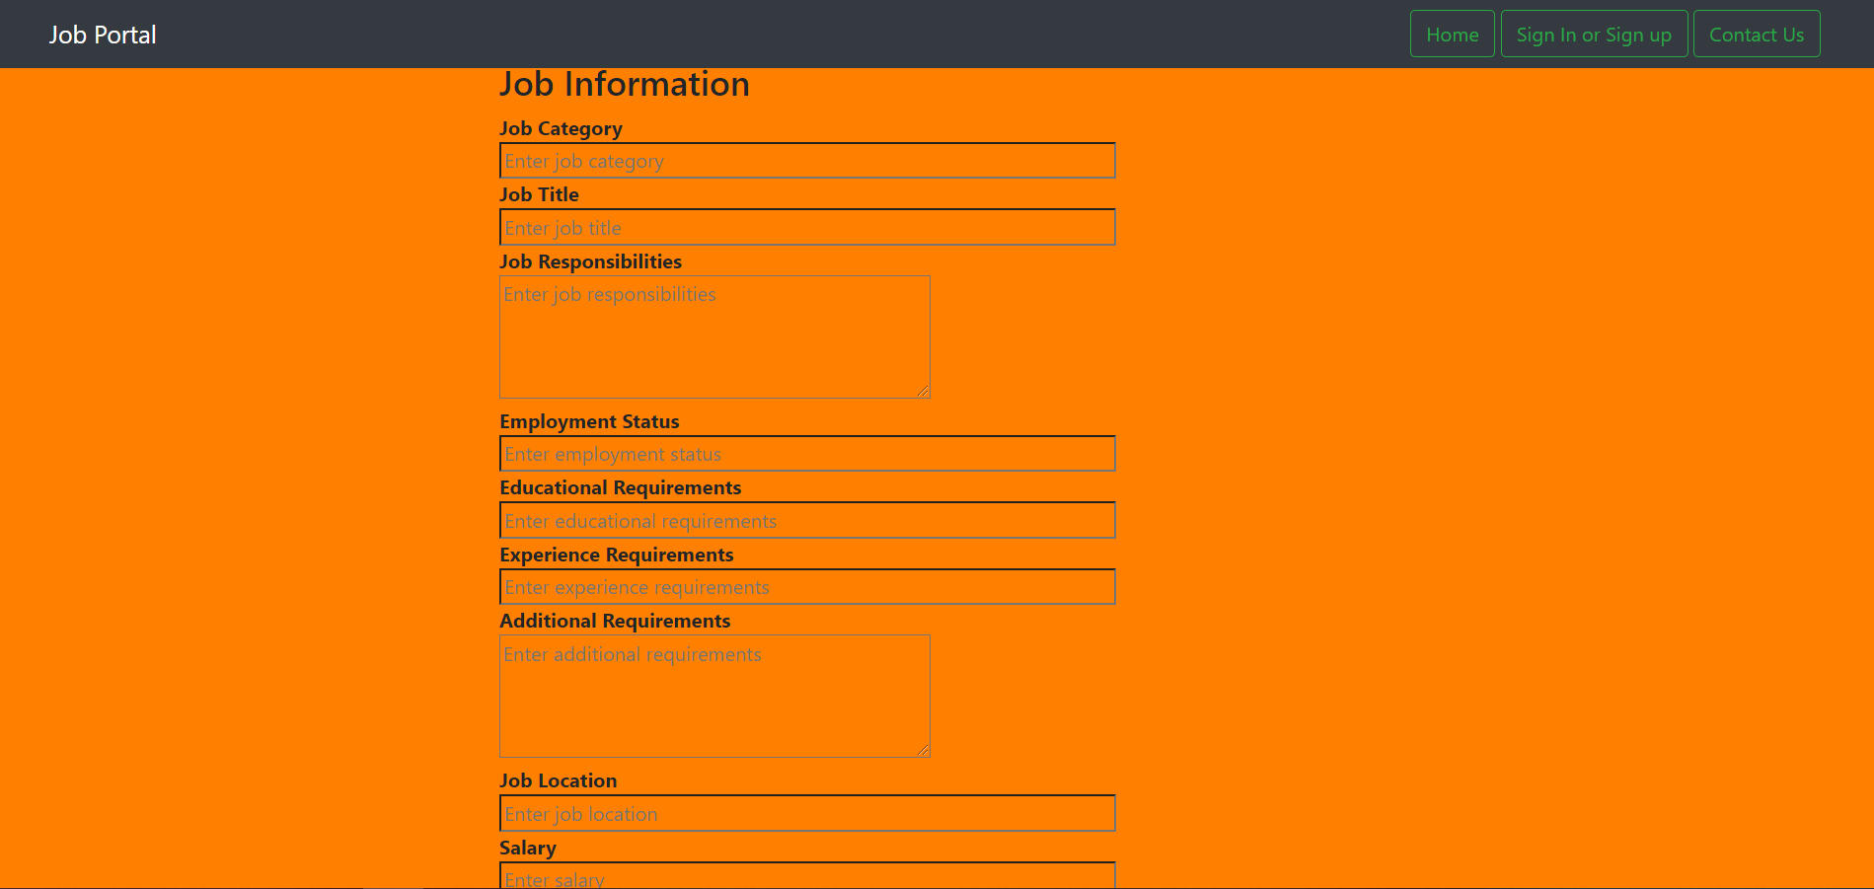

**Job Searching:**

Everyone capable of searching through jobs. They can search job by job category and job location.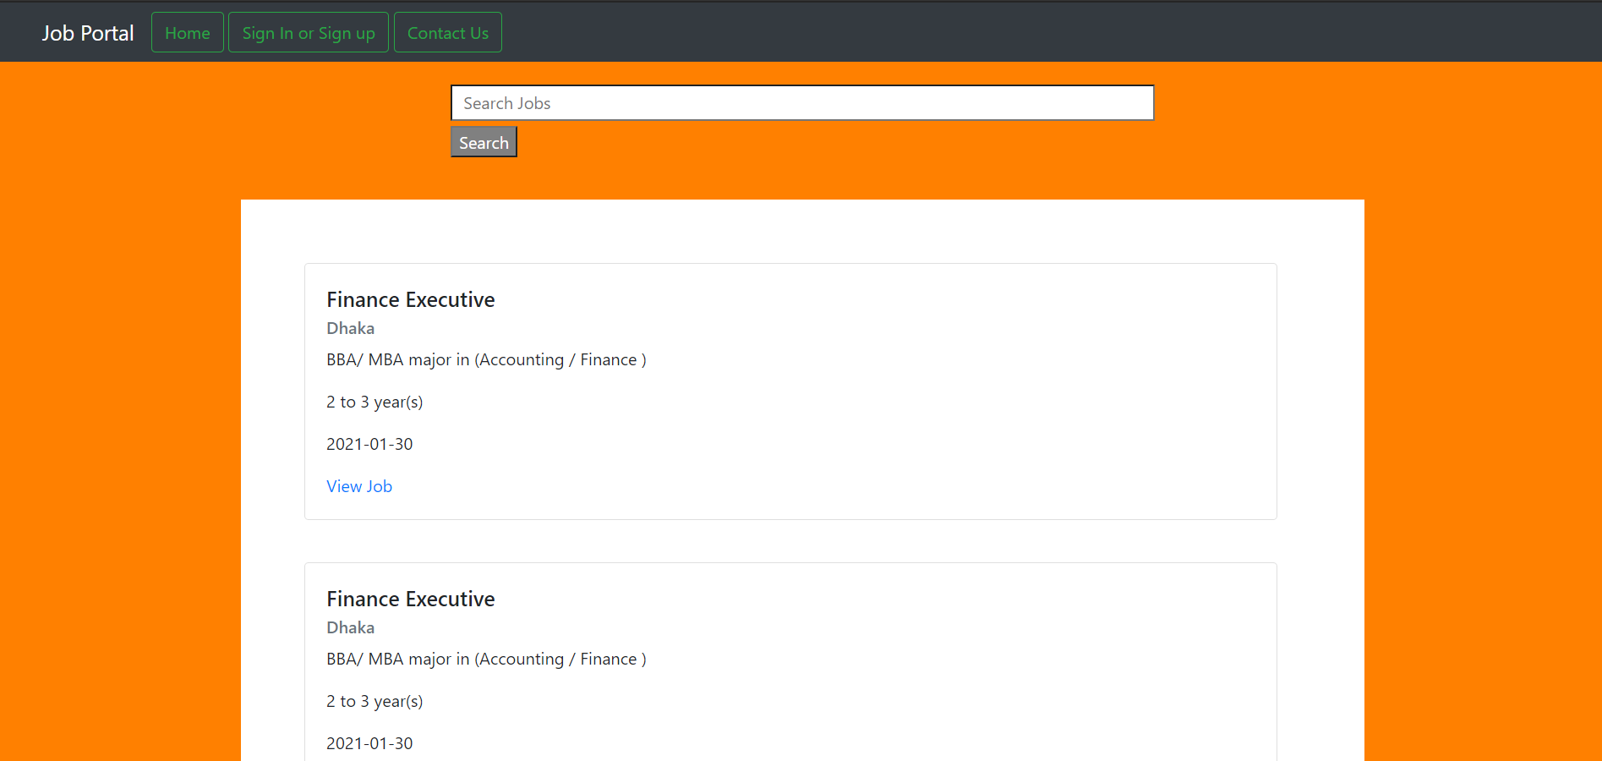

**Job Application Management:**

The employers are capable of handling all the job applications applied by the jobseekers.

**Technology**

**Front Language: HTML, CSS, JavaScript**

**Backend Language: PHP, Mysql DataBase**