***[Microservices and Microkernels](https://www.my-course.co.uk/mod/hsuforum/view.php?f=19607) Are the Future***

As IT professionals and IT enthusiasts we like the new and the shiny like technology magpies we flock to the latest and greatest technology this however is not how the end users think the users of the solutions we design want a solution that first of all works and is reliable and affordable. To a large degree they are platform and technology agnostic. Preferring instead to look at the overall solution rather than the components that the solution is based on.

That being said there are trends currently happening in the IT realm that affect the direction of travel of technology. Cloud first is the current mantra from most large organization [Creese Jon 2021] and the growth of microservices has largely been driven by the adoption of a cloud computing business model. With the ability to scale an application delivery no longer being restricted by the compute resource that an organization had on hand. Given sufficient funding an application can scale to meet almost any workload.

Are Microservices the future to a large degree yes for cloud solutions the microservices design pattern is a very appealing way of delivering solutions to scale [Manual Juan 2021] and is becoming the dominant way of delivering IT solutions. if, however, we take a step back and look at the makeup of the technology landscape with a single technology stack would not work across all use cases we need to right technology for the individual use case be that Microservices, Microkernels or other technology should be driven by the users not the other way around.

But if there is one thing, we have learned from the computing revolution, is it is very hard to predict the future though there are certainly patterns mainframes to commodity servers to VMs , VM to Containers so history shows us computing is becoming more decentralised

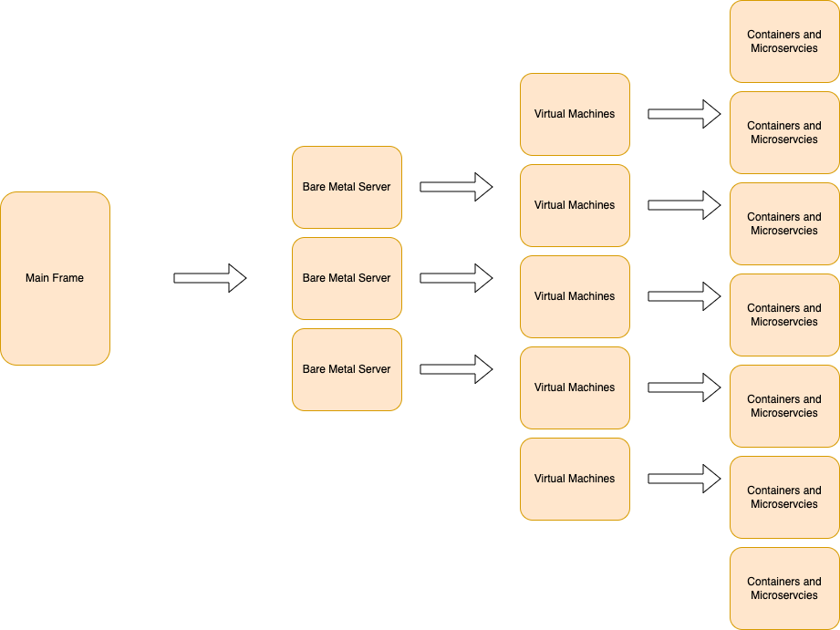

or in the words of Franco Ongaro thankyou team3 space domain project background reading.

***"The future is not something to predict. The future is something to build.."*—Franco Ongaro @ESA**

In other words, we can help shape the future by the choices we make in the systems we design and build even if we cannot predict it. That is why reason why Microservices and Microservices will make up part of the future landscape of IT solutions but the traditional solutions will still be part of the IT landscape for many years yet and that is. A good thing as only having one type of solution hinders innovation and who knows in a year’s time micro services may have competition from Quantum computing / block chain computing or new technologies, we are not even aware of yet.

**References**

# Creese Jos [Society for innovation, technology and modernisation] Accessed 24.05.2022

https://socitm.net/wp-content/uploads/2021/02/Socitm-report-cloud-computing.pdf

Soldani, Jacopo & Tamburri, Damian & Heuvel, Willem-Jan. (2018). The Pains and Gains of Microservices: A Systematic Grey Literature Review. Journal of Systems and Software. 146. 10.1016/j.jss.2018.09.082. Accessed 24.05.2022

<https://docs.microsoft.com/en-us/azure/architecture/microservices/design/patterns>

<https://www.contentful.com/blog/2020/12/15/microservices-to-future-of-quantum-computing-with-cto-juan-manuel/> Accessed 24.05.2022

<https://medium.com/the-challenge/a-brief-history-of-decentralized-computing-d0d665783bcf> Accessed 24.05.2022