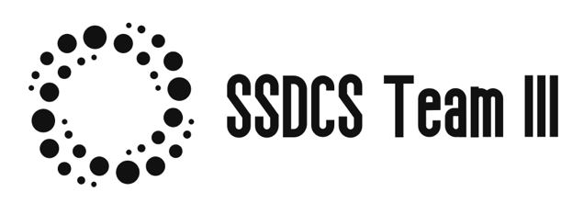

**Teamwork Contract March 2022**

|  |
| --- |
| GOALS: What are our team goals for this project?  What do we want to accomplish? What skills do we want to develop or refine? |
| As a Team we want to accomplish the following from this Secure Software Development Module.   * Produce a well put together Design Proposal Report comprising the following   1. Technical Diagrams created using Industry Standard UML  2. Catalogue of technical challenges to be addressed.  3. Catalogue of the solutions requirements and how we will implement them.  4. Catalogue of assumptions and any prerequisites.  5. Catalogue of the development tools services and libraries that will be used   * Produce well designed and implemented Prototype Systems consisting of  1. Code Written in Python 3.x 2. Code Written in accordance with best practice following Python PEP8 Guide. 3. Full Code Coverage via Unit Testing and Unit Test Cases 4. Accurate Documentation on the solution 5. Multiple Platform Support     **What skills do we want to develop or refine ?**  **Theoretical Skills**   * SDCL Stages of the Software Development Lifecycle * Software Design and Software Development methodologies * Knowledge of Containerisation Technologies * knowledge related to the secure development of software * Increased knowledge regulations affecting security and data protection * Analytical Skills in the software development realm   **Practical Skills**   * Team Coding (Code Review Pull Requests) * GitHub Actions * Team Working Skills * Python Secure Coding best practice * Distributed computing with python |
| EXPECTATIONS: What do we expect of one another in regard to attendance at meetings, participation, frequency of communication, the quality of work, etc.? |
| As a team we will  ● All engage and participate in tasks assigned as part of the group work.  ● Put our technical and non-technical skills at the disposal of the team.  ● Attend team meetings as dictated by the team and the schedule of work.  ● We will endeavour to help each other and reply to messages in a timely manner.  ● Keep Documentation we are responsible for up to date. |
| POLICIES & PROCEDURES: What rules can we agree on to help us meet our goals and expectations, such as preparatory tasks, generating ideas, evaluating outcomes? |
| Set up a collaborative development messaging and document environment to allow effective group working.   * GitHub * Slack * Google Docs |
| ROLES: Which roles do we need in this project and how do we allocate them? Will there be a project lead? Is there a need to rotate roles? |
| Roles will be assigned based on individual members strengths or interests in relation to the project and the tasks required to deliver the solution. |
| CONSEQUENCES: How will we address non-performance regarding these goals, expectations, policies and procedures? How do we resolve disagreements? |
| Resolving Disagreements between the team  The team as a whole will try to resolve disagreements between members using sound principles of team management   1. We will strive to treat everyone in the team equally without bias and be open and honest at all times. 2. We will try to spot conflict early and try to resolve any issues before it becomes a bigger issue that could affect the cohesion of the team. 3. We will ensure that all the members of the team listen to each other’s opinion and point of view and that everyone’s contribution to the project is equally valued. Nobody should feel that their contribution to the project is not valued. 4. In a conflict between two members of the team the other members of the team should not take sides but act to deescalate the conflict.   In the event our actions fail then we will arrange a session with Cathryn Peoples to discuss the disagreements and find a solution.  **Non-Performance**  In the event of non-performance, we will carry out the following actions   1. Arrange a meeting to the discuss the issues 2. Pending the result of the meeting [1] a further meeting with Module tutor maybe required to resolve the issue. 3. In the event issues cannot be resolved tasks will be reassigned to the remaining members of the team. |

**Team Member Name and Date**

|  |  |
| --- | --- |
| **Name** | **Date** |
| Abdulahi Alihu Ngamjeh |  |
| Ian Wolloff |  |
| Aidan Curley |  |
| Kaoru Kitamura |  |