Assignment 1
Advanced Solidity Patterns & Security Fundamentals
PART 1 — Advanced Solidity Design Patterns
Task 1: Factory Pattern Implementation
Name: Iskander Kustayev
Group: SE-2403

Deliverables:
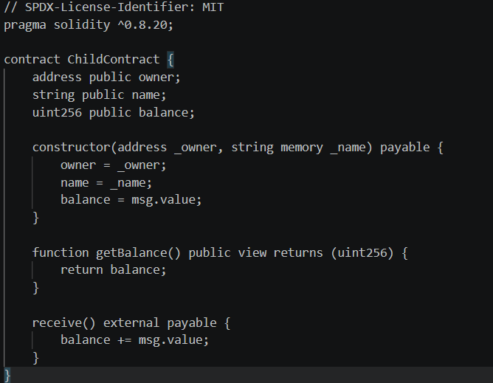
• ChildContract.sol

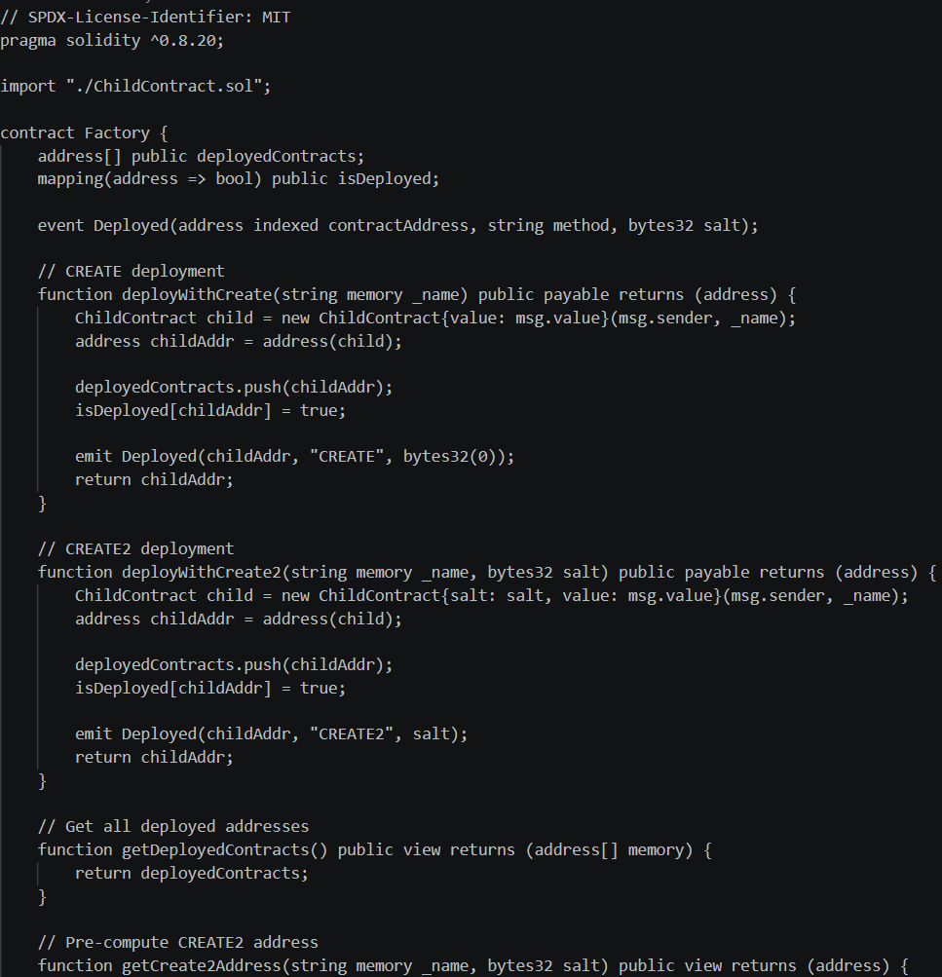
Factory.sol

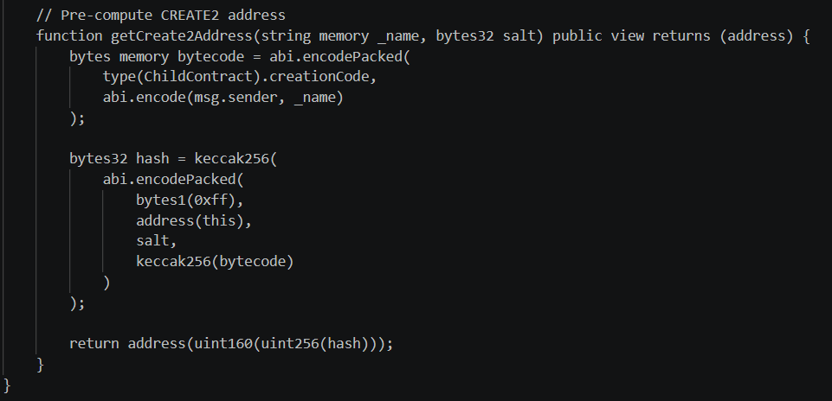

Test of the Factory.sol
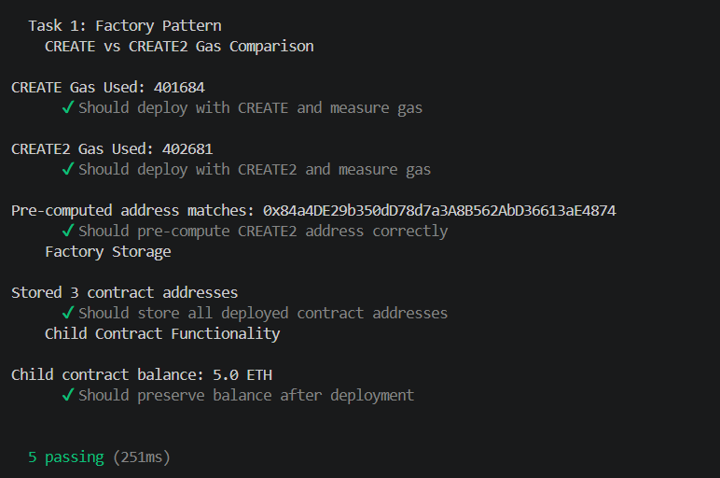
Running the node
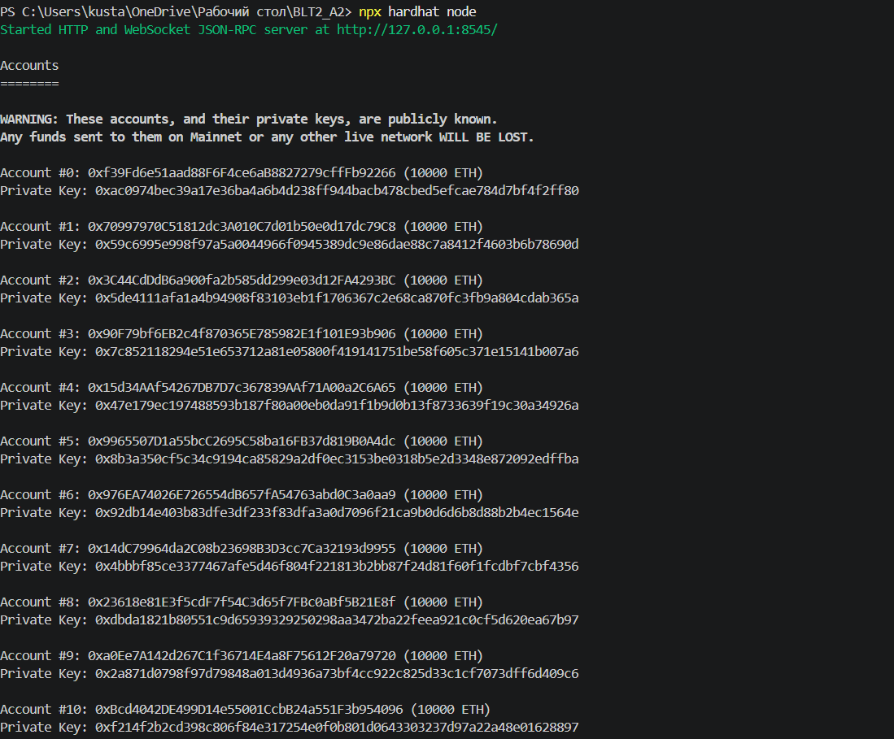
• Deployment logs showing both create and create2
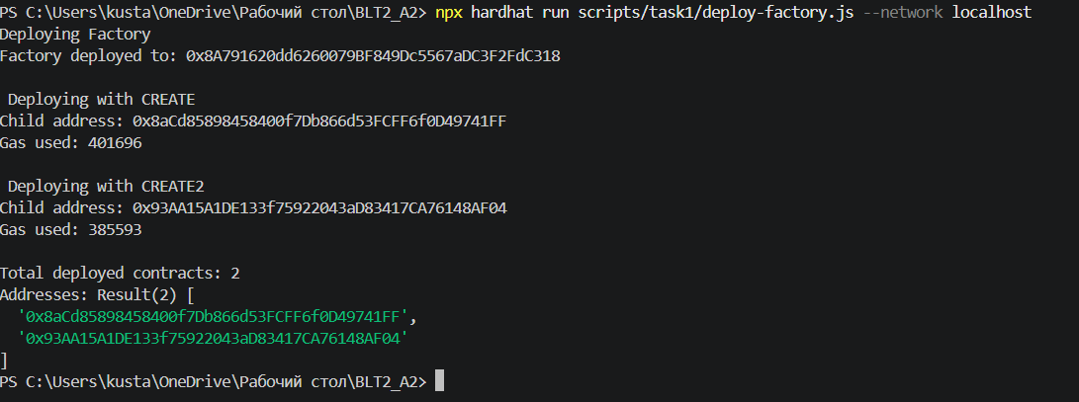
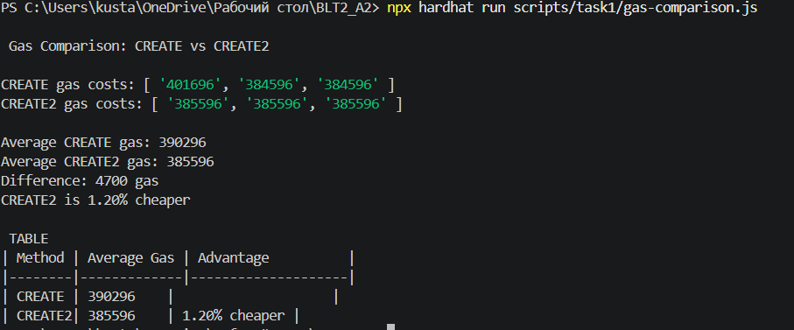
• Gas comparison table (create vs create2)

