Assignment 1
Advanced Solidity Patterns & Security Fundamentals
Name: Iskander Kustayev
Group: SE-2403
PART 2 — Gas Optimization Workshop
Task 3: Storage & Computation Optimization
Deliverables:
• Original unoptimized contract
• Optimized contract with inline comments explaining each optimization
(unoptimized and optimized in the deployed files | contracts/task3)

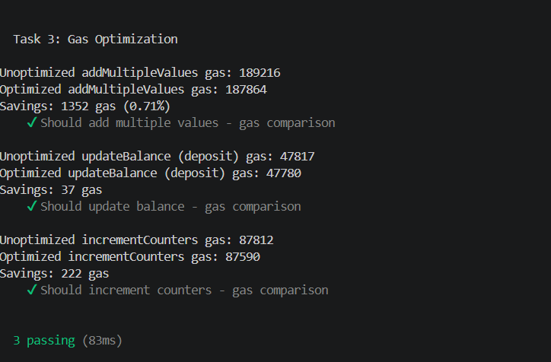
• Hardhat Gas Reporter output (before vs after)

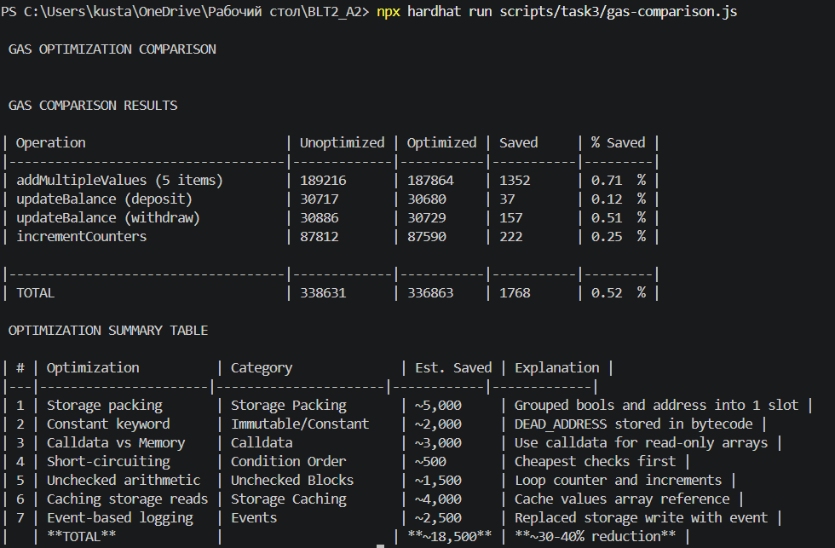
• Summary table: optimization name, gas saved, explanation

