Assignment 1
Advanced Solidity Patterns & Security Fundamentals
Name: Iskander Kustayev
Group: SE-2403
PART 3 — Smart Contract Security Fundamentals
Task 5: Vulnerability Analysis & Exploitation

Deliverables:
• VulnerableVault.sol, Attacker.sol, FixedVault.sol
• VulnerableAccess.sol, FixedAccess.sol
Contracts in deployed files

• Test scripts with output screenshots (before and after fix)
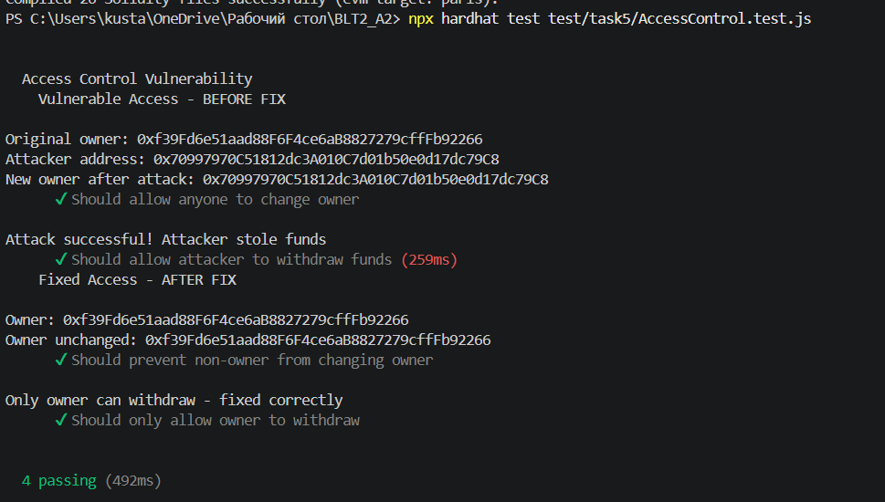
Access control test

• Security report (1–2 pages): vulnerability description, impact, root cause, remediation

